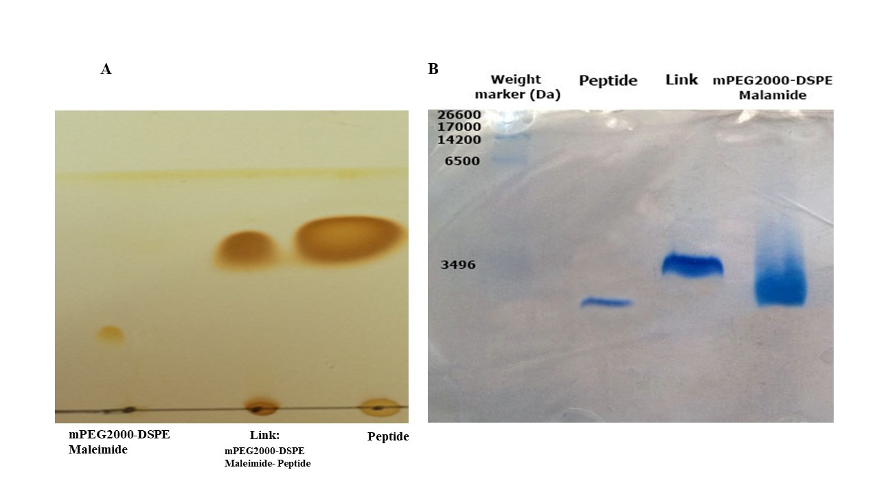
Figure1: Conjugation of GE11 peptide with mPEG2000- DSPE Maleimide. Figure 1A represents the TLC test for confirmation of linkage between GE11 and mPEG2000- DSPE Maleimide. Figure 1B also shows the confirmation of linkage by SDS PAGE test.

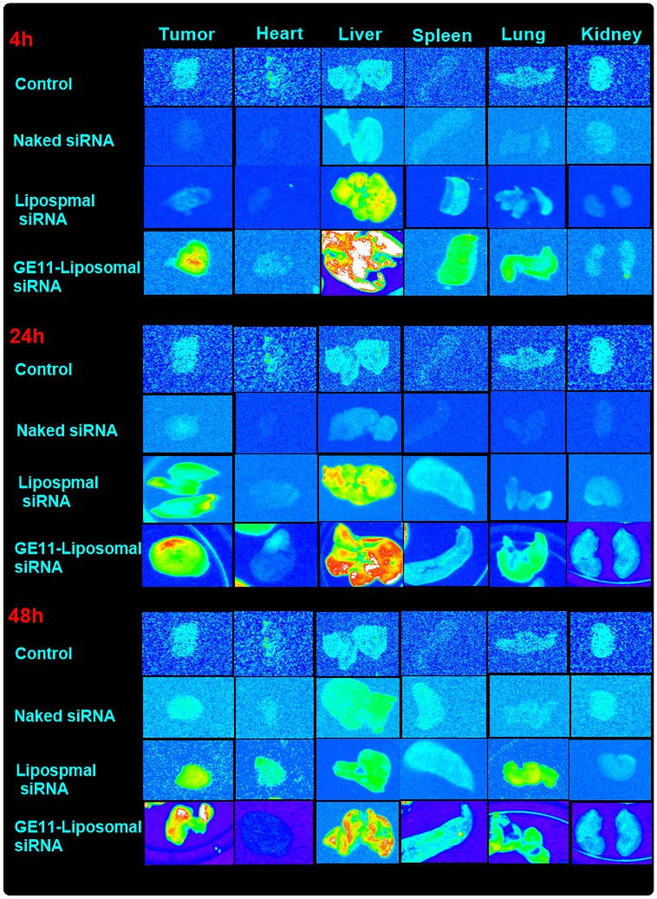

Figure 2: Tissue biodistribution of EGFR-targeted and non-targeted liposomal formulation containing Cy3-siRNA at three-time intervals (4, 24 and 48 h post injection) in tumor site, heart, liver, spleen, lung, and kidney tissues. The intensity of Cy3 fluorescence dye indicates qualitative drug accumulation in different tissues.
Figure 3: Gating strategy of Tumor infiltrated lymphocytes by flowcytometry

