Valorization of Pomelo Peel into a Carboxyl-Rich Adsorbent for Charge-Selective Removal of Cationic Dyes
Linlin Du^{a*}, Jiaxing Jiangª, Dayong Xie^{b}, Yingbo Zhangª, Bing Niuª, Sisi Maª, Wenying Shiª
ª College of Textile Engineering, Henan University of Engineering, Zhengzhou 451191, China
b. Henan Tongtai Textile Co., Ltd, Zhoukou 475400, China

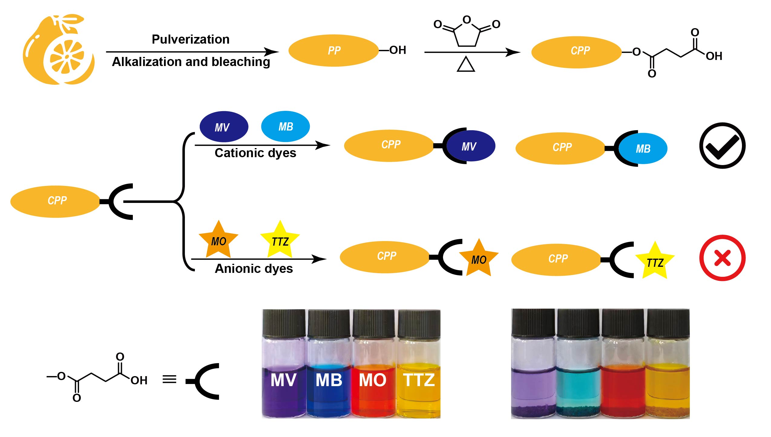
Figure S1. Synthesis flow chart and adsorption effect diagram of CPP.

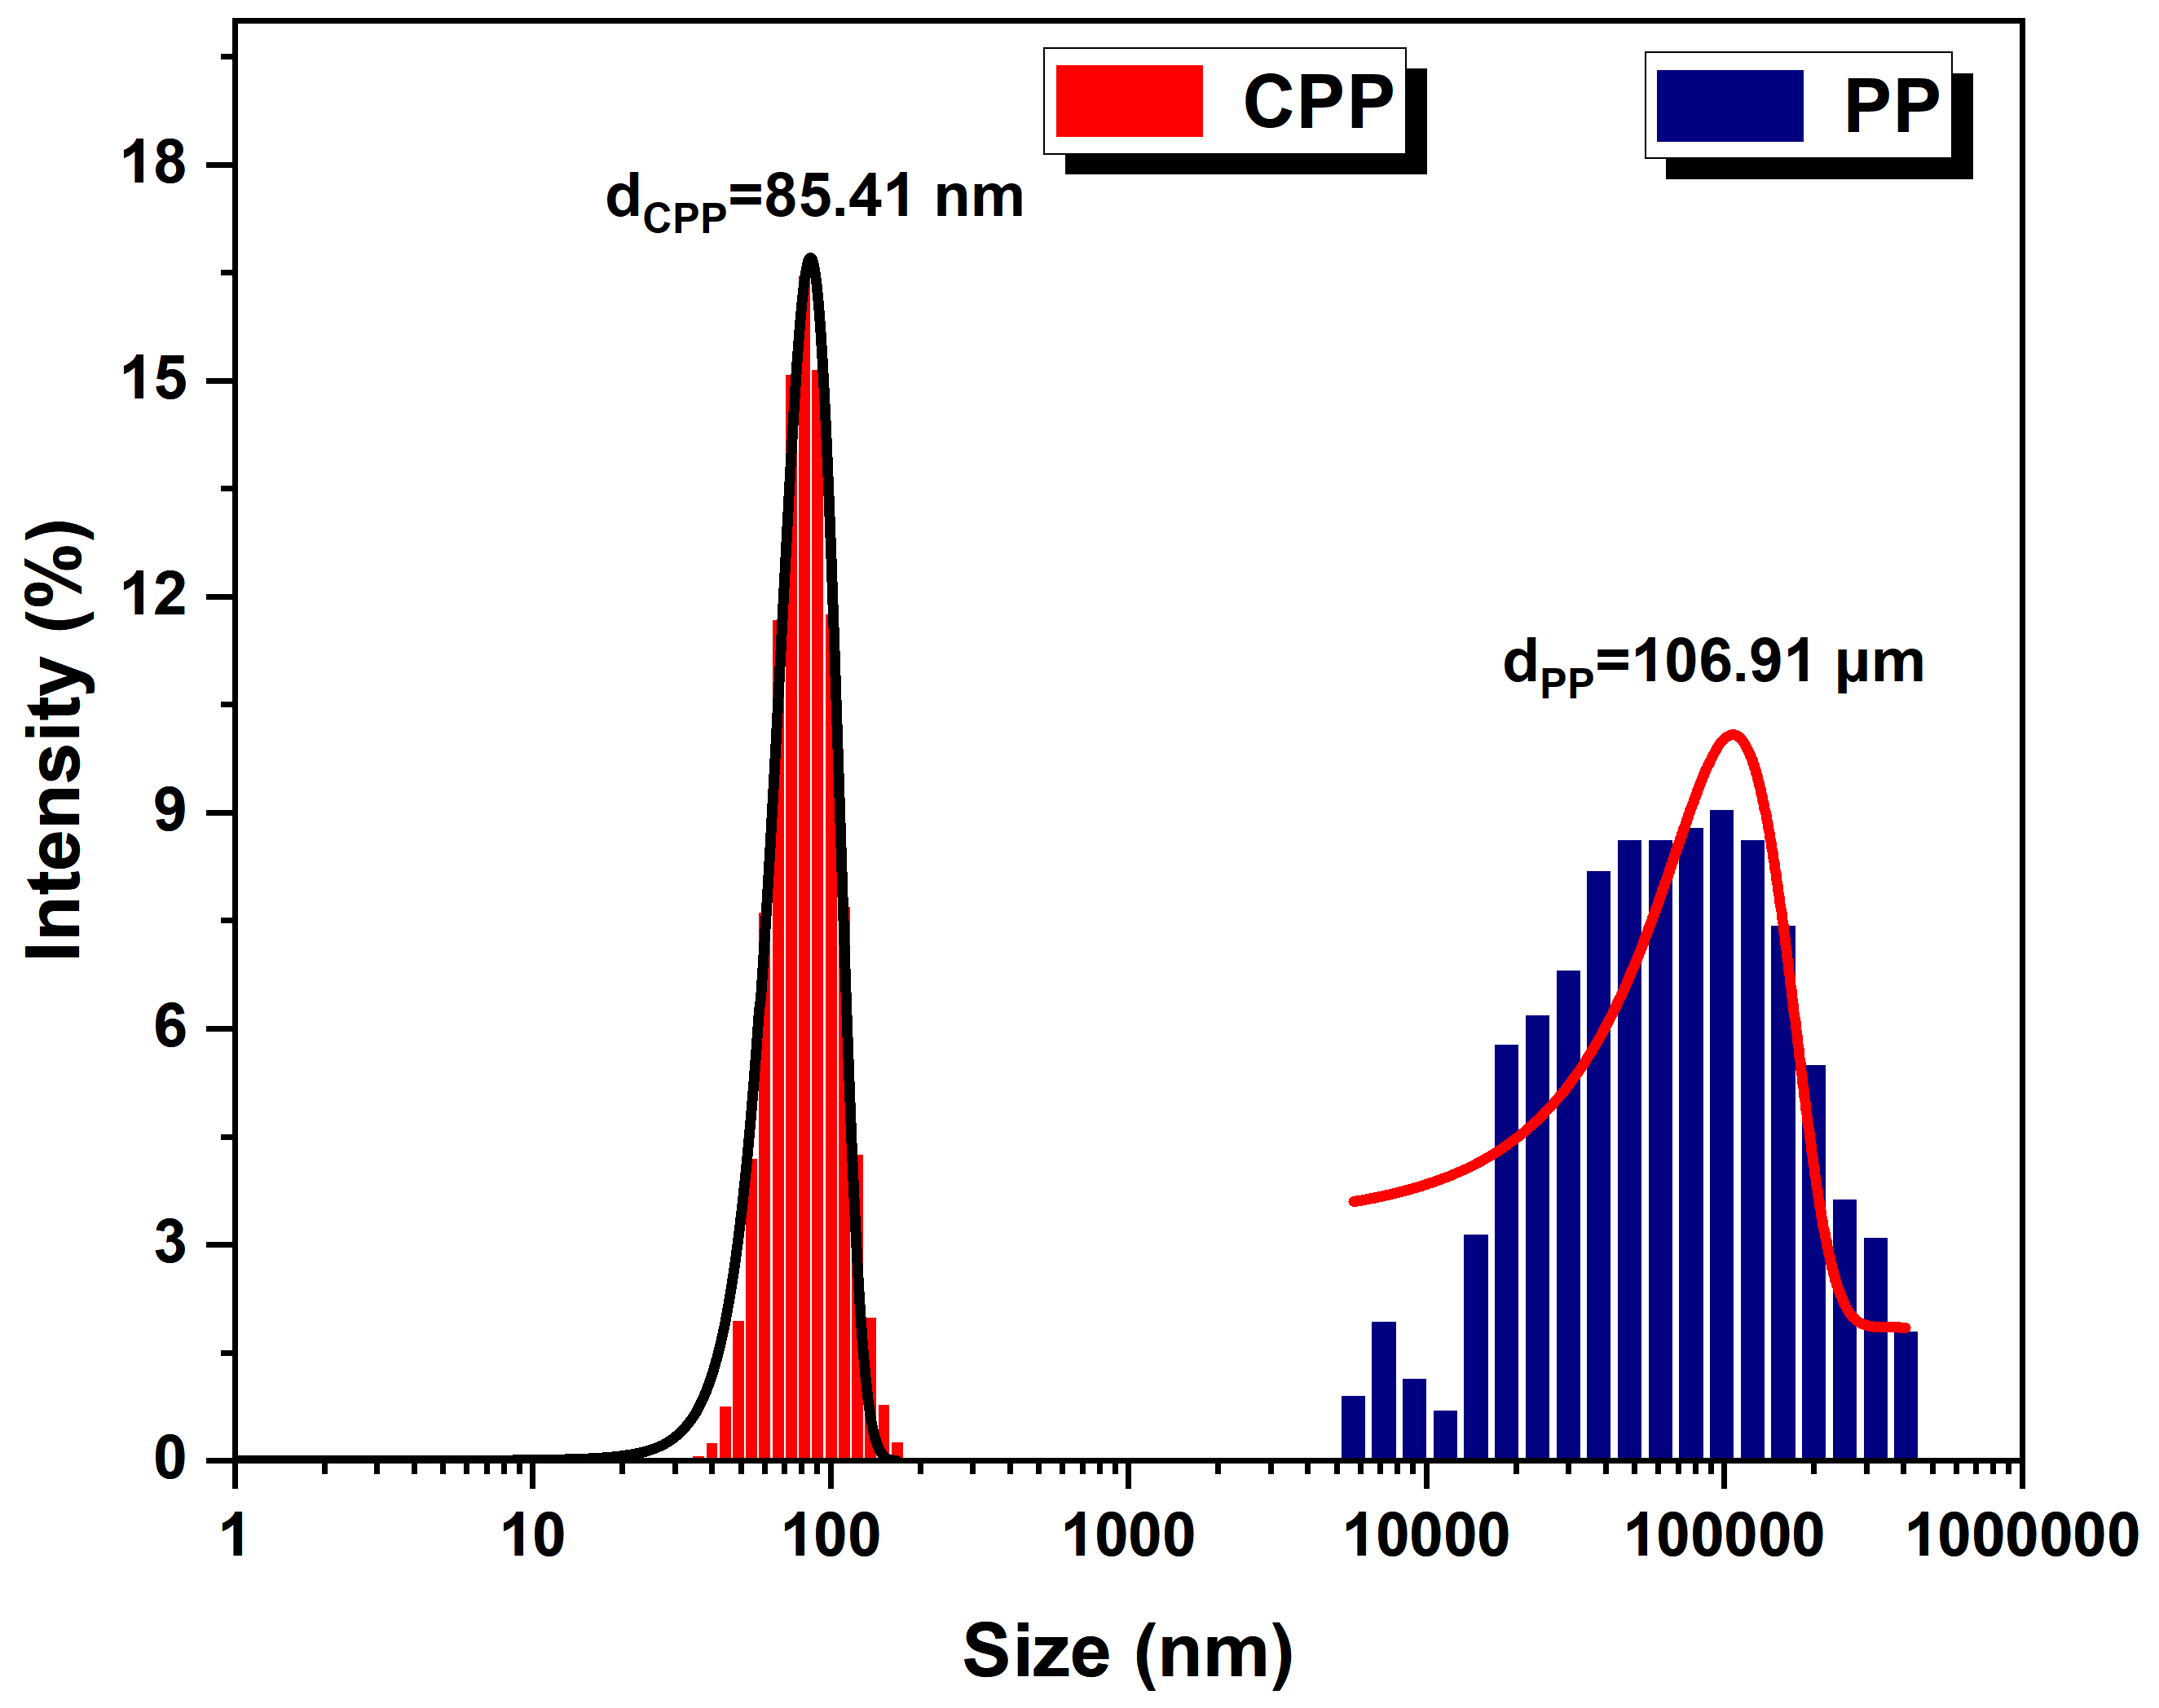
Figure S2. DLS curves of PP and CPP.


Figure S3. Images of water contact angles of CPP.

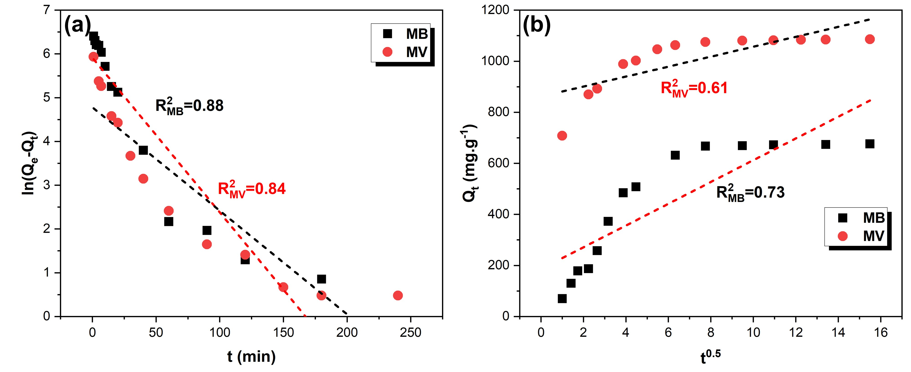
Figure S4. (a) Pseudo-first-order kinetic model. (b) Intraparticle diffusion model.

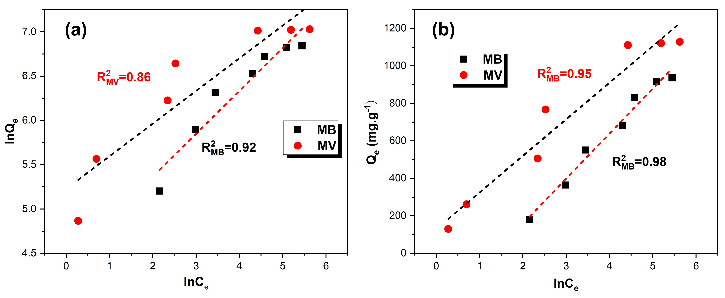
Figure S5. (a) Freundlich isotherm model. (b) Temkin isotherm model.

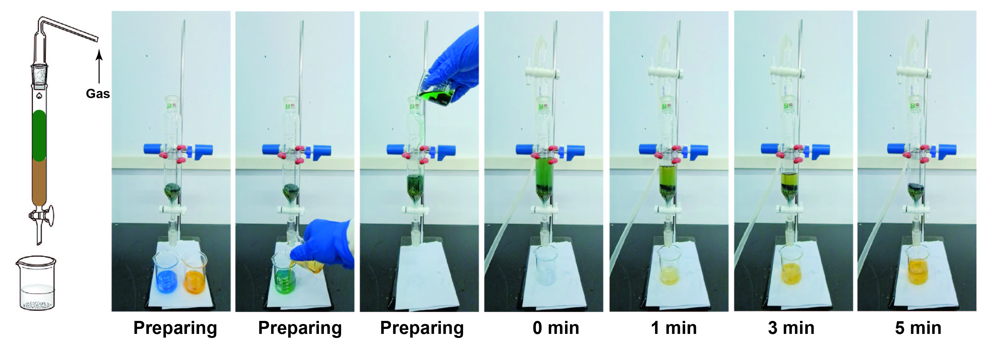
Figure S6. Video snapshots of an MB/MO mixed solution flowing through a packed column filled with CPP powder (MB and MO concentrations: 10 mg·L⁻¹).

