Supplementary materials
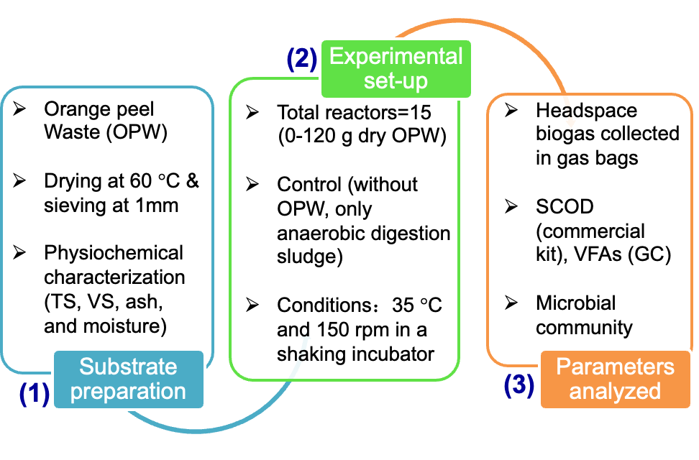
Fig. S1. A schematic representation of the substrate preparation, experimental-setup, and parameters analyzed in this study.

