Supplementary Figures and Table

CD146⁺ endothelial and pericyte populations define a repair-associated neovascularization program in rheumatoid arthritis pannus

Yoko Miura, *Nadia Milad, Atsushi Usami, Shunichi Kosugi, Hideki Noguchi, and Satoshi Kanazawa

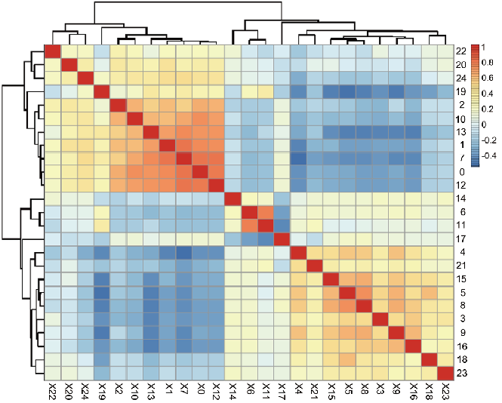
Supplementary Figure 1: Heat map derived from scRNA-seq data. Vertical and Horizontal bars indicate cluster numbers. c14 (endothelial cells) and c19 (type-2 pericytes) represent distinct populations. c11 and c6 (type-2 pericytes) exhibited similar gene expression patterns. C0, c1, c2, c7, c10, c12, and c13 (macrophages) showed similar gene expression patterns. Similar gene expression patterns were observed in c3, c4, c8, c9, and c16 (type-1 pericytes). This heat map data supports the annotation based on the FltSNE analysis in Figure 3A.

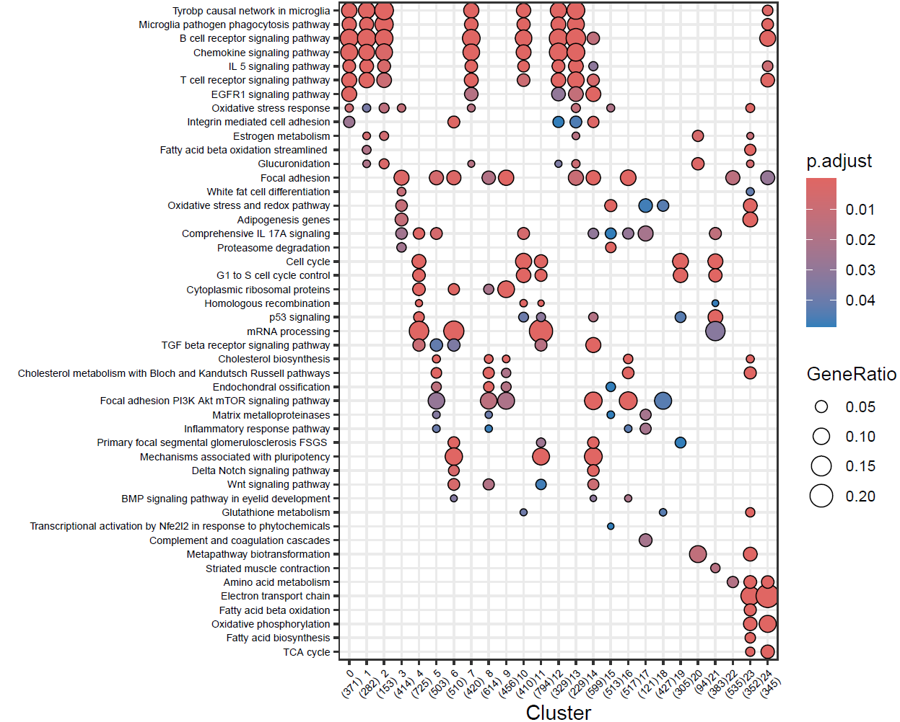
Supplementary Figure 2: Gene set enrichment analysis using clusterProfiler and WikiPathways. Clusters 6/11/14 are associated with pluripotency-related mechanisms, while the Delta/Notch signaling cascade is specifically enriched in the transition between clusters 6 and 14.

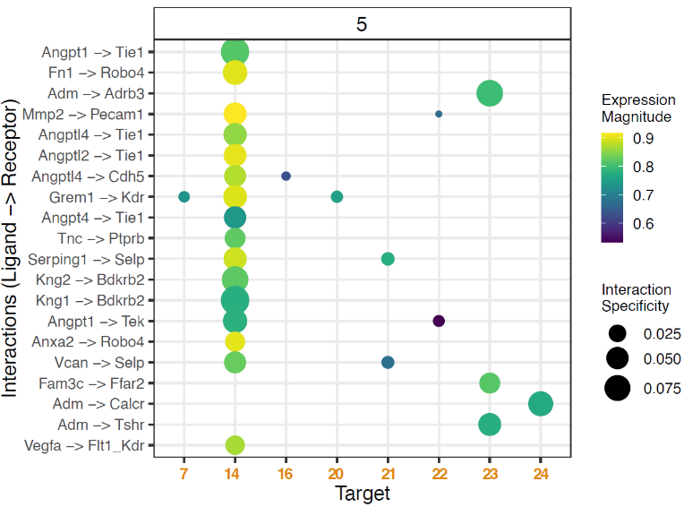
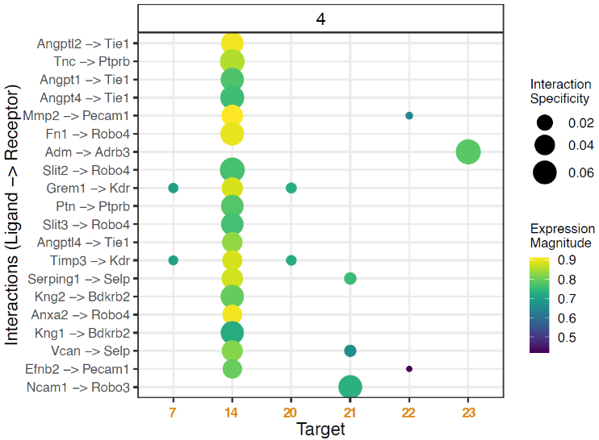
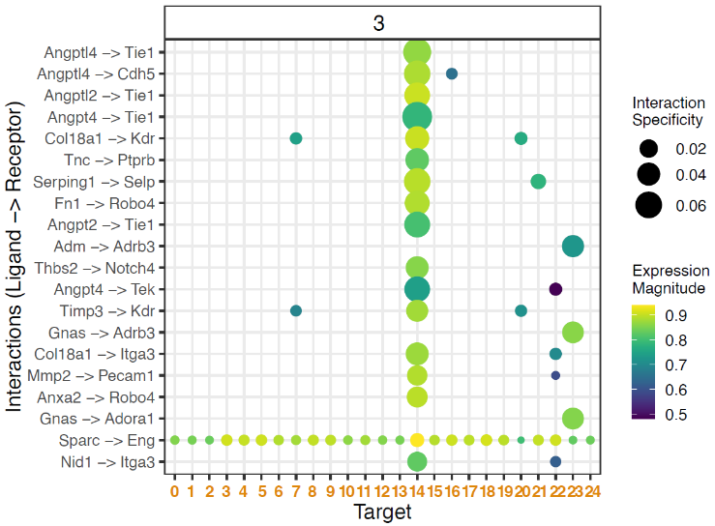
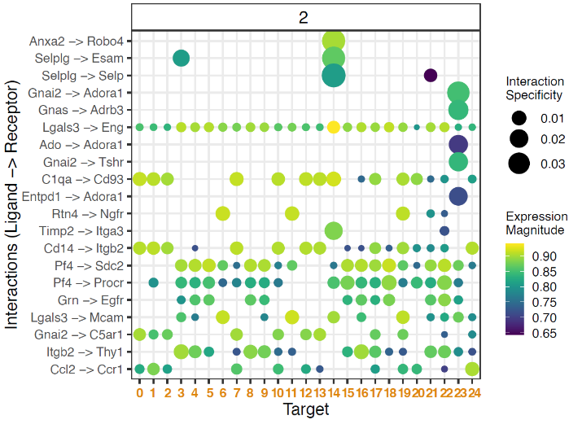
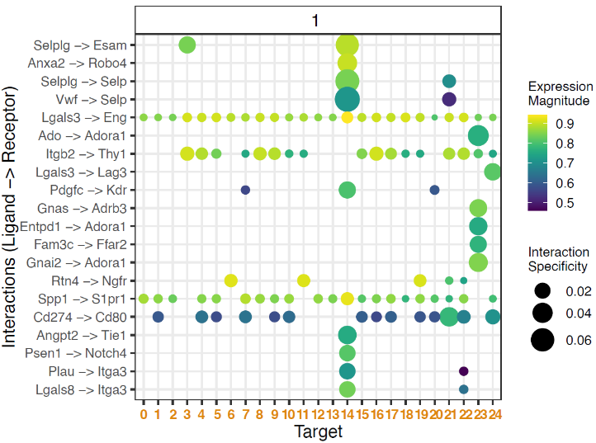
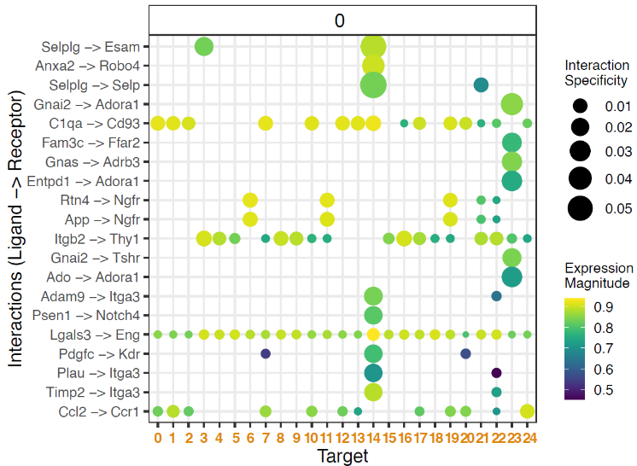

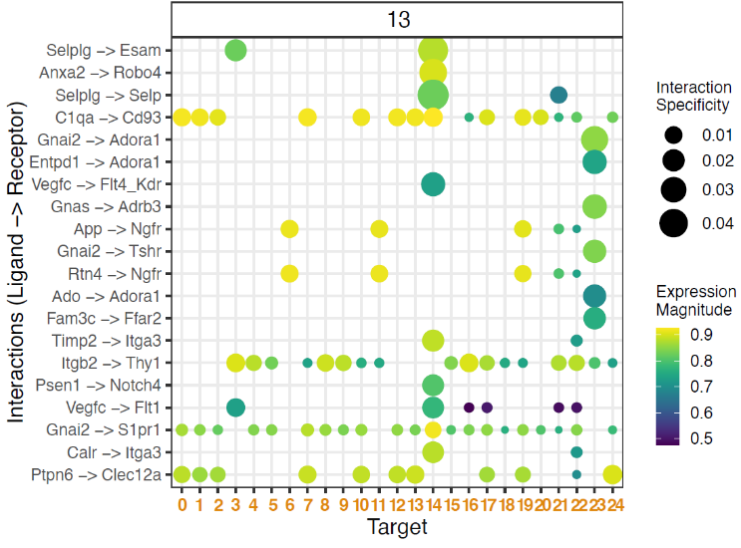
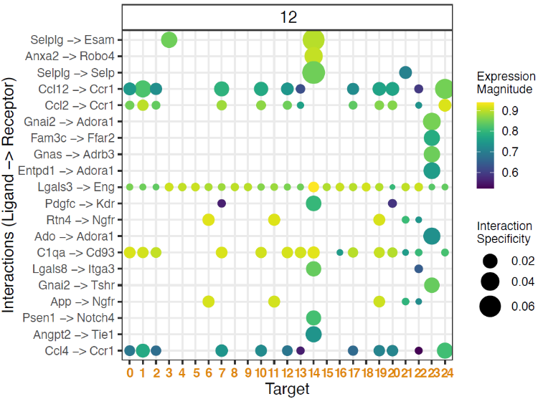
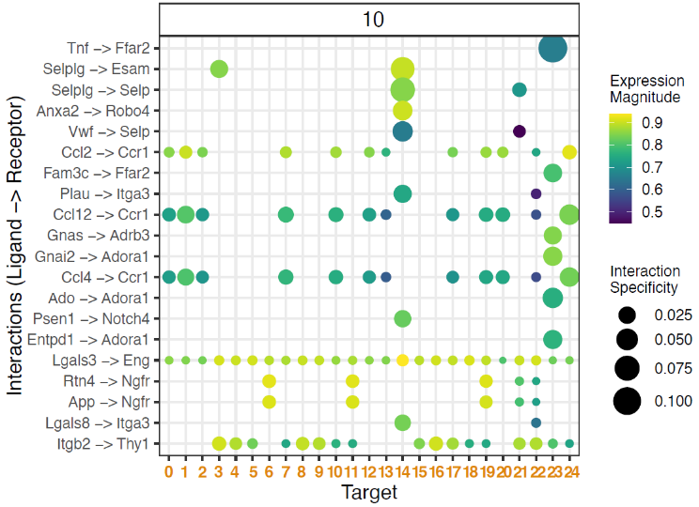
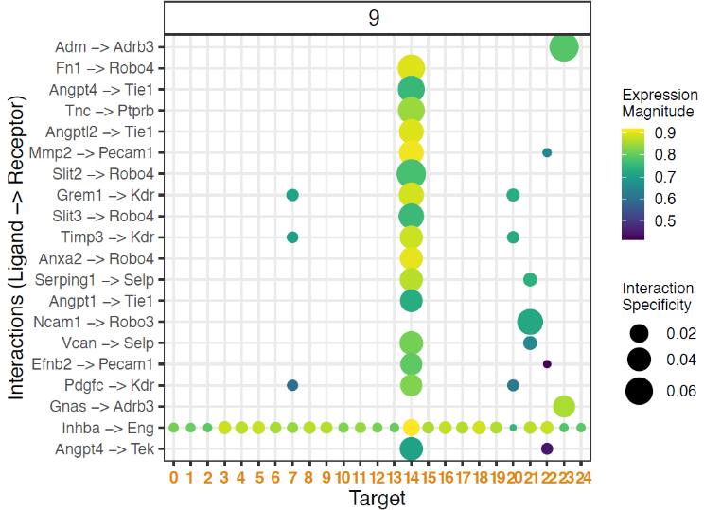
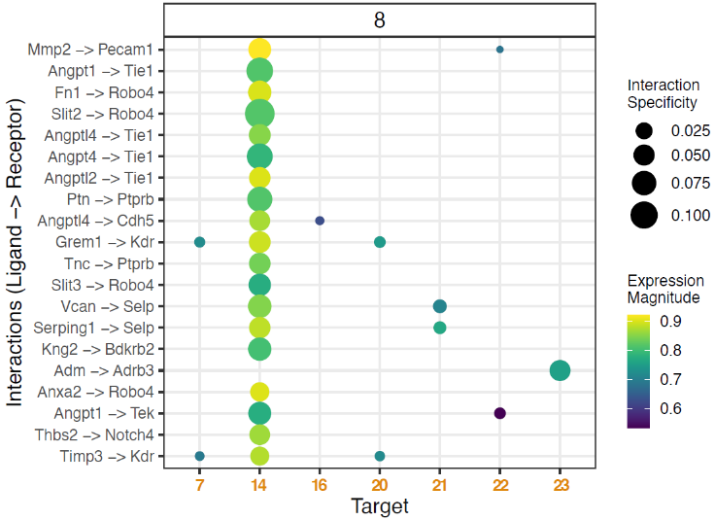
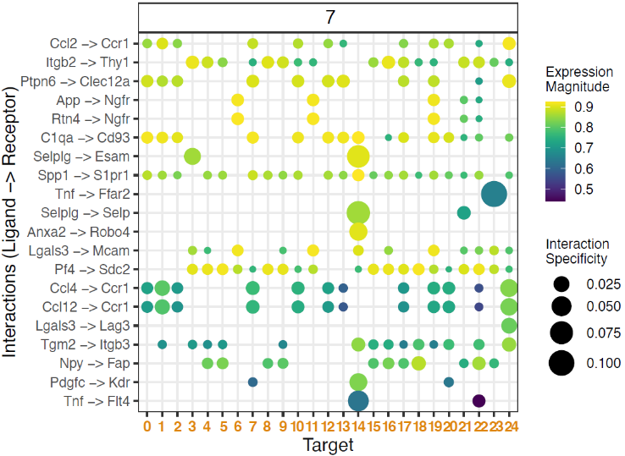

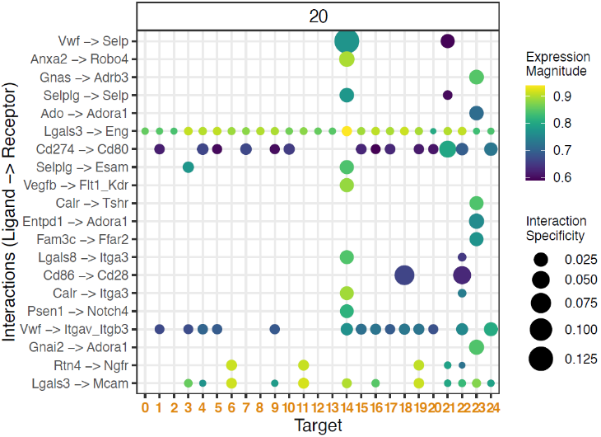
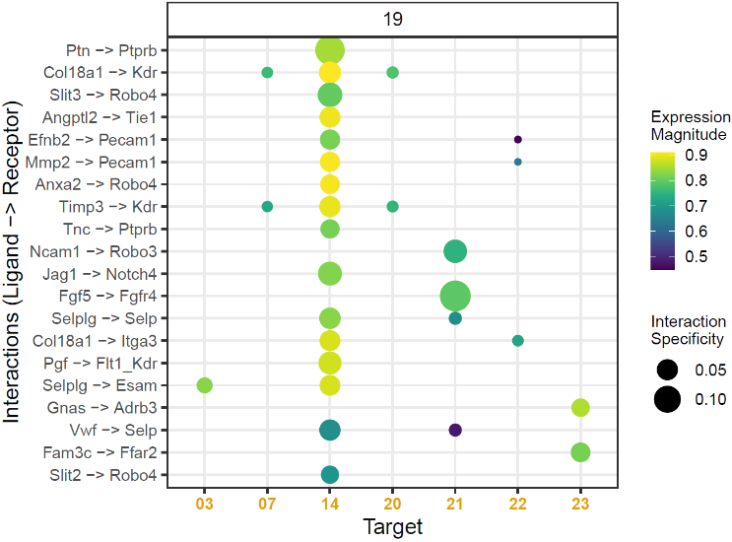
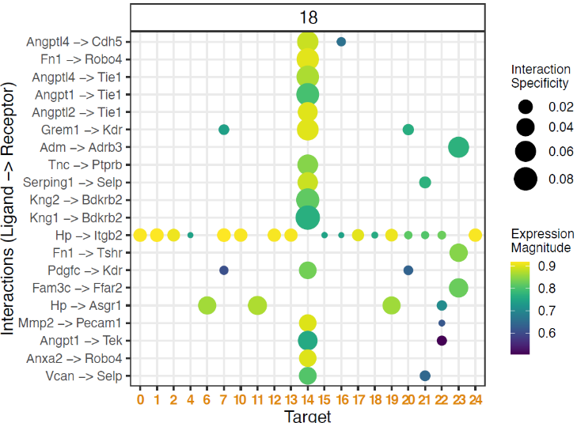
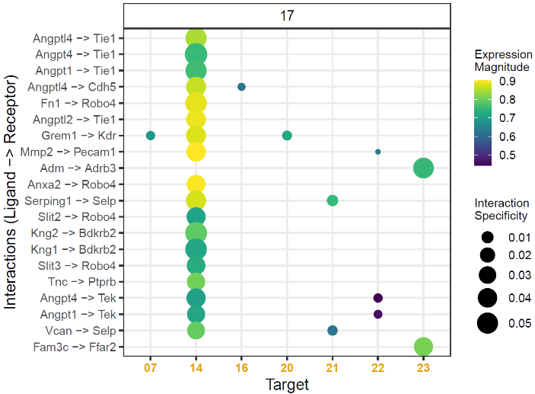
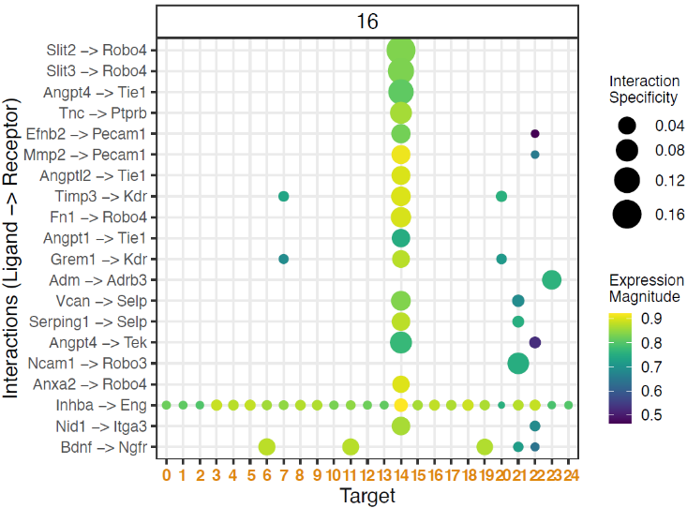
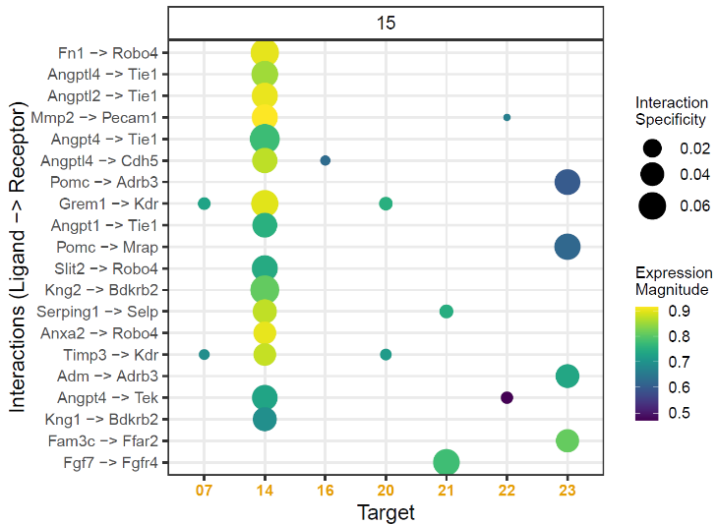

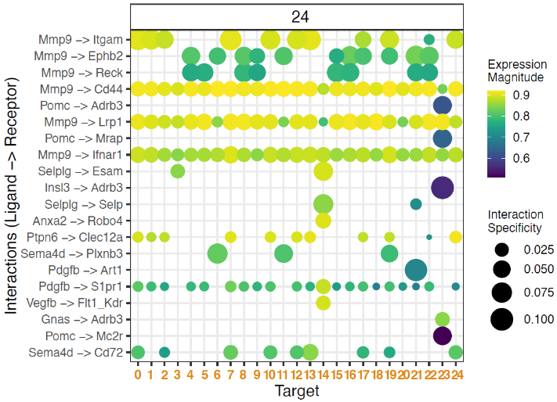
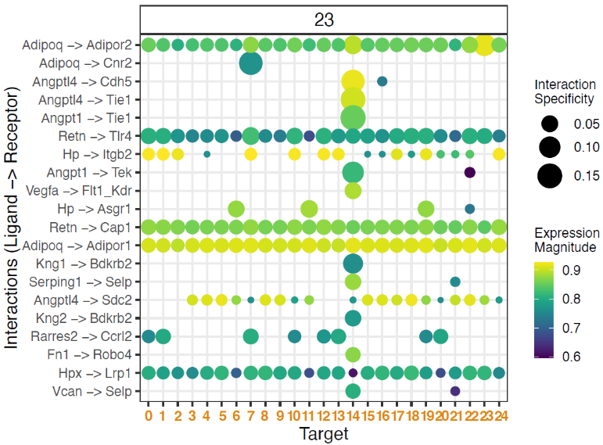
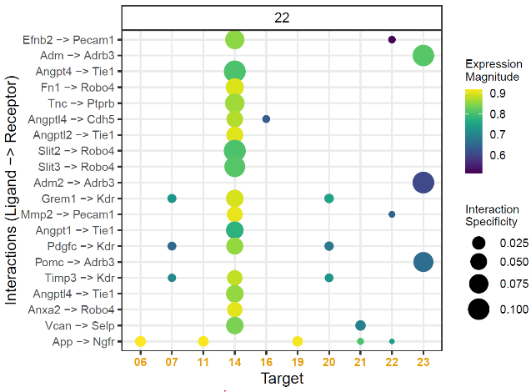
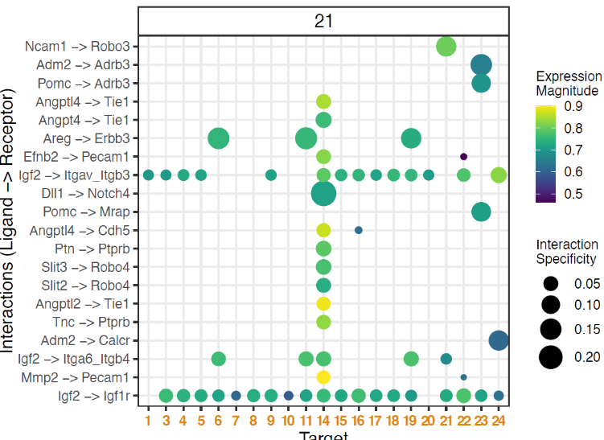

Supplementary Figure 3: LIANA analysis for clusters 0 through 24 (excluding 6, 11, 14, and 19). The top row indicates each cluster number. Each row shows the expression of each ligand within the cluster, with each ligand’s receptor represented by a vertical bar. Each cluster number is represented by a horizontal bar.

Supplementary Table 1: Type-1 pericyte markers detected in CD146⁺/Pdgfrb⁻ cells.

 | CD146⁺/Pdgfrb⁻ cells
Type-1 pericyte markers | Cluster  3 | Cluster 4 | Cluster 8 | Cluster 9 | Cluster 10
Collagen type 1 alpha 1 chain, Col1a1 | - | + | + | + | +
Actin alpha 2, smooth muscle, Acta2 | + | + | - | + | +
Angiopoetin 2, Angpt2 | - | - | - | - | -
C-C motif chemokine ligand 2 (MCP-1), Ccl2 | - | + | + | + | +
Cellular communication network factor 2, Ccn2 | + | + | + | + | +
C-X-C motif chemokine ligand 2, Cxcl2 | - | - | - | - | -
Endothelin receptor type A, Endnra | + | - | - | - | -
Endothelin receptor type B, Endnrb | + | - | - | - | -
Fibronectin 1, Fn1 | - | + | - | - | -
Interleukin 6, Il6 | - | - | - | - | +
Matrix metalloproteinase 2, Mmp2 | - | + | + | + | -
Periostin, Postn | + | - | + | + | +
Regulator of G-protein signaling 5, Rgs5 | + | - | - | - | -
Smad family member 3, Smad3 | - | - | + | - | -
TIMP metallopeptidase inhibitor 1, Timp1 | - | + | + | + | +
Type-1 pericytes markers detected in CD146-/ Pdgfrb+ cells are listed. Each cluster is annotated using tSNE data from scRNA-seq. +: positive mRNA expression, -: negative mRNA expression

