Supplementary Appendix

Table of Contents
Table of Contents 1
Introductory description 1
Part A 2
Worked examples: five representative combinations 2
Part B 5
Empirical CDFs for the 25 quantitative criteria 5
Category: Data adequacy 5
Category: Cohesion 9
Category: Unidimensionality 10
Category: Temporal stability 16

Introductory description
This appendix supplements the empirical analysis chapter with two pieces of detail. Part A reports the full per-criterion decision values for five worked-example combinations drawn from the 20-index pool, showing how the population-level results translate into concrete cases of varying size and substantive composition. Part B reproduces the empirical cumulative distribution functions (ECDFs) for each of the 25 quantitative criteria across all 654,046 evaluated combinations, providing a granular view of the criterion-by-criterion evidence behind the headline summary in Table 2 of the main chapter.

Part A

Worked examples: five representative combinations
To illustrate the population-level brute-force result with concrete cases, we re-ran the same analysis pipeline (pooled and yearly PCA, pooled and yearly maximum-likelihood one-factor confirmatory factor analysis, and the full 27-criteria battery) on five hand-picked combinations from the 20-index pool. The combinations were chosen to span a wide range of pool size (from 4 to 16 indices), substantive composition (core governance; governance plus democracy; governance plus development; mixed broad; near-full pool), and joint country-year sample size (from 227 to 1,734).
Table A1 reports the per-criterion decision values for each example. Green-shaded cells indicate that the criterion is satisfied for the combination; pink-shaded cells indicate failure. The table is read by criterion (row) and combination (column).

Table A1. Per-criterion decision values for five representative combinations from the 20-index pool.
Criterion | E1 | E2 | E3 | E4 | E5
Indices in combination | CPI, WGI-GE, WGI-RL, V-Dem LD | CPI, WGI-GE, WGI-RL, V-Dem LD, V-Dem Poly, FH | CPI, WGI-GE, WGI-RL, V-Dem LD, HDI, IAHDI, SPI, WHR | CPI, WGI-GE, V-Dem LD, HDI, SPI, WHR, GPI, WPFI, HER, Henley | CPI, WGI-GE, WGI-RL, V-Dem LD, V-Dem Poly, FH, HDI, IAHDI, GII, SPI, WHR, GPI, WPFI, HER, GII-inn, Henley
p (number of indices) | 4 | 6 | 8 | 10 | 16
n (joint country-years) | 1,734 | 1,368 | 1,217 | 1,229 | 227
DATA ADEQUACY
n ≥ 100 | 1734 | 1368 | 1217 | 1229 | 227
Max |z| ≤ 4.00 | 2.530 | 2.541 | 3.258 | 3.870 | 3.221
n/p ≥ 10.00 | 433.5 | 228.0 | 152.1 | 122.9 | 14.2
det(R) > 0.00001 | 0.0025 | 5.8e-6 | 1.1e-7 | 1.7e-6 | 5.9e-15
KMO ≥ 0.70 | 0.791 | 0.849 | 0.892 | 0.897 | 0.935
Bartlett (p < 0.05) | < 0.001 | < 0.001 | < 0.001 | < 0.001 | < 0.001
COHESION
Min |r| ≥ 0.35 | 0.698 | 0.635 | 0.627 | 0.323 | 0.428
Mean |r| ≥ 0.55 | 0.849 | 0.819 | 0.815 | 0.682 | 0.741
Sign coherence (PC1) | Pass | Pass | Pass | Pass | Pass
Sign coherence (FA1) | Pass | Pass | Pass | Pass | Pass
UNIDIMENSIONALITY
Kaiser (λ₂ < 1) | 0.346 | 0.727 | 0.663 | 1.053 | 1.546
Eigenvalue separation λ₁/λ₂ ≥ 3 | 10.27 | 7.01 | 10.14 | 6.84 | 7.88
PC1 explained variance ≥ 0.60 | 0.889 | 0.850 | 0.840 | 0.721 | 0.761
Mean h² ≥ 0.45 | 0.868 | 0.775 | 0.797 | 0.688 | 0.716
Min h² ≥ 0.35 | 0.659 | 0.518 | 0.552 | 0.298 | 0.319
SRMR ≤ 0.08 | 0.112 | 0.138 | 0.130 | 0.197 | 0.166
RMSEA ≤ 0.06 | 0.332 | 0.658 | 0.472 | 0.311 | 0.341
CFI ≥ 0.95 | 0.963 | 0.676 | 0.722 | 0.744 | 0.626
χ² (p > 0.05) | < 0.001 | < 0.001 | < 0.001 | < 0.001 | < 0.001
Min |loading| (PC1) ≥ 0.25 | 0.456 | 0.394 | 0.318 | 0.242 | 0.202
Min |loading| (FA1) ≥ 0.40 | 0.812 | 0.720 | 0.743 | 0.546 | 0.564
PC1 vs FA1 similarity ≥ 0.95 | 1.000 | 0.993 | 0.998 | 0.999 | 0.997
Note: E1 = Core governance (CPI, WGI-GE, WGI-RL, V-Dem LD). E2 = Governance + democracy (E1 + V-Dem Polyarchy + Freedom House). E3 = Governance + development (E1 + HDI + IAHDI + SPI + WHR). E4 = Mixed broad (10 indices spanning governance, democracy, development, peace, press freedom, economic freedom, mobility). E5 = 16 indices (full pool minus GSPI, GDI, PPHDI, QNI for data-availability reasons). Green = criterion satisfied; pink = criterion failed; — = criterion not computable. All quantities estimated using the factor-analyzer (Python) ML routine and semopy for SEM fit statistics; identical engines to those used in the population brute-force run.
Three patterns are apparent in Table A1.
First, every combination satisfies the substantive unidimensionality criteria. Eigenvalue separation λ₁/λ₂ exceeds three in all five cases (range 6.8 to 10.1); PC1 explains between 72% and 88% of variance; sign coherence is universal; PC1-FA1 similarity exceeds 0.95 throughout. The conclusion from the population-level analysis (that the LGF is recovered with near-uniformity) is reproduced in each individual worked example.
Second, the same large-sample artefact governing the ML fit indices is reproduced. All five examples have pooled samples in the hundreds or thousands; all five fail the conventional RMSEA, CFI, and χ² thresholds, while passing every substantive unidimensionality and cohesion criterion. The pattern matches the demonstration in Section 5.4 of the main chapter: the fit-index failures are a function of sample size and model degrees of freedom, not of substantive model misfit.
Third, the worked examples confirm the population-level finding that adding indices to the pool does not degrade the LGF. Moving from E1 (4 indices) to E5 (16 indices), the PC1 explained-variance ratio drifts down only modestly (from 0.88 to 0.76), the eigenvalue separation remains comfortably above the threshold (in every case above 6.8), and the mean communality stays above 0.68. The robustness of the LGF across pool-size is a feature, not a bug, of the brute-force framework: it shows that the result does not depend on whether one happens to pick a tight governance core or a broad pool of heterogeneous indicators.

Part B

Empirical CDFs for the 25 quantitative criteria
This part of the appendix reproduces, criterion by criterion, the empirical cumulative distribution function (ECDF) of decision values across all 654,046 evaluated combinations of the 20-index pool. Each plot displays three lines where the criterion is evaluated at both pooled and yearly levels: the pooled (all-years) ECDF in blue; the per-combination mean of the yearly ECDFs in orange; and the all-years pooled ECDF (one observation per combination-year) in green. The vertical red dashed line marks the criterion's threshold; the green-shaded region marks the acceptance area.
The reading is uniform across the plots. Where the curve sits well inside the acceptance region (to the right of the threshold for ≥-criteria, to the left for ≤-criteria), the criterion passes for the overwhelming majority of evaluated combinations. Where the curve sits outside the acceptance region, the criterion fails. The two sign-coherence criteria (one for PC1, one for FA1) are not displayed here because they are binary pass/fail rather than continuous-valued; both pass for 100% of evaluated combinations.
The 25 ECDFs are organised by category (data adequacy, cohesion, unidimensionality, temporal stability) and presented in the order used in the main chapter's Table 2.

Category: Data adequacy
Figure A1. Sample size n ≥ 100.
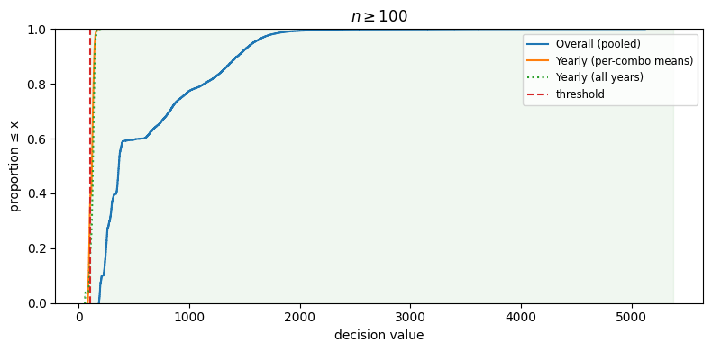
Reading: Sample size of each evaluated combination. The criterion is universally satisfied on the pooled data.

Figure A2. Max |z| ≤ 4.00.
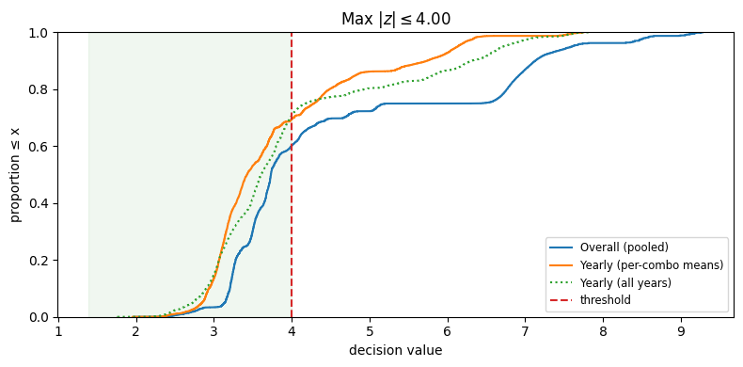
Reading: Distribution of the maximum absolute standardised value per combination. About 60% pass; combinations with extreme country-year outliers fail.

Figure A3. Observations-to-variables ratio n/p ≥ 10.
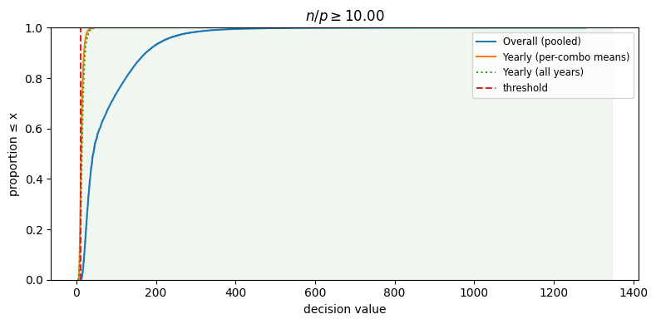
Reading: Sample-size-to-indicator-count ratio. Universally satisfied on the pooled data, comfortably above the conventional 10:1 threshold.
Figure A4. det(R) > 0.00001.
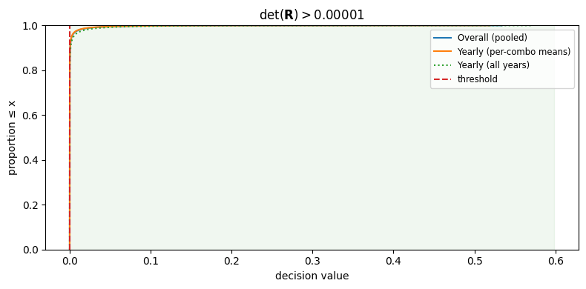
Reading: Determinant of the correlation matrix. About a third of combinations pass; the rest exhibit multicollinearity that pushes the determinant toward zero.
Figure A5. KMO ≥ 0.70
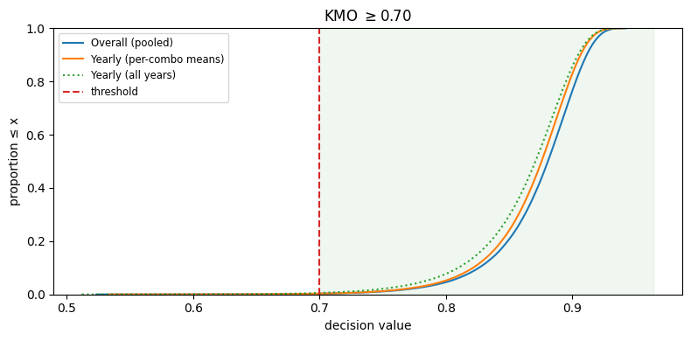
Reading: Kaiser-Meyer-Olkin measure of sampling adequacy. The distribution is concentrated around a mean of 0.87, well above the conventional 0.70 threshold.
Figure A6. Bartlett test (p < 0.05)
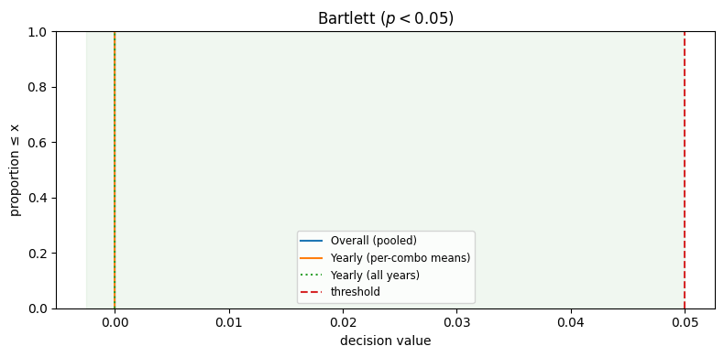
Reading: Bartlett test of sphericity. Universally satisfied: every correlation matrix in the pool is distinguishable from an identity matrix.

Category: Cohesion
Figure A7. Min |r| ≥ 0.35.
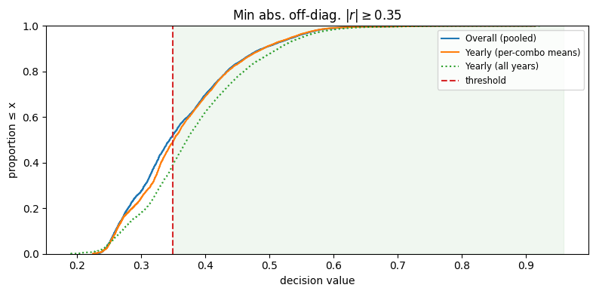
Reading: Minimum absolute pairwise correlation within each combination. Roughly half of combinations pass; failures occur when one index pair correlates only modestly.
Figure A8. Mean |r| ≥ 0.55
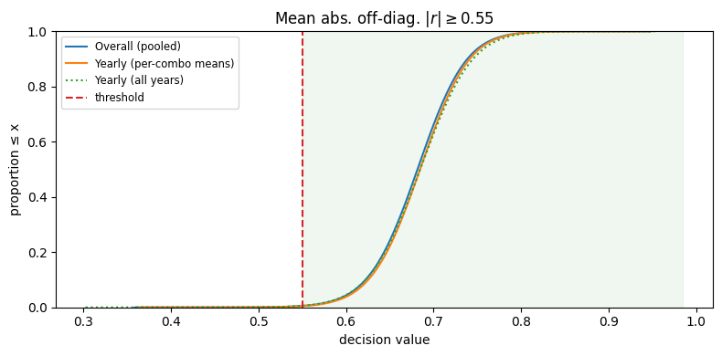
Reading: Mean absolute pairwise correlation. The distribution is concentrated around 0.68, well above the conventional 0.55 threshold.

Category: Unidimensionality
Figure A9. Kaiser criterion (λ₂ < 1)
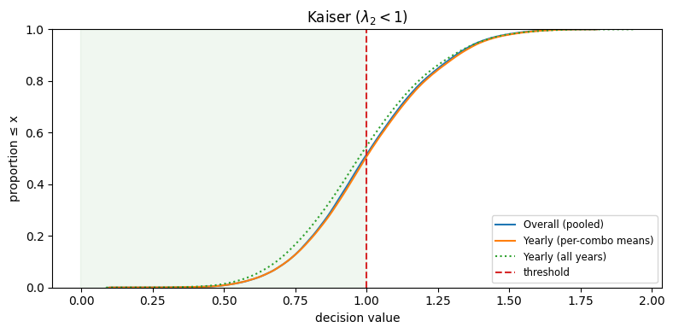
Reading: Second eigenvalue of the correlation matrix. Passes for about half of combinations; many have a non-trivial second factor in addition to the dominant first.
Figure A10. Eigenvalue separation λ₁/λ₂ ≥ 3
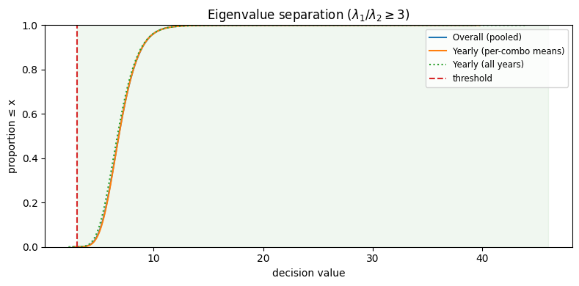
Reading: Ratio of the first to the second eigenvalue. Universally passes, with mean ratio 7.0, indicating a clearly dominant first dimension.
Figure A11. PC1 explained variance ≥ 0.60
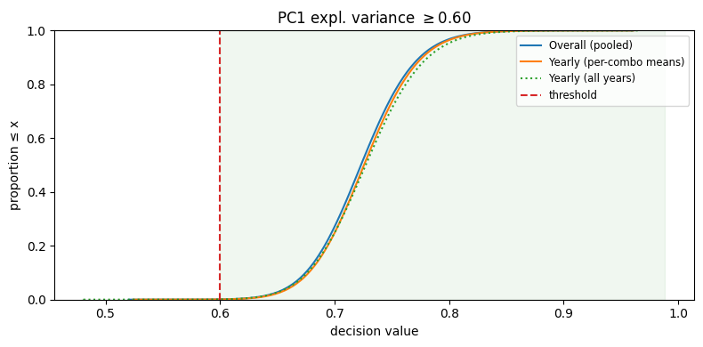
Reading: Proportion of total variance captured by the first principal component. The distribution is concentrated around 0.72, comfortably above the 0.60 threshold.
Figure A12. Mean communality h² ≥ 0.45
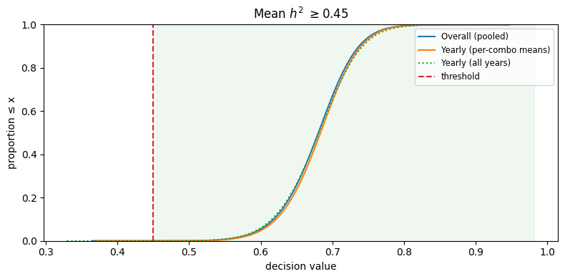
Reading: Mean ML communality across indicators. The distribution is concentrated around 0.68, with universal pass.

Figure A13. Min communality h² ≥ 0.35
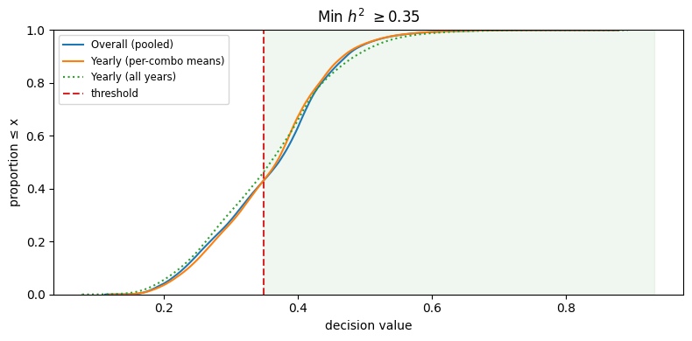
Reading: Minimum ML communality. Passes for about 57% of combinations; failures occur when one index contributes little to the common factor.

Figure A14. SRMR ≤ 0.08
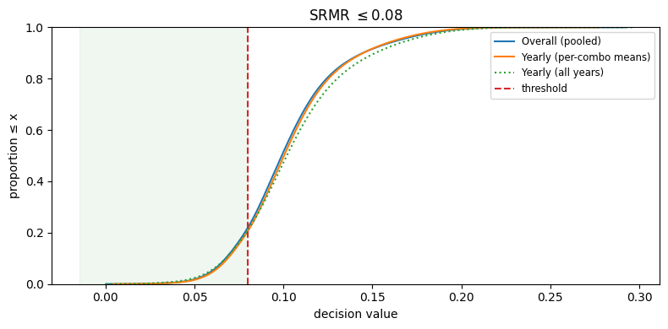
Reading: Standardised root mean square residual. Passes for 22% of combinations; the rest exceed the threshold but typically by modest margins.

Figure A15. RMSEA ≤ 0.06
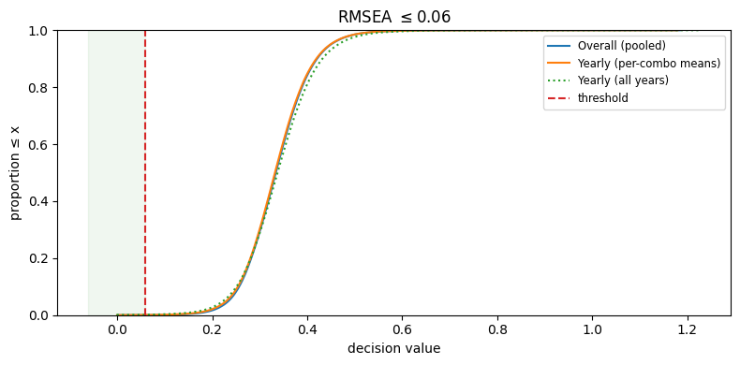
Reading: Root mean square error of approximation. Fails in essentially all combinations on a literal reading; see Section 5.4 of the main chapter for the artefact diagnosis.

Figure A16. CFI ≥ 0.95
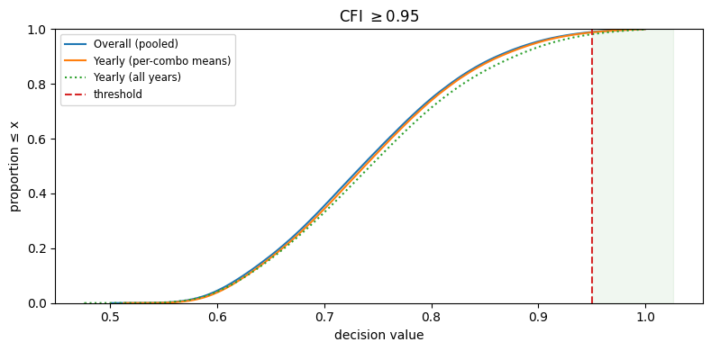
Reading: Comparative fit index. Fails in 99% of combinations on a literal reading; the failure is an artefact of the high baseline correlation in the pool.

Figure A17. χ² test (p > 0.05)
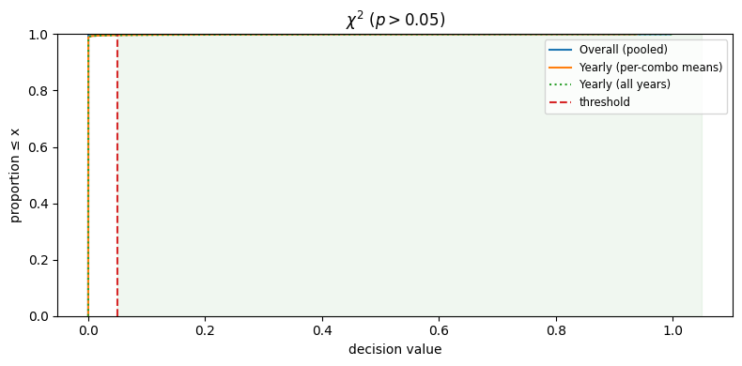
Reading: Chi-square goodness-of-fit p-value. Universally fails on a literal reading; this is the canonical large-sample artefact of the χ² statistic.

Figure A18. Min |loading| (PC1) ≥ 0.25
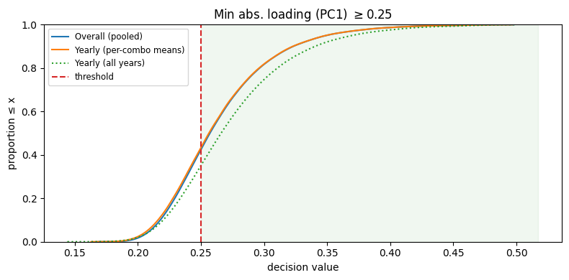
Reading: Minimum absolute PC1 loading. Passes for 58% of combinations; failures occur when one index contributes little to the dominant direction.
Figure A19. Min |loading| (FA1) ≥ 0.40
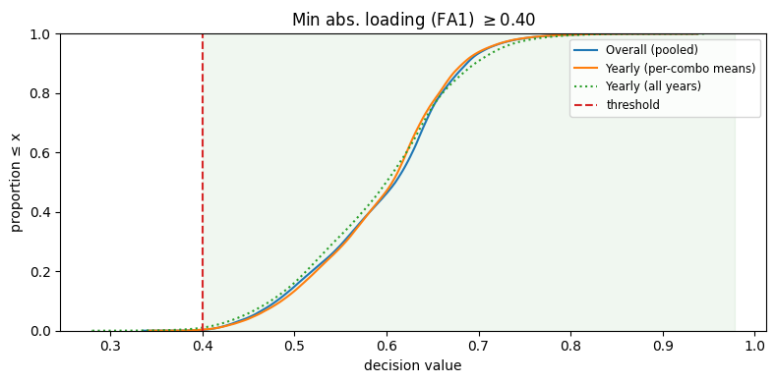
Reading: Minimum absolute ML factor loading. Passes universally (99.8%) with mean minimum 0.595.

Figure A20. PC1 vs FA1 loading similarity ≥ 0.95
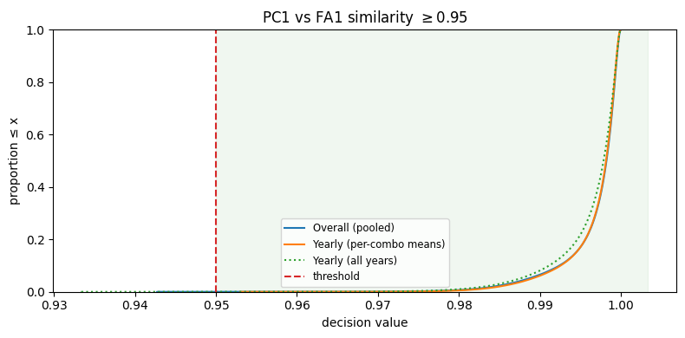
Reading: Absolute cosine similarity between PCA and FA loading vectors. Effectively perfect agreement: both methods recover the same dominant direction.

Category: Temporal stability
Figure A21. Global similarity (PC1) ≥ 0.99
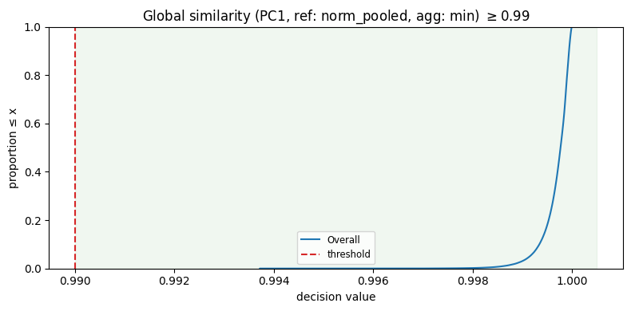
Reading: Minimum cosine similarity between any yearly PC1 loading vector and the pooled reference. Universally satisfied; the distribution is a near-step function at 1.0.
Figure A22. Adjacent similarity (PC1) ≥ 0.99
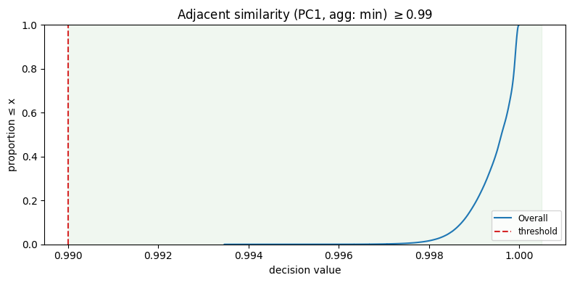
Reading: Year-on-year smoothness of the PC1 loading vector. Universally satisfied; consecutive-year loading vectors are almost identical.
Figure A23. Global similarity (FA1) ≥ 0.99
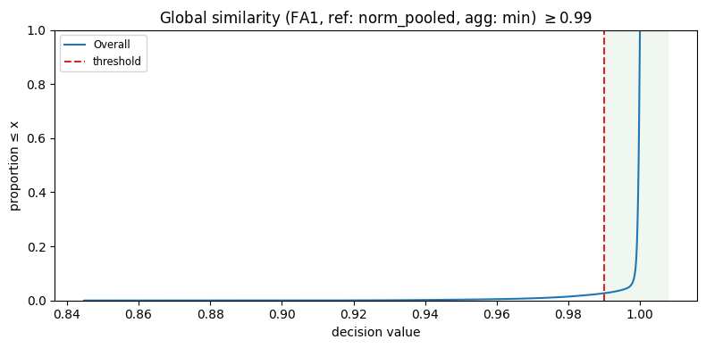
Reading: Minimum cosine similarity between any yearly FA1 loading vector and the pooled reference. Passes for 97.3% of combinations.

Figure A24. Adjacent similarity (FA1) ≥ 0.99
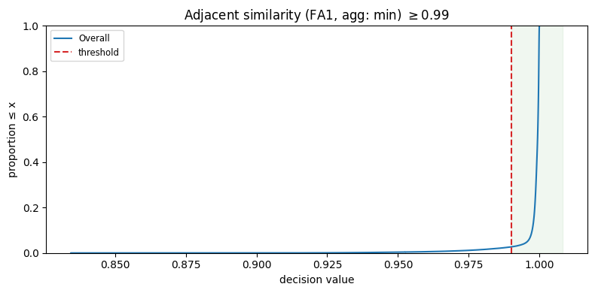
Reading: Year-on-year smoothness of the FA1 loading vector. Passes for 97.3% of combinations.
Figure A25. Loading magnitude CV (FA1) ≤ 0.10
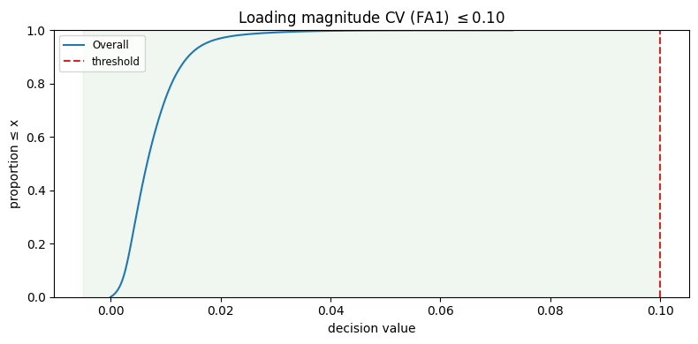
Reading: Coefficient of variation of the raw FA1 loading-vector norms across years. Universally satisfied with mean 0.008: not only direction but magnitude of the factor is stable.

