Supplementary Information for

Giant plasticity in ceramic semiconductors via crystal conformational switching
Chong Wang^{1,2†}, Zeya Li^{3†}, Biao Ma¹, Penghui Li¹, Yingchun Cheng^{1,4}*, Yeqiang Bu⁵, Kun Zhai¹, Tianyu Xue¹, Hongtao Yuan^{2,6}*, Anmin Nie¹*, Hongtao Wang⁵,
Yongjun Tian¹, Zhongyuan Liu¹
- Center for High Pressure Science, State Key Laboratory of Metastable Materials Science and Technology, Yanshan University, Qinhuangdao, 066044, China.
- National Laboratory of Solid State Microstructures, College of Engineering and Applied Sciences, and Collaborative Innovation Center of Advanced Microstructures, Nanjing University, Nanjing 210093, China.
- Quantum Science Center of Guangdong-Hong Kong-Macao Greater Bay Area, Shenzhen 518045, China
- Key Laboratory for Microstructural Material Physics of Hebei Province, School of Science, Yanshan University, Qinhuangdao, 066004, China.
- Center for X-mechanics, School of Aeronautics and Astronautics, Zhejiang University, Hangzhou 310027, China.
- Jiangsu Physical Science Research Center, Nanjing 210093, China.

† These authors contributed equally to this work.
*Corresponding author.
E-mail: anmin@ysu.edu.cn (A.N.); htyuan@nju.edu.cn (H.T.Y.); iamyccheng@ysu.edu.cn (Y.C.C.).

Outline:
- Fabrication of GeSe samples for in-situ TEM compression testing
- Critical strain for chair-boat transition in GeSe ceramic crystal
- Reproducibility of chair-boat-transition induced superplasticity in GeSe samples
- Lattice variation and mechanical stability of GeSe under uniaxial compressive strain
- Chair-boat transition mechanism of GeSe under compression strain
- Machine learning force field training and validation
- Molecular dynamic simulation for chair-boat transition in GeSe
- Lattice bending in GeSe with compressing strain along armchair direction
- Observation of interlayer sliding in GeSe with compressing strain along <021> direction ($θ$ = 45°)
- Observation of chair-boat-transition in GeSe samples with compressing strain along zigzag direction
- Anisotropic mechanical property of GeSe
- Comparison of ultimate engineering stress and plastic strain for GeSe and other materials
- Applicability chair-boat-transition-mediated superplasticity to other materials

- Fabrication of GeSe samples for in-situ TEM compression testing
To investigate the superplastic deformation behavior of GeSe, we employed in-situ transmission electron microscopy (TEM) compression testing. Compression specimens were fabricated from as-grown single-crystalline GeSe using a focused ion beam (FIB) technique. Gallium ion beam currents ranging from 9.3 nA to 10 pA (working voltage 30 kV) were used from coarse milling to final polishing. Prior to microfabrication of compression samples with specific crystallographic orientations, the orientation of the GeSe crystal mounted on the stage was determined by electron backscatter diffraction (EBSD).
The fabrication process of GeSe samples involved the following steps. First, a thin lamella was milled from a bulk GeSe crystal and subsequently cut and transferred onto a TEM half-grid fixed by Pt deposition (Supplementary Fig. 1a–d). Second, the lamella was laterally narrowed to form a strip array with a width of approximately 3 μm and further milled into an array of cylindrical pillars with diameters ranging from ~100 nm to several micrometers (Supplementary Fig. 1e,f). Third, in-situ compression experiments were performed inside the TEM using a high-precision mechanical testing holder (Bruker PI95) equipped with a diamond flat punch. The diamond punch was sequentially brought into contact with individual GeSe pillars and used to apply uniaxial compressive strain (Fig. 1c in main text). The strain was evaluated by measuring the axial deformation of the GeSe pillars along the loading direction during compression. Finally, load–displacement curves were obtained and subsequently converted into the corresponding stress–strain curves (Fig. 1d in main text).

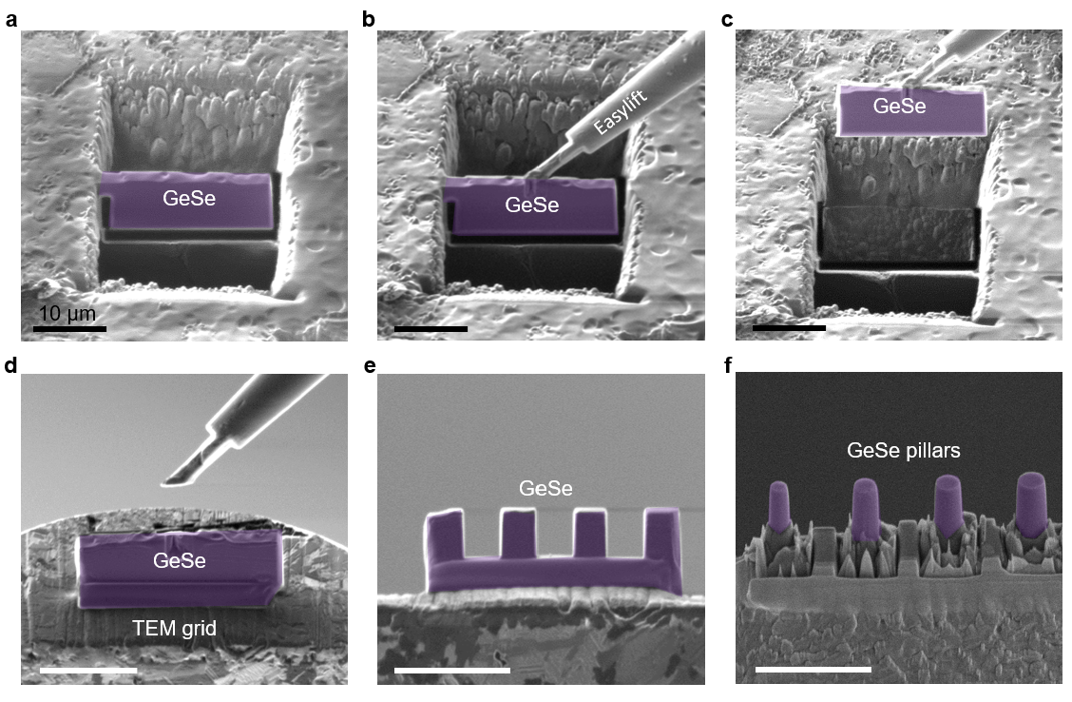
Supplementary Figure 1. Focused ion beam (FIB) fabrication procedure of GeSe nanopillars for TEM measurements. a, SEM image acquired during Ga⁺ FIB milling of the GeSe sample, in which two trenches are milled and a thin GeSe lamella is isolated by a U-shaped cut. b, The GeSe lamella welded to an EasyLift micromanipulator via in-situ Pt deposition. c, After severing the remaining connection to the bulk, the lamella is lifted out using the EasyLift probe. d, The extracted GeSe lamella fixed onto the top edge of a TEM grid by Pt deposition. e, Multiple square cross-sectioned rectangular GeSe blocks patterned by stepwise FIB milling. f, Final cylindrical GeSe nanopillars obtained through annular FIB milling.

- Critical strain for chair-boat transition in GeSe ceramic crystal
Uniaxial compression tests were performed on 30 GeSe samples along [001] direction (the out-of-plane direction), and the critical value of strain associated with the onset of the chair–boat structural transition was statistically analyzed, as summarized in Supplementary Fig. 2. The average critical strain was determined to be approximately 6.9%, as indicated by the red dashed line in the left panel of Supplementary Fig. 2. This value is further supported by the statistical distribution and the corresponding fitting curve shown in the right panel of Supplementary Fig. 2. Supplementary Table 1 summarizes the critical strain values obtained during in-situ compression of the 30 GeSe nanopillars, together with the angle between the chair–boat transformation domain and the [001] direction, as well as the diameters of the nanopillars prior for testing. The data presented in Supplementary Table 1 demonstrates the high reproducibility of the chair–boat structural transition under uniaxial compression. In addition, representative in situ TEM images acquired immediately before and at the onset of the chair–boat transition are provided in Supplementary Fig. 3. For each nanopillar, the critical strain is defined as the engineering strain at which the first transformed (boat-type) domains become discernible (highlighted by the white arrows). The four examples show critical strains of 6.7–8.1%, consistent with the statistical average extracted from the 30-sample dataset, and visually illustrate the reproducible nucleation of the transformed domains at the early stage of compression.

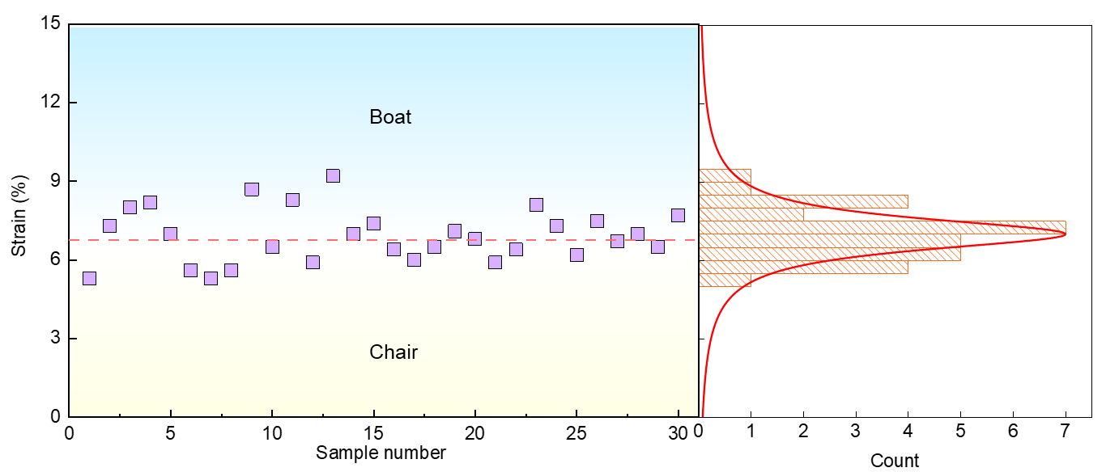
Supplementary Figure 2. Determination of the critical strain for chair–boat transition in GeSe. Left panel: Critical strain at which the chair–boat structural transition is observed during in-situ TEM compression for 30 individual GeSe samples. The critical strain for the emergence of plasticity is determined based on the emergence of stripy-shaped domains in TEM images. The dashed line indicating the average critical strain separating the chair and boat deformation regimes. Right panel: Corresponding statistical distribution of the critical strains obtained from 30 GeSe samples.

Supplementary Figure 3 | Critical strain for the onset of the chair–boat transition in GeSe nanopillars during in-situ compression. a–d, Representative TEM images before (left) and at the onset of the strain-induced chair–boat transition (right) in four GeSe nanopillars under uniaxial compression. The critical strain, defined as the engineering strain at which the first transformed (boat-type) domains become discernible, is indicated in each panel (7.4%, 6.7%, 7.5% and 8.1%). Yellow arrows mark the loading direction, and cyan lines denote the indenter–pillar contact plane. White arrows highlight the initial appearance of transformed domains. Scale bars, 200 nm in (a) and 100 nm in (b–d).

Supplementary Table 1. Detailed information 30 GeSe nanopillars with different diameters under strain along [001] direction.
Sample | $ε_{c}$ (%) | $θ_{domain}$ (°) | $d_{sample}$ (nm)
1 | 5.3 | 41 | 214
2 | 7.3 | 42, 138 | 192
3 | 8.0 | 43 | 212
4 | 8.2 | 41 | 170
5 | 7.0 | 40 | 206
6 | 5.6 | 45, 135 | 183
7 | 5.3 | 44 | 104
8 | 8.7 | 42, 138 | 110
9 | 6.5 | 42, 138 | 181
10 | 8.3 | 41 | 194
11 | 5.9 | 43 | 184
12 | 9.2 | 45 | 278
13 | 7.0 | 43, 137 | 263
14 | 7.4 | 41 | 255
15 | 6.4 | 39 | 230
16 | 6.0 | 42 | 157
17 | 6.5 | 43 | 180
18 | 7.1 | 40, 140 | 205
19 | 6.8 | 41 | 255
20 | 5.9 | 42 | 310
21 | 6.4 | 44 | 285
22 | 8.1 | 41, 139 | 153
23 | 7.3 | 42, 138 | 185
24 | 6.2 | 43 | 194
25 | 7.5 | 45 | 303
26 | 6.7 | 45 | 235
27 | 7.2 | 42 | 265
28 | 7.0 | 43, 137 | 197
29 | 6.5 | 41 | 283
30 | 7.7 | 41, 139 | 173
$ε_{c}$ is the critical strain for the emergence of the chair–boat transition, $θ_{domain}$ is the angle between the emergent domain and [001] direction of GeSe, and $d_{sample}$ is the diameter of the pristine GeSe sample before testing.

- Reproducibility of chair-boat-transition induced superplasticity in GeSe samples
To confirm the reproducibility of chair–boat–transition-induced superplasticity in GeSe, in-situ compression experiments were systematically performed on GeSe nanopillars with different characteristic length scales. As shown in Supplementary Fig. 4, a representative GeSe nanopillar with a diameter of approximately 170 nm was subjected to uniaxial compression along the [001] direction inside the TEM. During the compression process, a series of TEM images were acquired at increasing strain levels, together with the corresponding engineering stress–strain curve. As the applied compressive strain increases, chair–boat transformation domains repeatedly nucleate within the nanopillar and subsequently expand and propagate. These structural evolution processes are accompanied by intermittent stress drops superimposed on an overall strain-hardening response in the stress–strain curve, indicating a strong correlation between the progression of the structural transition and the macroscopic mechanical response.
At smaller length scales, in-situ high-resolution TEM compression experiments provide direct atomic-scale evidence for the reproducibility of the chair–boat transition. As presented in Supplementary Fig. 5, a GeSe nanopillar compressed along the [001] direction was continuously imaged along the [100] (zigzag) direction at different loading times. At the early stage of deformation, lattice distortion develops without a discernible phase transformation. With further loading, the initial nucleation of the β-GeSe phase associated with the chair–boat structural transition becomes clearly visible at the atomic scale. Upon continued compression, the transformed β-phase domains progressively grow and extend into the surrounding α-phase matrix. The consistent observation of the nucleation and growth behavior of the chair–boat transformation domains across different loading times demonstrates that the structural transition is highly reproducible at the atomic scale. Taken together, the in-situ compression results obtained at both the nanoscale and atomic scale demonstrate that the chair–boat conformation transition in GeSe nanopillars occurs in a repeatable and robust manner under uniaxial compressive loading. The close correspondence between the evolution of transformation domains and the characteristic features in the stress–strain response further supports the reproducibility of chair–boat–transition-induced superplasticity in GeSe across multiple length scales.
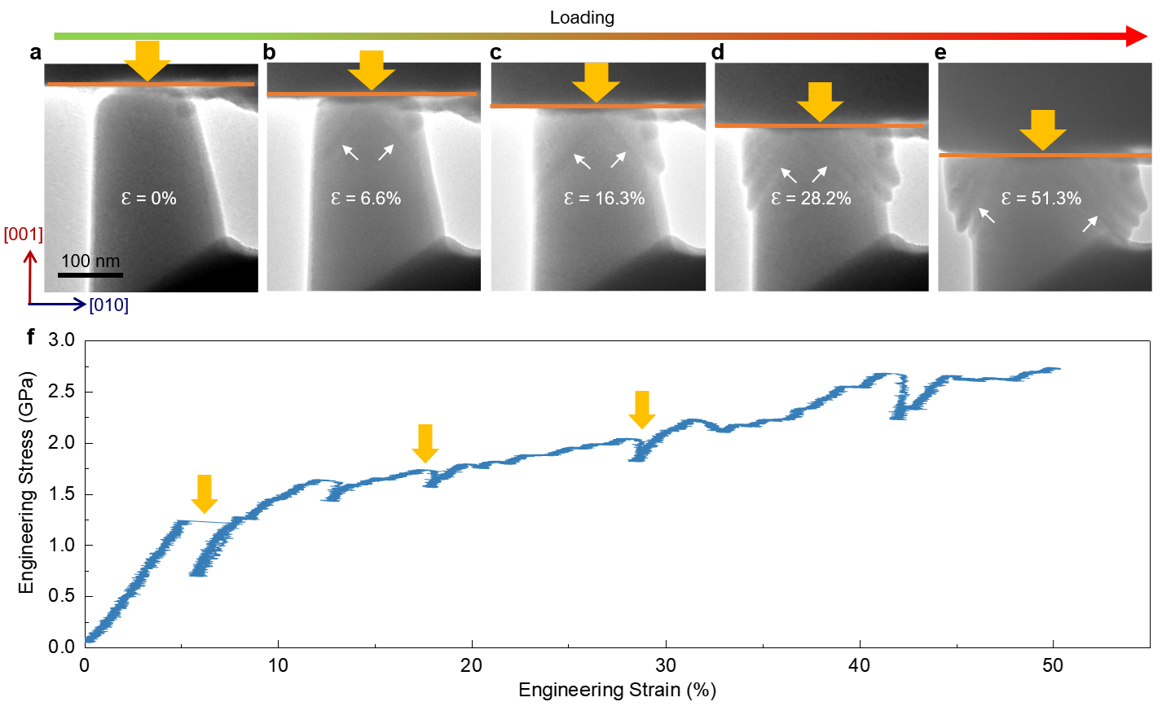
Supplementary Figure 4. In-situ TEM images of a GeSe nanopillar under uniaxial compression along the [001] direction. a–e Structural evolution of the GeSe nanopillar as the applied compressive strain $ε$ increases from 0% to 51.3%. At $ε$ = 0%, the nanopillar preserves its initial morphology without observable lattice distortion (a). At $ε$ = 6.6%, the first signatures of strain-induced phase transformation emerge, as indicated by the white arrows (b). With further loading, the transformed domains expand progressively, corresponding to $ε$ = 16.3%, 28.2%, and 51.3%, respectively (c–e). The sequence highlights the nucleation and growth of the transformation fronts under increasing compressive strain. f, Corresponding engineering stress–strain curve obtained during the in-situ TEM compression test, showing a continuous strain response accompanied by intermittent stress drops, which associate with the nucleation and propagation of stripy domains during superplastic deformation.
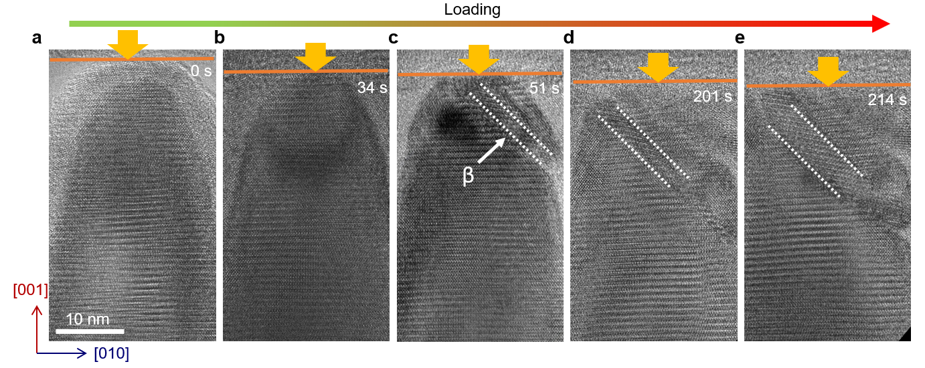Supplementary Figure 5. In-situ high-resolution TEM imaging of a GeSe nanopillar during uniaxial compression along [001] direction, viewed along the [100] (zigzag) direction. a–e Time-resolved HRTEM images acquired at 0, 34, 51, 201, and 214 s during continuous loading. (a) At 0 s, the nanopillar remains in the undeformed state without discernible structural transformation. (b) At 34 s, lattice distortion develops under applied strain, while no phase transition is observed. (c) At 51 s, the initial nucleation of the β-GeSe phase is detected, as highlighted by the dashed region. (d,e) With further increasing strain, the β-phase domains progressively expand, indicating strain-driven phase growth under sustained compression.

- Lattice variation and mechanical stability of GeSe under uniaxial compressive strain
The atomic structure presented in Supplementary Fig. 6a-c illustrates the anisotropic nature of GeSe, which is also reflected by lattice variation under uniaxial compressive strain along the [100], [010] and [001] directions. By applying compressive uniaxial strain along [100] direction, the lattice constant along [010] increases, while that of [001] decreases (Supplementary Fig. 6d). In contrast, both lattice constants along [100] and [001] increases by applying compressive uniaxial strain along [010] direction (Supplementary Fig. 6e). Interesting, by applying compressive uniaxial strain along [001] direction, the lattice constant along [100] direction varies slightly (Supplementary Fig. 6f)¹.
For the mechanical stability, the elastic constants for a stable structure should satisfy the Born stability criteria. α-GeSe belongs to Orthorhombic system. The following are the necessary and sufficient Born criteria for an orthorhombic system²:
$$\begin{matrix}{\text{C}}_{\text{11}}\text{>0,}{\text{ C}}_{\text{11}}{\text{C}}_{\text{22}}\text{>}{\text{C}}_{\text{12}}^{\text{2}}\text{,} \\ {\text{C}}_{\text{11}}{\text{C}}_{\text{22}}{\text{C}}_{\text{33}}\text{+2}{\text{C}}_{\text{12}}{\text{C}}_{\text{13}}{\text{C}}_{\text{23}}\text{-}{\text{C}}_{\text{11}}{\text{C}}_{\text{23}}^{\text{2}}\text{-}{\text{C}}_{\text{22}}{\text{C}}_{\text{13}}^{\text{2}}\text{-}{\text{C}}_{\text{33}}{\text{C}}_{\text{12}}^{\text{2}}\text{>0,} \\ {\text{C}}_{\text{44}}\text{>0, }{\text{C}}_{\text{55}}\text{>0,}{\text{ C}}_{\text{66}}\text{>0.}\end{matrix}$$
We defined six functions: ${\text{Y1}\text{=C}}_{\text{11}}$, ${\text{Y2}\text{= C}}_{\text{11}}{\text{C}}_{\text{22}}\text{-}{\text{C}}_{\text{12}}^{\text{2}}$, ${\text{Y3}\text{=C}}_{\text{11}}{\text{C}}_{\text{22}}{\text{C}}_{\text{33}}\text{+2}{\text{C}}_{\text{12}}{\text{C}}_{\text{13}}{\text{C}}_{\text{23}}\text{-}{\text{C}}_{\text{11}}{\text{C}}_{\text{23}}^{\text{2}}\text{-}{\text{C}}_{\text{22}}{\text{C}}_{\text{13}}^{\text{2}}\text{-}{\text{C}}_{\text{33}}{\text{C}}_{\text{12}}^{\text{2}}$, $Y4={\text{C}}_{\text{44}}$, $Y5={\text{C}}_{\text{55}}$, ${\text{Y6}\text{=C}}_{\text{66}}$. Supplementary Figure 7 presents the evolution of Y1 to Y6 on uniaxial compressive strain along [010], [100] and [001] directions. The Y2 and Y3 Born criteria are not satisfied for GeSe under uniaxial compressive strain of 4% along [100] direction. However, the six functions (Y1 to Y6) are all positive for GeSe under uniaxial compressive strain along [010] direction from 0% to 10%, indicating elastic stability. The Y3 becomes negative when compressive strain along [001] direction over 7%, suggesting failure of mechanical stability.
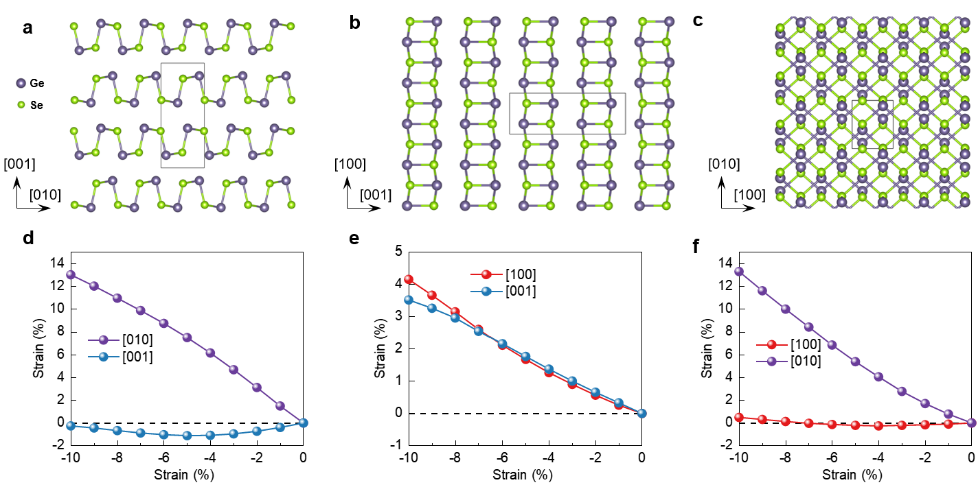
Supplementary Figure 6. Lattice variation of GeSe under uniaxial compressive strain. a-c Atomic structures of GeSe along [100], [010] and [001] crystallographic directions (zigzag, armchair and out-of-plane). Purple and green spheres represent germanium and selenium atoms, respectively. d-f Lattice parameter variations of GeSe under uniaxial compressive strain up to -10% along [100], [010] and [001] directions, respectively.

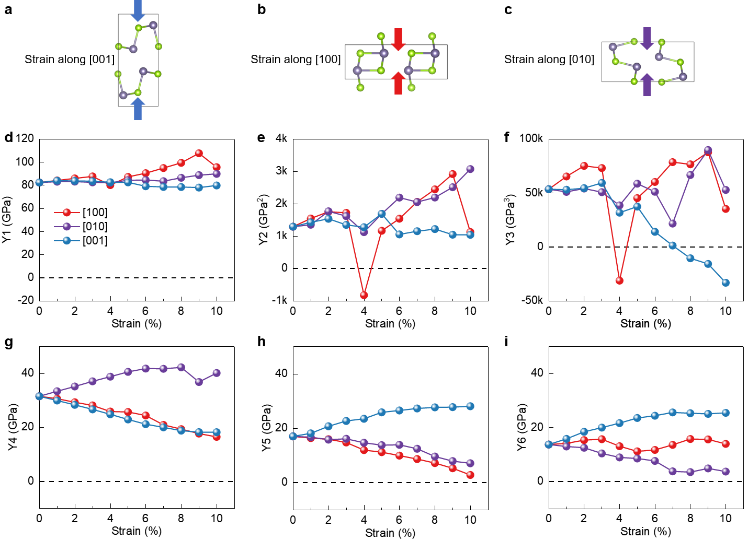
Supplementary Figure 7. Mechanical stability of α-GeSe under uniaxial compressive strain. a-c, Schematics of uniaxial compressive strain direction on α-GeSe. d-i, The evolution of Y1 to Y6 on uniaxial compressive strain along [100], [010] and [001] directions from 0% to 10%.

- Chair-boat transition mechanism of GeSe under compression strain
To elucidate the structural evolution and kinetic mechanism of the chair-to-boat conformation transition in monolayer α-GeSe under 30% shear strain, we performed climbing-image nudged elastic band (CI-NEB) calculations. The minimum energy path (MEP) for the initial chair-to-boat transition is presented in Supplementary Fig. 8a. The energy profile reveals a single prominent kinetic barrier of approximately 10.5 meV/atom, separating the initial chair state (index 1) from the final boat-like state (index 52). This relatively low barrier indicates that the transition is kinetically accessible. Interestingly, the barrier for subsequent or collective transitions is significantly lower. As shown in Supplementary Fig. 8b, following the primary transition, the energy barrier for the followed conformation changes drops to approximately 3.0 meV/atom and 2.2 meV/atom. This disparity confirms that the initial chair-to-boat flip serves as the kinetic bottleneck for the phase transformation. Once this initial nucleation-like event occurs, the structural reorganization propagates with much greater ease.
The atomistic mechanism underlying this transition is characterized by a concerted "hinging" or "flopping" motion of the Ge-Se bonds. Analysis of the geometric parameters along the reaction coordinate (Supplementary Fig. 9) reveals several critical characteristics. The first characteristic is the transition state. The energy peak corresponds to a "half-chair" or "planar-like" configuration (index 29 in Supplementary Fig. 8a). At this state, the buckling height of the GeSe lattice is at its minimum, creating a high-symmetry but energetically unfavorable geometry that imposes the maximum energy penalty. The second characteristic is the bond length variation. During the transition, the in-plane (IP) and out-of-plane (OP) Ge-Se bond lengths undergo distinct fluctuations. As the system approaches the transition state (TS), the bond lengths vary within a range of 2.57 Å to 2.61 Å, reflecting the structural softening required to cross the barrier (Supplementary Fig. 9). The third characteristic is the dihedral angle flipping. The most definitive signature of the transition is the evolution of the Ge1-Se1-Se2-Ge2 dihedral angle. As shown in Supplementary Fig. 9b, the dihedral angle increases monotonically from approximately 120° in the chair phase to nearly 180° at the transition state, eventually settling at a new equilibrium value (~230°) in the boat phase.
The 30% shear strain effectively "pre-distorts" the chair lattice, shifting its geometry closer to the transition state compared to the unstrained state. This reduces the atomic displacement vectors necessary for the transition, thereby lowering the kinetic barrier from its zero-strain value. The drop in the energy barrier to ~3 meV/atom for subsequent steps suggests that the first transformed unit cell induces a local strain field that further destabilizes the neighboring chair units. In practical ambient conditions, where the thermal energy k_{B}T≈26 meV at 300 K, these barriers are negligible. This implies that at 30% shear strain, the chair-to-boat transition in GeSe can be triggered spontaneously by thermal fluctuations, leading to ultrafast kinetics and a rapid structural deformation in monolayer.

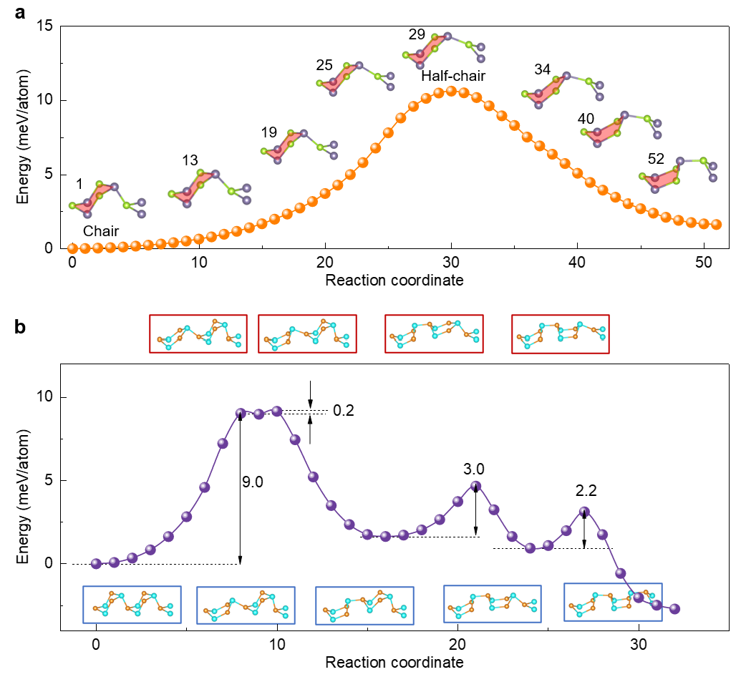
Supplementary Figure 8. Energy barriers of a serial chair to boat conformation transitions for monolayer GeSe under shear strain $ε_{yz}$ of 30% (which induces the (010) plane shift along the [001] direction). a, Energy barrier of the first two chair to boat conformation transition. The insets show the atomic configurations of ground state, transition states and final state. Note that this data is given in Fig. 3 in main text, here we only replot it to show the details for the chair to boat conformation transition b, Energy barriers of the four initial ‘chair’ to ‘boat’ conformation transitions.

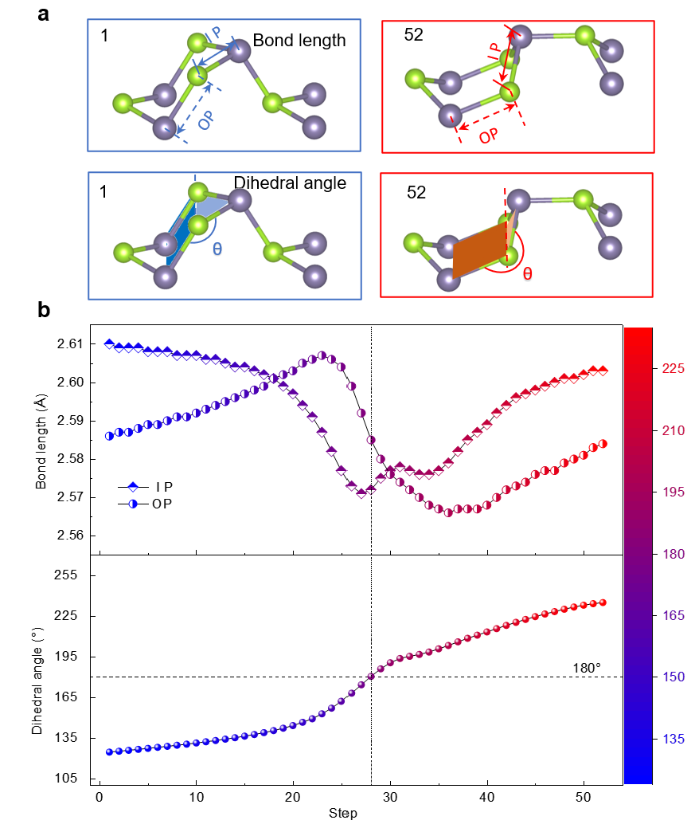
Supplementary Figure 9. Structural evolution of the first two ‘chair’ to ‘boat’ conformation transition for monolayer GeSe under shear strain $ε_{yz}$ of 30% (which induces the (010) plane shift along the [001] direction). a. The definition of in-plane (IP), out-of-plane (OP) Ge-Se bond and dihedral angle (Ge-Se-Se-Ge) in chair and boat conformation. b. Quantitative analysis of bond length (top panel) and dihedral angle (bottom panel) variations across sequential steps from chair to boat conformation transition. Data points are color-coded by dihedral angle (color bar, right), with blue representing the ‘chair’ conformation and red indicating the boat conformation. Vertical dashed lines highlight critical transition state of ‘half-chair-half-boat’ conformation.
- Machine learning force field (MLFF) training and validation
The developed Machine Learning Force Field (MLFF) was rigorously validated against first-principles calculations to ensure its predictive accuracy for the GeSe system. Specifically, the structural accuracy of the MLFF was validated by comparing its predicted lattice parameters and unit cell volumes with DFT reference values for both α-GeSe and β-GeSe (Supplementary Table 2). The MLFF exhibits excellent fidelity in reproducing the DFT potential energy surface. For the two polymorphs, deviations in unit cell volume are minimal, with differences of only 0.25% for the α-phase and 0.57% for the β-phase (Supplementary Table 3). Moreover, the MLFF achieves high precision across all individual lattice dimensions (a, b, and c), with percentage deviations consistently below 1%. This close structural and volumetric agreement confirms that the MLFF serves as a highly accurate surrogate model, enabling accelerated first-principles-level investigations of GeSe systems.
Beyond structural fidelity, the MLFF demonstrates a robust capability in capturing the dynamical properties of GeSe. The phonon dispersion relations were calculated using the finite displacement method as implemented in the Phonopy package³. For the α-GeSe and β-GeSe phases, supercells of dimensions 4 × 4 × 2 and 5 × 3 × 2 were employed, respectively. The phonon dispersion relations calculated from the MLFF exhibit a high degree of consistency with DFT reference results for both polymorphs (Supplementary Fig. 10), successfully reproducing key vibrational features essential for understanding phase stability and thermal transport. The ability of the MLFF to simultaneously deliver accurate structural parameters and phonon spectra confirms its reliability as a computationally efficient surrogate for expensive ab initio methods in exploring the complex phase behavior of GeSe.

Supplementary Table 2. Comparison of lattice parameters for GeSe obtained from experiments, DFT calculations and MLFF method
 | Method | a (Å) | b (Å) | c (Å)
α-GeSe | experiment | 3.833 | 4.394 | 10.840
α-GeSe | DFT | 3.891 | 4.493 | 10.971
α-GeSe | MLFF | 3.869 | 4.529 | 10.973
β-GeSe | experiment | 3.826 | 5.809 | 8.090
β-GeSe | DFT | 3.870 | 5.926 | 8.273
β-GeSe | MLFF | 3.876 | 5.949 | 8.275

Supplementary Table 3. Unit cell volume comparison between DFT and MLFF calculations for GeSe polymorphs.
Phase | DFT Vol (Å³) | MLFF Vol (Å³) | Diff (%)
α-GeSe | 191.80 | 192.28 | 0.25%
β-GeSe | 189.73 | 190.81 | 0.57%
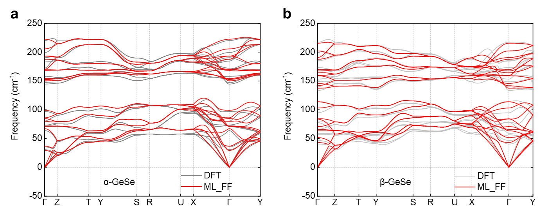
Supplementary Figure 10. Comparison of phonon dispersion predicted by DFT (gray lines) and MLFF (red lines). a,b, Phonon spectrum for the α-GeSe phase (a) and for the β-GeSe phase (b). The results obtained from the developed MLFF (red lines) are compared against the underlying DFT (grey lines) calculations. The high degree of overlap between the MLFF and DFT spectra across the entire Brillouin zone demonstrates the accuracy of the MLFF in capturing the dynamical properties and vibrational characteristics of both GeSe phases.

- Molecular dynamic simulation for chair-boat transition of bulk GeSe
We further investigate structural phase transition of bulk GeSe under uniaxial compression along [001] direction at 300 K using the NPT ensemble to allow for lateral cell relaxation (σ_{xx}= σ_{yy} = 0). The bulk GeSe was modeled using a 10x10x10 supercell (8000 atoms) to ensure statistical convergence. Strain was applied incrementally with an equilibration time of 2 ps per strain step of 0.1%. The local atomic shear strain and structural configurations were analyzed using OVITO⁴, with the shear strain components calculated via the atomic displacement gradient relative to the zero-strain α-phase GeSe as the reference. The energetic and mechanical profiles in Supplementary Fig. 11 provides the key thermodynamic evidence for the structural transformation. When ε < 9.7%, the total energy per atom exhibits a characteristic parabolic increase, consistent with harmonic elastic deformation. At the critical strain of 9.7%, the GeSe system reaches a mechanical instability point, manifested as a sharp, discontinuous drop in energy (~10 meV/atom). This jump indicates an exothermic structural reconfiguration from α-phase to a more stable β-phase (chair to boat). Simultaneously, the axial stress σ_{zz} exhibits a dramatic relaxation from 3.4 GPa to 0.7 GPa. This stress-drop is a hallmark of of a first-order phase transition, where external mechanical work is converted into internal potential energy of atomic rearrangement.
Supplementary Figure 12 shows the macroscopic geometric response of GeSe under uniaxial strain, which reveals the complex anisotropic nature of the phase transformation. During compression along the [001] direction in the α-phase, the a-axis of GeSe displays an anomalous expansion attributed to the strong Poisson effect inherent to its puckered layered structure. As the interlayer distance (c-axis) decreases, intra-layer bonds lengthen along the a-axis to preserve optimal bond lengths. At the critical strain of 9.7%, the a-axis undergoes a sharp collapse while expansion along the b-axis accelerates. This leads to a notable decrease in the a/b ratio from 0.87, marking a significant symmetry-shifting event. Further compelling evidence is provided by the volumetric collapse shown in Supplementary Fig. 12e. The discontinuity indicates an abrupt increase in atomic packing density. In the α-phase, GeSe maintains a hollow, puckered structure; upon transition, these puckers flatten, enabling atoms to occupy a more compact arrangement. This discontinuous change in volume correlates with the latent heat of transformation and confirms that the α- and β-phases coexist as distinct thermodynamic states at the phase boundary.
The radial distribution function (RDF) heatmap in Supplementary Fig. 13 offers a detailed fingerprint of the structural evolution. Prior to reaching the critical strain of 9.7%, the peaks shift smoothly toward smaller interatomic distances (r), consistent with uniform compression across the structure. At the phase transition point, a pronounced and abrupt rearrangement occurs for r > 3.0 Å, indicating that although the primary covalent bonds (~2.6 Å) are preserved, the medium-range atomic order undergoes significant reconfiguration. A direct comparison of the RDF profiles at 9.0% and 10.0% strain further reveals specific structural changes. The profile at 10.0% strain—corresponding to the β-phase—displays noticeable broadening and splitting of the second and third neighbor peaks. The disappearance of the distinct peak near ~3.4 Å and the concurrent emergence of new spectral features around ~3.7 Å suggest a substantial reorientation of the Ge–Se–Ge bond angles. This coordination shell reconstruction provides a mechanistic explanation for the observed stress relaxation: by reorienting the bonding network, the system attains a new local energy minimum that accommodates the applied strain with a reduced internal restoring force.
Atomic snapshots and local shear strain mapping ($ε_{yz}$) provide insight into the underlying mechanism for the α-β phase transition (Supplementary Fig. 14). In α-phase GeSe, atomic displacements are largely uniform. Upon crossing the phase boundary, however, we observe the formation of localized shear bands or strain domains. Rather than compressing uniformly, the lattice undergoes coordinated tilting and sliding motions—a characteristic feature of martensitic-like transformations. Uniaxial pressure along the z-axis induces internal resolved shear stresses on the inclined Ge–Se bonds. When these stresses exceed the Peierls barrier for bond rotation, the lattice abruptly reconfigures into the β-phase structure. The local shear strain maps clearly illustrate that the transition propagates through localized distortions. This mechanism explains the abrupt stress drop: once layers begin to tilt, the resulting shear forces promote similar rotations in neighboring layers, triggering a cascading structural collapse. The α-to-β transition can thus be described as a symmetry-altering, shear-dominated process.
In summary, using NPT ensemble simulations, we have characterized a strain-driven first-order phase transition in bulk GeSe at a critical strain of ε_{z} = 9.7%. The transition is governed by a shear-mediated mechanism, leading to a volumetric collapse, significant stress relaxation, and mechanical softening. Microscopic restructuring—evidenced by radial distribution function analysis and localized shear strain patterns—reveals that the β-phase achieves higher packing density through coordinated rotation of intralayer bond networks.

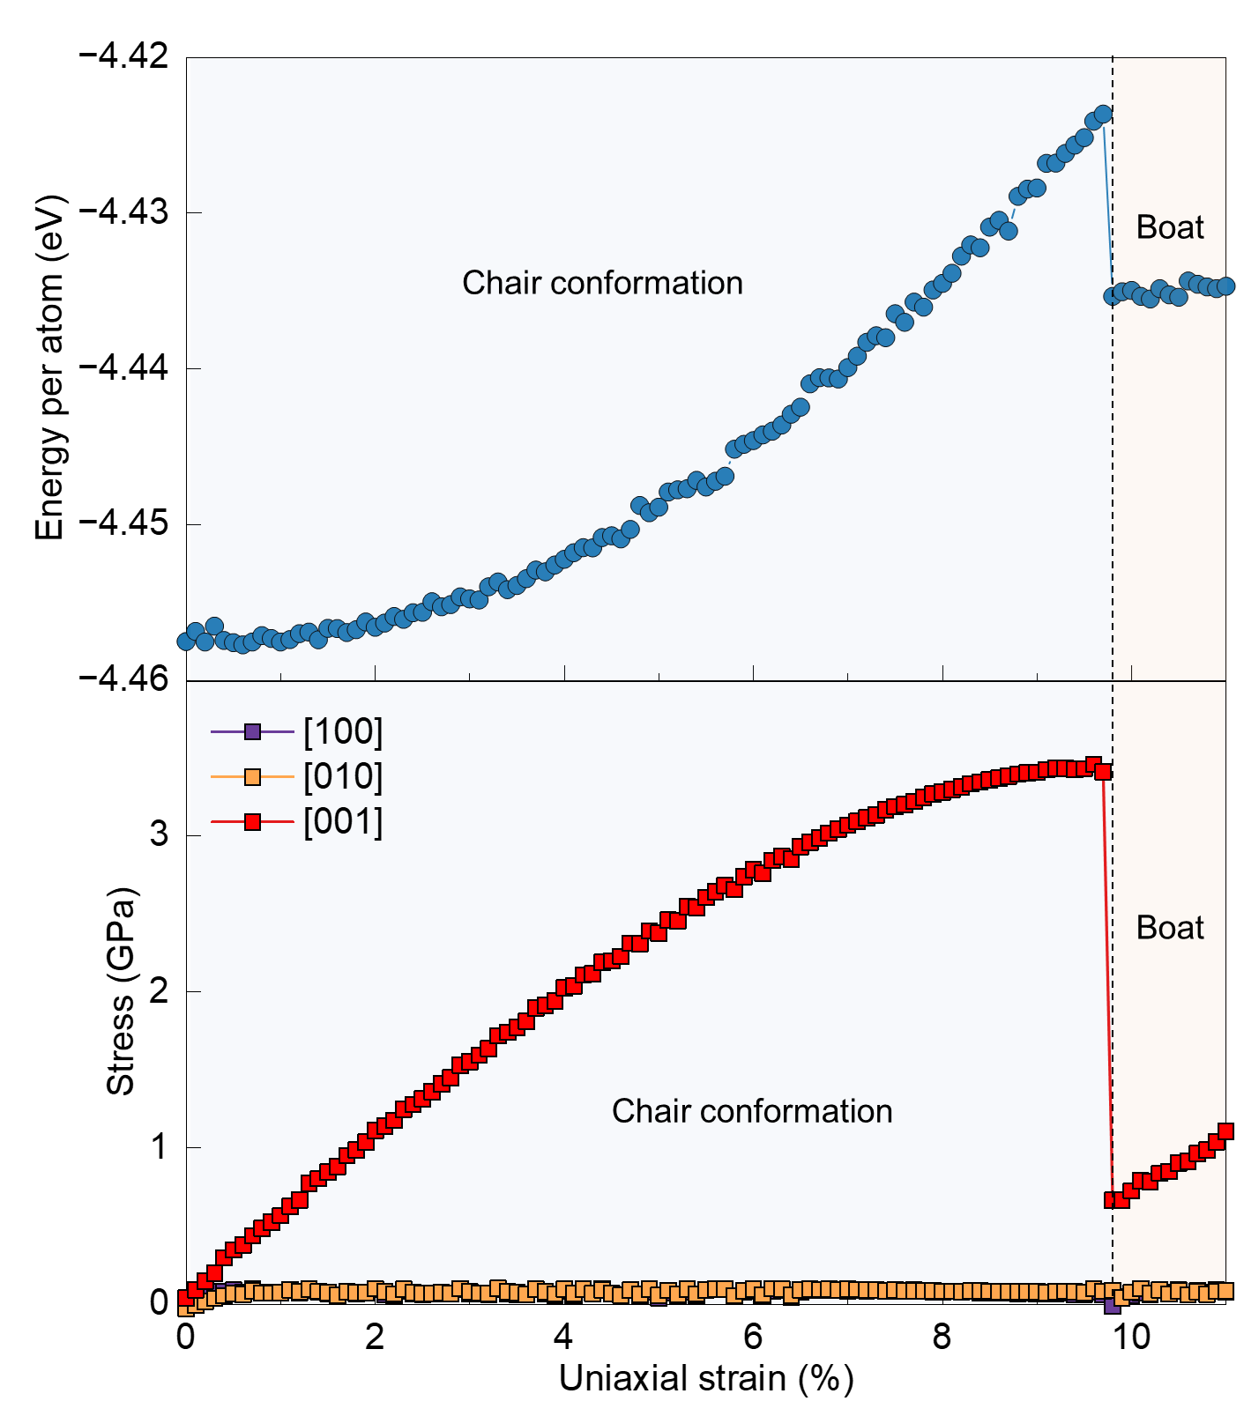
Supplementary Figure 11. Energetic and mechanical signatures of the chair-boat transition of GeSe under strain. Evolution of total energy per atom and cauchy stress components as a function of uniaxial strain ε_{z}. The transition at ε_{c} = 9.7% is marked by an abrupt energy drop and stress relaxation.
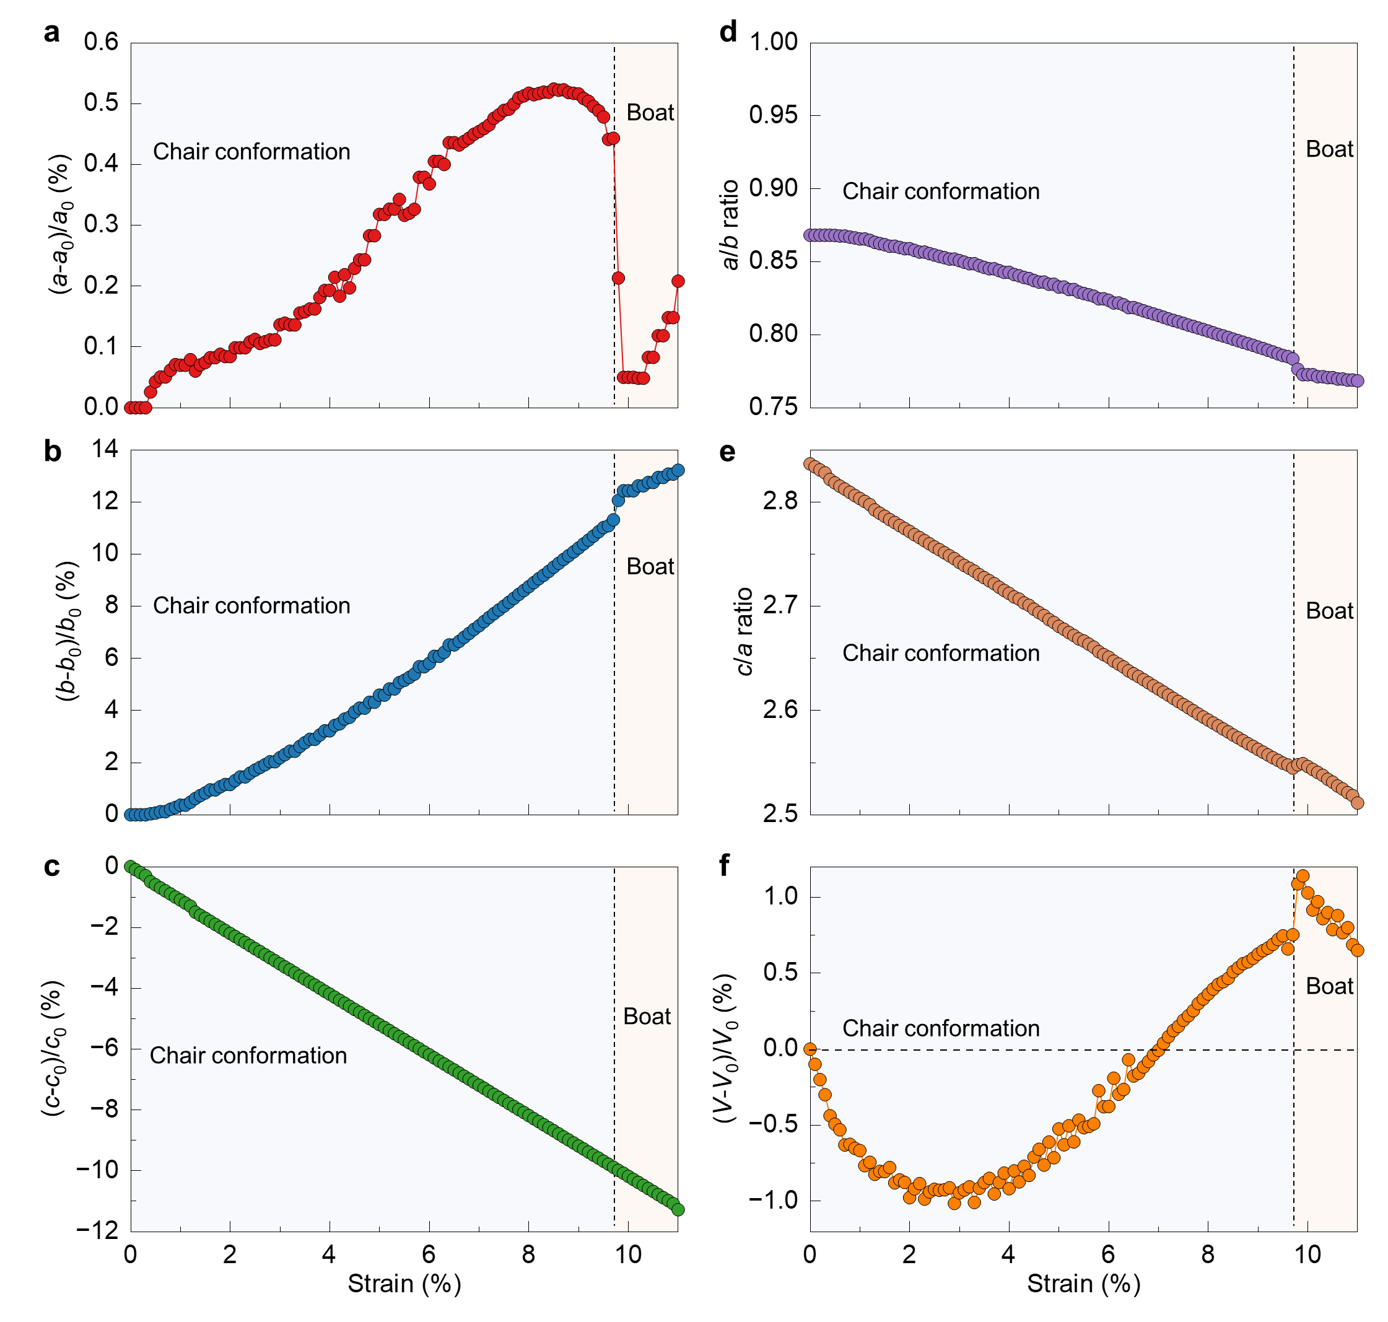
Supplementary Figure 12. Quantitative structural evolution and thermodynamic response of GeSe under strain. a-c, Relative variations of lattice constants a, b, and c as a function of strain. d, In-plane anisotropy a/b ratio as a function of strain. e, c/a ratio as a function of strain. f, Relative variations of volume of GeSe as a function of strain.
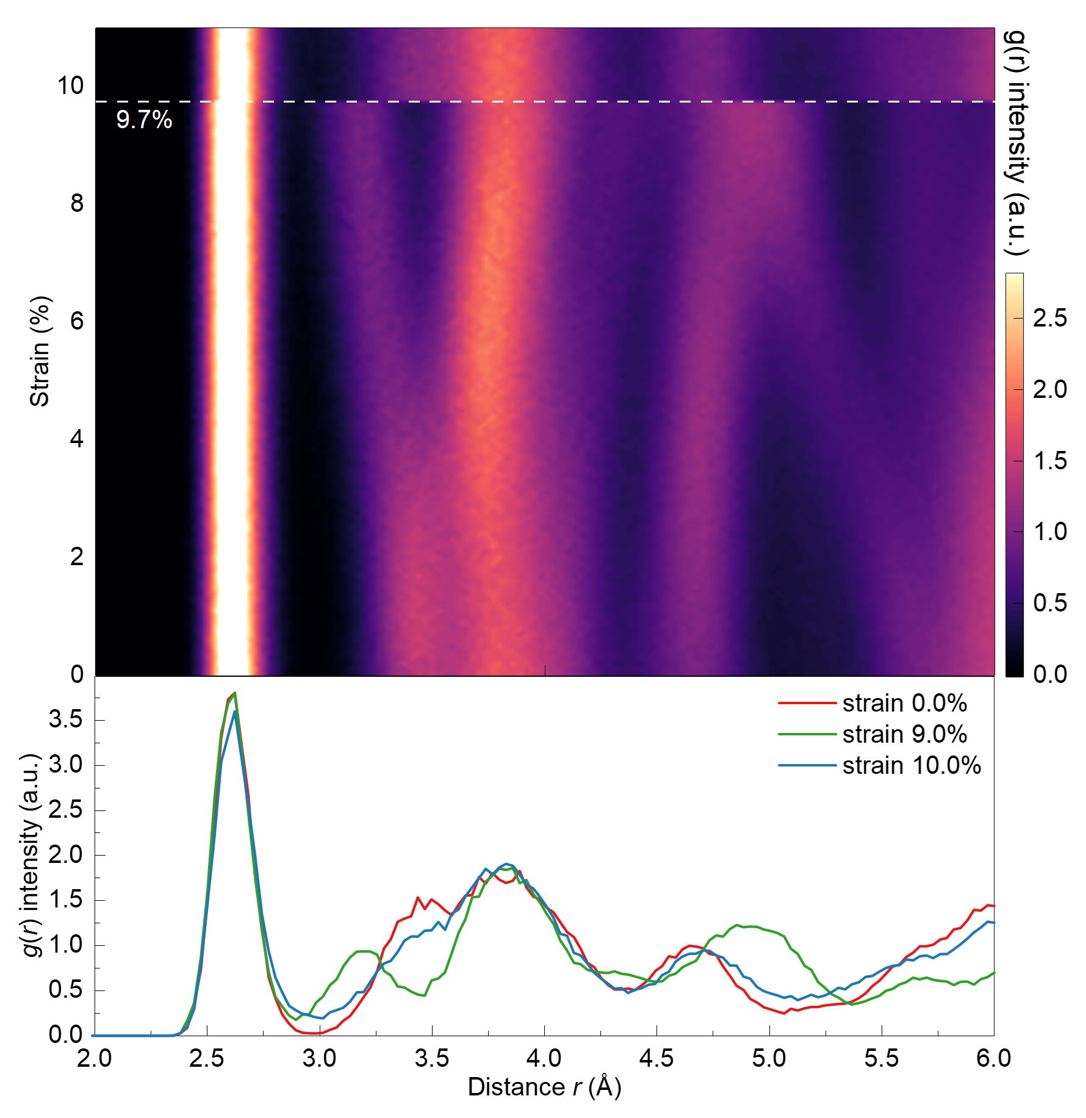
Supplementary Figure 13. Radial distribution function (RDF) evolution of GeSe under compressive strain. Top panel: Intensity heatmap of g(r) across the strain range. Bottom panel: Selective line profiles at strain of 0.0%, 9.0%, and 10.0%.
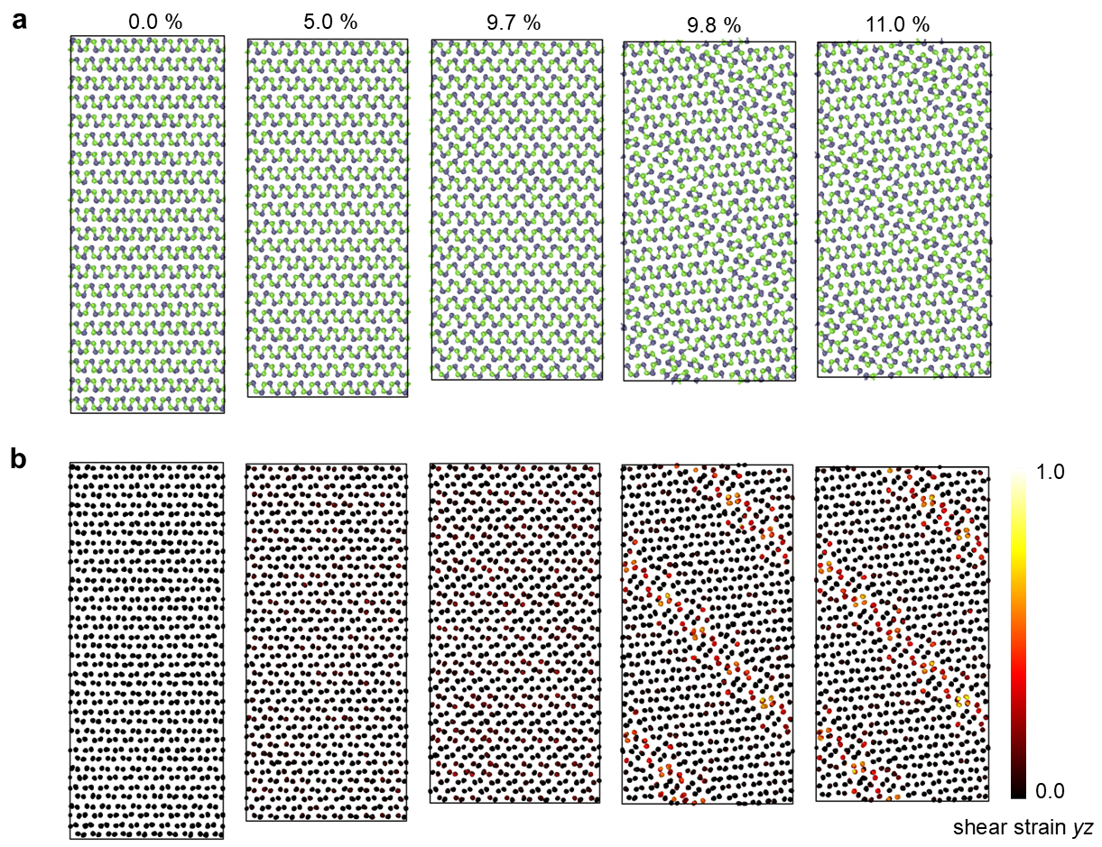
Supplementary Figure 14. Real-space visualization of the shear-mediated mechanism for chair-boat transition. a, Atomic snapshots at strain of 0.0%, 5.0%, 9.7%, 9.8% and 10.0%. Lattice tilt when strain is over 9.7%. b, Local shear strain (YZ) mapping revealing localized deformation bands when strain is over 9.7%.

To deep understand the α- to β-GeSe phase transition, we performed machine learning force field molecular dynamics (MLFF-MD) simulations on nanopillar α-GeSe under out-of-plane compression strain to simulate the chair-to-boat conformation transition process, as shown in Fig. 3 in the main text. Here, we provide more details about the transition process of GeSe. Under uniaxial compression along the [001] direction, the α-GeSe nanopillar exhibits a distinct mechanical response governed by a sequential structural transformation. As shown in the stress-strain relationship (Supplementary Fig. 15h), the stress increases linearly during the initial elastic regime but undergoes an abrupt stress-relaxation (drop) at a critical compressive strain of approximately 8%. This mechanical instability marks the incipient phase transformation from the initial α-GeSe (chair conformation) to β-phase (boat conformation), as confirmed by the localized atomic structural evolution (Supplementary Fig. 15a,b). Upon subsequent loading, the transformed β-phase region propagates steadily along the nanopillar axis (Supplementary Fig. 15c-f), resulting in a plateau-like stress response with minor fluctuations (Supplementary Fig. 15h). Beyond a threshold strain of 50%, the stress rises monotonically, signaling the onset of strain-induced amorphization. This transition is characterized by the total collapse of long-range order and the formation of a disordered network (Supplementary Fig. 15g). Notably, the mechanical deformation exhibits significant in-plane anisotropy during the α-to-β transition; due to the anisotropic Young’s modulus of the crystalline phase, the lateral expansion along the [100] direction is substantially smaller than that along the [010] direction (Supplementary Fig. 15a-f). However, as the system enters the fully amorphous regime (>50% strain), the deformation mode shifts from anisotropic to isotropic, reflecting the loss of lattice-directionality. Furthermore, our analysis indicates that the phase transformation is an intrinsic bulk property, as the presence of an amorphous surface layer on the nanopillar exerts negligible influence on the α-to-β transition pathway.
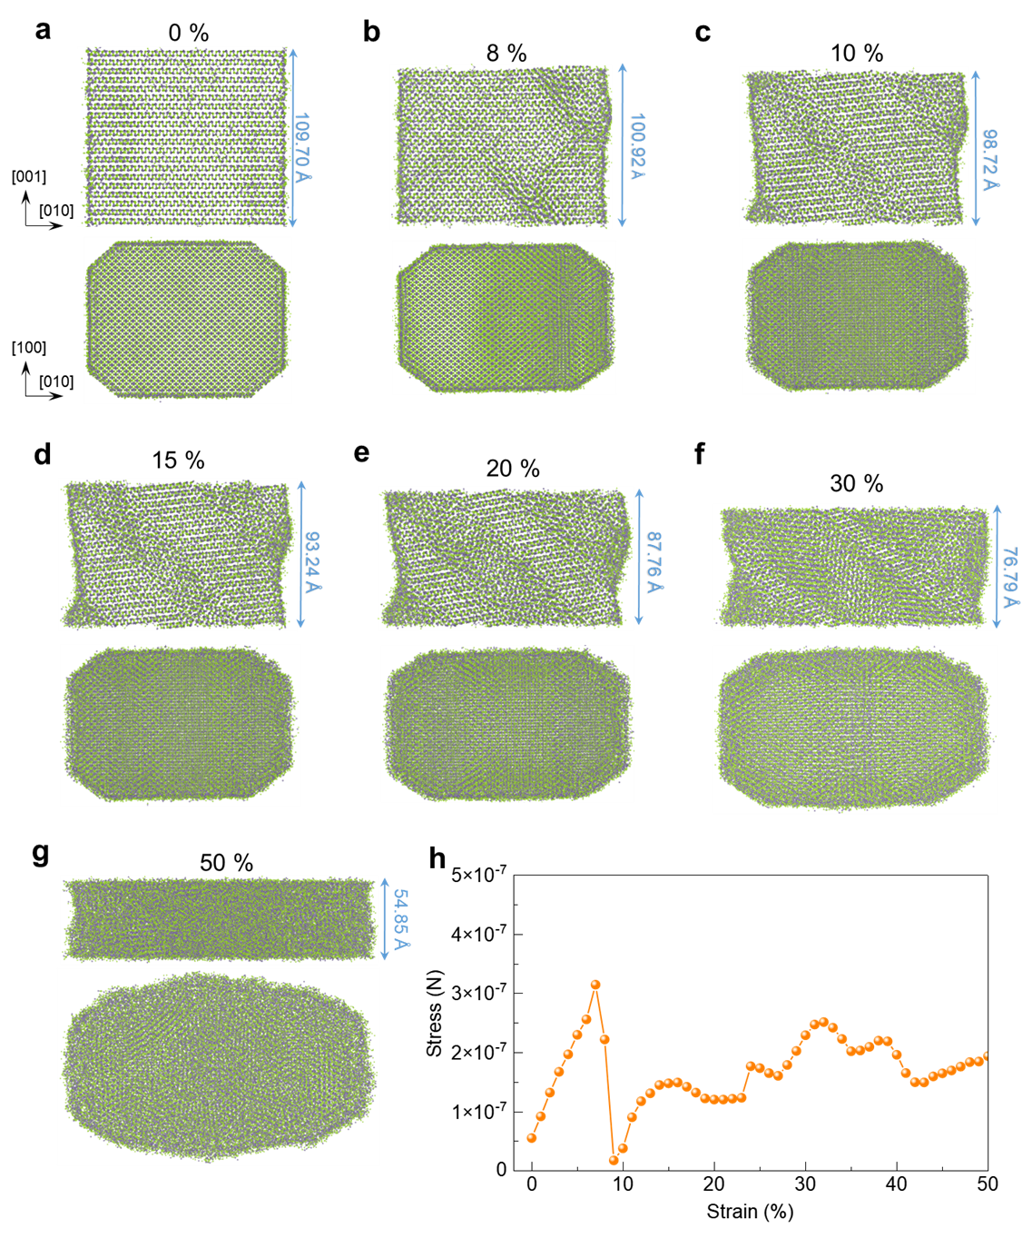
Supplementary Figure 15. Evolution of the deformation and stress-strain curve of α-GeSe nanopillar under uniaxial compressive strain along [001] direction. a-g, The side views of α-GeSe nanopillar at different strain levels: 0%, 8%, 10%, 15%, 20%, 30%, and 50% respectively. h, The corresponding stress-strain curve.

- Lattice bending in GeSe samples with compressing strain along armchair direction
In-situ compression of GeSe nanopillars along the armchair direction was performed to observe the deformation behavior, with the process primarily characterized by lattice bending. As shown in Supplementary Fig. 16a–c, during the early stages of compression, the nanopillar undergoes bending without any visible signs of phase transition. The applied compressive strain leads to gradual lattice distortion, but no chair–boat structural transformation domains are observed in these images. The corresponding engineering stress–strain curve in Supplementary Fig. 16d demonstrates a continuous strain-hardening response. Importantly, there are no sudden drops or jumps in the curve, which would typically indicate phase nucleation or transformation. This suggests that, under compression along the armchair direction, the deformation is dominated by lattice bending, rather than the nucleation of phase transition domains.

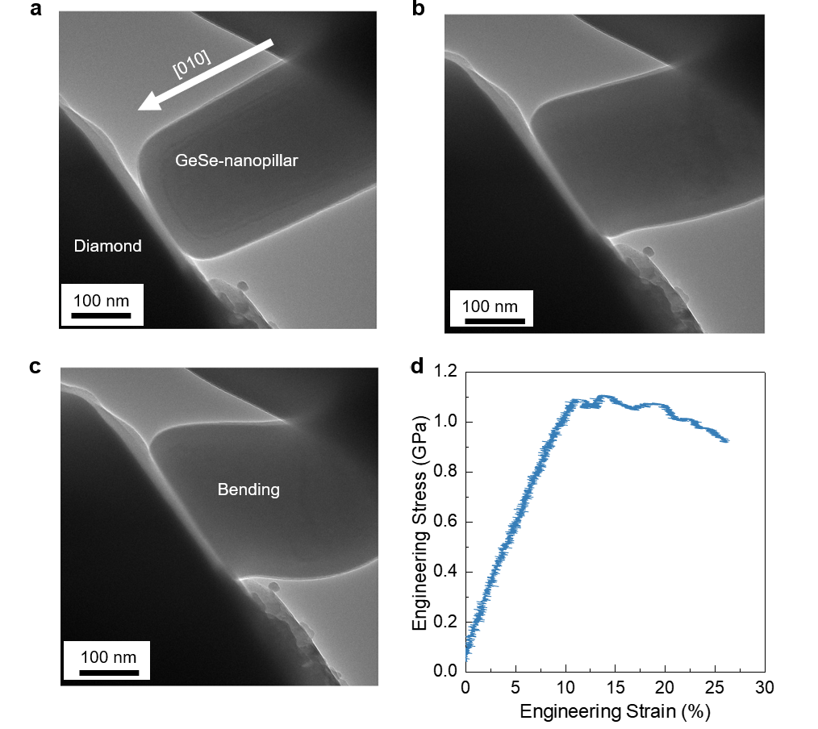
Supplementary Figure 16. Lattice bending in GeSe samples with compressing strain along armchair direction. a, At the initial stage of compression, the loading direction is indicated by the arrow, and the nanopillar remains relatively undeformed. b, As compression progresses, lattice distortion begins to develop. c, At higher strains, significant lattice bending is observed, reflecting the ongoing deformation. d, Corresponding engineering stress–strain curve, showing the relationship between the applied strain and stress response during the compression process.

- Observation of interlayer sliding in GeSe samples with compressing strain along <021> direction ($θ$= 45°)
To investigate the influence of loading orientation on the chair–boat structural transition in GeSe, we performed in-situ compression tests with varied loading directions, as illustrated in Supplementary Fig. 17a. In this experiment, the loading direction was oriented at a 45° angle relative to both the out-of-plane and the armchair direction, while observations were along the zigzag direction. During the compression process, we observed clear signs of interlayer sliding, indicated by the orange arrows in Supplementary Fig. 17b–d. These observations suggest that under compression along this 45° direction, no significant phase transition occurs. Instead, the deformation appears to be primarily governed by interlayer sliding, as indicated by the progressive movement between the layers without lattice distortion typically associated with a structural phase change.
To further verify this hypothesis, we conducted in situ high-resolution TEM compression along the same 45° loading direction. As shown in Supplementary Fig. 18, time-resolved high-resolution TEM images recorded during the compression process clearly highlight the pronounced interlayer sliding (indicated by the arrows), while no evidence of the chair–boat structural transition is observed. The atomic-scale imaging further supports the notion that, under compression along the 45° direction, the GeSe nanopillar undergoes significant interlayer sliding without transitioning from the α-phase to the β-phase, as would typically be observed in compression along other directions. These results conclusively demonstrate that when compressed along the 45° direction, the GeSe nanopillar primarily exhibits interlayer sliding rather than a phase transition, indicating the importance of the loading orientation in controlling the nature of deformation in GeSe during compression.
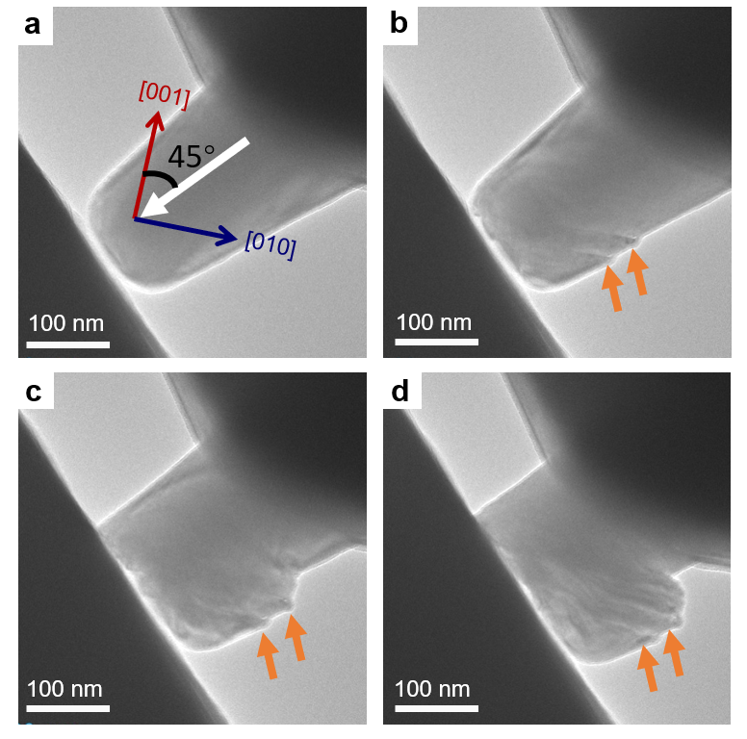
Supplementary Figure 17. In-situ TEM observation of interlayer sliding in a GeSe nanopillar under compression. a, TEM image acquired at the initial stage of in-situ compression of a GeSe nanopillar, with the inset indicating the loading direction oriented along the armchair direction and tilted by 45° relative to the c axis. b–d, Sequential TEM images recorded during further loading, revealing pronounced interlayer sliding, as highlighted by the orange arrows.

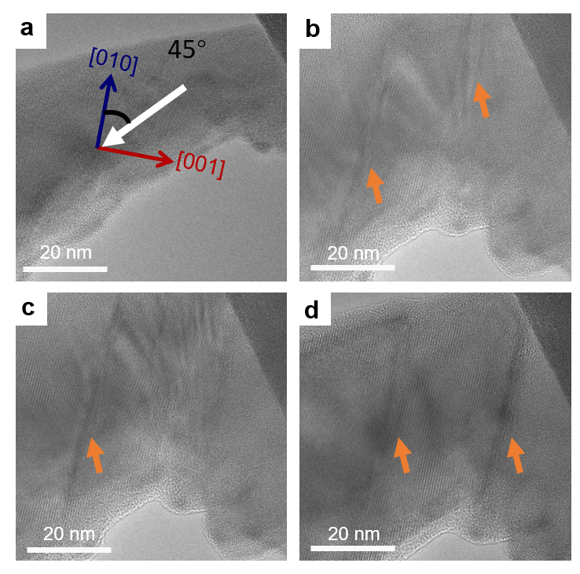
Supplementary Figure 18. In situ high-resolution TEM observation of interlayer sliding in a GeSe nanopillar under compression. a, High-resolution TEM image acquired at the initial stage of in-situ compression of a GeSe nanopillar. The inset schematically illustrates the loading direction aligned with the armchair direction and tilted by 45° relative to the $c$ axis. b–d, Sequential high-resolution TEM images recorded during further loading, showing pronounced interlayer sliding, as indicated by the orange arrows.

- Observation of chair-boat-transition in GeSe samples with compressing strain along zigzag direction
We performed in-situ compression experiments on GeSe nanopillars along the [100] (zigzag) direction to examine the corresponding structural response under uniaxial loading. As shown in Supplementary Fig. 19, compression was applied along [100] direction and the nanopillars were imaged along [010] direction. Time-resolved HRTEM images and the corresponding FFT patterns (Supplementary Fig. 19a–e), acquired at 0, 59, 73, 92 and 141 s during continuous loading, reveal a progressive evolution of the lattice structure. At the initial stage (0 s), the nanopillar exhibits the α-GeSe structure, as further confirmed by the atomic-resolution HAADF-STEM image obtained from the region highlighted by the yellow dashed box (Supplementary Fig. 19f). With increasing compressive strain (Supplementary Fig. 19b–d), gradual lattice distortion develops without an abrupt phase transition. At 141 s, pronounced changes in the FFT pattern indicate the onset of a strain-induced structural transformation; the region outlined by the blue dashed box corresponds to the atomic-resolution HAADF-STEM image in Supplementary Fig. 19g, which reveals the formation of the β-GeSe phase. A combined analysis of in situ HRTEM observations, atomic-resolution HAADF-STEM imaging (Supplementary Fig. 19f–i), and comparison with established crystallographic models of α-GeSe and β-GeSe (Supplementary Fig. 19j,k) allows the structural transition induced by compression along [100] direction to be identified as an α-to-β (chair–boat) phase transformation.
Using the same experimental strategy, additional in situ compression experiments were carried out with the loading direction along the [100] direction while imaging along [001] direction, as shown in Supplementary Fig. 20. Time-resolved HRTEM images and corresponding FFT patterns (Supplementary Fig. 20a–e), acquired at 0, 95, 136, 157 and 166 s during continuous loading, reveal a similar sequence of lattice evolution. At 0 s, the nanopillar retains the α-GeSe structure, as confirmed by the atomic-resolution HAADF-STEM image obtained from the region highlighted by the yellow dashed box (Supplementary Fig. 20f). With increasing strain (Supplementary Fig. 20b–d), progressive lattice distortion develops without an apparent phase transformation. At 166 s, pronounced changes in the FFT pattern are observed, suggesting the onset of a strain-induced structural transition; the region outlined by the blue dashed box corresponds to the atomic-resolution HAADF-STEM image in Supplementary Fig. 20g, revealing the formation of the β-GeSe phase. Enlarged views of the HAADF-STEM images before and after compression (Supplementary Fig. 20h,i), together with comparison to the corresponding atomic structure models of α-GeSe and β-GeSe (Supplementary Fig. 20j,k), provide strong evidence for an α-to-β phase transformation during zigzag-direction compression. The consistency of the structural evolution observed under different imaging geometries confirms that the chair–boat structural transition in GeSe nanopillars is robust and independent of the observation direction.

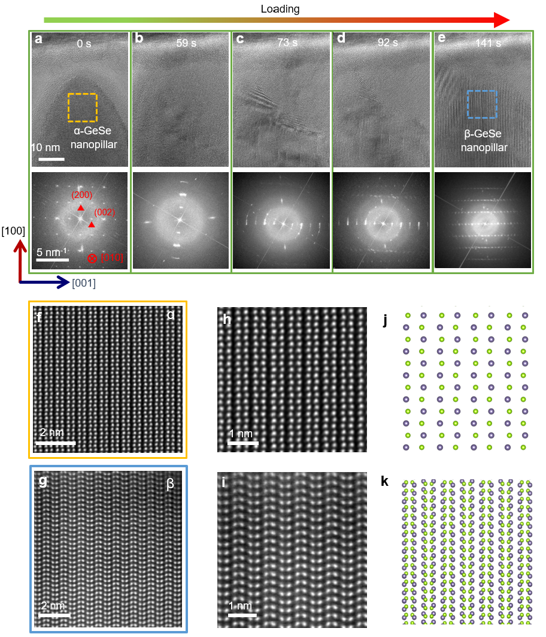
Supplementary Figure 19. In-situ high-resolution TEM observation of a GeSe nanopillar under uniaxial compression along [100] (zigzag) direction, imaged along [010] (armchair) direction. a–e, Time-resolved HRTEM images (top) and the corresponding FFT patterns (bottom) acquired during continuous compression at 0, 59, 73, 92 and 141 s. f, The atomic-resolution HAADF-STEM image of region highlighted by the yellow dashed box in (a). g, The atomic-resolution HAADF-STEM image of region highlighted by the blue dashed box in (e). h,i, Enlarged views of the HAADF-STEM images in (f) and (g). j,k, Corresponding atomic structure models for the α-GeSe and β-GeSe viewed along [010] direction.
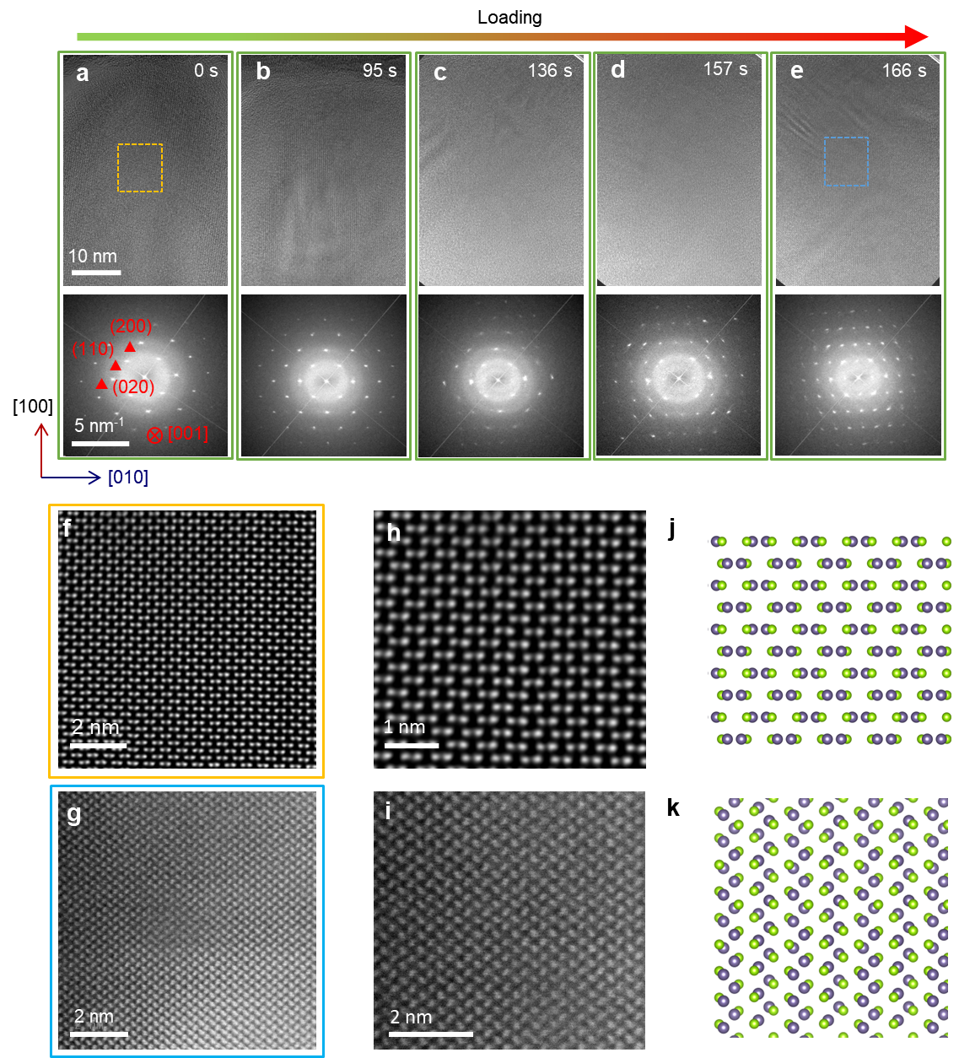
Supplementary Figure 20. In situ high-resolution TEM observation of a GeSe nanopillar during uniaxial compression along [100] (zigzag) direction, imaged along [001] (out-of-plane) direction. a–e, Time-resolved HRTEM images (top row) and the corresponding FFT patterns (bottom row) acquired during continuous compression at 0, 95, 136, 157 and 166 s, respectively. f, The atomic-resolution HAADF-STEM image of region highlighted by the yellow dashed box in (a). g, The atomic-resolution HAADF-STEM image of region highlighted by the blue dashed box in (e). h,i, Enlarged views of the HAADF-STEM images in (f) and (g). j,k, Corresponding atomic structure models for the α-GeSe and β-GeSe viewed along [001] direction.
- Anisotropic mechanical property of GeSe
As illustrated in Supplementary Fig. 21a, the unit cell α-GeSe in the (100)–(001) plane exhibits a characteristic puckered layered structure. The green and purple spheres represent Se and Ge atoms, respectively, forming the distinct "chair" conformation. This specific atomic arrangement is the structural origin of the material's pronounced mechanical anisotropy, as the bonding strength and lattice responses differ significantly along the [100] (zigzag) and [010] (armchair) directions. The elastic properties of α-GeSe are highly orientation-dependent, as quantitatively depicted in the polar plots of Supplementary Fig. 21b–d. Poisson’s Ratio: The polar plot of Poisson’s ratio ν exhibits a distinct four-fold symmetric distribution with significant orientation dependence (Supplementary Fig. 21b). The maxima reached along directions offset from the principal axes indicate regions of enhanced transverse coupling. This implies that uniaxial compression along a specific in-plane direction triggers a disproportionately large expansion in the orthogonal direction, providing the necessary geometric flexibility for the 'opening up' of the puckered structure during the chair-to-boat transition. Young’s modulus shows a prominent two-fold (appearing four-fold symmetric) distribution with a maximum along the 90°/270° axis (corresponding to the out-of-plane direction) and a significantly lower value along the 0°/180° armchair direction (Supplementary Fig. 21d). This indicates that the lattice is much stiffer when compressed along the [001] direction compared to the [100] direction. Shear Modulus: Similar anisotropy is observed in the shear modulus, with maxima at specific orientations (Supplementary Fig. 21c). This variability suggests that the resistance to shear deformation—the primary driver for the chair-to-boat transition—is highly sensitive to the direction of the applied load.
The mechanical anisotropy revealed in these plots directly governs the phase transformation behavior observed under strain. The lower Young’s modulus along [010] directions explains why uniaxial compression along the [001] direction, coupled with shear strain $ε_{yz}$ (which induces the (010) plane shift along the [001] direction), can so effectively trigger the structural deformation. The highly directional Poisson’s ratio acts as a “geometric governor”, determining how the lattice reshapes itself to accommodate external strain before the ultimate transition into the boat phase. These results provide a fundamental explanation for the anisotropic deformation observed in GeSe nanopillars (previously discussed in Supplementary Fig. 15). Because the Young's modulus is lower and the Poisson's coupling is specific along the [010] (armchair) direction, the nanopillar exhibits much larger lateral expansion along [010] direction during the chair-to-boat transition. The directional minima in the shear modulus (Supplementary Fig. 21c) correlate with the facilitated "bond-flopping" mechanism. When external shear strain aligns with these low-resistance directions, the kinetic barrier for the dihedral angle shift (from 120° to 180°) is minimized, promoting the rapid propagation of the β-GeSe phase.
To understand the propagation of phase transition, we investigate the electron resonance during chair to boat transformation transition. Here, we only investigate the first reaction step that only one Se atom flopping to saddle point of chair to boat transformation. The position of the Se atom is shown in Supplementary Fig. 22a-c. The corresponding charge density difference indicates electron accumulation and dissipation. The charge density difference reveals that the direction exhibiting a more significant change in electron density with increasing distance corresponds to the direction of electron resonance, highlighting a stronger electronic response. Supplementary Fig. 22d-f shows that the electron resonant directions are along <021> and <010> directions. Therefore, the fast directions of chair to boat transformation transition are along <021> and <010> directions, which are consistent with experimental observation.

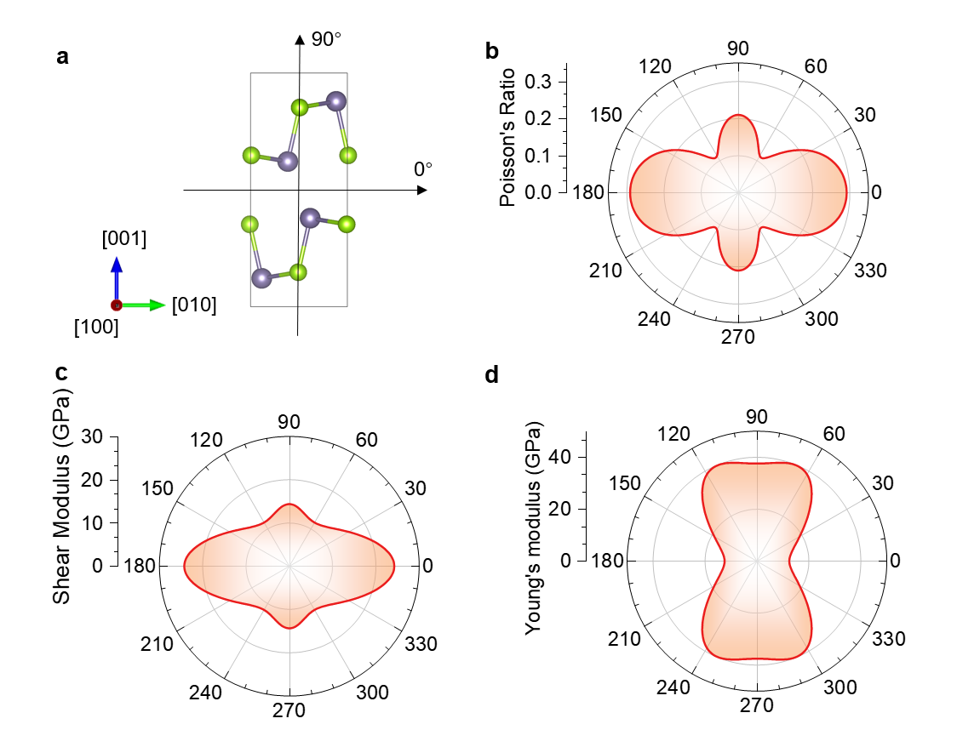
Supplementary Figure 21. a, Schematic of the crystal structure of GeSe viewed along [100] direction with Se and Ge atoms represented by green and purple spheres, respectively. The unit cell is outlined by a gray rectangle. $θ$ is denoted as the angle between the loading direction and armchair direction of GeSe. b, Polar plots of Poisson’s ratio, c, shear modulus, and d, Young’s modulus as a function of orientation. Each plot shows a fourfold symmetric distribution with maxima and minima at specific angles.

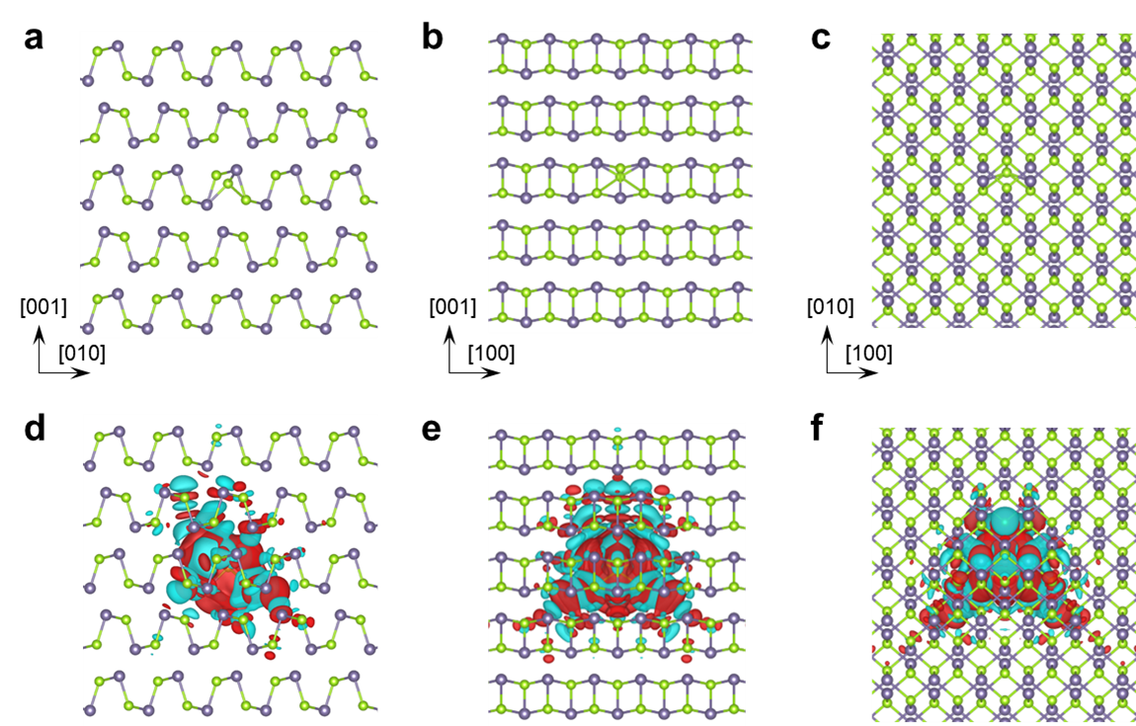
Supplementary Figure 22. Electron resonance during chair-boat conformation transition. a-c, Atomic structures of bulk GeSe with one Se atom at saddle point of chair-boat conformation transition viewed along [100], [010] and [001] directions. d-f, Charge density difference between GeSe with one Se atom at addle point of chair-boat conformation transition and that without bond rotation. Ge and Se atoms are coloured in purple and green. The red and cyan isosurfaces indicate the increase and decrease of the charge density, respectively. The value of isosurface is 10⁻⁴ e/bohr³. Note that panel (d) is also given in Fig. 4 in main text.

- Comparison of ultimate engineering stress and strain of GeSe and other materials
Supplementary Table 4 summarizes a comparison of the ultimate engineering stress and ultimate engineering strain of GeSe with those of a broad range of representative material systems, including bulk and nanoscale metallic glasses, high-entropy alloys, conventional structural alloys, and low-dimensional semiconductors. The compiled data highlight that GeSe exhibits an uncommon combination of a high ultimate engineering stress together with a large attainable engineering strain. In contrast, bulk metallic glasses typically achieve relatively high strength at the expense of limited plastic deformability, whereas many low-dimensional semiconductors and van der Waals materials display large strains but sustain only low stresses. The comparison places GeSe in a distinct regime of the strength–strain space, underscoring its ability to sustain both high stress and large deformation relative to other material classes.

Supplementary Table 4. Comparison of ultimate engineering stress and strain for GeSe and other materials.
Materials | Ultimate engineering stress (GPa) | Ultimate engineering strain (%) | Refs.
GeSe | 7.5 | 93 | This work
Al-based bulk metallic glass | 1.53 | 11 | 5
Fe-based bulk metallic glass | 3 | 30 | 6
Fe-based Bulk metallic glass | 3.1 | 6.6 | 7
Ta₈₀Co₂₀ nanoscale metallic glass | 4.5 | 80 | 8
Mg–Zn–Ca bulk metallic glass | 0.23 | 17 | 9
Iron-based metallic glasses | 4.5 | 50 | 10
Hierarchical nanostructured aluminum alloy | 1.7 | 70 | 11
High-entropy MAX | 0.7 | 20 | 12
Ti-Nb-Fe-Cr alloys | 2 | 40 | 13
Refractory high entropy alloys (RHEAs) | 1.14 | 50 | 14
Lightweight Mg alloys | 1.2 | 16 | 15
Nanolamellar medium entropy alloy | 5 | 25 | 16
Mg alloys | 0.9 | 15 | 17
(TiZrNbHf)₉₈Ni₂ alloy | 2.5 | 65 | 18
Nanodomained alloy | 3.3 | 60 | 19
MoTaVW RHEA | 1.4 | 22 | 20
Mg | 1.0 | 56.4 | 21
InSe | 0.1 | 80 | 22
GaSe | 0.1 | 20 | 23
CsPbX₃ | 0.25 | 50 | 24

- Applicability chair-boat-transition-mediated superplasticity to other materials
To explore the applicability of the chair–boat structural transition in materials with similar structures, we conducted in situ compression on GeS nanopillars. The samples were compressed along the [001] direction under TEM, where clear chair–boat transformation domains were observed, as shown in Supplementary Fig. 23a. Following the in-situ loading, we performed HAADF-STEM imaging (Supplementary Fig. 23b) to examine the structural evolution. Additionally, energy-dispersive X-ray spectroscopy (EDS) was used to analyze the elemental composition of the compressed GeS nanopillar (Supplementary Fig. 23c), and EDS elemental maps for Ge (Supplementary Fig. 23d) and S (Supplementary Fig. 23e) were obtained, revealing the distribution of these elements throughout the nanopillar.

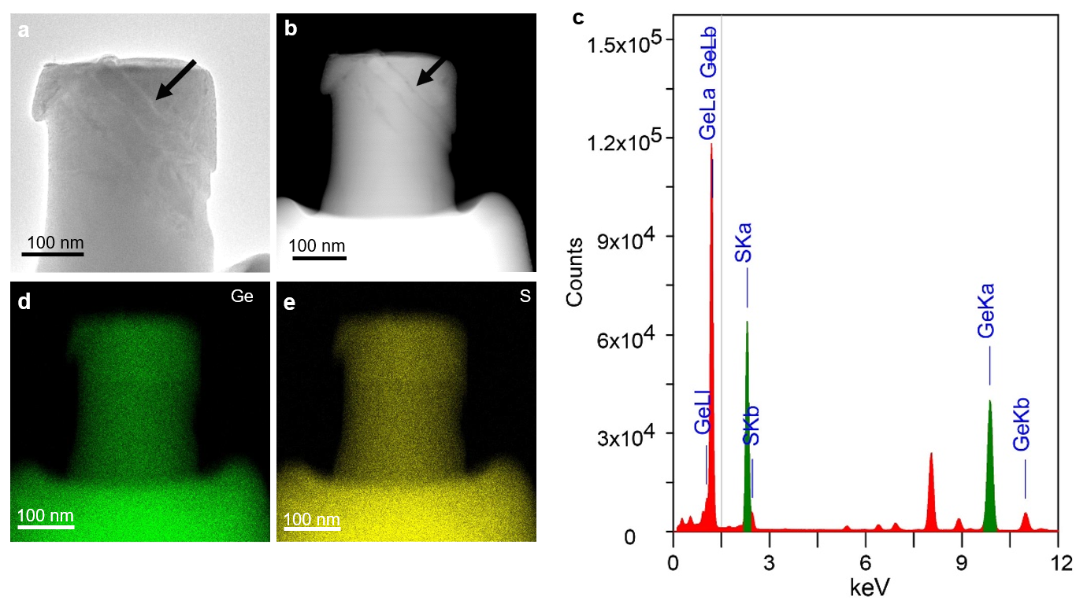
Supplementary Figure 23. Post-compression structural and compositional characterization of a GeS nanopillar. a, TEM image of a GeS nanopillar after in-situ compression, where the black arrow marks the β-phase transformed region (boat-type configuration). b, Corresponding STEM image of the same GeS nanopillar after in-situ compression, with the β-phase (boat region) indicated by the black arrow. c, Energy-dispersive X-ray spectroscopy (EDS) spectrum collected from the compressed GeS nanopillar, confirming the presence of Ge and S. d,e, EDS elemental maps of Ge (d) and S (e), respectively, showing the elemental distribution within the nanopillar.

References

1 Kong, X. et al. Tunable auxetic properties in group-IV monochalcogenide monolayers. Physical Review B 98, 184104, doi:10.1103/PhysRevB.98.184104 (2018).
2 Mouhat, F. & Coudert, F.-X. Necessary and sufficient elastic stability conditions in various crystal systems. Physical Review B 90, 224104, doi:10.1103/PhysRevB.90.224104 (2014).
3 Togo, A. & Tanaka, I. First principles phonon calculations in materials science. Scripta Materialia 108, 1-5, doi:https://doi.org/10.1016/j.scriptamat.2015.07.021 (2015).
4 Stukowski, A. Visualization and analysis of atomistic simulation data with OVITO–the Open Visualization Tool. Modelling and Simulation in Materials Science and Engineering 18, 015012, doi:10.1088/0965-0393/18/1/015012 (2010).
5 Yin, J., Cai, H., Cheng, X. & Zhang, X. Al-based bulk metallic glass with large plasticity and ultrahigh strength. Journal of Alloys and Compounds 648, 276-279, doi:https://doi.org/10.1016/j.jallcom.2015.05.285 (2015).
6 Guo, S. F., Liu, L., Li, N. & Li, Y. Fe-based bulk metallic glass matrix composite with large plasticity. Scripta Materialia 62, 329-332, doi:https://doi.org/10.1016/j.scriptamat.2009.10.024 (2010).
7 Guo, S. & Su, C. Micro/nano ductile-phases reinforced Fe-based bulk metallic glass matrix composite with large plasticity. Materials Science and Engineering: A 707, 44-50, doi:https://doi.org/10.1016/j.msea.2017.09.036 (2017).
8 Liu, X. et al. Multi-scale inhomogeneity and anomalous mechanical response of nanoscale metallic glass pillar by cryogenic thermal cycling. Rare Metals 43, 6771-6780, doi:https://doi.org/10.1007/s12598-024-02964-7 (2024).
9 Li, K. et al. New biodegradable Mg–Zn–Ca bulk metallic glass composite with large plasticity reinforced by SnZn alloy. Materials Science and Engineering: A 873, 145045, doi:https://doi.org/10.1016/j.msea.2023.145045 (2023).
10 Sarac, B. et al. Origin of large plasticity and multiscale effects in iron-based metallic glasses. Nature Communications 9, 1333, doi:10.1038/s41467-018-03744-5 (2018).
11 Wu, G. et al. Hierarchical nanostructured aluminum alloy with ultrahigh strength and large plasticity. Nature Communications 10, 5099, doi:10.1038/s41467-019-13087-4 (2019).
12 Wu, Z. et al. High-entropy MAX phase with ultrahigh strength and large plasticity mediated by local chemical fluctuations. Materials Today 80, 61-73, doi:https://doi.org/10.1016/j.mattod.2024.08.004 (2024).
13 Rabadia, C. D. et al. High-strength β stabilized Ti-Nb-Fe-Cr alloys with large plasticity. Materials Science and Engineering: A 732, 368-377, doi:https://doi.org/10.1016/j.msea.2018.07.031 (2018).
14 Liu, C., Zhang, L.-C., Wang, K. & Wang, L. Improving strength and plasticity via pre-assembled dislocation networks in additively manufactured refractory high entropy alloy. Acta Materialia 283, 120526, doi:https://doi.org/10.1016/j.actamat.2024.120526 (2025).
15 Liu, B.-Y. et al. Large plasticity in magnesium mediated by pyramidal dislocations. Science 365, 73-75, doi:10.1126/science.aaw2843 (2019).
16 Cao, Z. et al. Nanolamellar medium entropy alloy composites with high strength and large plasticity. Journal of Alloys and Compounds 873, 159775, doi:https://doi.org/10.1016/j.jallcom.2021.159775 (2021).
17 Jeong, J. et al. Nanoscale mechanisms limiting non-basal plasticity in magnesium. Acta Materialia 296, 121261, doi:https://doi.org/10.1016/j.actamat.2025.121261 (2025).
18 Liu, C. et al. Near-theoretical strength and deformation stabilization achieved via grain boundary segregation and nano-clustering of solutes. Nature Communications 15, 9283, doi:10.1038/s41467-024-53349-4 (2024).
19 Wu, G. et al. Substantially enhanced homogeneous plastic flow in hierarchically nanodomained amorphous alloys. Nature Communications 14, 3670, doi:10.1038/s41467-023-39296-6 (2023).
20 Li, Y. et al. Ultrastrong, high plasticity, and softening-resistant refractory high-entropy alloy via stable isostructural coherent interfaces. Scripta Materialia 254, 116337, doi:https://doi.org/10.1016/j.scriptamat.2024.116337 (2025).
21 Liu, B.-Y. et al. Rejuvenation of plasticity via deformation graining in magnesium. Nature Communications 13, 1060, doi:10.1038/s41467-022-28688-9 (2022).
22 Wei, T.-R. et al. Exceptional plasticity in the bulk single-crystalline van der Waals semiconductor InSe. Science 369, 542-545, doi:10.1126/science.aba9778 (2020).
23 Wang, H. et al. Orientation-dependent large plasticity of single-crystalline gallium selenide. Cell Reports Physical Science 3, 100816, doi:https://doi.org/10.1016/j.xcrp.2022.100816 (2022).
24 Li, X. et al. Multislip-enabled morphing of all-inorganic perovskites. Nature Materials 22, 1175-1181, doi:10.1038/s41563-023-01631-z (2023).

