In doped NiCo-LDH as bifunctional electrocatalysts for overall water splitting
Zicheng Huang¹ · Mengwei Yu¹ · Yulun Xie^{1, *} · Yuedong Guo¹
¹School of Mechanical Engineering, Anhui Institute of Information Technology, Wuhu 241100, Anhui, People’s Republic of China
* Corresponding author: 2015063@aiit.edu.cn

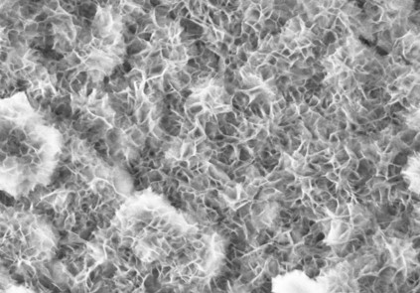
Figure S1 SEM images of NiCo LDH

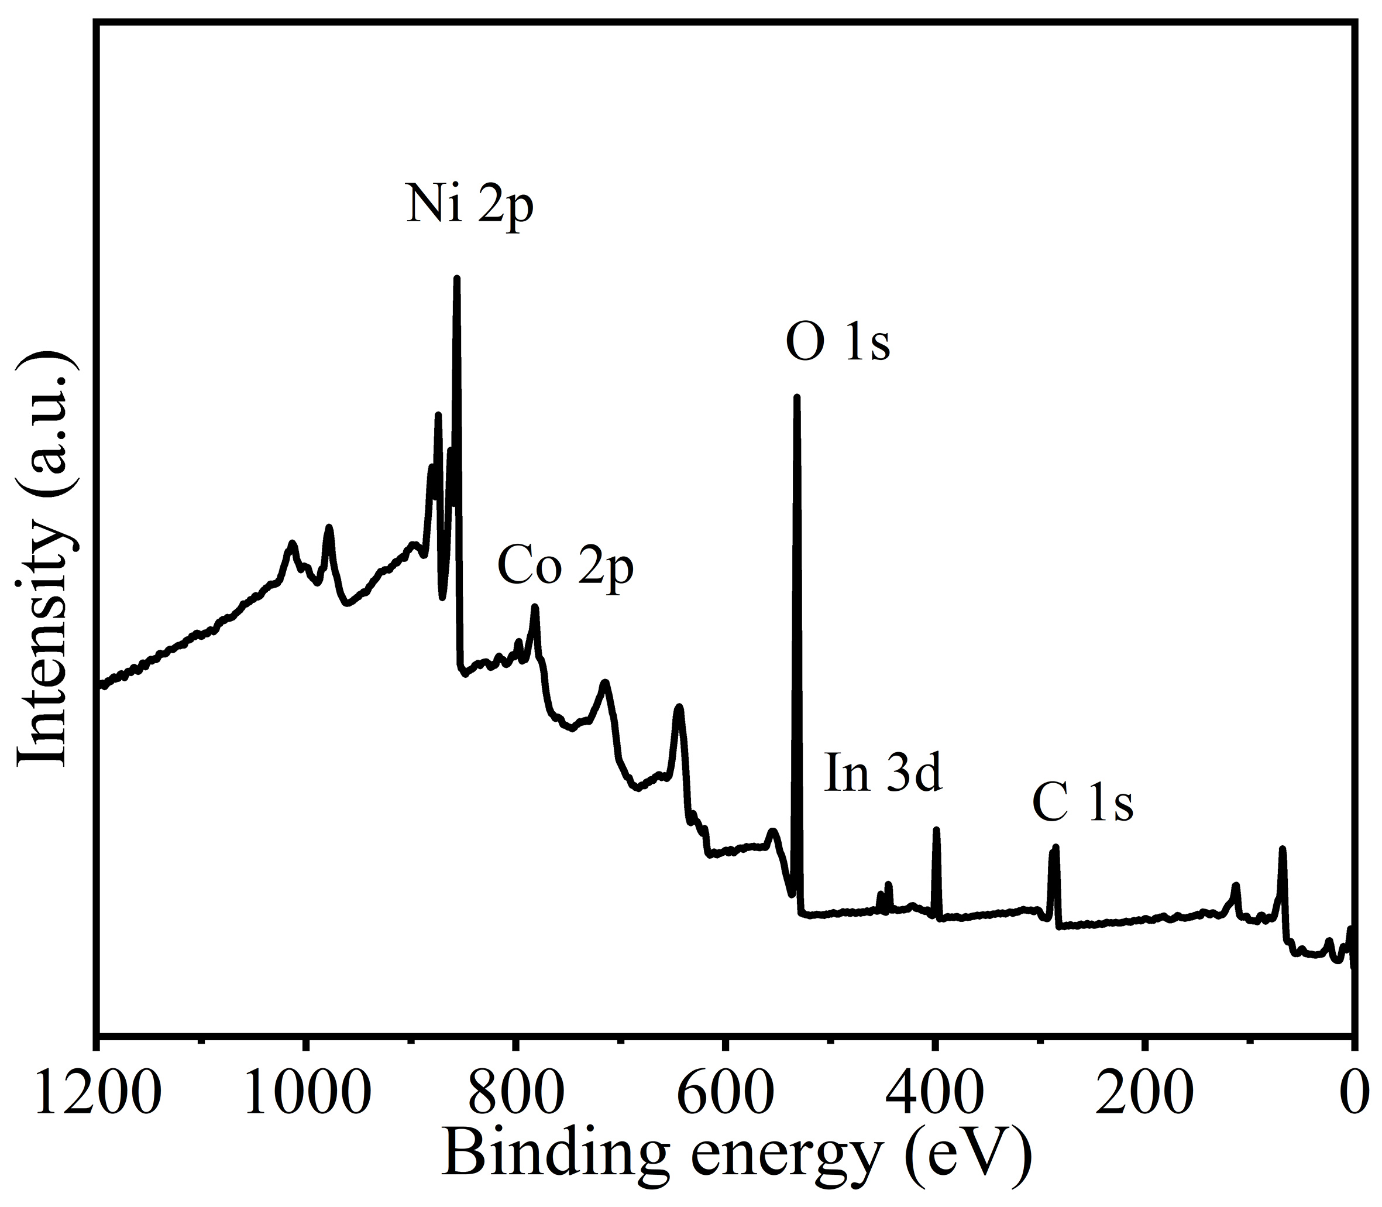
Figure S2 XPS survey spectra of In1.0-NiCo LDH

