Supplementary information
Novel mechanism of HIV elite control by enriching gut dipeptides as HIV-1 antagonist but Prevotella agonist

Authors:
Maike Sperk¹, Anoop T. Ambikan¹, Shilpa Ray¹, Kamal Singh², Flora Mikaeloff¹, Rafael Ceña Diez¹, Ashwathy Narayanan¹, Jan Vesterbacka³, Piotr Nowak³, Anders Sönnerborg^{1, 3, a}, Ujjwal Neogi^{1, 4, a} *

Affiliations:
¹Division of Clinical Microbiology, Department of Laboratory Medicine, Karolinska Institute, ANA Futura, Campus Flemingsberg, Stockholm, Sweden.
²Christopher S. Bond Life Sciences Center, University of Missouri, Columbia, MO, 65211, USA
³Department of Medicine Huddinge, Division of Infectious Diseases, Karolinska Institute, I73, Karolinska University Hospital, Huddinge, 141 86 Stockholm, Sweden
⁴Department of Microbiology and Immunology, University of Missouri, Columbia, MO, 65211, USA
ª Equal contribution
*Corresponding author

Supplementary Figure 1 Outlier detection
Unsupervised PCA of all samples with all metabolites. EC06 and EC14 are well-separated from the remaining EC samples, and are considered as outliers. HIV-1 elite controllers (EC, n=14) are marked orange, HIV-negative control (HC, n=12) green, and viremic progressors (VP, n=16) red.

Supplementary Figure 2 Metabolomic heatmap
Unsupervised hierarchical clustering analyses based on all metabolites detected (n=825) shows clustering of all EC with the exception of one. Presented data includes samples of HC (n=12, green), EC (n=12, orange), and VP (n=16, red).

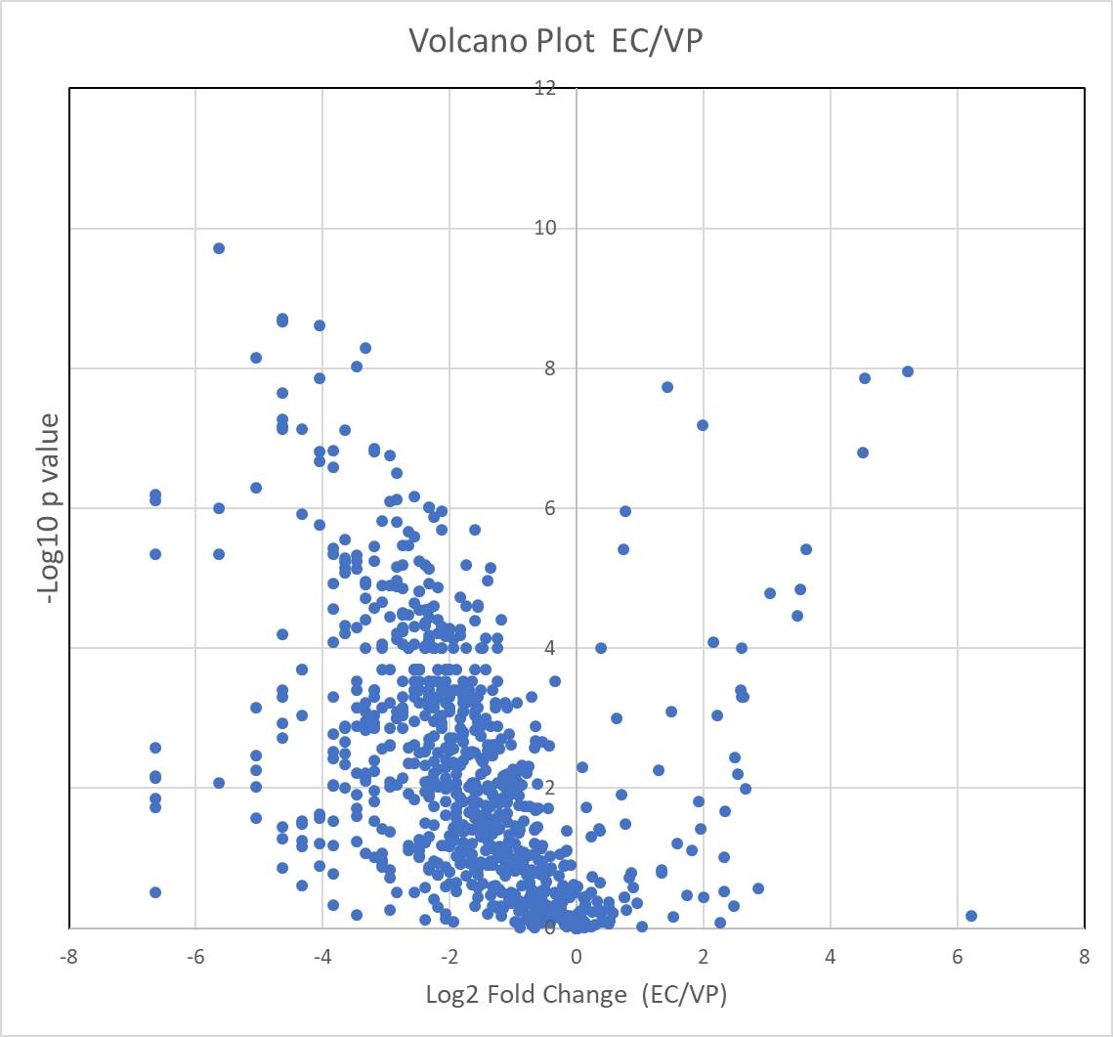
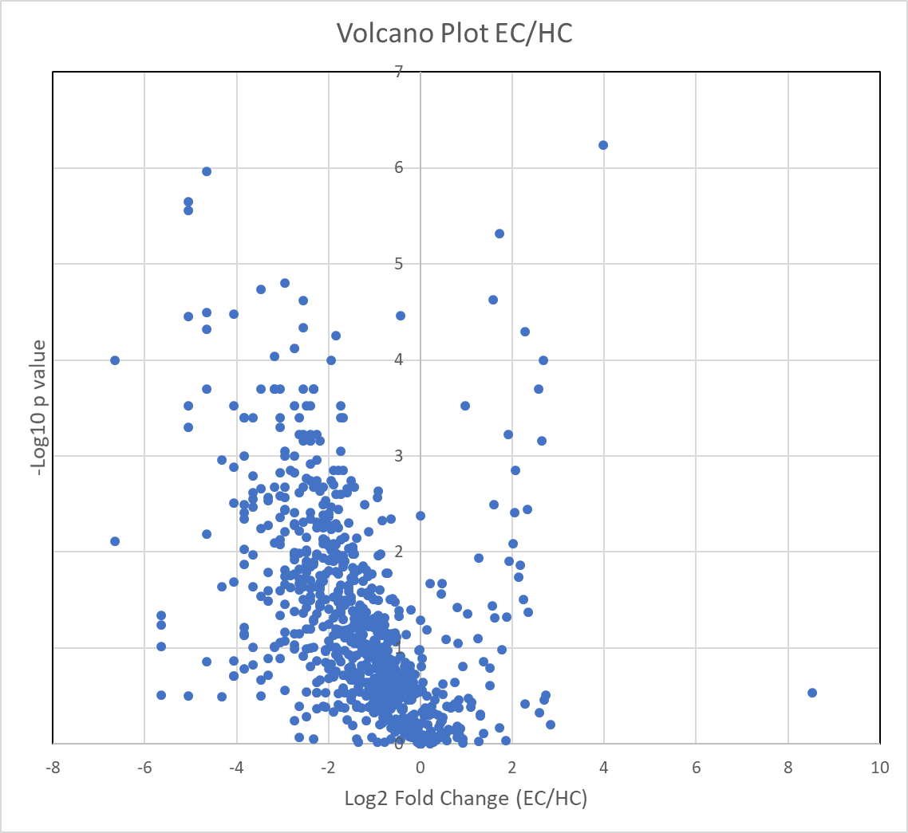
a.
b.

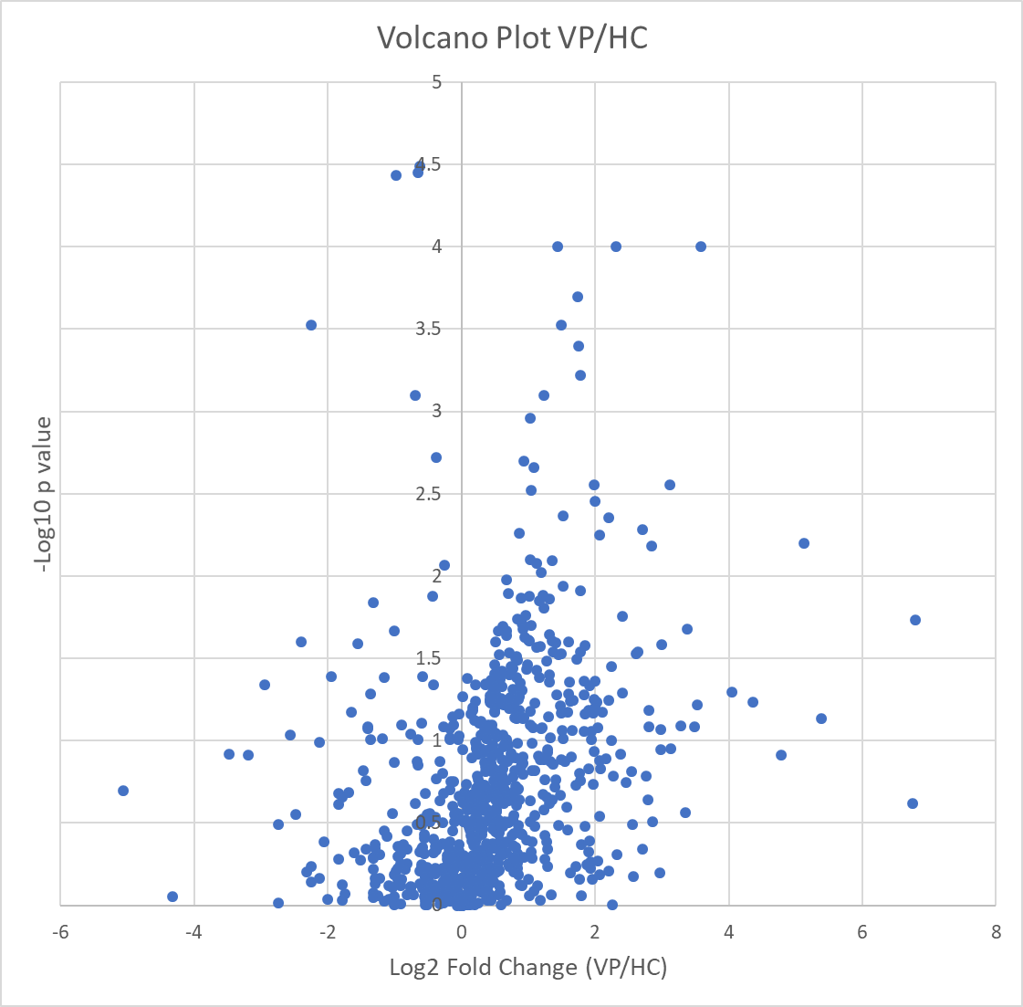
c.

Supplementary Figure 3 Differential metabolites between groups
Volcano plots of differential metabolites in feces are presented for
a. EC vs HC
b. EC vs VP
c. VP vs HC.
Supplementary Figure 4 Metabolite Network
Network of the metabolites that were significantly different between HC and VP. Rectangular nod shapes represent the eight super pathways that are shown in different colors according to the legend. Circles are used for sub pathways belonging to the eight super pathways. Octagonal nod shapes show the single metabolites, where a gradient was applied depending on foldchange from 0.01 = green (decreased metabolite level), 0= yellow (non-significant) to red (foldchange from 4.8 to 39). Size of the octagons indicate p-value: the bigger the size the lower the p-value. Lines connect each metabolite to its respective sub pathway and sub pathway to their respective super pathways.

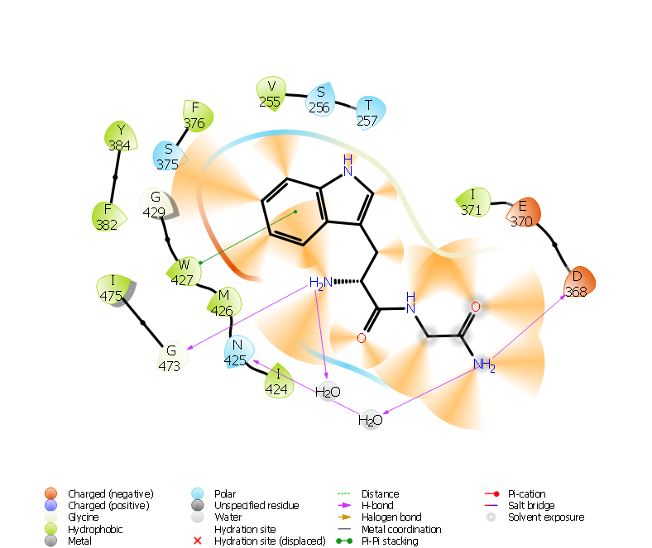
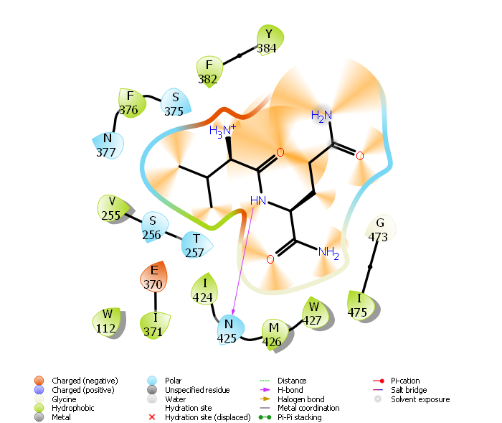
b.
a.
WG
VQ

c.
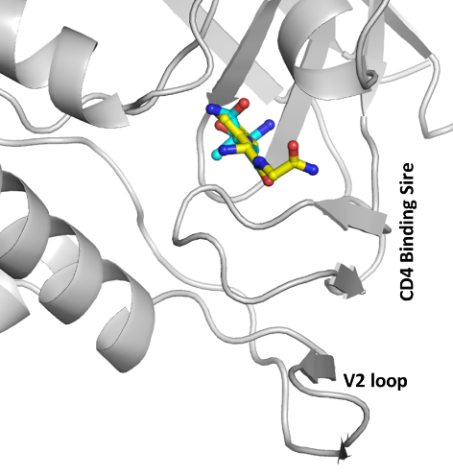
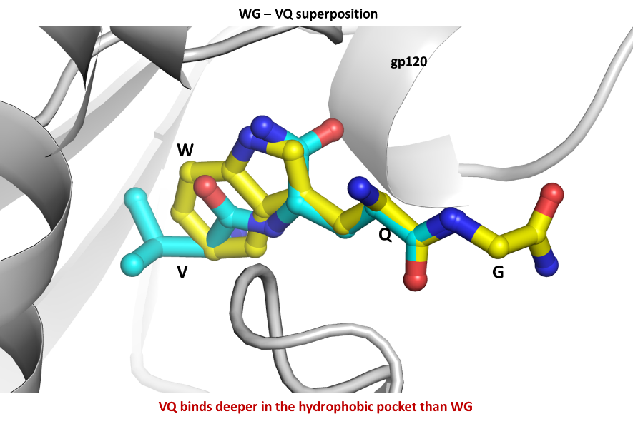
d.

Supplementary Figure 5 In silico docking analyses
a. & b. Ligand interaction diagram of the interactions between gp120 and a. WG or b. VQ peptides. The diagrams were generated by program Maestro program of the Schrodinger Suite (Schrodinger Inc., NY). The interactions are represented as orange lighted cones. The hydrophobic, acidic and polar residues are colored as green, red and cyan. The chemical structure of peptide bond is shown as lines. The H-bonds are represented as magenta arrows and the π- π interactions are shown as green lines.
c. In silico protein-peptide docking shows that VQ binds deeper than WG in the hydrophobic pocket of viral protein gp120.
d. In silico protein-peptide docking displays that the predicted binding site of both dipeptides VQ and WG is close to the CD4 binding site in gp120.

Supplementary Figure 6 Additional boxplots of microbiome-related metabolites
Boxplots showing scaled intensity of 13 selected metabolites that are derived by the gut microbiota. Metabolites are either part of short and medium chain fatty acids, secondary bile acids, or tryptophan metabolism. For all selected biochemicals, EC (orange) have lower levels relative to HC (green) and VP (red); for most of the metabolites shown, based on Mann-Whitney test (two-sided) with *indicating p-value<0.05, **p-value<0.01, and ***p-value<0.001 respectively. Median values and interquartile ranges are indicated by bars.

Supplementary Figure 7 Additional data of dipeptide activity against Prevotella
a. & b. Barplot illustrating growth of four Prevotella strains in colony-forming units per milliliter (CFU/mL) when incubated with or without a dipeptide (concentration of 1mM and of 5mM respectively). Controls are depictured with a lighter color and dipeptide incubation with two darker colors. Barplots show mean and error bars indicating the standard deviation of three independent experiments in biological triplicates. Level of significance is indicated by asterisks (*p-value < 0.05) determined by ANOVA a. Incubation of bacteria with tryptophylglycine amide (WG-am) b. incubation of bacteria with valylglutamine amide (VQ-am).

Supplementary Table 1 Metabolomics data table

