Supplementary Method
Muscle pathology was scored on four domains, inflammation, vascular, myofiber and connective tissue. Inflammation domain: Perivascular inflammation was scored on H&E: 0 (none), 1 (1 cluster ), 2 (2 or more clusters). Macrophage inflammation was scored on esterase or CD68 stain, excluding sarcoplasmic macrophages in fibers undergoing myophagocytosis: 0 (none or <4 cells in a 20x filed), 1 (if >4 cells in a 20x field or 1 cluster of 10 cells or more), 2 (if >2 clusters or >20 cells in a 20x field. Vascular domain: capillary C5b-9 expression: 0 (none), 1 (focal, weak and non-circumferential), 2 (robust circumferential stain, clustered or diffuse). Perimysial vessel abnormality: mural thickening, and/or endothelial swelling and/or transmural inflammation. 0 (Absence), 1 (presence). Muscle fiber domain: Myofiber damage include sarcoplasmic basophilia, vacuolation, pallor/rarification, myophagocytosis, acid phosphatase positive fibers. For each of panfascicular or perifascicular distribution, 0 (none), 1 (present in 1 or 2 fascicles), 2 (present in 3 or more fascicles). Diffuse scattered distribution was scored as 0 (non-diffuse) or 1 (diffuse). Necrotic fiber by C5b-9 sarcoplasmic reactivity: 0 (none), 1 (<6 per 20x field), 2 (>=6 per 20x field). Regenerating fiber by alkaline phosphatase (ALP) sarcoplasmic reactivity: 0 (none), 1 (<6 per 20x field), 2 (>=6 per 20x field). Internal myonuclei in non-basophilic fiber: 0 (<3%), 1 (>=3%). Myofiber atrophy: pan-fascicular atrophy was defined as significant atrophy in some fascicles but not others. Atrophic fibers were scattered throughout the fascicle, and not limited to type IIb fibers or myofibers with neurogenic features. 0 (absent), 1 (involving 1-2 fascicles), 2 (involving 3 or more fascicles). Perifascicular atrophy defined as >6 atrophic fibers out of 10 fibers along the edge of fascicles, not exclusive to type IIb, 0 (absent), 1 (involving 1-2 fascicles), 2 (involving 3 or more fascicles). Diffuse scattered atrophy defined as significant presence of atrophic fibers randomly distributed without significant interfascicular variation, that was not exclusive to type IIb, and not neurogenic, 0 (absent), 1 (present). Connective tissue domain: ALP perimysial connective tissue reactivity: 0 (none), 1 (weak and focal), 2 (strong or widespread). Perimysial fibrosis:0 (absent), 1 (any presence). Endomysial fibrosis: 0 (absent), 1 (any presence)
Immunohistochemical staining reactivity were scored on viable myofibers, excluding necrotic and regenerating fibers, as the following: MxA: 0 (absence of viable myofiber staining), 1 (presence of any positive fiber, focal and weak), 2 (strong or widespread myofiber expression). MHCI: 0 (absence of viable myofiber staining), 1 (patchy and weak myofiber staining), 2 (perifascicular or diffuse staining patterns). MHCII: 0 (absence of myofiber staining), 1 (presence of any positive viable fiber, focal and weak), 2 (strong or widespread myofiber expression).

Supplementary figure 1 Pan-fascicular necrotizing myopathy
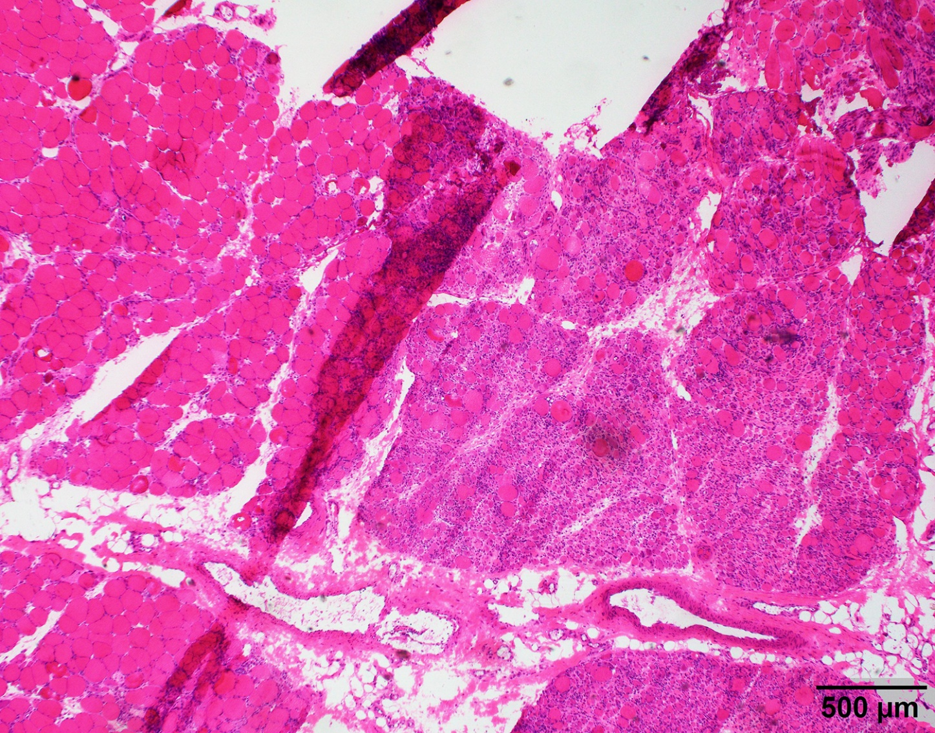
Low power (4x) view of a lupus myositis case with a PanF damage pattern. Several adjacent fascicles on the right demonstrated severe myositis (fibrotic regenerating phase), while the fascicles on the left were relatively uninvolved.

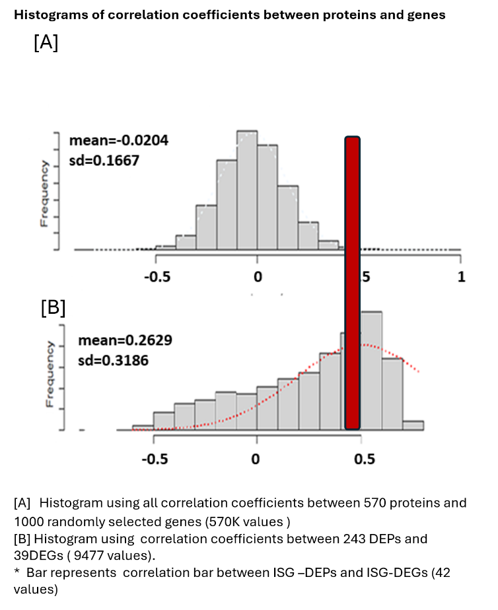
Supplementary figure 2
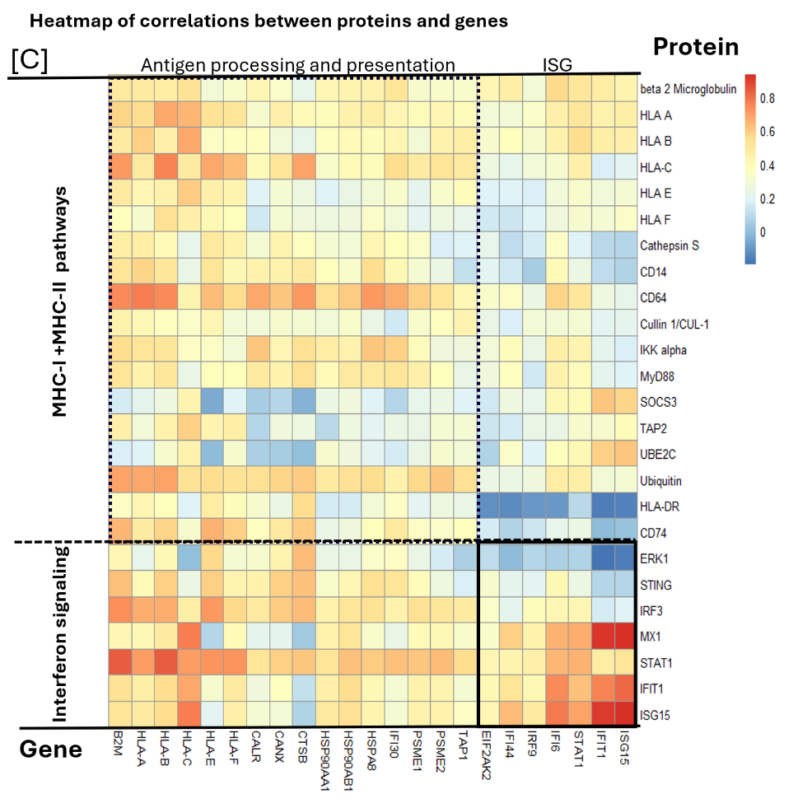

Supplementary figure 3
The common deferentially expressed proteins (DEPs) in myositis compared to normal control.
Purple box-apoptosis/necrosis markers; high in ASyS, Mi2 and lupus, low in NXP2.
Red box-IFN1 markers: high in lupus, Mi2 and NXP2, low in ASyS.

Supplementary figure 4
Disease specific DEPs in different myositis.
Glut1 and MAO-A were selectively expressed in LM. (red arrow).
Hypoxia marker were selectively expressed in DM-NXP2 (blue arrow)

