Supplementary Information for

Selective survival at the Cretaceous–Paleogene boundary driven by infrared radiation and climate cooling

Kunio Kaiho, Naga Oshima, Tatsuro Ando

This PDF file includes:

Detailed Texts 1 to 3
Supplementary Figures 1 to 10
Supplementary Tables 1 to 17
Supplementary References

Detailed Text 1: Detailed survival and extinction patterns of tetrapod vertebrates
We selected non-avian dinosaurs as a representative extinct group, birds as a representative minimally surviving group, crocodilians as a representative aquatic surviving tetrapod group, and mammals as a representative abundantly surviving group (Supplementary Table 1).
Among birds, ground-dwelling Neornithes, ecologically comparable to modern ducks, quails, pheasants, and sandpipers, survived the K–Pg extinction event, whereas arboreal birds disappeared (Supplementary Fig. 2)^{S1}. Neornithes represented only approximately 7% of avian diversity during the Maastrichtian but increased to approximately 80% during the Danian (Fig. 1c, d). Despite this shift, Danian bird fossil occurrences remained sparse relative to crocodilians and mammals (Fig. 1d, f, h).
Overall avian diversity declined to approximately 17% across the boundary. Species-level survival rates from the Maastrichtian to the Danian were 0% for non-avian dinosaurs and birds, and 4.5% and 7.1% for crocodilians and mammals, respectively. Genus-level survival rates were 0%, 19.0%, and 17.3%, respectively (Supplementary Table 2). The apparent absence of surviving bird species likely reflects both extremely low survival and poor fossilization potential. Nevertheless, birds subsequently underwent the most rapid diversification, increasing approximately tenfold during the Paleocene and eightyfold during the Paleogene (Fig. 1j).
Several Late Cretaceous crocodilian groups, including Paralligatoridae from Russia, Mongolia, and Romania, disappeared at the end of the Cretaceous. However, some crocodilian-related taxa outside modern lineages survived, including Sebecosuchia and Dyrosauridae. Their persistence may have been facilitated by occupation of detritus-supported food webs, use of low-latitude warm refugia, reduced dependence on water-column productivity, and freshwater reproductive strategies.
Mammals likewise possessed globally distributed surviving lineages during the Maastrichtian and rapidly re-expanded during the Danian (Fig. 1g, h). However, lineage composition changed markedly. Eutherians, which were relatively uncommon during the Maastrichtian, became dominant during the Danian, whereas metatherians declined substantially. This faunal restructuring was accompanied by an approximately threefold increase in mammalian diversity (Supplementary Table 1).

Detailed Text 2. Flight capability and body-size differences between birds and non-avian dinosaurs
The flight performance of non-neornithine Mesozoic birds remains incompletely understood, but available evidence suggests considerable diversity in flight modes and capabilities^{S2–S5}. Some taxa may have achieved flight performance comparable to that of modern birds. For example, Confuciusornis has been interpreted as possessing flight capabilities only slightly inferior to those of extant birds^{S6}, whereas small enantiornithines probably employed efficient flight styles similar to those of modern sparrows and woodpeckers^{S7–S9}. In addition, some ornithurines appear to have utilized lift generated by tail fanning, a flight mechanism widespread among modern birds^{S10, S11}.
Ornithurines, including the ancestors of crown-group birds (Neornithines), likely possessed the most advanced flight performance among Mesozoic birds^{S12, S13}. Because these taxa were more closely related to modern birds than were Confuciusornis and Enantiornithes, they may have been capable of more efficient long-distance flight and dispersal (Supplementary Fig. 2). Such capabilities would have been advantageous following the Chicxulub impact by enabling rapid movement toward isolated climatic refugia and facilitating aerial detection of surviving vegetation and habitable environments during the impact winter.
Body size may have provided an additional survival advantage. Based on the calculations described in the Methods, small non-avian theropods would have required approximately ten times more food than birds. Small non-avian theropods typically weighed 3–20 kg and measured 0.6–1.1 m in body length^{S12–S15}, whereas surviving neornithine birds were considerably smaller, with Asteriornis weighing approximately 0.4 kg and Vegavis approximately 3 kg. Their lower energetic requirements would have reduced dependence on primary productivity and increased the likelihood of surviving under resource-limited post-impact conditions.
Together, advanced flight capability, small body size, and reduced food requirements likely enhanced the ability of surviving neornithine birds to locate food resources, reach climatic refugia, and persist during the prolonged environmental stress following the K–Pg impact. These traits may therefore have contributed significantly to the selective survival and subsequent evolutionary radiation of crown birds.

Detailed Text 3: Environmental disturbance occurred between an asteroid impact and impact winter
The immediate effects of the asteroid impact—particularly intense infrared radiation and the associated lethal heat pulse—likely caused widespread destruction, especially among exposed organisms near the impact site^{S10}. Infrared radiation generated by reentering ejecta may have produced extreme surface heating lasting from minutes to hours, scorching terrestrial metazoans and vegetation^{S10, S11}. However, because forests covered only ~50% of the land surface^{S16}, some organisms may have survived in sparsely vegetated regions or open habitats. Although population sizes likely declined sharply, complete extinction during this phase was unlikely.
Evidence from acipenseriform fish bones indicates seasonal growth interruptions extending into the final years of the Cretaceous, consistent with boreal spring conditions at ~50°N in the North American inland sea^{S17}. The modeled timing of the impact (June 1st) coincides with boreal spring, supporting this interpretation.
Wildfires ignited by the impact would have further reduced terrestrial biomass. While plant communities are vulnerable to burning, most vegetation can regenerate within 1–6 months, suggesting that food shortages were severe but short-lived. Reduced plant productivity would have disproportionately affected herbivores, and animals that survived the initial infrared radiation likely experienced additional population losses due to temporary food scarcity.
The impact may also have damaged the ozone layer, allowing short-wavelength ultraviolet radiation to reach the surface and harm exposed organisms^{S18}. In contrast, organisms living underground, underwater, or within forested refugia would have been largely protected from both wildfires and enhanced UV exposure. Acid rain was probably most intense near the impact site^{S19, S20}, while marine and freshwater ecosystems were generally less affected. Some marine animals may have been killed by locally generated underwater shock waves. Species possessing lungs or air bladders are particularly vulnerable to rapid pressure changes caused by underwater explosions^{S21}, whose destructive effects are well documented.
Compared with non-avian dinosaurs, birds—owing to their smaller body size and flight capability—were better able to locate food and refugia. Mammals likely survived by sheltering in burrows or migrating to grasslands, steppes, or desert oases, feeding on roots, fruits, and insects. Crocodilians could have avoided extreme heat and wildfires by remaining submerged in water. Heat-induced population declines alone are generally insufficient to cause extinction, except among unsheltered tetrapods and endemic species with limited mobility.
In contrast, prolonged global cooling following the impact likely represented the primary driver of widespread extinction. The effects of impact-induced infrared radiation and wildfires on net primary productivity, extinction patterns, and survival are examined in detail in the following sections.
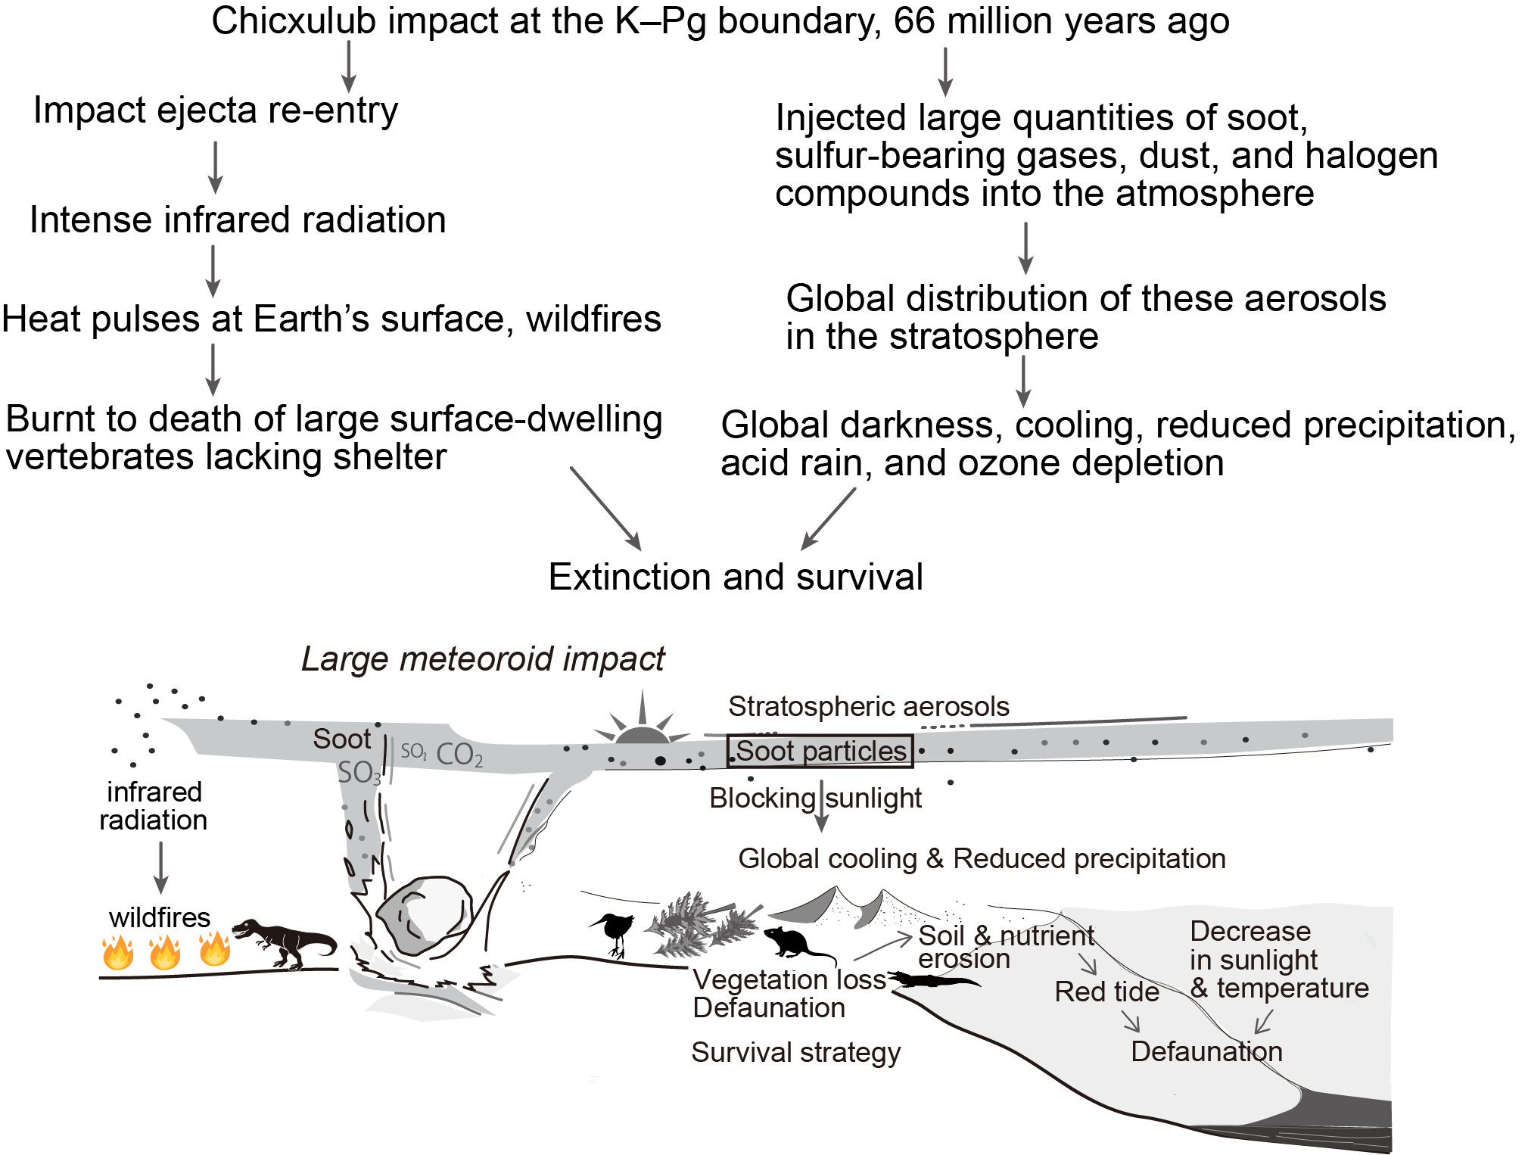
Supplementary Fig. 1. Mechanism of environmental changes and extinction driven by large meteoroid impacts. These two lines of causes, infrared radiation and sunlight reduction, have been proposed for the Cretaceous–Paleontology boundary mass extinction, resulting in large-scale ecological collapse and mass extinctions (see main text).

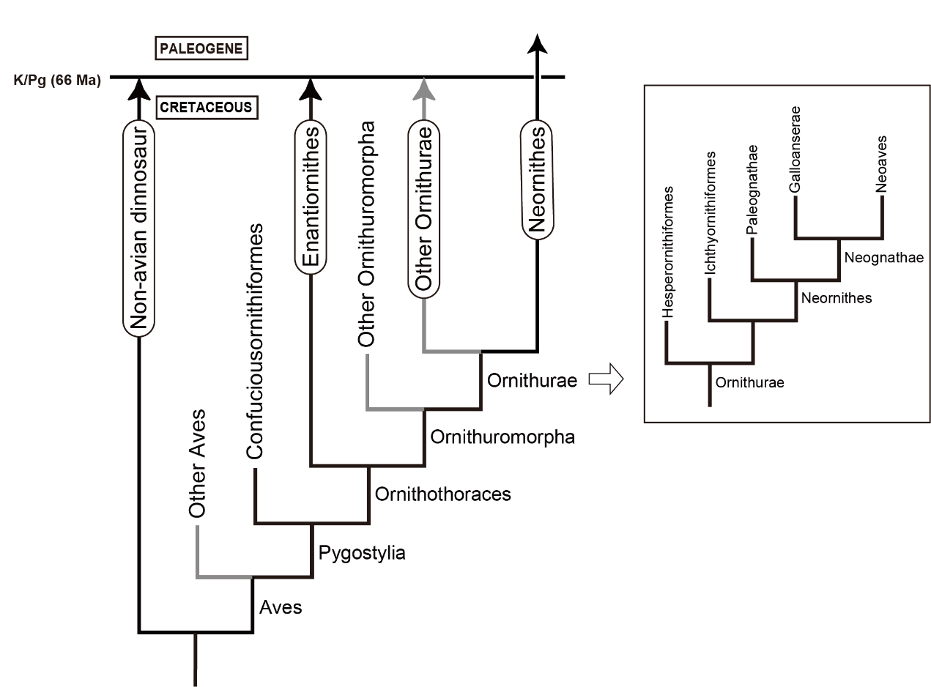
Supplementary Fig. 2. Simplified phylogeny of Aves (birds) around the K-Pg boundary, modified after Slack et al.^{S22} and O’Conner and Jingmai^{S23}. Gray lines are paraphyletic. The enclosed area is the phylogeny of Ornithurae. The dietary reconstruction of neornithine fossils indicates that the early neornithines were predominantly herbivorous (Paleognathae and Galloanseres), with some exhibiting a zoophagous/omnivorous (Neoaves) diet.

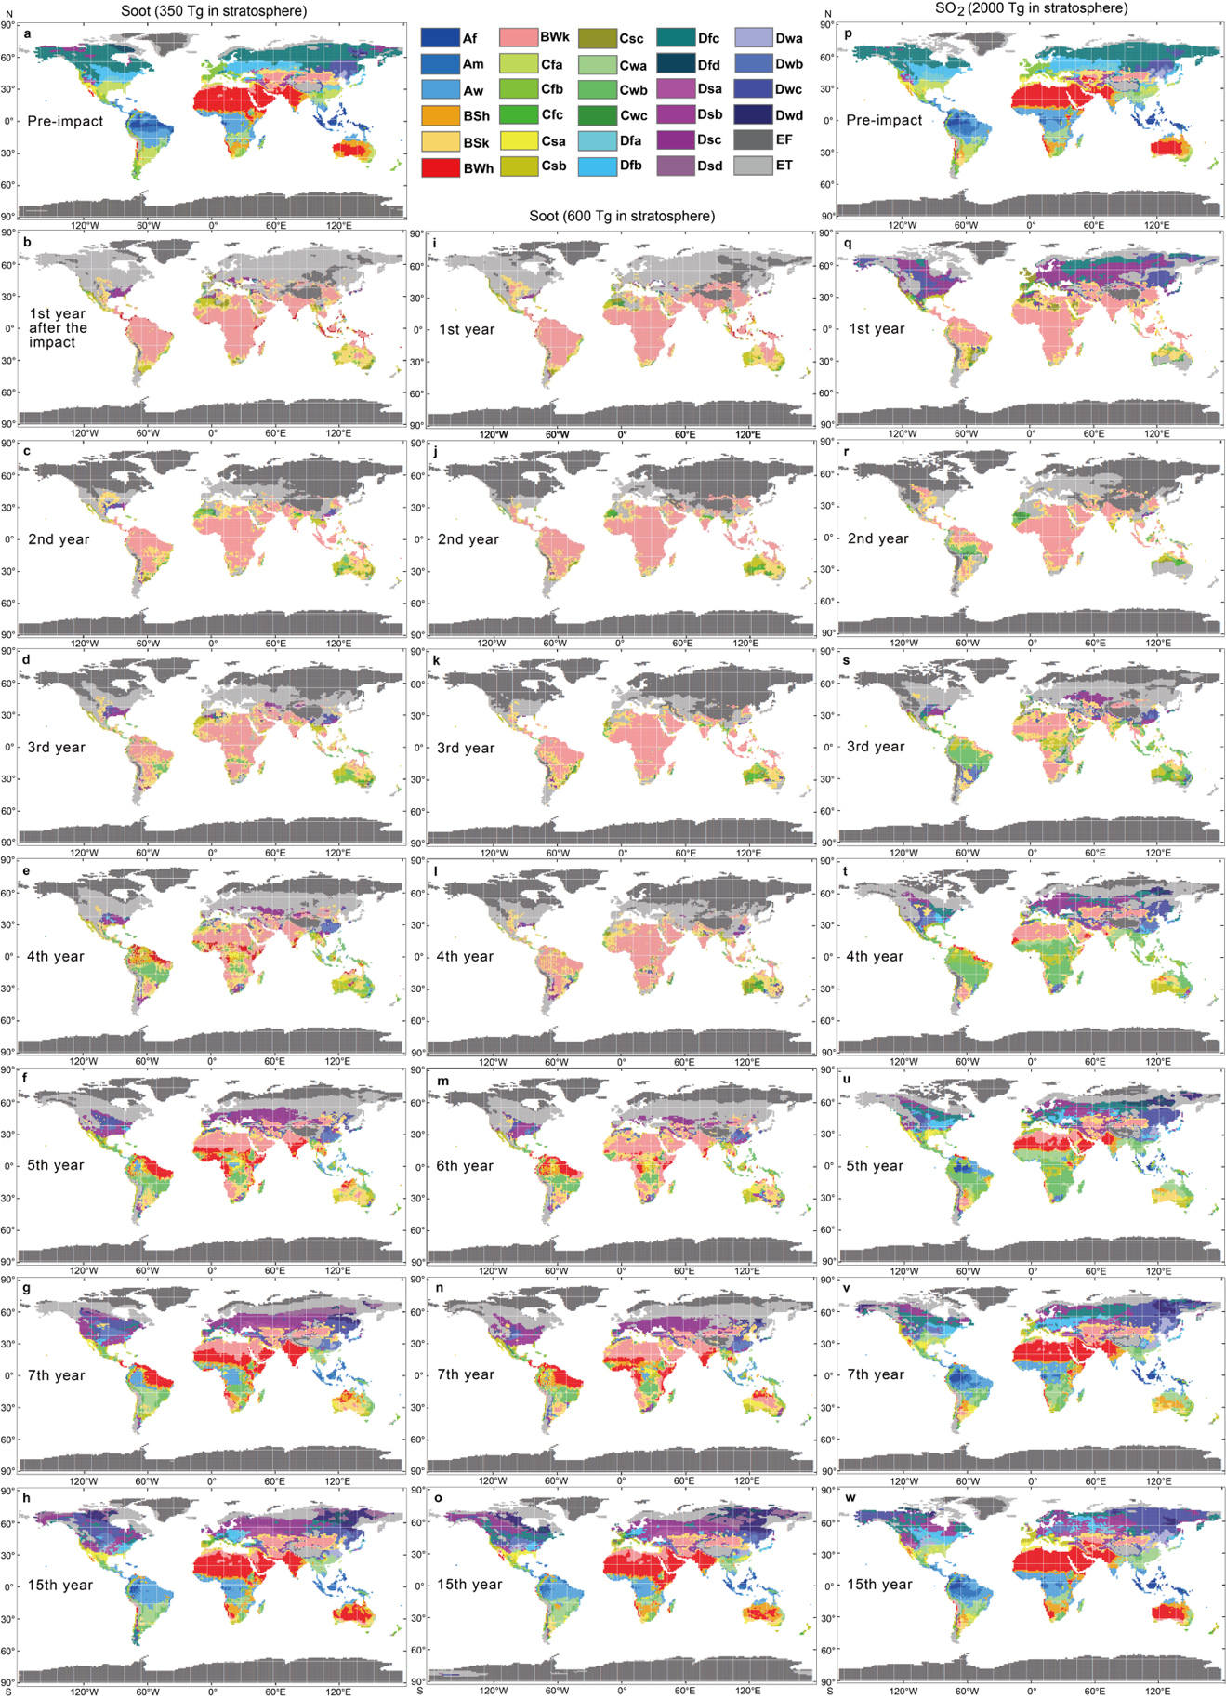
Supplementary Fig. 3. Köppen climate classification maps showing changes on modern earth due to global cooling from stratospheric soot and sulfuric acid aerosols formed by the chicxulub impact. (a) Pre-impact case (control experiment). (b–h) First to 15th year after the Chicxulub impact for the impact case. (i–o) First to 15th year after the Chicxulub impact for the stronger-cooling impact case. (f–w) First to 15th year after the Chicxulub impact for the SO₂ case. The location of the asteroid impact is Chicxulub, Mexico. The base data used are monthly averages of surface air temperature and precipitation^{S24}. The climate classifications are indicated by the following abbreviations: Af: Tropical Rainforest. Am: Tropical Monsoon. Aw: Tropical Savanna. BSh: Hot Semiarid Steppe. BSk: Cold Semiarid Steppe. BWh: Hot Desert. BWk: Cold Desert Group. C: Temperate/Mesothermal. Cfa: Humid Subtropical. Cfb: Oceanic. Cfc: Subpolar Oceanic. Csa: Mediterranean Hot Summer. Csb: Mediterranean Warm/Cold Summer. Csc: Mediterranean Cold Summer. Cwa: Dry-Winter Humid Subtropical. Cwb: Dry-Winter Subtropical Highland. Cwc: Dry-Winter Subpolar Oceanic Group. D: Continental/Microthermal (Cold). Dfa/Dsa/Dwa: Hot Summer Continental. Dfb/Dsb/Dwb: Warm Summer Continental or Hemiboreal. Dfc/Dsc/Dwc: Subarctic or Boreal. Dfd/Dsd/Dwd: Subarctic or Boreal Climates with Severe Winters. ET: Tundra. EF: Ice Cap (Frost). Note: The climate classification for India in panel (a) is not accurately estimated due to a significant underestimation of Indian monsoonal precipitation in the climate model calculations for soot. A more reliable classification is provided in panel (p) based on a new model for SO₂. (c, g, k, o, s, w) 1-year average for the third (coldest) year after the impact in the stronger cooling impact case (soot case). (d, h, l, p, t, x) 1-year average for the second (coldest) year after the impact in the SO₂ case.

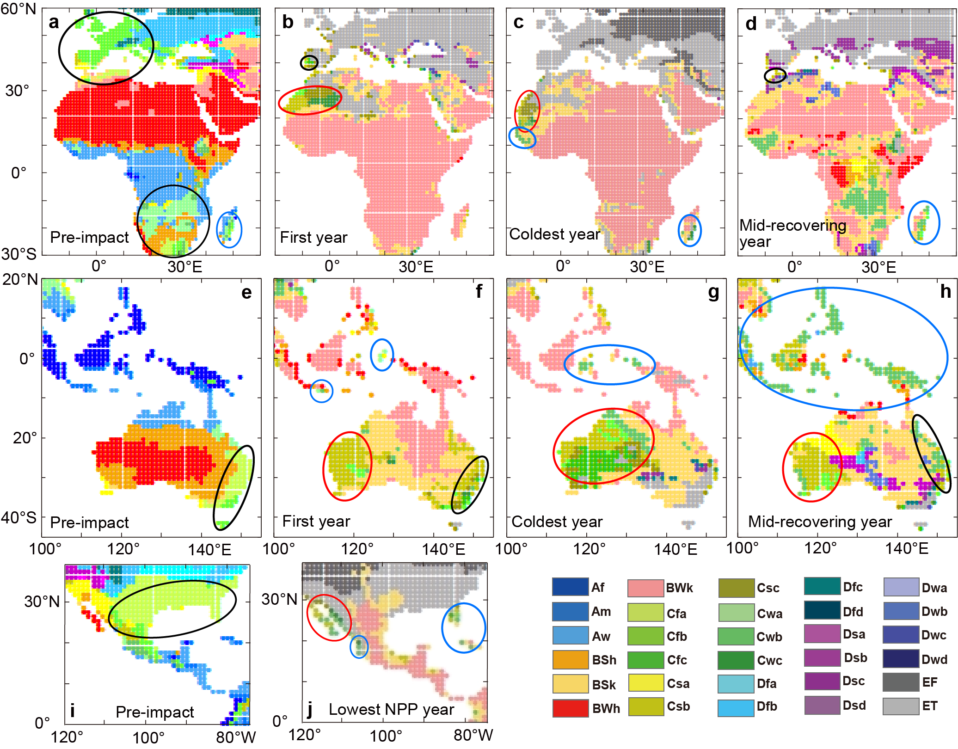
Supplementary Fig. 4. Köppen climate classification maps on selected areas before and after the Chicxulub impact on the modern Earth in case of soot 600 Tg in stratosphere. (a–j) Köppen climate classification maps (closeup map of Supplementary Figure 3a, i, k, m for a–h and Supplementary Figure 3j for i and j). There are temperate areas in oval. Preimpact climate of red, blue, and black oval areas are subtropical desert, low latitude oceanic climate, and temperate, respectively. The climate classifications are indicated by the following abbreviations: Af: Tropical Rainforest. Am: Tropical Monsoon. Aw: Tropical Savanna. BSh: Hot Semiarid Steppe. BSk: Cold Semiarid Steppe. BWh: Hot Desert. BWk: Cold Desert Group. C: Temperate/Mesothermal. Cfa: Humid Subtropical. Cfb: Oceanic. Cfc: Subpolar Oceanic. Csa: Mediterranean Hot Summer. Csb: Mediterranean Warm/Cold Summer. Csc: Mediterranean Cold Summer. Cwa: Dry-Winter Humid Subtropical. Cwb: Dry-Winter Subtropical Highland. Cwc: Dry-Winter Subpolar Oceanic Group. D: Continental/Microthermal (Cold). Dfa/Dsa/Dwa: Hot Summer Continental. Dfb/Dsb/Dwb: Warm Summer Continental or Hemiboreal. Dfc/Dsc/Dwc: Subarctic or Boreal. Dfd/Dsd/Dwd: Subarctic or Boreal Climates with Severe Winters. ET: Tundra. EF: Ice Cap (Frost). (a, e, k) Pre-impact case (control experiment). (b–d, f–h, i, j) soot scenario (stronger-cooling impact case).

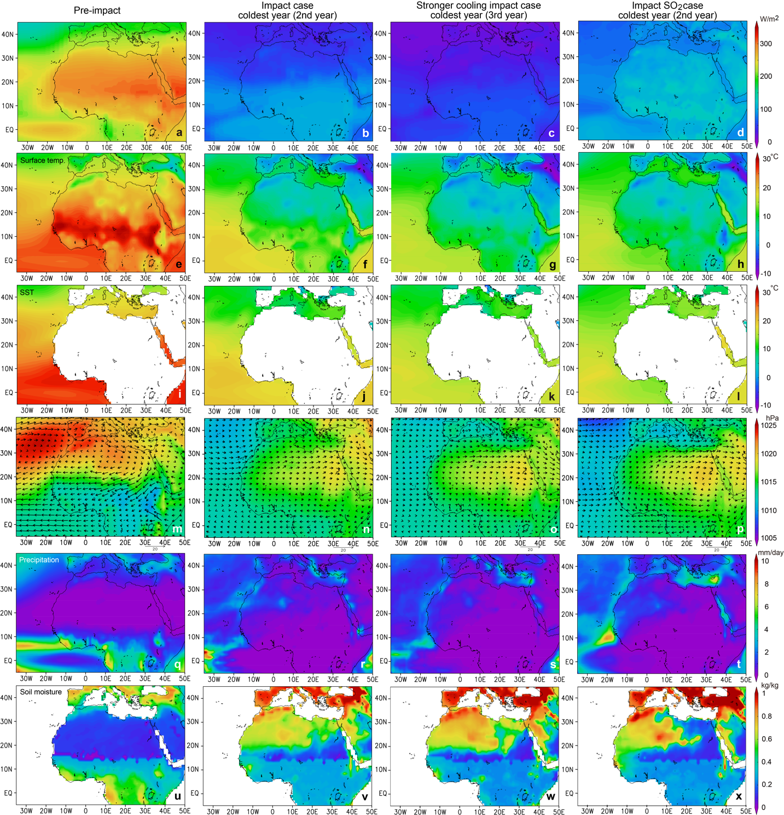
Supplementary Fig. 5. Changes in meteorological fields over southern Europe – northern Africa induced by the Chicxulub impact on modern Earth. (a–d) Downward shortwave radiation (SW) at the surface on land (W m⁻²). (e–h) Annual mean surface air temperature (°C). (i–l) Annual mean sea surface temperature (SST) (°C). (m–p) Sea level pressure (hPa, filled contours) with horizontal winds at the 850-hPa level (m s⁻¹, vectors with scaling near the lower right corner). (q–t) Annual mean precipitation (mm day⁻¹). (u–x) Soil moisture saturation averaged for depths of 0–5 cm (kg kg⁻¹ for soot and kg m⁻² for sulfuric acid). (a, e, i, m, q, u) Thirty-year average for the pre-impact case (the control experiment). (b, f, j, n, r, v) 1-year average for the second (coldest) year after the impact in the impact case.

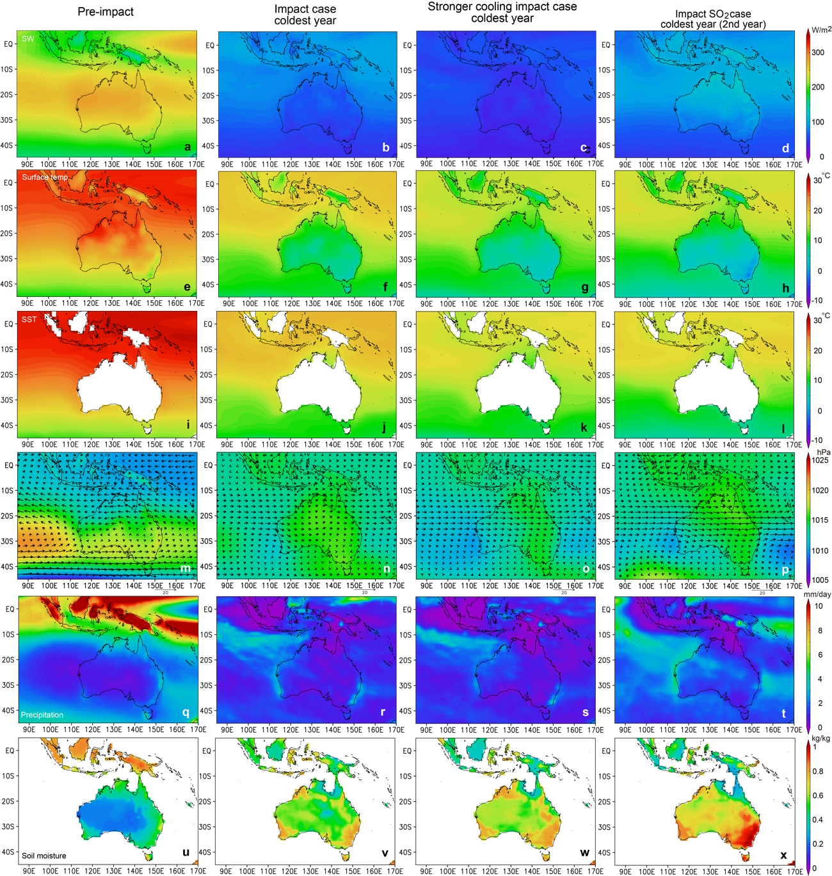
Supplementary Fig. 6. Changes in meteorological fields over Australia – Indonesia induced by the Chicxulub impact on modern Earth. (a–d) Downward shortwave radiation (SW) at the surface on land (W m⁻²). (e–h) Annual mean surface air temperature (°C). (i–l) Annual mean sea surface temperature (SST) (°C). (m–p) Sea level pressure (hPa, filled contours) with horizontal winds at the 850-hPa level (m s⁻¹, vectors with scaling near the lower right corner). (q–t) Annual mean precipitation (mm day⁻¹). (u–x) Soil moisture saturation averaged for depths of 0–5 cm (kg kg⁻¹ for soot and kg m⁻² for sulfuric acid). (a, b, i, m, q, u) Thirty-year average for the pre-impact case (the control experiment). (b, f, j, n, r, v) 1-year average for the second (coldest) year after the impact in the impact case. (c, g, k, o, s, w) 1-year average for the third (coldest) year after the impact in the stronger cooling impact case (soot case). (d, h, l, p, t, x) 1-year average for the second (coldest) year after the impact in the SO₂ case.

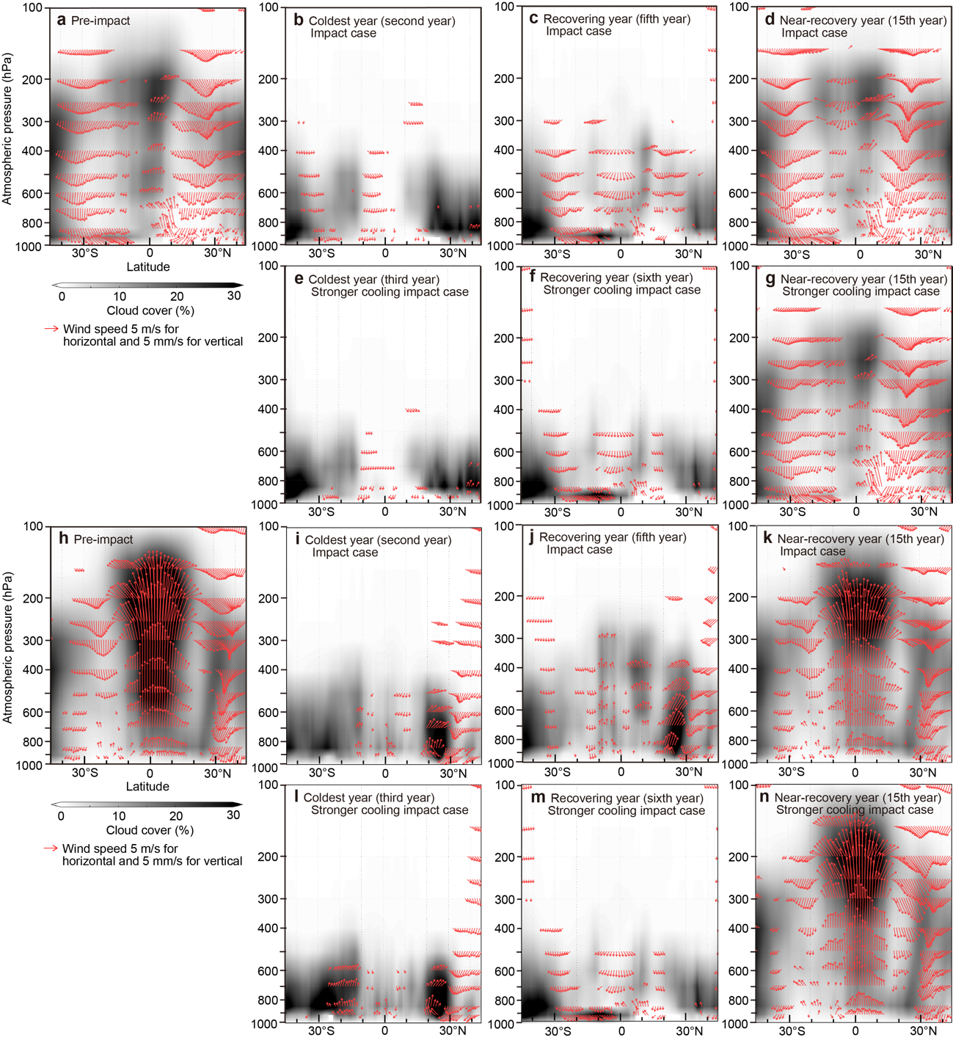
Supplementary Fig. 7. Latitude-pressure cross-section of atmospheric meridional circulation and cloud cover over Africa–southern Europe and Australia–eastern Asia before and after the Chicxulub impact on modern Earth. Pre-impact case (the control experiment) (a), the impact case (b–d), and stronger cooling impact case (e–g) over Africa–southern Europe. Pre-impact case (the control experiment) (h), the impact case (i–k), and stronger cooling impact case (l–n) over Australia–eastern Asia. Thirty-year average wind velocity (red vectors; meridional velocity (m s⁻¹) and vertical velocity (mm s⁻¹)) and cloud cover (%, grayscale) averaged longitudinally between 0°E and 20°E (A-G) and between 115°E and 130°E (h–n) for the pre-impact case (a and h), and the 1-year average of those for the impact case and stronger cooling impact case for the coldest year (b, e, i, and l), recovering phase year (c, f, j, and m), and near-recovery phase year (d, g, k, and n) after the Chicxulub impact. Wind vectors with vertical velocity magnitudes greater than 1 mm s⁻¹ are plotted.

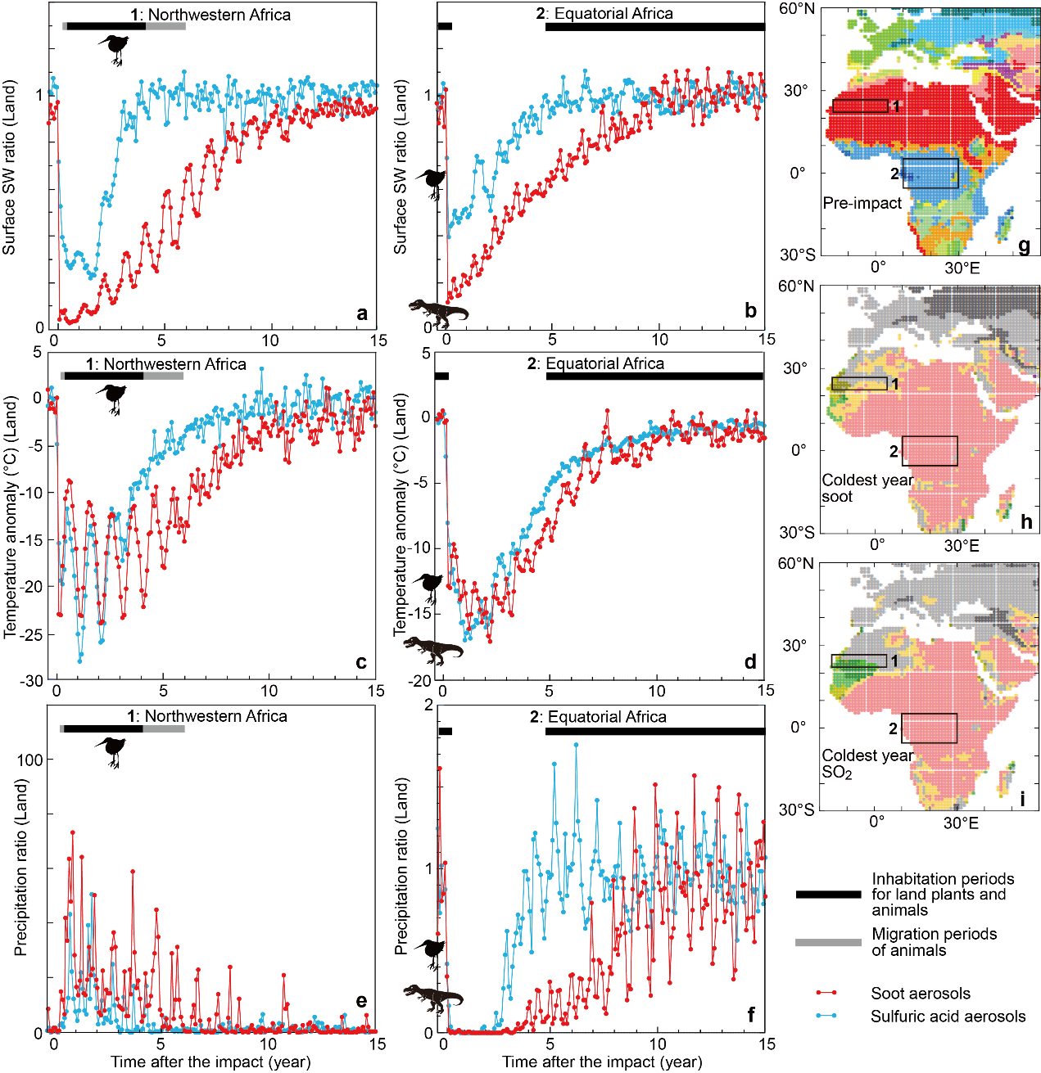
Supplementary Fig. 8. Regional climate changes over southern Europe, northwestern Africa, and equatorial Africa on the modern Earth caused by soot and sulfuric acid aerosols formed by the Chicxulub impact and estimated habitable areas of birds and non-avian dinosaurs from half a year before to 15 years after the impact. (a–b) Changes in the regional averages of downward shortwave radiation (SW) at the surface on land (W m⁻²). (c–d) Surface air temperature on land (°C). (e–f) Precipitation on land (mm day⁻¹). (a–f) Monthly anomalies from the pre-impact case (the control experiment) are shown for temperature, and the ratios relative to the control experiment are shown for shortwave radiation and precipitation. Note that the vertical scales are different in each panel. Black silhouettes indicate ground-dwelling birds and non-avian dinosaurs, which are threatened or extinct groups. (g–i) The climate classification maps show the locations of the three regions 1–2 in (a–f), including the pre-impact temperate, hot desert, and tropical areas. (1) Northern Africa (22°N–27°N, 15°W–5°E) in the modern Earth (g–i). (2) Equatorial Africa (5°S–5°N, 10°E–30°E) in the modern Earth (g–i).

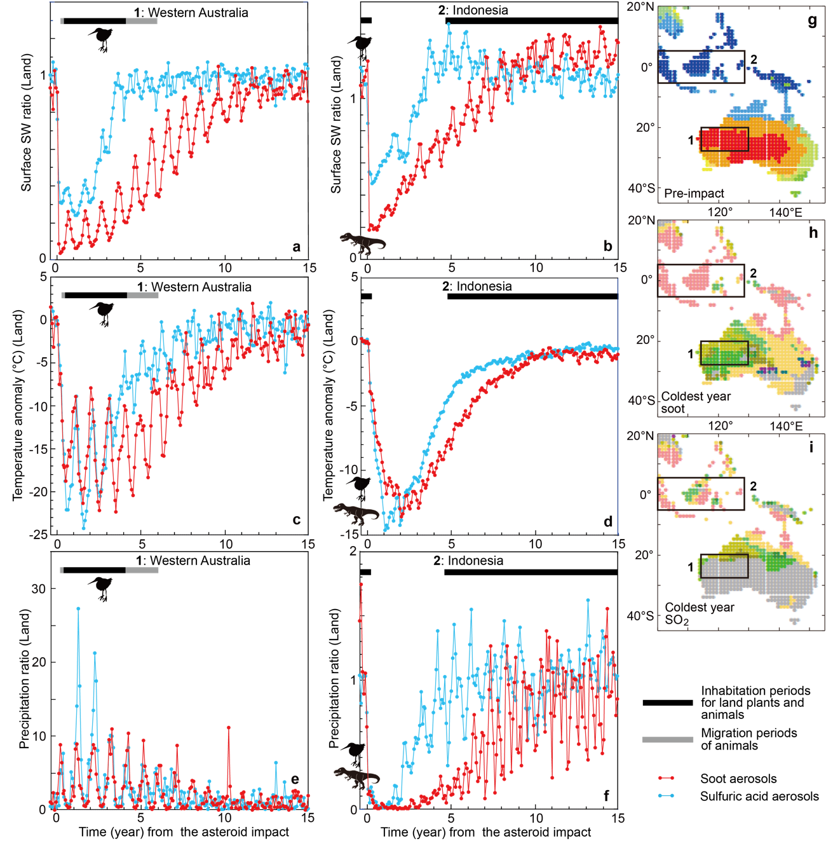
Supplementary Fig. 9. Regional climate changes over Australia – equatorial Maritime Continent caused by soot aerosols and sulfuric acid aerosols formed by the Chicxulub impact and estimated habitable areas of birds and non-avian dinosaurs from half a year before to 15 years after the impact. (a–b) Changes in the regional averages of downward shortwave radiation (SW) at the surface on land (W m⁻²). (c–d) Surface air temperature on land (°C). (e–f) Precipitation on land (mm day⁻¹). (a–f) Monthly anomalies from the pre-impact case (the control experiment) are shown for temperature, and the ratios relative to the control experiment are shown for shortwave radiation and precipitation. Note that the vertical scales are different in each panel. Black silhouettes indicate ground-dwelling birds and non-avian dinosaurs, which are threatened or extinct groups. (g–i) The climate classification maps show the locations of the three regions 1–3 in (a–f), including the pre-impact temperate, hot desert, and tropical areas. (1) Western Australia (20°S–28°S, 115°E–130°E) in the modern Earth (g–i). (2) Equatorial Maritime Continent (5°N–5°S, 100°E–130°E) in the modern Earth (g–i).

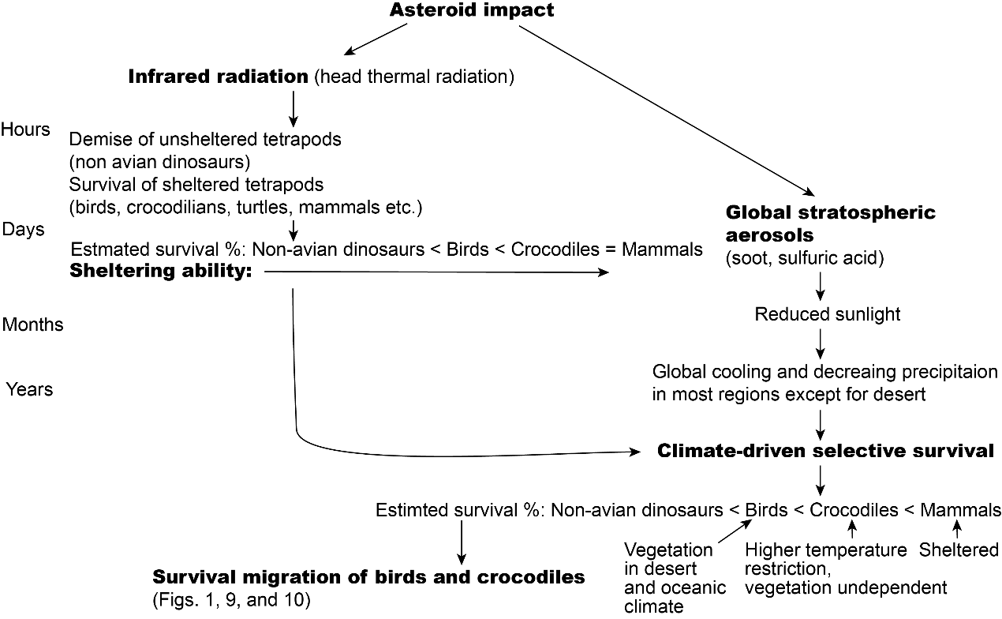
Supplementary Fig. 10. Mechanisms and evidence for extinction and survival of terrestrial tetrapods at the Cretaceous–Paleogene boundary. Survival migration of birds and crocodilians is inferred to explain their fossil occurrences in the Maastrichtian and Danian intervals shown in Figure 1.

 | Age | Dinosauria (non-avian) | Aves | Crocodylomorpha | Mammalia
Species | Paleogene | 0 | 516 | 136 | 5272
Species | Paleocene | 0 | 38 | 48 | 806
Species | Danian | 0 | 5 | 21 | 428
Species | Maastrichtian | 210 | 30 | 44 | 113
Genera | Paleogene | 0 | 366 | 97 | 2791
Genera | Paleocene | 0 | 44 | 32 | 458
Genera | Danian | 0 | 5 | 22 | 243
Genera | Maastrichtian | 214 | 27 | 42 | 81
Supplementary Table 1. Number of species and genera of Dinosauria (non-avian), Aves, Crocodylomorpha, and Mammalia in each geological age.

 | Dinosauria
 | (non-avian) | Aves | Crocodylomorpha | Mammalia
Species ratio in Danian/Maastrichtian | 0 | 0.106 | 0.477 | 3.788
Survival species % | 0 | 0 | 4.5 | 7.1
Survival genus % | 0 | 0 | 19.0 | 17.3
Abundance in a refuge area | 200–1,000 | 30,000–200,000 | Abundant | Abundant
Supplementary Table 2. Number of species and genera ratios, survival species and genera percentages and inhabitable area ratios in Danian/Maastrichtian. 0.00 for non-avian dinosaurs is due to the global infrared radiation and wildfire. 0.05 for non-avian dinosaurs is due to the global cooling.

Hemisphere | Pre-impact | First year | Coldest third year | Mid-recovering sixth year
Northern | Cold | Tundra | Ice cap | Tundra
Northern | Cold steppe | Tundra | Tundra | Tundra
Northern | Cold desert | Tundra | Tundra | Cold
Northern | Temperate Cfb Cfc Cw | Tundra | Tundra | Tundra
Northern | Temperate Cfa (America) | Tundra | Tundra | Cold
Northern | Temperate Cfa (Asia) | Cold desert | Tundra | Cold
Northern | Temperate Cs (lowest latitudes) | Temperate | Tundra | Cold
Northern | Hot desert west | Temperate | Temperate (half area) | Cold steppe
Northern | Hot desert central | Tundra | Tundra | Cold desert
Northern | Hot desert east | Cold desert | Cold desert | Cold desert
Northern | Hot desert <15° latitudes | Cold desert | Cold desert | Cold desert
Northern | Hot steppe | Cold desert | Cold desert | Cold steppe
Northern | Oceanic tropical–warm temperate | Temperate | Temperate | Temperate
Northern | Maritime Continent | Cold desert | Cold desert | Temperate
Northern | Tropical 10°N–20°N | Cold desert | Cold desert | Cold desert
Northern | Tropical 0–10°N | Cold desert | Cold desert | Hot desert
Northern | Tropical 0–10°S | Cold desert | Cold desert | Hot desert
Southern | Tropical 10°S–15°S | Cold desert | Cold desert | Cold desert
Southern | Tropical 15°S–30°S | Cold desert | Cold desert | Temperate
Southern | Maritime Continent | Cold desert | Cold desert | Temperate
Southern | Oceanic tropical (island, peninsula) | Temperate | Temperate | Temperate
Southern | Hot steppe west | Cold Steppe | Temperate | Temperate
Southern | Hot steppe central | Cold Steppe | Temperate | Cold steppe
Southern | Hot steppe east | Cold desert | Cold steppe | Cold steppe
Southern | Hot desert west | Temperate | Temperate | Temperate
Southern | Hot desert central | Cold steppe | Temperate | Temperate
Southern | Hot desert east | Cold desert | Cold steppe | Cold steppe
Southern | Temperate Cfa (lower latitudes) | Temperate | Tundra | Temperate
Southern | Temperate Cfb (higher latitudes) | Tundra | Tundra | Tundra
Supplementary Table 3. Köppen climate classifications for the pre-impact, first year, coldest year, and mid-recovery phase under a strong soot aerosol impact scenario at the Cretaceous–Paleogene transition. Transitions from tropical–warm temperate to temperate climates are based on Supplementary Fig. 4b, c, f, g, and j. This table is derived from areas at 0–500 m elevation shown in Supplementary Figs. S2a and S2i–2o.

Hemisphere | Pre-impact | First year | Coldest second year |  | Mid-recovering fourth year
Northern | Cold | Tundra* |  | Tundra | Cold
Northern | Cold steppe | Cold steppe |  | Cold steppe | Cold steppe
Northern | Cold desert | Cold desert |  | Cold desert | Cold desert
Northern | Temperate Cfb Cfc Cw | Cold/Temperate |  | Tundra | Cold
Northern | Temperate Cfa (America) | Cold/Temperate |  | Tundra | Cold
Northern | Temperate Cfa (Asia) | Cold desert |  | Tundra | Cold
Northern | Temperate Cs (lowest latitudes) | Temperate |  | Tundra | Temperate
Northern | Hot desert west | Temperate |  | Temperate | Cold desert**
Northern | Hot desert central | Cold steppe |  | Tundra | Cold desert
Northern | Hot desert east | Cold desert |  | Cold desert | Cold desert
Northern | Hot steppe | Cold desert |  | Cold desert | Temperate
Northern | Oceanic tropical–warm temperate | Temperate |  | Temperate | Temperate
Northern | Maritime Continent | Cold desert |  | Cold desert | Temperate
Northern | Tropical | Cold desert |  | Cold desert | Temperate
Northern | Tropical | Cold desert |  | Cold desert | Temperate
Northern | Maritime Continent | Cold desert |  | Cold desert | Temperate
Southern | Oceanic tropical (island, peninsula) | Temperate |  | Temperate | Temperate
Southern | Hot steppe west | Temperate |  | Temperate | Cold desert
Southern | Hot steppe central | Temperate |  | Temperate | Cold steppe
Southern | Hot steppe east | Temperate |  | Temperate | Cold steppe
Southern | Hot desert northwest | Cold steppe |  | Tundra*** | Temperate
Southern | Hot desert southwest | Tundra*** |  | Tundra | Temperate
Southern | Hot desert east | Cold steppe |  | Tundra | Temperate
Southern | Temperate Cfa (lower latitudes) | Cold |  | Tundra | Temperate
Southern | Temperate Cfb (higher latitudes) | Tundra |  | Tundra | Temperate
Supplementary Table 4. Köppen climate classification during the pre-impact, first year, coldest year, and mid-recovering year in SO₂ emission case for Cretaceous-Paleogene transition. This table is based on 0–500 m elevation areas in Supplementary Figure 2p–w. *Refer to summer temperature in the end-Cretaceous in Upchurch et al.^{S25}. **with small Hot desert in the lowest latitude. ***West edge is Temperate.

Region |  | Temperature (°K) |  | Temperature (°C) |  | Difference (°C) |  | Temperature (°C) |  | Crocodi-
Longitude | Latitude | Coldest one year |  | Coldest one year |  | End-K – Modern |  | Coldest one year |  | lians
 |  | Min | Max | Min | Max | Min | Max | Min | Max
 | 25°N–30°N | 268.3 | 278.1 | -4.9 | 4.9 | -1 | -3 | -2.9 | 4.9
 | 20°N–25°N | 268.5 | 277.5 | -4.6 | 4.3 | -3 | -3 | -4.6 | 4.3
 | 15°N–20°N | 271.5 | 279.4 | -1.6 | 6.2 | -3 | -3 | -1.6 | 6.2
 | 10°N–15°N | 274.2 | 281.8 | 1.1 | 8.7 | 2 | 1.5 | 6.1 | 13.2
 | 5–10°N | 276.7 | 281.4 | 3.5 | 8.2 | 1 | 2 | 7.5 | 13.2
W. Europe-Africa | 0–5°N | 278.1 | 281.2 | 4.9 | 8 | 0 | 1.5 | 7.9 | 12.5
10W–20E | 0–5°S | 277.3 | 281.3 | 4.1 | 8.2 | 1 | 1 | 8.1 | 12.2
 | 5°S–10°S | 275.5 | 281.2 | 2.4 | 8 | 0.5 | 1.5 | 5.9 | 12.5
 | 10°S–15°S | 271.5 | 278.7 | -1.6 | 5.6 | -1.5 | 0 | -0.1 | 8.6
 | 15°S–20°S | 271 | 279 | -2.2 | 5.8 | 2 | 2 | 2.8 | 10.8
 | 20°S–25°S | 271.2 | 279.7 | -1.9 | 6.5 | -1 | -1 | 0.1 | 8.5
 | 25°S–30°S | 270.4 | 277.1 | -2.8 | 3.9 | -2 | -1 | -1.8 | 5.9
 | 25°N–30°N | 268.3 | 278.4 | -4.8 | 5.2 | -1 | -3 | -2.8 | 5.2
 | 20°N–25°N | 269.9 | 277.1 | -3.3 | 3.9 | -3 | -3 | -3.3 | 3.9
 | 15°N–20°N | 270 | 278.9 | -3.1 | 5.7 | -3 | -3 | -3.1 | 5.7
 | 10°N–15°N | 273.1 | 281.1 | 0 | 8 | 2 | 1.5 | 5 | 12.5
 | 5–10°N | 274.6 | 280 | 1.4 | 6.9 | 1 | 2 | 5.4 | 11.9
Europe-Africa | 0–5°N | 277.3 | 280.7 | 4.1 | 7.5 | 0 | 1.5 | 7.1 | 12
10E–30E | 0–5°S | 276 | 280.6 | 2.8 | 7.5 | 1 | 1 | 6.8 | 11.5
 | 5°S–10°S | 274.4 | 281 | 1.2 | 7.8 | 0.5 | 1.5 | 4.7 | 12.3
 | 10°S–15°S | 270.3 | 279.3 | -2.9 | 6.1 | -1.5 | 0 | -1.4 | 9.1
 | 15°S–20°S | 269.9 | 281 | -3.2 | 7.8 | 2 | 2 | 1.8 | 12.8
 | 20°S–25°S | 271.6 | 280.5 | -1.6 | 7.3 | -1 | -1 | 0.4 | 9.3
 | 25°S–30°S | 268.2 | 277.1 | -5 | 3.9 | -2 | -1 | -4 | 5.9
 | 25°N–30°N | 266 | 276.8 | -7.1 | 3.7 | -1 | -3 | -5.1 | 3.7
 | 20°N–25°N | 269.7 | 278.5 | -3.5 | 5.3 | -3 | -3 | -3.5 | 5.3
 | 15°N–20°N | 273.1 | 278.8 | 0 | 5.6 | -3 | -3 | 0 | 5.6
 | 10°N–15°N | 274.2 | 280.1 | 1 | 6.9 | 2 | 1.5 | 6 | 11.4
 | 5–10°N | 275.3 | 279.5 | 2.1 | 6.3 | 1 | 2 | 6.1 | 11.3
W. Asia-E.Euro- | 0–5°N | 277.8 | 280.8 | 4.6 | 7.7 | 0 | 1.5 | 7.6 | 12.2
Russia | 0–5°S | 274.9 | 278.7 | 1.8 | 5.6 | 1 | 1 | 5.8 | 9.6
20E–80E | 5°S–10°S | 273.1 | 280.3 | 0 | 7.1 | 0.5 | 1.5 | 3.5 | 11.6
 | 10°S–15°S | 271.4 | 280.7 | -1.7 | 7.5 | -1.5 | 0 | -0.2 | 10.5
 | 15°S–20°S | 271.4 | 281.3 | -1.7 | 8.2 | 2 | 2 | 3.3 | 13.2
 | 20°S–25°S | 270.5 | 281.8 | -2.7 | 8.6 | -1 | -1 | -0.7 | 10.6
 | 25°S–30°S | 268.6 | 277.7 | -4.6 | 4.5 | -2 | -1 | -3.6 | 6.5
 | 25°N–30°N | 258.7 | 275.4 | -14.4 | 2.2 | -1 | -3 | -12.4 | 2.2
 | 20°N–25°N | 263.8 | 278.2 | -9.4 | 5.1 | -3 | -3 | -9.4 | 5.1
 | 15°N–20°N | 270.7 | 281 | -2.4 | 7.9 | -3 | -3 | -2.4 | 7.9
 | 10°N–15°N | 276.9 | 282.2 | 3.7 | 9.1 | 2 | 1.5 | 8.7 | 13.6
 | 5–10°N | 281.5 | 283 | 8.4 | 9.8 | 1 | 2 | 12.4 | 14.8
East Asia | 0–5°N | 280.7 | 282.3 | 7.6 | 9.1 | 0 | 1.5 | 10.6 | 13.6
to Australia | 0–5°S | 280.7 | 283.2 | 7.5 | 10 | 1 | 1 | 11.5 | 14
100E–140E | 5°S–10°S | 281.7 | 284.2 | 8.6 | 11.1 | 0.5 | 1.5 | 12.1 | 15.6
 | 10°S–15°S | 278.6 | 284.4 | 5.4 | 11.2 | -1.5 | 0 | 6.9 | 14.2
 | 15°S–20°S | 274.4 | 283.3 | 1.2 | 10.1 | 2 | 2 | 6.2 | 15.1
 | 20°S–25°S | 272.9 | 282.1 | -0.3 | 8.9 | -1 | -1 | 1.7 | 10.9
 | 25°S–30°S | 272.1 | 280.9 | -1.1 | 7.8 | -2 | -1 | -0.1 | 9.8
 | 25°N–30°N | 268.7 | 278 | -4.4 | 4.8 | -1 | -3 | -2.4 | 4.8
 | 20°N–25°N | 271.4 | 277.9 | -1.7 | 4.7 | -3 | -3 | -1.7 | 4.7
 | 15°N–20°N | 275.2 | 280.6 | 2.1 | 7.5 | -3 | -3 | 2.1 | 7.5
 | 10°N–15°N | 278 | 282.5 | 4.9 | 9.3 | 2 | 1.5 | 9.9 | 13.8
 | 5–10°N | 278.4 | 280.8 | 5.3 | 7.7 | 1 | 2 | 9.3 | 12.7
America | 0–5°N | 276.7 | 282.3 | 3.6 | 9.2 | 0 | 1.5 | 6.6 | 13.7
50W–110W | 0–5°S | 277.3 | 283.3 | 4.2 | 10.1 | 1 | 1 | 8.2 | 14.1
 | 5°S–10°S | 274.8 | 283 | 1.7 | 9.8 | 0.5 | 1.5 | 5.2 | 14.3
 | 10°S–15°S | 271.8 | 282.1 | -1.4 | 9 | -1.5 | 0 | 0.1 | 12
 | 15°S–20°S | 267.3 | 279.5 | -5.8 | 6.4 | 2 | 2 | -0.8 | 11.4
 | 20°S–25°S | 268.7 | 280.5 | -4.4 | 7.4 | -1 | -1 | -2.4 | 9.4
 | 25°S–30°S | 268.4 | 280.5 | -4.8 | 7.4 | -2 | -1 | -3.8 | 9.4
Supplementary Table 5. Monthly averaged surface air temperatures over land in the coldest year at 5° latitude intervals between 30°N and 30°S after the impact accompanied by the estimated areas of survival of crocodilians in the combined case of Senel et al.^{S26} after the impact. Survival of crocodilians depends on surface temperature. Bold and underlined values show strong support for survival (S). Only-bold values show week support for survival (S). Terrestrial temperature differences between end-Cretaceous (K) and modern Earth are from Upchurch et al.^{S25}.

Climate | Fossil occurrence in Maastrichtian and Danian |  |  |  |  |  | Temperature
classification | Non-avian | Birds | Mammals | Crocodilians |  |  | Min | Max
 | Dinosaurs |  |  | B | C, S | D, P | (°C) | (°C)
Tropical | M | Barren | M | Barren | M | M, D | >18
Desert–Steppe | Barren | Barren | Barren | Barren | Barren | Barren |  | >10
Temperate (C) | M, D | M, D | M, D | M, D | M, D | M, D | 0–18
Warm C (Ca) | M, D | M, D | M, D | M, D | M, D | M, D | 0–18 | >22
Warm Cb | M, D | M, D | M, D | M, D | M, D | Barren | 5–18 | <22
Cool Cb | M, D | M, D | Barren | Barren | Barren | Barren | 0–5 | <22
Cold | M, D | Barren | M | Barren | Barren | Barren | <0 | >10
Tundra | – | – | – | – | – | – |  | 0–10
Ice cap | – | – | – | – | – | – |  | <0
Supplementary Table 6. Relationship between climate classifications and fossil occurrences across the Maastrichtian and Danian. ET and EF climate types are absent in both intervals except for a brief period following the Chicxulub impact. ET conditions appear six years after the impact, whereas EF conditions occur only during the third post-impact year. M: Maastrichtian; D: Danian. Cb are divided into cool C and coolest C by 5°C for minimum monthly temperature. 5°C is the minimum monthly temperature for middle latitude modern crocodilians. B: Borealosuchus. C: Crocodyria. S: Sebecosuchia. D: Dyrosauridae. P: Pholidosauridae.

2600 BC | SW | SIR | Temp. | Temp. | NPP | NPP | Precipi. | Precipi. | NPP | NPP | NPP
 | annual | annual | annual | annual | from T | from T | /day | /year | from P | from P | from P
Longitude | average | average | average | average |  | X SWc |  |  |  | X SIR | X SIR
Latitude |  |  | (°K) | (°C) |  |  | (mm/day) | (mm/year) |  |  | X WFR
W. Europe-Africa 10W-20E
1st year 25-30N | 0.048 | 0.302 | 279.2 | 6 | 1.063 | 0.322 | 0.934 | 341 | 0.608 | 0.184 | 0.184
20-25N | 0.06 | 0.31 | 279.5 | 6.3 | 1.089 | 0.338 | 0.77 | 281 | 0.511 | 0.158 | 0.158
15-20N | 0.088 | 0.329 | 281.4 | 8.3 | 1.256 | 0.413 | 0.202 | 74 | 0.143 | 0.047 | 0.047
10-15N | 0.129 | 0.357 | 283.4 | 10.3 | 1.431 | 0.51 | 0.066 | 24 | 0.048 | 0.017 | 0.017
5-10N | 0.155 | 0.374 | 284.8 | 11.6 | 1.553 | 0.58 | 0.043 | 16 | 0.031 | 0.012 | 0.012
0-5N | 0.193 | 0.399 | 285 | 11.9 | 1.574 | 0.629 | 0.014 | 5 | 0.01 | 0.004 | 0.002
0-5S | 0.206 | 0.408 | 285 | 11.9 | 1.575 | 0.643 | 0.015 | 5 | 0.011 | 0.004 | 0.002
5-10S | 0.203 | 0.406 | 284.5 | 11.3 | 1.526 | 0.62 | 0.022 | 8 | 0.016 | 0.006 | 0.003
10--15S | 0.195 | 0.4 | 280.9 | 7.7 | 1.206 | 0.483 | 0.037 | 13 | 0.027 | 0.011 | 0.0055
15--20S | 0.185 | 0.394 | 282.4 | 9.2 | 1.338 | 0.527 | 0.089 | 33 | 0.064 | 0.025 | 0.0125
20--25S | 0.18 | 0.391 | 279.2 | 6 | 1.063 | 0.416 | 0.331 | 121 | 0.231 | 0.09 | 0.045
25--30S | 0.167 | 0.382 | 282.1 | 8.9 | 1.31 | 0.501 | 0.407 | 149 | 0.282 | 0.108 | 0.108
2nd year 25-30N | 0.099 | 0.336 | 277.2 | 4.1 | 0.912 | 0.307 | 0.836 | 306 | 0.551 | 0.185 | 0.185
20-25N | 0.121 | 0.351 | 277.3 | 4.2 | 0.919 | 0.323 | 0.616 | 225 | 0.416 | 0.146 | 0.146
15-20N | 0.158 | 0.376 | 279.1 | 6 | 1.061 | 0.399 | 0.216 | 79 | 0.153 | 0.057 | 0.057
10-15N | 0.203 | 0.406 | 281.4 | 8.2 | 1.25 | 0.507 | 0.056 | 20 | 0.04 | 0.016 | 0.016
5-10N | 0.246 | 0.435 | 282.7 | 9.5 | 1.362 | 0.593 | 0.023 | 9 | 0.017 | 0.007 | 0.007
0-5N | 0.303 | 0.473 | 282.9 | 9.7 | 1.381 | 0.653 | 0.001 | 0 | 0 | 0 | 0
0-5S | 0.319 | 0.484 | 282.9 | 9.8 | 1.385 | 0.67 | 0.002 | 1 | 0.001 | 0.001 | 0.001
5-10S | 0.313 | 0.48 | 282.1 | 9 | 1.316 | 0.631 | 0.009 | 3 | 0.007 | 0.003 | 0.003
10--15S | 0.287 | 0.462 | 278.6 | 5.5 | 1.021 | 0.472 | 0.388 | 142 | 0.27 | 0.125 | 0.125
15--20S | 0.255 | 0.441 | 279.7 | 6.5 | 1.104 | 0.487 | 0.387 | 141 | 0.269 | 0.118 | 0.118
20--25S | 0.232 | 0.426 | 277.2 | 4.1 | 0.912 | 0.388 | 0.567 | 207 | 0.385 | 0.164 | 0.164
25--30S | 0.203 | 0.406 | 278.3 | 5.2 | 0.995 | 0.404 | 0.547 | 200 | 0.373 | 0.151 | 0.151
3rd year 25-30N | 0.188 | 0.396 | 276.5 | 3.3 | 0.855 | 0.339 | 0.609 | 223 | 0.412 | 0.163 | 0.163
20-25N | 0.209 | 0.41 | 276.8 | 3.6 | 0.877 | 0.36 | 0.503 | 184 | 0.345 | 0.141 | 0.141
15-20N | 0.248 | 0.436 | 279.1 | 5.9 | 1.057 | 0.461 | 0.271 | 99 | 0.191 | 0.083 | 0.083
10-15N | 0.31 | 0.478 | 282 | 8.8 | 1.302 | 0.622 | 0.14 | 51 | 0.1 | 0.048 | 0.048
5-10N | 0.382 | 0.526 | 282.9 | 9.7 | 1.38 | 0.726 | 0.036 | 13 | 0.026 | 0.014 | 0.014
0-5N | 0.47 | 0.585 | 283.1 | 9.9 | 1.401 | 0.819 | 0.002 | 1 | 0.001 | 0.001 | 0.001
0-5S | 0.484 | 0.594 | 283.4 | 10.3 | 1.429 | 0.849 | 0.007 | 3 | 0.005 | 0.003 | 0.003
5-10S | 0.455 | 0.575 | 282.4 | 9.3 | 1.34 | 0.77 | 0.053 | 19 | 0.038 | 0.022 | 0.022
10--15S | 0.396 | 0.535 | 278.1 | 5 | 0.981 | 0.525 | 0.711 | 260 | 0.475 | 0.254 | 0.254
15--20S | 0.354 | 0.507 | 278.9 | 5.7 | 1.04 | 0.527 | 0.247 | 90 | 0.175 | 0.089 | 0.089
20--25S | 0.31 | 0.478 | 276.5 | 3.3 | 0.855 | 0.409 | 0.648 | 237 | 0.436 | 0.209 | 0.209
25--30S | 0.265 | 0.448 | 277.4 | 4.2 | 0.923 | 0.413 | 0.775 | 283 | 0.514 | 0.23 | 0.23
6th year 25-30N | 0.496 | 0.602 |  |  |  |  | 0.539 | 197 | 0.367 | 0.221 | 0.221
20-25N | 0.546 | 0.635 |  |  |  |  | 0.244 | 89 | 0.172 | 0.109 | 0.109
15-20N | 0.583 | 0.66 |  |  |  |  | 0.192 | 70 | 0.136 | 0.09 | 0.09
10-15N | 0.62 | 0.685 |  |  |  |  | 0.915 | 334 | 0.597 | 0.409 | 0.409
5-10N | 0.609 | 0.678 |  |  |  |  | 0.72 | 263 | 0.48 | 0.326 | 0.326
0-5N | 0.717 | 0.75 |  |  |  |  | 0.301 | 110 | 0.211 | 0.159 | 0.159
0-5S | 0.777 | 0.791 |  |  |  |  | 0.135 | 49 | 0.097 | 0.077 | 0.077
5-10S | 0.694 | 0.735 |  |  |  |  | 0.276 | 101 | 0.194 | 0.143 | 0.143
10--15S | 0.71 | 0.746 |  |  |  |  | 0.986 | 360 | 0.638 | 0.476 | 0.476
15--20S | 0.664 | 0.715 |  |  |  |  | 0.42 | 153 | 0.29 | 0.207 | 0.207
20--25S | 0.598 | 0.671 |  |  |  |  | 0.482 | 176 | 0.331 | 0.222 | 0.222
25--30S | 0.534 | 0.628 |  |  |  |  | 0.331 | 121 | 0.231 | 0.145 | 0.145
Europe-Africa 10-30E
1st year 25-30N | 0.053 | 0.306 | 279.2 | 6 | 1.064 | 0.325 | 0.313 | 114 | 0.219 | 0.067 | 0.067
20-25N | 0.067 | 0.315 | 278.9 | 5.7 | 1.042 | 0.328 | 0.429 | 157 | 0.297 | 0.093 | 0.093
15-20N | 0.091 | 0.331 | 278.5 | 5.3 | 1.009 | 0.334 | 0.223 | 81 | 0.158 | 0.052 | 0.052
10-15N | 0.13 | 0.357 | 283 | 9.9 | 1.393 | 0.498 | 0.051 | 19 | 0.037 | 0.013 | 0.013
5-10N | 0.158 | 0.376 | 283.4 | 10.3 | 1.429 | 0.537 | 0.028 | 10 | 0.02 | 0.008 | 0.004
0-5N | 0.186 | 0.395 | 284.5 | 11.4 | 1.527 | 0.603 | 0.018 | 7 | 0.013 | 0.005 | 0.0025
0-5S | 0.201 | 0.404 | 284.2 | 11.1 | 1.5 | 0.607 | 0.015 | 5 | 0.011 | 0.004 | 0.002
5-10S | 0.197 | 0.402 | 283.8 | 10.7 | 1.464 | 0.589 | 0.018 | 7 | 0.013 | 0.005 | 0.0025
10--15S | 0.194 | 0.4 | 280.8 | 7.7 | 1.201 | 0.48 | 0.048 | 18 | 0.035 | 0.014 | 0.007
15--20S | 0.19 | 0.397 | 281.7 | 8.5 | 1.275 | 0.506 | 0.058 | 21 | 0.042 | 0.017 | 0.0085
20--25S | 0.194 | 0.4 | 281.5 | 8.4 | 1.265 | 0.506 | 0.171 | 62 | 0.122 | 0.049 | 0.0245
25--30S | 0.187 | 0.395 | 279.7 | 6.6 | 1.11 | 0.439 | 0.39 | 142 | 0.271 | 0.107 | 0.0535
2nd year 25-30N | 0.112 | 0.345 | 276.7 | 3.6 | 0.872 | 0.301 | 0.174 | 63 | 0.124 | 0.043 | 0.043
20-25N | 0.131 | 0.358 | 276.4 | 3.3 | 0.852 | 0.305 | 0.187 | 68 | 0.133 | 0.048 | 0.048
15-20N | 0.163 | 0.379 | 278.3 | 5.2 | 0.995 | 0.377 | 0.107 | 39 | 0.077 | 0.029 | 0.029
10-15N | 0.205 | 0.407 | 280.7 | 7.6 | 1.192 | 0.486 | 0.018 | 7 | 0.013 | 0.005 | 0.005
5-10N | 0.245 | 0.434 | 281 | 7.9 | 1.218 | 0.529 | 0.007 | 2 | 0.005 | 0.002 | 0.002
0-5N | 0.291 | 0.465 | 282.2 | 9.1 | 1.322 | 0.615 | 0.003 | 1 | 0.002 | 0.001 | 0.001
0-5S | 0.31 | 0.478 | 281.9 | 8.8 | 1.296 | 0.619 | 0.002 | 1 | 0.002 | 0.001 | 0.001
5-10S | 0.312 | 0.479 | 281.4 | 8.3 | 1.252 | 0.6 | 0.01 | 3 | 0.007 | 0.003 | 0.003
10--15S | 0.3 | 0.471 | 278.6 | 5.5 | 1.018 | 0.479 | 0.237 | 87 | 0.168 | 0.079 | 0.079
15--20S | 0.264 | 0.447 | 279.2 | 6.1 | 1.067 | 0.477 | 0.248 | 91 | 0.175 | 0.078 | 0.078
20--25S | 0.241 | 0.431 | 278.2 | 5.1 | 0.99 | 0.427 | 0.33 | 120 | 0.231 | 0.1 | 0.1
25--30S | 0.223 | 0.419 | 276.1 | 3 | 0.832 | 0.349 | 0.558 | 204 | 0.38 | 0.159 | 0.159
3rd year 25-30N | 0.2 | 0.404 | 276.2 | 3 | 0.835 | 0.337 | 0.179 | 65 | 0.127 | 0.051 | 0.051
20-25N | 0.229 | 0.423 | 275.8 | 2.7 | 0.808 | 0.342 | 0.16 | 58 | 0.114 | 0.048 | 0.048
15-20N | 0.267 | 0.449 | 278.2 | 5 | 0.982 | 0.441 | 0.037 | 13 | 0.026 | 0.012 | 0.012
10-15N | 0.324 | 0.487 | 281.1 | 8 | 1.226 | 0.597 | 0.014 | 5 | 0.01 | 0.005 | 0.005
5-10N | 0.382 | 0.526 | 281.3 | 8.2 | 1.244 | 0.654 | 0.003 | 1 | 0.002 | 0.001 | 0.001
0-5N | 0.451 | 0.572 | 282.5 | 9.4 | 1.349 | 0.772 | 0.003 | 1 | 0.002 | 0.001 | 0.001
0-5S | 0.474 | 0.588 | 282.3 | 9.2 | 1.331 | 0.782 | 0.035 | 13 | 0.025 | 0.015 | 0.015
5-10S | 0.461 | 0.579 | 281.5 | 8.4 | 1.261 | 0.73 | 0.039 | 14 | 0.028 | 0.016 | 0.016
10--15S | 0.417 | 0.55 | 278.1 | 5 | 0.978 | 0.538 | 0.515 | 188 | 0.352 | 0.194 | 0.194
15--20S | 0.469 | 0.584 | 278.6 | 5.4 | 1.017 | 0.594 | 0.17 | 62 | 0.121 | 0.071 | 0.071
20--25S | 0.406 | 0.542 | 277.6 | 4.4 | 0.936 | 0.507 | 0.338 | 124 | 0.236 | 0.128 | 0.128
25--30S | 0.362 | 0.513 | 275.3 | 2.2 | 0.775 | 0.398 | 0.641 | 234 | 0.432 | 0.222 | 0.222
6th year 25-30N | 0.49 | 0.599 |  |  |  |  | 0.388 | 142 | 0.27 | 0.161 | 0.161
20-25N | 0.547 | 0.636 |  |  |  |  | 0.177 | 65 | 0.126 | 0.08 | 0.08
15-20N | 0.585 | 0.662 |  |  |  |  | 0.046 | 17 | 0.033 | 0.022 | 0.022
10-15N | 0.627 | 0.69 |  |  |  |  | 0.754 | 275 | 0.501 | 0.346 | 0.346
5-10N | 0.68 | 0.726 |  |  |  |  | 0.97 | 354 | 0.629 | 0.456 | 0.456
0-5N | 0.725 | 0.756 |  |  |  |  | 0.782 | 286 | 0.518 | 0.392 | 0.392
0-5S | 0.761 | 0.78 |  |  |  |  | 1.039 | 380 | 0.669 | 0.521 | 0.521
5-10S | 0.72 | 0.752 |  |  |  |  | 1.062 | 388 | 0.681 | 0.513 | 0.513
10--15S | 0.701 | 0.74 |  |  |  |  | 1.928 | 704 | 1.12 | 0.829 | 0.829
15--20S | 0.641 | 0.699 |  |  |  |  | 0.78 | 285 | 0.517 | 0.361 | 0.361
20--25S | 0.59 | 0.665 |  |  |  |  | 0.572 | 209 | 0.388 | 0.258 | 0.258
25--30S | 0.563 | 0.647 |  |  |  |  | 0.713 | 260 | 0.476 | 0.308 | 0.308
W Asia-E Euro 20E-80E
1st year 25-30N | 0.054 | 0.306 | 276.6 | 3.5 | 0.865 | 0.265 | 0.225 | 82 | 0.16 | 0.049 | 0.049
20-25N | 0.073 | 0.319 | 280.2 | 7.1 | 1.15 | 0.366 | 0.23 | 84 | 0.163 | 0.052 | 0.052
15-20N | 0.099 | 0.336 | 281.7 | 8.5 | 1.278 | 0.43 | 0.237 | 87 | 0.168 | 0.056 | 0.056
10-15N | 0.123 | 0.353 | 283.8 | 10.7 | 1.468 | 0.518 | 0.23 | 84 | 0.163 | 0.057 | 0.0285
5-10N | 0.143 | 0.366 | 283.9 | 10.8 | 1.475 | 0.54 | 0.043 | 16 | 0.031 | 0.011 | 0.0055
0-5N | 0.149 | 0.37 | 285.2 | 12 | 1.587 | 0.587 | 0.029 | 11 | 0.021 | 0.008 | 0.004
0-5S | 0.161 | 0.378 | 283.8 | 10.6 | 1.461 | 0.552 | 0.057 | 21 | 0.041 | 0.016 | 0.008
5-10S | 0.165 | 0.381 | 283.5 | 10.4 | 1.438 | 0.547 | 0.083 | 30 | 0.06 | 0.023 | 0.0115
10--15S | 0.177 | 0.389 | 282.6 | 9.5 | 1.361 | 0.529 | 0.097 | 35 | 0.07 | 0.027 | 0.0135
15--20S | 0.188 | 0.396 | 283.3 | 10.1 | 1.418 | 0.562 | 0.113 | 41 | 0.081 | 0.032 | 0.016
20--25S | 0.196 | 0.401 | 283.6 | 10.4 | 1.445 | 0.58 | 0.16 | 58 | 0.114 | 0.046 | 0.023
25--30S | 0.194 | 0.4 | 279.9 | 6.7 | 1.124 | 0.45 | 0.415 | 152 | 0.287 | 0.115 | 0.0575
2nd year 25-30N | 0.118 | 0.349 | 274.8 | 1.6 | 0.738 | 0.257 | 0.308 | 113 | 0.216 | 0.075 | 0.075
20-25N | 0.133 | 0.359 | 278 | 4.8 | 0.967 | 0.347 | 0.347 | 127 | 0.242 | 0.087 | 0.087
15-20N | 0.167 | 0.382 | 279.2 | 6 | 1.066 | 0.407 | 0.144 | 53 | 0.103 | 0.039 | 0.039
10-15N | 0.194 | 0.4 | 281.1 | 8 | 1.227 | 0.491 | 0.124 | 45 | 0.089 | 0.036 | 0.036
5-10N | 0.222 | 0.419 | 281.2 | 8.1 | 1.239 | 0.519 | 0.034 | 12 | 0.024 | 0.01 | 0.01
0-5N | 0.232 | 0.426 | 282.5 | 9.4 | 1.351 | 0.575 | 0.023 | 9 | 0.017 | 0.007 | 0.007
0-5S | 0.261 | 0.445 | 281.1 | 8 | 1.231 | 0.547 | 0.017 | 6 | 0.012 | 0.005 | 0.005
5-10S | 0.288 | 0.463 | 280.8 | 7.6 | 1.197 | 0.554 | 0.021 | 8 | 0.016 | 0.007 | 0.007
10--15S | 0.296 | 0.468 | 280.1 | 6.9 | 1.14 | 0.534 | 0.105 | 39 | 0.076 | 0.036 | 0.036
15--20S | 0.267 | 0.449 | 280.8 | 7.6 | 1.196 | 0.537 | 0.173 | 63 | 0.123 | 0.055 | 0.055
20--25S | 0.235 | 0.427 | 280.4 | 7.2 | 1.162 | 0.497 | 0.323 | 118 | 0.226 | 0.097 | 0.097
25--30S | 0.228 | 0.423 | 276.4 | 3.3 | 0.85 | 0.359 | 0.606 | 221 | 0.41 | 0.173 | 0.173
3rd year 25-30N | 0.202 | 0.405 | 274.7 | 1.6 | 0.732 | 0.297 | 0.354 | 129 | 0.247 | 0.1 | 0.1
20-25N | 0.226 | 0.421 | 277.4 | 4.3 | 0.924 | 0.389 | 0.396 | 145 | 0.275 | 0.116 | 0.116
15-20N | 0.268 | 0.45 | 278.6 | 5.5 | 1.018 | 0.458 | 0.099 | 36 | 0.071 | 0.032 | 0.032
10-15N | 0.312 | 0.479 | 280.8 | 7.6 | 1.197 | 0.574 | 0.094 | 34 | 0.067 | 0.032 | 0.032
5-10N | 0.354 | 0.507 | 280.9 | 7.8 | 1.212 | 0.615 | 0.024 | 9 | 0.017 | 0.009 | 0.009
0-5N | 0.386 | 0.528 | 282.4 | 9.3 | 1.341 | 0.708 | 0.023 | 8 | 0.016 | 0.009 | 0.009
0-5S | 0.425 | 0.555 | 281.1 | 7.9 | 1.223 | 0.678 | 0.062 | 23 | 0.045 | 0.025 | 0.025
5-10S | 0.443 | 0.567 | 280.4 | 7.3 | 1.168 | 0.662 | 0.04 | 14 | 0.029 | 0.016 | 0.016
10--15S | 0.413 | 0.547 | 279.3 | 6.1 | 1.075 | 0.587 | 0.269 | 98 | 0.189 | 0.104 | 0.104
15--20S | 0.348 | 0.503 | 279.8 | 6.7 | 1.117 | 0.562 | 0.298 | 109 | 0.209 | 0.105 | 0.105
20--25S | 0.298 | 0.47 | 279.4 | 6.3 | 1.085 | 0.51 | 0.44 | 161 | 0.304 | 0.143 | 0.143
25--30S | 0.291 | 0.465 | 275.6 | 2.4 | 0.792 | 0.368 | 0.667 | 244 | 0.448 | 0.208 | 0.208
6th year 25-30N | 0.502 | 0.606 |  |  |  |  | 0.328 | 120 | 0.229 | 0.139 | 0.139
20-25N | 0.535 | 0.628 |  |  |  |  | 0.175 | 64 | 0.125 | 0.078 | 0.078
15-20N | 0.559 | 0.644 |  |  |  |  | 0.229 | 84 | 0.162 | 0.105 | 0.105
10-15N | 0.581 | 0.659 |  |  |  |  | 1.102 | 403 | 0.704 | 0.464 | 0.464
5-10N | 0.625 | 0.689 |  |  |  |  | 0.959 | 350 | 0.622 | 0.429 | 0.429
0-5N | 0.666 | 0.716 |  |  |  |  | 0.728 | 266 | 0.485 | 0.348 | 0.348
0-5S | 0.707 | 0.743 |  |  |  |  | 1.2 | 438 | 0.757 | 0.563 | 0.563
5-10S | 0.703 | 0.741 |  |  |  |  | 1.34 | 490 | 0.833 | 0.617 | 0.617
10--15S | 0.661 | 0.713 |  |  |  |  | 1.886 | 689 | 1.101 | 0.785 | 0.785
15--20S | 0.592 | 0.667 |  |  |  |  | 1.356 | 495 | 0.841 | 0.561 | 0.561
20--25S | 0.554 | 0.641 |  |  |  |  | 0.845 | 309 | 0.556 | 0.357 | 0.357
25--30S | 0.563 | 0.647 |  |  |  |  | 0.923 | 337 | 0.601 | 0.389 | 0.389
E Asia 100E-120E
1st year 25-30N | 0.085 | 0.327 | 268 | -5.2 | 0.381 | 0.125 | 0.177 | 65 | 0.126 | 0.041 | 0.0205
20-25N | 0.09 | 0.33 | 274.5 | 1.3 | 0.716 | 0.237 | 0.591 | 216 | 0.401 | 0.132 | 0.066
15-20N | 0.074 | 0.319 | 282.6 | 9.5 | 1.359 | 0.434 | 1.126 | 411 | 0.717 | 0.229 | 0.1145
2nd year 25-30N | 0.157 | 0.375 | 268.5 | -4.7 | 0.401 | 0.15 | 0.867 | 317 | 0.569 | 0.213 | 0.1065
20-25N | 0.147 | 0.369 | 275.2 | 2.1 | 0.767 | 0.283 | 0.957 | 349 | 0.621 | 0.229 | 0.1145
15-20N | 0.13 | 0.357 | 280.4 | 7.2 | 1.166 | 0.416 | 0.913 | 333 | 0.596 | 0.213 | 0.1065
3rd year 25-30N | 0.258 | 0.443 | 268.8 | -4.3 | 0.415 | 0.184 | 0.953 | 348 | 0.619 | 0.274 | 0.137
20-25N | 0.252 | 0.439 | 275 | 1.8 | 0.751 | 0.33 | 0.947 | 346 | 0.616 | 0.27 | 0.135
15-20N | 0.232 | 0.426 | 279.9 | 6.7 | 1.123 | 0.478 | 0.689 | 252 | 0.461 | 0.196 | 0.098
6th year 25-30N | 0.484 | 0.594 |  |  |  |  | 2.308 | 843 | 1.286 | 0.764 | 0.382
20-25N | 0.501 | 0.606 |  |  |  |  | 2.108 | 770 | 1.201 | 0.727 | 0.3635
15-20N | 0.593 | 0.667 |  |  |  |  | 1.047 | 382 | 0.673 | 0.449 | 0.2245
Indonesia 100-140E
1st year 10-15N | 0.131 | 0.358 | 288.6 | 15.5 | 1.884 | 0.674 | 0.514 | 188 | 0.352 | 0.126 | 0.063
5-10N | 0.169 | 0.383 | 291.5 | 18.4 | 2.113 | 0.81 | 0.947 | 346 | 0.616 | 0.236 | 0.118
0-5N | 0.195 | 0.4 | 289.9 | 16.8 | 1.99 | 0.797 | 0.474 | 173 | 0.326 | 0.13 | 0.065
0-5S | 0.198 | 0.403 | 290.3 | 17.2 | 2.022 | 0.814 | 0.462 | 169 | 0.318 | 0.128 | 0.064
5-10S | 0.177 | 0.388 | 291.4 | 18.3 | 2.106 | 0.818 | 0.824 | 301 | 0.543 | 0.211 | 0.1055
10--15S | 0.148 | 0.369 | 287.4 | 14.3 | 1.782 | 0.658 | 0.366 | 134 | 0.255 | 0.094 | 0.047
2nd year 10-15N | 0.208 | 0.41 | 284.8 | 11.7 | 1.553 | 0.636 | 0.231 | 84 | 0.163 | 0.067 | 0.067
5-10N | 0.268 | 0.45 | 287.3 | 14.2 | 1.774 | 0.798 | 0.309 | 113 | 0.217 | 0.097 | 0.097
0-5N | 0.307 | 0.476 | 285.4 | 12.3 | 1.607 | 0.764 | 0.133 | 49 | 0.095 | 0.045 | 0.045
0-5S | 0.313 | 0.48 | 285.7 | 12.6 | 1.633 | 0.784 | 0.11 | 40 | 0.079 | 0.038 | 0.038
5-10S | 0.293 | 0.467 | 286.8 | 13.7 | 1.73 | 0.807 | 0.227 | 83 | 0.161 | 0.075 | 0.075
10--15S | 0.182 | 0.392 | 285 | 11.9 | 1.571 | 0.616 | 0.673 | 246 | 0.452 | 0.177 | 0.177
3rd year 10-15N | 0.332 | 0.493 | 284 | 10.9 | 1.482 | 0.73 | 0.348 | 127 | 0.243 | 0.12 | 0.12
5-10N | 0.407 | 0.543 | 285.9 | 12.8 | 1.651 | 0.896 | 0.241 | 88 | 0.17 | 0.092 | 0.092
0-5N | 0.452 | 0.573 | 284.7 | 11.6 | 1.545 | 0.885 | 0.134 | 49 | 0.096 | 0.055 | 0.055
0-5S | 0.44 | 0.565 | 285 | 11.9 | 1.571 | 0.887 | 0.492 | 180 | 0.337 | 0.191 | 0.191
5-10S | 0.432 | 0.56 | 285.7 | 12.6 | 1.633 | 0.914 | 0.23 | 84 | 0.163 | 0.091 | 0.091
10--15S | 0.284 | 0.46 | 284.7 | 11.6 | 1.545 | 0.711 | 0.721 | 263 | 0.481 | 0.222 | 0.222
6th year 10-15N | 0.731 | 0.76 |  |  |  |  | 1.837 | 671 | 1.078 | 0.819 | 0.819
5-10N | 0.759 | 0.779 |  |  |  |  | 2.944 | 1075 | 1.531 | 1.192 | 1.192
0-5N | 0.764 | 0.782 |  |  |  |  | 2.233 | 816 | 1.255 | 0.981 | 0.981
0-5S | 0.705 | 0.742 |  |  |  |  | 2.635 | 962 | 1.417 | 1.051 | 1.051
5-10S | 0.736 | 0.763 |  |  |  |  | 3.372 | 1232 | 1.676 | 1.279 | 1.279
10--15S | 0.655 | 0.709 |  |  |  |  | 0.777 | 284 | 0.515 | 0.365 | 0.365
Australia 120E-140E
1st year 15--20S | 0.143 | 0.366 | 285.2 | 12.1 | 1.591 | 0.582 | 0.645 | 236 | 0.435 | 0.159 | 0.0795
20--25S | 0.137 | 0.362 | 283.1 | 10 | 1.403 | 0.508 | 0.677 | 247 | 0.454 | 0.164 | 0.164
25--30S | 0.135 | 0.36 | 282.5 | 9.4 | 1.35 | 0.486 | 0.691 | 252 | 0.463 | 0.167 | 0.167
30--35S | 0.139 | 0.363 | 282.7 | 9.6 | 1.369 | 0.497 | 0.676 | 247 | 0.454 | 0.165 | 0.0825
35--40S | 0.15 | 0.371 | 283.1 | 10 | 1.404 | 0.52 | 0.532 | 194 | 0.363 | 0.135 | 0.0675
2nd year 15--20S | 0.166 | 0.381 | 283.4 | 10.3 | 1.432 | 0.546 | 1.033 | 377 | 0.665 | 0.254 | 0.254
20--25S | 0.156 | 0.375 | 281.4 | 8.2 | 1.251 | 0.468 | 1.143 | 417 | 0.726 | 0.272 | 0.272
25--30S | 0.154 | 0.373 | 280.4 | 7.3 | 1.168 | 0.436 | 0.937 | 342 | 0.61 | 0.227 | 0.227
30--35S | 0.146 | 0.368 | 280.4 | 7.2 | 1.166 | 0.429 | 0.807 | 295 | 0.533 | 0.196 | 0.196
35--40S | 0.158 | 0.376 | 280.3 | 7.1 | 1.156 | 0.435 | 0.431 | 157 | 0.298 | 0.112 | 0.112
3rd year 15--20S | 0.213 | 0.413 | 283.2 | 10 | 1.409 | 0.582 | 1.359 | 496 | 0.842 | 0.348 | 0.348
20--25S | 0.247 | 0.436 | 281 | 7.9 | 1.221 | 0.532 | 1.28 | 467 | 0.8 | 0.349 | 0.349
25--30S | 0.24 | 0.431 | 279.7 | 6.6 | 1.108 | 0.477 | 1.018 | 372 | 0.656 | 0.282 | 0.282
30--35S | 0.236 | 0.428 | 279.2 | 6 | 1.064 | 0.456 | 0.739 | 270 | 0.492 | 0.211 | 0.211
35--40S | 0.256 | 0.442 | 278.8 | 5.6 | 1.034 | 0.456 | 0.474 | 173 | 0.326 | 0.144 | 0.144
6th year 15--20S | 0.578 | 0.657 |  |  |  |  | 1.061 | 387 | 0.68 | 0.447 | 0.447
20--25S | 0.508 | 0.611 |  |  |  |  | 1.038 | 379 | 0.667 | 0.408 | 0.408
25--30S | 0.473 | 0.587 |  |  |  |  | 1.022 | 373 | 0.659 | 0.387 | 0.387
N America 70W-110W
1st year 25-30N | 0.06 | 0.31 | 279.3 | 6.1 | 1.072 | 0.333 | 1.022 | 373 | 0.658 | 0.204 | 0.204
20-25N | 0.087 | 0.328 | 282.6 | 9.4 | 1.355 | 0.445 | 1.325 | 484 | 0.825 | 0.271 | 0.271
15-20N | 0.102 | 0.338 | 285.8 | 12.6 | 1.638 | 0.554 | 1.484 | 542 | 0.907 | 0.307 | 0.1535
2nd year 25-30N | 0.123 | 0.352 | 276.9 | 3.7 | 0.884 | 0.312 | 0.957 | 350 | 0.621 | 0.219 | 0.219
20-25N | 0.166 | 0.381 | 279.1 | 6 | 1.062 | 0.405 | 0.813 | 297 | 0.537 | 0.205 | 0.205
15-20N | 0.184 | 0.393 | 282.2 | 9.1 | 1.324 | 0.521 | 0.405 | 148 | 0.281 | 0.11 | 0.11
3rd year 25-30N | 0.207 | 0.409 | 276.1 | 3 | 0.829 | 0.339 | 0.943 | 345 | 0.614 | 0.251 | 0.251
20-25N | 0.271 | 0.451 | 278.1 | 4.9 | 0.976 | 0.44 | 1.038 | 379 | 0.668 | 0.301 | 0.301
15-20N | 0.273 | 0.453 | 281.4 | 8.2 | 1.251 | 0.567 | 0.781 | 285 | 0.518 | 0.235 | 0.235
6th year 25-30N | 0.443 | 0.567 |  |  |  |  | 1.677 | 612 | 1.002 | 0.568 | 0.568
20-25N | 0.562 | 0.647 |  |  |  |  | 1.806 | 660 | 1.064 | 0.688 | 0.688
15-20N | 0.534 | 0.628 |  |  |  |  | 1.857 | 678 | 1.088 | 0.683 | 0.683
M-S America 50-70W
1st year 10-15N | 0.167 | 0.382 | 287 | 13.9 | 1.748 | 0.668 | 0.004 | 1 | 0.003 | 0.001 | 0.0005
5-10N | 0.169 | 0.383 | 285.6 | 12.5 | 1.625 | 0.623 | 0.066 | 24 | 0.048 | 0.018 | 0.009
0-5N | 0.134 | 0.36 | 285.7 | 12.6 | 1.633 | 0.587 | 0.128 | 47 | 0.092 | 0.033 | 0.0165
0-5S | 0.128 | 0.356 | 286.8 | 13.7 | 1.73 | 0.616 | 0.071 | 26 | 0.051 | 0.018 | 0.009
5-10S | 0.142 | 0.365 | 286.1 | 13 | 1.669 | 0.61 | 0.088 | 32 | 0.063 | 0.023 | 0.0115
10--15S | 0.155 | 0.374 | 284.8 | 11.7 | 1.553 | 0.58 | 0.168 | 61 | 0.12 | 0.045 | 0.0225
15--20S | 0.188 | 0.396 | 281.7 | 8.6 | 1.282 | 0.507 | 0.198 | 72 | 0.141 | 0.056 | 0.028
20--25S | 0.194 | 0.4 | 281.6 | 8.4 | 1.269 | 0.508 | 0.266 | 97 | 0.188 | 0.075 | 0.0375
25--30S | 0.184 | 0.394 | 281.7 | 8.6 | 1.279 | 0.504 | 0.435 | 159 | 0.3 | 0.118 | 0.059
2nd year 10-15N | 0.199 | 0.403 | 284 | 10.9 | 1.482 | 0.598 | 0.014 | 5 | 0.01 | 0.004 | 0.004
5-10N | 0.256 | 0.442 | 283.1 | 10 | 1.402 | 0.619 | 0.054 | 20 | 0.039 | 0.017 | 0.017
0-5N | 0.199 | 0.403 | 283.1 | 10 | 1.402 | 0.565 | 0.063 | 23 | 0.045 | 0.018 | 0.018
0-5S | 0.194 | 0.4 | 284 | 10.9 | 1.482 | 0.593 | 0.165 | 60 | 0.118 | 0.047 | 0.047
5-10S | 0.204 | 0.407 | 283.1 | 10 | 1.402 | 0.57 | 0.258 | 94 | 0.182 | 0.074 | 0.074
10--15S | 0.232 | 0.425 | 281.6 | 8.5 | 1.27 | 0.54 | 0.372 | 136 | 0.258 | 0.11 | 0.11
15--20S | 0.268 | 0.45 | 278.5 | 5.4 | 1.013 | 0.456 | 0.332 | 121 | 0.232 | 0.105 | 0.105
20--25S | 0.244 | 0.434 | 278.4 | 5.3 | 1.004 | 0.436 | 0.328 | 120 | 0.229 | 0.099 | 0.099
25--30S | 0.217 | 0.415 | 278.4 | 5.2 | 1 | 0.415 | 0.471 | 172 | 0.324 | 0.135 | 0.135
3rd year 10-15N | 0.381 | 0.525 | 283.8 | 10.7 | 1.464 | 0.769 | 0.023 | 8 | 0.017 | 0.009 | 0.009
5-10N | 0.376 | 0.522 | 283.1 | 10 | 1.402 | 0.731 | 0.211 | 77 | 0.15 | 0.078 | 0.078
0-5N | 0.312 | 0.479 | 282.9 | 9.8 | 1.384 | 0.663 | 0.166 | 61 | 0.118 | 0.057 | 0.057
0-5S | 0.307 | 0.475 | 283.7 | 10.6 | 1.455 | 0.692 | 0.231 | 84 | 0.163 | 0.078 | 0.078
5-10S | 0.325 | 0.488 | 282.7 | 9.6 | 1.366 | 0.667 | 0.43 | 157 | 0.297 | 0.145 | 0.145
10--15S | 0.351 | 0.505 | 281.2 | 8.1 | 1.235 | 0.624 | 0.501 | 183 | 0.343 | 0.173 | 0.173
15--20S | 0.361 | 0.512 | 277.7 | 4.6 | 0.95 | 0.487 | 0.417 | 152 | 0.288 | 0.148 | 0.148
20--25S | 0.318 | 0.483 | 277.4 | 4.3 | 0.924 | 0.446 | 0.432 | 158 | 0.298 | 0.144 | 0.144
25--30S | 0.271 | 0.452 | 277.1 | 3.9 | 0.898 | 0.406 | 0.659 | 241 | 0.443 | 0.2 | 0.2
6th year 10-15N | 0.647 | 0.703 |  |  |  |  | 0.445 | 163 | 0.307 | 0.216 | 0.216
5-10N | 0.71 | 0.746 |  |  |  |  | 1.16 | 424 | 0.736 | 0.549 | 0.549
0-5N | 0.768 | 0.785 |  |  |  |  | 0.625 | 228 | 0.422 | 0.331 | 0.331
0-5S | 0.811 | 0.813 |  |  |  |  | 0.706 | 258 | 0.472 | 0.384 | 0.384
5-10S | 0.823 | 0.821 |  |  |  |  | 1.378 | 503 | 0.852 | 0.7 | 0.7
10--15S | 0.734 | 0.761 |  |  |  |  | 2.145 | 783 | 1.217 | 0.926 | 0.926
15--20S | 0.604 | 0.675 |  |  |  |  | 1.98 | 723 | 1.144 | 0.772 | 0.772
20--25S | 0.528 | 0.624 |  |  |  |  | 1.486 | 543 | 0.908 | 0.566 | 0.566
25--30S | 0.515 | 0.615 |  |  |  |  | 1.159 | 423 | 0.735 | 0.452 | 0.452
Supplementary Table 7. Net primary productivity (NPP) over land during the first, second, third, and sixth years after the impact, shown at 5° latitude intervals between 30°N and 30°S for the stronger-cooling impact case (2600-Tg BC). Temp. (T): temperature. Precipi. (P): precipitation. NPP calculated from P × SIR represents the actual NPP in low latitudes, as these values are consistently lower than NPP calculated from T. SIR: sunligth impact rate. Therefore, NPP calculations using T × SIR are omitted for the sixth year. WFR: wildfire reduction factor (0.5 for the first year after the impact, except for pre-impact desert regions; 1.0 for all other cases). Red latitudes in the first year indicate pre-impact desert regions, where were not affected by wildfire. Blue NPP values represent < 0.11 kg C m⁻² yr⁻¹. Data on temperature in the sixth year are omitted because NPP values between 50°N and 50°S latitudes are determined by precipitation (Supplementary Table 13).

 | Non-avian dinosaurs | Birds | Mammals | Crocodilians
Abundance | NPP |  |  | Monthly temperature
/ time after the impact | (kg C m⁻² yr⁻¹) |  |  | Minimum | Maximum
Abundant | >0.30 (forest and savanna) |  |  | >16 | >18
Common | 0.20–0.30 (grass and shrub) |  |  | Ca & equivalent temperature
Rare | 0.11–0.20 (steppe, tundra, cold deciduous forest) |  |  | warm Cb & equivalent temperature
Barren | <0.11 (ice and polar desert, hot desert) |  |  | <5.5 | <16
First month | rear survivors |  | one rank down abundance
1st–3rd year after the impact | complete extinction | same as the above definition, but keeping diversity
4th–6th year after the impact
Supplementary Table 8. Definition of the abundance of each animal group before and after the Chicxulub impact. Abundances are assumed to remain constant until six years after the impact, reflecting severely limited reproduction under extreme post-impact environmental conditions. Ca and Cb denote temperate climate zones in the Köppen climate classification, as used in the Maastrichtian climate classification map of Burgener et al.^{S27}.

Avian abundance (x) | Avian species richness (y)
20.0 | 6.0
30.0 | 10.0
120.0 | 20.0
375.0 | 30.0
500.0 | 33.0
600.0 | 35.0
1150.0 | 40.0
Supplementary Table 9. Avian abundance and species richness in temperate grasslands in northern Mexico in modern Earth. These data were sampled in the winter of 2022–2023 (Tinaja 2) in Figure 2 of Titulaer et al.^{S28}. Y = 19.2log(x)-19. R = +0.998.

Region |  | Temperature (°K) |  | Temperature (°C) |  | Difference (°C) |  | Temperature (°C) |  |  | Crocodi-
Longitude | Latitude | Coldest one year |  | Coldest one year |  | End-K – Modern |  | Coldest one year |  | Climate | lians
 |  | Min | Max | Min | Max | Min | Max | Min | Max | classification | survival
 | 25°N–30°N | 271.3 | 281.1 | -1.9 | 7.9 | 2 | 0 | 0.1 | 7.9 | W. Tundra
 | 20°N–25°N | 271.5 | 280.5 | -1.6 | 7.3 | 0 | 0 | -1.6 | 7.3 | W. Tundra
 | 15°N–20°N | 274.5 | 282.4 | 1.4 | 9.2 | 0 | 0 | 1.4 | 9.2 | W. Tundra
 | 10°N–15°N | 277.2 | 284.8 | 4.1 | 11.7 | 5 | 4.5 | 9.1 | 16.2 | Cb | S
 | 5–10°N | 279.7 | 284.4 | 6.5 | 11.2 | 4 | 5 | 10.5 | 16.2 | Cb | S
W. Europe-Africa | 0–5°N | 281.1 | 284.2 | 7.9 | 11 | 3 | 4.5 | 10.9 | 15.5 | Cb
10W–20E | 0–5°S | 280.3 | 284.3 | 7.1 | 11.2 | 4 | 4 | 11.1 | 15.2 | Cb
 | 5°S–10°S | 278.5 | 284.2 | 5.4 | 11 | 3.5 | 4.5 | 8.9 | 15.5 | Cb
 | 10°S–15°S | 274.5 | 281.7 | 1.4 | 8.6 | 1.5 | 3 | 2.9 | 11.6 | Cb
 | 15°S–20°S | 274 | 282 | 0.8 | 8.8 | 5 | 5 | 5.8 | 13.8 | Cb
 | 20°S–25°S | 274.2 | 282.7 | 1.1 | 9.5 | 2 | 2 | 3.1 | 11.5 | Cb
 | 25°S–30°S | 273.4 | 280.1 | 0.2 | 6.9 | 1 | 2 | 1.2 | 8.9 | W. Tundra
 | 25°N–30°N | 271.3 | 281.4 | -1.8 | 8.2 | 2 | 0 | 0.2 | 8.2 | W. Tundra
 | 20°N–25°N | 272.9 | 280.1 | -0.3 | 6.9 | 0 | 0 | -0.3 | 6.9 | W. Tundra
 | 15°N–20°N | 273 | 281.9 | -0.1 | 8.7 | 0 | 0 | -0.1 | 8.7 | W. Tundra
 | 10°N–15°N | 276.1 | 284.1 | 3 | 11 | 5 | 4.5 | 8 | 15.5 | Cb
 | 5–10°N | 277.6 | 283 | 4.4 | 9.9 | 4 | 5 | 8.4 | 14.9 | Cb
Europe-Africa | 0–5°N | 280.3 | 283.7 | 7.1 | 10.5 | 3 | 4.5 | 10.1 | 15 | Cb
10E–30E | 0–5°S | 279 | 283.6 | 5.8 | 10.5 | 4 | 4 | 9.8 | 14.5 | Cb
 | 5°S–10°S | 277.4 | 284 | 4.2 | 10.8 | 3.5 | 4.5 | 7.7 | 15.3 | Cb
 | 10°S–15°S | 273.3 | 282.3 | 0.1 | 9.1 | 1.5 | 3 | 1.6 | 12.1 | Cb
 | 15°S–20°S | 272.9 | 284 | -0.2 | 10.8 | 5 | 5 | 4.8 | 15.8 | Cb
 | 20°S–25°S | 274.6 | 283.5 | 1.4 | 10.3 | 2 | 2 | 3.4 | 12.3 | Cb
 | 25°S–30°S | 271.2 | 280.1 | -2 | 6.9 | 1 | 2 | -1 | 8.9 | W. Tundra
 | 25°N–30°N | 269 | 279.8 | -4.1 | 6.7 | 2 | 0 | -2.1 | 6.7 | W. Tundra
 | 20°N–25°N | 272.7 | 281.5 | -0.5 | 8.3 | 0 | 0 | -0.5 | 8.3 | W. Tundra
 | 15°N–20°N | 276.1 | 281.8 | 3 | 8.6 | 0 | 0 | 3 | 8.6 | W. Tundra
 | 10°N–15°N | 277.2 | 283.1 | 4 | 9.9 | 5 | 4.5 | 9 | 14.4 | Cb
 | 5–10°N | 278.3 | 282.5 | 5.1 | 9.3 | 4 | 5 | 9.1 | 14.3 | Cb
W. Asia-E. Euro- | 0–5°N | 280.8 | 283.8 | 7.6 | 10.7 | 3 | 4.5 | 10.6 | 15.2 | Cb
Russia | 0–5°S | 277.9 | 281.7 | 4.8 | 8.6 | 4 | 4 | 8.8 | 12.6 | Cb
20E–80E | 5°S–10°S | 276.1 | 283.3 | 3 | 10.1 | 3.5 | 4.5 | 6.5 | 14.6 | Cb
 | 10°S–15°S | 274.4 | 283.7 | 1.3 | 10.5 | 1.5 | 3 | 2.8 | 13.5 | Cb
 | 15°S–20°S | 274.4 | 284.3 | 1.3 | 11.2 | 5 | 5 | 6.3 | 16.2 | Cb | S
 | 20°S–25°S | 273.5 | 284.8 | 0.3 | 11.6 | 2 | 2 | 2.3 | 13.6 | Cb
 | 25°S–30°S | 271.6 | 280.7 | -1.6 | 7.5 | 1 | 2 | -0.6 | 9.5 | W. Tundra
 | 25°N–30°N | 261.7 | 278.4 | -11.4 | 5.2 | 2 | 0 | -9.4 | 5.2 | W. Tundra
 | 20°N–25°N | 266.8 | 281.2 | -6.4 | 8.1 | 0 | 0 | -6.4 | 8.1 | W. Tundra
 | 15°N–20°N | 273.7 | 284 | 0.6 | 10.9 | 0 | 0 | 0.6 | 10.9 | Cb
 | 10°N–15°N | 279.9 | 285.2 | 6.7 | 12.1 | 5 | 4.5 | 11.7 | 16.6 | Cb | S
 | 5–10°N | 284.5 | 286 | 11.4 | 12.8 | 4 | 5 | 15.4 | 17.8 | Cb | S
East Asia | 0–5°N | 283.7 | 285.3 | 10.6 | 12.1 | 3 | 4.5 | 13.6 | 16.6 | Cb | S
to Australia | 0–5°S | 283.7 | 286.2 | 10.5 | 13 | 4 | 4 | 14.5 | 17 | Cb | S
100E–140E | 5°S–10°S | 284.7 | 287.2 | 11.6 | 14.1 | 3.5 | 4.5 | 15.1 | 18.6 | Cb | S
 | 10°S–15°S | 281.6 | 287.4 | 8.4 | 14.2 | 1.5 | 3 | 9.9 | 17.2 | Cb | S
 | 15°S–20°S | 277.4 | 286.3 | 4.2 | 13.1 | 5 | 5 | 9.2 | 18.1 | Cb | S
 | 20°S–25°S | 275.9 | 285.1 | 2.7 | 11.9 | 2 | 2 | 4.7 | 13.9 | Cb
 | 25°S–30°S | 275.1 | 283.9 | 1.9 | 10.8 | 1 | 2 | 2.9 | 12.8 | Cb
 | 25°N–30°N | 271.7 | 281 | -1.4 | 7.8 | 2 | 0 | 0.6 | 7.8 | W. Tundra
 | 20°N–25°N | 274.4 | 280.9 | 1.3 | 7.7 | 0 | 0 | 1.3 | 7.7 | W. Tundra
 | 15°N–20°N | 278.2 | 283.6 | 5.1 | 10.5 | 0 | 0 | 5.1 | 10.5 | Cb
 | 10°N–15°N | 281 | 285.5 | 7.9 | 12.3 | 5 | 4.5 | 12.9 | 16.8 | Cb | S
 | 5–10°N | 281.4 | 283.8 | 8.3 | 10.7 | 4 | 5 | 12.3 | 15.7 | Cb
America | 0–5°N | 279.7 | 285.3 | 6.6 | 12.2 | 3 | 4.5 | 9.6 | 16.7 | Cb | S
50W–110W | 0–5°S | 280.3 | 286.3 | 7.2 | 13.1 | 4 | 4 | 11.2 | 17.1 | Cb | S
 | 5°S–10°S | 277.8 | 286 | 4.7 | 12.8 | 3.5 | 4.5 | 8.2 | 17.3 | Cb | S
 | 10°S–15°S | 274.8 | 285.1 | 1.6 | 12 | 1.5 | 3 | 3.1 | 15 | Cb
 | 15°S–20°S | 270.3 | 282.5 | -2.8 | 9.4 | 5 | 5 | 2.2 | 14.4 | Cb
 | 20°S–25°S | 271.7 | 283.5 | -1.4 | 10.4 | 2 | 2 | 0.6 | 12.4 | Cb
 | 25°S–30°S | 271.4 | 283.5 | -1.8 | 10.4 | 1 | 2 | -0.8 | 12.4 | Cb
Supplementary Table 10. Monthly averaged surface air temperatures over land in the coldest year at 5° latitude intervals between 30°N and 30°S after the impact accompanied by the estimated areas of survival of crocodilians in the stronger-cooling impact (2600-Tg BC) case in the end-Cretaceous. Survival of crocodilians depends on surface temperature. Terrestrial temperature differences between end-Cretaceous (K) and modern Earth are from Upchurch et al.^{S25}. W. Tundra denotes warm tundra conditions, characterized by low seasonal temperature variation at low latitudes during sunlight-blocking events. S indicates survival (habitable) conditions.

 | Measure
 | Average S | Thickness | S deposition |  |  |  |  |  | deposition | Stratospheric | S amount
 | Ir-Hg layer |  |  |  |  | Average |  |  | area | S amount | from target rocks
 | (ppm) | (cm) | (μg S/g) | (μg S/cm³) | (μg S/cm²) |  | (μg S/km²) | (g S/km²) | (10⁶ km²) | (10⁶ g S) | (10¹² g S)
Value | 4300 | 0.1 | 4300 | 9890 | 989 | 670 | 670 x 10¹⁰ | 670 x 10⁴ | 260 | 1700 x 10⁶ | Stratosphere: 2000
 | 780 | 0.2 | 780 | 1794 | 358.8 |  |  |  |  | 1700 (10¹² g S)
Equation |  |  |  | x 2.3 | x thickness |  |  |  | 510/2.0 | 670 x 10⁴ x 260 | See method in Ref. S13
Supplementary Table 11. Estimated global average sulfur (S) concentration in depositional environments of the K–Pg boundary layer, derived from Chicxulub impact target rocks. 4300 ppm and 780 ppm are from Stevens Klint and Caravaca, respectively^{S29}. 2.3 in “Equation” is density of sedimentary rocks. 510 represents global surface area (10⁶ km²). 2 is global surface area/depositional area ratio (see method section).

Region |  | Temperature (°K) |  | Temperature (°C) |  | Difference (°C) |  | Temperature (°C) |  |  | Crocodi-
Longitude | Latitude | Coldest one year |  | Coldest one year |  | End-K – Modern |  | Coldest one year |  | Climate | lians
 |  | Min | Max | Min | Max | Min | Max | Min | Max | classification | Survival
 | 25°N–30°N | 271.3 | 281.1 | -1.9 | 7.9 | 2 | 0 | 0.1 | 7.9 | W. Tundra
 | 20°N–25°N | 271.5 | 280.5 | -1.6 | 7.3 | 0 | 0 | -1.6 | 7.3 | W. Tundra
 | 15°N–20°N | 274.5 | 282.4 | 1.4 | 9.2 | 0 | 0 | 1.4 | 9.2 | W. Tundra
 | 10°N–15°N | 277.2 | 284.8 | 4.1 | 11.7 | 5 | 4.5 | 9.1 | 16.2 | Cb | S
 | 5–10°N | 279.7 | 284.4 | 6.5 | 11.2 | 4 | 5 | 10.5 | 16.2 | Cb | S
W. Europe-Africa | 0–5°N | 281.1 | 284.2 | 7.9 | 11 | 3 | 4.5 | 10.9 | 15.5 | Cb
10W–20E | 0–5°S | 280.3 | 284.3 | 7.1 | 11.2 | 4 | 4 | 11.1 | 15.2 | Cb
 | 5°S–10°S | 278.5 | 284.2 | 5.4 | 11 | 3.5 | 4.5 | 8.9 | 15.5 | Cb
 | 10°S–15°S | 274.5 | 281.7 | 1.4 | 8.6 | 1.5 | 3 | 2.9 | 11.6 | Cb
 | 15°S–20°S | 274 | 282 | 0.8 | 8.8 | 5 | 5 | 5.8 | 13.8 | Cb
 | 20°S–25°S | 274.2 | 282.7 | 1.1 | 9.5 | 2 | 2 | 3.1 | 11.5 | Cb
 | 25°S–30°S | 273.4 | 280.1 | 0.2 | 6.9 | 1 | 2 | 1.2 | 8.9 | W. Tundra
 | 25°N–30°N | 271.3 | 281.4 | -1.8 | 8.2 | 2 | 0 | 0.2 | 8.2 | W. Tundra
 | 20°N–25°N | 272.9 | 280.1 | -0.3 | 6.9 | 0 | 0 | -0.3 | 6.9 | W. Tundra
 | 15°N–20°N | 273 | 281.9 | -0.1 | 8.7 | 0 | 0 | -0.1 | 8.7 | W. Tundra
 | 10°N–15°N | 276.1 | 284.1 | 3 | 11 | 5 | 4.5 | 8 | 15.5 | Cb
 | 5–10°N | 277.6 | 283 | 4.4 | 9.9 | 4 | 5 | 8.4 | 14.9 | Cb
Europe-Africa | 0–5°N | 280.3 | 283.7 | 7.1 | 10.5 | 3 | 4.5 | 10.1 | 15 | Cb
10E–30E | 0–5°S | 279 | 283.6 | 5.8 | 10.5 | 4 | 4 | 9.8 | 14.5 | Cb
 | 5°S–10°S | 277.4 | 284 | 4.2 | 10.8 | 3.5 | 4.5 | 7.7 | 15.3 | Cb
 | 10°S–15°S | 273.3 | 282.3 | 0.1 | 9.1 | 1.5 | 3 | 1.6 | 12.1 | Cb
 | 15°S–20°S | 272.9 | 284 | -0.2 | 10.8 | 5 | 5 | 4.8 | 15.8 | Cb
 | 20°S–25°S | 274.6 | 283.5 | 1.4 | 10.3 | 2 | 2 | 3.4 | 12.3 | Cb
 | 25°S–30°S | 271.2 | 280.1 | -2 | 6.9 | 1 | 2 | -1 | 8.9 | W. Tundra
 | 25°N–30°N | 269 | 279.8 | -4.1 | 6.7 | 2 | 0 | -2.1 | 6.7 | W. Tundra
 | 20°N–25°N | 272.7 | 281.5 | -0.5 | 8.3 | 0 | 0 | -0.5 | 8.3 | W. Tundra
 | 15°N–20°N | 276.1 | 281.8 | 3 | 8.6 | 0 | 0 | 3 | 8.6 | W. Tundra
 | 10°N–15°N | 277.2 | 283.1 | 4 | 9.9 | 5 | 4.5 | 9 | 14.4 | Cb
 | 5–10°N | 278.3 | 282.5 | 5.1 | 9.3 | 4 | 5 | 9.1 | 14.3 | Cb
W. Asia-E. Euro- | 0–5°N | 280.8 | 283.8 | 7.6 | 10.7 | 3 | 4.5 | 10.6 | 15.2 | Cb
Russia | 0–5°S | 277.9 | 281.7 | 4.8 | 8.6 | 4 | 4 | 8.8 | 12.6 | Cb
20E–80E | 5°S–10°S | 276.1 | 283.3 | 3 | 10.1 | 3.5 | 4.5 | 6.5 | 14.6 | Cb
 | 10°S–15°S | 274.4 | 283.7 | 1.3 | 10.5 | 1.5 | 3 | 2.8 | 13.5 | Cb
 | 15°S–20°S | 274.4 | 284.3 | 1.3 | 11.2 | 5 | 5 | 6.3 | 16.2 | Cb | S
 | 20°S–25°S | 273.5 | 284.8 | 0.3 | 11.6 | 2 | 2 | 2.3 | 13.6 | Cb
 | 25°S–30°S | 271.6 | 280.7 | -1.6 | 7.5 | 1 | 2 | -0.6 | 9.5 | W. Tundra
 | 25°N–30°N | 261.7 | 278.4 | -11.4 | 5.2 | 2 | 0 | -9.4 | 5.2 | W. Tundra
 | 20°N–25°N | 266.8 | 281.2 | -6.4 | 8.1 | 0 | 0 | -6.4 | 8.1 | W. Tundra
 | 15°N–20°N | 273.7 | 284 | 0.6 | 10.9 | 0 | 0 | 0.6 | 10.9 | Cb
 | 10°N–15°N | 279.9 | 285.2 | 6.7 | 12.1 | 5 | 4.5 | 11.7 | 16.6 | Cb | S
 | 5–10°N | 284.5 | 286 | 11.4 | 12.8 | 4 | 5 | 15.4 | 17.8 | Cb | S
East Asia | 0–5°N | 283.7 | 285.3 | 10.6 | 12.1 | 3 | 4.5 | 13.6 | 16.6 | Cb | S
to Australia | 0–5°S | 283.7 | 286.2 | 10.5 | 13 | 4 | 4 | 14.5 | 17 | Cb | S
100E–140E | 5°S–10°S | 284.7 | 287.2 | 11.6 | 14.1 | 3.5 | 4.5 | 15.1 | 18.6 | Cb | S
 | 10°S–15°S | 281.6 | 287.4 | 8.4 | 14.2 | 1.5 | 3 | 9.9 | 17.2 | Cb | S
 | 15°S–20°S | 277.4 | 286.3 | 4.2 | 13.1 | 5 | 5 | 9.2 | 18.1 | Cb | S
 | 20°S–25°S | 275.9 | 285.1 | 2.7 | 11.9 | 2 | 2 | 4.7 | 13.9 | Cb
 | 25°S–30°S | 275.1 | 283.9 | 1.9 | 10.8 | 1 | 2 | 2.9 | 12.8 | Cb
 | 25°N–30°N | 271.7 | 281 | -1.4 | 7.8 | 2 | 0 | 0.6 | 7.8 | W. Tundra
 | 20°N–25°N | 274.4 | 280.9 | 1.3 | 7.7 | 0 | 0 | 1.3 | 7.7 | W. Tundra
 | 15°N–20°N | 278.2 | 283.6 | 5.1 | 10.5 | 0 | 0 | 5.1 | 10.5 | Cb
 | 10°N–15°N | 281 | 285.5 | 7.9 | 12.3 | 5 | 4.5 | 12.9 | 16.8 | Cb | S
 | 5–10°N | 281.4 | 283.8 | 8.3 | 10.7 | 4 | 5 | 12.3 | 15.7 | Cb
America | 0–5°N | 279.7 | 285.3 | 6.6 | 12.2 | 3 | 4.5 | 9.6 | 16.7 | Cb | S
50W–110W | 0–5°S | 280.3 | 286.3 | 7.2 | 13.1 | 4 | 4 | 11.2 | 17.1 | Cb | S
 | 5°S–10°S | 277.8 | 286 | 4.7 | 12.8 | 3.5 | 4.5 | 8.2 | 17.3 | Cb | S
 | 10°S–15°S | 274.8 | 285.1 | 1.6 | 12 | 1.5 | 3 | 3.1 | 15 | Cb
 | 15°S–20°S | 270.3 | 282.5 | -2.8 | 9.4 | 5 | 5 | 2.2 | 14.4 | Cb
 | 20°S–25°S | 271.7 | 283.5 | -1.4 | 10.4 | 2 | 2 | 0.6 | 12.4 | Cb
 | 25°S–30°S | 271.4 | 283.5 | -1.8 | 10.4 | 1 | 2 | -0.8 | 12.4 | Cb
Supplementary Table 12. Monthly averaged land surface air temperatures in the coldest year at 5° latitude intervals between 30°N and 30°S following the impact, together with estimated areas of crocodilian survival under the 2000-Tg SO₂ impact scenario at the end-Cretaceous. Terrestrial temperature differences between the end-Cretaceous (K) and modern Earth are based on Upchurch et al.^{S25}. W. Tundra denotes warm tundra conditions, characterized by low seasonal temperature variation at low latitudes during sunlight-blocking events. S indicates survival (habitable) conditions.

 |  | Soot during the sixth year after the Chicxulub impact
Region |  | Temperature (°K) |  | Temperature (°C) |  | Difference (°C) |  | Temperature (°C) |  | Crocodi-
Longitude | Latitude | Coldest one year |  | Coldest one year |  | End-K – Modern |  | Coldest one year |  | lians
 |  | Min | Max | Min | Max | Min | Max | Min | Max
 | 25°N–30°N | 270.4 | 287.9 | -2.7 | 14.8 | 2.0 | 0.0 | -0.7 | 14.8
 | 20°N–25°N | 274.6 | 290.0 | 1.5 | 16.9 | 0.0 | 0.0 | 1.5 | 16.9
 | 15°N–20°N | 278.9 | 293.9 | 5.8 | 20.7 | 0.0 | 0.0 | 5.8 | 20.7 | S
 | 10°N–15°N | 283.4 | 294.1 | 10.2 | 21.0 | 5.0 | 4.5 | 15.2 | 25.5 | S
 | 5–10°N | 286.5 | 291.6 | 13.3 | 18.5 | 4.0 | 5.0 | 17.3 | 23.5 | S
W. Europe-Africa | 0–5°N | 289.3 | 292.9 | 16.2 | 19.8 | 3.0 | 4.5 | 19.2 | 24.3 | S
10W–20E | 0–5°S | 289.0 | 292.0 | 15.8 | 18.9 | 4.0 | 4.0 | 19.8 | 22.9 | S
 | 5°S–10°S | 285.8 | 290.6 | 12.7 | 17.4 | 3.5 | 4.5 | 16.2 | 21.9 | S
 | 10°S–15°S | 279.2 | 287.6 | 6.1 | 14.5 | 1.5 | 3.0 | 7.6 | 17.5 | S
 | 15°S–20°S | 278.3 | 290.2 | 5.1 | 17.0 | 5.0 | 5.0 | 10.1 | 22.0 | S
 | 20°S–25°S | 274.5 | 288.5 | 1.3 | 15.3 | 2.0 | 2.0 | 3.3 | 17.3
 | 25°S–30°S | 273.1 | 286.9 | -0.1 | 13.7 | 1.0 | 2.0 | 0.9 | 15.7
 | 25°N–30°N | 272.6 | 288.8 | -0.5 | 15.6 | 2.0 | 0.0 | 1.5 | 15.6
 | 20°N–25°N | 274.7 | 290.4 | 1.5 | 17.2 | 0.0 | 0.0 | 1.5 | 17.2
 | 15°N–20°N | 278.5 | 293.8 | 5.3 | 20.6 | 0.0 | 0.0 | 5.3 | 20.6
 | 10°N–15°N | 283.3 | 294.3 | 10.1 | 21.2 | 5.0 | 4.5 | 15.1 | 25.7 | S
 | 5–10°N | 285.8 | 293.5 | 12.6 | 20.3 | 4.0 | 5.0 | 16.6 | 25.3 | S
Europe-Africa | 0–5°N | 288.8 | 294.0 | 15.6 | 20.9 | 3.0 | 4.5 | 18.6 | 25.4 | S
10E–30E | 0–5°S | 287.5 | 292.6 | 14.4 | 19.5 | 4.0 | 4.0 | 18.4 | 23.5 | S
 | 5°S–10°S | 284.8 | 291.4 | 11.6 | 18.2 | 3.5 | 4.5 | 15.1 | 22.7 | S
 | 10°S–15°S | 278.6 | 288.4 | 5.5 | 15.3 | 1.5 | 3.0 | 7.0 | 18.3 | S
 | 15°S–20°S | 278.1 | 290.9 | 4.9 | 17.7 | 5.0 | 5.0 | 9.9 | 22.7 | S
 | 20°S–25°S | 276.0 | 290.4 | 2.9 | 17.3 | 2.0 | 2.0 | 4.9 | 19.3
 | 25°S–30°S | 271.7 | 287.5 | -1.4 | 14.4 | 1.0 | 2.0 | -0.4 | 16.4
 | 25°N–30°N | 271.8 | 290.3 | -2.7 | 14.8 | 2.0 | 0.0 | -0.7 | 14.8
 | 20°N–25°N | 276.3 | 291.9 | 1.5 | 16.9 | 0.0 | 0.0 | 1.5 | 16.9
 | 15°N–20°N | 279.6 | 292.7 | 5.8 | 20.7 | 0.0 | 0.0 | 5.8 | 20.7 | S
 | 10°N–15°N | 283.5 | 292.0 | 10.2 | 21.0 | 5.0 | 4.5 | 15.2 | 25.5 | S
 | 5–10°N | 285.4 | 291.7 | 13.3 | 18.5 | 4.0 | 5.0 | 17.3 | 23.5 | S
W. Asia-E.Euro- | 0–5°N | 287.2 | 293.7 | 16.2 | 19.8 | 3.0 | 4.5 | 19.2 | 24.3 | S
Russia | 0–5°S | 285.0 | 291.5 | 15.8 | 18.9 | 4.0 | 4.0 | 19.8 | 22.9 | S
20E–80E | 5°S–10°S | 282.6 | 290.7 | 12.7 | 17.4 | 3.5 | 4.5 | 16.2 | 21.9 | S
 | 10°S–15°S | 278.6 | 289.9 | 6.1 | 14.5 | 1.5 | 3.0 | 7.6 | 17.5 | S
 | 15°S–20°S | 277.8 | 291.6 | 5.1 | 17.0 | 5.0 | 5.0 | 10.1 | 22.0 | S
 | 20°S–25°S | 277.3 | 291.6 | 1.3 | 15.3 | 2.0 | 2.0 | 3.3 | 17.3 | S
 | 25°S–30°S | 272.3 | 288.2 | -0.1 | 13.7 | 1.0 | 2.0 | 0.9 | 15.7
 | 25°N–30°N | 258.3 | 286.7 | -1.4 | 17.2 | 2.0 | 0.0 | 0.6 | 17.2
 | 20°N–25°N | 269.2 | 288.9 | 3.2 | 18.7 | 0.0 | 0.0 | 3.2 | 18.7
 | 15°N–20°N | 280.4 | 291.8 | 6.4 | 19.6 | 0.0 | 0.0 | 6.4 | 19.6 | S
 | 10°N–15°N | 288.0 | 294.4 | 14.9 | 21.3 | 5.0 | 4.5 | 19.9 | 25.8 | S
 | 5–10°N | 289.9 | 292.6 | 16.7 | 19.4 | 4.0 | 5.0 | 20.7 | 24.4 | S
East Asia | 0–5°N | 289.5 | 292.1 | 16.3 | 19.0 | 3.0 | 4.5 | 19.3 | 23.5 | S
to Australia | 0–5°S | 289.0 | 291.9 | 15.8 | 18.7 | 4.0 | 4.0 | 19.8 | 22.7 | S
100E–140E | 5°S–10°S | 288.0 | 292.7 | 14.8 | 19.6 | 3.5 | 4.5 | 18.3 | 24.1 | S
 | 10°S–15°S | 283.1 | 294.6 | 10.0 | 21.4 | 1.5 | 3.0 | 11.5 | 24.4 | S
 | 15°S–20°S | 279.5 | 295.3 | 6.3 | 22.1 | 5.0 | 5.0 | 11.3 | 27.1 | S
 | 20°S–25°S | 274.4 | 295.4 | 1.3 | 22.3 | 2.0 | 2.0 | 3.3 | 24.3
 | 25°S–30°S | 272.6 | 292.1 | -0.6 | 19.0 | 1.0 | 2.0 | 0.4 | 21.0
 | 25°N–30°N | 272.9 | 285.4 | -0.3 | 12.3 | 2.0 | 0.0 | 1.7 | 12.3
 | 20°N–25°N | 276.8 | 285.7 | 3.6 | 12.5 | 0.0 | 0.0 | 3.6 | 12.5
 | 15°N–20°N | 280.9 | 288.4 | 7.8 | 15.3 | 0.0 | 0.0 | 7.8 | 15.3
 | 10°N–15°N | 287.7 | 292.2 | 14.5 | 19.0 | 5.0 | 4.5 | 19.5 | 23.5 | S
 | 5–10°N | 287.4 | 294.6 | 14.3 | 21.4 | 4.0 | 5.0 | 18.3 | 26.4 | S
America | 0–5°N | 288.2 | 292.2 | 15.0 | 19.1 | 3.0 | 4.5 | 18.0 | 23.6 | S
50W–110W | 0–5°S | 287.1 | 296.9 | 13.9 | 23.8 | 4.0 | 4.0 | 17.9 | 27.8 | S
 | 5°S–10°S | 283.4 | 294.9 | 10.2 | 21.7 | 3.5 | 4.5 | 13.7 | 26.2 | S
 | 10°S–15°S | 279.2 | 292.3 | 6.1 | 19.2 | 1.5 | 3.0 | 7.6 | 22.2 | S
 | 15°S–20°S | 273.9 | 289.1 | 0.7 | 15.9 | 5.0 | 5.0 | 5.7 | 20.9 | S
 | 20°S–25°S | 271.9 | 288.6 | -1.3 | 15.5 | 2.0 | 2.0 | 0.7 | 17.5
 | 25°S–30°S | 269.9 | 288.1 | -3.3 | 14.9 | 1.0 | 2.0 | -2.3 | 16.9
Supplementary Table 13. Monthly averaged surface air temperatures over land at 5° latitude intervals between 30°N and 30°S in the stronger-cooling impact (2600-Tg BC) case during the sixth year after the Chicxulub impact (mid recovering year) in the earliest Paleogene.

 |  | end-Cretaceous | SR | SR | SR | SIR | SIR | SIR | NPP | NPP |  |  | NPP
 | Climate classification | latitude | first | third | sixth | first | third | sixth |  | X SIR |  |  | X SIR X WFR
 | After the impact |  | year | year | year | year | year | year |  | 1st yr | 3rd yr | 6th yr | 1st yr | 3rd yr | 6th yr
 | Tropical (Am, Aw) | 20°N–20°S | 0.155 | 0.362 | 0.676 | 0.374 | 0.513 | 0.723 | 0.830 | 0.310 | 0.426 | 0.600 | 0.155 | 0.426 | 0.600
Oceanic tropical–warm temperate |  | 20°N–20°S | 0.155 | 0.362 | 0.676 | 0.374 | 0.513 | 0.723 | 0.830 | 0.310 | 0.426 | 0.600 | 0.155 | 0.426 | 0.600
 | new temperate from desert | 10–30°N, 20–40°S | 0.120 | 0.272 | 0.550 | 0.350 | 0.452 | 0.639 | 0.582 | 0.204 | 0.263 | 0.372 | 0.204 | 0.263 | 0.372
 | Temperate (Cfa) | 20–60°N, S | 0.113 | 0.241 | 0.498 | 0.346 | 0.431 | 0.604 | 0.582 | 0.201 | 0.251 | 0.351 | 0.101 | 0.251 | 0.351
 | Cool temperate (Cfb) | 60°–80°N | 0.059 | 0.188 | 0.522 | 0.310 | 0.396 | 0.620 | 0.488 | 0.151 | 0.193 | 0.303 | 0.076 | 0.193 | 0.303
 | Cold mixed forest (Da/Db) | 70°–90°N | 0.059 | 0.188 | 0.522 | 0.310 | 0.396 | 0.620 | 0.368 | 0.114 | 0.146 | 0.228 | 0.057 | 0.146 | 0.228
 | grass & shrub |  | 0.113 | 0.241 | 0.498 | 0.346 | 0.431 | 0.604 | 0.268 | 0.093 | 0.116 | 0.162 | 0.046 | 0.116 | 0.162
 | Cold deciduous forest (Dc/Dd) | 70°–90°N | 0.059 | 0.188 | 0.522 | 0.310 | 0.396 | 0.620 | 0.182 | 0.056 | 0.072 | 0.113 | 0.028 | 0.072 | 0.113
 | Tundra (ET) | 70°–90°N | 0.059 | 0.188 | 0.522 | 0.310 | 0.396 | 0.620 | 0.137 | 0.042 | 0.054 | 0.085 | 0.042 | 0.054 | 0.085
 | semidesert (Steppe) | 20°–40°N, S | 0.113 | 0.241 | 0.498 | 0.346 | 0.431 | 0.604 | 0.118 | 0.041 | 0.051 | 0.071 | 0.041 | 0.051 | 0.071
 | Hot desert | 10–30°N, 20–40°S | 0.131 | 0.267 | 0.530 | 0.350 | 0.452 | 0.639 | 0.102 | 0.036 | 0.046 | 0.065 | 0.036 | 0.046 | 0.065
Supplementary Table 14. Net primary productivity (NPP) in each climate classification and vegetation. Average NPP data in each climate classification and vegetation in modern Earth are from Foley^{S30}. SR: sunlight ratio. SIR: sunlight impact ratio. WFR: wildfire reduction factor. Bold texts represent NPP enough for birds like grass, shrub, and forests. Regular texts represent low NPP cold deciduous forest. Italic texts represent low NPP like semidesert (steppe) and tundra. Underlined texts represent very low NPP like desert. Underlined texts represent very low NPP like desert and ice cap climates.

 | SW | SIR | Temp (K) | Temp (°C) | NPP from T |  | Precipitation |  | NPP from P
 | annual | annual | annual | annual |  |  | day | annual
2600 BC | average | average | average | average |  | x SIR | (mm) | (mm) |  | x SIR
E Europe 10W-20E
1st year 55-60N | 0.08 | 0.324 | 272.3 | -0.8 | 0.587 | 0.190 | 1.292 | 472 | 0.807 | 0.261
50-55N | 0.053 | 0.306 | 275.2 | 2 | 0.765 | 0.234 | 0.745 | 272 | 0.496 | 0.152
45-50N | 0.044 | 0.3 | 274.1 | 0.9 | 0.691 | 0.207 | 0.701 | 256 | 0.469 | 0.141
40-45N | 0.043 | 0.299 | 277.1 | 3.9 | 0.9 | 0.269 | 1.2 | 438 | 0.758 | 0.226
35-40N | 0.038 | 0.295 | 278.8 | 5.6 | 1.031 | 0.305 | 1.251 | 457 | 0.785 | 0.232
30-35N | 0.045 | 0.3 | 277.7 | 4.5 | 0.945 | 0.283 | 0.826 | 302 | 0.544 | 0.163
25-30N | 0.048 | 0.302 | 279.2 | 6 | 1.063 | 0.322 | 0.934 | 341 | 0.608 | 0.184
20-25N | 0.06 | 0.31 | 279.5 | 6.3 | 1.089 | 0.338 | 0.77 | 281 | 0.511 | 0.158
15-20N | 0.088 | 0.329 | 281.4 | 8.3 | 1.256 | 0.413 | 0.202 | 74 | 0.143 | 0.047
10-15N | 0.129 | 0.357 | 283.4 | 10.3 | 1.431 | 0.51 | 0.066 | 24 | 0.048 | 0.017
5-10N | 0.155 | 0.374 | 284.8 | 11.6 | 1.553 | 0.58 | 0.043 | 16 | 0.031 | 0.012
0-5N | 0.193 | 0.399 | 285 | 11.9 | 1.574 | 0.629 | 0.014 | 5 | 0.01 | 0.004
0-5S | 0.206 | 0.408 | 285 | 11.9 | 1.575 | 0.643 | 0.015 | 5 | 0.011 | 0.004
5-10S | 0.203 | 0.406 | 284.5 | 11.3 | 1.526 | 0.62 | 0.022 | 8 | 0.016 | 0.006
10--15S | 0.195 | 0.4 | 280.9 | 7.7 | 1.206 | 0.483 | 0.037 | 13 | 0.027 | 0.011
15--20S | 0.185 | 0.394 | 282.4 | 9.2 | 1.338 | 0.527 | 0.089 | 33 | 0.064 | 0.025
20--25S | 0.18 | 0.391 | 279.2 | 6 | 1.063 | 0.416 | 0.331 | 121 | 0.231 | 0.09
25--30S | 0.167 | 0.382 | 282.1 | 8.9 | 1.31 | 0.501 | 0.407 | 149 | 0.282 | 0.108
30--35S | 0.161 | 0.378 | 283.7 | 10.6 | 1.456 | 0.55 | 0.982 | 359 | 0.636 | 0.24
2nd year 55-60N | 0.146 | 0.368 | 266.8 | -6.4 | 0.336 | 0.124 | 1.388 | 507 | 0.858 | 0.316
50-55N | 0.117 | 0.348 | 271.2 | -2 | 0.524 | 0.182 | 0.879 | 321 | 0.576 | 0.201
45-50N | 0.11 | 0.343 | 270.3 | -2.8 | 0.483 | 0.166 | 0.676 | 247 | 0.454 | 0.156
40-45N | 0.106 | 0.341 | 274 | 0.9 | 0.69 | 0.235 | 0.984 | 360 | 0.637 | 0.217
35-40N | 0.098 | 0.336 | 276.4 | 3.2 | 0.847 | 0.284 | 0.939 | 343 | 0.611 | 0.205
30-35N | 0.103 | 0.339 | 275.7 | 2.5 | 0.799 | 0.271 | 0.701 | 256 | 0.469 | 0.159
25-30N | 0.099 | 0.336 | 277.2 | 4.1 | 0.912 | 0.307 | 0.836 | 306 | 0.551 | 0.185
20-25N | 0.121 | 0.351 | 277.3 | 4.2 | 0.919 | 0.323 | 0.616 | 225 | 0.416 | 0.146
15-20N | 0.158 | 0.376 | 279.1 | 6 | 1.061 | 0.399 | 0.216 | 79 | 0.153 | 0.057
10-15N | 0.203 | 0.406 | 281.4 | 8.2 | 1.25 | 0.507 | 0.056 | 20 | 0.04 | 0.016
5-10N | 0.246 | 0.435 | 282.7 | 9.5 | 1.362 | 0.593 | 0.023 | 9 | 0.017 | 0.007
0-5N | 0.303 | 0.473 | 282.9 | 9.7 | 1.381 | 0.653 | 0.001 | 0 | 0 | 0
0-5S | 0.319 | 0.484 | 282.9 | 9.8 | 1.385 | 0.67 | 0.002 | 1 | 0.001 | 0.001
5-10S | 0.313 | 0.48 | 282.1 | 9 | 1.316 | 0.631 | 0.009 | 3 | 0.007 | 0.003
10--15S | 0.287 | 0.462 | 278.6 | 5.5 | 1.021 | 0.472 | 0.388 | 142 | 0.27 | 0.125
15--20S | 0.255 | 0.441 | 279.7 | 6.5 | 1.104 | 0.487 | 0.387 | 141 | 0.269 | 0.118
20--25S | 0.232 | 0.426 | 277.2 | 4.1 | 0.912 | 0.388 | 0.567 | 207 | 0.385 | 0.164
25--30S | 0.203 | 0.406 | 278.3 | 5.2 | 0.995 | 0.404 | 0.547 | 200 | 0.373 | 0.151
30--35S | 0.183 | 0.393 | 280.3 | 7.2 | 1.161 | 0.456 | 0.555 | 203 | 0.378 | 0.148
3rd year 55-60N | 0.213 | 0.413 | 263.7 | -9.5 | 0.24 | 0.099 | 1.096 | 400 | 0.7 | 0.289
50-55N | 0.204 | 0.407 | 269.8 | -3.3 | 0.459 | 0.187 | 0.882 | 322 | 0.578 | 0.235
45-50N | 0.209 | 0.41 | 270 | -3.1 | 0.468 | 0.192 | 0.667 | 244 | 0.448 | 0.184
40-45N | 0.198 | 0.403 | 273.7 | 0.5 | 0.668 | 0.269 | 1.067 | 390 | 0.684 | 0.275
35-40N | 0.185 | 0.394 | 275.7 | 2.6 | 0.801 | 0.316 | 0.93 | 340 | 0.606 | 0.239
30-35N | 0.19 | 0.397 | 274.9 | 1.8 | 0.746 | 0.296 | 0.64 | 234 | 0.431 | 0.171
25-30N | 0.188 | 0.396 | 276.5 | 3.3 | 0.855 | 0.339 | 0.609 | 223 | 0.412 | 0.163
20-25N | 0.209 | 0.41 | 276.8 | 3.6 | 0.877 | 0.36 | 0.503 | 184 | 0.345 | 0.141
15-20N | 0.248 | 0.436 | 279.1 | 5.9 | 1.057 | 0.461 | 0.271 | 99 | 0.191 | 0.083
10-15N | 0.31 | 0.478 | 282 | 8.8 | 1.302 | 0.622 | 0.14 | 51 | 0.1 | 0.048
5-10N | 0.382 | 0.526 | 282.9 | 9.7 | 1.38 | 0.726 | 0.036 | 13 | 0.026 | 0.014
0-5N | 0.47 | 0.585 | 283.1 | 9.9 | 1.401 | 0.819 | 0.002 | 1 | 0.001 | 0.001
0-5S | 0.484 | 0.594 | 283.4 | 10.3 | 1.429 | 0.849 | 0.007 | 3 | 0.005 | 0.003
5-10S | 0.455 | 0.575 | 282.4 | 9.3 | 1.34 | 0.77 | 0.053 | 19 | 0.038 | 0.022
10--15S | 0.396 | 0.535 | 278.1 | 5 | 0.981 | 0.525 | 0.711 | 260 | 0.475 | 0.254
15--20S | 0.354 | 0.507 | 278.9 | 5.7 | 1.04 | 0.527 | 0.247 | 90 | 0.175 | 0.089
20--25S | 0.31 | 0.478 | 276.5 | 3.3 | 0.855 | 0.409 | 0.648 | 237 | 0.436 | 0.209
25--30S | 0.265 | 0.448 | 277.4 | 4.2 | 0.923 | 0.413 | 0.775 | 283 | 0.514 | 0.23
30--35S | 0.222 | 0.419 | 279.3 | 6.2 | 1.078 | 0.452 | 0.951 | 347 | 0.618 | 0.259
 |  |  |  |  |  |  |  | 0 | 0
6th year 25-30N | 0.496 | 0.602 |  |  |  |  | 0.539 | 197 | 0.367 | 0.221
20-25N | 0.546 | 0.635 |  |  |  |  | 0.244 | 89 | 0.172 | 0.109
15-20N | 0.583 | 0.66 |  |  |  |  | 0.192 | 70 | 0.136 | 0.09
10-15N | 0.62 | 0.685 |  |  |  |  | 0.915 | 334 | 0.597 | 0.409
5-10N | 0.609 | 0.678 |  |  |  |  | 0.72 | 263 | 0.48 | 0.326
0-5N | 0.717 | 0.75 |  |  |  |  | 0.301 | 110 | 0.211 | 0.159
0-5S | 0.777 | 0.791 |  |  |  |  | 0.135 | 49 | 0.097 | 0.077
5-10S | 0.694 | 0.735 |  |  |  |  | 0.276 | 101 | 0.194 | 0.143
10--15S | 0.71 | 0.746 |  |  |  |  | 0.986 | 360 | 0.638 | 0.476
15--20S | 0.664 | 0.715 |  |  |  |  | 0.42 | 153 | 0.29 | 0.207
20--25S | 0.598 | 0.671 |  |  |  |  | 0.482 | 176 | 0.331 | 0.222
25--30S | 0.534 | 0.628 |  |  |  |  | 0.331 | 121 | 0.231 | 0.145
Afirca-Europe 10-30E
1st year 55-60N | 0.082 | 0.325 | 269.7 | -3.4 | 0.455 | 0.148 | 0.799 | 292 | 0.529 | 0.172
50-55N | 0.059 | 0.31 | 271.6 | -1.5 | 0.55 | 0.17 | 0.496 | 181 | 0.34 | 0.105
45-50N | 0.042 | 0.298 | 271.9 | -1.3 | 0.561 | 0.168 | 0.516 | 189 | 0.353 | 0.105
40-45N | 0.039 | 0.296 | 275.5 | 2.3 | 0.786 | 0.233 | 0.841 | 307 | 0.554 | 0.164
35-40N | 0.035 | 0.293 | 278 | 4.8 | 0.969 | 0.284 | 1.329 | 486 | 0.827 | 0.243
30-35N | 0.043 | 0.299 | 279.8 | 6.6 | 1.113 | 0.332 | 0.383 | 140 | 0.266 | 0.079
25-30N | 0.053 | 0.306 | 279.2 | 6 | 1.064 | 0.325 | 0.313 | 114 | 0.219 | 0.067
20-25N | 0.067 | 0.315 | 278.9 | 5.7 | 1.042 | 0.328 | 0.429 | 157 | 0.297 | 0.093
15-20N | 0.091 | 0.331 | 276.1 | 3 | 0.83 | 0.275 | 0.223 | 81 | 0.158 | 0.052
10-15N | 0.13 | 0.357 | 283 | 9.9 | 1.393 | 0.498 | 0.051 | 19 | 0.037 | 0.013
5-10N | 0.158 | 0.376 | 283.4 | 10.3 | 1.429 | 0.537 | 0.028 | 10 | 0.02 | 0.008
0-5N | 0.186 | 0.395 | 284.5 | 11.4 | 1.527 | 0.603 | 0.018 | 7 | 0.013 | 0.005
0-5S | 0.201 | 0.404 | 284.2 | 11.1 | 1.5 | 0.607 | 0.015 | 5 | 0.011 | 0.004
5-10S | 0.197 | 0.402 | 283.8 | 10.7 | 1.464 | 0.589 | 0.018 | 7 | 0.013 | 0.005
10--15S | 0.194 | 0.4 | 280.8 | 7.7 | 1.201 | 0.48 | 0.048 | 18 | 0.035 | 0.014
15--20S | 0.19 | 0.397 | 281.7 | 8.5 | 1.275 | 0.506 | 0.058 | 21 | 0.042 | 0.017
20--25S | 0.194 | 0.4 | 281.5 | 8.4 | 1.265 | 0.506 | 0.171 | 62 | 0.122 | 0.049
25--30S | 0.187 | 0.395 | 279.7 | 6.6 | 1.11 | 0.439 | 0.39 | 142 | 0.271 | 0.107
30--35S | 0.175 | 0.387 | 280.4 | 7.2 | 1.164 | 0.451 | 0.88 | 321 | 0.576 | 0.223
2nd year 55-60N | 0.158 | 0.376 | 264.1 | -9 | 0.252 | 0.095 | 0.861 | 315 | 0.566 | 0.212
50-55N | 0.123 | 0.353 | 267.1 | -6 | 0.348 | 0.123 | 0.481 | 176 | 0.33 | 0.117
45-50N | 0.104 | 0.34 | 267.9 | -5.3 | 0.376 | 0.128 | 0.472 | 172 | 0.324 | 0.11
40-45N | 0.103 | 0.339 | 272.3 | -0.8 | 0.586 | 0.198 | 0.752 | 275 | 0.5 | 0.169
35-40N | 0.094 | 0.333 | 275.4 | 2.2 | 0.777 | 0.259 | 1.135 | 415 | 0.722 | 0.241
30-35N | 0.097 | 0.335 | 277.4 | 4.2 | 0.921 | 0.308 | 0.322 | 118 | 0.226 | 0.076
25-30N | 0.112 | 0.345 | 276.7 | 3.6 | 0.872 | 0.301 | 0.174 | 63 | 0.124 | 0.043
20-25N | 0.131 | 0.358 | 276.4 | 3.3 | 0.852 | 0.305 | 0.187 | 68 | 0.133 | 0.048
15-20N | 0.163 | 0.379 | 278.3 | 5.2 | 0.995 | 0.377 | 0.107 | 39 | 0.077 | 0.029
10-15N | 0.205 | 0.407 | 280.7 | 7.6 | 1.192 | 0.486 | 0.018 | 7 | 0.013 | 0.005
5-10N | 0.245 | 0.434 | 281 | 7.9 | 1.218 | 0.529 | 0.007 | 2 | 0.005 | 0.002
0-5N | 0.291 | 0.465 | 282.2 | 9.1 | 1.322 | 0.615 | 0.003 | 1 | 0.002 | 0.001
0-5S | 0.31 | 0.478 | 281.9 | 8.8 | 1.296 | 0.619 | 0.002 | 1 | 0.002 | 0.001
5-10S | 0.312 | 0.479 | 281.4 | 8.3 | 1.252 | 0.6 | 0.01 | 3 | 0.007 | 0.003
10--15S | 0.3 | 0.471 | 278.6 | 5.5 | 1.018 | 0.479 | 0.237 | 87 | 0.168 | 0.079
15--20S | 0.264 | 0.447 | 279.2 | 6.1 | 1.067 | 0.477 | 0.248 | 91 | 0.175 | 0.078
20--25S | 0.241 | 0.431 | 278.2 | 5.1 | 0.99 | 0.427 | 0.33 | 120 | 0.231 | 0.1
25--30S | 0.223 | 0.419 | 276.1 | 3 | 0.832 | 0.349 | 0.558 | 204 | 0.38 | 0.159
30--35S | 0.207 | 0.408 | 277 | 3.8 | 0.893 | 0.365 | 0.874 | 319 | 0.573 | 0.234
3rd year 55-60N | 0.231 | 0.425 | 260.9 | -12.3 | 0.176 | 0.075 | 0.742 | 271 | 0.494 | 0.21
50-55N | 0.214 | 0.413 | 265.6 | -7.5 | 0.296 | 0.122 | 0.48 | 175 | 0.33 | 0.136
45-50N | 0.198 | 0.403 | 267.8 | -5.4 | 0.373 | 0.15 | 0.432 | 158 | 0.299 | 0.12
40-45N | 0.186 | 0.395 | 272.9 | -0.2 | 0.621 | 0.245 | 0.808 | 295 | 0.534 | 0.211
35-40N | 0.174 | 0.387 | 275.5 | 2.4 | 0.789 | 0.305 | 1.121 | 410 | 0.714 | 0.276
30-35N | 0.176 | 0.388 | 276.9 | 3.8 | 0.888 | 0.345 | 0.291 | 106 | 0.205 | 0.079
25-30N | 0.2 | 0.404 | 276.2 | 3 | 0.835 | 0.337 | 0.179 | 65 | 0.127 | 0.051
20-25N | 0.229 | 0.423 | 275.8 | 2.7 | 0.808 | 0.342 | 0.16 | 58 | 0.114 | 0.048
15-20N | 0.267 | 0.449 | 278.2 | 5 | 0.982 | 0.441 | 0.037 | 13 | 0.026 | 0.012
10-15N | 0.324 | 0.487 | 281.1 | 8 | 1.226 | 0.597 | 0.014 | 5 | 0.01 | 0.005
5-10N | 0.382 | 0.526 | 281.3 | 8.2 | 1.244 | 0.654 | 0.003 | 1 | 0.002 | 0.001
0-5N | 0.451 | 0.572 | 282.5 | 9.4 | 1.349 | 0.772 | 0.003 | 1 | 0.002 | 0.001
0-5S | 0.474 | 0.588 | 282.3 | 9.2 | 1.331 | 0.782 | 0.035 | 13 | 0.025 | 0.015
5-10S | 0.461 | 0.579 | 281.5 | 8.4 | 1.261 | 0.73 | 0.039 | 14 | 0.028 | 0.016
10--15S | 0.417 | 0.55 | 278.1 | 5 | 0.978 | 0.538 | 0.515 | 188 | 0.352 | 0.194
15--20S | 0.469 | 0.584 | 278.6 | 5.4 | 1.017 | 0.594 | 0.17 | 62 | 0.121 | 0.071
20--25S | 0.406 | 0.542 | 277.6 | 4.4 | 0.936 | 0.507 | 0.338 | 124 | 0.236 | 0.128
25--30S | 0.362 | 0.513 | 275.3 | 2.2 | 0.775 | 0.398 | 0.641 | 234 | 0.432 | 0.222
30--35S | 0.315 | 0.481 | 276.1 | 2.9 | 0.828 | 0.398 | 0.999 | 365 | 0.645 | 0.311
6th year 25-30N | 0.49 | 0.599 |  |  |  |  | 0.388 | 142 | 0.27 | 0.161
20-25N | 0.547 | 0.636 |  |  |  |  | 0.177 | 65 | 0.126 | 0.08
15-20N | 0.585 | 0.662 |  |  |  |  | 0.046 | 17 | 0.033 | 0.022
10-15N | 0.627 | 0.69 |  |  |  |  | 0.754 | 275 | 0.501 | 0.346
5-10N | 0.68 | 0.726 |  |  |  |  | 0.97 | 354 | 0.629 | 0.456
0-5N | 0.725 | 0.756 |  |  |  |  | 0.782 | 286 | 0.518 | 0.392
0-5S | 0.761 | 0.78 |  |  |  |  | 1.039 | 380 | 0.669 | 0.521
5-10S | 0.72 | 0.752 |  |  |  |  | 1.062 | 388 | 0.681 | 0.513
10--15S | 0.701 | 0.74 |  |  |  |  | 1.928 | 704 | 1.12 | 0.829
15--20S | 0.641 | 0.699 |  |  |  |  | 0.78 | 285 | 0.517 | 0.361
20--25S | 0.59 | 0.665 |  |  |  |  | 0.572 | 209 | 0.388 | 0.258
25--30S | 0.563 | 0.647 |  |  |  |  | 0.713 | 260 | 0.476 | 0.308
W Asia-E Euro 20E-80E
1st year 55-60N | 0.08 | 0.323 | 264.3 | -8.9 | 0.257 | 0.083 | 0.535 | 195 | 0.365 | 0.118
50-55N | 0.053 | 0.306 | 265.5 | -7.6 | 0.294 | 0.09 | 0.382 | 139 | 0.265 | 0.081
45-50N | 0.033 | 0.292 | 267.2 | -6 | 0.349 | 0.102 | 0.288 | 105 | 0.202 | 0.059
40-45N | 0.031 | 0.291 | 268.7 | -4.4 | 0.41 | 0.119 | 0.371 | 136 | 0.258 | 0.075
35-40N | 0.034 | 0.293 | 267.8 | -5.3 | 0.374 | 0.11 | 0.377 | 138 | 0.262 | 0.077
30-35N | 0.04 | 0.297 | 270.8 | -2.4 | 0.506 | 0.15 | 0.281 | 103 | 0.198 | 0.059
25-30N | 0.054 | 0.306 | 276.6 | 3.5 | 0.865 | 0.265 | 0.225 | 82 | 0.16 | 0.049
20-25N | 0.073 | 0.319 | 280.2 | 7.1 | 1.15 | 0.366 | 0.23 | 84 | 0.163 | 0.052
15-20N | 0.099 | 0.336 | 281.7 | 8.5 | 1.278 | 0.43 | 0.237 | 87 | 0.168 | 0.056
10-15N | 0.123 | 0.353 | 283.8 | 10.7 | 1.468 | 0.518 | 0.23 | 84 | 0.163 | 0.057
5-10N | 0.143 | 0.366 | 283.9 | 10.8 | 1.475 | 0.54 | 0.043 | 16 | 0.031 | 0.011
0-5N | 0.149 | 0.37 | 285.2 | 12 | 1.587 | 0.587 | 0.029 | 11 | 0.021 | 0.008
0-5S | 0.161 | 0.378 | 283.8 | 10.6 | 1.461 | 0.552 | 0.057 | 21 | 0.041 | 0.016
5-10S | 0.165 | 0.381 | 283.5 | 10.4 | 1.438 | 0.547 | 0.083 | 30 | 0.06 | 0.023
10--15S | 0.177 | 0.389 | 282.6 | 9.5 | 1.361 | 0.529 | 0.097 | 35 | 0.07 | 0.027
15--20S | 0.188 | 0.396 | 283.3 | 10.1 | 1.418 | 0.562 | 0.113 | 41 | 0.081 | 0.032
20--25S | 0.196 | 0.401 | 283.6 | 10.4 | 1.445 | 0.58 | 0.16 | 58 | 0.114 | 0.046
25--30S | 0.194 | 0.4 | 279.9 | 6.7 | 1.124 | 0.45 | 0.415 | 152 | 0.287 | 0.115
30--35S | 0.179 | 0.39 | 279.5 | 6.3 | 1.09 | 0.425 | 0.852 | 311 | 0.56 | 0.218
2nd year 55-60N | 0.137 | 0.361 | 258.7 | -14.4 | 0.138 | 0.05 | 0.436 | 159 | 0.301 | 0.109
50-55N | 0.103 | 0.339 | 260.7 | -12.4 | 0.173 | 0.059 | 0.304 | 111 | 0.213 | 0.072
45-50N | 0.087 | 0.329 | 263.3 | -9.9 | 0.23 | 0.076 | 0.24 | 88 | 0.169 | 0.056
40-45N | 0.091 | 0.331 | 266 | -7.2 | 0.308 | 0.102 | 0.288 | 105 | 0.202 | 0.067
35-40N | 0.099 | 0.336 | 265.9 | -7.3 | 0.304 | 0.102 | 0.397 | 145 | 0.275 | 0.093
30-35N | 0.109 | 0.343 | 269 | -4.1 | 0.424 | 0.145 | 0.338 | 123 | 0.236 | 0.081
25-30N | 0.118 | 0.349 | 274.8 | 1.6 | 0.738 | 0.257 | 0.308 | 113 | 0.216 | 0.075
20-25N | 0.133 | 0.359 | 278 | 4.8 | 0.967 | 0.347 | 0.347 | 127 | 0.242 | 0.087
15-20N | 0.167 | 0.382 | 279.2 | 6 | 1.066 | 0.407 | 0.144 | 53 | 0.103 | 0.039
10-15N | 0.194 | 0.4 | 281.1 | 8 | 1.227 | 0.491 | 0.124 | 45 | 0.089 | 0.036
5-10N | 0.222 | 0.419 | 281.2 | 8.1 | 1.239 | 0.519 | 0.034 | 12 | 0.024 | 0.01
0-5N | 0.232 | 0.426 | 282.5 | 9.4 | 1.351 | 0.575 | 0.023 | 9 | 0.017 | 0.007
0-5S | 0.261 | 0.445 | 281.1 | 8 | 1.231 | 0.547 | 0.017 | 6 | 0.012 | 0.005
5-10S | 0.288 | 0.463 | 280.8 | 7.6 | 1.197 | 0.554 | 0.021 | 8 | 0.016 | 0.007
10--15S | 0.296 | 0.468 | 280.1 | 6.9 | 1.14 | 0.534 | 0.105 | 39 | 0.076 | 0.036
15--20S | 0.267 | 0.449 | 280.8 | 7.6 | 1.196 | 0.537 | 0.173 | 63 | 0.123 | 0.055
20--25S | 0.235 | 0.427 | 280.4 | 7.2 | 1.162 | 0.497 | 0.323 | 118 | 0.226 | 0.097
25--30S | 0.228 | 0.423 | 276.4 | 3.3 | 0.85 | 0.359 | 0.606 | 221 | 0.41 | 0.173
30--35S | 0.213 | 0.413 | 276.1 | 2.9 | 0.828 | 0.342 | 0.959 | 350 | 0.623 | 0.257
3rd year 55-60N | 0.213 | 0.413 | 256.2 | -17 | 0.103 | 0.043 | 0.475 | 173 | 0.326 | 0.135
50-55N | 0.186 | 0.395 | 259.5 | -13.6 | 0.151 | 0.06 | 0.379 | 138 | 0.264 | 0.104
45-50N | 0.17 | 0.384 | 262.9 | -10.3 | 0.22 | 0.084 | 0.233 | 85 | 0.165 | 0.063
40-45N | 0.182 | 0.392 | 266.1 | -7.1 | 0.311 | 0.122 | 0.301 | 110 | 0.211 | 0.083
35-40N | 0.189 | 0.397 | 266 | -7.2 | 0.307 | 0.122 | 0.339 | 124 | 0.237 | 0.094
30-35N | 0.194 | 0.4 | 269 | -4.1 | 0.423 | 0.169 | 0.336 | 123 | 0.235 | 0.094
25-30N | 0.202 | 0.405 | 274.7 | 1.6 | 0.732 | 0.297 | 0.354 | 129 | 0.247 | 0.1
20-25N | 0.226 | 0.421 | 277.4 | 4.3 | 0.924 | 0.389 | 0.396 | 145 | 0.275 | 0.116
15-20N | 0.268 | 0.45 | 278.6 | 5.5 | 1.018 | 0.458 | 0.099 | 36 | 0.071 | 0.032
10-15N | 0.312 | 0.479 | 280.8 | 7.6 | 1.197 | 0.574 | 0.094 | 34 | 0.067 | 0.032
5-10N | 0.354 | 0.507 | 280.9 | 7.8 | 1.212 | 0.615 | 0.024 | 9 | 0.017 | 0.009
0-5N | 0.386 | 0.528 | 282.4 | 9.3 | 1.341 | 0.708 | 0.023 | 8 | 0.016 | 0.009
0-5S | 0.425 | 0.555 | 281.1 | 7.9 | 1.223 | 0.678 | 0.062 | 23 | 0.045 | 0.025
5-10S | 0.443 | 0.567 | 280.4 | 7.3 | 1.168 | 0.662 | 0.04 | 14 | 0.029 | 0.016
10--15S | 0.413 | 0.547 | 279.3 | 6.1 | 1.075 | 0.587 | 0.269 | 98 | 0.189 | 0.104
15--20S | 0.348 | 0.503 | 279.8 | 6.7 | 1.117 | 0.562 | 0.298 | 109 | 0.209 | 0.105
20--25S | 0.298 | 0.47 | 279.4 | 6.3 | 1.085 | 0.51 | 0.44 | 161 | 0.304 | 0.143
25--30S | 0.291 | 0.465 | 275.6 | 2.4 | 0.792 | 0.368 | 0.667 | 244 | 0.448 | 0.208
30--35S | 0.266 | 0.448 | 275.2 | 2.1 | 0.767 | 0.344 | 1.012 | 370 | 0.653 | 0.293
6th year 25-30N | 0.502 | 0.606 |  |  |  |  | 0.328 | 120 | 0.229 | 0.139
20-25N | 0.535 | 0.628 |  |  |  |  | 0.175 | 64 | 0.125 | 0.078
15-20N | 0.559 | 0.644 |  |  |  |  | 0.229 | 84 | 0.162 | 0.105
10-15N | 0.581 | 0.659 |  |  |  |  | 1.102 | 403 | 0.704 | 0.464
5-10N | 0.625 | 0.689 |  |  |  |  | 0.959 | 350 | 0.622 | 0.429
0-5N | 0.666 | 0.716 |  |  |  |  | 0.728 | 266 | 0.485 | 0.348
0-5S | 0.707 | 0.743 |  |  |  |  | 1.2 | 438 | 0.757 | 0.563
5-10S | 0.703 | 0.741 |  |  |  |  | 1.34 | 490 | 0.833 | 0.617
10--15S | 0.661 | 0.713 |  |  |  |  | 1.886 | 689 | 1.101 | 0.785
15--20S | 0.592 | 0.667 |  |  |  |  | 1.356 | 495 | 0.841 | 0.561
20--25S | 0.554 | 0.641 |  |  |  |  | 0.845 | 309 | 0.556 | 0.357
25--30S | 0.563 | 0.647 |  |  |  |  | 0.923 | 337 | 0.601 | 0.389
E Asia 100E-120E
1st year 55-60N | 0.064 | 0.313 | 257.3 | -15.8 | 0.118 | 0.037 | 0.238 | 87 | 0.168 | 0.053
50-55N | 0.026 | 0.288 | 257.5 | -15.6 | 0.12 | 0.035 | 0.069 | 25 | 0.05 | 0.014
45-50N | 0.022 | 0.285 | 258.6 | -14.6 | 0.136 | 0.039 | 0.074 | 27 | 0.053 | 0.015
40-45N | 0.024 | 0.286 | 260.1 | -13 | 0.162 | 0.046 | 0.066 | 24 | 0.047 | 0.014
35-40N | 0.03 | 0.29 | 262.5 | -10.6 | 0.211 | 0.061 | 0.03 | 11 | 0.022 | 0.006
30-35N | 0.049 | 0.303 | 264.5 | -8.6 | 0.264 | 0.08 | 0.015 | 6 | 0.011 | 0.003
25-30N | 0.085 | 0.327 | 268 | -5.2 | 0.381 | 0.125 | 0.177 | 65 | 0.126 | 0.041
20-25N | 0.09 | 0.33 | 274.5 | 1.3 | 0.716 | 0.237 | 0.591 | 216 | 0.401 | 0.132
15-20N | 0.074 | 0.319 | 282.6 | 9.5 | 1.359 | 0.434 | 1.126 | 411 | 0.717 | 0.229
2nd year 55-60N | 0.108 | 0.342 | 253 | -20.1 | 0.072 | 0.025 | 0.189 | 69 | 0.134 | 0.046
50-55N | 0.071 | 0.318 | 253.6 | -19.5 | 0.077 | 0.024 | 0.051 | 19 | 0.037 | 0.012
45-50N | 0.064 | 0.313 | 255.4 | -17.7 | 0.094 | 0.03 | 0.021 | 8 | 0.016 | 0.005
40-45N | 0.071 | 0.317 | 257.9 | -15.3 | 0.126 | 0.04 | 0.014 | 5 | 0.01 | 0.003
35-40N | 0.092 | 0.332 | 261 | -12.2 | 0.178 | 0.059 | 0.02 | 7 | 0.014 | 0.005
30-35N | 0.13 | 0.357 | 263.3 | -9.9 | 0.23 | 0.082 | 0.116 | 43 | 0.084 | 0.03
25-30N | 0.157 | 0.375 | 268.5 | -4.7 | 0.401 | 0.15 | 0.867 | 317 | 0.569 | 0.213
20-25N | 0.147 | 0.369 | 275.2 | 2.1 | 0.767 | 0.283 | 0.957 | 349 | 0.621 | 0.229
15-20N | 0.13 | 0.357 | 280.4 | 7.2 | 1.166 | 0.416 | 0.913 | 333 | 0.596 | 0.213
3rd year 55-60N | 0.177 | 0.389 | 250.3 | -22.9 | 0.052 | 0.02 | 0.158 | 58 | 0.113 | 0.044
50-55N | 0.124 | 0.353 | 251.6 | -21.6 | 0.06 | 0.021 | 0.059 | 21 | 0.042 | 0.015
45-50N | 0.148 | 0.369 | 254.1 | -19 | 0.082 | 0.03 | 0.025 | 9 | 0.018 | 0.007
40-45N | 0.161 | 0.378 | 257.6 | -15.6 | 0.121 | 0.046 | 0.029 | 11 | 0.021 | 0.008
35-40N | 0.183 | 0.393 | 261 | -12.1 | 0.179 | 0.07 | 0.142 | 52 | 0.102 | 0.04
30-35N | 0.215 | 0.414 | 263.7 | -9.5 | 0.24 | 0.099 | 0.384 | 140 | 0.267 | 0.11
25-30N | 0.258 | 0.443 | 268.8 | -4.3 | 0.415 | 0.184 | 0.953 | 348 | 0.619 | 0.274
20-25N | 0.252 | 0.439 | 275 | 1.8 | 0.751 | 0.33 | 0.947 | 346 | 0.616 | 0.27
15-20N | 0.232 | 0.426 | 279.9 | 6.7 | 1.123 | 0.478 | 0.689 | 252 | 0.461 | 0.196
6th year 25-30N | 0.484 | 0.594 |  |  |  |  | 2.308 | 843 | 1.286 | 0.764
20-25N | 0.501 | 0.606 |  |  |  |  | 2.108 | 770 | 1.201 | 0.727
15-20N | 0.593 | 0.667 |  |  |  |  | 1.047 | 382 | 0.673 | 0.449
Indonesia 100-140E
1st year 10-15N | 0.131 | 0.358 | 288.6 | 15.5 | 1.884 | 0.674 | 0.514 | 188 | 0.352 | 0.126
5-10N | 0.169 | 0.383 | 291.5 | 18.4 | 2.113 | 0.81 | 0.947 | 346 | 0.616 | 0.236
0-5N | 0.195 | 0.4 | 289.9 | 16.8 | 1.99 | 0.797 | 0.474 | 173 | 0.326 | 0.13
0-5S | 0.198 | 0.403 | 290.3 | 17.2 | 2.022 | 0.814 | 0.462 | 169 | 0.318 | 0.128
5-10S | 0.177 | 0.388 | 291.4 | 18.3 | 2.106 | 0.818 | 0.824 | 301 | 0.543 | 0.211
10--15S | 0.148 | 0.369 | 287.4 | 14.3 | 1.782 | 0.658 | 0.366 | 134 | 0.255 | 0.094
2nd year 10-15N | 0.208 | 0.41 | 284.8 | 11.7 | 1.553 | 0.636 | 0.231 | 84 | 0.163 | 0.067
5-10N | 0.268 | 0.45 | 287.3 | 14.2 | 1.774 | 0.798 | 0.309 | 113 | 0.217 | 0.097
0-5N | 0.307 | 0.476 | 285.4 | 12.3 | 1.607 | 0.764 | 0.133 | 49 | 0.095 | 0.045
0-5S | 0.313 | 0.48 | 285.7 | 12.6 | 1.633 | 0.784 | 0.11 | 40 | 0.079 | 0.038
5-10S | 0.293 | 0.467 | 286.8 | 13.7 | 1.73 | 0.807 | 0.227 | 83 | 0.161 | 0.075
10--15S | 0.182 | 0.392 | 285 | 11.9 | 1.571 | 0.616 | 0.673 | 246 | 0.452 | 0.177
3rd year 10-15N | 0.332 | 0.493 | 284 | 10.9 | 1.482 | 0.73 | 0.348 | 127 | 0.243 | 0.12
5-10N | 0.407 | 0.543 | 285.9 | 12.8 | 1.651 | 0.896 | 0.241 | 88 | 0.17 | 0.092
0-5N | 0.452 | 0.573 | 284.7 | 11.6 | 1.545 | 0.885 | 0.134 | 49 | 0.096 | 0.055
0-5S | 0.44 | 0.565 | 285 | 11.9 | 1.571 | 0.887 | 0.492 | 180 | 0.337 | 0.191
5-10S | 0.432 | 0.56 | 285.7 | 12.6 | 1.633 | 0.914 | 0.23 | 84 | 0.163 | 0.091
10--15S | 0.284 | 0.46 | 284.7 | 11.6 | 1.545 | 0.711 | 0.721 | 263 | 0.481 | 0.222
6th year 10-15N | 0.731 | 0.76 |  |  |  |  | 1.837 | 671 | 1.078 | 0.819
5-10N | 0.759 | 0.779 |  |  |  |  | 2.944 | 1075 | 1.531 | 1.192
0-5N | 0.764 | 0.782 |  |  |  |  | 2.233 | 816 | 1.255 | 0.981
0-5S | 0.705 | 0.742 |  |  |  |  | 2.635 | 962 | 1.417 | 1.051
5-10S | 0.736 | 0.763 |  |  |  |  | 3.372 | 1232 | 1.676 | 1.279
10--15S | 0.655 | 0.709 |  |  |  |  | 0.777 | 284 | 0.515 | 0.365
Australia 120E-140E
1st year 15--20S | 0.143 | 0.366 | 285.2 | 12.1 | 1.591 | 0.582 | 0.645 | 236 | 0.435 | 0.159
20--25S | 0.137 | 0.362 | 283.1 | 10 | 1.403 | 0.508 | 0.677 | 247 | 0.454 | 0.164
25--30S | 0.135 | 0.36 | 282.5 | 9.4 | 1.35 | 0.486 | 0.691 | 252 | 0.463 | 0.167
30--35S | 0.139 | 0.363 | 282.7 | 9.6 | 1.369 | 0.497 | 0.676 | 247 | 0.454 | 0.165
35--40S | 0.15 | 0.371 | 283.1 | 10 | 1.404 | 0.52 | 0.532 | 194 | 0.363 | 0.135
2nd year 15--20S | 0.166 | 0.381 | 283.4 | 10.3 | 1.432 | 0.546 | 1.033 | 377 | 0.665 | 0.254
20--25S | 0.156 | 0.375 | 281.4 | 8.2 | 1.251 | 0.468 | 1.143 | 417 | 0.726 | 0.272
25--30S | 0.154 | 0.373 | 280.4 | 7.3 | 1.168 | 0.436 | 0.937 | 342 | 0.61 | 0.227
30--35S | 0.146 | 0.368 | 280.4 | 7.2 | 1.166 | 0.429 | 0.807 | 295 | 0.533 | 0.196
35--40S | 0.158 | 0.376 | 280.3 | 7.1 | 1.156 | 0.435 | 0.431 | 157 | 0.298 | 0.112
3rd year 15--20S | 0.213 | 0.413 | 283.2 | 10 | 1.409 | 0.582 | 1.359 | 496 | 0.842 | 0.348
20--25S | 0.247 | 0.436 | 281 | 7.9 | 1.221 | 0.532 | 1.28 | 467 | 0.8 | 0.349
25--30S | 0.24 | 0.431 | 279.7 | 6.6 | 1.108 | 0.477 | 1.018 | 372 | 0.656 | 0.282
30--35S | 0.236 | 0.428 | 279.2 | 6 | 1.064 | 0.456 | 0.739 | 270 | 0.492 | 0.211
35--40S | 0.256 | 0.442 | 278.8 | 5.6 | 1.034 | 0.456 | 0.474 | 173 | 0.326 | 0.144
6th year 15--20S | 0.578 | 0.657 |  |  |  |  | 1.061 | 387 | 0.68 | 0.447
20--25S | 0.508 | 0.611 |  |  |  |  | 1.038 | 379 | 0.667 | 0.408
25--30S | 0.473 | 0.587 |  |  |  |  | 1.022 | 373 | 0.659 | 0.387
N America 70W-110W
1st year 55-60N | 0.063 | 0.312 | 260.7 | -12.5 | 0.172 | 0.054 | 0.343 | 125 | 0.24 | 0.075
50-55N | 0.052 | 0.305 | 263.8 | -9.4 | 0.243 | 0.074 | 0.344 | 125 | 0.24 | 0.073
45-50N | 0.045 | 0.3 | 267.1 | -6.1 | 0.345 | 0.104 | 0.332 | 121 | 0.232 | 0.07
40-45N | 0.044 | 0.299 | 269.5 | -3.6 | 0.446 | 0.133 | 0.359 | 131 | 0.25 | 0.075
35-40N | 0.045 | 0.3 | 271.7 | -1.5 | 0.552 | 0.166 | 0.448 | 164 | 0.309 | 0.093
30-35N | 0.05 | 0.303 | 275.5 | 2.3 | 0.784 | 0.238 | 0.627 | 229 | 0.423 | 0.128
25-30N | 0.06 | 0.31 | 279.3 | 6.1 | 1.072 | 0.333 | 1.022 | 373 | 0.658 | 0.204
20-25N | 0.087 | 0.328 | 282.6 | 9.4 | 1.355 | 0.445 | 1.325 | 484 | 0.825 | 0.271
15-20N | 0.102 | 0.338 | 285.8 | 12.6 | 1.638 | 0.554 | 1.484 | 542 | 0.907 | 0.307
2nd year 55-60N | 0.109 | 0.343 | 254.4 | -18.7 | 0.084 | 0.029 | 0.302 | 110 | 0.212 | 0.073
50-55N | 0.1 | 0.337 | 258.5 | -14.7 | 0.134 | 0.045 | 0.237 | 87 | 0.168 | 0.057
45-50N | 0.099 | 0.336 | 262.4 | -10.8 | 0.208 | 0.07 | 0.214 | 78 | 0.152 | 0.051
40-45N | 0.109 | 0.343 | 265.2 | -7.9 | 0.284 | 0.097 | 0.274 | 100 | 0.193 | 0.066
35-40N | 0.12 | 0.35 | 268.4 | -4.8 | 0.396 | 0.139 | 0.554 | 202 | 0.377 | 0.132
30-35N | 0.111 | 0.345 | 273.4 | 0.3 | 0.653 | 0.225 | 0.834 | 305 | 0.549 | 0.189
25-30N | 0.123 | 0.352 | 276.9 | 3.7 | 0.884 | 0.312 | 0.957 | 350 | 0.621 | 0.219
20-25N | 0.166 | 0.381 | 279.1 | 6 | 1.062 | 0.405 | 0.813 | 297 | 0.537 | 0.205
15-20N | 0.184 | 0.393 | 282.2 | 9.1 | 1.324 | 0.521 | 0.405 | 148 | 0.281 | 0.11
3rd year 55-60N | 0.18 | 0.391 | 253 | -20.1 | 0.072 | 0.028 | 0.224 | 82 | 0.159 | 0.062
50-55N | 0.185 | 0.394 | 256.9 | -16.2 | 0.112 | 0.044 | 0.202 | 74 | 0.143 | 0.056
45-50N | 0.192 | 0.399 | 261.1 | -12.1 | 0.18 | 0.072 | 0.204 | 75 | 0.145 | 0.058
40-45N | 0.212 | 0.412 | 264.7 | -8.5 | 0.267 | 0.11 | 0.298 | 109 | 0.209 | 0.086
35-40N | 0.206 | 0.408 | 268.5 | -4.7 | 0.401 | 0.163 | 0.624 | 228 | 0.422 | 0.172
30-35N | 0.192 | 0.399 | 273.3 | 0.2 | 0.644 | 0.257 | 0.798 | 291 | 0.528 | 0.21
25-30N | 0.207 | 0.409 | 276.1 | 3 | 0.829 | 0.339 | 0.943 | 345 | 0.614 | 0.251
20-25N | 0.271 | 0.451 | 278.1 | 4.9 | 0.976 | 0.44 | 1.038 | 379 | 0.668 | 0.301
15-20N | 0.273 | 0.453 | 281.4 | 8.2 | 1.251 | 0.567 | 0.781 | 285 | 0.518 | 0.235
6th year 25-30N | 0.443 | 0.567 |  |  |  |  | 1.677 | 612 | 1.002 | 0.568
20-25N | 0.562 | 0.647 |  |  |  |  | 1.806 | 660 | 1.064 | 0.688
15-20N | 0.534 | 0.628 |  |  |  |  | 1.857 | 678 | 1.088 | 0.683
M-S America 50-70W
1st year 10-15N | 0.167 | 0.382 | 287 | 13.9 | 1.748 | 0.668 | 0.004 | 1 | 0.003 | 0.001
5-10N | 0.169 | 0.383 | 285.6 | 12.5 | 1.625 | 0.623 | 0.066 | 24 | 0.048 | 0.018
0-5N | 0.134 | 0.36 | 285.7 | 12.6 | 1.633 | 0.587 | 0.128 | 47 | 0.092 | 0.033
0-5S | 0.128 | 0.356 | 286.8 | 13.7 | 1.73 | 0.616 | 0.071 | 26 | 0.051 | 0.018
5-10S | 0.142 | 0.365 | 286.1 | 13 | 1.669 | 0.61 | 0.088 | 32 | 0.063 | 0.023
10--15S | 0.155 | 0.374 | 284.8 | 11.7 | 1.553 | 0.58 | 0.168 | 61 | 0.12 | 0.045
15--20S | 0.188 | 0.396 | 281.7 | 8.6 | 1.282 | 0.507 | 0.198 | 72 | 0.141 | 0.056
20--25S | 0.194 | 0.4 | 281.6 | 8.4 | 1.269 | 0.508 | 0.266 | 97 | 0.188 | 0.075
25--30S | 0.184 | 0.394 | 281.7 | 8.6 | 1.279 | 0.504 | 0.435 | 159 | 0.3 | 0.118
30--35S | 0.168 | 0.383 | 282.2 | 9.1 | 1.324 | 0.507 | 0.504 | 184 | 0.345 | 0.132
35--40S | 0.181 | 0.392 | 280.9 | 7.8 | 1.21 | 0.474 | 0.792 | 289 | 0.524 | 0.205
40--45S | 0.211 | 0.411 | 277.8 | 4.7 | 0.956 | 0.393 | 0.975 | 356 | 0.632 | 0.26
45--50S | 0.205 | 0.408 | 276.5 | 3.3 | 0.856 | 0.349 | 0.642 | 235 | 0.433 | 0.176
50--55S | 0.205 | 0.407 | 276.1 | 3 | 0.832 | 0.339 | 0.694 | 253 | 0.465 | 0.189
2nd year 10-15N | 0.199 | 0.403 | 284 | 10.9 | 1.482 | 0.598 | 0.014 | 5 | 0.01 | 0.004
5-10N | 0.256 | 0.442 | 283.1 | 10 | 1.402 | 0.619 | 0.054 | 20 | 0.039 | 0.017
0-5N | 0.199 | 0.403 | 283.1 | 10 | 1.402 | 0.565 | 0.063 | 23 | 0.045 | 0.018
0-5S | 0.194 | 0.4 | 284 | 10.9 | 1.482 | 0.593 | 0.165 | 60 | 0.118 | 0.047
5-10S | 0.204 | 0.407 | 283.1 | 10 | 1.402 | 0.57 | 0.258 | 94 | 0.182 | 0.074
10--15S | 0.232 | 0.425 | 281.6 | 8.5 | 1.27 | 0.54 | 0.372 | 136 | 0.258 | 0.11
15--20S | 0.268 | 0.45 | 278.5 | 5.4 | 1.013 | 0.456 | 0.332 | 121 | 0.232 | 0.105
20--25S | 0.244 | 0.434 | 278.4 | 5.3 | 1.004 | 0.436 | 0.328 | 120 | 0.229 | 0.099
25--30S | 0.217 | 0.415 | 278.4 | 5.2 | 1 | 0.415 | 0.471 | 172 | 0.324 | 0.135
30--35S | 0.182 | 0.392 | 279 | 5.8 | 1.05 | 0.411 | 0.543 | 198 | 0.37 | 0.145
35--40S | 0.192 | 0.399 | 277.8 | 4.7 | 0.956 | 0.381 | 0.605 | 221 | 0.409 | 0.163
40--45S | 0.219 | 0.417 | 274.7 | 1.6 | 0.735 | 0.306 | 0.821 | 300 | 0.542 | 0.226
45--50S | 0.202 | 0.405 | 273.6 | 0.4 | 0.661 | 0.268 | 0.77 | 281 | 0.511 | 0.207
50--55S | 0.196 | 0.401 | 273.2 | 0.1 | 0.64 | 0.257 | 0.582 | 213 | 0.395 | 0.159
3rd year 10-15N | 0.381 | 0.525 | 283.8 | 10.7 | 1.464 | 0.769 | 0.023 | 8 | 0.017 | 0.009
5-10N | 0.376 | 0.522 | 283.1 | 10 | 1.402 | 0.731 | 0.211 | 77 | 0.15 | 0.078
0-5N | 0.312 | 0.479 | 282.9 | 9.8 | 1.384 | 0.663 | 0.166 | 61 | 0.118 | 0.057
0-5S | 0.307 | 0.475 | 283.7 | 10.6 | 1.455 | 0.692 | 0.231 | 84 | 0.163 | 0.078
5-10S | 0.325 | 0.488 | 282.7 | 9.6 | 1.366 | 0.667 | 0.43 | 157 | 0.297 | 0.145
10--15S | 0.351 | 0.505 | 281.2 | 8.1 | 1.235 | 0.624 | 0.501 | 183 | 0.343 | 0.173
15--20S | 0.361 | 0.512 | 277.7 | 4.6 | 0.95 | 0.487 | 0.417 | 152 | 0.288 | 0.148
20--25S | 0.318 | 0.483 | 277.4 | 4.3 | 0.924 | 0.446 | 0.432 | 158 | 0.298 | 0.144
25--30S | 0.271 | 0.452 | 277.1 | 3.9 | 0.898 | 0.406 | 0.659 | 241 | 0.443 | 0.2
30--35S | 0.236 | 0.428 | 277.3 | 4.2 | 0.917 | 0.393 | 0.659 | 241 | 0.443 | 0.19
35--40S | 0.247 | 0.436 | 275.7 | 2.6 | 0.803 | 0.35 | 0.621 | 227 | 0.42 | 0.183
40--45S | 0.258 | 0.443 | 272.9 | -0.3 | 0.62 | 0.275 | 0.759 | 277 | 0.505 | 0.224
45--50S | 0.254 | 0.44 | 272.3 | -0.9 | 0.584 | 0.257 | 0.713 | 261 | 0.477 | 0.21
50--55S | 0.231 | 0.425 | 272.2 | -0.9 | 0.581 | 0.247 | 0.478 | 175 | 0.328 | 0.14
6th year 10-15N | 0.647 | 0.703 |  |  |  |  | 0.536 | 196 | 0.366 | 0.257
5-10N | 0.71 | 0.746 |  |  |  |  | 1.16 | 424 | 0.736 | 0.549
0-5N | 0.768 | 0.785 |  |  |  |  | 0.625 | 228 | 0.422 | 0.331
0-5S | 0.811 | 0.813 |  |  |  |  | 0.706 | 258 | 0.472 | 0.384
5-10S | 0.823 | 0.821 |  |  |  |  | 1.378 | 503 | 0.852 | 0.7
10--15S | 0.734 | 0.761 |  |  |  |  | 2.145 | 783 | 1.217 | 0.926
15--20S | 0.604 | 0.675 |  |  |  |  | 1.98 | 723 | 1.144 | 0.772
20--25S | 0.528 | 0.624 |  |  |  |  | 1.486 | 543 | 0.908 | 0.566
25--30S | 0.515 | 0.615 |  |  |  |  | 1.159 | 423 | 0.735 | 0.452
Supplementary Table 15. Net primary productivity (NPP) over land during the first, second, third, and sixth years after the impact, shown at 5° latitude intervals between 60°N and 60°S for the stronger-cooling impact case (2600-Tg BC).

Climate classification  and vegetation in | NPP (kg C m⁻² y⁻¹)
modern Earth | Average
toropical rainforest | 1.147
toropical dry forest and savanna | 0.830
temperate decidous forest | 0.582
cool mixed forest | 0.488
cold mixed forest | 0.368
grass and shrub | 0.268
cold deciduous forest | 0.182
tundra | 0.137
semidesert | 0.118
hot desert | 0.102
ice and polar desert | 0.081
Supplementary Table 16. Net primary productivity (NPP) in each climate classification and vegetation. Data are from Lieth^{S31}.

Plant genera | Surface SW | Plant biomass
 | ratio | ratio (R) | Reference
Echinochloa | 1.00 | 1.00 | Chauhan^{S3}
 | 0.50 | 0.48 | Chauhan^{S3}
 | 0.25 | 0.24 | Chauhan^{S3}
Fagus | 1.00 | 1.00 | Guo and Werger^{S4}
 | 0.18 | 0.86 | Guo and Werger^{S4}
 | 0.015 | 0.07 | Guo and Werger^{S4}
Baccharis | 1.00 | 1.00 | van Auken and Bush^{S5}
 | 0.55 | 0.20 | van Auken and Bush^{S5}
 | 0.25 | 0.10 | van Auken and Bush^{S5}
 | 0.10 | 0.00 | van Auken and Bush^{S5}
Gingo | 1.00 | 0.73 | Xu et al.^{S6}
 | 0.76 | 1.00 | Xu et al.^{S6}
 | 0.40 | 0.85 | Xu et al.^{S6}
 | 0.25 | 0.50 | Xu et al.^{S6}
Lindera | 1.00 | 0.73 | Aleric and Kirkman^{S7}
 | 0.42 | 1.00 | Aleric and Kirkman^{S7}
 | 0.19 | 1.00 | Aleric and Kirkman^{S7}
Supplementary Table 17. Experimental data of the plant biomass ratio (R) resulting from a reduction in downward shortwave radiation (SW). Surface SW: downward shortwave radiation (SW) at the surface on land (W m⁻²).

Supplemental References
S1. Field, D. J. et al. Early evolution of modern birds structured by global forest collapse at the end-Cretaceous mass extinction. Current Biology 28, 1825–1831 (2018).
S2. Wang, S. et al. Digital restoration of the pectoral girdles of two early Cretaceous birds and implications for early-flight evolution. eLife 2022, e76086 (2022).
S3. Serrano, F. J. & Chiappe, L. M. “Aerodynamic Modelling of a Cretaceous Bird Reveals Thermal Soaring Capabilities during Early Avian Evolution.” J. Roy. Soc. Interface 14 20170182 (2017).
S4. Chiappe, L. M., Serrano, F. J., Abramowicz, S. & Göhlich, U. B. Flight Performance of the Early Cretaceous Bird Confuciusornis Sanctus: Evidence from an Exceptionally Preserved Fossil. Spanish J. Palaeontol. 38, 101–22 (2023).
S5. Liu D. et al. Aerodynamics in Enantiornithines: Information from a New Chinese Early Cretaceous Bird. PloS One 12, e0184637 (2017).
S6. Serrano, F. J. et al. Flight Reconstruction of Two European Enantiornithines (Aves, Pygostylia) and the Achievement of Bounding Flight in Early Cretaceous Birds. Palaeontology 61, 359–368 (2018).
S7. Navalón, G., Marugán-Lobón, J., Chiappe, L. M., Sanz, J. L. & Buscalioni, Á. D. Soft-Tissue and Dermal Arrangement in the Wing of an Early Cretaceous Bird: Implications for the Evolution of Avian Flight. Sci. Rep. 5, 14864 (2015).
S8. Gatesy, S. M. & Dial K. P. From frond to fan: Archaeopteryx and the evolution of short-tailed birds. Evolution. International J. Org. Evolution 50, 2037–2048 (1996).
S9. Clarke, J. A., Zhou, Z. & Zhang, F. Insight into the Evolution of Avian Flight from a New Clade of Early Cretaceous Ornithurines from China and the Morphology of Yixianornis Grabaui. J. Anatomy 208, 287–308 (2006).
S10. Robertson, D. S., Lewis, W. M., Sheehan, P. M. & Toon, O. B. K-Pg extinction: Reevaluation of the heat-fire hypothesis. J. Geophys. Res. Biogeosci. 118, 329–336 (2013).
S11. Robertson, D. S., McKenna, M. C. Toon, O. B., Hope, S. & Lillegraven, J. A. Survival in the first hours of the Cenozoic. Geol. Soc. Am. Bull., 116, 760–768 (2004).
S12. Altangerel, P., Norell, M. A., Chiappe, L. M. & Clark, J. M. Flightless bird from the Cretaceous of Mongolia. Nature 362, 623–26 (1993).
29.S13. Forster, C. A., Sampson, S. D., Chiappe, L. M. & Krause, D. W. The Theropod ancestry of birds: New evidence from the Late Cretaceous of Madagascar. Science 279, 1915–1919 (1998).
S14. Lee, S. et al. A New Alvarezsaurid Dinosaur from the Nemegt Formation of Mongolia. Sci. Rep. 9, 15493 (2019).
S15. Funston, G. Caenagnathids of the Dinosaur Park Formation (Campanian) of Alberta, Canada: Anatomy, Osteohistology, Taxonomy, and Evolution. Vertebrate Anatomy Morphol. Palaeontol. 8, 105–53 (2020).
S16. Sandker, M., Finegold, Y., D’Annunzio, R. & Lindquist, E. Global deforestation patterns: Comparing recent and past forest loss processes through a spatially explicit analysis. Int. For. Rev. 19, 350–368 (2017).
S17. During, M. A. D. et al. The Mesozoic terminated in boreal spring. Nature 603, 91−94 (2022).
S18. Ishida, H., Kaiho, K. & Asano S. Effects of a large asteroid impact on ultra-violet radiation in the Atmosphere. Geophys. Res. Lett. 34, L23805, (2007)
S19. Ohno, S. et al. Production of sulphate-rich vapour during the Chicxulub impact and implications for ocean acidification. Nat. Geosci. 7, 279–282 (2014).
S20. Schmidt, A. et al. Selective environmental stress from sulphur emitted by continental flood basalt eruptions. Nat. Geosci. 9, 77–82 (2015).
S21. Hosseini, S. H. R., Kaiho, K. & Takayama, K. Response of ocean bottom dwellers exposed to underwater shock waves. Shock Waves 26, 69–74 (2016).
S22. Slack, K. F. et al. Early Penguin Fossils, plus Mitochondrial Genomes, Calibrate Avian Evolution. Molecular Biology and Evolution 23, 1144–1155 (2006).
S23. O’Conner, J. K & Jingmai, K. Enantiornithes. Current Biology 32, R1166-1172 (2022).
S24. Kaiho, K. et al. Global climate change driven by soot at the K–Pg boundary as the cause of the mass extinction. Sci. Rep. 6, 28427 (2016).
S25. Upchurch, G. R. Jr, Otto-Bliesner, B. L., and Scotese, C. Vegetation−atmosphere interactions and their role in global warming during the latest Cretaceous. Phil. Trans. R. Soc. Lond. B 353, 97–112 (1998).
S26. Senel, C. B. et al. Chicxulub impact winter sustained by fine silicate dust. Nat. Geosci. 16, 1033-1040 (2023).
S27. Burgener, L., Hyland, E., Reich, B. J. & Scotese, C. Cretaceous climates: Mapping paleo- Köppen climatic zones using a Bayesian statistical analysis of lithologic, paleontologic, and geochemical proxies. Palaeogeogr., Palaeoclimatol., Palaeoecol. 613, 111373 (2023).
S28. Titulaer, M., Gurrola, C. M. A., Castillo, A. M., Camargo-Sanabria, A. A., Hernández-Quiroz, N. S. Winter Bird Diversity and Community Structure in Relation to Shrub Cover and Invasive Exotic Natal Grass in Two Livestock Ranches in the Chihuahuan Desert, Mexico. Birds 5, 404–416 (2024).
S29. Rodiouchkina, K., Reduced contribution of sulfur to the mass extinction associated with the Chicxulub impact event. Nat. Commun. 16, 620 (2025).
S30. Foley, J.A. Net primary productivity in the terrestrial biosphere: The application of a global model. J. Geophys. Res. 99, 20,773-20,783 (1994).
S31. Lieth, H. Modeling the primary productivity of the world, in Primary Productivity of the Biosphere, (ed. Leith, H. & Whittaker, R. H.) 237–263 (Springer-Verlag, New York., 1975).

