SUPPLEMENTARY FIGURES
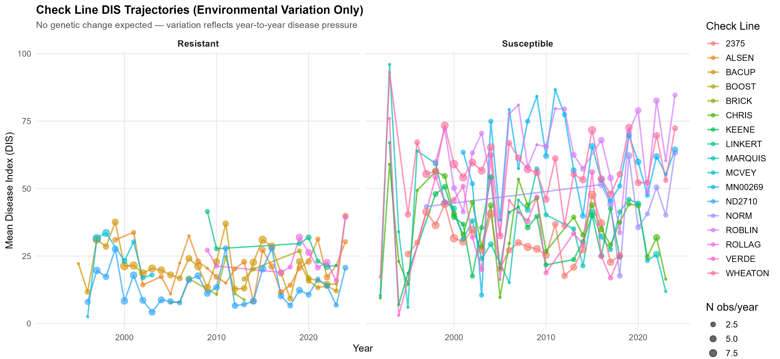
Figure S2. Check line DIS trajectories over 32 years. Absence of trend confirms environmental, not genetic, variation.

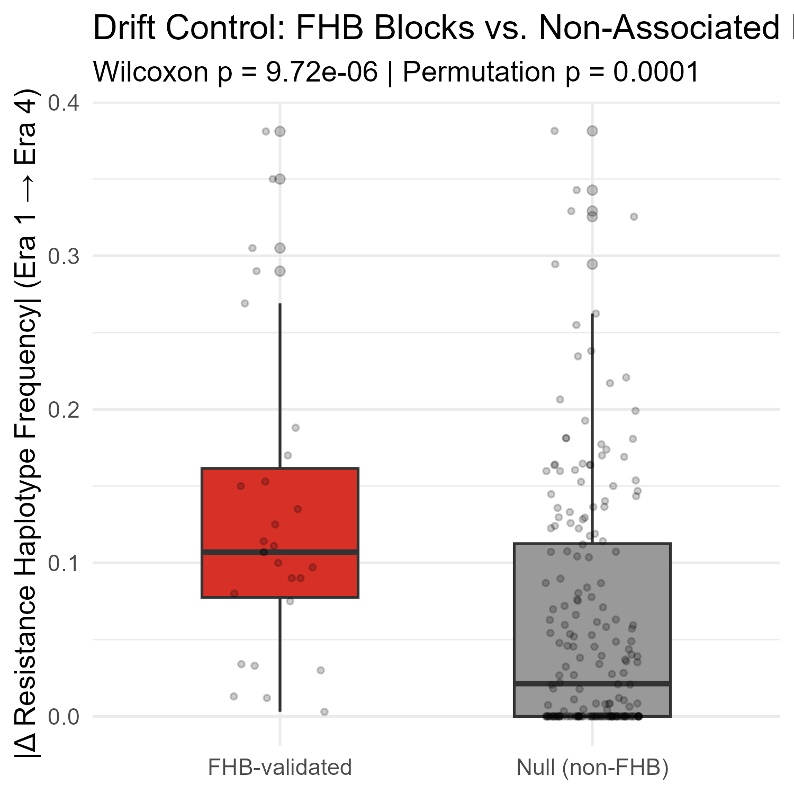
Figure S4. Drift control: |Δfreq| at FHB-validated blocks vs. non-associated blocks.

