Table S4 Information of motifs in tomato G2-like proteins
Name | Patterns | Sequences
Motif 1 | 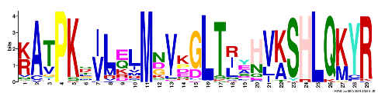 | KATPKSILZLMNVKGLTRYHVKSHLQKYR
Motif 2 | 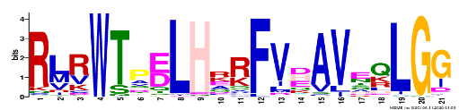 | RLRWTPELHRRFVDAVEQLGG
Motif 3 | 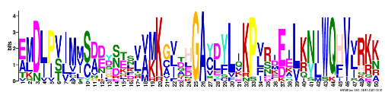 | EMDLPVIMMSDDYSESVVMKGVTHGAYDYLIKPVRDEELKNIWQHVVRKK
Motif 4 | 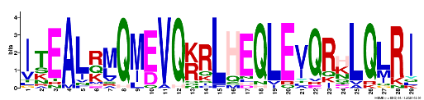 | ITEALRMQMEVQKRLHEQLEVQRHLQLRI
Motif 5 | 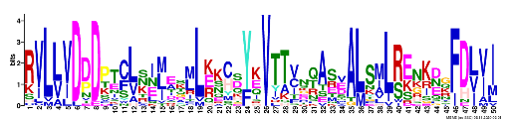 | RVLLVDDDPTCLKILEKMLKKCSYKVTTVNQASEALSMLRENKDGFDLVI
Motif 6 | 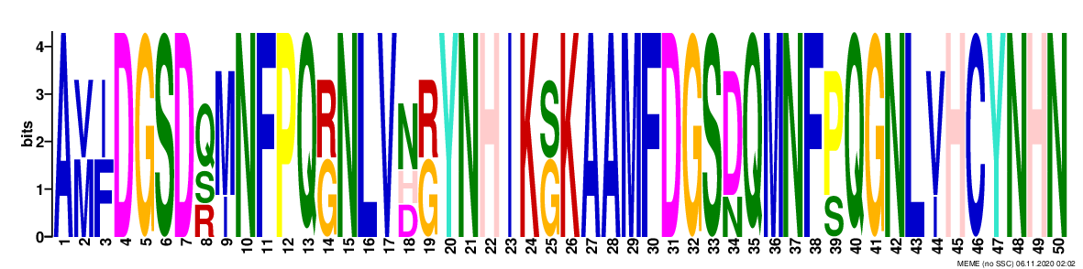 | AVFDGSDQMNFPQGNLVNGYNHIKGKAAMFDGSDQMNFPQGNLVHCYNHN
Motif 7 | 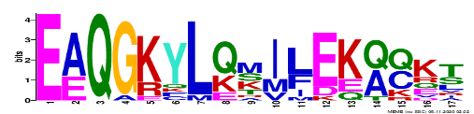 | EAQGKYLQMILEKQQKT
Motif 8 | 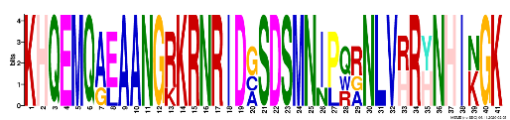 | KHQEMQAEAANGRKRNRIDGSDSMNIPQRNLVRRHNHIKGK
Motif 9 | 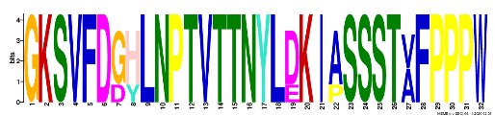 | GKSVFDGHLNPTVTTNYLDKIASSSTVFPPPW
Motif 10 | 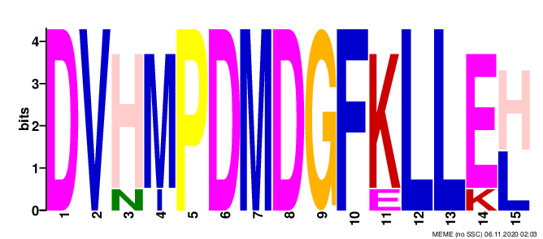 | DVHMPDMDGFKLLEH
Motif 11 | 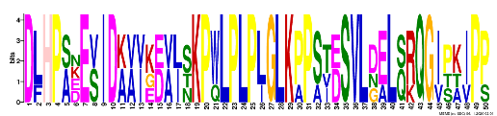 | DLHPADEVIDKVIKDVJSKPWLPLPLGLKPPSTDSVLDELQRQGIPKIPP
Motif 12 | 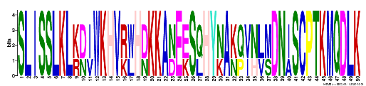 | SLISSLKLKDIWKHVRWHDKKANEESQHYNAKQVNLMDNISCPTKMQDLK
Motif 13 | 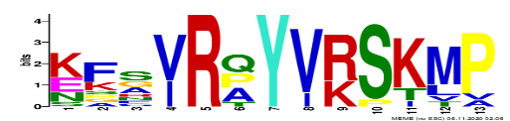 | KFSVRQYVRSKMP
Motif 14 | 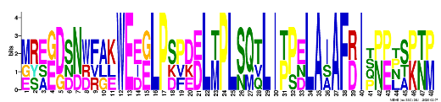 | MREGDSNWFAKWEEGLPSPDDLTPLSQTLIPPELAIAFDISPPPSPTP
Motif 15 | 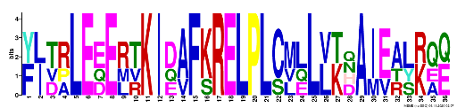 | YJTRLEEERTKIDAFKRELPLCMLLLKHAIEALKQZ

