Supplementary Figures

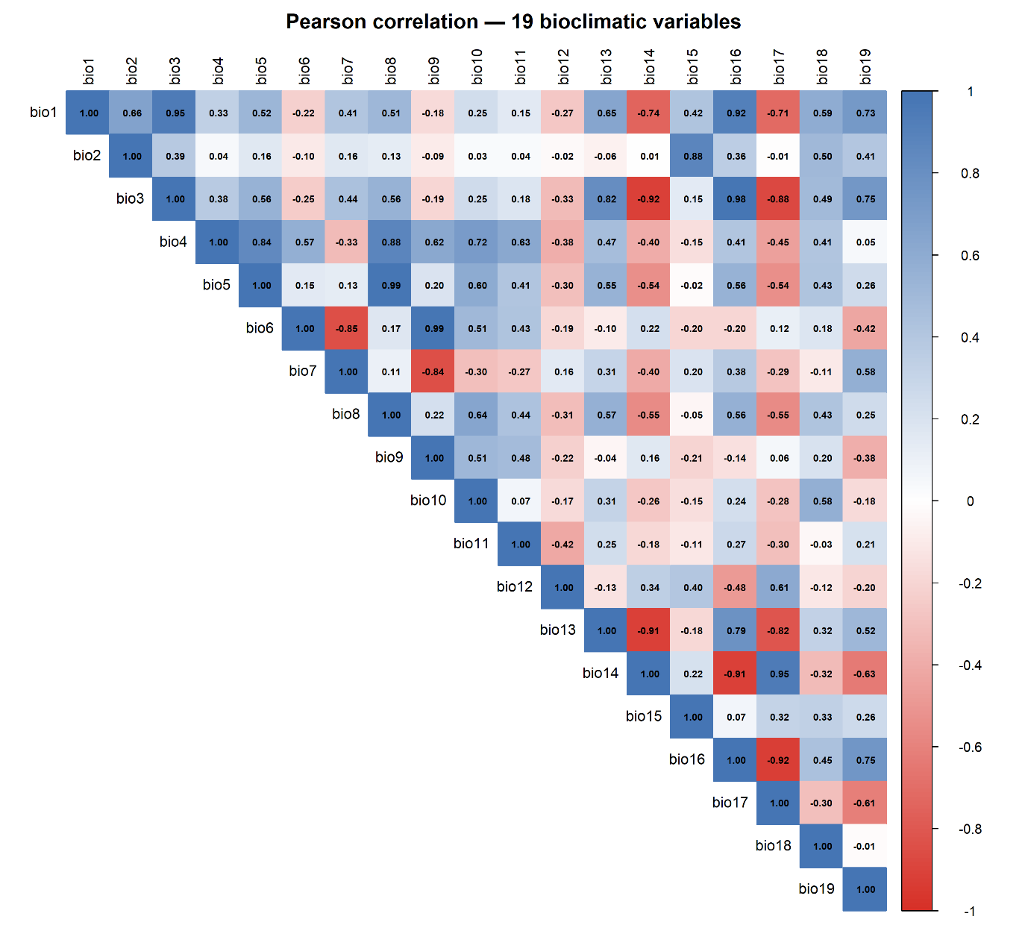

Figure S1. Pearson correlation matrix of all 19 WorldClim v2.1 bioclimatic variables computed from values extracted at 281 spatially thinned occurrence localities of Zaprionus indianus. Colour scale ranges from −1 (dark red; strong negative correlation) to +1 (dark blue; strong positive correlation). Variable pairs with |r| > 0.7 (indicated by high-intensity colours) were considered collinear; one variable from each pair was removed using the findCorrelation() function (caret package; Kuhn, 2008). Correlation coefficients are displayed within each cell.

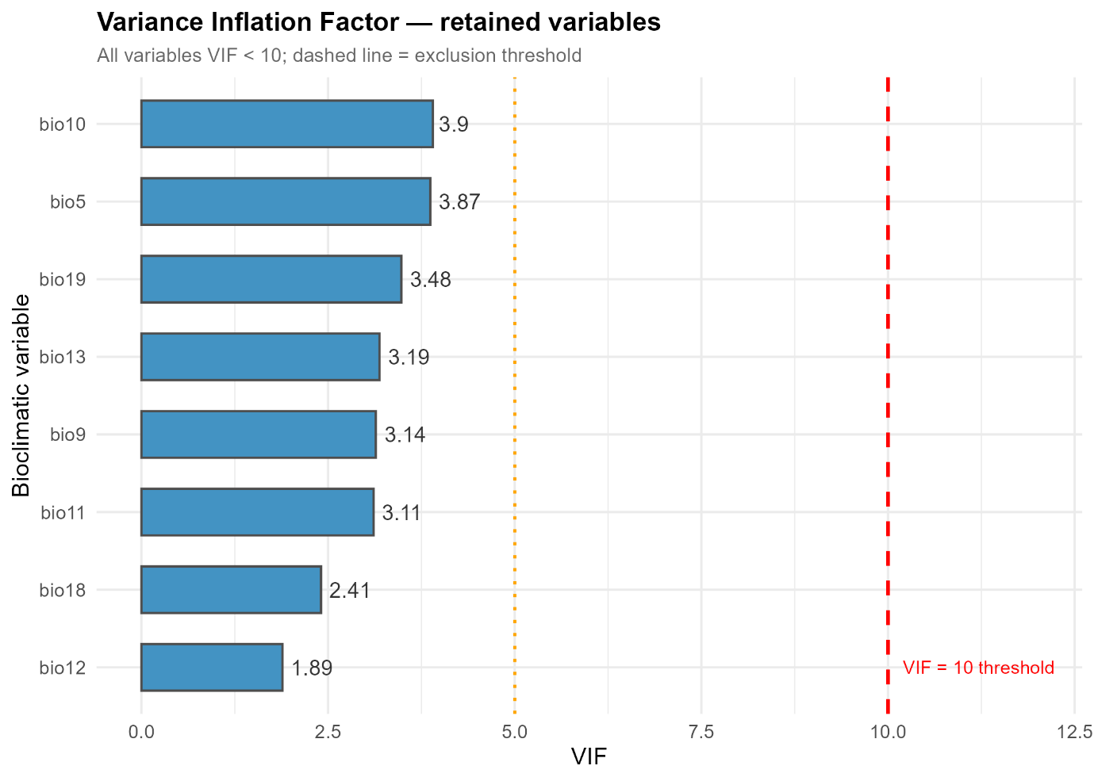
Figure S2. Variance Inflation Factor (VIF) values for the eight bioclimatic variables retained for model calibration following correlation and VIF filtering. All retained variables had VIF < 10 (dashed red line = exclusion threshold), with values ranging from 1.89 (bio12) to 3.90 (bio10), indicating negligible residual multicollinearity. VIF analysis was performed using the vifstep() function in the usdm package (Naimi et al., 2014).

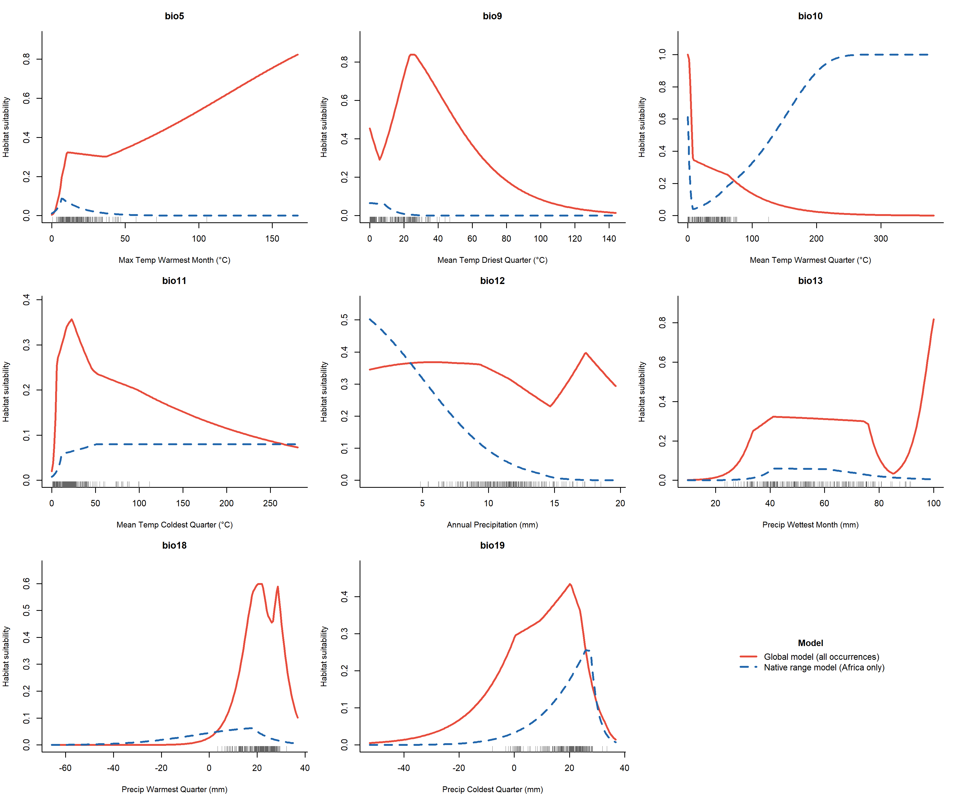

Figure S3. Marginal response curves for the eight bioclimatic predictor variables included in the MaxEnt models. Red solid lines indicate the global model (trained on all 281 occurrence localities); blue dashed lines indicate the native range model (trained on 40 Afrotropical localities). Response curves show predicted habitat suitability as a function of each variable, with all other variables held at their mean values across the training dataset. Rug marks at the base of each panel indicate the distribution of presence localities along each variable axis. Temperature variables are displayed in degrees Celsius.

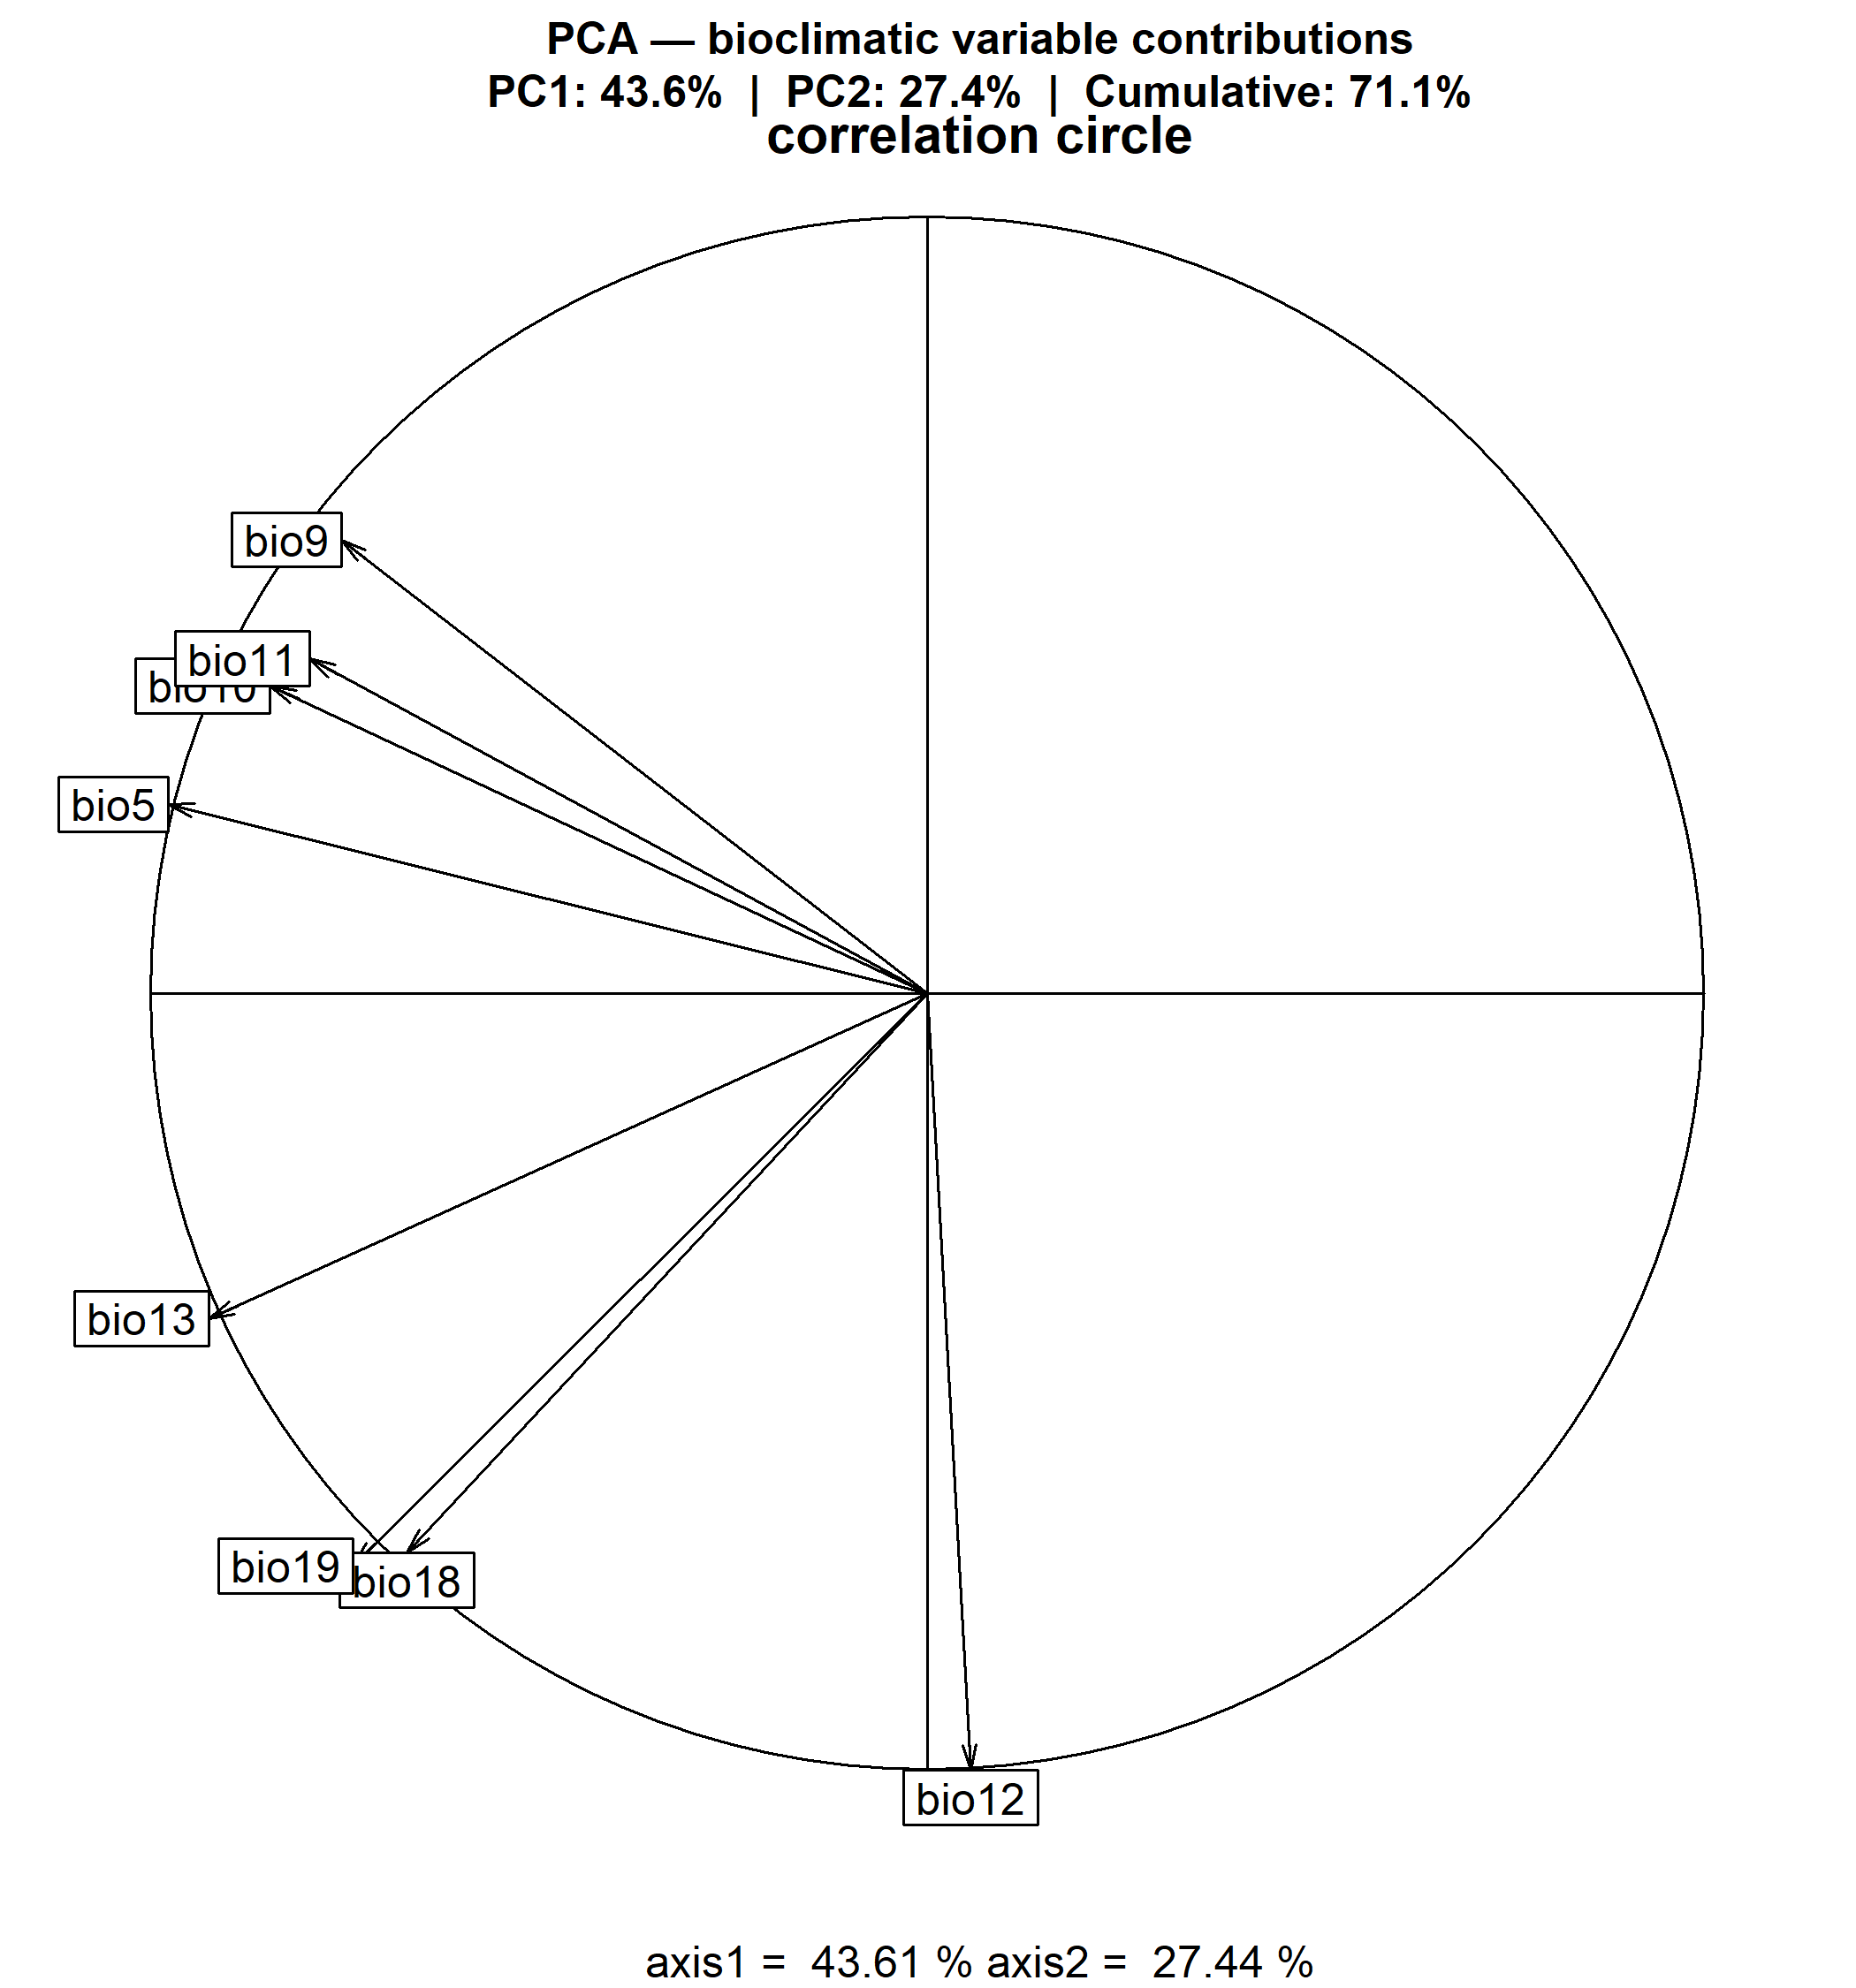
Figure S4. PCA correlation circle showing the contribution and loading direction of each bioclimatic variable on the first two principal components of the pooled native-invaded environmental space used for ecospat niche analysis. Arrow length is proportional to the contribution of each variable to the respective PC axis. PC1 explained 43.6% and PC2 explained 27.4% of total variance (cumulative: 71.1%). Thermal variables (bio5, bio9, bio10, bio11) load predominantly on PC1; precipitation variables (bio12, bio13, bio18, bio19) are separated along PC2.

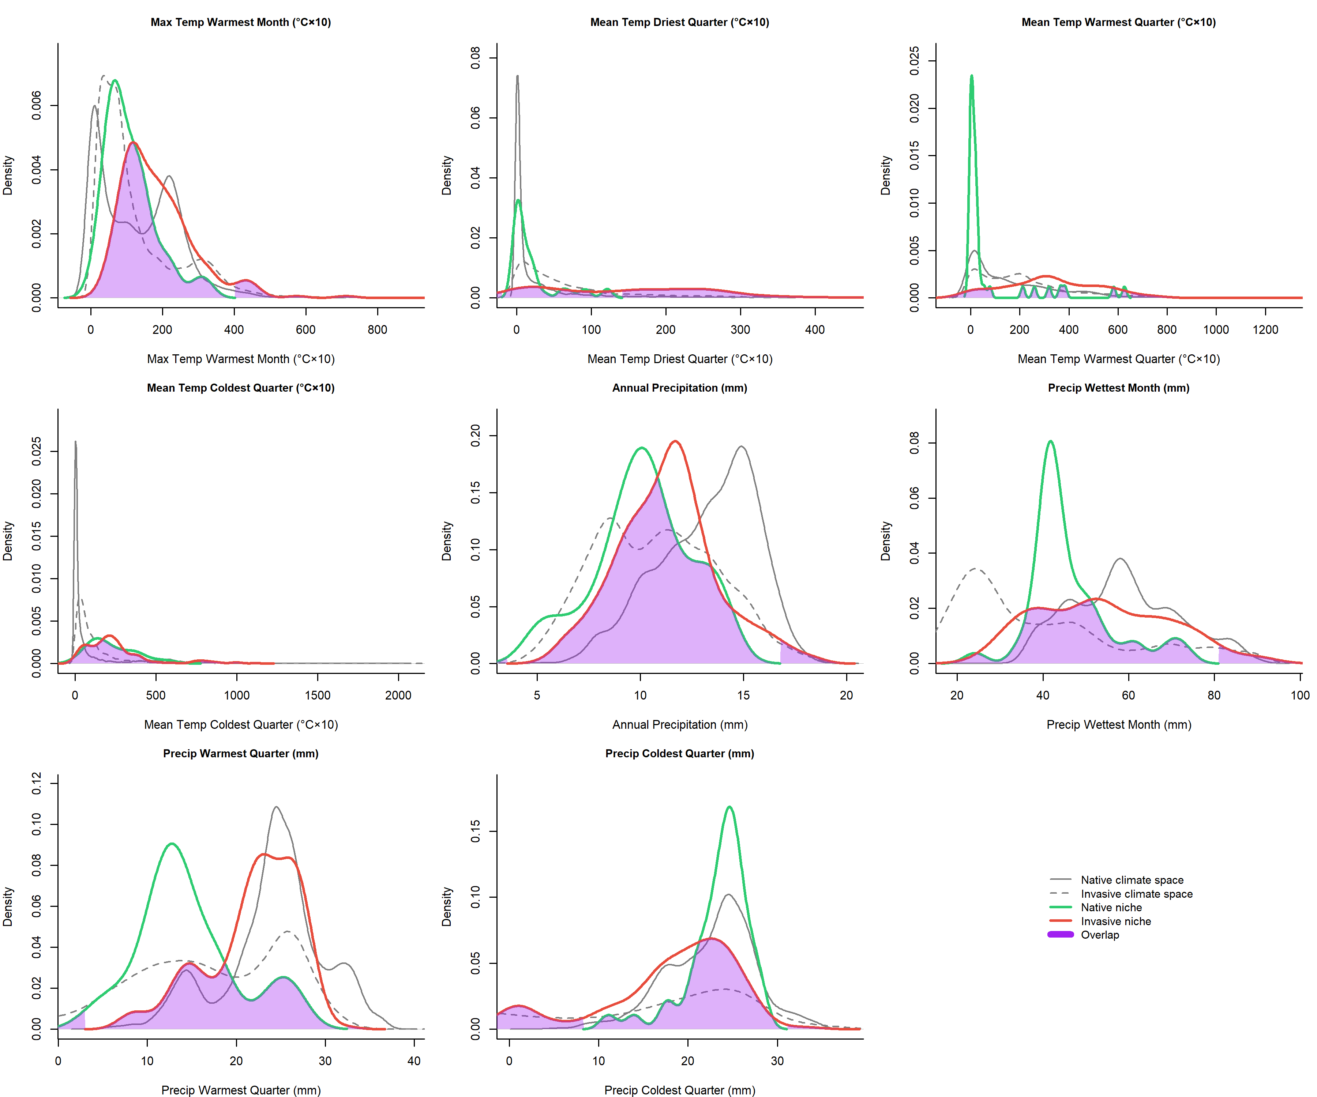

Figure S5. Univariate kernel density distributions of eight bioclimatic variables for Zaprionus indianus in native (green solid lines) and invaded (red solid lines) occurrence environments, overlaid on the density distributions of native (grey solid lines) and invaded (grey dashed lines) background climatic space. Purple shading indicates the region of overlap between native and invaded occurrence densities. The relatively narrow native niche distributions compared to the broader invaded niche distributions are consistent with the niche expansion quantified in the ecospat analysis.

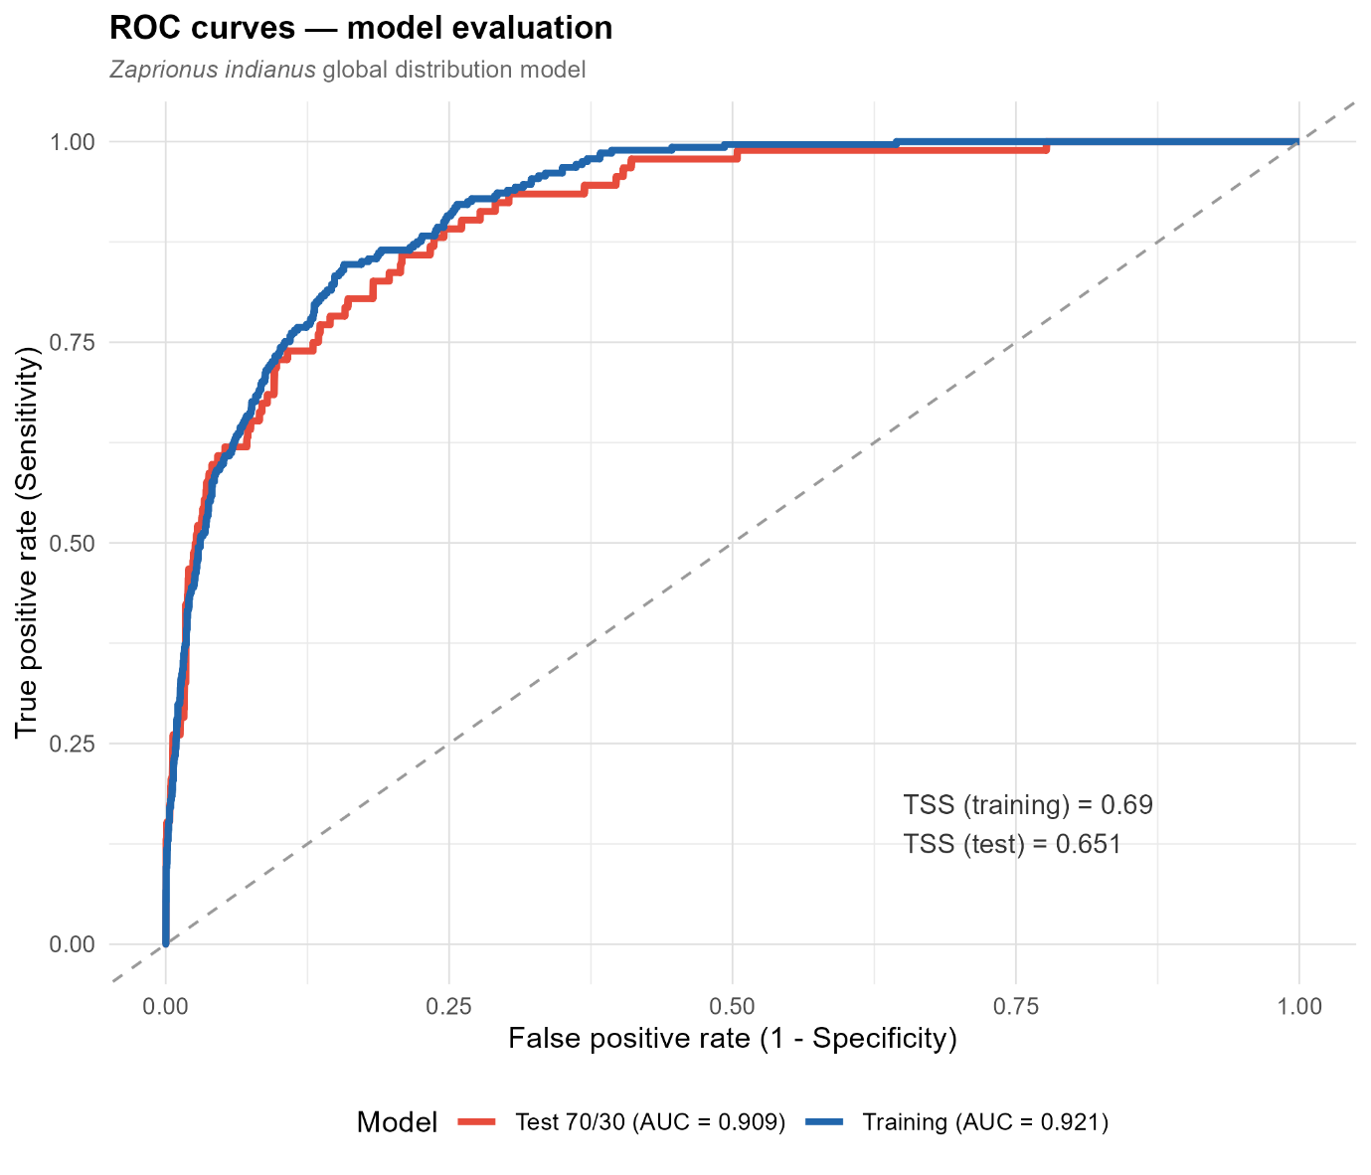
Figure S6. Receiver Operating Characteristic (ROC) curves for the global MaxEnt model of Zaprionus indianus. Blue line: training ROC curve (AUC = 0.921). Red line: test ROC curve from 70/30 random split evaluation (AUC = 0.909). Dashed diagonal line indicates random discrimination (AUC = 0.500). TSS values are shown for both evaluations (training TSS = 0.690; test TSS = 0.651). The minimal difference between training and test metrics indicates that the model generalised well to withheld data with negligible overfitting.

Tables

Table S1. Summary of occurrence record processing for Zaprionus indianus.
Processing step | Records retained | Notes
Raw records downloaded from GBIF | 1,893 | All records with coordinates for Zaprionus indianus
After basis of record filter | 718 | Human observations and preserved specimens only
After duplicate removal | 438 | Identical longitude-latitude pairs removed
After coordinate cleaning (CoordinateCleaner) | 400 | Records flagged as centroids, institutions, or sea removed
After spatial thinning (spThin, 10 km) | 281 | One record per 10 km minimum distance; best of 10 replicates
Native range (Afrotropical, final) | 40 | Lon: −20° to 55°E; Lat: 35°S to 38°N
Invaded range (global, final) | 241 | All records outside the native range definition
Note. Occurrence data were downloaded from the Global Biodiversity Information Facility (GBIF; DOI: 10.15468/dl.nmtg23; Chakraborty & Rajpurohit, 2026). Records were restricted to human observations and preserved specimens and filtered to remove missing or zero coordinates. Duplicate records sharing identical coordinates were removed using dplyr (Wickham et al., 2023). Coordinate quality was assessed using the CoordinateCleaner package (Zizka et al., 2019), removing records flagged as country centroids, capital cities, GBIF headquarters, biodiversity institutions, and sea coordinates. Spatial thinning was applied using a minimum nearest-neighbour distance of 10 km across 10 replicate runs; the replicate retaining the greatest number of localities was selected (spThin; Aiello-Lammens et al., 2015).

Table S2. Correlation filtering results for all 19 WorldClim v2.1 bioclimatic variables.
Code | Variable | Status | Reason
bio1 | Annual mean temperature | Removed | Correlated with bio5, bio10, bio11 (|r| > 0.7)
bio2 | Mean diurnal range | Removed | Correlated with retained thermal variables (|r| > 0.7)
bio3 | Isothermality | Removed | Correlated with retained thermal variables (|r| > 0.7)
bio4 | Temperature seasonality | Removed | Correlated with retained variables (|r| > 0.7)
bio5 | Max temperature of warmest month | Retained | VIF = 3.87; passed both correlation and VIF filters
bio6 | Min temperature of coldest month | Removed | Correlated with bio11 (|r| > 0.7)
bio7 | Temperature annual range | Removed | Correlated with retained variables (|r| > 0.7)
bio8 | Mean temperature of wettest quarter | Removed | Correlated with retained thermal variables (|r| > 0.7)
bio9 | Mean temperature of driest quarter | Retained | VIF = 3.14; passed both correlation and VIF filters
bio10 | Mean temperature of warmest quarter | Retained | VIF = 3.90; passed both correlation and VIF filters
bio11 | Mean temperature of coldest quarter | Retained | VIF = 3.11; passed both correlation and VIF filters
bio12 | Annual precipitation | Retained | VIF = 1.89; passed both correlation and VIF filters
bio13 | Precipitation of wettest month | Retained | VIF = 3.19; passed both correlation and VIF filters
bio14 | Precipitation of driest month | Removed | Correlated with bio17/bio19 (|r| > 0.7)
bio15 | Precipitation seasonality | Removed | Correlated with retained precipitation variables (|r| > 0.7)
bio16 | Precipitation of wettest quarter | Removed | Correlated with bio13 (|r| > 0.7)
bio17 | Precipitation of driest quarter | Removed | Correlated with retained variables (|r| > 0.7)
bio18 | Precipitation of warmest quarter | Retained | VIF = 2.41; passed both correlation and VIF filters
bio19 | Precipitation of coldest quarter | Retained | VIF = 3.48; passed both correlation and VIF filters
Note. Pearson correlation coefficients were computed from environmental values extracted at 281 spatially thinned occurrence localities of Zaprionus indianus. Variables with pairwise |r| > 0.7 were considered collinear; one variable from each correlated pair was removed using the findCorrelation() function (caret package; Kuhn, 2008), which prioritises removal of the variable with the highest mean absolute correlation. Following correlation filtering, the remaining nine variables were subjected to Variance Inflation Factor (VIF) analysis using vifstep() in the usdm package (Naimi et al., 2014), with variables exhibiting VIF ≥ 10 excluded iteratively. VIF values shown are for the final retained set only. Grey shading indicates variables retained for model calibration. Removed variables were not carried forward in any subsequent analysis.

