Supplementary information

Dual-Mode Colorimetric and RGB Detection of Sulfide Based on a Magnetic Fe₃O₄/CoFe₂O₄/Ce-BDC Hybrid Nanozyme

Qingyuan Wengª, Xinyi Wen^{a,c}, Tianyuan Wei^{b}, Qing Zhang^{c}, Wanying Zhu^{c}, Junli Hong^{a,c,*}

ª The First Clinical Medical College, Nanjing Medical University, Nanjing, Jiangsu 211166, China.
^{b}National Clinical Research Center of Kidney Diseases, Jinling Clinical Medical College, Nanjing Medical University, Nanjing, China.
^{c} School of Pharmacy, Nanjing Medical University, Nanjing, Jiangsu 211166, China.
* Corresponding authors.
E-mail address: junlihong@njmu.edu.cn (Junli Hong)

Reagents and Apparatus
Colbalt nitrate hexahydrate and 3,3’,5,5’-tetramethylbenzidine dihydrochloride (TMB HCl) were produced by Shanghai Macklin Reagent Co., Ltd. (Shanghai, China). Zinc sulfate heptahydrate, anhydrous calcium chloride, ferric chloride hexahydrate, polyvinylpyrrolidone, and anhydrous sodium acetate were purchased from China Pharmaceutical Chemical Reagents Co., LTD. (Shanghai). Terephthalic acid, cerium ammonium nitrate, ferric chloride were purchased from Shanghai Aladdin Biochemical Technology Co., LTD. (Shanghai). Zinc acetate was provided by Shanghai Shiyi Chemical Reagent Co., LTD. Anhydrous magnesium sulfate was purchased from Shanghai Cisihewei Chemical Co., LTD. Ammonium chloride and polyethylene glycol (200) were produced by Xilong Chemical Co., LTD. (Shantou, Guangdong).

Uv-vis spectra and absorbance were recorded by a TECAN microwell plate instrument (Nanjing Kelinde Scientific Instrument Co., LTD.). The specific surface area detection (BET) map was measured by the American MAC ASAP2460. Fourier transform infrared (FT-IR) spectra were provided by Thermo Thermo Nicolet iS5, USA. Transmission electron microscopy (TEM) figure Nippon Electron JEM 2100PLUS measurement. Scanning electron microscopy (SEM) plots were measured by Hitachi Regulus 8100/Su8600, Japan. Hysteresis loop test (VSM) plots were measured by Quantum Design mpms squid vsm (USA). X-ray photoelectron spectroscopy (XPS) maps were provided by Thermo Fisher Escalab 250xi, USA. X-ray diffraction (XRD) measurements were provided by Bruker D8 ADVANCE, Bruker, Germany. Thermogravimetric analysis (TG) plots were measured by Nacho STA 449 F5 (Germany).

S1 The Synthesis of Fe₃O₄, FCF and FCF/Ce-MOF
Synthesis of Fe₃O₄ nanoparticles and subsequent composite assembly. Fe₃O₄ nanoparticles were synthesized via a hydrothermal method. Briefly, FeCl₃·6H₂O (0.6 g), sodium acetate (NaAc, 1.2 g), polyethylene glycol-200 (PEG-200, 0.27 mL), and polyvinylpyrrolidone K30 (PVP-K30, 0.5 g) were sequentially dissolved in 14 mL of ethylene glycol under magnetic stirring for 30 min, affording a homogeneous transparent yellow-brown solution. The precursor solution was then transferred into a polytetrafluoroethylene-lined stainless steel autoclave and heated at 200 ℃ for 6 h. After naturally cooling to room temperature, the magnetic nanoparticles were collected using an external magnet, washed three times with ethanol/deionized water (1:1, v/v), and dried under vacuum at 60 ℃. The obtained Fe₃O₄ nanoparticles (100 mg) were dispersed in ~30 mL of deionized water by ultrasonication for 3-5 min, followed by the addition of PVP (50 mg). FeCl₃·6H₂O (262 mg) and Co(NO₃)₂·6H₂O (142 mg), each pre-dissolved in a small amount of water, were then added to the suspension. Subsequently, urea (174 mg) was directly introduced, and the mixture was stirred for 10-15 min to ensure homogeneity. The resulting mixture was transferred to a Teflon-lined autoclave and heated at 120 ℃ for 6 h. After cooling to room temperature, the resulting solid (100 mg) was re-dispersed in an ethanol/water mixture (1:1, v/v; 10-12 mL). Separately, H₂BDC (62 mg) was dissolved in 2-3 mL of ethanol by sonication with mild heating (≤60 ℃), while Ce(NO₃)₃ (163 mg) was dissolved in 1-2 mL of deionized water. These solutions were then added to the above suspension, followed by PVP (30 mg) and acetic acid (90 µL) under gentle stirring.

S2 Preparation of Hydrogel Sensors
The catalytic reaction was carried out by incubating the FCF/Ce-BDC nanocomposite with TMB and H₂O₂ in acetate-buffered saline (ABS, pH 3.5) at 37 ℃ under static conditions for 20 min. Following the reaction, 13 mg of sodium alginate was added, and the mixture was stirred vigorously at 800 rpm for 5 min to obtain solution A. In parallel, solution B was prepared by dissolving calcium chloride (0.6 M) in a polyacrylic acid matrix (0.05 M, 1800 Da). Hydrogel beads were then fabricated by extruding solution A into solution B using a syringe pump at a flow rate of 50 μL·min⁻¹, where spherical structures formed through ionic cross-linking. For on-site detection, a custom smartphone application enabled colorimetric analysis by extracting RGB values from images of the hydrogels. A 20 μL aliquot of sulfide standard or sample was deposited onto the hydrogel surface and allowed to react at ambient temperature (25 ± 1 ℃) for 10 min; the sulfide concentration was then quantified based on the linear correlation with the blue-channel intensity.

S3 Preparation of Cotton Fabric-based Sensors
To ensure uniform deposition of the FCF/Ce-BDC probe onto a textile substrate, cotton fabric was selected. The reverse side of the fabric was gently marked with a pencil to delineate multiple identical test zones, facilitating accurate positioning and identification of the colorimetric array. An ethanol dispersion of FCF/Ce-BDC (1.5 mg·mL⁻¹) was then applied in 10 µL aliquots onto each designated area and left to dry at room temperature. The droplets dried without forming a coffee-ring effect, resulting in a uniform cotton-based colorimetric interface ready for subsequent use.

S4 Preparation of Cotton Swab-based Sensor
A cotton-swab colorimetric sensor was developed using medical-grade absorbent cotton as a three-dimensional porous scaffold for immobilizing FCF/Ce-BDC nanoprobes. The fibrillar cellulose network at the swab tip enables directional anchoring through hydrogen bonding with surface functional groups of the nanoprobes. An ethanol suspension of the nanoprobes (1.2 mg·mL⁻¹) was precisely dispensed at 500 µL per detection spot, followed by gradient vacuum drying (25 ℃, -0.08 MPa) to induce directional solvent evaporation. This approach effectively suppressed coffee-ring formation and promoted near-monolayer self-assembly of the probes throughout the cotton matrix. The resulting biomimetic hierarchical microcavity structure offers mechanical flexibility and autonomous wicking behavior, facilitating on-site sample preconcentration and synchronized colorimetric readout.

S5 Characterization of Fe₃O₄, FCF and FCF/Ce-BDC
Transmission electron microscopy (TEM; 120 kV) and scanning electron microscopy (SEM) reveal that the synthesized material possesses a hierarchical hybrid morphology derived from the integration of Fe₃O₄, CoFe₂O₄ and Ce-BDC components (Fig. 1A-1C)(Fig. 2A and 2B). Compared with the FCF precursor, the final composite exhibits a slightly increased particle size and a more textured outer surface, suggesting the successful surface growth of the Ce-BDC framework. As shown in inset of Fig. 1B, the particles maintain a relatively uniform spherical morphology with improved dispersion, while the presence of discernible lattice fringes in the HRTEM inset indicates the formation of well-defined crystalline domains within the composite. SEM images further show that the surface becomes denser and rougher after the introduction of the Ce-BDC component, consistent with the construction of a hybrid interfacial layer. Elemental mapping demonstrates the homogeneous distribution of C, N, O, Fe, Co and Ce throughout the particles (Fig. 1J-1I), supporting the effective incorporation of all structural units within the hybrid framework. Collectively, these observations indicate that the synthesized FCF/Ce-BDC composite possesses a well-organized hierarchical architecture with uniform elemental dispersion.
The FT-IR spectrum of the final FCF/Ce-BDC nanozyme displays several characteristic absorption bands associated with both the magnetic inorganic component and the organic coordination framework (Fig. 1D). The band at 575.95 cm⁻¹ is attributed to Fe-O stretching vibrations, confirming the presence of the magnetic Fe₃O₄/CoFe₂O₄ domain. The broad absorption centered at 3356.58 cm⁻¹ corresponds to O-H stretching vibrations originating from surface hydroxyl groups and adsorbed water molecules. In addition, the peaks at 1554.66 cm⁻¹ and 1387.35 cm⁻¹ are assigned to the asymmetric and symmetric stretching vibrations of carboxylate groups (COO⁻), respectively, indicating the coordination of BDC ligands with metal centers in the Ce-BDC framework. The band at 1505.02 cm⁻¹ is associated with aromatic C=C skeletal vibrations, while the peak at 880.58 cm⁻¹ can be ascribed to the out-of-plane C-H bending vibration of the para-substituted benzene ring. Other bands observed in the fingerprint region, including those at 1288.11 cm⁻¹, 1110.77 cm⁻¹, 1018.06 cm⁻¹, 934.33 cm⁻¹, 1660.13 cm⁻¹, 1464.45 cm⁻¹ and 2952.81 cm⁻¹, further support the presence of the organic framework and the successful integration of Ce-BDC into the magnetic hybrid nanozyme. Collectively, these spectral features verify the successful formation of the FCF/Ce-BDC composite.
The porosity of the synthesized materials was evaluated by N₂ adsorption-desorption measurements. Both FCF (Fig. S2C) and FCF/Ce-BDC (Fig. 1E) display type-IV isotherms, consistent with mesoporous architectures that facilitate substrate diffusion. The pore-size distribution (Fig. S2D and 1E) indicates an average pore diameter of 17.5259 nm for FCF and 23.2584 nm for FCF/Ce-BDC. The Brunauer-Emmett-Teller (BET) specific surface areas were determined to be 27.3961 m²·g⁻¹ for FCF and 17.0077 m²·g⁻¹ for FCF/Ce-BDC. These results suggest that the porous Ce-BDC overlayer provides additional accessible surface area and transport channels, which are favorable for reactant adsorption and catalytic turnover.
Thermogravimetric analysis (TGA; Fig. 1F) was conducted to evaluate the thermal stability of Fe₃O₄, FCF, and FCF/Ce-BDC. Bare Fe₃O₄ exhibited only a slight weight loss of 4.74% below 480 ℃, and still retained 93.67% of its initial mass at 800 ℃, indicating excellent intrinsic thermal robustness. Similarly, the FCF precursor showed a modest mass loss of 6.76% below 500 ℃, with a high residual mass of 91.36% at 800 ℃, suggesting that the magnetic hybrid intermediate also possesses good thermal stability. In contrast, the final FCF/Ce-BDC composite displayed a two-step weight-loss behavior, with a loss of 8.7% from 35 ℃ to 340 ℃ and an additional 9.3% loss from 340 ℃ to 520 ℃, followed by a residual mass of 60.81% at 800 ℃. The initial mass loss can be ascribed to the removal of physically adsorbed water and weakly bound species, whereas the subsequent more pronounced loss is likely associated with the decomposition of the outer Ce-BDC coordination framework. Despite the introduction of the organic framework, the final composite still retains substantial thermal integrity, confirming its structural stability and successful integration of the Ce-BDC component into the magnetic hybrid nanozyme.
The magnetic properties of the synthesized materials were further evaluated by M-H measurements (Fig. 1I). The Fe₃O₄, FCF and FCF/Ce-BDC samples all exhibit obvious magnetic response, indicating that the composite retains sufficient magnetism for external separation. The gradual attenuation of magnetic response after surface modification is expected, because the introduction of non-magnetic coordination layers partially dilutes the magnetic contribution of the Fe₃O₄-based domain. Nevertheless, the final composite still can be rapidly separated from solution under an external magnetic field within 10s (Fig. 1I), demonstrating its practical magnetic recoverability.

S6 Preparation of Actual Samples:
Preparation of healthy human serum:
To precipitate proteins, whole blood was combined with an equal volume of 10% trichloroacetic acid and incubated on ice for 10 minutes. The resulting mixture was centrifuged at 12, 000 rpm for 15 minutes, and the supernatant was collected for subsequent analysis.

Preparation of lake water:
To remove impurities, a 50 mL aliquot of Tianyuan Lake water was subjected to treatment with Fe(OH)₃. The resulting solution was subsequently centrifuged at 10, 000 rpm for 15 minutes, and the supernatant was collected for further analysis..

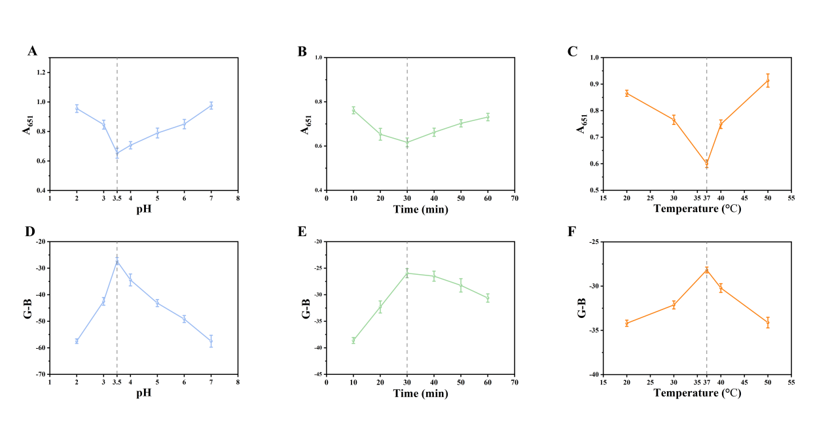
Fig. S1. (A-C) Optimization of experiment condition in the colorimetric detection mode: pH, reaction timeand, temperature. (D-F) Optimization of experiment condition in the RGB detection mode: pH, reaction timeand, temperature.

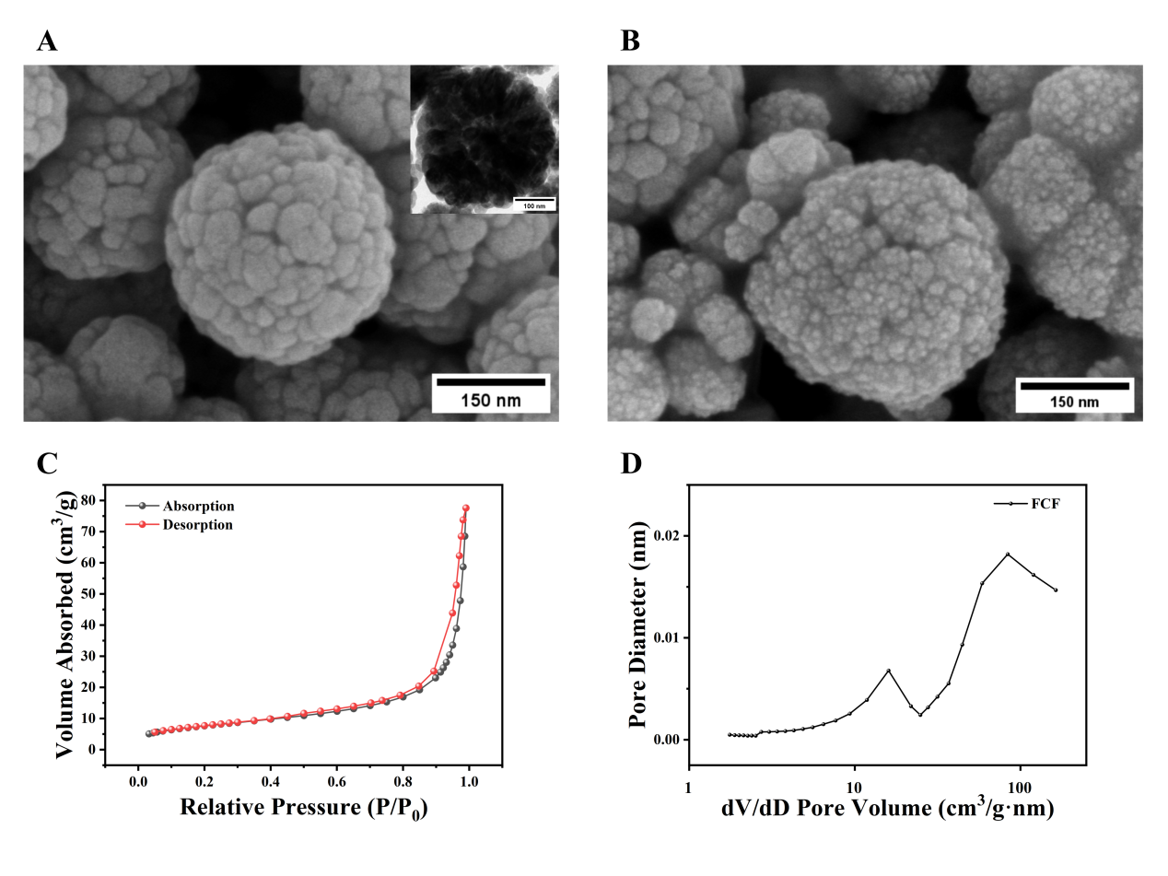
Fig. S2. (A) TEM images of Fe₃O₄. Inset of (A): SEM images of Fe₃O₄. (B) TEM images of FCF. (C) N₂ adsorption and desorption isotherms of FCF. (D) Pore size distribution of FCF.

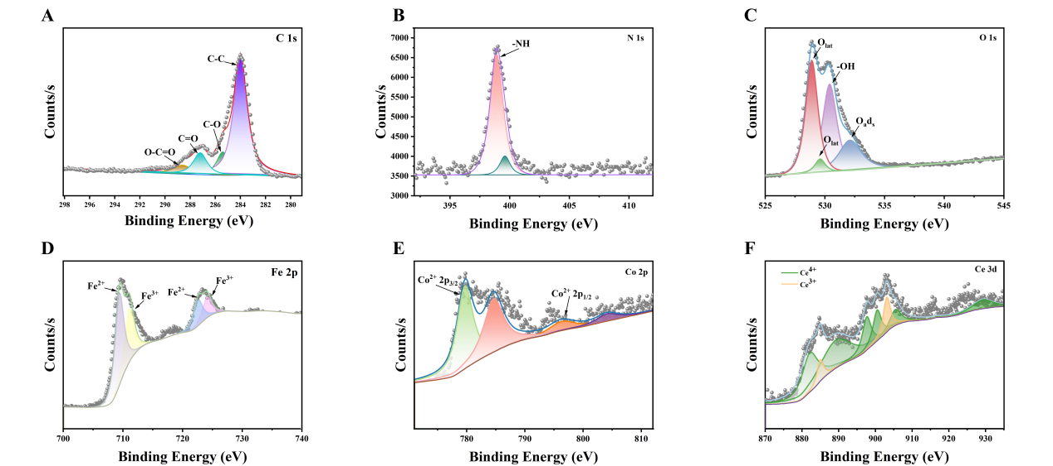
Fig. S3. The XPS spectra of (A) C 1s, (B) N 1s, (C) O 1s, (D) Fe 2p, (E) Co 2p and (F) Ce 3d.

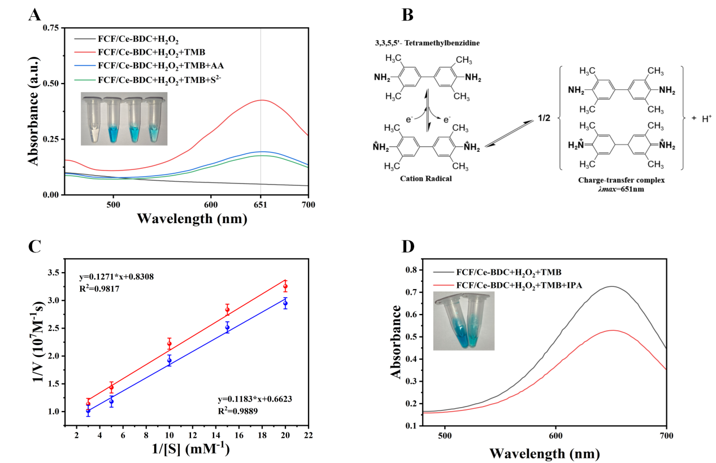
Fig. S4. (A) Changes of UV absorption values of the system at different components. (B) The mechanism for the phenomenon observed in (A). (C) Changes in the activity of nanozymes before and after sulfide encapsulation. (D) TMB + H₂O₂ + FCF/Ce-BDC without or with a •OH radical scavenger (isopropyl alcohol).

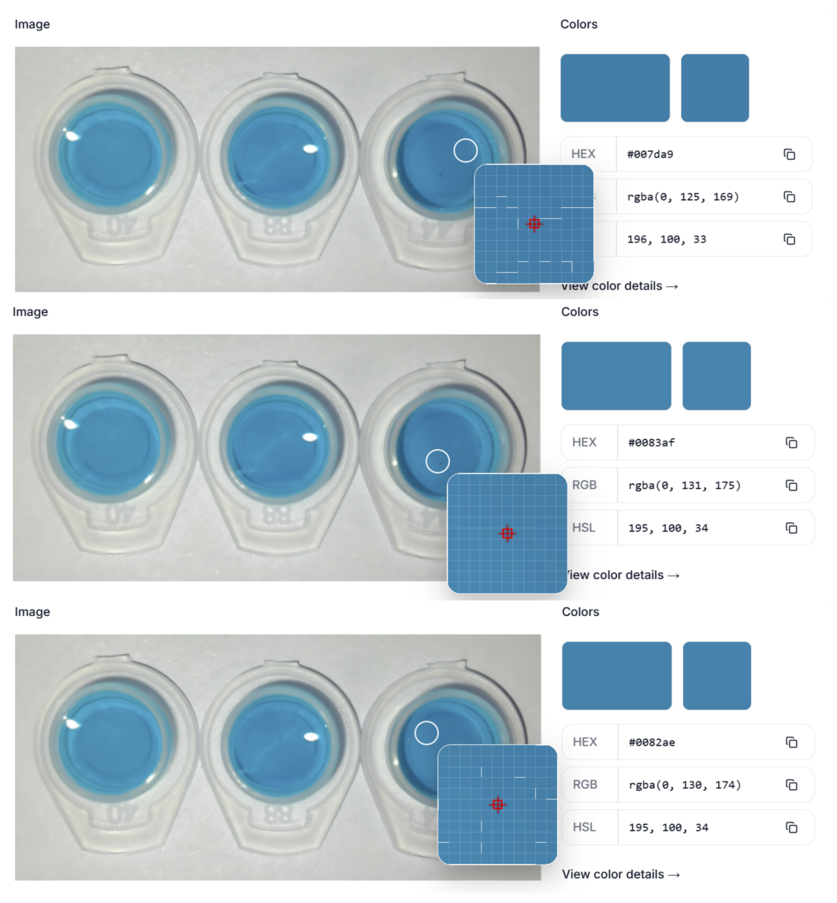
Fig. S5. The color picker platform analyzes RGB information in images (n = 3).

Table S1 The table of element types and contents of FCF/Ce-BDC by XPS.
Name | Peak BE | FWHM eV | Area (P) CPS.eV | Atomic %
C 1s | 284.81 | 1.87 | 45357.16 | 47.63
N 1s | 399.74 | 1.64 | 8169.79 | 5.53
O 1s | 530.07 | 3.19 | 76593.99 | 33.22
Fe 2p | 710.52 | 3.99 | 91008.17 | 9.26
Co 2p | 780.50 | 3.85 | 29460.31 | 2.53
Ce 3d | 885.01 | 11.70 | 63888.93 | 1.83

Table S2 Kinetic parameters (K_{m} and V_{max}) for TMB of Fe₃O₄, FCF and FCF/Ce-BDC.
Material | K_{m}  (mM) | V_{max}  (10⁻⁷ M/s)
Fe₃O₄ | 0.1634 | 1.4870
Fe₃O₄/CoFe₂O₄ | 0.1576 | 2.8393
Fe₃O₄/CoFe₂O₄/Ce-BDC | 0.1966 | 2.0292

Table S3 Kinetic parameters (K_{m} and V_{max}) for TMB of FCF/Ce-BDC synthesized by different ratio.
Fe₃O₄ : CoFe₂O₄ : Ce-BDC | K_{m}  (mM) | V_{max}  (10⁻⁷ M/s)
1.2 : 0.6 : 1 | 0.2315 | 1.5747
1.2 : 1.3 : 1 | 0.1966 | 2.0292
1.2 : 1.3 : 2 | 0.3146 | 1.2432

Table S4 Comparison of different strategies for Sulfide assay.
Substrate / Probe | Detection Method | Linear Range (μM) | LOD (μM) | Detection time | Ref.
Fe₃O₄ /CoFe₂O₄/Ce-BDC | Colorimetric (dual-mode RGB) | 10-300 | 0.29 | 20min | This work
MgFe₂O₄/PVP@ZIF-67@Ag | Colorimetric | 0-100 | 0.057 | 30min | [1]
Ru NPs | Colorimetric | 0-1.8 | 0.0156 | 5min | [2]
Ce-MOF | dual-mode  (fluorometric/colorimetric) | Colorimetric: 200-2300  Fluorescence: 16-320 | Colorimetric: 0.262  Fluorescence: 0.156 | 30min | [3]
Mo-CDs | dual-mode  ultraviolet and colorimetric | 2.5-900 | 0.076 | 30min | [4]
Cu@N-GQDs | dual-mode  (fluorometric/colorimetric) | Colorimetric: 10-600  Fluorescence: 0-40 | Colorimetric: 3.5  Fluorescence: 0.5 | 15min | [5]
MnO₂/Au/Ag  nanoframes  (OXD mimic) | Color analysis  (Smartphone) | 2.1-33 | 3.85 | 10min | [6]
Fe₃O₄/PAMAM/MnO₂  composite  (POD mimic) | UV-Vis  spectrum | 1-100 | 0.89 | 90min | [7]

Table S5 Two-sample independent t-Test
Concentration (μM) | t-Statistic | p-Value | Interpretation
50 | -1.024 | 0.324 | p > 0.05, no significant difference
100 | 0.876 | 0.419 | p > 0.05, no significant difference
150 | -0.246 | 0.825 | p > 0.05, no significant difference

Table S6 Determination results of Sulfide in lake water (n = 3)
Sample | Detected  (μM) | Added  (μM) | Colorimetric sensor |  |  | RGB sensor
Sample | Detected  (μM) | Added  (μM) | Founded (μM) | Recovery  (%) | RSD  (%) | Founded (μM) | Recovery  (%) | RSD  (%)
1 | ND | 50 | 49.27 | 98.54 | 0.53 | 51.68 | 103.36 | 5.72
1 | ND | 100 | 96.11 | 96.11 | 0.72 | 93.52 | 93.52 | 5.18
1 | ND | 150 | 148.63 | 99.09 | 0.57 | 151.94 | 101.29 | 3.96
2 | ND | 50 | 52.34 | 104.68 | 0.92 | 49.21 | 98.42 | 6.03
2 | ND | 100 | 99.72 | 99.72 | 0.68 | 102.37 | 102.37 | 2.74
2 | ND | 150 | 151.88 | 101.25 | 0.52 | 148.88 | 99.25 | 7.81
3 | ND | 50 | 48.92 | 97.84 | 0.35 | 50.66 | 101.32 | 4.29
3 | ND | 100 | 102.47 | 102.47 | 0.84 | 99.03 | 99.03 | 5.11
3 | ND | 150 | 147.76 | 98.51 | 0.73 | 150.72 | 100.48 | 7.23
ND = Not detected.

References
- Cirillo, C., Iuliano, M., Astorga, E. N., et al., 2025. Microchem. J. 212, 113381. https://doi.org/10.1016/j.microc.2025.113381
- Li, H., Geng, W., Sun, X., et al., 2021. Meat Sci. 177, 108507. https://doi.org/10.1016/j.meatsci.2021.108507
- Cheng, Q., Du, X., Fu, Z., et al., 2024. Polymers 16(12), 1747. https://doi.org/10.3390/polym16121747
- Li, D., Chen, H., Zheng, Y., et al., 2025. Spectrochim. Acta, Part A 326, 125274. https://doi.org/10.1016/j.saa.2024.125274
- Nguyen, V. A. N., Vu, T. H., Nguyen, P. T., et al., 2025. Biosensors 15(8), 528. https://doi.org/10.3390/bios15080528
- Cho, S. H., Son, H., Lee, G. J., 2026. ACS Appl. Nano Mater. 9 (10), 4685-4698. https://doi.org/10.1021/acsanm.5c05883
- Su, L., Liu, B., Wu, N., et al., 2022. Biosens. Bioelectron. X 11, 100155. https://doi.org/10.1016/j.biosx.2022.100155

