Supporting Information for
Metal telluride-nitride electrocatalysts for sustainably overall seawater electrolysis

Ruopeng Li¹, Yaqiang Li¹, Peixia Yang¹*, Penghui Ren¹, Dan Wang², Xiangyu Lu¹, Ruoyu Xu³, Yaohua Li⁴, Junmin Xue⁵, Jinqiu Zhang¹, Maozhong An¹, Jingyuan Ma⁶, Bo Wang¹*, Huakun Liu⁷, Shixue Dou⁷*
This profile includes Computational details, 29 Figures, 4 Tables, 2 Videos, 20 references.
COMSOL Multiphysics simulation:
The electron current density on the electrodes, as well as the electric field density, and OH⁻ and Cl⁻ within the vicinity of the electrode surface, were simulated using the COMSOL Multiphysics finite-element-based solver (https://www.comsol.com/). In this work, a single three-dimensional model was constructed（nanowire with a length of 500 nm，a diameter of 200 nm, and covered with 50 nm pieces of side length）based on the morphology to study the relationship between potential, current, and electric field distribution. Taking into account the complexity of the calculations, we used two-dimensional models with different curvatures to fit the electric field distribution, and used a one-dimensional linear model to study the properties of the electric double layer during the anode reaction.
The electrochemical module in COMSOL was used to obtain the reaction current density for the OH⁻ and Cl⁻ mixture using the Butler–Volmer equation: The ‘Electric currents’ module was used to solve the free electron density on the electrode under a specific electrode bias potential. The free electron density (ρ) and the electric field (E) were solved according to E = −∇V, where V is the potential. The charge density ρ was obtained by Gauss’s law: ρ = ε_{r}ε₀∇E, where ε₀ is the dielectric function for a vacuum and ε_{r} represents the dielectric function for the electrode materials and for the electrolyte solution (1 and 78, respectively). The NaCl and KOH concentrations were 1 mol L⁻¹ and 0.5 mol L⁻¹ respectively. The electric conductivity of the anode was set at 4.42 × 10⁷ S m⁻¹, while the electrolyte conductivity of the electrolyte was assumed to be 15 S m⁻¹.
The electrical double layer was established according to the Gouy-Chapman-Stern model with a Helmholtz layer and a diffusion layer, in which the Helmholtz layer consisted of a monolayer of hydrated anions and the diffusion layer consisted of both anions and cations. The electric field is constant within the Helmholtz layer, while the electric field within the diffusion layer is described by Gauss’s law. The ion distribution within electrical double layer was obtained by the Poisson–Nernst–Planck equations:
$∇∙\left(D_{i}∇c_{i}-z_{i}u_{i}Fc_{i}∇V\right)=0$ 1-1
$∇^{2}V=0 (d<d_{z})$ 1-2
$∇^{2}V=-\frac{ρ }{ε_{0}ε_{r}} (d>d_{z})$ 1-3
Where D_{i} represents the diffusion coefficients of OH⁻, Cl⁻, K⁺, and Na⁺ (5.23 × 10⁻⁵ cm² s⁻¹, 2.03 × 10⁻⁵ cm² s⁻¹, 1.98 × 10⁻⁵ cm² s⁻¹, and 1.35 × 10⁻⁵ cm² s⁻¹, respectively), c_{i} represents the concentrations of OH⁻, Cl⁻, K⁺, and Na⁺, z_{i} represents the valences of all the ions, u_{i} represents the ionic migration ratios of different ions, F is the Faraday constant, V is the potential, ρ is the charge density, and d_{z} is the thickness of the Helmholtz layer.
The reaction current density was calculated by combining the ‘Electrochemical’ and ‘Transport of diluted species’ modules according to the Butler–Volmer equation:
$i=i_{0}[\exp\left(\frac{nα_{a}Fη}{RT}\right)-exp⁡(-\frac{nα_{c}Fη}{RT})]$ 1-4
where i₀ is the exchange current density, η is the overpotential, α_{c} and α_{a} are the cathodic and anodic charge transfer coefficients, respectively, n is the number of electrons in this electrode reaction, R is the universal gas constant, and T is the temperature.

Figure S1 SEM images and EDS analyses of (a, b) NiTe-NiCo(OH)_{x} and (c, d) NiTe-NiFe(OH)_{x}.

Figure S2 SEM images and EDS analyses of NiTe-NiCoN

Figure S3 SEM images and EDS analyses of NiTe-NiFeN.

Figure S4 TEM images of NiTe.

Figure S5 Selected area electron diffraction patterns of (a) NiTe-NiCoN and (b) NiTe-NiFeN.

Figure S6 X-Ray photoelectron spectroscopy (XPS) survey spectra of (a) NiTe; (b) NiTe-NiCoN; (c) NiTe-NiFeN; and (d) element distribution.

Figure S7 Liquid contact angle (top) and gas evolution angle (bottom) for NiTe, NiCoN-NF, NiFeN-NF, NiTe-NiCoN and NiTe-NiFeN.

Figure S8 SEM images of (a) NiCoN-NF and (b) NiFeN-NF; (c) XRD spectra; (d, e) the corresponding EDS analyses.

Figure S9 LSV curves and the corresponding tafel slopes of (a) NiTe-NiFeN for HER and (b) NiTe-NiCoN for OER.

Figure S10. (a-e) CV curves of NiTe-NiCoN, NiCoN-NF, NiTe-NiFeN, NiFeN-NF, andd NiTe in 1M KOH solution. (f) calculated C_{dl} values and (g, h) ECSA normalized LSV curves of the all-prepared samples.

Figure S11. TOF values of all the prepared samples at the overpotentials of 150 mV (HER) and 300 mV (OER).

Compared with the control group consisting of NiCoN-NF and NiFeN-NF, it can be seen that the activity contribution of the heterostructured catalyst is greater from the nitride layer (NiCo and NiFe nitrides), and the synergy is also positive towards increasing HER/OER activity.

Figure S12. (a, b) Electrochemical impedance spectroscopy (EIS) measurements.

Figure S13 LSV curves and SEM images of (a, c) NiTe-NiCoN and; (b, d) NiTe-NiFeN after the stability test. Scale bar, 200 nm

Figure S14 X-ray photoelectron spectroscopy (XPS) survey and high-resolution spectra of (a-c) NiTe-NiCoN; (d-f) NiTe-NiFeN after reaction.

The peak separation of about 17.6 eV in the Ni 2p spectrum and the peak for metal oxygen bonding in the O 1s spectrum, together prove the formation of surface hydroxide and oxyhydroxide after the HER and the OER.

Figure S15 Collection of natural seawater. (a) Photograph of Shenzhen Bay (Guangdong Province, China). (b) Photograph of the alkaline seawater collected for the adjusted seawater solution with precipitates removed by leaving it to standing still (pH around 13.8).

Figure S16 The corrosion polarization curves of NiTe, NiTe-NiCoN and NiTe-NiFeN in 1 M KOH + 0.5 M NaCl.

Figure S17 The HER and OER LSV curves of NiTe, NiCoN-NF and NiFeN-NF in 1 M KOH + seawater solution.

Figure S18 EDS analyses of the as-prepared electrocatalysts after seawater electrolysis

After the reaction in the alkaline seawater medium, the presence of chloride ions, sodium ions and impurity components (calcium and magnesium compounds, etc.) in the seawater on the catalyst surface was identified.

Figure S19 The LSV curves for alkaline seawater electrolysis of the NiTe-NiCoN | NiTe-NiFeN couple at 60 ℃

Figure S20 (a) Self-installed solar-powered system and (b) wind-powered system.

Figure S21 (a) Using drainage gas collection system to test gas production rate; (b) O-toluidiune test (top: the chemical reaction process between O-toluidine and NaOCl; middle: the ultraviolet-visible absorption spectra of the standard solutions for testing and the alkaline seawater solution before and after electrolysis; bottom: photographs of the above samples.).

Figure S22 Relaxed configurations for calculating adsorption energies of NiTe, NiTe-NiCo₂N, NiTe-Ni₃FeN, NiCo₂N and Ni₃FeN.

The reference potential is set as the potential of the standard hydrogen electrode (SHE), and the chemical potentials (chemical potential per H) for the initial (H⁺ + e⁻) and final (1/2 H₂) states are equal. Considering that the triplet state of the O₂ molecule is poorly described in the current DFT scheme, the free energy of the O₂ molecule was obtained according to G_{O2} = 2G_{H2O} -2G_{H2} + 4.92. The overall OER can then be described by a four-stage process: ΔG₁ = ΔG_{*OH} – eU (1) ΔG₂ = ΔG_{*O} –ΔG_{*OH} – eU (2) ΔG₃ = ΔG_{*OOH} - ΔG_{*O} – eU (3) ΔG₄ = 4.92 -ΔG_{*OOH} – eU (4).

Figure S23 The calculated H₂O absorption for NiTe, NiTe-NiCo₂N, and NiTe-Ni₃FeN.
Figure S24 (a, b) The calculated H absorption and the OER kinetic of NiTe-NiCo₂N and NiTe-Ni₃FeN with different site; (c, d) the charge density difference of NiTe-NiCo₂N and NiTe-Ni₃FeN with top view.

Figure S25 SEM and surface electric field distribution images of a, b) NiTe-NiFeN (400 ℃ NH₃ treatment) and c, d) NiTe-NiFeN (475 ℃ NH₃ treatment).

Compared with the NiTe-NiFeN sample with the 475 ℃ NH₃ treatment, the as-prepared NiTe-NiFeN maintained a higher surface roughness at the lower temperature of 400 ℃, and the relatively high surface potential proves that more electrons accumulate on it.

Figure S26 a) Current density distribution of the simulated electrochemical models (left: core-shell with tip structure; right: smooth structure). b) The anion diffusion flux of the two models at different potentials.

The core-shell structure with the “hot spot” effect (left model) can optimize the current density distribution, thereby increasing the ion diffusion rate in the solution and ensuring sufficient reactants for the catalytic reaction, which is particularly critical for stable working conditions at high current densities.

Figure S27 a-c) Electric field distribution diagram of structures with different radii of curvature (5 nm, 18 nm, 50 nm). d) Difference in the central electric field distribution under different Helmholtz layer potentials. e) Electric field strength and the corresponding anion concentrations.

The high-curvature structure promotes a concentrated distribution of the electric field near the electrode (inner Helmholtz layer), and the differences in the ion concentration (OH⁻ and Cl⁻) distributions under different electric field strengths will be revealed in the structural characteristics. In the simulated alkaline seawater system, as the electric field strength increases, the OH⁻ radicals will be more concentrated to occupy the active sites, thereby improving the OER kinetic properties.

Figure S28 The relationship between Helmholtz layer position, the electric field distribution, and the anion concentration at different potentials; a) 0.4 V; b) 0.5 V.

Under the condition of high curvature structure, the electric field environment inside the Helmholtz layer is directly related to the electrode distance, which gives the anion concentration different gradient distributions between OH⁻ and Cl⁻.
Figure S29 LSV curves of the NiTe-NiFeN with different NH₃ treatment temperature in 1 M KOH + 0.5 NaCl electrolyte.

Table S1 ICP analyses of NiTe, NiTe-NiCoN, and NiTe-NiFeN

 | Ni | Co | Fe
NiTe  (Dissolved mass ) 1.27 mg cm⁻² | 0.580 mg/L | - | -
NiTe-NiCoN  (Dissolved mass ) 1.52 mg cm⁻² | 0.680 mg/L | 0.019 mg/L | -
NiTe-NiFeN  (Dissolved mass ) 1.75 mg cm⁻² | 1.107 mg/L | - | 0.113 mg/L
NiCoN-NF  (Dissolved mass ) 1.13 mg cm⁻² | 0.920 mg/L | 0.031 mg/L | -
NiFeN-NF  (Dissolved mass ) 1.25 mg cm⁻² | 1.513 mg/L | - | 0.180 mg/L

Table S2 XPS analyses of NiTe, NiTe-NiCoN, and NiTe-NiFeN

Peak area ratio (%)  Peak position (eV) | NiTe | NiTe-NiCoN | NiTe-NiFeN
Ni 2p_{1/2} | 874.1 (34.1%) | 873.3 (36.2%) | 873.8 (37.5%)
Ni 2p_{3/2} | 856.3 (65.9%) | 855.9 (63.8%) | 856 (62.5%)
Ni-N | - | 852.4 (23,6%) | 852.3 (35.8%)
Co 2p_{3/2} | - | 780.6 (68.1%) | -
Co 2p_{1/2} | - | 786.4 (31.9%) | -
Co-N | - | 778.6 (13.5%) | -
Fe 2p_{3/2} | - | - | 711.6 (78.7%)
Fe 2p_{1/2} | - | - | 724.1 (21.3%)
Te 3d_{3/2} | 582.8 (41.1%) | 572.5 (38.6%) | 582.5 (39.1%)
Te 3d_{5/2} | 572.7 (58.9%) | 582.5 (61.4%) | 572.5 (60.9%)
M-H |  | 398.7 (86.7%) | 398.7 (80.3%)
N-H |  | 401.3 (13.3%) | 400.6 (19.7%)

Table S3. The preparation method, morphology, overpotential and Tafel slopes of the non-noble metal-based HER/OER electrocatalysts in 1 M KOH solution.

Non-noble metal-based electrocatalyst | Preparation method | Morphology | Overpotential  (mV) | Tafel slope  (mV dec⁻¹)
NiTe₂¹ | Hydrothermal reaction | 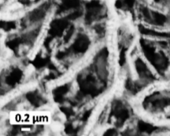 | HER: 157 (Ƞ₁₀) | HER: 91
NiTe² | Hydrothermal reaction | 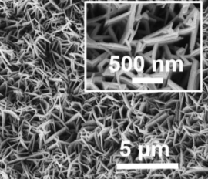 | OER: 262 (Ƞ₁₀) | 74
Te@NiTe₂/NiS³ | Hydrothermal procedure + solvothermal reaction | 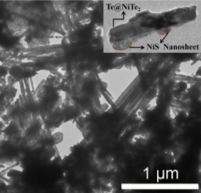 | HER: 101 (Ƞ₁₀) | HER: 70.3
Pb_{0.95}Ni_{0.05}Te⁴ | Two-step Te self-sacrificed  template solvothermal method | 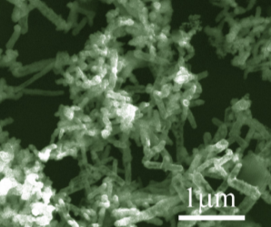 | OER: 387 (Ƞ₁₀) | 96
Ni₂P/NiTe₂⁵ | Hydrothermal procedure + high- temperature  phosphating | 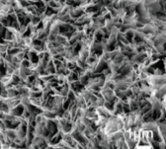 | HER: 62 (Ƞ₁₀) | 80
N-doped Ni₃S₂⁶ | Hydrothermal procedure + Ammonia treatment | 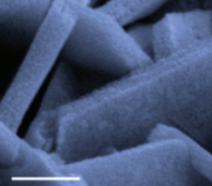 | HER:155 (Ƞ₁₀) | 113
NiTe/NiS⁷ | Two step hydrothermal reaction | 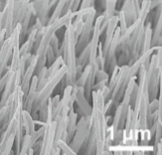 | OER: 254(Ƞ₁₀₀) | 49
Ni₃Te₂⁸ | Hydrothermal reaction + phosphating and electrodeposition | 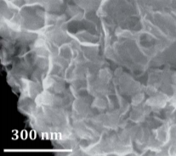 | HER: 237 (Ƞ₁₀)  OER: 180 (Ƞ₁₀) | HER: 126.8  OER: 61.5
NiCo₂N/NF⁹ | Electrodeposition and NH₃ treatment | 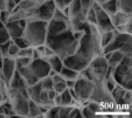 | HER: 150 (Ƞ₁₀)  OER: 260 (Ƞ₁₀) | HER: 79  OER: 69
Ni₂Co-N¹⁰ | Hydrothermal reaction + NH₃ treatment | 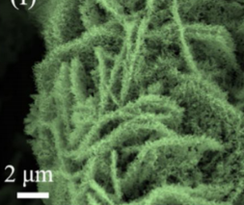 | HER: 143 (Ƞ₁₀)  OER: 214 (Ƞ₁₀) | HER: 104  OER: 53
NiCoO₂/CoO/Ni₃N¹¹ | Hydrothermal reaction + NH₃ treatment | 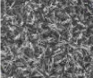 | OER: 115 (Ƞ₁₀) | OER: 64.2
N-NiVFeP/  NFF¹² | Hydrothermal reaction + Ammonia treatment | 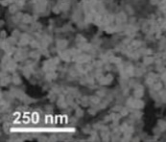 | OER: 247 (Ƞ₁₀) | OER: 35
Cu₁Ni₂-N¹³ | Hydrothermal reaction + Ammonia treatment | 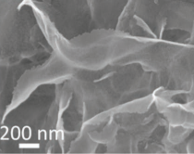 | HER: 71.4 (Ƞ₁₀) | HER: 74.2
(Ni_{3−x}Fe_{x})FeN/Ni¹⁴ | Nitriding the corresponding NiFe-based precursors. | 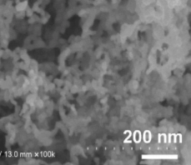 | OER: 223 (Ƞ₁₀) | OER: 68
(Ni-MoO₂/NF-IH@NiFe LDH/NF-IH)¹⁵ | High-frequency induction heating (IH) | 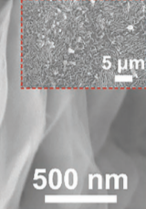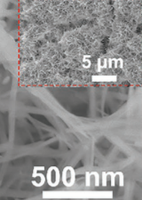 | HER: 39 (Ƞ₁₀)  OER: 246 (Ƞ₁₀) | HER: 75  OER: 60.2
Co₉S₈/Cu₂S/CF¹⁶ | Multistep impregnation and electrodeposition | 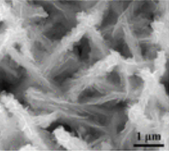 | HER: 165 (Ƞ₁₀)  OER: 195 (Ƞ₁₀) | HER: 80.2  OER: 78.8
NiCo||NiFe¹⁷ | Gas-templated electrodeposition | 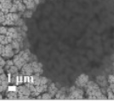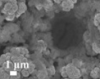 | HER: 86 (Ƞ₁₀)  OER: 206 (Ƞ₁₀) | HER: 62.1  OER: 43.5
NiCoFe-PS¹⁸ | Hydrothermal electrodeposition + dealloying and sulfidization / phosphorization | 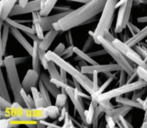 | HER: 97.8 (Ƞ₁₀)  OER: 195 (Ƞ₁₀) | HER: 51.8  OER: 40.3
NiMoO_{x}-NiMoS¹⁹ | Hydrothermal reaction + oxidation plasma treatment | 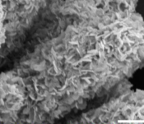 | HER: 38 (Ƞ₁₀)  OER: 186 (Ƞ₁₀) | HER: 38  OER: 34
MoO₃/Ni–NiO²⁰ | Novel sequential electrodeposition strategy. | 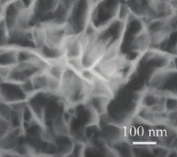 | HER: 62 (Ƞ₁₀)  OER: 347 (Ƞ₁₀) | HER: 59  OER：60

Table S4. EIS analyses corresponding to Nyquist curves in Figure S11.

 | R_{ct} (Ω) | R_{Ω} (Ω) | CPE-T(F) | CPE-P (F)
NiTe-NiCoN | 3.522 | 2.727 | 0.008071 | 0.64386
NiCoN-NF | 6.476 | 2.70 | 0.0063507 | 0.7497
NiTe | 53.68 | 5.137 | 0.005424 | 0.77566
NiTe-NiFeN | 4.648 | 3.794 | 0.05765 | 0.73894
NiFeN-NF | 8.859 | 3.504 | 0.015465 | 0.76072
NiTe | 38.47 | 4.441 | 0.0037573 | 0.77264

Movie S1 NiTe-NiCoN || NiTe-NiFeN seawater electrolyzer was tested by a solar-powered system at 2 V.

Movie.S2 NiTe-NiCoN || NiTe-NiFeN seawater electrolyzer was tested by a wind-powered system at about 1.7 V.

References
1 Anantharaj, S., Karthick, K. & Kundu, S. NiTe₂ Nanowire Outperforms Pt/C in High-Rate Hydrogen Evolution at Extreme pH Conditions. Inorg Chem 57, 3082-3096 (2018).
2 Wang, Z. & Zhang, L. In situ growth of NiTe nanosheet film on nickel foam as electrocatalyst for oxygen evolution reaction. Electrochem. Commun. 88, 29-33 (2018).
3 Mingli, F., Xue, L., Dandan, W., Yinling, W. & Maoguo, L. Fabrication of Te@NiTe₂/NiS heterostructures for electrocatalytic hydrogen evolution reaction. Electrochim. Acta 328, 135075 (2019).
4 Wang, Q., Zhu, J., Wang, H., Yu, S. & Wu, X. Anchoring NiTe domains with unusual composition on Pb_{0.95}Ni_{0.05}Te nanorod as superior lithium-ion battery anodes and oxygen evolution catalysts. Mater. Today Energy 11, 199-210 (2019).
5 Li, Y. et al. Phosphine vapor-assisted construction of heterostructured Ni2P/NiTe2 catalysts for efficient hydrogen evolution. Energy & Environ. Sci. 13, 1799-1807 (2020).
6 Kou, T. et al. Theoretical and Experimental Insight into the Effect of Nitrogen Doping on Hydrogen Evolution Activity of Ni₃S₂ in Alkaline Medium. Adv. Energy Mater. 8, 1703538 (2018).
7 Xue, Z. et al. Interfacial Electronic Structure Modulation of NiTe Nanoarrays with NiS Nanodots Facilitates Electrocatalytic Oxygen Evolution. Adv Mater. 31, 1900430 (2019).
8 De Silva, U. et al. Nickel telluride as a bifunctional electrocatalyst for efficient water splitting in alkaline medium. J.Mater. Chem. A 6, 7608-7622 (2018).
9 Wang, Y., Zhang, B., Pan, W., Ma, H. & Zhang, J. 3 D Porous Nickel-Cobalt Nitrides Supported on Nickel Foam as Efficient Electrocatalysts for Overall Water Splitting. ChemSusChem 10, 4170-4177 (2017).
10 Gao, X. et al. Surface nitridation of nickel-cobalt alloy nanocactoids raises the performance of water oxidation and splitting. Appl. Catal. B. 270, 118889 (2020).
11 Li, Y. et al. Ni/Co-based nanosheet arrays for efficient oxygen evolution reaction. Nano Energy 52, 360-368 (2018).
12 Fan, H. et al. Plasma-heteroatom-doped Ni-V-Fe trimetallic phospho-nitride as high-performance bifunctional electrocatalyst. Appl. Catal. B.268, 118440 (2020).
13 Wang, Z. et al. Copper–Nickel Nitride Nanosheets as Efficient Bifunctional Catalysts for Hydrazine–Assisted Electrolytic Hydrogen Production. Adv. Energy Mater. 9, 190039 (2019).
14 Yan, M. et al. In situ construction of porous hierarchical (Ni_{3-x}Fe_{x})FeN/Ni heterojunctions toward efficient electrocatalytic oxygen evolution. Nano Research 13, 328-334 (2020).
15 Xiong, G. et al. Rapid Synthesis of Various Electrocatalysts on Ni Foam Using a Universal and Facile Induction Heating Method for Efficient Water Splitting. Adv.d Funct. Mater. 31, 2009580 (2021).
16 Zang, Z. H. et al. Co₉S₈ Nanosheet Coupled Cu₂S Nanorod Heterostructure as Efficient Catalyst for Overall Water Splitting. Acs Appl.Mater. & Interfaces 13, 9865-9874 (2021).
17 Zhou, J. Q. et al. Ultrafast fabrication of porous transition metal foams for efficient electrocatalytic water splitting. Appl. Catal. B 288, 120002 (2021).
18 Yao, M. et al. Self-Supportive Mesoporous Ni/Co/Fe Phosphosulfide Nanorods Derived from Novel Hydrothermal Electrodeposition as a Highly Efficient Electrocatalyst for Overall Water Splitting. Small 15, 1905201 (2019).
19 Zhai, P. L. et al. Engineering active sites on hierachical transition bimetal oxides/sulfies heterostructure array enabling robust overall water splitting. Nat. Commun. 11, 5462 (2020).
20 Li, X. P. et al. Sequential Electrodeposition of Bifunctional Catalytically Active Structures in MoO₃/Ni-NiO Composite Electrocatalysts for Selective Hydrogen and Oxygen Evolution. Adv. Mater. 32, 2003414 (2020).

