Appendices
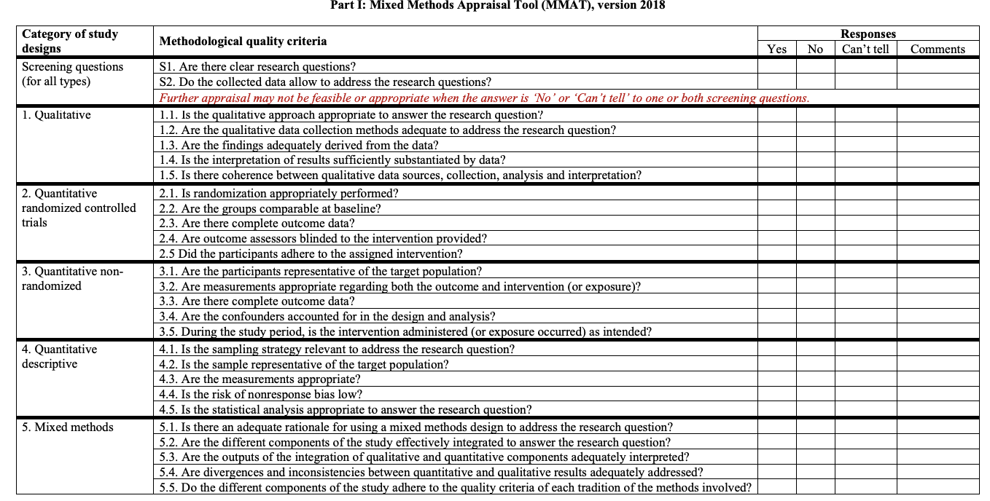
Figure 1. Mixed Methods Assessment Tool version 2018

Figure 2. The PRISMA-S 2020 27-item checklist for what must be included in a systematic review.
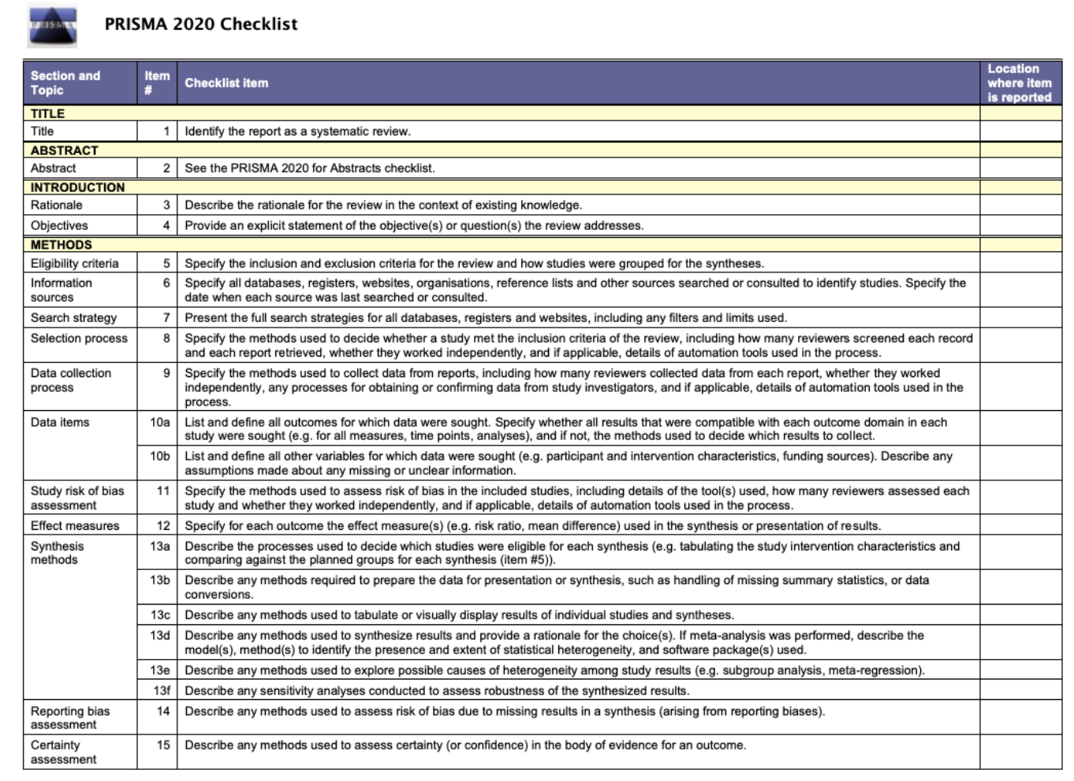

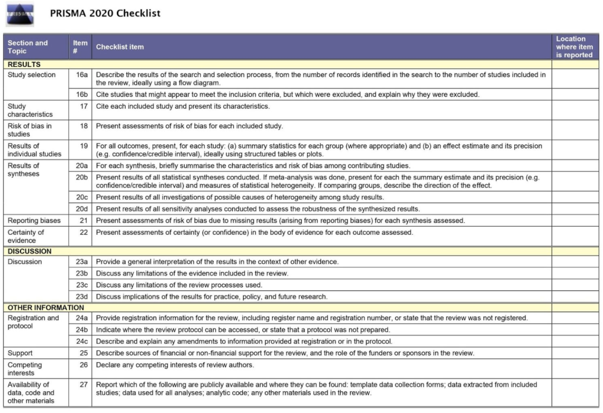
Figure 3. The NIH Checklist for quality assessment of systematic review and meta-analyses
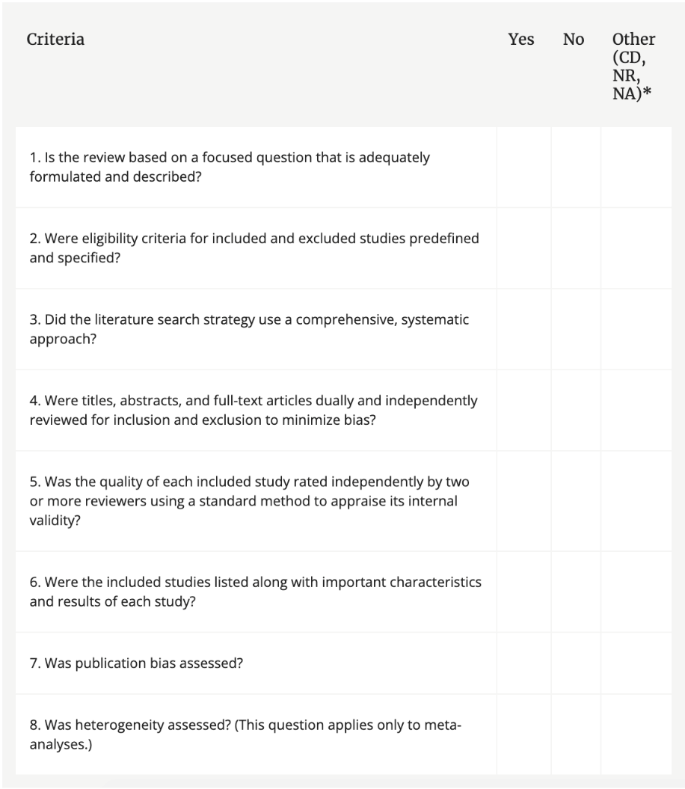

Figure 4. Flow diagram representing the steps taken from the beginning to end of data extraction and sourcing of research materials.
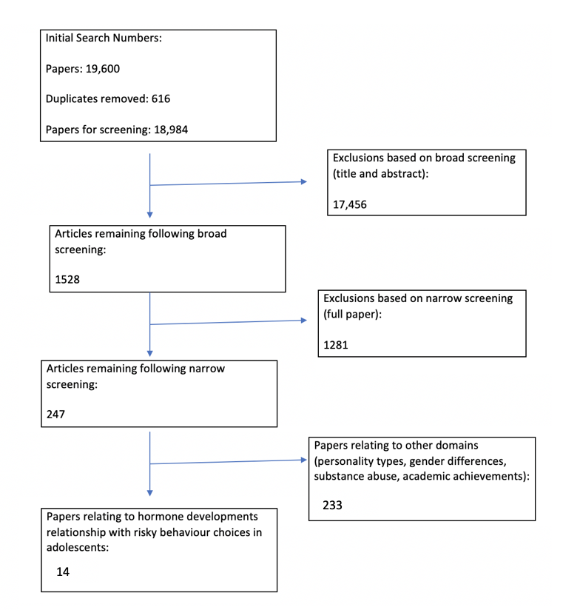

Figure 5. A summary table displaying the authors, population, method, outcomes, findings, conclusions and limitations of each study.
Authors/ Location | Population/topic | Method | Outcomes/variables | Findings | Conclusions | Limitations
Harden et al (2018)  USA | 810 adolescents.  Sensation seeking and hormonal development | Self-reported surveys and salivary testing | - Age  - Pubertal development  - Testosterone  - Estradiol  - Stoplight  - BART score  - IGT score  - Sensation seeking | Sensation seeking significantly related to testosterone in girls and estradiol in boys | Sensation seeking and reward sensitivity are more evidenced for boys than girls. More research needed on sex-specific developmental mechanisms. | Hormones were only measured once even though there are multiple dimensions that could affect their levels at the time of testing.
Shulman et al, (2015)  USA and Canada | 8,270 individuals aged 10-25.  Sex differences in impulse control and sensation seeking | Longitudinal study using self-administered assessments | - Age  - Sex  - Impulse control  - Sensation seeking  - Time point | Risk taking behaviours have a larger magnitude during adolescence for males than females. | Male and female sensation seeking trajectories are similar. More research needed assessing changes in pubertal hormones. | The scales used are indirect measures and the scales were only 3-items long so may not capture all facets.
De Macks et al, (2016)  USA | 78 adolescent girls  risky decision making by girls due to hormones and reward circuitry | Interviews, computer tasks, questionnaires and an MRI scan. Home-kit saliva samples | - Testosterone level  - Estradiol level  - PDS score  - RQ score  - Age | Higher testosterone levels was linked to higher levels of risk taking. Both hormones contribute indirectly. | Further research is needed outside of a laboratory setting for individual differences. Indicates texting may be possible for biomarkers. | The risk-taking items were not applicable to the real world and the results are up to interpretation which is risky.
Braams et al, (2015)  The Netherlands | 299 male participants, age 8-26  neural responses to reward, puberty and risky behaviours | Longitudinal study over 2 years. MRI scans, PDS, BART and BAS/BIS questionnaire. Saliva samples | - Age  - PDS score  - Testosterone  - BAS score  - BIS score  - BART score  - Time point | Longitudinal peak in nucleus accumbens activity to rewards. Individual differences seen | Future research should determine which factor lead to stabilization of the reward system to reduce risky behaviours | They did not parametrically manipulate rewards and losses to distinguish between drives for activities
Rosenblitt et al, (2001)  USA | 68 males and 75 females.  Sensation seeking and hormones in men and women | SSS-V self-report scale, with 4 subscales, saliva samples | - Gender  - SSS-V  - Saliva sample  - age | Testosterone levels were higher in males and subsequently so were sensation seeking behaviours. No significant relationship between testosterone and sensation seeking directly. | Theory based interdisciplinary research should be done to improve the understand of biological influences on human behaviour. Controls for gendered expectations should be included. | Could not control for social and religious values towards risk and sensation seeking behaviours. Not representative of college students all across America or men and women retrospectively.
De Macks et al (2011)  The Netherlands and USA | 17 males and 33 females aged 10-16  testosterone, ventral striatum activation and monetary rewards | PBIP and PBIP self-report scales, saliva samples, fMRI and Jackpot Gambling task | - gender  - risk-taking condition  - estradiol level  - testosterone level  - DHEA levels  - PDS score  - PBIP score | Higher Testosterone levels in boys and girls linked to increased reward-related activation. Higher estradiol in girls linked to increase reward-related activation. | Gonadal hormones such as testosterone and estradiol are linked to neural response of increased reward sensitivity. There was more robust result for boys than girls. | Age was correlated with puberty and testosterone maybe confounding the relationship between testosterone and striatum activation.
Campbell et al (2010)  USA | 98 male participants aged 18-23  testosterone exposure, dopaminergic reward and sensation seeking | Saliva samples, a questionnaire, sensation seeking scales and background information all collected. Then a facial photograph and scans of hands. | - SSS scores  - Frontal facial photographs  - 2D:4D hand scans  - DNA samples  - Testosterone levels  - Ethnicity  - Age  - Sexual orientation  - DRD4 gene | Testosterone levels linked to boredom susceptibility Increased testosterone linked to less storage of dopamine and more sensation seeking. | Testosterones link to sensation seeking could be via genetic quality not dopamine levels. More research should be done on the dopaminergic reward system and using fMRI for androgen impacts. | Was unable to determine the specific link and therefore relationship between testosterone and sensation seeking.
Kerschbaum et al (2006)  Austria | 19 female and 23 male participants aged 17-19 years old  Gender differences in sensation seeking and social interaction due to testosterone in adolescents. | Saliva testosterone taken and sensation seeking questionnaires done on SSS-V, anxiety and social interactions. | - Testosterone levels  - Zuckerman’s SSS-V questionnaire  - Gender  - Examination | No significant relationship between anxiety and testosterone. No correlation between testosterone and SSS-V scores for males but is for females. | Men react to stressors with fight or flight and women react with tend and befriend. Gender dependant correlation found here. Girls with high testosterone are highly likeable by peers. | Discrepancies between this study and previous findings due to using different paradigms. Possibly inconsistent.
Peper et al, (2018)  Netherlands | 299 male and female participants aged 8-26  multifaceted risk taking relationship with sex steroid hormones | Longitudinal study done over 3 time points measuring risk taking and impulsiveness personality types against testosterone and estradiol | - BART money score  - BART explosions score  - BIS-11 score  - BIS avoidance score  - BAS approach score  - BPA-Q score  - NEO_PI score  - Testosterone levels  - Estradiol levels  - Gender  - Time point | Estradiol is not associated with risk taking in males. Estradiol and testosterone had no impact on risk taking in females. Higher testosterone in males linked to impulsive personalities but nothing else. | Non-linear age related patterns in risk-taking behaviours. Salivary testosterone is a biomarker for developmental processes and estradiol is a biomarker for individual differences. Testosterone accelerates maturational processes. | They used participants undergoing puberty as well as ones who had surpassed it. Participants were paid a fee to participate. BART task and delayed discounting task don’t represent real life risk taking.
Peper et al (2013)  Netherlands | 268 male and female participants aged 8-25 years old  contributions from testosterone and orbito-frontal cortex to risk taking in adolescents. | The participants underwent hormonal sampling, neuroimaging sessions and behavioural testing within different pubertal groups testing for age vs pubertal development. | - Age  - PDS  - Testosterone level  - BART explosions score  - BART money score  - Estimated IQ | BART risk taking scale associated with pubertal development. Higher testosterone was linked to more explosions on BART. Males have more explosions of risk taking than females. | More longitudinal studies are needed to show development of OFC and its protective effect on risk-taking. First study to show testosterone contributes to risk taking due to medial OFC morphology. Sheds light on hormonal development over age. | Testosterone gender differences may be due to natural variation which wasn’t considered. This also makes testosterone more reliable to measure. PDS may be a better indicator for risk taking for girls than testosterone.
Braams et al (2016)  Netherlands | Male and female participants aged 8-27 years old  Nucleus accumbens response to rewards and testosterone levels related to alcohol use in adolescents and young adults | Longitudinal study over 2 time points recruited through newspapers. Completed questionnaires and saliva samples as well as experimental tasks in a lab. | - Age  - Testosterone levels  - Left nucleus accumbens  - Right nucleus score accumbens score  - Average glasses a night  - Average glasses a month  - Total lifetime glasses. | Right nucleus accumbens and testosterone predicted consumption of alcohol. Testosterone at the first point predicted alcohol usage at the second time point per month | Nucleus accumbens activation for reward seeking is linked to alcohol usage. Confirmed relationship between neural activation and risk taking. Testosterone showed predictive relationship of alcohol 2 years later. | Self-report measures used so not as reliable. Large variation for participants measuring month by month on circumstances e.g. more parties/events. Risk-taking is too broad to be a singular category and should’ve been broken down.
Mehta et al, (2015)  USA | Study 1-115 Male and female students aged 18-30.  Study 2- 165 male students aged 18-30  Testosterone and cortisol jointly modulate risk-taking | 2 studies, one using both sexes, one using only males. Study 1 did self-report tasks, informant reported tasks and saliva samples. Study 2 did self-report tasks and saliva samples. | - Zuckerman’s impulsive sensation seeking scale.  - Cortisol levels  - Testosterone levels  - Informant reports  - Age  - Gender  - Time of saliva sample | Significant relationship between high testosterone, low cortisol and self-reported risk taking. No relationships found when cortisol is high. Significant relationship between testosterone cortisol and informant reports. No gender differences | Consistent positive relationships between testosterone and risk taking when cortisol is low. Small effect size when cortisol is high suggesting cortisol is a mediating factor between testosterone and risk-taking in both sexes. | Non-adolescent age range so testosterone isn’t dependant on puberty. Hormone samples were taken at different times of the day according to participants. Can’t be sure that testosterone and cortisol are a direct link to risk-taking behaviours due to endogenous hormone concentrations.
Cardoos et al (2017)  USA | 63 females aged 10-14 years old with ethnically diverse backgrounds. High socioeconomic status  social status strategy in early adolescent girls. Testosterone and value-based decision making. | One lab visit doing questionnaires and tasks. Parents did Child behaviour checklist and girls did an at home salivary sample collection. Given 20 dollars and pries | - Age  - WISC_IV Vocabulary  - Socioeconomic status  - Pubertal development scale  - Testosterone levels  - Estradiol levels.  - Auction task. | Self-reported pubertal development and testosterone both predicted overbidding on auction task. Estradiol had no significant impact. | Additional evidence here for association between pubertal development and girls drive for social status. Additional research needed into specific pathway from puberty development to hormones. | Value based decisions rather than sensation seeking decisions. Monetary reward issued. Self-report measure of puberty used to obtain limited reliability. Needed to be a longitudinal study.
Stanton et al, (2010)  USA | 154 students from Michigan University both male and female. Mostly white population mean age of approx. 20 years old.  Testosterone and risk taking in the Iowa gambling task. | Providing consent at the lab. Study done via computer programs. Personality questionnaires, 2 cognitive tasks and a salivary sample was taken. Completed Iowa gambling task. | - Gender  - Testosterone levels  - IGT  - Personality questionnaire  - Cognitive tasks | Higher testosterone individuals took greater risk than low testosterone individuals. Testosterone associated with greater risk taking similar results in both genders but not significant for men when tested separately. | Endogenous testosterone positively associated with increases in risk taking among men and women. Low testosterone individuals avoided monetary punishment via loss. Higher testosterone equals higher economic risk taking. Matches real world domains e.g. investors. | Only used a single task for economic risk taking so not generalise able. Didn’t examine estradiol even though there was cause to. Gender differences were not investigated enough.

