Randomized Placebo-Controlled Trial of Psyllium Fiber in Functional Abdominal Pain Disorders in Children
Journal: Digestive Diseases and Sciences
Manjit Kaur, Ujjal Poddar, Anshu Srivastava, Moinak Sen Sarma, Prabhakar Mishra
Corresponding Author:
Ujjal Poddar.
Professor and Head, Department of Pediatric Gastroenterology,
Sanjay Gandhi Post Graduate Institute of Medical Sciences,
Raebareli Road, Lucknow 226014, India.
E-mail: ujjalpoddar@hotmail.com; Telephone: 00915222494418.
Fax number 00915222668017

Supplementary information (S1)
Pain score table (To be filled by parents/child)

S.NO | DATE | TIME OF ONSET | TIME ENDED | INTENSITY POINTS | ANALGESIC USE (+/-) | NAME AND DOSE | MODE OF ADM

Visual analogue scale (To be filled by parents)
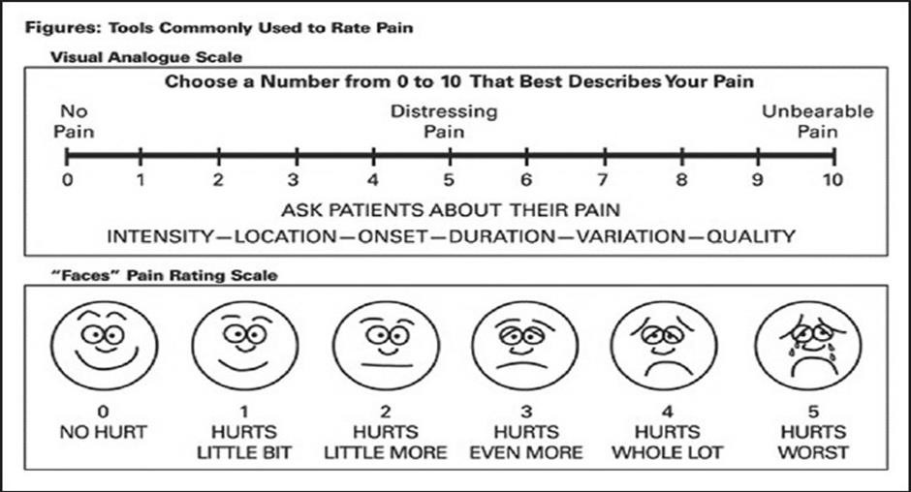

Instructions for score pain frequency and duration

Scores | Pain frequency  (No. of pain episodes- total (baseline 4 weeks and during treatment-12  weeks) treatment) * |  | Pain duration (in hours)
Scores | Baseline (4 weeks) | During-  treatment (12 weeks) | Baseline (4 weeks) | During-  treatment (12 weeks)
0 | No pain | No pain | No pain | No pain
2 | ≤4 | ≤12 | ≤4 | ≤12
4 | >4-8 | >12-24 | >4-8 | >12-24
6 | >8-12 | >24-36 | >8-12 | >24-36
8 | >12-16 | >36-48 | >12-16 | >36-48
10 | >16 | >48 | >16 | >48

*At least 10 minutes of pain is considered as 1 episode

Pain Score Table (To be filled by investigator)

 | BEFORE RANDOMIZATION | AFTER 3 MONTHS
INTENSITY (/10)
FREQUENCY (/10)
DURATION (/10)
TOTAL (/30)
Quality of life score (/10)

Number of doses of analgesic used (after 3 months):

Supplementary information (S2)

Quality of life scale (to be filled by investigator)

10 | Stay in bed all day, Feel hopeless and helpless about life
9 | Stay in bed at least half the day Have no contact with outside world
8 | Get out of bed but don’t get dressed. Stay at home all day
7 | Get dressed in the morning Minimal activities at home. Contact with friends via phone, email
6 | Struggle but fulfil daily home responsibilities No outside activity Not able to work/volunteer
5 | Do simple chores around the house. Minimal activities outside of home two days a week
4 | Work/volunteer limited hours. Take part in limited social activities on weekends
3 | Work/volunteer for a few hours daily. Can be active at least five hours a day. Can make plans to do simple activities on weekends
2 | Work/volunteer for at least six hours daily Have energy to make plans for one evening  social activity during the week Active on weekends
1 | Work/volunteer/be active eight hours daily. Take part in family life. Outside social activities limited
0 | Go to work/volunteer each day. Normal daily activities each day. Have a social life outside of work  Take an active part in family life

