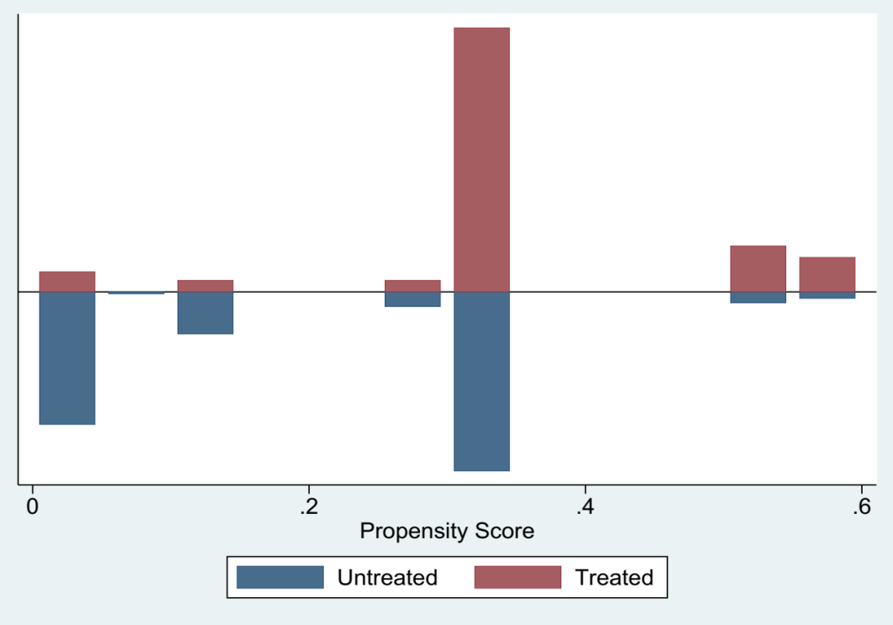

Supplementary figure 1: Propensity Score match common support on covariates for SMD sub-study

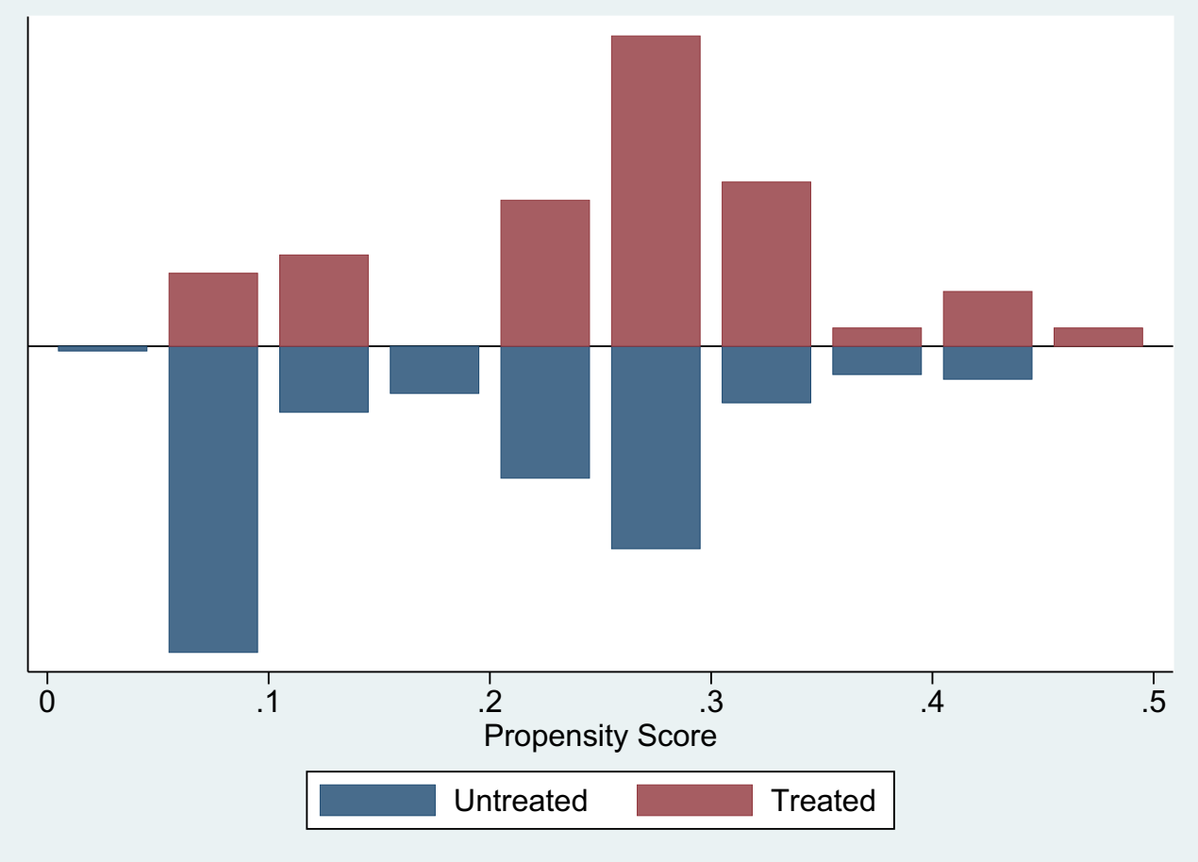
Supplementary figure 2: Propensity Score match common support on covariates for depression sub-study
Supplementary Table 1. Predictors of changes in income and consumption expenditure over 12- months in households of persons in severe mental disorder interventions.
I. Household income
Characteristics | Change in income† (T2-T1)
Characteristics | Unadjusted model | Adjusted model
Characteristics | ß (CI) | ß (CI)
Female household head(ref. male) | -572.28(-3056.34, 1911.77) | -279.86 (-5628.60, 5068.87)
No formal education (ref. Primary and above) | -197.37(-2487.27, 2092.51) | -338.55 (-3153.20, 2476.09)
Rural (ref. urban) | -1612.30(-4501.31, 1276.69) | -1313.00 (-3734.47, 6360.48)
Baseline WHODAS complex score | 20.575(-27.42, 68.57) | -7.25(-27.83, 26.38)
Months treatment followed | 521.88(-66.56, 977.20) | 401.48(- 443.47, 1246.44)
Baseline income | 0.424(0.032, 0 .816) | -0.188(-0. 530, 0.153)
II. Household consumption expenditure
Characteristics | Change in consumption expenditure†
Characteristics | Unadjusted model | Adjusted model
Characteristics | ß (CI) | ß (CI)
Female household head(ref. male) | 925.54(-1168.36, 3019.44) | -795.06(-1967.91, 3558.04)
No formal education (ref. Primary and above) | -1124.65 (-3052.34, 803.03) | -2456.71*(-4651.32, -262.11)
Rural(ref. urban) | -1652.37(-4059.48, 754.72) | -2363.20(-5909.34, 1182.94)
Household debt | 0.164(-0.164, 0.493) | -0.207(-0.473, 0.889)
Baseline consumption | -0.211***(-0.320, -0.102) | -0.274(-0.610, 0.060)

†=Birr; US$1= Birr 20.69 (2015) ; P<0.05*, P<0.001***.; WHODAS (World Health Organization Disability Assessment Scale)

Supplementary Table 2. Predictors of changes in income and consumption over 12- months in households of persons in depression intervention
I. Household income
Characteristics | Change in income†
Characteristics | Unadjusted model | Adjusted model
Characteristics | ß (CI) | ß (CI)
Female household head (ref. male) | -238.28 (-2519.49, 2042.92) | -663.79 (-2843.27, 1515.68)
No formal education(ref. Primary and above) | 664.73 (-1223.36, 2552.83) | -146.39 (-1683.36, 1976.15)
Rural residence(ref. urban) | -3685.38**(-6134.70, -1236.07) | -3347.13(-7074.75, 380.24)
Baseline WHODAS complex score | 31.75 (-19.37, 82.88) | -2.36 (-44.16, 48.90)
Months treatment followed | 331.52(-221.47, 884.52) | 105.59 (-320.64, 531.83)
Baseline income | -0.56***1(-0.750, -0.372) | -0.433***(-0.669, -0.197)
II. Household consumption expenditure
Characteristics | Change in consumption expenditure†
Characteristics | Unadjusted model | Adjusted model
Characteristics | ß (CI) | ß (CI)
Female household head | -3468.58(-7426.42 , 489.25) | -3372.58 (-5530.32, 1214.83)
No formal education(ref. primary and above) | 1874.13(-1435.13, 5183.40) | -354.16 (-2795.46, 2087.13)
Rural residence (ref. urban) | -935.11(-5279.48, 3409.26) | -1398.24 (-4681.23, 1884.73)
Household debt | -0.109(-0.228, 0.448) | -0.057(-0.136, 0.252)
Baseline consumption | -0.908***(-1.052, -0.765) | -0.861***(-1.077, -0.645)

†=Birr; US$1= Birr 20.69 (2015) ; P<0.01**;P<0.001***.; WHODAS (World Health Organization Disability Assessment Scale).

