Visible light active Nitrogen and Cobalt co-doped TiO₂ Nanoparticles: Synthesis, Characterization and Photocatalytic activity
Aroosa Javed* ª, Memoona Qammar^{a, b}, Rooha Khurram^{c}, Zaib-un-Nisaª and Habib Nasirª

- Department of chemistry, National University of Sciences and Technology (NUST), Sector H-12 Islamabad 44000, Pakistan
- Department of Chemistry, Hong Kong University of Science and Technology (HKUST), Clear Water Bay Road, Kowloon, 999077, Hong Kong SAR
- Beijing Key laboratory for green catalysis and separation, Department of Chemistry and Chemical engineering Beijing university of technology Beijing 100124, China
*Corresponding author.
Aroosa Javed
Email: aroosa.899@gmail.com
Contact number: +92-302-5276422

__________________________________________________________________________________

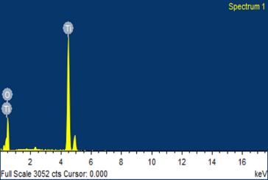
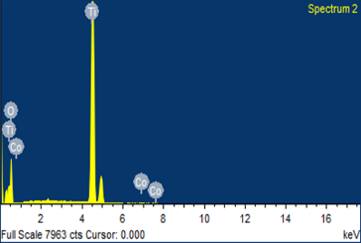
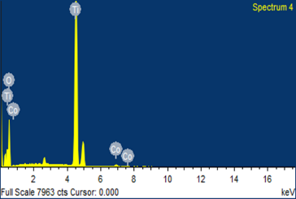
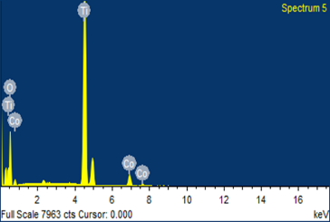
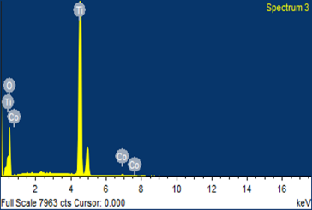
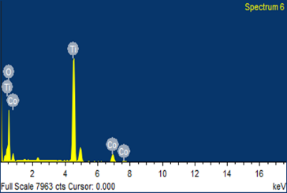
Figure S1. EDX Spectra of (a) TiO₂ (b) CoN-TiO₂-1 (c) CoN-TiO₂-2 (d) CoN-TiO₂-3 (e CoN-TiO₂-4) (f) CoN-TiO₂-5

a
b
d
e
c
f

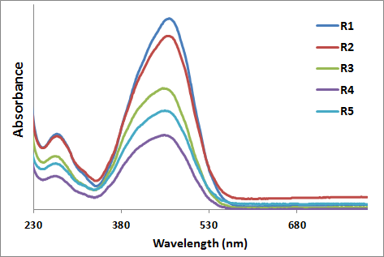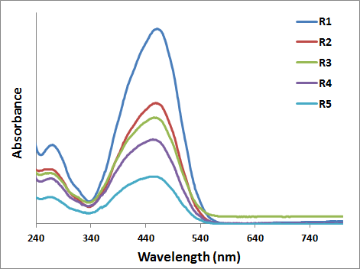
(b)
(a)
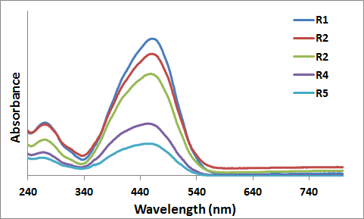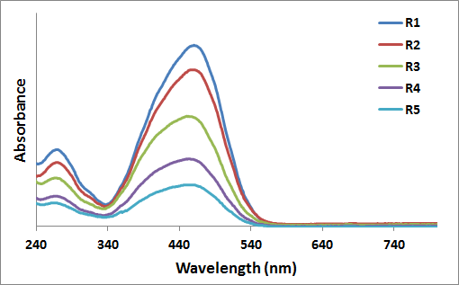
(d)
(c)
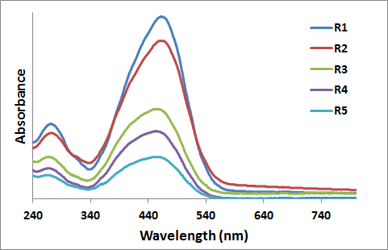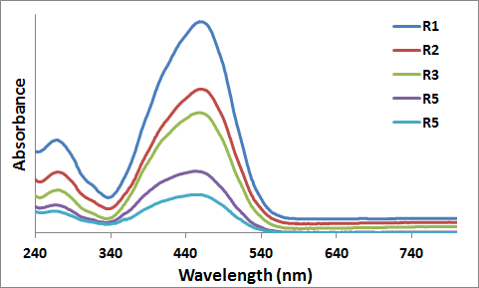
(f)
(e)

Figure S2. Degradation graphs of methyl orange by using (a) undoped TiO₂ (b) CoN-TiO₂-1 (c) CoN-TiO₂-2 (d) CoN-TiO₂-3 (e) CoN-TiO₂-4 (f) CoN-TiO₂-5

Catalyst | Time (hr.) | Absorbance | C_{t} | C_{o} | C_{t}/C_{o} | ln C_{t}/C_{o} | Negative of ln C_{t}/C_{o}
TiO₂ nanoparticles | 1 | 0.64 | 1.64 | 1.68 | 0.98 | - 0.02 | 0.02
TiO₂ nanoparticles | 2 | 0.58 | 1.53 | 1.68 | 0.91 | - 0.09 | 0.09
TiO₂ nanoparticles | 3 | 0.53 | 1.43 | 1.68 | 0.85 | - 0.16 | 0.16
TiO₂ nanoparticles | 4 | 0.49 | 1.36 | 1.68 | 0.81 | - 0.21 | 0.21
TiO₂ nanoparticles | 5 | 0.45 | 1.23 | 1.68 | 0.73 | - 0.31 | 0.31
CoN-TiO₂-1 | 1 | 0.59 | 1.54 | 1.62 | 0.95 | - 0.05 | 0.05
CoN-TiO₂-1 | 2 | 0.49 | 1.36 | 1.62 | 0.84 | - 0.13 | 0.13
CoN-TiO₂-1 | 3 | 0.42 | 1.22 | 1.62 | 0.75 | - 0.24 | 0.24
CoN-TiO₂-1 | 4 | 0.36 | 1.10 | 1.62 | 0.68 | - 0.38 | 0.38
CoN-TiO₂-1 | 5 | 0.26 | 0.91 | 1.62 | 0.56 | - 0.58 | 0.58
CoN-TiO₂-2 | 1 | 0.57 | 1.51 | 1.62 | 0.93 | - 0.08 | 0.08
CoN-TiO₂-2 | 2 | 0.46 | 1.30 | 1.62 | 0.80 | - 0.22 | 0.22
CoN-TiO₂-2 | 3 | 0.37 | 1.13 | 1.62 | 0.70 | - 0.42 | 0.42
CoN-TiO₂-2 | 4 | 0.32 | 1.02 | 1.62 | 0.63 | - 0.56 | 0.56
CoN-TiO₂-2 | 5 | 0.22 | 0.84 | 1.62 | 0.52 | - 0.65 | 0.65
CoN-TiO₂-3 | 1 | 0.54 | 1.45 | 1.60 | 0.91 | - 0.07 | 0.07
CoN-TiO₂-3 | 2 | 0.44 | 1.25 | 1.60 | 0.78 | - 0.25 | 0.25
CoN-TiO₂-3 | 3 | 0.35 | 1.08 | 1.60 | 0.68 | - 0.38 | 0.38
CoN-TiO₂-3 | 4 | 0.28 | 0.95 | 1.60 | 0.60 | - 0.51 | 0.51
CoN-TiO₂-3 | 5 | 0.19 | 0.78 | 1.60 | 0.49 | - 0.71 | 0.71
CoN-TiO₂-4 | 1 | 0.53 | 1.43 | 1.56 | 0.87 | - 0.10 | 0.10
CoN-TiO₂-4 | 2 | 0.39 | 1.17 | 1.56 | 0.75 | - 0.28 | 0.28
CoN-TiO₂-4 | 3 | 0.32 | 1.02 | 1.56 | 0.65 | - 0.43 | 0.43
CoN-TiO₂-4 | 4 | 0.23 | 0.86 | 1.56 | 0.55 | - 0.60 | 0.60
CoN-TiO₂-4 | 5 | 0.15 | 0.70 | 1.56 | 0.45 | - 0.80 | 0.80
CoN-TiO₂-5 | 1 | 0.45 | 1.28 | 1.49 | 0.86 | - 0.15 | 0.15
CoN-TiO₂-5 | 2 | 0.31 | 1.01 | 1.49 | 0.68 | - 0.38 | 0.38
CoN-TiO₂-5 | 3 | 0.26 | 0.91 | 1.49 | 0.61 | - 0.49 | 0.49
CoN-TiO₂-5 | 4 | 0.17 | 0.74 | 1.49 | 0.50 | - 0.7 | 0.7
CoN-TiO₂-5 | 5 | 0.11 | 0.63 | 1.49 | 0.42 | - 0.87 | 0.87
Table S1. Degradation rate calculation for MO degradation under visible light

