Supplementary Material

Supplementary Figure S1. Risk of Bias 2 (RoB 2) traffic-light plot
Per-study, per-domain judgements for the 9 randomised controlled trials included in the meta-analysis, generated using the robvis R package (McGuinness & Higgins, 2021). D1 = bias due to randomisation; D2 = bias due to deviations from intended interventions; D3 = bias due to missing outcome data; D4 = bias in measurement of the outcome; D5 = bias in selection of the reported result. Green (+) = low risk; yellow (−) = some concerns; red (×) = high risk.
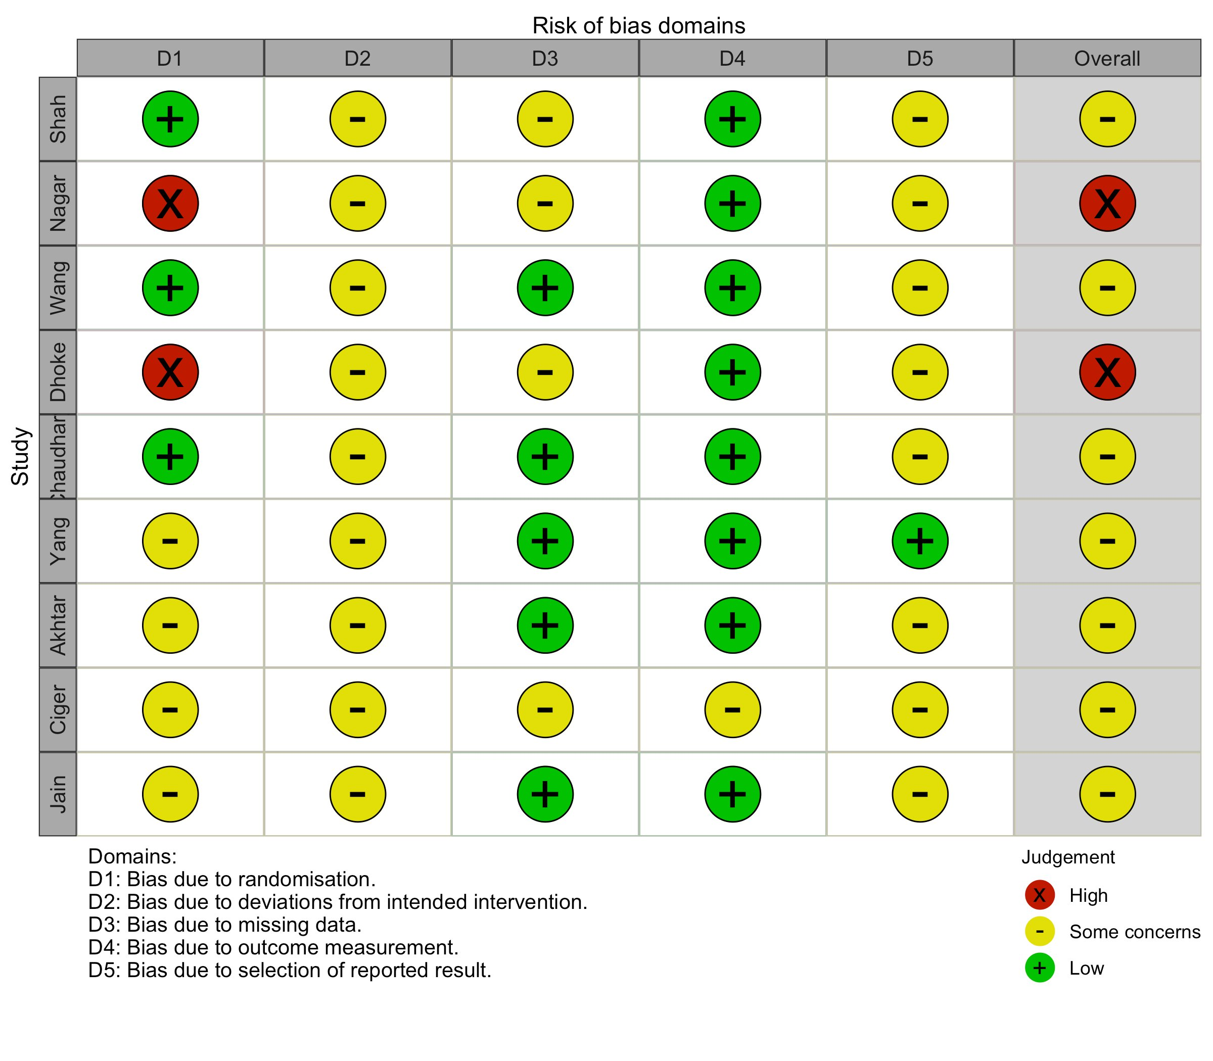

Supplementary Figure S2. Risk of Bias 2 (RoB 2) summary plot
Distribution of risk-of-bias judgements across all 9 randomised controlled trials, by domain.
