Table S1. Inclusion and Exclusion Criteria for Mothers in the Research.
 | Details
Inclusion Criteria | The gestational age was between 37 to 42 weeks  Having regular prenatal visits  Clinical data is available  Their infants delivered later are restricted to normal full-term
Exclusion Criteria | < 18 years  Multiple pregnancy  Having infectious diseases caused by bacteria, virus or parasite  ♦ Group B hemolytic Streptococcus  ♦ Hepatitis A, B, and C viruses  ♦ vaginal trichomoniasis  ♦ HIV  Inflammatory diseases  ♦ Ankylosing spondylitis  ♦ Chorioamnionitis  Metabolic diseases  ♦ Diabetes mellitus (all subtypes of DM including gestational diabetes)  Pregnancy-associated diseases  ♦ Preeclampsia  ♦ Gestational hypertension  Reproductive system disorders  ♦ Ovarian cyst  ♦ Duplex uterus  ♦ Uterine abnormal development  Aberrant pregnancy state  ♦ Pregnancy with intrauterine devices  ♦ Prolonged pregnancy  ♦ The placenta abnormality  ♦ Relative cephalopelvic disproportion  ♦ General contracted pelvis  ♦ Different blood type between maternal and fetus  Chromosomal/single gene syndromes  ♦ Thalassemia  Tumors  ♦ Pituitary adenoma  ♦ Uterine fibroids

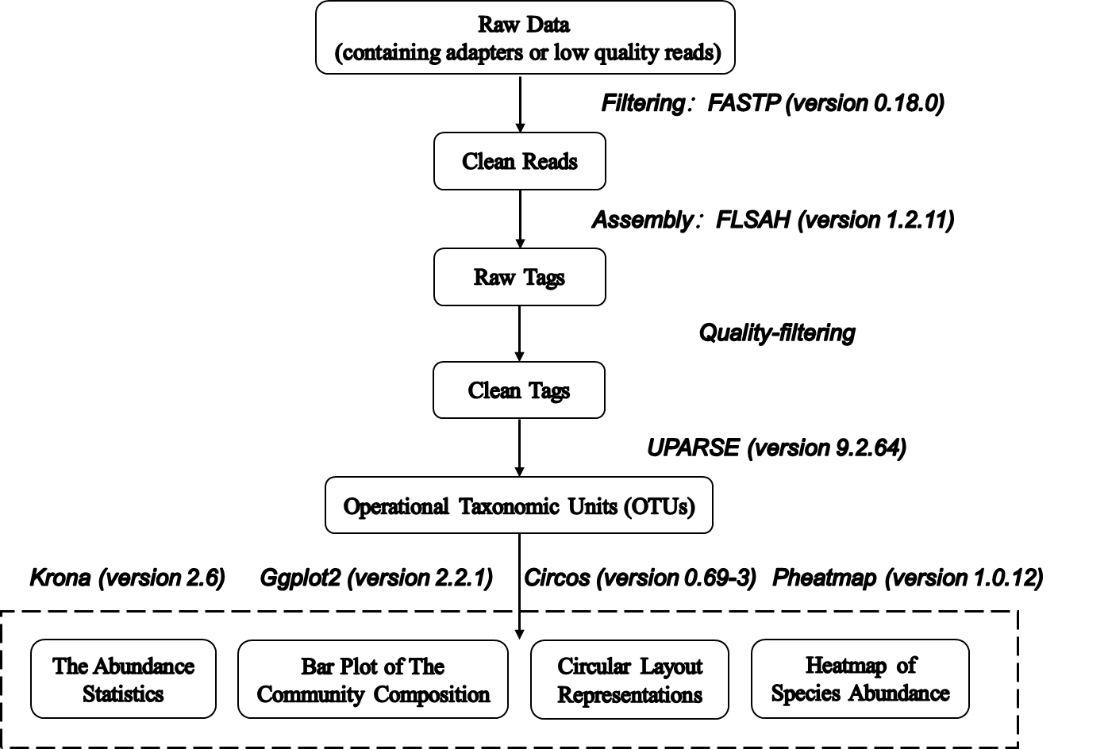

Figure S1. Overall Protocol of Reads Processing and Sequence Analysis.

Figure S2. Rarefaction curves of each group. Number of observed species (Sobs) identified with increase of sequencing depth in maternal and neonatal samples.

Figure S3. The distance heatmap of each sample. The distance heatmap was conducted based on unweighted Unifrac matrix at OTU level to characterize the similarities of bacterial composition among samples. Rows and columns represented different samples, and the color of the grid indicated the distance between corresponding samples. The darker color of the grid meant the greater difference of flora structure between samples.
Abbreviations: TSC, Transitional stools of caesarean delivered neonates; TSS, Transitional stools of caesarean delivered neonates with the treatment of swabbing maternal vaginal fluid; TSN, Transitional stools of natural delivered neonates; VN, Vaginal fluids of the pregnant women who underwent natural delivery; V, Vaginal fluids of the pregnant women who underwent caesarean delivery; FN, Feces of the women who underwent natural delivery; F, Feces of the pregnant women who underwent caesarean delivery.

Figure S4. Circos Plots at Phylum and Genus Level. The circos plots displayed the relationship about species composition in the form of ‘sample-species’ lines. The thickness of the corresponding line represented the proportion of species in the sample. Species whose relative abundance (the number of species tags in the sample/the total number of tags in the sample) reached more than 0.1% were displayed in the diagram.
Abbreviations: TSC, Transitional stools of caesarean delivered neonates; TSS, Transitional stools of caesarean delivered neonates with the treatment of swabbing maternal vaginal fluid; TSN, Transitional stools of natural delivered neonates; VN, Vaginal fluids of the pregnant women who underwent natural delivery; V, Vaginal fluids of the pregnant women who underwent caesarean delivery; FN, Feces of the women who underwent natural delivery; F, Feces of the pregnant women who underwent caesarean delivery.
Figure S5. Venn Plots at Phylum and Genus Level. Venn plots were used to represented the common and unique phyla (A) and genera (B) among different groups.
Abbreviations: TSC, Transitional stools of caesarean delivered neonates; TSS, Transitional stools of caesarean delivered neonates with the treatment of swabbing maternal vaginal fluid; V, Vaginal fluids of the pregnant women who underwent caesarean delivery.

