Correlated Oxide Nanocrystal Inks for Hole-Selective Contacts in n-i-p Perovskite Photovoltaics
Shuai Yuan¹, Congcong Zhang^{2*}, Haruko Tamegai², Miwako Furue³, Fumiyasu Awai³,
Takumi Kinoshita³, Satoshi Uchida², Takaya Kubo², Hiroshi Segawa^{1,2,3*}
¹Komaba Institute for Science, Graduate School of Arts and Sciences, The University of Tokyo, Japan
²Initiatives for Global Security and Energy Transition, Research Center for Advanced Science and Technology (RCAST), Graduate School of Engineering, The University of Tokyo, Japan
³Department of General Systems Studies, Graduate School of Arts and Sciences, The University of Tokyo, Japan
*Emails: Congcong Zhang (zhang.congcong@mail.u-tokyo.ac.jp); Hiroshi Segawa (csegawa@g.ecc.u-tokyo.ac.jp).

Supplementary Notes
Supplementary Note 1
The full non-relativistic Hamiltonian, which consists of both electrons and nuclei, is used to describe the energy of the interacting electron system. Based on the Born-Oppenheimer approximation, in which the nuclei are treated as a fixed external potential, the Hamiltonian can be written as^{[1]}:
$H=\sum_{i=1}^{n}{-\frac{ℏ^{2}}{2m}}∇_{i}^{2}-\sum_{i=1}^{n}{\sum_{I=1}^{N}{\frac{e^{2}Z_{I}}{\left|r_{i}-R_{I}\right|}}}+\frac{1}{2}\sum_{i,j=1}^{n}{\frac{e^{2}}{\left|r_{i}-r_{j}\right|}}+\frac{1}{2}\sum_{I,J=1}^{N}{\frac{e^{2}Z_{I}Z_{J}}{\left|r_{i}-r_{j}\right|}+}λ\overset{⃑}{L}∙\overset{⃑}{S}$ ,
the electronic charge is e, its mass is m and the position is r. The atomic number of the I_{th} nucleus is Z_{I} and the location is R_{I}. Here, the first term represents the one-electron kinetic energy, the second term is the Coulomb potential between electrons and nuclei, and the third term denotes the most important Coulomb repulsion among electrons in a correlation system. The fourth term is repulsion between various nuclei, and the last part is the spin-orbital coupling, once a relativistic effect is under consideration, especially in systems containing heavy elements.
In the absence of electron-electron interactions, the positions of electrons do not substantially affect the total energy, and the wavefunction of the system could be constructed from independent one-electron states written as:
$Ψ\left(x_{1},…,x_{n}\right)=\prod_{i=1}^{n}{ψ_{i}\left(x_{i}\right)=ψ_{1}\left(x_{1}\right)}…ψ_{n}\left(x_{n}\right)$ ,
this gives rise to the Hartree–Fock approximation, in which a mean-field is used to replace the electron-electron Coulomb interactions, allowing a Slater determinant to capture the exchange energy and describe the total energy of weak correlation systems, such as main-group semiconductors and most organics^{[2]}.
Once the Coulomb coupling between electrons is non-negligible and even comparable to their kinetic energies, such as the d- and f-orbital electrons where their radial (R_{n,l}(r)) and angular (Y_{l,m}(θ,φ)) distributions are narrow, the motion of each electron depends on the instantaneous positions of all other electrons, such that the exact many-electron eigenstates must be defined in the full 3n-dimensional configuration space rather than as a product of independent one-electron orbitals:
$Ψ\left(x_{1},…,x_{n}\right)≠\prod_{i=1}^{n}{ψ_{i}\left(x_{i}\right)}$ ,
The problem is therefore non-separable. The electron-electron interaction term couples electronic coordinates. This non-factorizability is the formal origin of many-body effects, including correlation, configuration mixing, satellite structures, and other phenomena that cannot be reduced to a pure one-electron picture.
Kohn-Sham DFT also fails to fully describe the many-body system, as it relies on the electron density rather than establishing the orbital wavefunction. Instead, the DFT+U method was developed to account for the on-site Coulomb repulsion that is insufficiently described in conventional DFT^{[3]}, as shown in Supplementary Fig. 1.
Supplementary Note 2
We establish the model Hamiltonian of NiO as H₀+H₁, where H₀ contains the on-site energy of electrons in Ni 3d (E_{d}) and O 2p (E_{p}), as well as the last term regarding the overlap/hopping integrals (T_{pd}). H₁ describes the electron-electron interactions, including Coulomb repulsion (U) and exchange energy in Ni 3d. The Ni 4s, 4p, and the empty states of O are neglected.
$H_{0}=\sum_{m}{E_{d}(m)d_{m}^{†}}d_{m}+\sum_{m}{E_{p}(m)p_{m}^{†}}p_{m}+\sum_{m}{T_{pd}(m)(d_{m}^{†}}p_{m}+p_{m}^{†}d_{m})$ ,
$H_{1}=\sum_{m,m^{,},n,n^{,}}{U\left(m,m^{,},n,n^{,}\right)}d_{m}^{†}d_{m^{,}}d_{n}^{†}d_{n^{,}}$ ,
the indices m and n label the orbital quantum numbers and spin. We retain all five Ni 3d orbitals, while for oxygen we keep only those symmetry-adapted 2p orbitals that can hybridize with the Ni 3d states. The operator $d_{m}^{†}$creates a hole in the Ni 3d orbital with energy $E_{d}(m)$. The octahedral crystal field is introduced as $10Dq$, which separates the Ni 3d levels into a doubly degenerate $e_{g}$manifold and a triply degenerate $t_{2g}$manifold, with
$E_{d}\left(e_{g}\right)=E_{d}+6Dq,{ E}_{d}\left(t_{2g}\right)=E_{d}-4Dq$ ,
the operator $p_{m}^{†}$creates a hole in the ligand O 2p states with energy $E_{p}(m)$. The hopping integrals allow linear combinations of O 2p orbitals and Ni 3d orbitals, and are parameterized within the Slater-Koster framework^{[4]}. We adopt the interatomic matrix elements in the Slater-Koster convention and describe the overlap integrals of Ni-O, O-O nearest-neighbor hopping using $dpσ$, $dpπ$, $ppσ$ and $ppπ$, respectively. The Ni-Ni nearest-neighbor hopping (dd$π$, dd$σ$ and ddδ) and the two-particle Coulomb interaction in O 2p are neglected. The dp$σ$ overlap representing the strongest interaction is defined along the local z direction ([100] direction of NiO); namely, the head-on $pdσ$ hopping corresponds to overlap between the O 2p_{z} and the Ni 3d_{z2} orbitals. The corresponding $pdπ$ terms then describe the side-on overlap between O 2p_{x,y} and the appropriate Ni 3d orbitals (Supplementary Scheme 1).
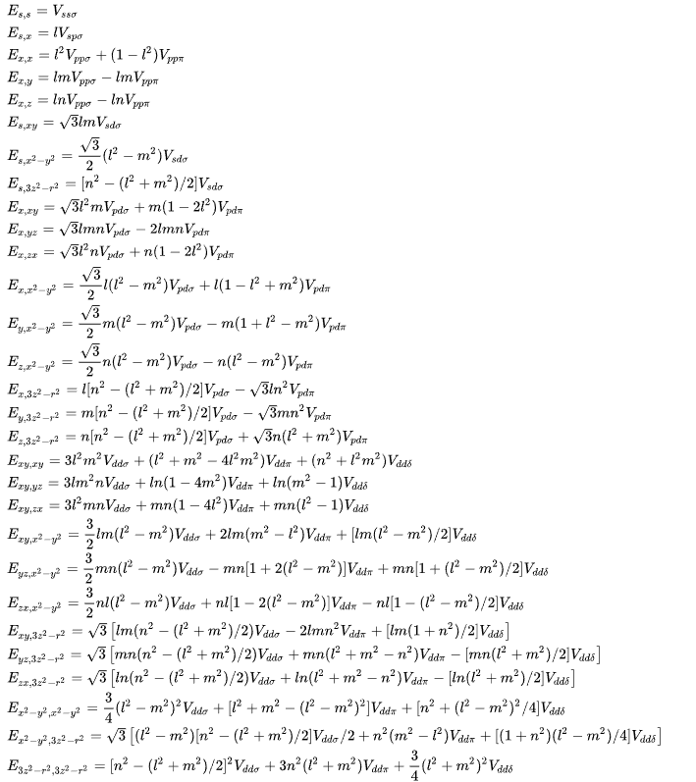
Supplementary Scheme 1. Matrix components of energy for simple cubic crystals, based on the two-center approximation. l, m, and n are the direction cosines to the neighboring atom^{[4]}.
Using d_{z2}, d_{x2-y2}, d_{xz}, d_{zy}, d_{xy}, p_{x}, p_{y} and p_{z} as basis vectors (Wannier representation), the Hamiltonian can thus be described as an 8×8 matrix as follows:
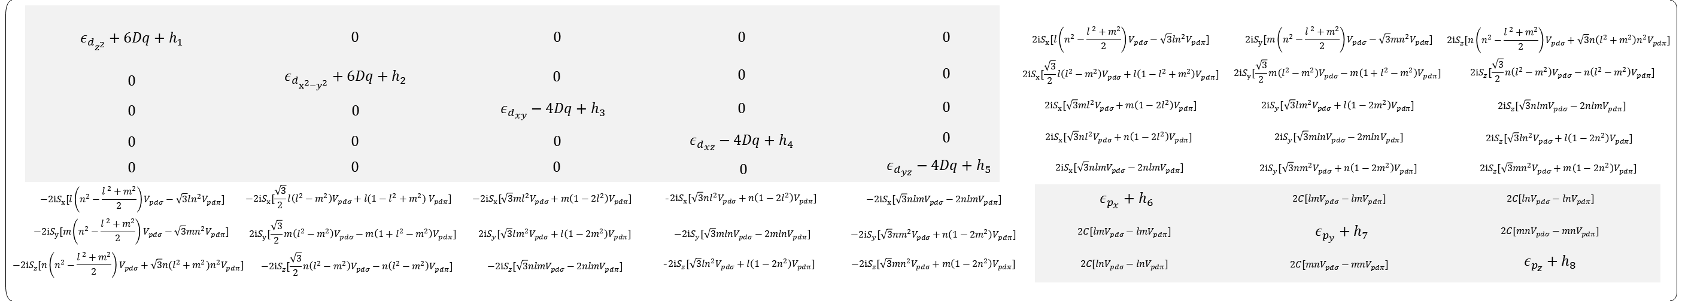
the diagonal terms represent the on-site orbital energies, while the off-diagonal terms are the interorbital hopping integrals. The off-diagonal elements in the upper-left and lower-right blocks represent the hopping integrals between nearest-neighbor atoms of the same type. Since the head-on $pdσ$ overlap along the z direction is the strongest, the corresponding antibonding state is pushed to the highest energy and therefore constitutes the VBM. As a result, the O 2p_{z} character is thus the largest in this state. The solutions of the secular equation define the orbital bonding scheme shown in Fig. 1f.
Supplementary Figures
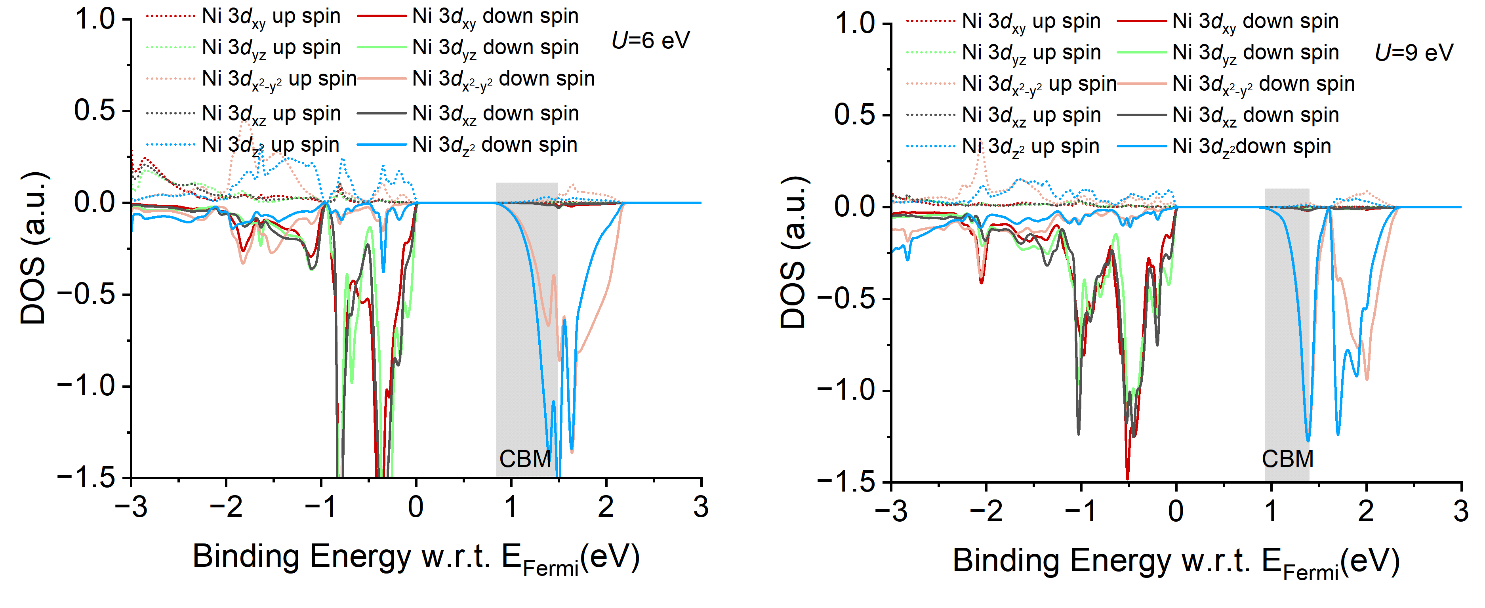
Supplementary Fig. 1. The density of states integrals from DFT+U calculations for NiO. The CBM is mainly dominated by the e_{g} down-spin states (Ni 3d_{z2} and 3d_{x2-y2} down-spin), regardless of the Coulomb repulsion (U) varied from 6 to 9 eV. Here, we focus only on the conduction band from DFT+U calculations, because it has long been recognized that the band gap and valence-band character predicted by such approaches are often inconsistent with experiment, given that the electronic structure of strongly correlated materials cannot be fully described within a one-electron approximation.

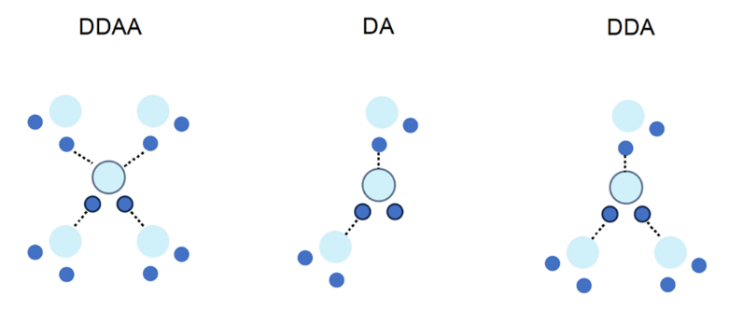
Supplementary Fig. 2. The intermolecular configurations of liquid water for different hydrogen-bonding networks. From left to right, the corresponding modes are the double-donor double-acceptor (DDAA), donor acceptor (DA), and double-donor acceptor (DDA), respectively^{[5]}.
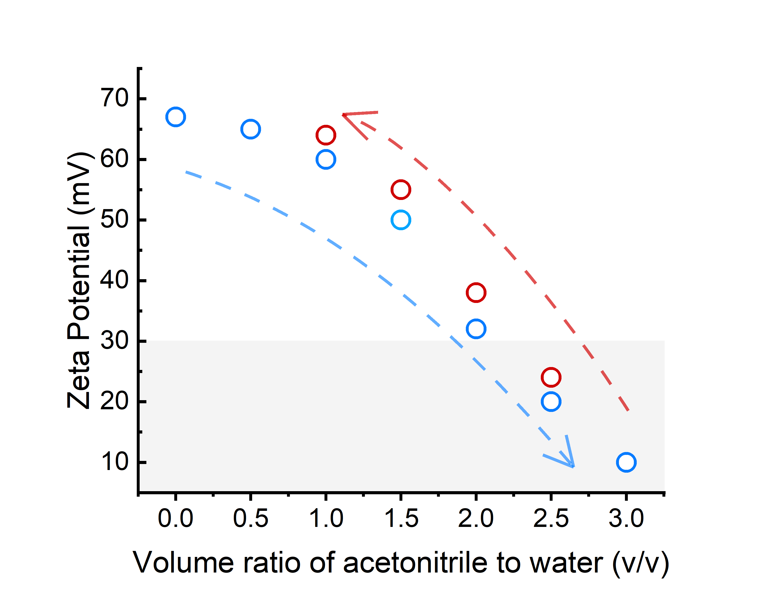
Supplementary Fig. 3. Reversible ligand exchange in the water-acetonitrile mixed NiO_{x} NC dispersions. Zeta potentials of NiO_{x} NC dispersions in neutral water–acetonitrile mixtures with different volume ratios. A 30 mg mL⁻¹ aqueous dispersion was used as the starting suspension. Acetonitrile was added in different amounts to adjust the water/acetonitrile volume ratio and trigger nanocrystal precipitation, after which neutral water was introduced to redisperse the NiO_{x} NCs.

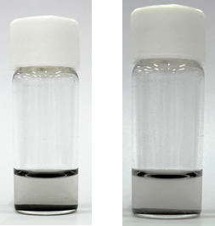
Supplementary Fig. 4. Colloidal dispersibility of as-synthesized NiO_{x} NC powder (left) and fully dried ACN-exchanged NiO_{x} NCs (right) in phosphonic acid ligand containing chloroform solution.
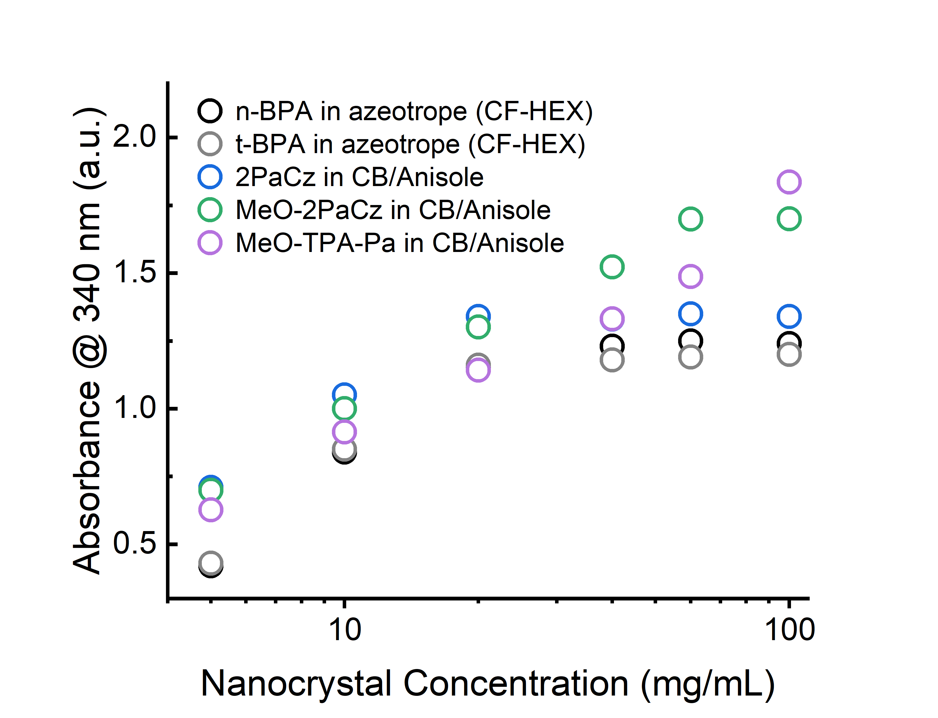
Supplementary Fig. 5. Absorptions of various NiO_{x}-ligand non-polar inks at a series of soluble concentrations. A binary azeotropic mixture of CF and n-hexane (HEX) in a 7:3 volume ratio was developed to tune the ink volatility and viscosity, thereby facilitating spin-coating. Initially, the absorbance of a 5 mg mL⁻¹ NC ink was measured as a reference. UV-vis spectroscopy was then performed on the non-polar inks at various concentrations, and the absorbance at 340 nm was recorded and linearly fitted to estimate the solubility of the nanocrystals in the supernatant after centrifugation. The π-π* transition of aromatic ligands such as MeO-2PACz and MeO-TPA-PA contributes to the absorbance at 340 nm, leading to slightly higher intensities compared with n-BPA and t-BPA samples.

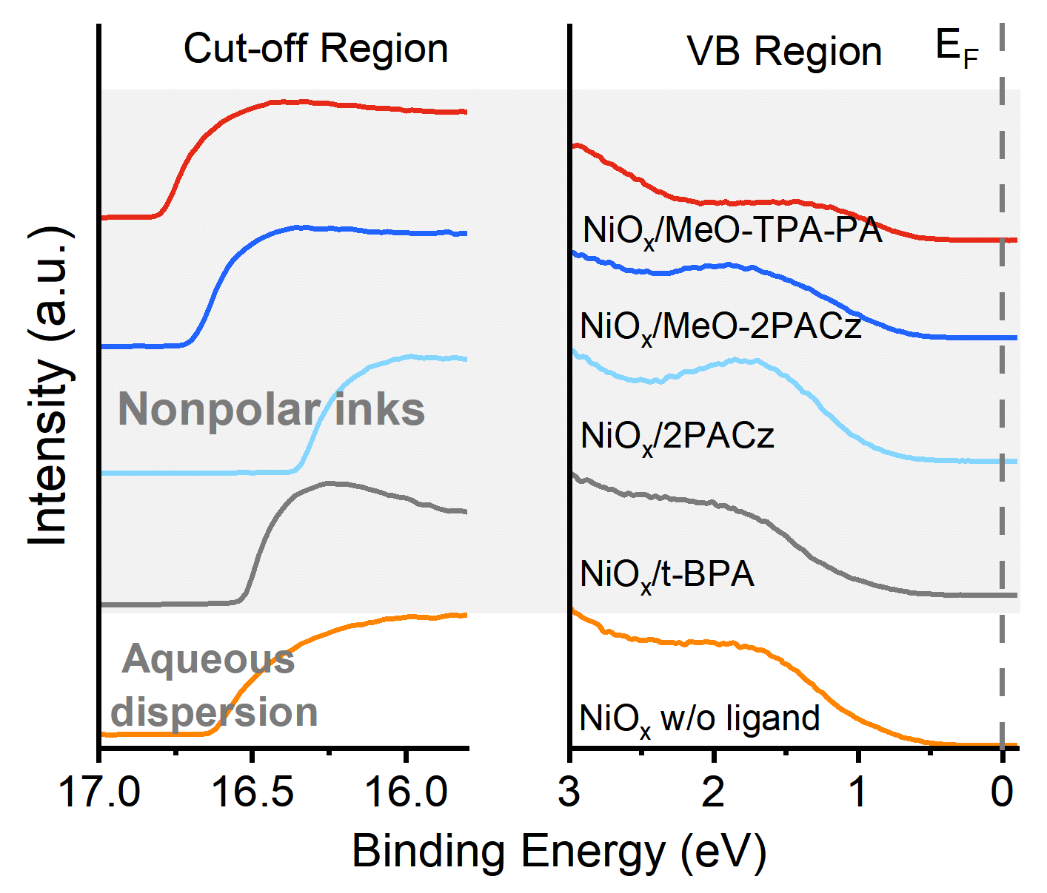
Supplementary Fig. 6. UPS spectra of a variety of functional layers, including perovskite film, bare NiO_{x} NC film, and ligand-functionalized NiO_{x} NC films processed from nonpolar inks.

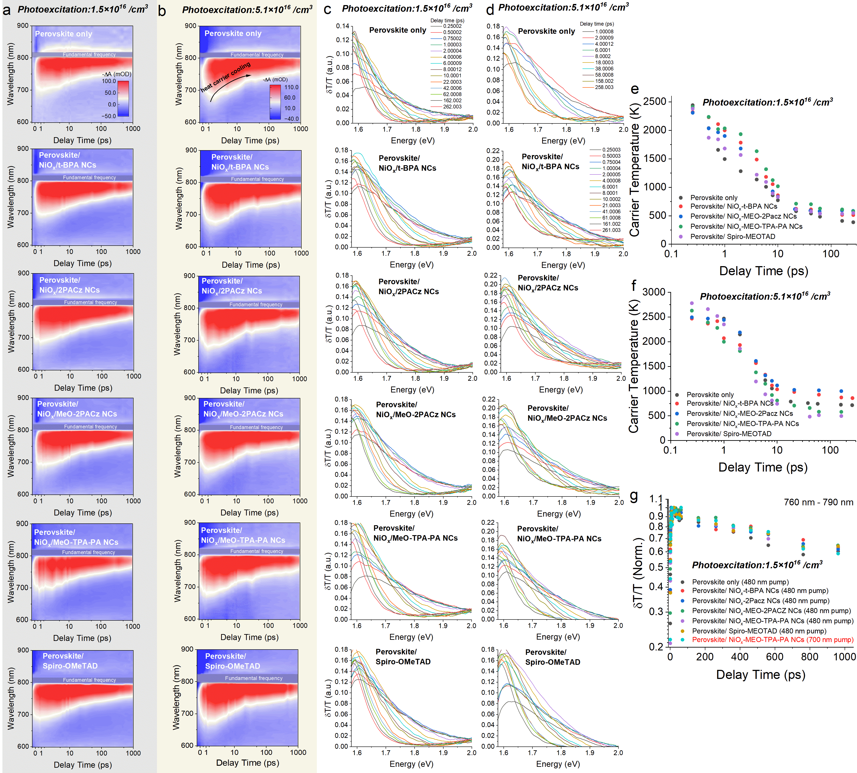Supplementary Fig. 7. TA maps, hot carrier cooling, and delay kinetics of various perovskite/ hole-selective contact bilayers at different photogenerated carrier densities under a 480 nm pump. a,b, The TA maps of perovskite/ hole-selective contact bilayers with initial photoexcitation of ~1.5×10¹⁶/cm³, and ~5.1×10¹⁶/cm³, respectively. The narrow saturation band originates from the 800 nm fundamental output of the Ti:Al₂O₃ laser together with the supercontinuum white-light probe. c, d, The high-energy tail of selected spectral curves at various delay times after the pump from a and b. e, f, Extracted carrier temperature of perovskite/ hole-selective contact bilayers with photoexcitation of ~1.5×10¹⁶/cm³, and ~5.1×10¹⁶/cm³, respectively. The carrier temperature is determined by fitting the high-energy tail of the TA spectra with a Boltzmann distribution model, f ~ exp(E-E_{f})/k_{B}T (E_{f}, Fermi energy, k_{B}, the Boltzmann constant)^{[6]}. g, TA kinetics (760-790 nm) of perovskite/ hole-selective contact bilayers under 480 nm and 700 nm pumps (Fig. 3e in the main body) with the photoexcitation of ~1.5×10¹⁶/cm³.
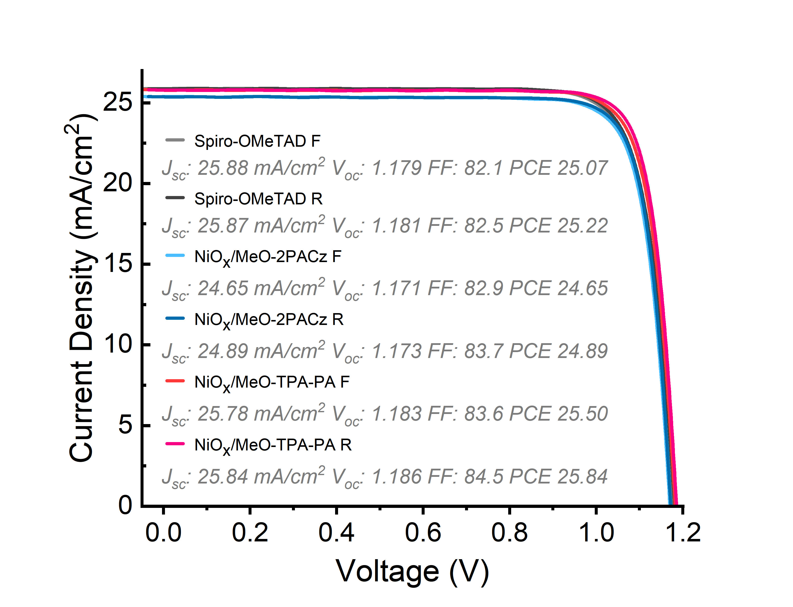
Supplementary Fig. 8. Representative forward and reverse-scan current density-voltage (J-V) curves of n-i-p perovskite solar cells with various hole-selective contacts under 100 mW cm⁻², AM 1.5 G illumination.

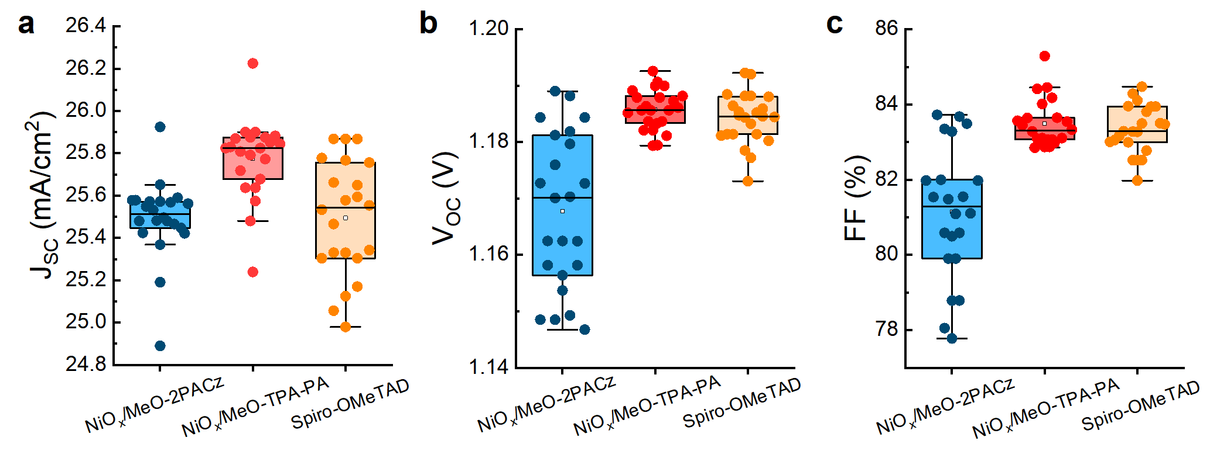
Supplementary Fig. 9. Statistics of photovoltaic parameters of NiO_{x}/MeO-2PACz, NiO_{x}/MeO-TPA-PA, and Spiro-OMeTAD devices (22 individual devices for each group). All data are extracted from a reverse scan; the bounds of the boxes are the 25th and 75th percentiles.
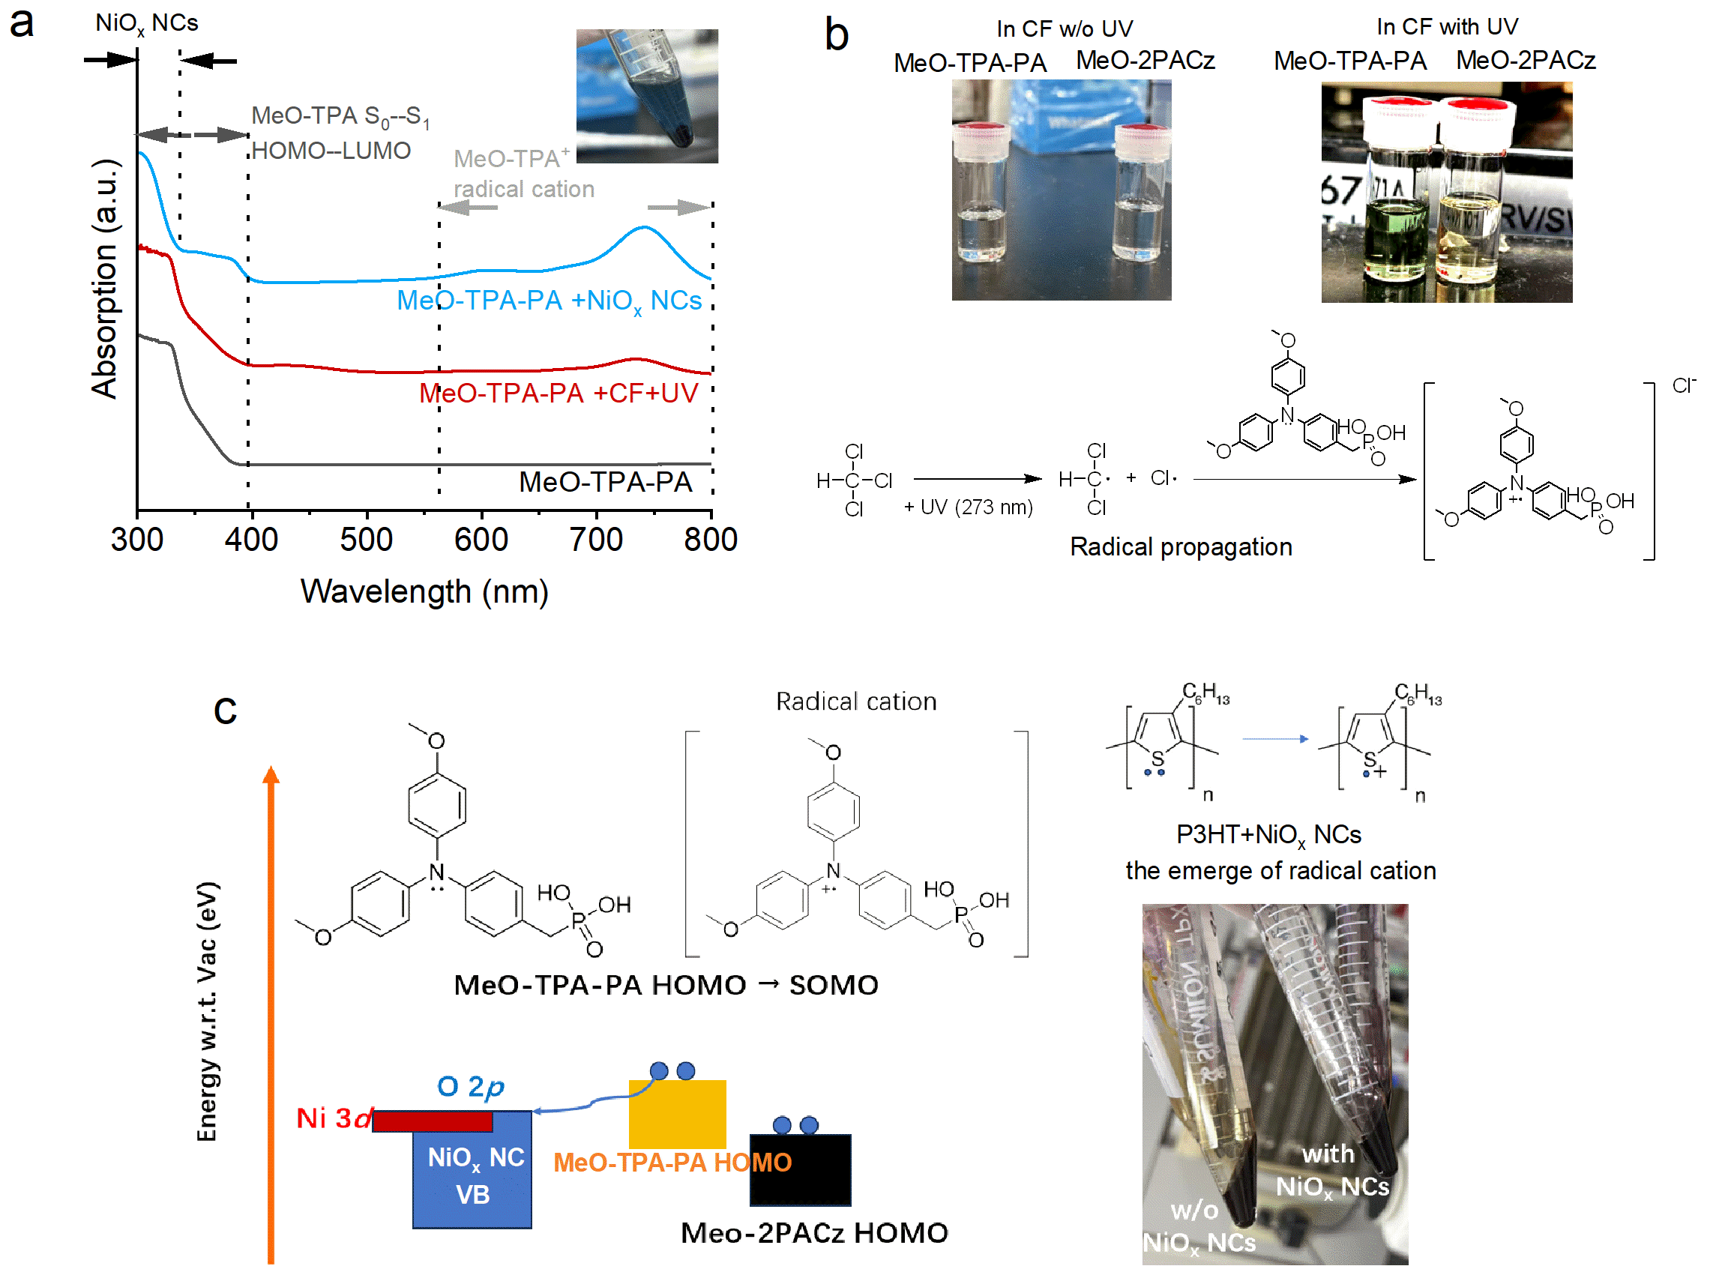
Supplementary Fig. 10. Redox interactions between NiO_{x} NC core and ligand molecules. a, Absorption spectra of NiO_{x}/ MeO-TPA-PA ink, MeO-TPA-PA molecule in chloroform after UV (273 nm) exposure, and the reference MeO-TPA-PA molecule. The inset shows a photograph of the MeO-TPA-PA ligand solution upon addition to the NiO_{x} NC precipitate before stirring. b, Radical propagation for MeO-TPA-PA and MeO-2PACz ligand molecules in chloroform with UV exposure. c, Ground-state electron transfer (redox) between NiO_{x} NCs and molecules featuring different HOMO levels.
MeO-TPA-PA is transparent in the visible region, with its HOMO-LUMO absorption arising from the π-π* transition located at around 400 nm. Upon addition of MeO-TPA-PA to the NiO_{x} NC precipitate, a new broad absorption band emerges across the yellow to near-infrared region (570-800 nm) (Supplementary Fig. 10a). In contrast, no such spectral change is observed for MeO-2PACz. To identify the origin of this feature, we trigger a radical reaction by UV irradiation of chloroform solutions of MeO-TPA-PA and MeO-2PACz. The resulting visible absorption renders the solutions colored, and the absorption of the MeO-TPA radical cation matches well with that observed in Supplementary Fig. 7a (Supplementary Fig. 10b)^{[7,8]}, indicating the ground-state electron transfer from the shallow HOMO of MeO-TPA to the VB of NiO_{x} NCs (Fig. 3a, Supplementary Fig. 10c). To substantiate this interpretation further, we mixed P3HT, which has a shallow HOMO of 4.6-4.8 eV, with NiO_{x} NCs. This also produced additional absorption attributable to radical cations, accompanied by a distinct color change of the solution from golden to dark purple (Supplementary Fig. 10c).
Synthesis of MeO-TPA-PA
The reaction apparatus was dried under anhydrous conditions and protected with argon. 4-(bis(4-methoxyphenyl)amino)benzaldehyde powder purchased from TCI (0.50 g, 1.50 mmol, 1.00 eq) and NaBH₄ (0.17 g, 4.54 mmol, 3.00 eq) were added to a 25 mL two-neck flask, and ethanol (10 mL) was added slowly. The reaction was initiated at room temperature. After 16 h, the reaction was quenched with NH₄Cl solution. The mixture was extracted with saturated brine/ethyl acetate, and the organic layer was dried over anhydrous magnesium sulfate. The solvent was then removed under reduced pressure to afford a light-yellow oily substance, which was used in the next step without further purification. Under argon protection, I₂ (0.4 g, 1.50mmol, 1.00 eq) and triethyl phosphite (1 mL) were added to the product obtained in the previous step. After stirring at room temperature for 48 h, the mixture was purified by column chromatography (ethyl acetate: petroleum ether = 2:3, v/v), yielding the intermediate product (diethyl (4-(bis(4-methoxyphenyl)amino)benzyl)phosphonate, 0.61 g, 89.0% yield). ¹H NMR (400 MHz, CDCl₃): δ (TMS, ppm) = 7.08 (d, J = 8 Hz, 2H), 7.01 (d, J = 8 Hz, 4H), 6.87 (d, J = 8 Hz, 2H), 6.81 (d, J = 8 Hz, 4H), 4.03 (t, J = 8 Hz, 4H), 3.79 (s, 6H), 3.07 (d, J = 20 Hz, 2H), 1.26 (m, 12H).
Diethyl (4-(bis(4-methoxyphenyl)amino)benzyl)phosphonate (0.61 g) was dissolved in anhydrous dichloromethane (18 mL) under an argon atmosphere, and bromotrimethylsilane (TMSBr, 10 eq, 2.06 g, 1.77 mL, 13.5 mol) was added dropwise. The reaction was stirred for 12 h at room temperature under an argon atmosphere. Afterwards, the solvent was partially distilled off under reduced pressure, and the liquid residue was dissolved in methanol (5 mL). Next, distilled water was added dropwise (50 mL) until the solution became opaque. The product was filtered off and washed with water to give 482 mg (90%) of white solid. ¹H NMR (400 MHz, CDCl₃): δ (TMS, ppm) = 7.08 (d, J = 8 Hz, 2H), 7.01 (d, J = 8 Hz, 4H), 6.87 (d, J = 8 Hz, 2H), 6.81 (d, J = 8 Hz, 4H), 3.79 (s, 6H), 3.01 (d, J = 20 Hz, 2H).
Supplementary Scheme 2. Synthetic route of (4-(bis(4-methoxyphenyl)amino)benzyl)phosphonic acid (MeO-TPA-PA).

References
[1] Stank, M., Adamowicz, L. Chapter Seven - Nonrelativistic non-Born-Oppenheimer approach for calculating atomic and molecular spectra using all-particle explicitly correlated Gaussian functions. Adv. Quantum Chem. 87, 263-279 (2023).
[2] Lykos, P. and Pratt, W. G. Discussion on The Hartree-Fock Approximation. Rev. Mod. Phys. 35, 496 (1963).
[3] Himmetoglu, B. et al. Hubbard-corrected DFT energy functionals: The LDA+U description of correlated systems. Int. J. Quantum Chem. 1, 14-49 (2014).
[4] Slater, C. J., Koster, F. G. Simplified LCAO method for the Periodic Potential Problem. Phys. Rev. 94, 1498-1524 (1954).
[5] Sun, Q. The Raman OH stretching bands of liquid water. Vib. Spectrosc. 2, 213-217 (2009)
[6] Dai, L. et al. Thermalization and relaxation mediated by phonon management in tin-lead perovskites. Light Sci. Appl. 12, 208 (2023).
[7] Schaub, A. D. et al. A Spherically Shielded Triphenylamine and Its Persistent Radical Cation. Chem. Eur. J. 15, 3264-3269 (2020).
[8] Rong, X. et al. A feasible strategy to obtain air-stable triphenylamine radicals in the solid state by introducing conjugated donor–acceptor modules. J. Mater. Chem. C, 11, 9640-9648 (2023).

