Supplementary files
Supplementary table A. Variance Inflation Factor and Tolerance values for all variables included in the multiple regression model.
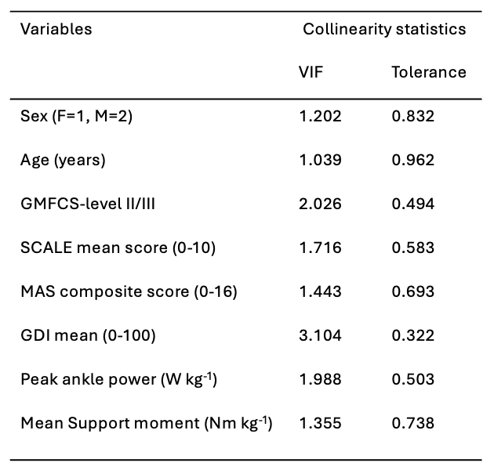
Abbreviations: F = Female; M = Male; GDI = Gait Deviation Index; GMFCS = Gross Motor Function Classification System; MAS = Modified Ashworth Scale; SCALE = Selective Control Assessment of the Lower Extremity; VIF = Variance Inflation Factor.

Supplementary table B. Collinearity diagnostics for all potential predictors included in the multiple regression model.
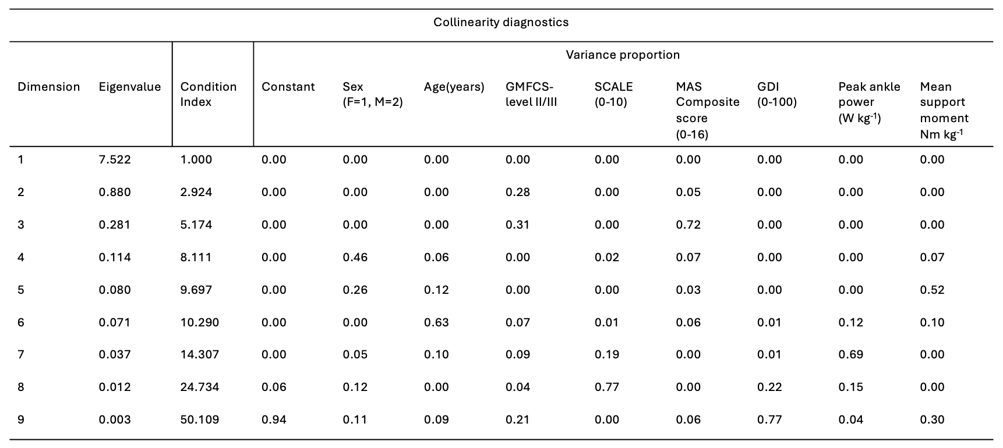
Abbreviations: F = Female; M = Male; GDI = Gait Deviation Index; GMFCS = Gross Motor Function Classification System; MAS = Modified Ashworth Scale; SCALE = Selective Control Assessment of the Lower Extremity.

