Table 5: Molecular Characterization of the Crisponi Cohort

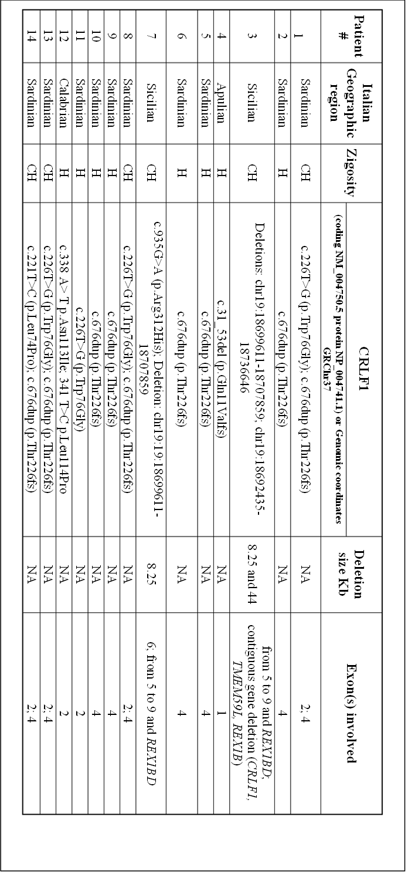
Table 5 Legend: CH: Compound heterozygous; Del: Deletion; GRCh37: Genome Reference Consortium Human Build 37; H: Homozygous; NA: Not Applicable

