Additional file 1:
Supplementary Methods, Supplementary Tables S1–S8 and Supplementary Fig. S1-S2

Supplementary Methods

Cohort assembly and echocardiographic linkage
Intensive care unit (ICU) stays meeting the Sepsis-3 criteria were identified from the MIMIC-IV derived sepsis concept. For each patient we retained the first qualifying ICU stay. Structured transthoracic echocardiographic (TTE) measurements were drawn from MIMIC-IV-ECHO v1.0 and linked to the clinical record; the index study for each patient was the earliest TTE performed within a window of 6 hours before to 24 hours after ICU admission. Studies were required to contain a measurable peak tricuspid-regurgitation (TR) jet velocity. Patients with a prosthetic mitral or tricuspid valve, haemodynamically significant congenital heart disease, prior heart transplantation, or durable mechanical circulatory support were excluded, these conditions being identified from International Classification of Diseases, Ninth and Tenth Revision, diagnosis and procedure codes recorded in any hospitalisation. To exclude implausible or non-physiological values, peak TR velocity was restricted to 1.0–6.0 m/s; studies outside this bound were treated as non-measurable. The time origin (t0) for every patient was the timestamp of this index echocardiogram, and all survival time was measured from t0, so that exposure ascertainment and the start of follow-up coincided and no period of guaranteed survival preceded the exposure (no immortal time).

Derived quantities and covariate definitions
Estimated PASP was calculated from the simplified Bernoulli equation as 4 × (peak TR velocity)² + 5 mmHg, assuming a fixed right atrial pressure of 5 mmHg. Right ventricular–pulmonary arterial (RV–PA) coupling was operationalised as the ratio of tricuspid annular plane systolic excursion to peak TR velocity (TAPSE/TR velocity, cm·s/m); higher values denote better coupling. Covariates were fixed at or around t0 and comprised age, sex, the Charlson comorbidity index, the first-day Sequential Organ Failure Assessment (SOFA) score, a pulmonary source of sepsis (pneumonia or aspiration codes), left ventricular ejection fraction (LVEF), the interval from ICU admission to echocardiogram, and admission year. Positive end-expiratory pressure (PEEP) and driving pressure are defined only during invasive mechanical ventilation; they were therefore not entered into the whole-cohort models (which would force list-wise deletion of every non-ventilated patient) but were used only within the ventilated-subgroup sensitivity analyses.

Missing-data handling and multiple imputation
Left ventricular ejection fraction was analysed as a dichotomous variable (reduced, <50%, versus not reduced) so that the 374 patients in whom systolic function was documented qualitatively but not quantified could be retained; all 4,174 patients therefore contributed to the primary and secondary Cox models. Continuous LVEF was required only for the baseline model used in the incremental-value analysis, which was correspondingly restricted to the 3,410 patients with both a quantified ejection fraction and a lactate value. As a sensitivity analysis, missing covariate data were addressed by multiple imputation by chained equations (mice), generating 20 imputed datasets; the Nelson–Aalen cumulative-hazard estimate and the event indicator were included among the imputation predictors, and the primary Cox model was refitted in each imputed dataset with estimates pooled by Rubin’s rules. Because the covariate set of the primary model contained no missing values once LVEF was dichotomised, the imputation was effectively a no-op for that model and the pooled estimate is numerically identical to the complete-data estimate; this is reported transparently and should not be interpreted as independent corroboration.

Incremental value and decision-curve analysis
The added value of estimated PASP beyond a parsimonious clinical model (age, SOFA score, lactate, and LVEF) was quantified by the change in the Harrell concordance index, by the integrated discrimination improvement (IDI), and by the continuous net reclassification improvement (NRI), each estimated at the 90-day horizon with 200 perturbation resamples. Clinical usefulness was further examined by decision-curve analysis, in which the net benefit of treating according to each model was plotted across threshold probabilities from 0 to 0.80; the discrimination, reclassification, and decision-curve analyses used the complete-case sample (n=3,410).

Software
Analyses were performed in R version 4.5 (R Foundation for Statistical Computing, Vienna, Austria) using the survival, rms, tableone, survIDINRI, dcurves, EValue, and mice packages. All tests were two-sided with a significance threshold of 0.05.

Supplementary Tables
Table S1. Full multivariable Cox proportional-hazards model for the primary continuous exposure (estimated PASP per 10 mmHg) and 90-day all-cause mortality.
Variable | Adjusted HR (95% CI) | P-value
Estimated PASP, per 10 mmHg | 1.14 (1.10–1.19) | <0.001
Age, per year | 1.02 (1.01–1.02) | <0.001
Male sex (vs female) | 0.90 (0.81–0.99) | 0.037
Charlson comorbidity index, per point | 1.08 (1.06–1.10) | <0.001
SOFA score, per point | 1.15 (1.14–1.17) | <0.001
Pulmonary source of sepsis (vs non-pulmonary) | 1.14 (1.03–1.26) | 0.010
LVEF <50% (vs ≥50%) | 1.18 (1.07–1.31) | 0.001
Invasive mechanical ventilation (vs none) | 1.02 (0.91–1.14) | 0.73
Time from ICU admission to echocardiogram, per hour | 0.99 (0.99–1.00) | 0.042
Admission year, per year | 0.999 (0.997–1.001) | 0.27
n=4,174; 1,599 deaths within 90 days. Hazard ratios are mutually adjusted. The reference categories are female sex, non-pulmonary source, LVEF ≥50%, and no invasive ventilation. CI, confidence interval; HR, hazard ratio; LVEF, left ventricular ejection fraction; PASP, pulmonary artery systolic pressure; SOFA, Sequential Organ Failure Assessment.
Table S2. Secondary (mediator-adjusted) Cox model adding arterial lactate and norepinephrine-equivalent vasopressor dose. In these 3,755 patients the hazard ratio for estimated PASP (per 10 mmHg) was 1.15 (1.11–1.20) before and 1.16 (1.12–1.21) after adding the mediators.
Variable | Adjusted HR (95% CI) | P-value
Estimated PASP, per 10 mmHg | 1.16 (1.12–1.21) | <0.001
Age, per year | 1.02 (1.01–1.02) | <0.001
Male sex (vs female) | 0.89 (0.80–0.98) | 0.025
Charlson comorbidity index, per point | 1.07 (1.05–1.10) | <0.001
SOFA score, per point | 1.11 (1.09–1.13) | <0.001
Pulmonary source of sepsis (vs non-pulmonary) | 1.13 (1.02–1.25) | 0.022
LVEF <50% (vs ≥50%) | 1.17 (1.05–1.30) | 0.004
Invasive mechanical ventilation (vs none) | 0.98 (0.87–1.10) | 0.74
Time from ICU admission to echocardiogram, per hour | 1.00 (0.99–1.01) | 0.51
Admission year, per year | 0.998 (0.996–1.000) | 0.077
Arterial lactate, per mmol/L | 1.13 (1.11–1.15) | <0.001
Norepinephrine-equivalent dose, per µg/kg/min | 1.14 (1.07–1.22) | <0.001
This model was fitted in the 3,755 patients with a recorded arterial lactate; the norepinephrine-equivalent dose was set to zero in patients not receiving a vasopressor and therefore does not restrict the sample. Adding these putative mediators did not attenuate the estimated-PASP association (HR 1.16 per 10 mmHg, versus 1.14 in the primary model), arguing against mediation through measured circulatory failure. Abbreviations as in Table S1.
Table S3. Adjusted associations of RV–PA coupling (TAPSE-to-TR-velocity ratio) with 90-day all-cause mortality.
Parameter | Adjusted HR (95% CI) | P-value
TAPSE/TR velocity, per 0.1 unit (continuous) | 0.92 (0.85–0.99) | 0.034
Coupling tertile — T3, highest (best) | Reference | —
Coupling tertile — T2, middle | 0.97 (0.60–1.56) | 0.89
Coupling tertile — T1, lowest (worst) | 1.59 (1.01–2.48) | 0.043
Analyses restricted to the 322 patients with both TAPSE and TR velocity available. Each model is adjusted for the full covariate set (age, sex, Charlson comorbidity index, SOFA score, pulmonary source, LVEF <50%, invasive ventilation, time from ICU admission to echocardiogram, and admission year). Tertiles were defined by the empirical distribution of the coupling ratio; the highest (best-coupling) tertile is the reference. RV–PA, right ventricular–pulmonary arterial; TAPSE, tricuspid annular plane systolic excursion; TR, tricuspid regurgitation; other abbreviations as in Table S1.
Table S4. Adjusted hazard ratio for 90-day mortality per 10-mmHg increment in estimated PASP, within predefined subgroups.
Subgroup | No. of patients | Adjusted HR (95% CI) | P for interaction
Overall | 4,174 | 1.14 (1.10–1.19) | —
Invasive ventilation — yes | 1,541 | 1.13 (1.06–1.21) | 0.25
Invasive ventilation — no | 2,633 | 1.15 (1.10–1.21)
LVEF — reduced (<50%) | 1,344 | 1.12 (1.05–1.20) | 0.63
LVEF — preserved (≥50%) | 2,830 | 1.16 (1.10–1.22)
Sepsis source — pulmonary | 1,557 | 1.13 (1.06–1.20) | —
Sepsis source — non-pulmonary | 2,617 | 1.15 (1.09–1.21)
Each estimate derives from a separate Cox model adjusted for the full covariate set. P values for interaction are from likelihood-ratio tests of the multiplicative exposure-by-subgroup term and were predefined only for invasive ventilation and LVEF stratum; the sepsis-source split is descriptive. Abbreviations as in Table S1.
Table S5. Sensitivity analyses for the association between estimated PASP and 90-day mortality.
Analysis | n | Adjusted HR (95% CI)
Primary model (reference) | 4,174 | 1.14 (1.10–1.19)
Day-3 landmark (patients alive beyond day 3) | 3,743 | 1.15 (1.09–1.20)
Peak TR jet velocity, per 1 m/s (alternative exposure) | 4,174 | 1.35 (1.23–1.49)
Invasively ventilated, additionally adjusted for PEEP | 1,541 | 1.11 (1.03–1.19)
Ventilated, adjusted for PEEP and driving pressure | 666 | 1.02 (0.93–1.13)
Excluding chronic pulmonary vascular disease or acute PE | 3,773 | 1.13 (1.09–1.18)
Multiple imputation (m=20), pooled estimate | 4,174 | 1.14 (1.10–1.19)
E-value (point estimate / lower confidence limit) | — | 1.43 / 1.34
Stratified by SOFA quartile and Charlson category | 4,174 | 1.15 (1.11–1.20)
Unless stated otherwise, models are adjusted for the full covariate set and express the hazard ratio per 10-mmHg increment in estimated PASP. The peak-TR-velocity analysis substitutes the directly measured velocity for derived PASP and is therefore expressed per 1 m/s. The PEEP and driving-pressure analyses are confined to invasively ventilated patients; in the plateau-pressure subset (n=666, with adequate events) the attenuation after adjustment for driving pressure most likely reflects confounding by ventilatory mechanics and acute lung-injury severity rather than limited power. Chronic pulmonary vascular disease was defined narrowly, from diagnosis codes for idiopathic pulmonary arterial hypertension, chronic thromboembolic pulmonary hypertension, and Eisenmenger syndrome, to avoid the circularity of secondary-pulmonary-hypertension codes that track an elevated PASP; 401 patients were excluded on this criterion or for an acute pulmonary embolism. The multiple-imputation row is shown for completeness; because the primary model had no missing covariates once LVEF was dichotomised, the imputation was effectively a no-op and reproduces the complete-data estimate (see Supplementary Methods). The E-value is computed for the primary point estimate and its lower confidence limit. PE, pulmonary embolism; PEEP, positive end-expiratory pressure; other abbreviations as in Table S1.
Table S6. Proportional-hazards diagnostics for the primary Cox model (scaled Schoenfeld residuals).
Term | χ² | df | P-value
Estimated PASP | 5.46 | 1 | 0.019
Age | 15.06 | 1 | <0.001
Male sex | 1.17 | 1 | 0.28
Charlson comorbidity index | 43.89 | 1 | <0.001
SOFA score | 85.35 | 1 | <0.001
Pulmonary source of sepsis | 38.40 | 1 | <0.001
LVEF <50% | 0.71 | 1 | 0.40
Invasive mechanical ventilation | 42.62 | 1 | <0.001
Time from ICU admission to echocardiogram | 6.24 | 1 | 0.013
Admission year | 0.74 | 1 | 0.39
GLOBAL test | 189.78 | 10 | <0.001
P values are from the test of a non-zero slope of scaled Schoenfeld residuals on transformed time. Estimated PASP showed only a minor deviation (P=0.019) and the categorical, restricted-cubic-spline, and landmark analyses were concordant, supporting the robustness of the primary result. In the restricted-cubic-spline model (four knots), the overall association of PASP with mortality was significant (Wald χ²=60.71, 3 df, P<0.001) with significant non-linearity (χ²=11.59, 2 df, P=0.003). Abbreviations as in Table S1.
Table S7. Adjusted association of estimated PASP (per 10 mmHg) with secondary mortality outcomes.
Secondary outcome | Adjusted estimate (95% CI) | P-value
28-day mortality, per 10 mmHg | HR 1.14 (1.09–1.19) | <0.001
28-day mortality, >50 vs ≤40 mmHg | HR 1.52 (1.32–1.75) | <0.001
In-hospital mortality, per 10 mmHg | OR 1.13 (1.07–1.20) | <0.001
In-hospital mortality, >50 vs ≤40 mmHg | OR 1.56 (1.27–1.91) | <0.001
Estimated PASP was modelled continuously (per 10 mmHg) and categorically (>50 versus ≤40 mmHg, the ≤40 mmHg group as reference). All models used the same covariate adjustment as the primary analysis (n=4,174); 28-day mortality was analysed by Cox proportional-hazards regression and in-hospital mortality by logistic regression. HR, hazard ratio; OR, odds ratio. Other abbreviations as in Table S1.
Table S8. Baseline characteristics of patients included in versus excluded from the analytic cohort.
Characteristic | Included (n=4,174) | Excluded (n=531) | SMD
Age, years | 67.4 (15.9) | 67.0 (15.4) | 0.03
Male sex, n (%) | 2,198 (52.7) | 308 (58.0) | 0.11
SOFA score | 6.9 (3.8) | 6.6 (3.7) | 0.09
Charlson comorbidity index | 6.1 (2.9) | 6.2 (2.8) | 0.04
Estimated PASP, mmHg | 38.1 (12.5) | 42.4 (15.0) | 0.31
Pulmonary source of sepsis, n (%) | 1,557 (37.3) | 196 (36.9) | 0.01
Invasive ventilation at baseline, n (%) | 1,541 (36.9) | 157 (29.6) | 0.16
90-day mortality, n (%) | 1,599 (38.3) | 150 (28.2) | 0.22
Data are mean (standard deviation) or n (%). Excluded patients had a prosthetic heart valve, congenital heart disease, a prior heart or lung transplant, or mechanical circulatory support. SMD, standardised mean difference between included and excluded patients; other abbreviations as in Table S1.

Supplementary Figures
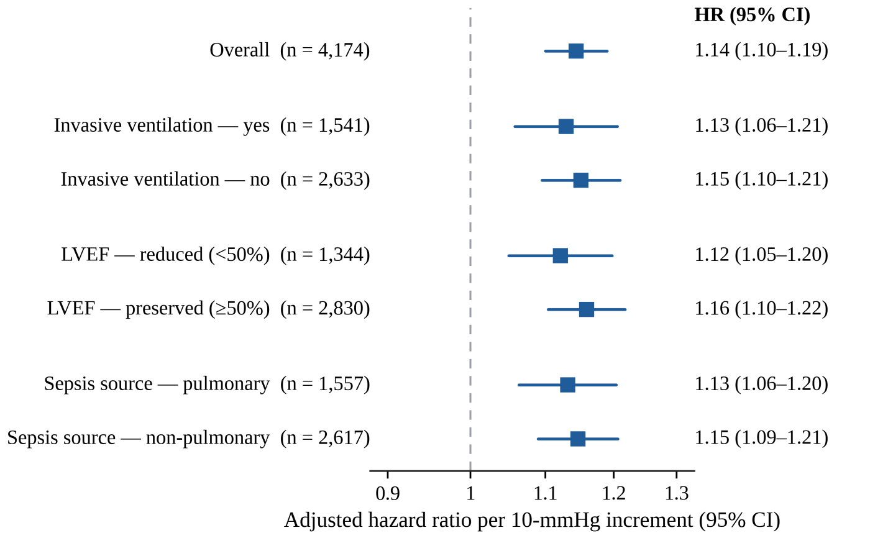Fig. S1. Adjusted hazard ratios for 90-day all-cause mortality per 10-mmHg increment in estimated pulmonary artery systolic pressure, within predefined subgroups. Each estimate derives from a separate Cox model adjusted for the full covariate set; points are the hazard ratios and horizontal bars the 95% confidence intervals, with the dashed vertical line marking the null (hazard ratio = 1). The x-axis is plotted on a logarithmic scale. Corresponding sample sizes and interaction P values are listed in Supplementary Table S4.
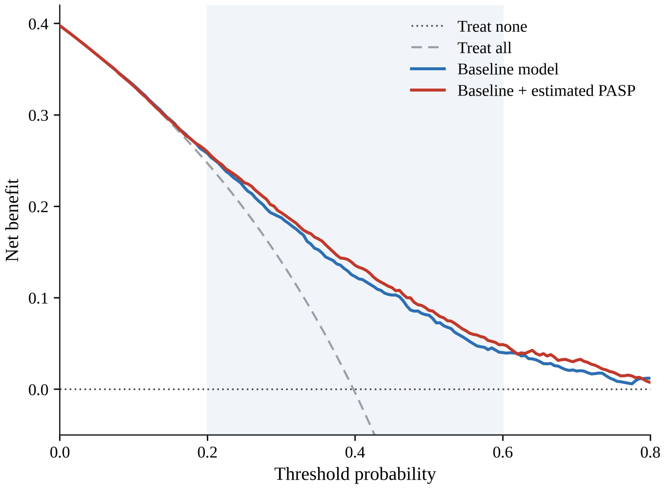
Fig. S2. Decision-curve analysis for the prediction of 90-day mortality, comparing a baseline clinical model (age, SOFA score, lactate, and left ventricular ejection fraction) with the same model augmented by estimated pulmonary artery systolic pressure. Net benefit is plotted against the threshold probability; the “treat-all” and “treat-none” strategies are shown for reference. Across the range of clinically plausible thresholds (0.20–0.60), the PASP-augmented model yielded a small but consistent increase in net benefit. The analysis used the complete-case sample (n=3,410).

