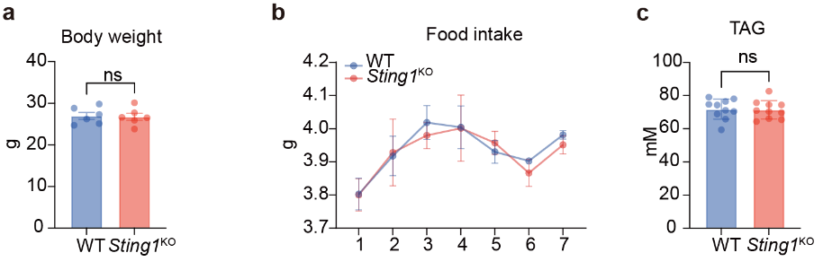
FigS1: STING deficiency has no effect on body weight, food intake or serum triglycerides.
a, Body weight of 8-week-old WT and Sting1-KO mice on a chow diet. n= 6 mice per group. b, Measurement of food intake at week 8 of WT and Sting1-KO mice on a chow diet. n= 3 mice per group. c, Quantification of serum triglyceride (TAG) of 8-week-old WT and Sting1-KO mice on a chow diet. n= 10 mice per group. Data are mean ± SD. P values were obtained using unpaired t test (a, c). ns means P > 0.05.

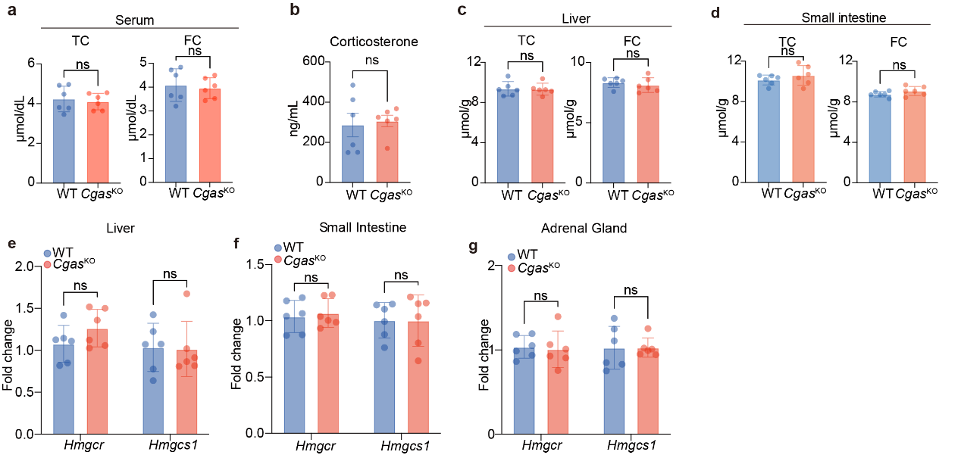
FigS2: Cgas knockout does not affect cholesterol metabolism in mice.
a-d, The TC and FC in serum (a), liver (c) and small intestine (d) and the corticosterone in serum (b) of 8-week-old, WT and Cgas-KO mice on a chow diet were detected by quantification Kits. e-g, The mRNA expression levels of SREBP-2 downstream genes in the liver (e), small intestine (f) and adrenal gland (g) of 8-week-old, WT and Cgas-KO mice on a chow diet. n= 6 mice per group. Data are mean ± SD. P values were obtained using unpaired t test (a-d) or ordinary two-way ANOVA (e-g). ns means P > 0.05.
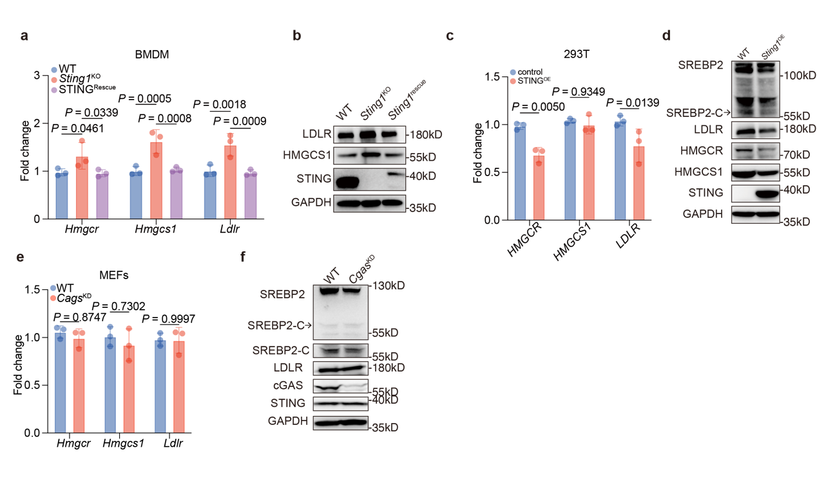
FigS3: STING deficiency induces cholesterol synthesis response.
a-b, BMDMs isolated from WT and Sting1-KO mice transduced with control vector or an mSTING-expressing plasmid for 24 h to rescue STING expression in KO cells. The mRNA expression levels of SREBP-2 downstream genes in the BMDMs (a). Western blot analysis of SREBP-2 downstream genes in the BMDMs (b). c-d, The mRNA expression levels of SREBP-2 downstream genes (c) and western blot analysis of SREBP-2 downstream genes (d) in the 293T cells transduced with control vector or hSTING expressed plasmid for 24 h. e-f, The mRNA expression levels of SREBP-2 downstream genes (e) and western blot analysis of SREBP-2 downstream genes (f) in the control and Cgas knockdown MEF cells. Data are mean ± SD of three independent biological experiments. P values were obtained using ordinary two-way ANOVA (a, c, e).
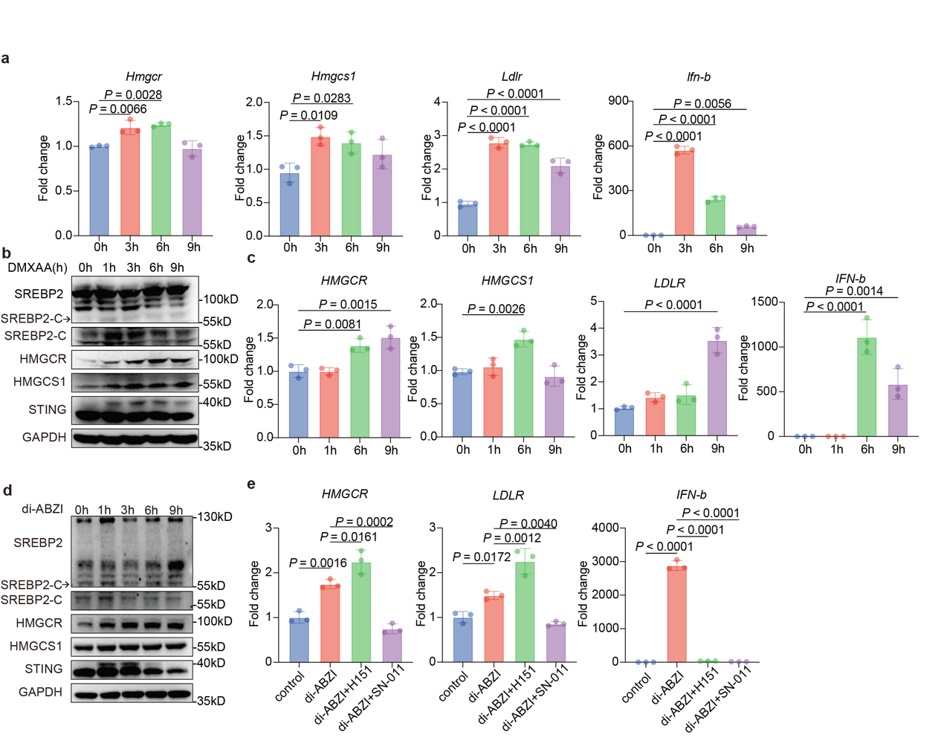
FigS4: Depletion of the ER-localized STING promotes SREBP-2 activation
a, The mRNA expression levels of SREBP-2 downstream genes in the iBMDM cells incubated with DMSO or DMXAA (10 µg/mL). b, Western blot analysis of SREBP-2 activation in the iBMDM cells incubated with DMSO or DMXAA (10 µg/mL). c, The mRNA expression levels of SREBP-2 downstream genes in the THP-1 cells incubated with DMSO or di-ABZI (5 µM). d, Western blot analysis of SREBP-2 activation in the THP-1 cells incubated with DMSO or di-ABZI (5 µM). e, The mRNA expression levels of SREBP-2 downstream genes in the THP-1 cells incubated with DMSO, H151 (5 µM) or SN-011 (5 µM) for 2 h, followed by incubation with di-ABZI (5 µM) for an additional 6 h. Data are mean ± SD of three independent biological experiments. P values were obtained using ordinary one-way ANOVA (a, c, e)
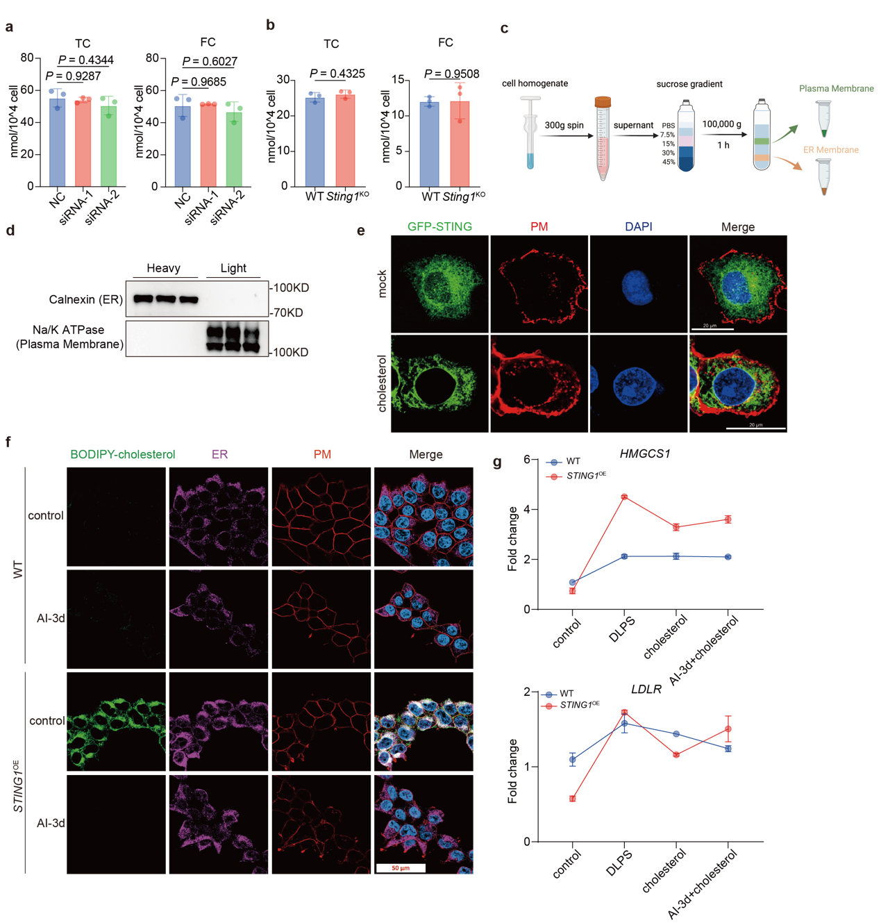

FigS5: STING mediates cholesterol PM-to-ER transfer.
a, The total cholesterol (TC) and free cholesterol (FC) in HT-29 cells. b, The levels of TC and FC content in primary MEFs. c, Schematic workflow for the purification of PM and ER fractions. d, Western blot analysis of purified ER and PM fractions of MEFs. e, Representative images of HeLa cells expressing GFP-STING incubated with 100 μM water-soluble cholesterol for 30 mins. GFP-STING (green), PM-resident protein Na⁺/K⁺- ATPase (red). Scale bar, 20 μm. f, Representative images of 293T cells transduced with control or STING expressed plasmid for 24 h and incubated with 2 μM Bodipy-cholesterol. ER-resident protein AGR2 (purple), PM-resident protein Na⁺/K⁺- ATPase (red), Bodipy-cholesterol (green). Scale bar, 50 μm. g, The mRNA expression levels of SREBP-2 downstream genes in 293T cells transduced with control or STING expressed plasmid for 24 h and treated with control or cholesterol-depleted serum (DLPS) and incubated simultaneously with DMSO or AI-3d (1 μM) for 6 h then incubated with 100 μM water-soluble cholesterol for 2 h. Data represent mean ± SD of three independent experiments. P values were obtained using ordinary one-way ANOVA (a) and unpaired t test (b).
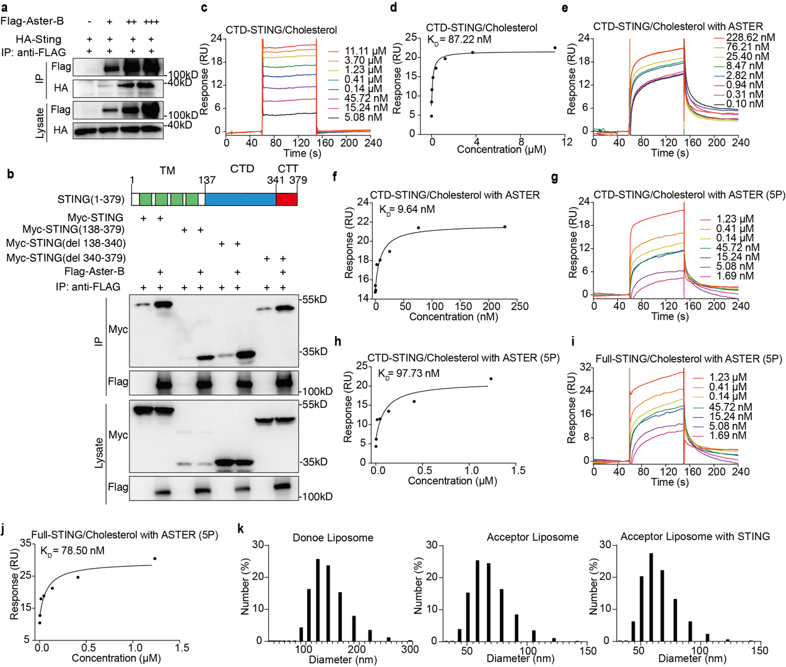
FigS6: STING is a downstream cholesterol acceptor of Asters.
a, Co-IP of Flag- Aster-B and HA-STING expressed in 293T cells. a, Co-IP of Flag- ASTER domain and Myc-STING truncations expressed in 293T cells. c-d, The binding ability of cholesterol to purified CTD-STING was detected by SPR. e-f, The binding ability of cholesterol to purified CTD-STING was detected by SPR when the purified ASTER domain of Aster-B (6 nM) was added into the running buffer. g-h, The binding ability of cholesterol to purified CTD domain of STING was detected by SPR when the purified ASTER domain mutants (5P) of Aster-B (6 nM) was added into the running buffer. i-j, The binding ability of cholesterol to purified full-length STING was detected by SPR when the purified ASTER domain mutant (5P) of Aster-B (6 nM) was added into the running buffer. k, The diameter quantification of donoe liposome and acceptor liposome with or without STING in FRET assay. Data represent mean ± SD of three independent experiments.
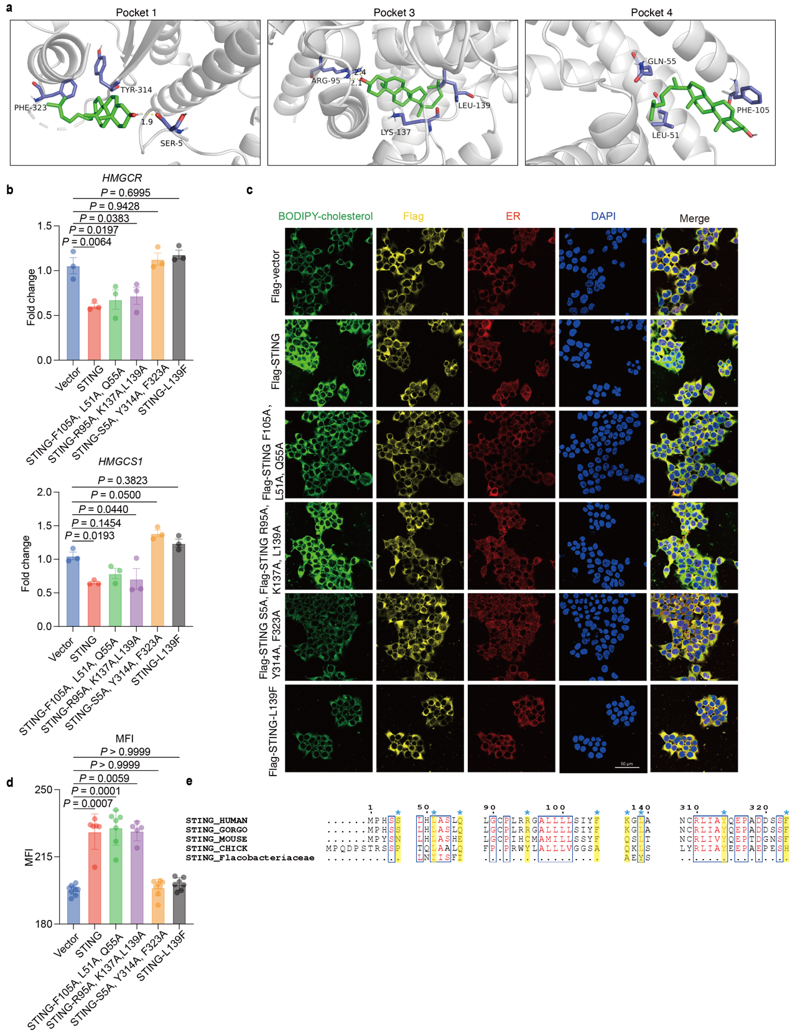
FigS7: STING is an evolution-conserved cholesterol channel.
a, Sematic representation of the cholesterol-binding pocket of STING (PDB ID: 6NT5) with the key residues for targeted mutations. Key parameters were calculated with Schrödinger Maestro. b, The mRNA expression levels of SREBP-2 downstream genes in 293T cells transduced with control, WT STING or STING mutations expressed plasmid for 24 h. c, Representative images of 293T cells transduced with control, Flag-STING or Flag-STING mutations expressed plasmid for 24 h and incubated with 2 μM Bodipy-cholesterol for 1 h. ER-resident protein AGR2 (red), Flag (yellow), Bodipy-cholesterol (green). Scale bar, 50 μm. d, Quantification of mean fluorescence intensity (MFI) of Bodipy-cholesterol from images as shown in c. e, Conservation of key cholesterol-binding residues in STING across species. Data represent mean ± SD of three independent experiments. P values were obtained using ordinary one-way ANOVA (b) or Kruskal-Wallis test (d).
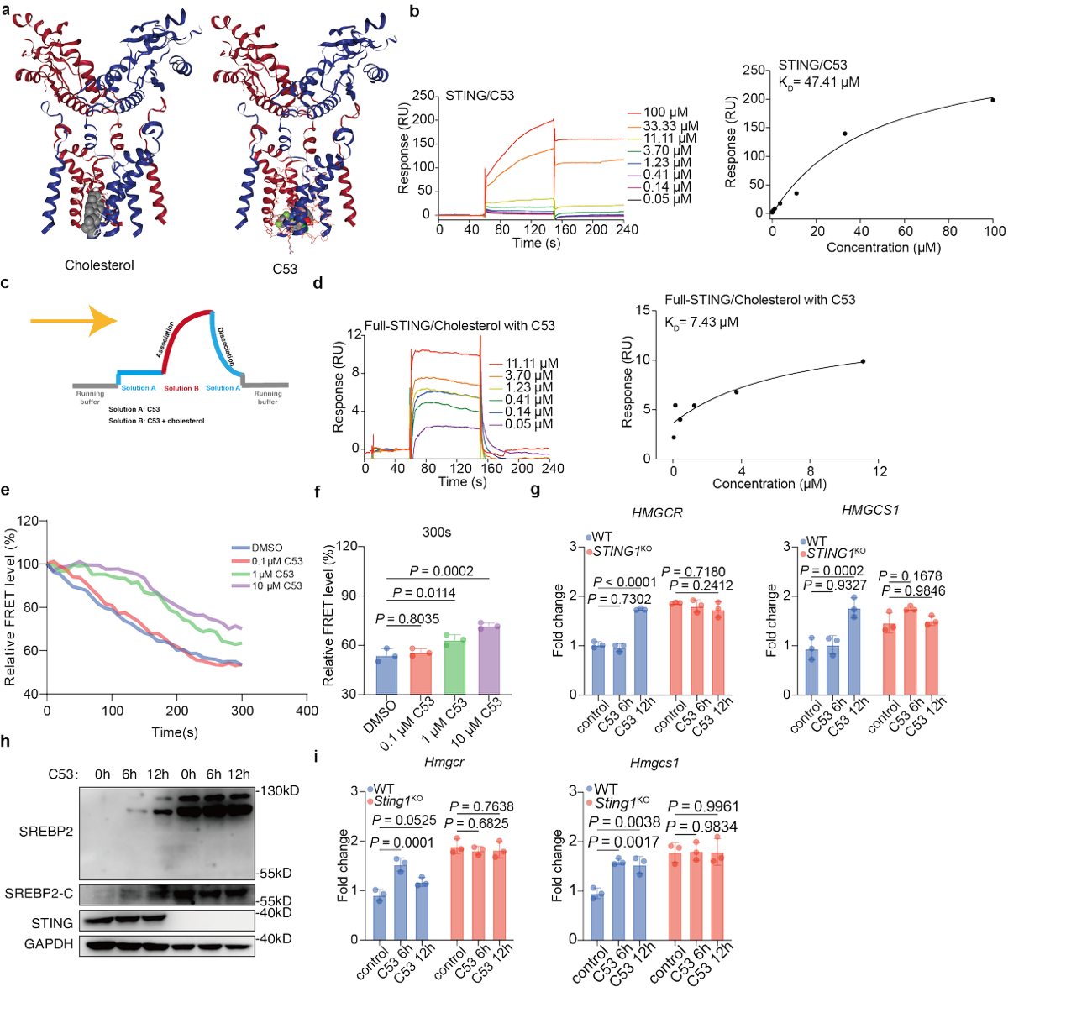
FigS8: C53 impairs cholesterol transfer by blocking the STING channel.
a, Predicted pocket 4 for human cholesterol-bound STING and C53-bound STING (PDB ID: 6NT5). Key parameters were calculated with Schrödinger Maestro. b, The binding ability of C53 to purified full-length STING was detected by SPR. c, Schematic of the competitive SPR assay. d, The influence of C53 (10 μM) to the cholesterol-STING binding was detected by competitive SPR. e-f, FRET values were simultaneously monitored when the L_{PM} liposomes and L_{ER} liposomes reconstituted with full-length STING protein were incubated with purified ASTER domain of Aster-B and C53. g, The mRNA expression levels of SREBP-2 downstream genes in THP-1 cells incubated with 10 μM C53. h, Western blot analysis of SREBP-2 downstream genes in THP-1 cells incubated with 10 μM C53. i, The mRNA expression levels of SREBP-2 downstream genes in MEFs incubated with 10 μM C53. Data represent mean ± SD of three independent experiments. P values were obtained using ordinary one-way ANOVA (f) and ordinary two-way ANOVA (g, i).
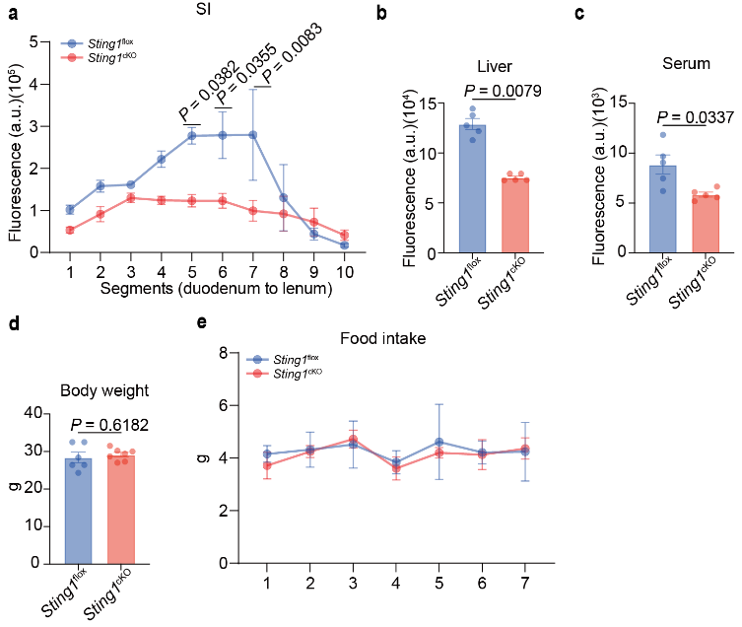
FigS9: STING facilitates dietary cholesterol uptake in intestinal epithelial cells.
a-c, Sting1^{flox} and Sting1^{cKO} mice were fasted overnight and administered Bodipy-cholesterol (500 μM/200 μL/mouse) via oral gavage. The small intestine segments (a), liver (b) and serum (c) were collected and the fluorescence intensity of Bodipy-cholesterol in tissue homogenates were measured. Results are expressed as fluorescence intensity per gram of tissue weight, and serum results are presented as fluorescence intensity per 100 µL of serum. n=5 mice each group. d, Body weight of 8-week-old Sting1^{flox} and Sting1^{cKO} mice on a chow diet. e, Measurement of food intake at week 8 of Sting1^{flox} and Sting1^{cKO} mice on a chow diet. n=6 mice each group. Data are mean ± SD. P values were obtained using ordinary two-way ANOVA (a, e), Mann-Whitney test (b), Welch’s t test (c) or unpaired t test (d).
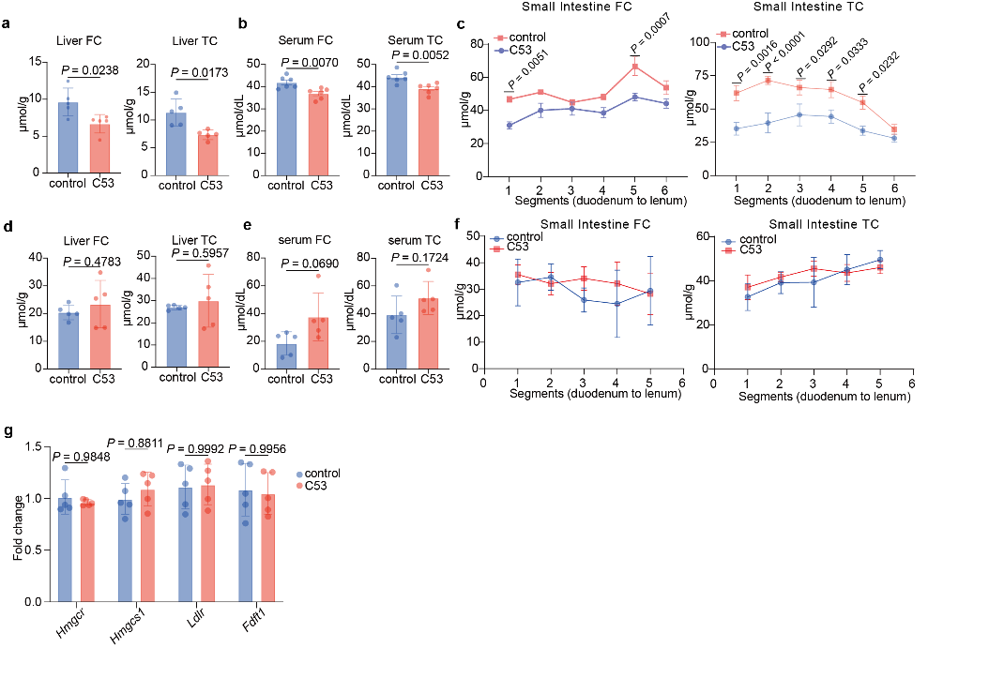
FigS10: C53 inhibits dietary cholesterol uptake in the small intestine.
a-c, WT mice were fasting overnight and were administered 10 mg/kg of C53 via oral gavage, followed by cholesterol (200 mg/kg) gavage 1 h later. Samples were collected 1 h later after the cholesterol administration. The free cholesterol (FC) and total cholesterol (TC) level of liver (a), serum (b) and jejunum sections (c). n=6 mice each group. d-g, Sting1-KO mice were fasting overnight and administered 10 mg/kg of C53 via oral gavage, followed by cholesterol (200 mg/kg) gavage 1 h later. Samples were collected 2 h later after the cholesterol administration. The free cholesterol (FC) and total cholesterol (TC) level of liver (d), serum (e) and jejunum sections (f). The mRNA expression levels of SREBP-2 downstream genes in duodenum (g). n=5 mice each group. Data are mean ± SD. P values were obtained using Welch’s t test (a, e), unpaired t test (b, d), ordinary two-way ANOVA (c, f, g).
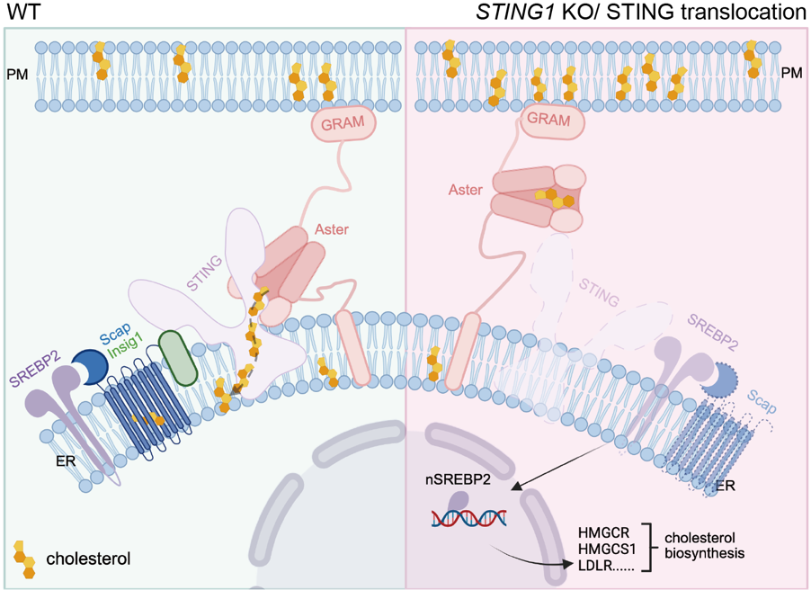
FigS11: Schematic of STING as a cholesterol transfer channel.
Under normal conditions (left), STING channels Aster-delivered cholesterol from the PM to the ER membrane. This ER cholesterol enables SCAP-INSIG1 to retain SREBP2 in the ER, thereby suppressing cholesterol synthesis. Upon STING deficiency or translocation (right), cholesterol fails to reach the ER and instead it builds up at the PM. This ER cholesterol scarcity releases SCAP from INSIG1, allowing SREBP2 nuclear translocation to active the expression of cholesterol-biosynthetic genes.

