Supplementary Materials

- Table S1. All edges weights within PGI-LB network
- Table S2. All edges weights within PGI-LB network of male
- Table S3. All edges weights within PGI-LB network of female
- Table S4. All edges weights within PGI-LB network of city samples
- Table S5. All edges weights within PGI-LB network of rural samples
- Figure S1.Robustness and difference test results of PGI-LB network
- Figure S2. Nonparametric Spearman correlation matrix for variables in female and male
- Figure S3-1. Robustness and difference test results of the male network
- Figure S3-2. Robustness and difference test results of the female network
- Figure S4. Nonparametric Spearman correlation matrix for variables in city and rural samples
- Figure S5-1. Robustness and difference test results of the city network
- Figure S5-2. Robustness and difference test results of the rural network

Table S1. All edges weights within PGI-LB network
 | IMP | DEJ | RPA | PL | RC | IB | UR
IMP | 0.000 | 0.580 | 0.186 | -0.101 | 0.000 | -0.034 | 0.000
DEJ | 0.580 | 0.000 | 0.217 | 0.000 | 0.000 | -0.074 | 0.000
RPA | 0.186 | 0.217 | 0.000 | -0.059 | -0.064 | -0.161 | 0.000
PL | -0.101 | 0.000 | -0.059 | 0.000 | 0.610 | 0.213 | 0.121
RC | 0.000 | 0.000 | -0.064 | 0.610 | 0.000 | 0.235 | 0.141
IB | -0.034 | -0.074 | -0.161 | 0.213 | 0.235 | 0.000 | 0.396
UR | 0.000 | 0.000 | 0.000 | 0.121 | 0.141 | 0.396 | 0.000

Table S2. All edges weights within PGI-LB network of male
 | IMP | DEJ | RPA | PL | RC | IB | UR
IMP | 0.000 | 0.565 | 0.238 | -0.081 | 0.000 | -0.060 | 0.000
DEJ | 0.565 | 0.000 | 0.198 | 0.000 | 0.000 | -0.067 | 0.000
RPA | 0.238 | 0.198 | 0.000 | -0.081 | -0.031 | -0.169 | 0.000
PL | -0.081 | 0.000 | -0.081 | 0.000 | 0.626 | 0.191 | 0.174
RC | 0.000 | 0.000 | -0.031 | 0.626 | 0.000 | 0.279 | 0.101
IB | -0.060 | -0.067 | -0.169 | 0.191 | 0.279 | 0.000 | 0.343
UR | 0.000 | 0.000 | 0.000 | 0.174 | 0.101 | 0.343 | 0.000

Table S3. All edges weights within PGI-LB network of female
 | IMP | DEJ | RPA | PL | RC | IB | UR
IMP | 0.000 | 0.591 | 0.111 | -0.100 | -0.034 | 0.000 | -0.011
DEJ | 0.591 | 0.000 | 0.226 | 0.000 | -0.016 | -0.071 | 0.000
RPA | 0.111 | 0.226 | 0.000 | -0.051 | -0.056 | -0.172 | 0.000
PL | -0.100 | 0.000 | -0.051 | 0.000 | 0.591 | 0.233 | 0.070
RC | -0.034 | -0.016 | -0.056 | 0.591 | 0.000 | 0.186 | 0.176
IB | 0.000 | -0.071 | -0.172 | 0.233 | 0.186 | 0.000 | 0.454
UR | -0.011 | 0.000 | 0.000 | 0.070 | 0.176 | 0.454 | 0.000

Table S4. All edges weights within PGI-LB network of city samples
 | IMP | DEJ | RPA | PL | RC | IB | UR
IMP | 0.000 | 0.593 | 0.210 | -0.055 | 0.000 | -0.036 | 0.000
DEJ | 0.593 | 0.000 | 0.216 | 0.000 | -0.005 | -0.069 | 0.000
RPA | 0.210 | 0.216 | 0.000 | -0.060 | -0.076 | -0.144 | -0.004
PL | -0.055 | 0.000 | -0.060 | 0.000 | 0.663 | 0.217 | 0.117
RC | 0.000 | -0.005 | -0.076 | 0.663 | 0.000 | 0.212 | 0.123
IB | -0.036 | -0.069 | -0.144 | 0.217 | 0.212 | 0.000 | 0.391
UR | 0.000 | 0.000 | -0.004 | 0.117 | 0.123 | 0.391 | 0.000

Table S5. All edges weights within PGI-LB network of rural samples
 | IMP | DEJ | RPA | PL | RC | IB | UR
IMP | 0.000 | 0.566 | 0.156 | -0.140 | 0.000 | 0.000 | -0.096
DEJ | 0.566 | 0.000 | 0.218 | 0.000 | -0.014 | -0.101 | 0.059
RPA | 0.156 | 0.218 | 0.000 | -0.084 | -0.029 | -0.205 | 0.056
PL | -0.140 | 0.000 | -0.084 | 0.000 | 0.535 | 0.196 | 0.125
RC | 0.000 | -0.014 | -0.029 | 0.535 | 0.000 | 0.261 | 0.178
IB | 0.000 | -0.101 | -0.205 | 0.196 | 0.261 | 0.000 | 0.406
UR | -0.096 | 0.059 | 0.056 | 0.125 | 0.178 | 0.406 | 0.000

Figure S1.Robustness and difference test results of PGI-LB network
Note: (a) Accuracy of edge weights. The red line depicts the sample edge weights and the gray bar depicts the bootstrapped confidence interval. (b) Bootstrapped difference test for edge weights. Gray boxes indicate edge weights that do not differ significantly from one another, while black boxes indicate edge weights that do differ significantly. Blue and red boxes on the diagonal correspond to edge weights with positive and negative correlations, respectively. (c) Stability of the bridge expected influence values. The red bar represents the average correlation between bridge expected influence. (d) Bootstrapped difference test for the bridge expected influence values. Gray boxes indicate the bridge expected influence that do not differ significantly from one another, while black boxes indicate the bridge expected influence that do differ significantly. The number in the white boxes (i.e., diagonal line) represent the value of the bridge expected influence.
Male
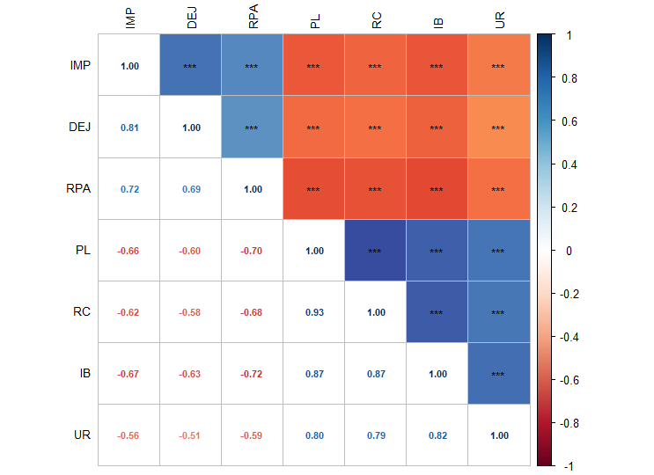
Female
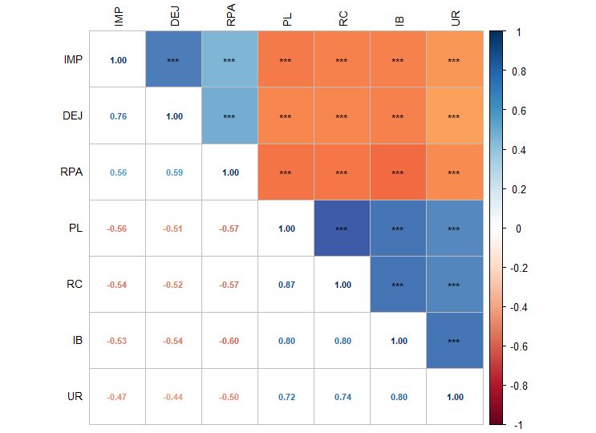
Figure S2. Nonparametric Spearman correlation matrix for variables in female and male
Note: * p < 0.05, ** p < 0.01, *** p < 0.001

Figure S3-1. Robustness and difference test results of the male network
Note: (a) Accuracy of edge weights. The red line depicts the sample edge weights and the gray bar depicts the bootstrapped confidence interval. (b) Bootstrapped difference test for edge weights. Gray boxes indicate edge weights that do not differ significantly from one another, while black boxes indicate edge weights that do differ significantly. Blue and red boxes on the diagonal correspond to edge weights with positive and negative correlations, respectively. (c) Stability of the bridge expected influence values. The red bar represents the average correlation between bridge expected influence. (d) Bootstrapped difference test for the bridge expected influence values. Gray boxes indicate the bridge expected influence that do not differ significantly from one another, while black boxes indicate the bridge expected influence that do differ significantly. The number in the white boxes (i.e., diagonal line) represent the value of the bridge expected influence.

Figure S3-2. Robustness and difference test results of the female network
Note: (a) Accuracy of edge weights. The red line depicts the sample edge weights and the gray bar depicts the bootstrapped confidence interval. (b) Bootstrapped difference test for edge weights. Gray boxes indicate edge weights that do not differ significantly from one another, while black boxes indicate edge weights that do differ significantly. Blue and red boxes on the diagonal correspond to edge weights with positive and negative correlations, respectively. (c) Stability of the bridge expected influence values. The red bar represents the average correlation between bridge expected influence. (d) Bootstrapped difference test for the bridge expected influence values. Gray boxes indicate the bridge expected influence that do not differ significantly from one another, while black boxes indicate the bridge expected influence that do differ significantly. The number in the white boxes (i.e., diagonal line) represent the value of the bridge expected influence.

City
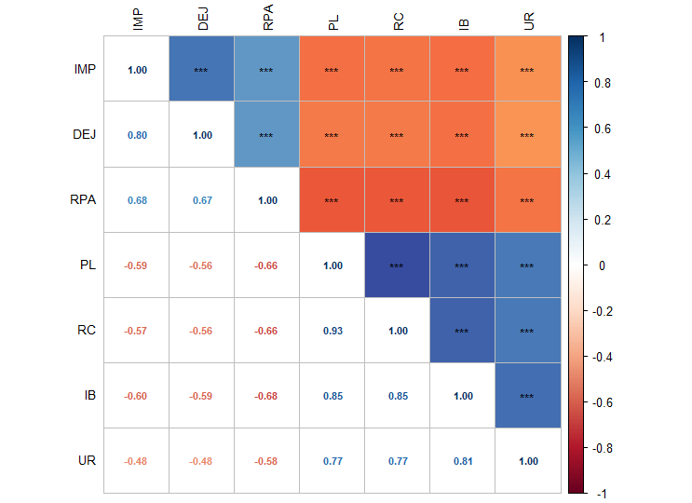
Rural
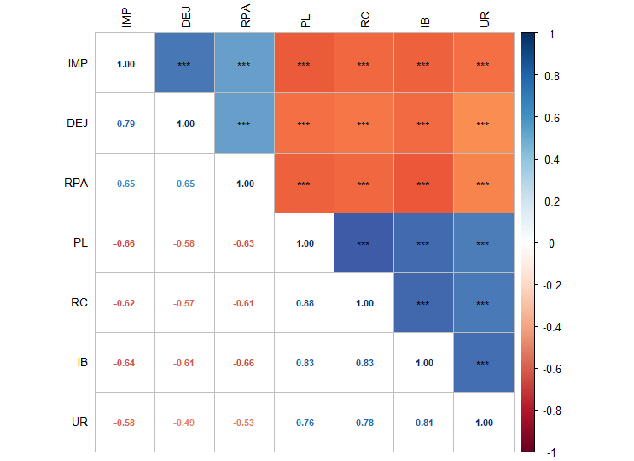

Figure S4. Nonparametric Spearman correlation matrix for variables in city and rural samples
Note: * p < 0.05, ** p < 0.01, *** p < 0.001

Figure S5-1. Robustness and difference test results of the city network
Note: (a) Accuracy of edge weights. The red line depicts the sample edge weights and the gray bar depicts the bootstrapped confidence interval. (b) Bootstrapped difference test for edge weights. Gray boxes indicate edge weights that do not differ significantly from one another, while black boxes indicate edge weights that do differ significantly. Blue and red boxes on the diagonal correspond to edge weights with positive and negative correlations, respectively. (c) Stability of the bridge expected influence values. The red bar represents the average correlation between bridge expected influence. (d) Bootstrapped difference test for the bridge expected influence values. Gray boxes indicate the bridge expected influence that do not differ significantly from one another, while black boxes indicate the bridge expected influence that do differ significantly. The number in the white boxes (i.e., diagonal line) represent the value of the bridge expected influence.

Figure S5-2. Robustness and difference test results of the rural network
Note: (a) Accuracy of edge weights. The red line depicts the sample edge weights and the gray bar depicts the bootstrapped confidence interval. (b) Bootstrapped difference test for edge weights. Gray boxes indicate edge weights that do not differ significantly from one another, while black boxes indicate edge weights that do differ significantly. Blue and red boxes on the diagonal correspond to edge weights with positive and negative correlations, respectively. (c) Stability of the bridge expected influence values. The red bar represents the average correlation between bridge expected influence. (d) Bootstrapped difference test for the bridge expected influence values. Gray boxes indicate the bridge expected influence that do not differ significantly from one another, while black boxes indicate the bridge expected influence that do differ significantly. The number in the white boxes (i.e., diagonal line) represent the value of the bridge expected influence.

