Supporting Information for:

By-Layer Covalent Organic Structure as a Metal-Free PCET Catalyst for Efficient Oxygen Evolution in Alkaline and Neutral Media

Soheila Nakhjiri Kamrani^{1,2}, Afshin Pashabadi^{1*} and Mohammad Joshaghani^{1,2 *}
¹ Faculty of Chemistry, Razi University, Kermanshah, 67149‐67346, Iran
² Nanoscience and Nanotechnology Research Center (NNRC), Razi University, Kermanshah, 67149‐67346, Iran
Corresponding authors E-mail: mjoshaghani@razi.ac.ir, apashabadi@razi.ac.ir,

Content of Supporting Information:
1. Materials and instrumentation

The chemical materials 3-Chloropropyl trimethoxysilane (CPTMS), 5,10,15,20-tetrakis(4-hydroxyphenyl) porphyrin (THPP), Methyl bromoacetate (MBA), Ethylenediamine (EDA), Toluene, Dioxane, Acetone (extra Pure), Methanol, Ethanol, Sodium carbonate (Na₂CO₃), Potassium iodide (KI), Potassium carbonate (K₂CO₃) was of analytical grade and used without further purification. The structure of synthesized Electrodes was examined with the ¹H NMR spectrum (Bruker MSI-400 MHz and Bruker BioSpin GmbH-500 MHz). The compounds were dissolved in DMSO and CDCl₃ as solvent. Chemical shifts were in part per million downfield from tetramethylsilane (TMS) as an internal standard. The morphology and elemental analysis of electrodes were determined by field emission scanning electron microscopy–energy dispersive X-ray analysis (FESEM-EDX) (Bruker, Quinta 200, Germany). The structural functional groups of electrodes composition were determined by Fourier-transform infrared (FTIR, Bruker within the wavelength range of 500–4000 nm).

2. Fabrication of electrodes step by step
By-layer nonmetallic proton relay (Shell-II) was synthesized by chemical and electrochemical reactions:

- Fabrication of GO electrode
First, surface of graphite (GR) electrodes turned into graphene oxide (GO) by cyclic voltammetry (CV) scanning-based electrochemical oxidation [potentials of 0-3 V vs. SCE in 0.025 mol PBS (Figure S1)]. The creation of functionalities like hydroxyl, hydroxyl carbonyl, and epoxy on the outer surface of the two-dimensional nanostructure made the surface characteristic suitable for CPTMS linker binding [1].
- Fabrication of GO-CPTMS electrode
The weight of the electrodes converted to GO was equal to 0.36 g. These electrodes were suspended in a reflux flask containing 200 mL of toluene solvent with 0.45 mL of CPTMS (2.5 mmol) and subjected to the reflux process at 110 °C for 24 hours. After the end of the reaction, the synthesized GO-CPTMS electrodes were dried.
- Fabrication of GO-CPTMS-THPP electrode
The electrodes prepared in the previous step were weighed and placed inside the reflux flask containing 40 mL of dioxane solvent, 0.52 g THPP (0.77 mmol), 1.3 g Na₂CO₃ (12.26 mmol), and 1.5 g KI (9.03 mmol) and subjected to the reflux process for 24 hours at 101 °C (the magnet used for the stirrer should not have any contact with the electrodes). The electrodes obtained in this step are GO-CPTMS-THPP, which were dried again (FT-IR analysis-and LSV confirmed the fabrication of these electrodes).
- Fabrication of GO-CPTMS-THPP-MBA electrode
In the next step, GO-CPTMS-THPP electrodes in a reflux flask containing 6 mmol MBA and 50 mL pure acetone (8.6 mmol) and 1.2 g K₂CO₃ refluxed for 24 hours under stirring conditions. After the end of the reaction, the fabricated GO-CPTMS-THPP-MBA electrodes were dried and weighed (0.18 g).
- Fabrication of electrode GO-CPTMS-THPP-MBA-EDA (Shell-I)
Electrodes prepared in the previous step were refluxed in a mixture of 1.8 mL of EDA (27 mmol), a 1:1 ratio of toluene and methanol solvent at a temperature range 60-70 °C for 8 hours. At this stage of the fabrication process, the Shell-I electrodes are constructed. By making the Shell-I electrodes, the first layer of the proton relay was made.
- Fabrication of THPP-MBA powder
For the second layer of electrodes with bilayer structure, it was done as follows: In order to synthesize THPP-MBA powder, 50 mL of extra pure acetone solvent, 6 mmol MBA and 1.2 gr (8.6 mmol) K₂CO₃ were poured into a reflux flask and put on a heater at 60 °C for 20 min under the reflux process. Then, 0.77 mmol THPP along with another 10 mL of extra pure acetone solvent was added to the previous mixture and the reflux continued for 24 hours. After the end of the reaction time, the powder structure obtained was dried.

- Fabrication of (Shell-I)-MBA-THPP-MBA electrode
The fabricated Shell-I electrodes in step e were placed in a reflux flask containing 0.5 g THPP-MBA powder and 50 mL ethanol solvent and subjected to the reflux process for 24 hours. The electrodes prepared in this step were called (Shell-I)-MBA-THPP-MBA, which were also dried for the next steps (0.15 g).
- Fabrication of Shell-II
(Shell-I)-MBA-THPP-MBA electrodes were kept suspended inside a reflux flask containing a 1:1 ratio of toluene and methanol solvents and 30 mmol EDA and refluxed at 60-70 °C for 24 hours. After the end of the reaction, the Shell-II electrodes were dried, and the final electrodes made were used as a proton relay to perform the OER reaction and electrochemical tests. FT-IR, HNMR, EDXA, CV, and LSV analyzes confirmed the step-by-step construction of these electrodes.

3. Electrochemical measurments
All the electrochemical experiments were performed on an Autolab system (potentiostat/galvanostat/impedance analyzer PalmSens3) with PS Trace software and a cell containing electrodes of Ag/AgCl (KCl 3 M) as reference electrode, a Pt wire as counter electrode and, and as-prepared modified GR electrodes (pencil tips with a diameter of 2mm and height of 2mm) as the working electrodes and KOH as the electrolyte solution. All the applied potentials were transformed into RHE. Linear scanning voltammetry (LSV) plots were recorded in 0.1, 1 and 3 M KOH electrolyte at a scan rate of 0.01 V/s. Electrochemical impedance spectroscopy (EIS) of modified electrodes was done in the AC frequencies ranging from 0.01 Hz to 100 kHz to approve the interfacial pathway of electron transfer during the OER process.

4. CHNO, ICP and EDXA elemental analyses
The CHNO elemental analysis of GO (Table S1 and Figure S2) shows a relatively high C/O atomic ratio about 1.4 which indicating effective oxidation of GR to GO. The H/O atomic ratio is 1.12 which together with C/O atomic ratio suggests an empirical formula C₄H₃O₃ or C₈O₂(OH)₂.2H₂O, the latter is that proposed by Clauss [2, 3]. Differences are probably due to the presence of lattice water. According to this empirical formula, it seems that the oxidation was carried out efficiently and also hydroxy and epoxy groups are the major oxygen containing groups. This is in agreement with the result obtained by FT-IR.
EDXA elemental analysis (Figure S3) shows the presence of O, C, and S in the prepared GO. The carbon to oxygen atomic ratio is about 1.29 which is in agreement with the results obtained by CHNO elemental analysis. The empirical chemical formula was C₄O₃ which confirms the CHNO elemental analysis. Very low atomic percent of sulfur about 0.41% comes from sulfuric acid used in the synthesis of GO. Indeed, according to the Dimiev–Tour model, sulfuric acid is intercalated into the GR basal plane to form C₍₂₁₋₂₈₎-(HSO₄⁻)_{n} (n=1,2). Part of the HSO₄⁻ groups on the GR plane could exchange with the hydroxides, generating hydroxy groups. The adjacent hydroxy groups may also loss water to generate epoxy groups. Eventually, GO is obtained wherein, hydroxy and epoxy groups are the main oxygen-containing functional groups. This is in agreement with FT-IR results.
The CHNO together with ICP elemental analysis confirm the linkage of CPTMS on the GO (Table S1). The empirical chemical formula is C₁₂H₁₀O₆Si and the Si/O ratio was 0.16 which in comparison with the Clauss’ empirical formula for GO, indicate that about 50% of hydroxy groups have replaced by CPTMS. The EDXA elemental analysis (Figure S4) also confirms the presence of equivalent number of silicone and chlorine as well as trace amount of sulfur.
The elemental analysis of GO-CPTMS-THPP (Table S1 and Figure S5) reveal that the empirical chemical formula is C₅₆H₃₉O₁₀N₄Si. The N/Si ratio is 4 which confirms the fully substitution of THPP to all CPTMS functional groups. Functionalization of THPP with MBA is also confirmed by elemental analysis (Table S1 and Figure S6). Again, the N/Si ratio was 4. The empirical chemical formula is C₆₅H₅₁O₁₆N₄Si or C₉H₄O₆(C₃H₆Si)(C₄₄H₂₆N₄O₄)(C₃H₅O₂)₃ which shows all of the hydroxy groups of porphyrin were substituted with MBA. On addition of EDA, the empirical chemical formula becomes C₆₈H₆₃O₁₃N₁₀Si with N/Si ratio equal to 10 which shows EDA was attached to all MBA (Table S1 and Figure S7). Addition of THPP-MBA (Figure S8) to the Shell-I and subsequent addition of EDA resulted in the formation of last electrodes with repeated functional layers (Table S1 and Figure S9).

5. UV-Vis studies
In the electronic spectrum, the metal-free porphyrin (THPP) with D_{2h} symmetry shows a typical Soret band (s> 200,000 L'mor¹ 'cm⁻¹) at 415 nm arising from the transition of a_{1u} ($π$)-e_{g}*($π$), and four weaker (s < 30,000 L'mor¹ 'cm⁻¹) Q bands in the (518, 556, 597 and 650 nm) range corresponding to the a_{2u} ($π$)-e_{g} *($π$) transition Figure S12. On coordination of THPP to magnesium and/or palladium ions, the lone pair electrons of the N atoms in the pyrrole rings are taken up by the metal ions resulting equivalency of all nitrogen atoms and increasing the symmetry to D_{4h}. Therefore, the intensity and the number of Q bands may be reduced. In the case of palladium, $π$-back bonding from electron rich of d orbitals of the metal to e_{g}*($π$) of the ligand, shifts the Soret band to shorter wavelengths (408 nm). While electrons of the metal ions are donated to the porphyrin molecule in $π-$back transitions, forming delocalized π bonds, which permit the easy flow of electrons within the delocalized π system also affects OH groups and proton release. For magnesium metal, don't have $π-$back transitions from metal to porphyrin as a result, a blue shift of the Soret bands occurred.

Supporting Figures, Table and Notes
Figure S1. CV curves of GO nanosheets constructed of GR electrode in pH 6.9 (0.025 M PBS). Scan rate: 0.05 Vs⁻¹ (first circle: black; final circle: violet).
Table S1. CHNO elemental analysis test results (W%) of electrodes’ GO (A), GO-CPTMS (B), GO-CPTMS-THPP (C), GO-CPTMS-THPP-MBA (D), Shell-I (E), (Shell-I)-MBA-THPP-MBA (F) Shell-II (G).
Figure S2. Atomic ratios in structures of electrodes’ GO (A), GO-CPTMS (B), GO-CPTMS-THPP (C), GO-CPTMS-THPP-MBA (D), Shell-I (E), (Shell-I)-MBA-THPP-MBA (F) Shell-II (G).
Figure S3. The SEM image (a) and the EDXA elemental analysis results (b) of GO electrode.
Figure S4. The SEM image (a) and the EDXA elemental analysis results (b) of GO-CPTMS electrode.
Figure S5. The SEM image (a) and the EDXA elemental analysis results (b) of GO-CPTMS-THPP electrode.
Figure S6. The SEM image (a) and the EDXA elemental analysis results (b) of GO-CPTMS-THPP-MBA electrode.
Figure S7. The SEM image (a) and the EDXA elemental analysis results (b) of Shell-I electrode.
Figure S8. The SEM image (a) and the EDXA elemental analysis results (b) of THPP-MBA powder.
Figure S9. The SEM image (a) and the EDXA elemental analysis results (b) of Shell-II.
Figures S10. (a) and (b) present FE-SEM images of the GR electrode before and after electrochemical treatment. It is clear in Figure S10 (a) GR flakes electrode is densely packed and has very flat and smooth surface, across the whole electrode surface, huge, extremely thin multilayer GR sheets with an outward orientation are visible. After the electrochemical exfoliation, Figure S10 (b) the size of the sheets has been grown up, rough surface appeared also large number of erratic wrinkles on the surface were revealed, which is caused by the oxidation process.
Figure S11. FT-IR spectrum of free THPP.
Figure S12. Placement of magnesium and palladium metal in THPP complex and their UV-Visible spectra changes.
Figure S13. The ¹H-NMR spectrum of THPP structure.
Figure S14. The ¹H-NMR spectrum of THPP-MBA structure.
Figure S15. The ¹H-NMR spectrum of THPP-MBA-EDA structure.
Figure S16. The ¹H-NMR spectrum of THPP-MBA-EDA-MBA-THPP-MBA structure.
Figure S17. The ¹H -NMR spectrum of THPP-MBA-EDA-MBA-THPP-MBA-EDA structure. . Figure S18. Linear sweep voltammetry (LSV) curve with a scan rate of 0.01 V/s in 0.1 M of KOH
Figure S19. Schematic of zero-point energy relationships in different classes of hydrogen bonding. The potential energy wells for hydrogen-bonded heteroatoms and the zero-point energy levels for H and D are qualitatively showed for the three classes of hydrogen bonds described in.^{[4]} In very strong or single-well hydrogen bonds, right, the zero-point energies of hydrogen and deuterium both lie well above the barrier, and the hydron is shared almost equally between the heteroatoms. In proton inventory data this feature is confirmed by low fractionation factor around 0.228.
Figure S20. The plot of j_{n}/j₀ as a function of n, where n = [D]/([D]+ [H]) at potential 1.7 vs. RHE and fitting curve. Insets are the corresponding Z and ∅ values extracted from the fitted curve.
Figure S21. The plot of j_{n}/j₀ as a function of n, where n = [D]/([D]+ [H]) at potential 1.8 vs. RHE and fitting curve. Insets are the corresponding Z and ∅ values extracted from the fitted curve.
Figure S22. The plot of j_{n}/j₀ as a function of n, where n = [D]/([D]+ [H]) at potential 1.9 vs. RHE and fitting curve. Insets are the corresponding Z and ∅ values extracted from the fitted curve.
Figure S23. The plot of j_{n}/j₀ as a function of n, where n = [D]/([D]+ [H]) at potential 2 vs. RHE and fitting curve. Insets are the corresponding Z and ∅ values extracted from the fitted curve. Figure S24. The cyclic voltammograms obtained in 1 M KOH and the relevant plot of current densities against sweeping rates ranging from 20 to 160 mV s−¹ at GR, ϕ=0.306
Figure S25. The cyclic voltammograms obtained in 1 M KOH and the relevant plot of current densities against sweeping rates ranging from 20 to 160 mV s−¹ at (Shell-I), ϕ=0.514.
Figure S26. The cyclic voltammograms obtained in 1 M KOH and the relevant plot of current densities against sweeping rates ranging from 20 to 160 mV s−¹ at (Shell-II), ϕ=0.265. Figure S27. (a) Cyclic voltammograms obtained from the non-Faradic region of GR at different scan rates. (b) C_{dl} calculation of GR.
Figure S28. (a) Cyclic voltammograms obtained from the non-Faradic region of Shell-I at different scan rates. (b) C_{dl} calculation of Shell-I.
Figure S29. (a) Cyclic voltammograms obtained from the non-Faradic region of Shell-II at different scan rates. (b) C_{dl} calculation of Shell-Il.
6) Kinetic Isotope Effects (Supporting Note 1)
7) Proton inventory studies (Supporting Note 2) 8) Supporting Note 3
9) Supporting references

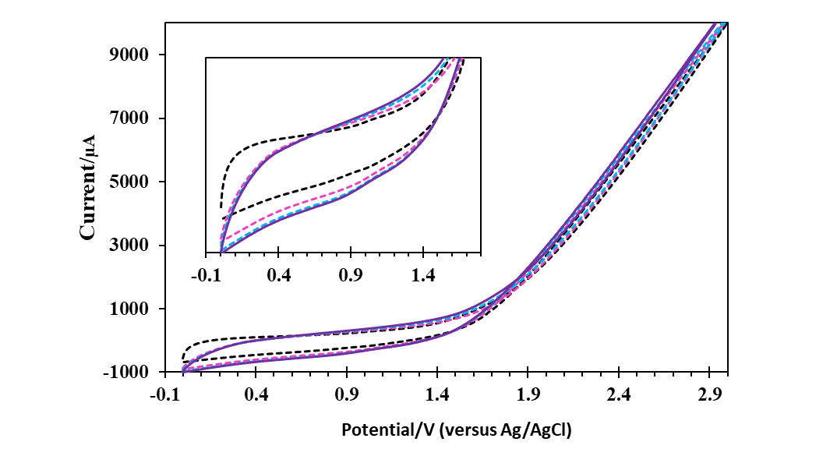
Figure S1. CV curves of graphene oxide (GO) nanosheets constructed of graphite (GR) electrode in pH 6.9 (0.025 M PBS). Scan rate: 0.05 Vs⁻¹ (first circle: black; final circle: violet).

Figure S2. Atomic ratios in structures of electrodes’ GO (A), GO-CPTMS (B), GO-CPTMS-THPP (C), GO-CPTMS-THPP-MBA (D), Shell-I (E), GO-CPTMS-THPP-MBA-EDA-MBA-THPP-MBA (F) Shell-II (G).

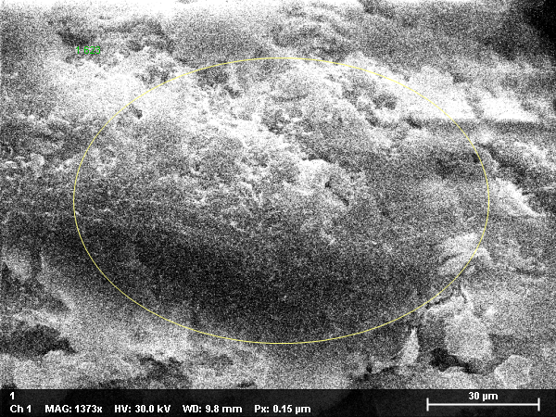
a

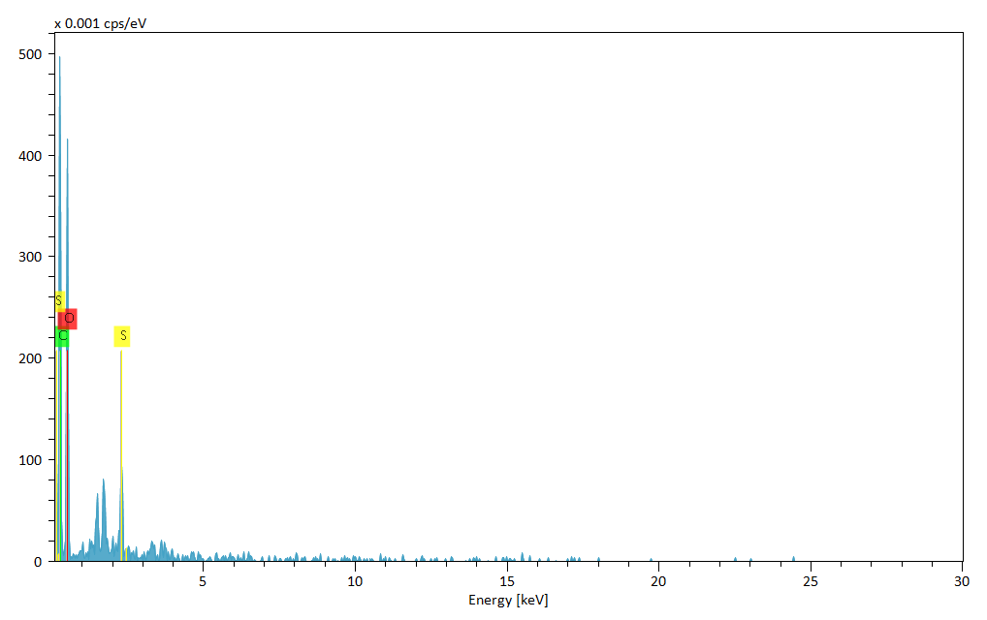
Element | W% | A%
Oxygen | 50.36 | 43.53
Carbon | 48.69 | 56.06
Sulfur | 0.95 | 0.41
Sum | 100.00 | 100.00
b

Figure S3. The SEM image (a) and the EDXA elemental analysis results (b) of GO electrode.

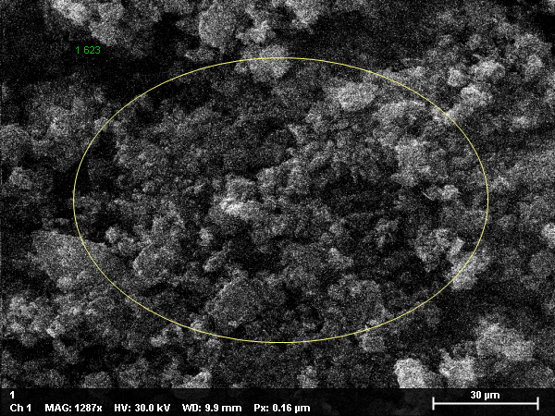
a

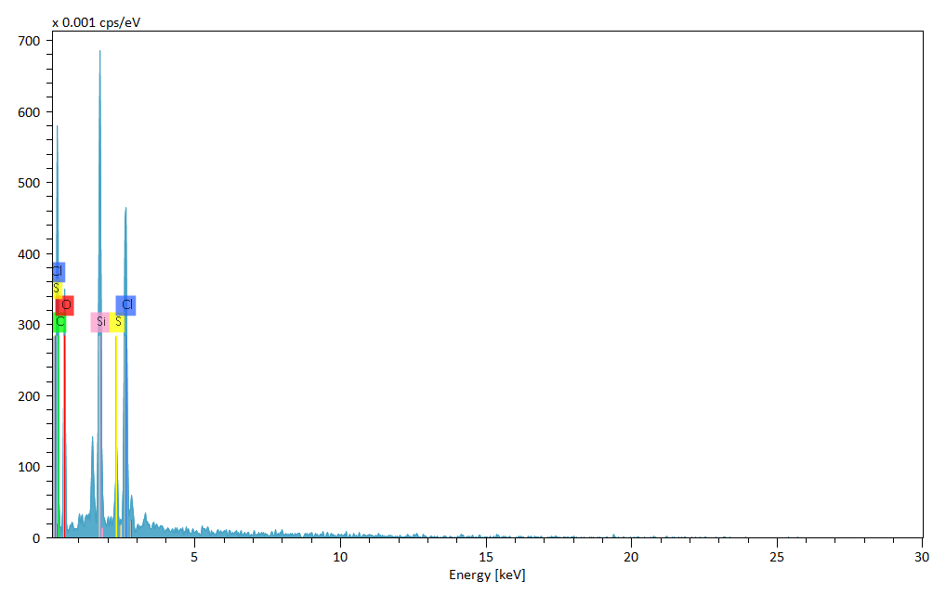
b
Element | W% | A%
Carbon | 56.33 | 65.62
Oxygen | 34.75 | 30.39
Silicon | 4.32 | 2.15
Chlorine | 3.97 | 1.57
Sulfur | 0.64 | 0.28
Sum | 100.00 | 100.00

Figure S4. The SEM image (a) and the EDXA elemental analysis results (b) of GO-CPTMS electrode.

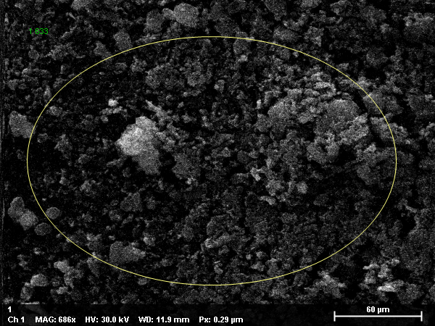
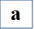
a

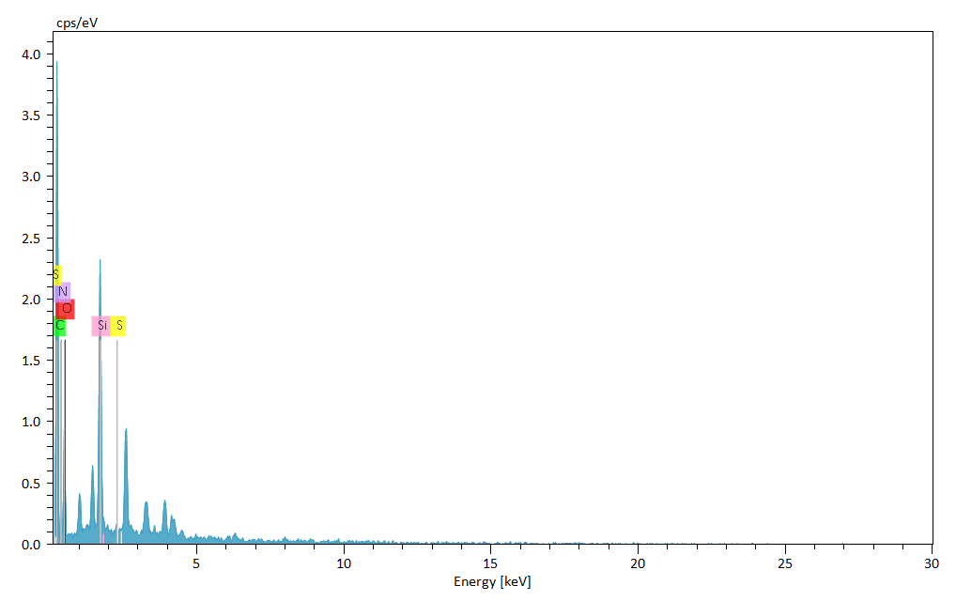
b
Element | W% | A%
Carbon | 63.75 | 70.70
Oxygen | 27.44 | 22.85
Nitrogen | 4.77 | 4.53
Silicon | 3.97 | 1.88
Sulfur | 0.08 | 0.03
Sum | 100.00 | 100.00

Figure S5. The SEM image (a) and the EDXA elemental analysis results (b) of GO-CPTMS-THPP electrode.

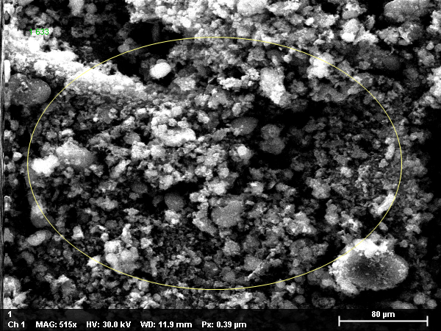
a

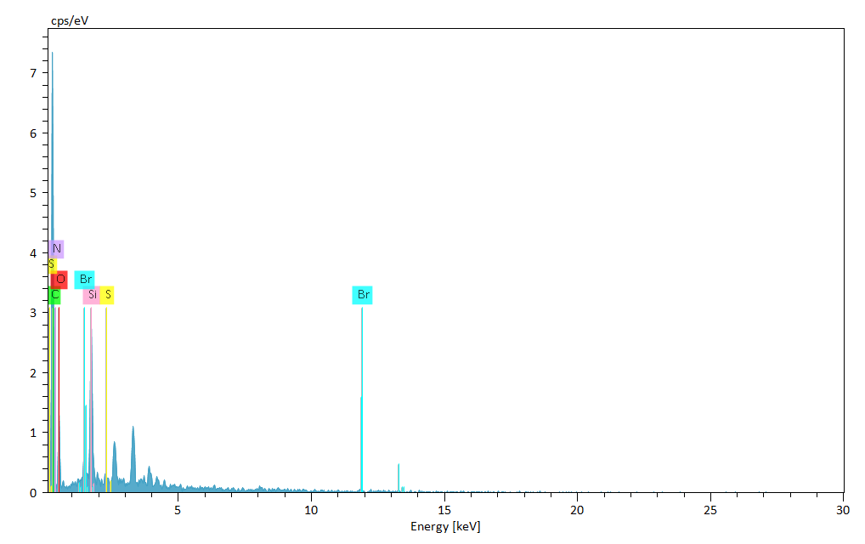
b
Element | W% | A%
Carbon | 66.89 | 73.43
Oxygen | 23.43 | 19.31
Nitrogen | 6.07 | 5.71
Silicon | 3.10 | 1.46
Bromine | 0.48 | 0.08
Sulfur | 0.03 | 0.01
Sum | 100.00 | 100.00

Figure S6. The SEM image (a) and the EDXA elemental analysis results (b) of GO-CPTMS-THPP-MBA electrode.

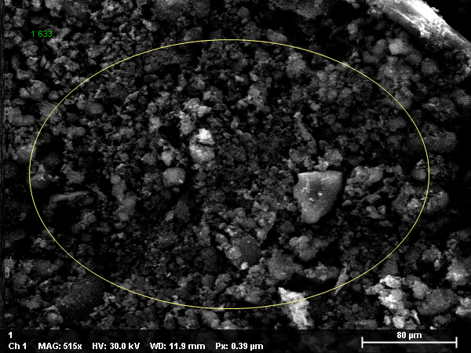
a

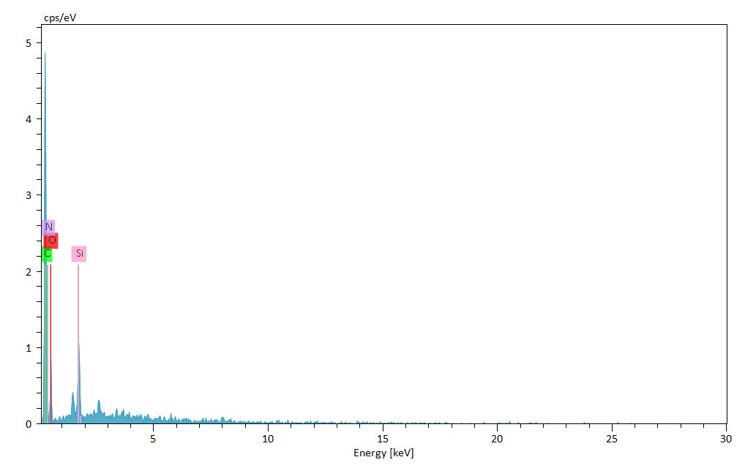
Element | W% | A%
Carbon | 65.07 | 70.83
Oxygen | 22.40 | 18.30
Nitrogen | 10.76 | 10.04
Silicon | 1.77 | 0.82
Sum | 100.00 | 100.00
b

Figure S7. The SEM image (a) and the EDXA elemental analysis results (b) of Shell-I electrode.

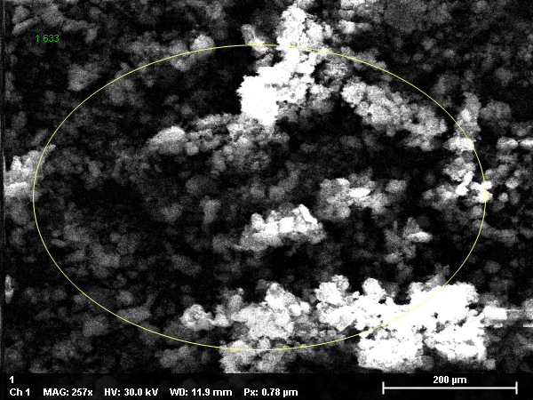
a

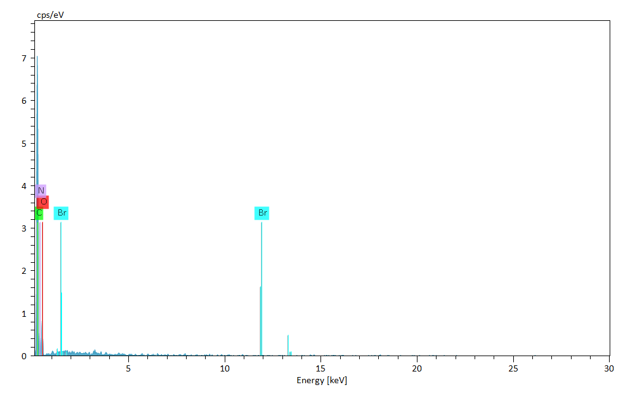
Element | W% | A%
Carbon | 70.88 | 75.92
Oxygen | 22.18 | 17.84
Nitrogen | 6.77 | 6.22
Bromine | 0.17 | 0.03
Sum | 100.00 | 100.00
b

Figure S8. The SEM image (a) and the EDXA elemental analysis results (b) of THPP-MBA powder.

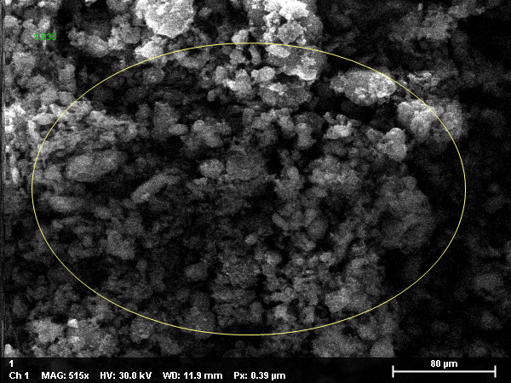
a

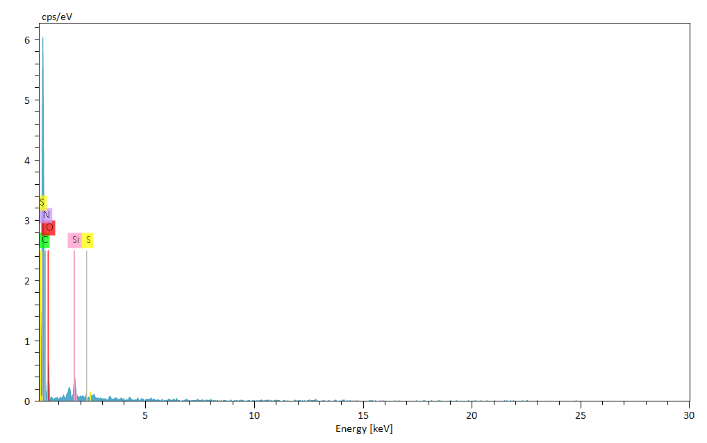
Element | W% | A%
Carbon | 68.24 | 73.37
Oxygen | 20.57 | 16.60
Nitrogen | 10.57 | 9.75
Silicon | 0.59 | 0.27
Sulfur | 6 | 0.01
Sum | 100.00 | 100.00
b

Figure S9. The SEM image (a) and the EDXA elemental analysis results (b) of Shell-II.

B
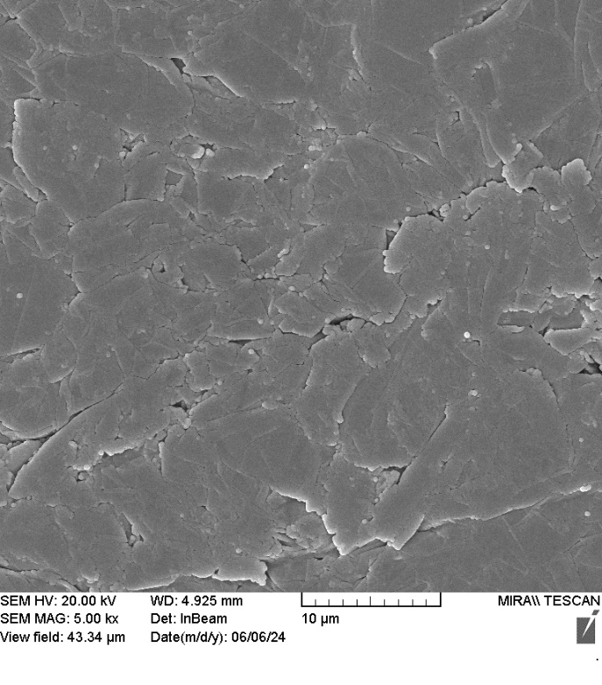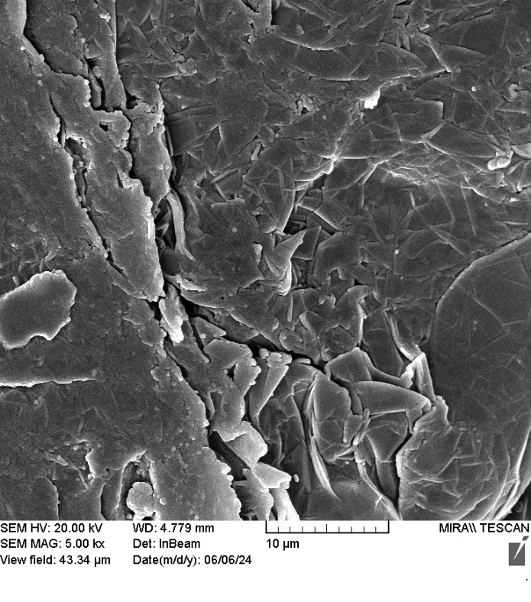
A
c

Figures S10. FE-SEM images of the the GR electrode before(A) and after (B) electrochemical treatment. It is clear in Figure S10 (A) GR flakes electrode is densely packed and has a smooth surface, across the whole electrode surface, extremely thin multilayer GR sheets with an outward orientation are visible. After the electrochemical exfoliation (B), the size of the sheets has been grown up, a rough surface appeared as well as the large number of erratic wrinkles on the surface were revealed, which is caused by the oxidation process.

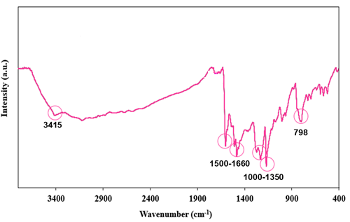
Figure S11. FT-IR spectrum of free THPP

Figure S12. Placement of magnesium and palladium metal in THPP complex and their UV-Visible spectra changes

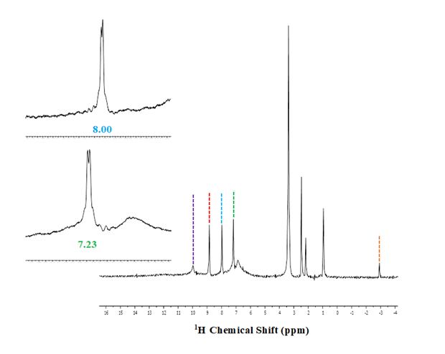
Figure S13. The ¹H NMR spectrum of THPP structure.

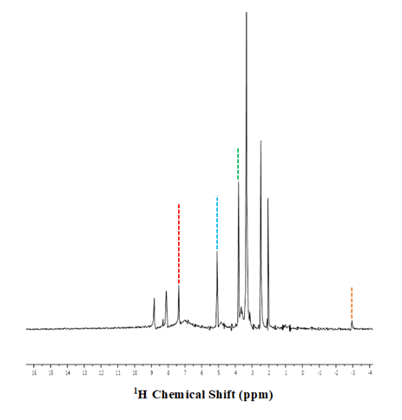

Figure S14. The ¹H NMR spectrum of THPP-MBA structure.

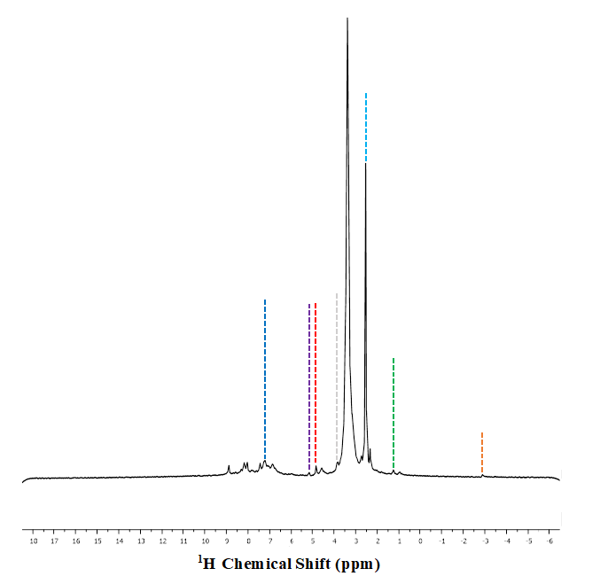

Figure S15. The ¹H NMR spectrum of THPP-MBA-EDA structure.

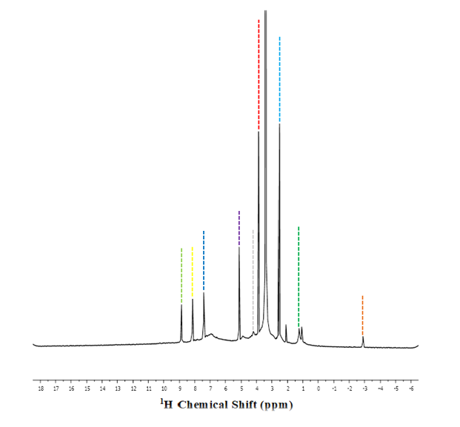

Figure S16. The ¹H NMR spectrum of THPP-MBA-EDA-MBA-THPP-MBA structure.

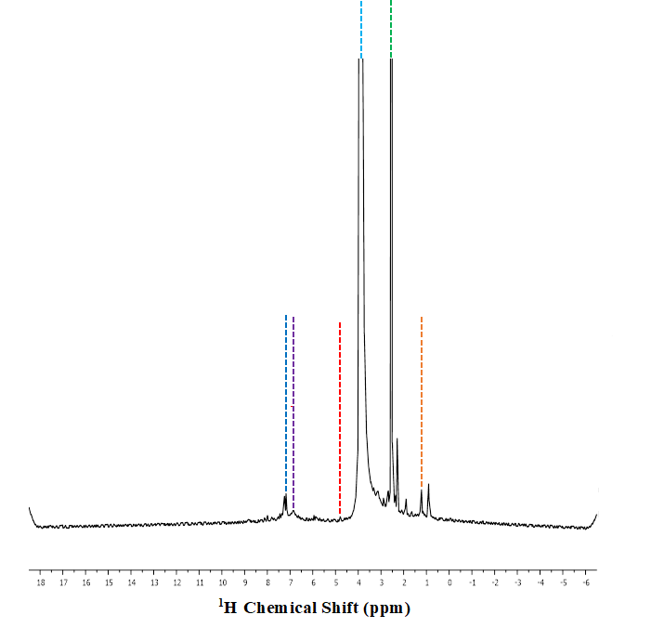

Figure S17. The ¹H NMR spectrum of THPP-MBA-EDA-MBA-THPP-MBA-EDA structure.

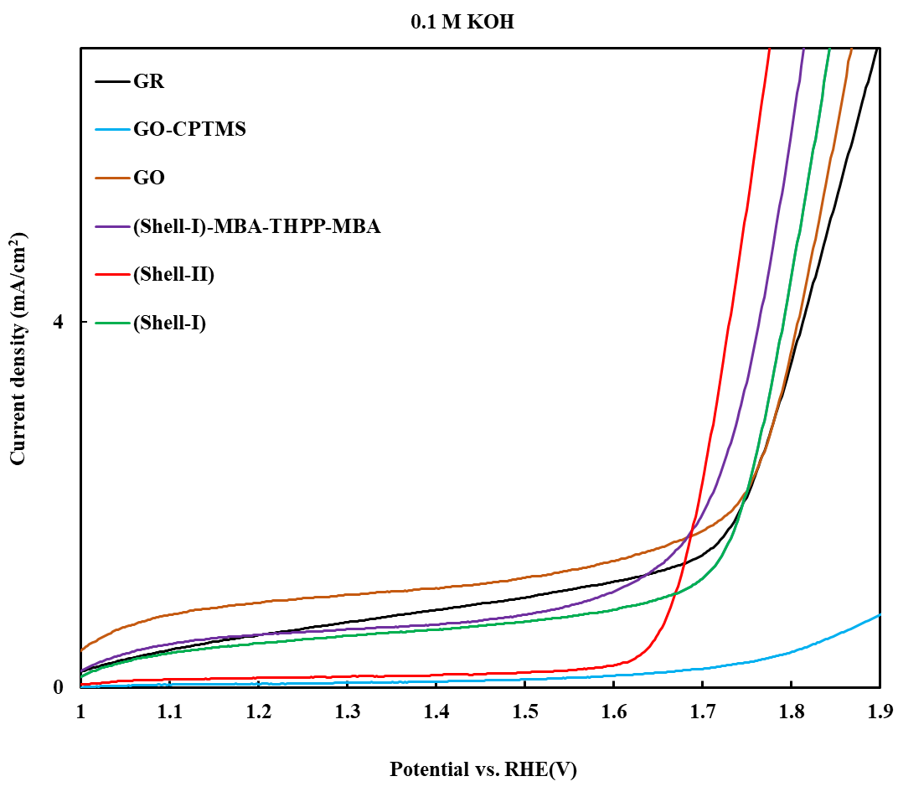
Figure S18. Linear sweep voltammetry (LSV) curve with a scan rate of 0.01 V/s in 0.1 M of KOH

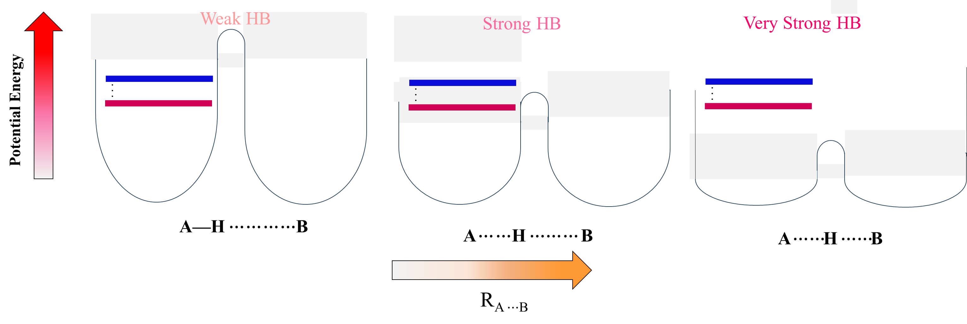

Figure S19. Schematic of zero-point energy relationships in different classes of hydrogen bonding. The potential energy wells for hydrogen-bonded heteroatoms and the zero-point energy levels for H (blue) and D (pink) are qualitatively showed for the three classes of hydrogen bonds described in [4]. In very strong or single-well hydrogen bonds, right, the zero-point energies of hydrogen and deuterium both lie well above the barrier, and the hydron is shared almost equally between the heteroatoms. In proton inventory data this feature is confirmed by low fractionation factor around 0.228.

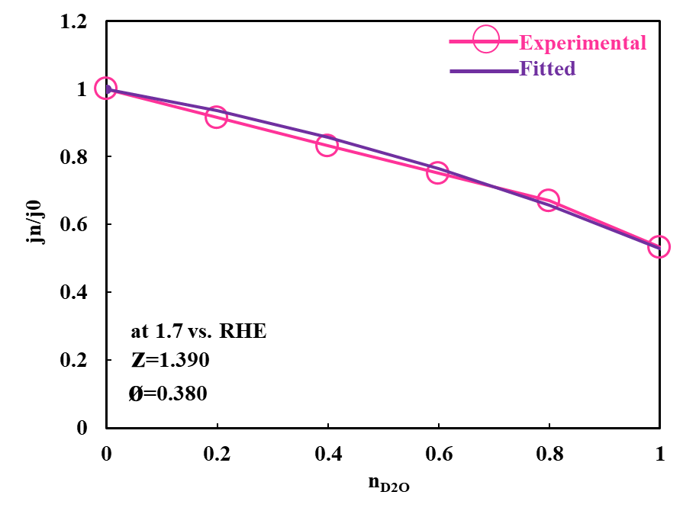
Figure S20. The plot of j_{n}/j₀ as a function of n, where n = [D]/([D]+ [H]) at potential 1.7 vs. RHE and fitting curve. Insets are the corresponding Z and ∅ values extracted from the fitted curve.

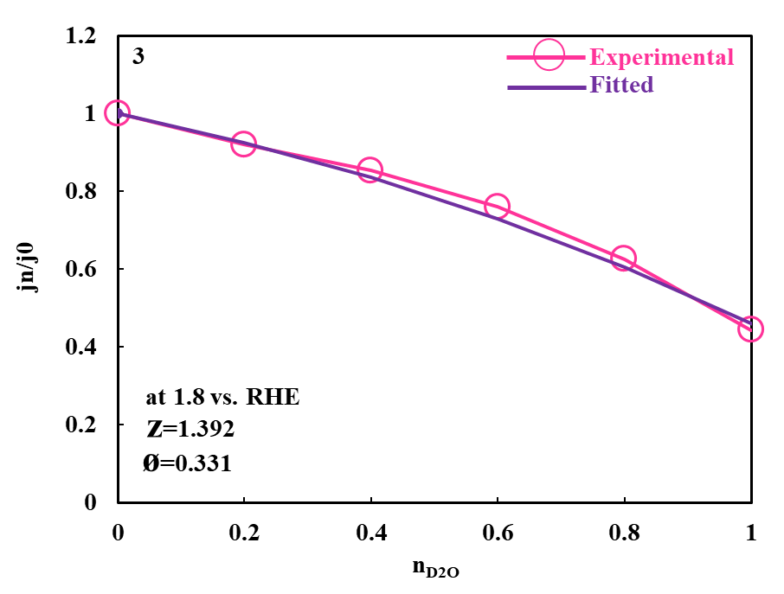
Figure S21. The plot of j_{n}/j₀ as a function of n, where n = [D]/([D]+ [H]) at potential 1.8 vs. RHE and fitting curve. Insets are the corresponding Z and ∅ values extracted from the fitted curve.

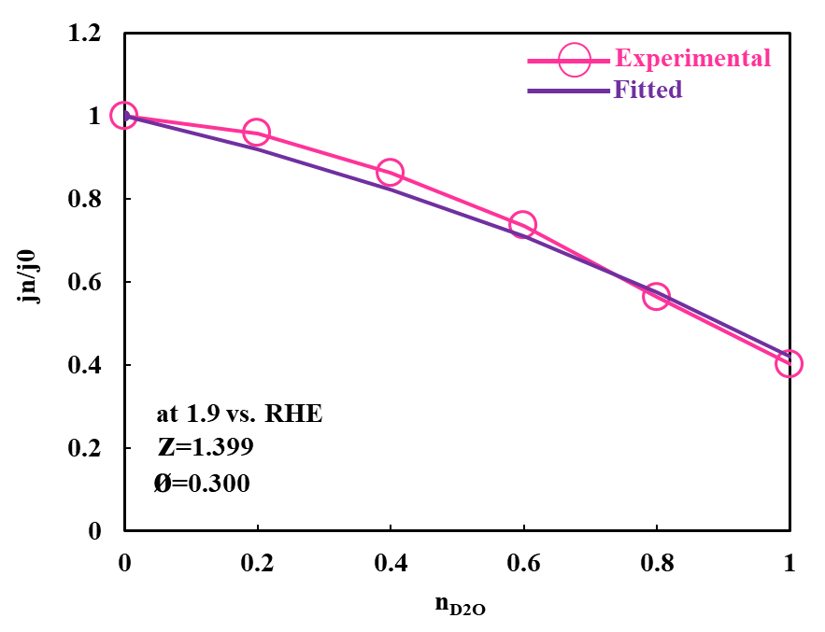
Figure S22. The plot of j_{n}/j₀ as a function of n, where n = [D]/([D]+ [H]) at potential 1.9 vs. RHE and fitting curve. Insets are the corresponding Z and ∅ values extracted from the fitted curve.

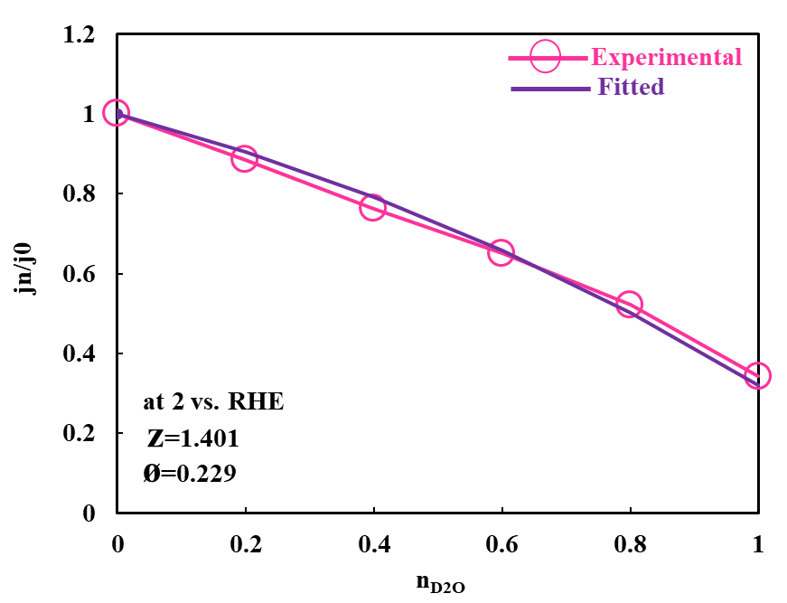
Figure S23. The plot of j_{n}/j₀ as a function of n, where n = [D]/([D]+ [H]) at potential 2 vs. RHE and fitting curve. Insets are the corresponding Z and ∅ values extracted from the fitted curve.

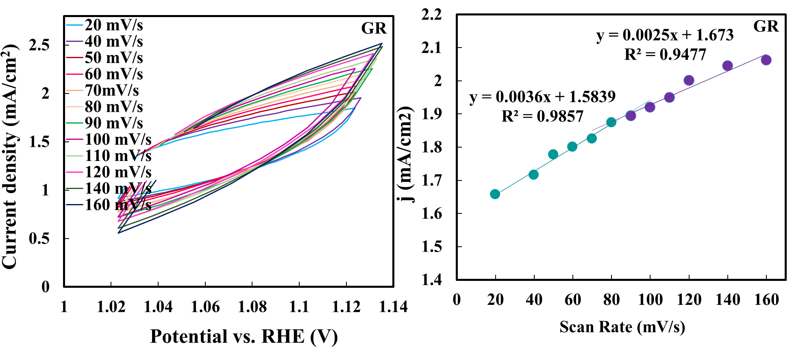

Figure S24. The cyclic voltammograms obtained at GR in 1 M KOH and the relevant plot of current densities against sweeping rates ranging from 20 to 160 mV s−¹ at GR, ϕ=0.306.

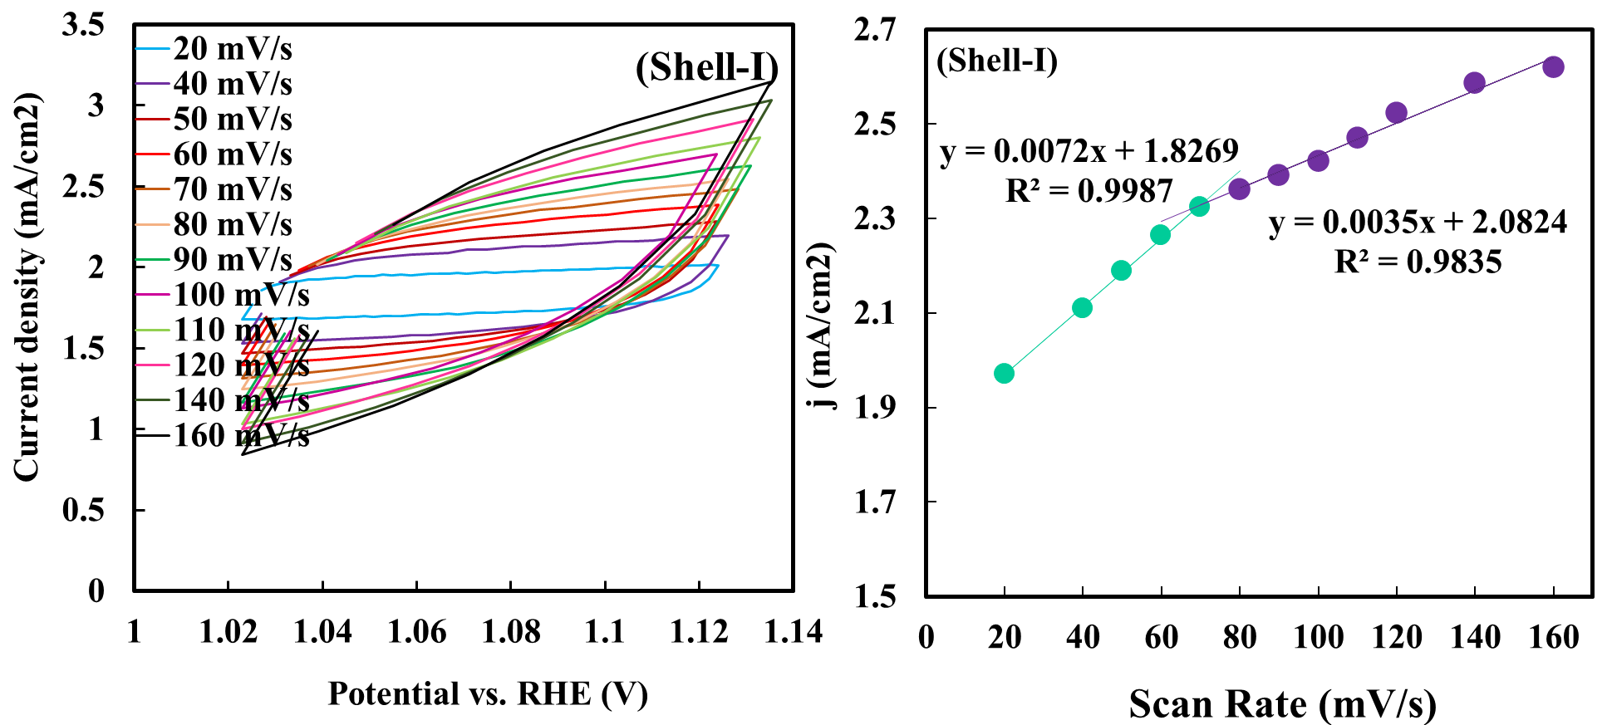

Figure S25. The cyclic voltammograms obtained at Shel-I in 1 M KOH and the relevant plot of current densities against sweeping rates ranging from 20 to 160 mV s−¹ at (Shell-I), ϕ=0.514.

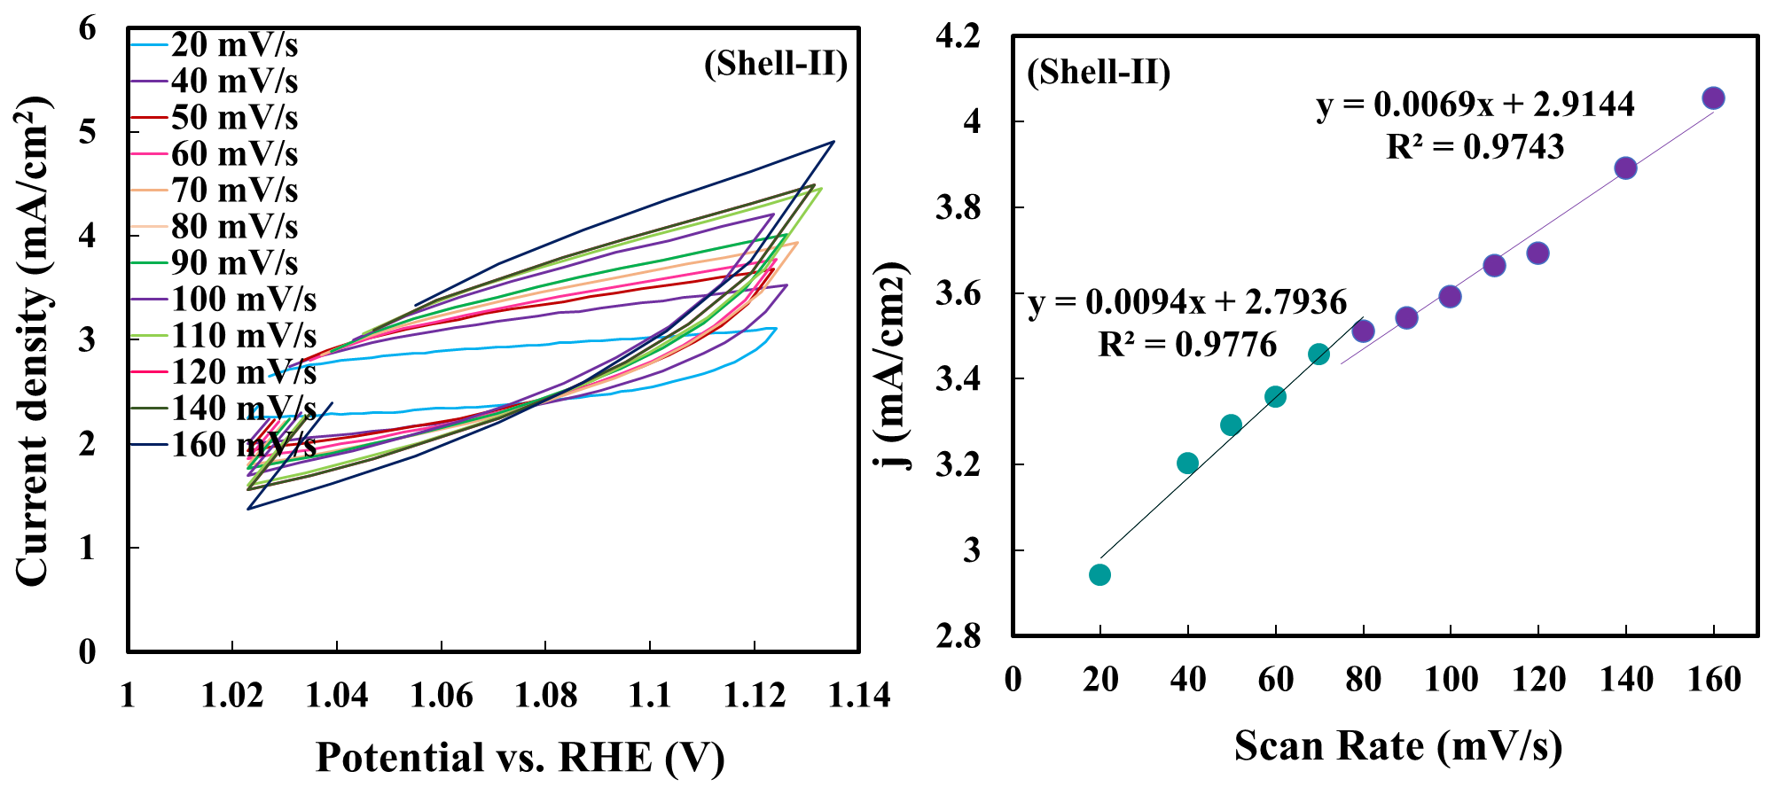

Figure S26. The cyclic voltammograms obtained at Shell-II in 1 M KOH and the relevant plot of current densities against sweeping rates ranging from 20 to 160 mV s−¹ at (Shell-II), ϕ=0.265.

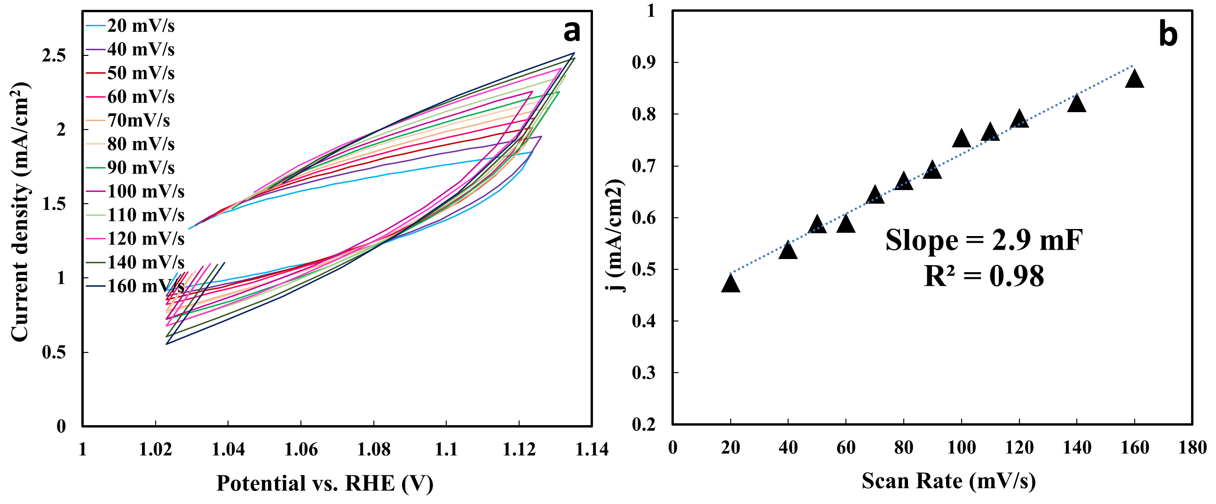

Figure S27. (a) Cyclic voltammograms obtained from the non-Faradic region of GR at different scan rates. (b) C_{dl} calculation of GR.

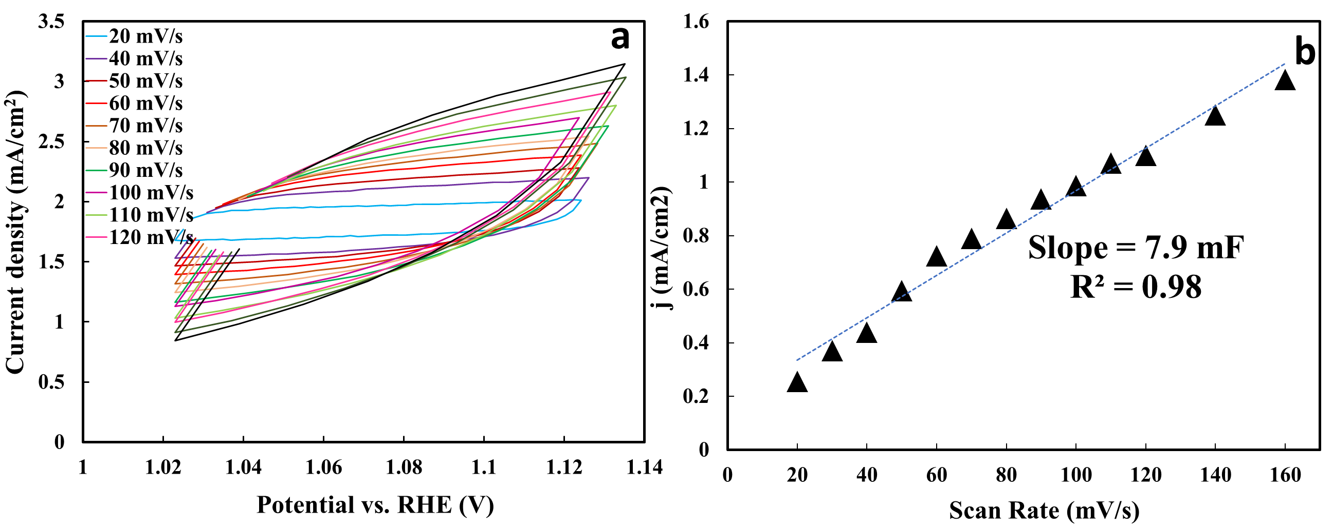

Figure S28. (a) Cyclic voltammograms obtained from the non-Faradic region of Shell-I at different scan rates. (b) C_{dl} calculation of Shell-I.

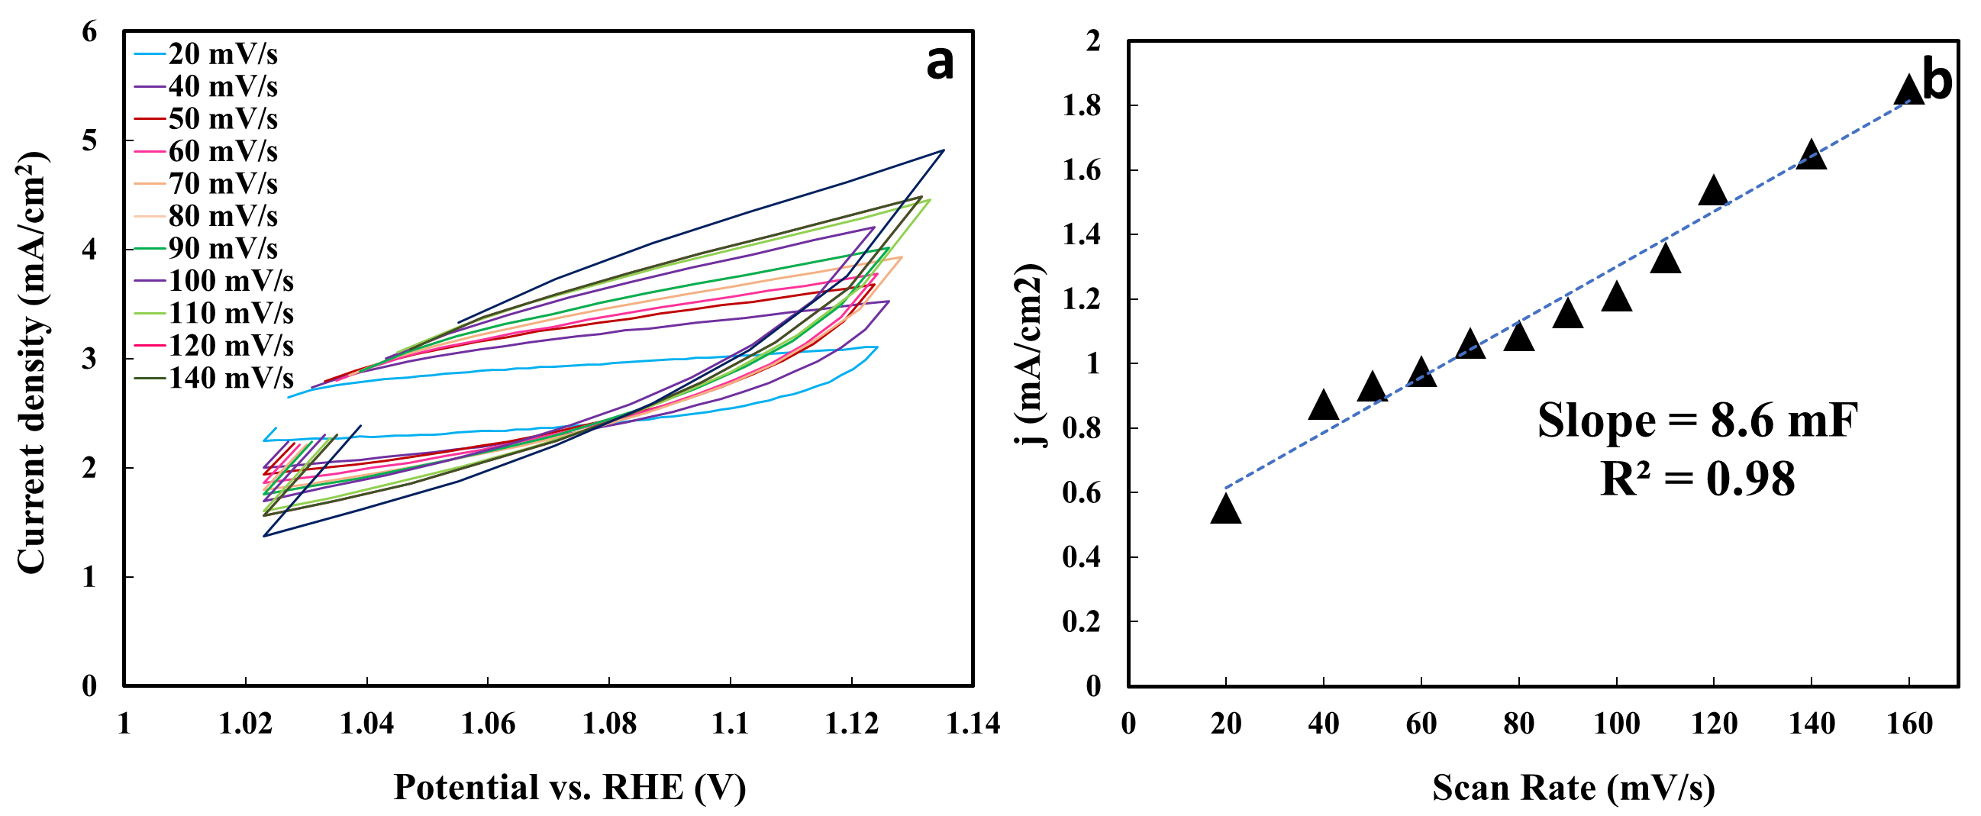

Figure S29. (a) Cyclic voltammograms obtained from the non-Faradic region of Shell-II at different scan rates. (b) C_{dl} calculation of Shell-Il.

6. Kinetic Isotope Effects (Supporting Note 1)
KIEs were studied via electrochemical methods. The LSVs were recorded with a scan rate of 5 mV s⁻¹ the experiments were carried out in pH adjusted aqueous KOH solution and K₃PO₄ in D₂O solution, the corresponding current densities at a certain overpotential of η were abbreviated as J(H₂O) and J(D₂O). The current density can be expressed by J=nFkC*, where 𝑛 = total number of electrons transferred, 𝑘 = heterogeneous rate constant, and 𝐶* = bulk concentration [5]. Dividing J in proteo solution to J in dutero solution gives:
$\frac{J_{H_{2}O}}{J_{D_{2}O}}=\frac{n_{H}k_{H}C_{H}^{*}}{n_{D}k_{D}C_{D}^{*}}$ eqn. S1
Since the measurements were performed in solutions with the equal pH(D), the concentration of hydroxide and deuteroxide are same, $C_{H=}^{*}C_{D}^{*}$, and by assuming unify n values in both solutions, KIE could be written as:
KIEs,_{H/D} = [$\frac{k_{H_{2}O}}{k_{D_{2}O}}$]_{ȵ} = [$\frac{J_{H_{2}O}}{J_{D_{2}O}}$]_{ȵ} eqn. S2
When measuring pH with the glass electrode in deuterated solution, we often add a constant value of 0.41, pD=pH+0.41. This correction was done via the calculation of electrochemical potential difference between an H₂|Pt electrode in H₂O and a D₂|Pt electrode in D₂O [6]. Because no OER dependency observed on [K₃PO₄], it was used as a proton-less basic agent in D₂O solution.

7. Proton inventory studies (Supporting Note 2)
The fitting of the experimental proton inventory data and calculations of the respective parameters (Z and ∅) were done through the Equation (1) in the main text, which was derived from the Kresge-Gross-Butler (Eqn. S3) [5]. This equation has been established to describe isotope effect arise from the combination of the isotope effect at a few sites, with the ∅ values quite different from one, and from a Z-effect, an aggregate isotope effect originated from most of sites with ∅ values individually close to unity [7]:
K_{n} = K₀ [$\frac{∏_{i=1 ( 1-n+nϕTi)}^{x}}{∏_{i=1 (}^{x}( 1-n+nϕRi)}$] Z^{n} eqn. S3
where 𝑘₀ is the kinetic rate constant in deutero solution, 𝑘_{𝑛} is the kinetic rate constant in proteo solution. n is the mole fraction of D₂O, x is the number of hydrogenic sites in the reactant/transition state, ∅_{Ti} and ∅_{Ri}, are the isotopic fractionation factor for hydrogenic site in the transition- and reactant-state, respectively. Zn describe the Z-effect, for Z = 1, there are no Z-sites contribution in the isotope effect; for Z > 1, the Z-sites deliver an inverse isotope effect, and for Z < 1, the Z-sites contribute a normal isotope effect [8-10]. If we assume a single hydrogenic site, the eqn. S3 could be simplified as:
K_{n} = K₀ [$\frac{(1-n+nϕT)}{(1-n+nϕR)}$] Z^{n} eqn. S4
We assumed the pronounced kinetics isotope effect occurs at a single hydrogenic site; thus, the x was equal to 1. Assuming J≈k, a simplified form of eqn. S4 is:

$\frac{j_{n}}{j_{0}}$ = (1- n + nϕ_{Ti})Z^{n} eqn. S5
Equation S5 was used to fit the proton inventory data, which showed a non-linear dome-shaped curve observed in the case of combination of normal and inverse contributions. A linear curve conveys a single site, a quadratic curve two sites, a cubic curve three sites, and finally an exponential curve indicate an infinite-site model [5, 7, 11]. There are two types of fractionation factors conveyed for hydrogen-transfer reactions on small molecules that involve a transition-state hydrogen bridge. These two-category pass through a transition-state hydrogen bridges; (I) When the transfer of proton happens through RDS, the labeled hydrogen has an important effect in the reaction-coordinate motion, herein, KIE about 2 to 10 are expected. (II) Another case is when PT is accompanied with another reaction, ET and/or heavy-atom reorganization (such a bond formation between heavier elements than hydrogen). The minimum value of KIE and fractionation factor are 1.5 and 0.3, respectively.

8. Supporting Note 3:
An electrochemical study was established to gain a comparative morphological insight. Figures S24-26 shows capacitive current graphed obtained at GR (Figure S24), Shell-I and Shell-II (Figures S25-26). All graphs clearly show two linear segments, located, respectively, in the low and high sweep rate domains. Inspired by the electrochemical porosity concept [12, 13], Da Silva et al. [14] defined the morphology factor ($φ$) as an accumulative parameter to explain the participation of the inner surface of the heterogeneous interfaces to the electrochemical signal:
$φ=\frac{C_{d,i}}{C_{d}}$ Eqn. 1
Where, Cd is the differential capacitance consisting of two internal (Cd,i) and external (Cd,e) region of the heterogeneous films, which defines the portion of external and internal surfaces on the overall Cd, which is defined as:
$C_{d=}{\left(\frac{{di}_{c}}{d_{v}}\right)}_{E}$ Eqn. 2
At low scan rate region, the first linear part in Figure S26
$i_{c=}C_{d}ν$ Eqn. 3
Similarly, the second linear part in Figure S26 (high can rate domain):
$i_{c=}i_{c,r}+C_{d}ν$ Eqn. 4
Here, ic,r denotes the capacitive current for $v$→0
Indeed, the overall capacitive current (ic) is the sum of the capacitive current flowing at the interface of the internal (ic,i), and external (ic,e) regions of the films:

$i_{c=}i_{c,i}+i_{c,e}$ Eqn. 5
Substitution of Eqs. (3) And (4) in Eq. (5) give Eq. (6):

$i_{c,i=}C_{d}ν-(i_{c,r}+C_{d,e}ν)$ Eqn. 6
Finally, differentiation of Eq. (6) vs. $ν$ leads to Eq. (7), allowing the calculation of Cd,i:

$C_{d,i=}C_{d}-C_{d,e}$ Eqn. 7
Cd,i, can be calculated by subtracting the slopes two linear parts (low and high can rates). Finally, the $φ$ can be obtained to compare the ratio of Cd,i to Cd. More information is in references [12-14].

9. Supporting References
[1] Zeng, F., Sun, Z., Sang, X., Diamond, D., Lau, K. T., Liu, X. & Su, D. S. In situ one-step electrochemical preparation of graphene oxide nanosheet-modified electrodes for biosensors. ChemSusChem. 4 (11), 1587-1591 (2011).
[2] Szabó, T., Berkesi, O., Forgó, P., Josepovits, K., Sanakis, Y., Petridis, D. & Dékány, I. Evolution of surface functional groups in a series of progressively oxidized graphite oxides. Chem. Mater. 18 (11), 2740-2749 (2006).
[3] Dimiev, A., Kosynkin, D. V., Alemany, L. B., Chaguine, P. & Tour, J. M. Pristine graphite oxide. J. Am. Chem. Soc. 134 (5), 2815-2822 (2012).
[4] Kohen, A. & Limbach, H. H. Isotope effects in chemistry and biology. CRC Press. (2005).
[5] Bard, A. J. & Faulkner, L. R. Others, Electrochem. Methods. 2, 580-632 (2001).
[6] Rubinson, K. A. Practical corrections for p (H, D) measurements in mixed H₂O/D₂O biological buffers. Analytical Methods. 9 (18), 2744-2750 (2017).
[7] Fitzpatrick, P. F. Combining solvent isotope effects with substrate isotope effects in mechanistic studies of alcohol and amine oxidation by enzymes. Biochim. Biophys. Acta, Proteins Proteomics. 1854 (11), 1746-1755 (2015).
[8] Liu, Y. & McCrory, C. C. Modulating the mechanism of electrocatalytic CO₂ reduction by cobalt phthalocyanine through polymer coordination and encapsulation. Nat.Commun. 10 (1), 1683 (2019).
[9] Schowen, R. L. The use of solvent isotope effects in the pursuit of enzyme mechanisms. J. Lable. Compd. Radiopharm. 50 (11‐12), 1052-1062 (2007).
[10] Venkatasubban, K. S. & Schowen, R. L. The Proton Inventory Techniqu. Crit. Rev. Biotechnol. 17 (1), 1-44 (1984).
[11] Haschke, S., Mader, M., Schlicht, S., Roberts, A. M., Angeles-Boza, A. M., Barth, J. A. & Bachmann, J. Direct oxygen isotope effect identifies the rate-determining step of electrocatalytic OER at an oxidic surface. Nat. Commun. 9, 1-8 (2018).
[12] De Pauli, C. P. & Trasatti, S. Electrochemical surface characterization of IrO₂+ SnO₂ mixed oxide electrocatalysts. J. Electroanal. Chem. 396 (1-2), 161-168 (1995).
[13] Spinolo, G., Ardizzone, S. & Trasatti, S. Surface characterization of Co₃O₄ electrodes prepared by the sol-gel method. J. Electroanal. Chem. 423 (1-2), 49-57 (1997).
[14] Da Silva, L. M., De Faria, L. A. & Boodts, J. F. C. Determination of the morphology factor of oxide layers. Electrochim. Acta. 47 (3), 395-403 (2001).

