AMB Express

Ammonium nitrate regulated the color characteristic changes of pigments in Monascus purpureus M9
Di Chen^{1*}, Yurong Wang², Mianhua Chen², Pei Fan¹, Guiling Li¹, Changlu Wang^{2*}
¹ College of Biological Engineering, Henan University of Technology, No.100, Lianhua Street, High-tech Industrial Development Area, Zhengzhou, 450001, P. R. China.
² Key Laboratory of Food Nutrition and Safety, Ministry of Education, College of Food Engineering and Biotechnology, Tianjin University of Science and Technology, No. 29, 13th Avenue, TEDA, Tianjin, 300457, P. R. China.
*Corresponding author
Di Chen
E-mail: chendi.1126@163.com
Changlu Wang
E-mail: clw123@tust.edu.cn

Table S1. Primers for RT-qPCR analyzing pigment biosynthetic genes
primers | sequence
β-actinF | 5'-TTCGAGACCTTCAACGCCC-3'
β-actinR | 5'-ACCCTCGTAGATGGGAACGA-3'
MpPKS5rtF | 5'-TGTCCGACGAGTTTCTGCAA-3'  GACCCAGATCCCACCTACCT  -3’
MpPKS5rtR | 5'-TATCAACGCTGCTTGGGCAT-3'
mppR1rtF | 5'-TCTGCAGTATGCCATGTGGG-3'
mppR1rtR | 5'-ATGGCACCGTCACTTAGCTC-3'
mppArtF | 5'-GGTCAATCTTCGTGGACCGT-3'
mppArtR | 5'-AGTCGGGTTGAGAAGATGCG-3'
mppBrtF | 5'-CGTCTCGCCCGATAACTTCA-3'
mppBrtR | 5'-TTGACAGACGGGTCGAAGTC-3'
mppCrtF | 5'-CAGTCCTCGTCCCTTCCAGT-3'
mppCrtR | 5'-CCACGGTGAAGGATGTCGAG-3'
mppGrtF | 5’- TCAACACGGGAGATGCTGTC-3'
mppGrtR | 5'-GCCAAAGGACAGGAGCAGAT-3'
mppDrtF | 5'-AGGAGTTCGGGCCATTCAAG-3'
mppDrtR | 5'-TCTTCGTCCATGGCATCTCG-3'
mppErtF | 5'-CTTCCCGATGCCGTTGTGAT-3'
mppErtR | 5'-CGTCTCGTGGATCATCTCGT-3'
mppR2rtF | 5'-ACGAAACCCTCCATGACACC-3'
mppR2rtR | 5'-TGCAGACAGCCTTGTGGTAG-3'
FasA2rtF | 5'-ATGGATCGCCCGATCTTGTC-3'
FasA2rtR | 5'-CTTTGTCGAGTCCGCTGGAT-3'
FasB2rtF | 5'-CCTCCAGGGATTACAACCCG-3'
FasB2rtR | 5'-ATTCAATGCCAGGTGCTCCA-3'
mppFrtF | 5'-TAGCATCGTACGTCGCCAAC-3'
mppFrtR | 5'-TGTCCTGGCAGCTGTATTGG-3'
Mpp7rtF | 5'-GCCCATCTTCAAGTACCAC-3'
Mpp7rtR | 5'-CCTTCAAGCCATTCTCATAG-3'

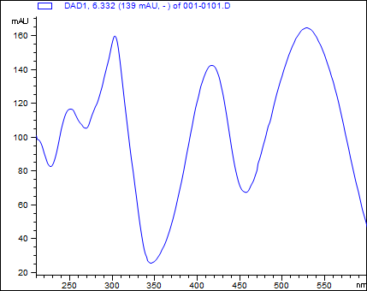
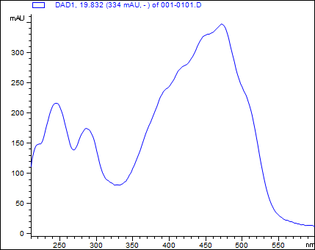
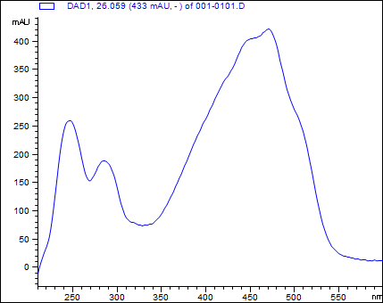
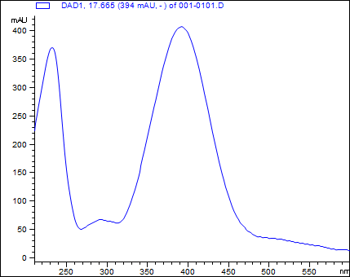
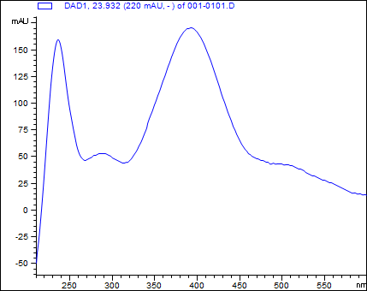

Figure. S1 The mass spectra and spectrum of Rubropunctatamine (R1) and Monascorubramine (R2), Monascin (Y1), and Ankaflavin (Y2), Rubropunctatin (O1) and Monascorubrin (O2), and three low-level amounts red pigments RX1, RX2, and RX3.

