The effect of coal gangue soilification on crop growth and bioavailability of heavy metals
Yanping Ji^{a,*}, Jianshi Caoª, Yingchao Liuª, Hao Liª, Ying Dongª, Shulin Qinª, Yongsheng Liª, Guowei Hanª, Zhengjun Feng^{b}
a. China Coal Technology & Engineering Group, Hangzhou Research Institute, Hangzhou, 311201, China
b. Institute of Resources and Environmental Engineering, Collaborative Innovation Center of High Value-Added Utilization of Coal-Related Wastes, Shanxi University, Taiyuan 030006, China
* Corresponding author: Yanping Ji, jypenetration@163.com

Text S1 Material and methods
The reagents used in experiments, such as sodium hydroxide (NaOH, > 99.8%), hydroxylammonium chloride (NH₂OH·HCl, > 99%), ammonium acetate (CH₃COONH₄, > 99%), and acetic acid (CH₃COOH, > 99%), were purchased from Shanghai Macklin Biochemical Co., Ltd, China. Hydrochloric acid (HCl, >35%), nitric acid (HNO₃, >67%), and hydrogen peroxide (H₂O₂, >30%) were purchased from Sinopharm Chemical Reagent Co., Ltd., Shanghai, China. The pH of the solutions was adjusted by using 1% HCl and NaOH solutions.

Text S2 Continuous extraction
The concentrations of heavy metal forms were detected using the BCR continuous extraction method, which was conducted as follows:
1) Exchangeable form: CH₃COOH solution (40 mL, 0.11 mol/L) was added to the centrifuge tube containing the 1.0 g soil. The centrifuge tube was shaken at room temperature for 16 h and then centrifuged at the rate of 4000 r/min for 10 min to measure the heavy metal concentration of the supernatant.
2) Reducible form: NH₂OH·HCl solution (40 mL, 0.5 mol/L) was added to the centrifuge tube containing the residual soil, and the pH was adjusted to 1.5 using HNO₃ solution. The tube was shaken at room temperature for 16 h and then centrifuged at the rate of 4000 r/min for 10 min to measure the heavy metal concentration of the supernatant.
3) Oxidizable form: 10 mL H₂O₂ was added to the centrifuge tube and reacted for 1 h, heated in a water bath at 85 ℃ for 1 hour, and then heated until nearly dry. Subsequently, repeat the aforementioned steps once. Add CH₃COONH₄ solution (50 mL, 1 mol/L), and the pH was adjusted to 2. The tube was then shaken at room temperature for 16 h. Further, the tube was centrifuged at the rate of 3000 r/min for 30 min to measure the heavy metal concentration of the supernatant.
4) Residual form: The residual soil was moved into the Teflon crucible. It was then digested by using a HCl–HNO₃–HF-HClO₄ system and dissolved in HNO₃ (1%) in a 50 mL volumetric flask.

Table S1: The properties of
Site | Soil texture |  |  | pH | SOM (g/kg) | d (μm)
Site | Clay | Silt | Sand | pH | SOM (g/kg) | d (μm)
AS | 14 | 21 | 65 | 7.98 | 14.5 | 791.9
LS | 28 | 29 | 43 | 7.31 | 50.3 | 119.8

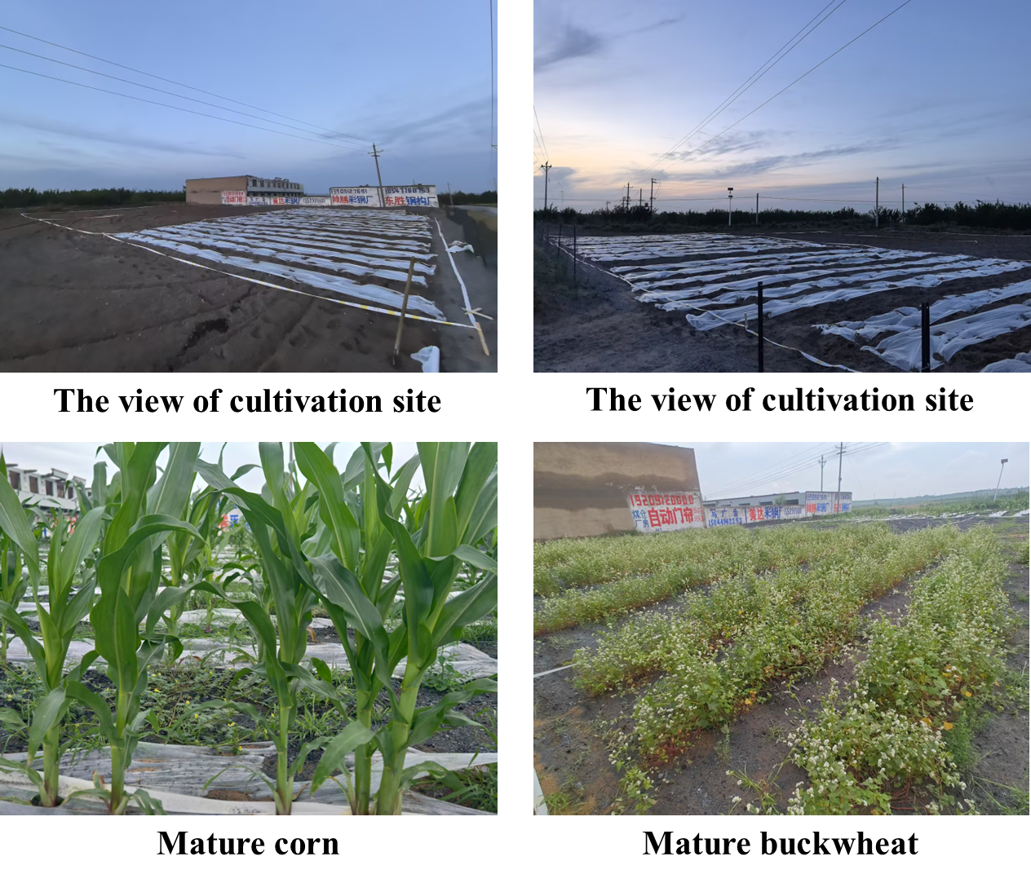
Figure S1. The picture of the experimental field after sowing and before harvest.

