Supplementary information (SI)
CRISPR/Cas12a-based method to discriminate Plasmodium ovale wallikeri and Plasmodium ovale curtisi.
Shucheng Ruan^{1,2#}, Xiaofei Zhao^{1#}, Songcheng Yu², Penghui Ji¹, Suhua Li¹, Hongwei Zhang¹, Yan Deng¹, Dongyang Zhao¹, Ruimin Zhou ¹*
¹Henan Province Center for Disease Control and Prevention; Henan medical Key Laboratory of Parasite Pathogen and Vector; Henan Key Laboratory of Infectious Pathogenic Microbiology; Zhengzhou, 450016, China
² College of Public Health, Zhengzhou University, Zhengzhou, 450001, China
# Shucheng Ruan and Xiaofei Zhao contributed equally to this work
*Corresponding author: Ruimin Zhou
Address: 105 Nongyenan Road, Zhengzhou City, P. R. China
Tel: 13938226397
E-mail: zrm920@126.com

Table S1. The usage of DNA and RNA probe sequences in this study.
Name | Sequence (From 5’ to 3’)
Pow | AACTATGCCGACTAGGTTTTGGATGAAAAGTTTTTAAATAAGAAAATTCCTTTTGGAAATTTCTTAGATTGCTTCCTTCAGT
Poc | AACTATGCCGACTAGGTTTTGGATGAAAGATTTTTAAATAAGAAAATTCCTTTCGGGGAAATTTCTTAGATTGCTTCCTTCAGT
Forward primer | AACTATGCCGACTAGGTT
Reverse primer | ACTGAAGGAAGCAATCTAAG
crRNA1 | UAAUUUCUACUAAGUGUAGAUAAGAAAAUUCCUUUUGGAAA
crRNA 2 | UAAUUUCUACUAAGUGUAGAUUUCCAAAAGGAAUUUUCUUA
crRNA 3 | UAAUUUCUACUAAGUGUAGAUCAAAAGGAAUUUUCUUAUUU
crRNA 4 | UAAUUUCUACUAAGUGUAGAUUUCCCCGAAAGGAAUUUUCU
crRNA 5 | UAAUUUCUACUAAGUGUAGAUAGAAAUUUCCCCGAAAGGA
Reporter | 6-FAM-TTTTTT-BHQ-1
The feasible of PCR amplification
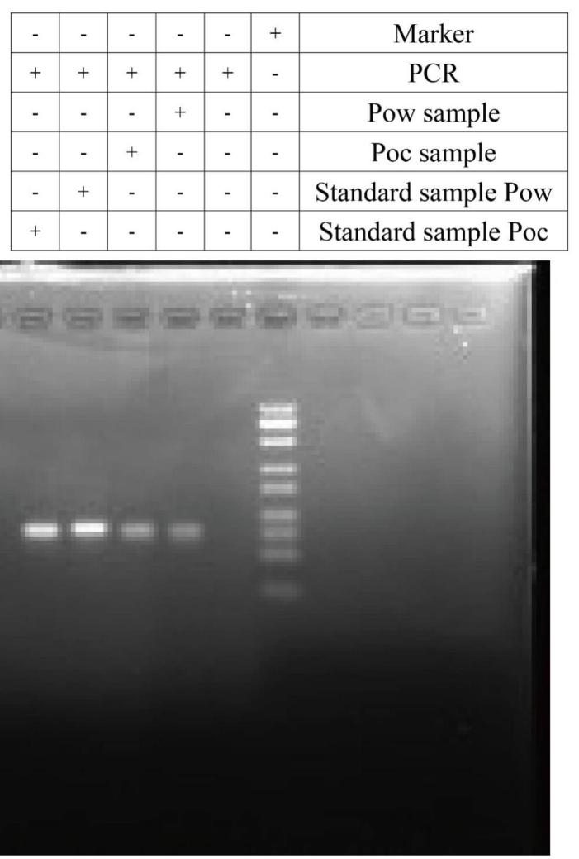
Fig. S1 Gel electrophoresis analysis of PCR product. Lane 1: Marker, Lane 2: Negative control, Lane 3: Sample Pow, Lane 4: Sample Poc, Lane 5: Standard sample Pow, Lane 6: Standard sample Poc.
Real sample tests
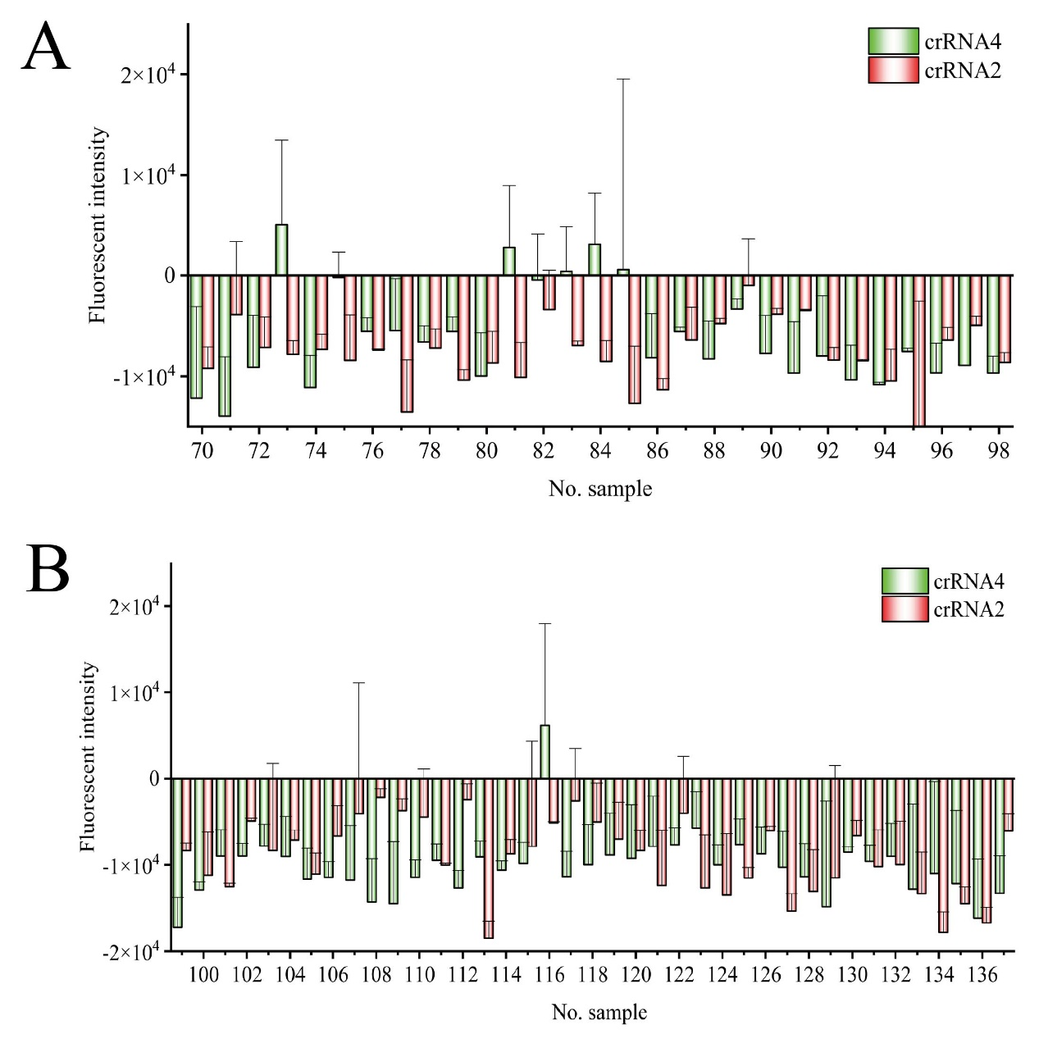
Fig. S2 CRISPR/Cas12a detection for other non-target malaria species. (A) The fluorescence result of P.m and P.v. (B) The fluorescence result of P.f.

Table S2. Comparison of different methods for discriminating Pow and Poc detection
Ref. | Target | Method | Equipment dependency | How to identify | Poc | Pow | Detection performance
(1) | 18S rRNA | Real-time qPCR | High | Not mentioned | 20 | 11 | 50 plasmid copies/uL (Pow)
(2) | 18S rRNA | Real-time qPCR | High | Differentiated with a small ΔTm | 14 | 19 | 88% specificity for P.ovale spp.
(3) | PoTRA | Nested PCR | low | Band size | 7 | 10 | 2 to 10 parasites/μL blood.
This study | 18S rRNA | CRISPR/Cas12a | low | Fluorescence intensity | 31 | 37 | 100 copy/μL for Pow, 30 copy/μL for Poc

Reference
1. Calderaro A, Piccolo G, Gorrini C, Montecchini S, Rossi S, Medici M C, et al. A New Real-Time PCR for the Detection of Plasmodium ovale wallikeri[J]. PLOS ONE, 2012, 7(10): e48033.
2. Lamien-Meda A, Fuehrer H-P, Noedl H. Novel high resolution melting (HRM) and snapback assays for simultaneous detection and differentiation of Plasmodium ovale spp[J]. Acta Tropica, 2019, 192: 75-81.
3. Tanomsing N, Imwong M, Sutherland Colin J, Dolecek C, Hien Tran T, Nosten F, et al. Genetic Marker Suitable for Identification and Genotyping of Plasmodium ovale curtisi and Plasmodium ovale wallikeri[J]. Journal of Clinical Microbiology, 2013, 51(12): 4213-4216.

