Long-term exposure to low concentrations of ambient benzene, genetic susceptibility and the risk of incident chronic obstructive pulmonary disease

Table SX. Details on categorical covariates included in this study
Categorical Covariates
Sex | Male/Female | 31
Ethnicity | White/Asian or Asian British/Black or Black British/Chinese/Mixed/Other ethnic group/Missing | 21000
Educational level | College/Non-College/Missing | 6138
Body mass index | Normal (less than 25 kg/m²)/Overweight (25 to 30 kg/m²)/Obesity (more than 30 kg/m²)/Missing | 21001
Tobacco smoking | Never/Previous/Current/Missing | 20116
Physical activity | Non-ideal/Ideal/Unkown | 22036
Health diet | Healthy/Unhealthy/Missing  1. Dairy ≥2 servings/day  2. Refined grains ≤2 servings/day  3. (Shell)fish ≥2 servings/week  4. Whole grains ≥3 servings/day  5. Fruit ≥3 servings/day  6. Vegetable ≥3 servings/day  7. Vegetable oils ≥2 servings/day  8. Unprocessed meats ≤2 servings/week  9. Processed meats ≤1 serving/week  10. Sugar-sweetened beverages No-consumption  The healthy dietary was defined as the total score more than 5 indicating meeting at least half of the dietary recommendation at least 5 items. | 1289, 1299, 1309, 1319, 1329, 1339, 1349, 1359, 1369, 1379, 1389, 3680, 6144, 10855, 1408, 1418, 1428, 1448, 1468
Baseline hypertension | Non-baseline hypertension/Baseline hypertension/Missing | 6150

Table SX. Details on continuous covariates included in this study
Covariates | Description | Field ID
Age | Continuous | 21022
Alcohol consumption | 1. 1 drink of beer/cider contained 2 standard drinks  2. 1 glass of red and white wine to contain 1.5 standard drinks  3. 1 glass of fortified wine to contain 1.25 standard drinks  4. 1 measures of spirits/liqueurs to contain 1 standard drinks  5. 1 glasses of other alcoholic drinks to contain 1 standard drinks  Alcohol consumption is the sum of standard drinks above | 1568, 1578, 1588, 1598, 1608, 5364

Table X. Associations Between Benzene Exposure and the Risks of COPD in sensitivity analyze Among White Participants
 | Benzene(continuous) | Benzene(quartiles)
 | HR (95% CI) for 1 μg/m³ increase | Quartile 1 | Quartile 2 | Quartile 3 | Quartile 4 | P for trend
COPD
Case/Overall |  | 836/65,415 | 1,325/65,828 | 1,571/66,438 | 1,849/65,277
Model 1 | 1.26 (1.21, 1.31) | Reference | 1.58 (1.45, 1.72) | 1.93 (1.77, 2.10) | 2.47 (2.85, 2.69) | <0.001
Model 2 | 1.21 (1.16, 1.25) | Reference | 1.56 (1.43, 1.70) | 1.78 (1.64, 1.94) | 2.17 (2.00, 2.36) | <0.001
Model 3 | 1.21 (1.15, 1.26) | Reference | 1.57 (1.44, 1.15) | 1.78 (1.63, 1.93) | 2.10 (1.93, 2.29) | <0.001
Model 1:Age (continuous, years), sex (female, male) .
Model 2:model 1 plus BMI(<30 kg/m2, ≥30 kg/m2),tobacco smoking (never, current or former smokers),alcohol consumption (never, current or former drinkers) and physical activity (inactive, active).
Model3:model 2 plus PM_{2.5}(continuous, μm/m³), hypertension base (Yes,No), hyperlipid base (Yes,No),diet (Ideal and unhealthy) and home income (low and high).
Abbreviations: SD, standard deviation; COPD, Chronic Obstructive Pulmonary Disease.HR, hazard ratio; CI, confidence interval.
P for trend was tested by using ordered integer values.

Table X. Associations Between Benzene Exposure and the Risks of COPD in sensitivity analyze（(Excluding the population without the relevant covariates)）
 | Benzene(continuous) | Benzene(quartiles)
 | HR (95% CI) for 1 μg/m³ increase | Quartile 1 | Quartile 2 | Quartile 3 | Quartile 4 | P for trend
COPD
Case/Overall |  | 419/35,877 | 607/38,172 | 660/36,367 | 695/34,841
Model 1 | 1.39 (1.36, 1.42) | Reference | 1.37 (1.21, 1.55) | 1.63 (1.44, 1.84) | 1.98 (1.76, 2.24) | <0.001
Model 2 | 1.38 (1.32, 1.46) | Reference | 1.32 (1.17, 1.50) | 1.48 (1.31, 1.68) | 1.71 (1.51, 1.93) | <0.001
Model 3 | 1.32 (1.16, 1.49) | Reference | 1.32(1.16, 1.49) | 1.47 (1.30, 1.66) | 1.66 (1.46, 1.89) | <0.001
Model 1:Age (continuous, years), sex (female, male) .
Model 2:model 1 plus BMI(<30 kg/m2, ≥30 kg/m2),tobacco smoking (never, current or former smokers),alcohol consumption (never, current or former drinkers) and physical activity (inactive, active).
Model3:model 2 plus PM_{2.5}(continuous, μm/m³), hypertension base (Yes,No), hyperlipid base (Yes,No),diet (Ideal and unhealthy) and home income (low and high).
Abbreviations: SD, standard deviation; COPD, Chronic Obstructive Pulmonary Disease.HR, hazard ratio; CI, confidence interval.
P for trend was tested by using ordered integer values.

Table X. Associations Between Benzene Exposure and the Risks of COPD in sensitivity analyze Excluding Participants With Follow-Up Duration < 2 Years
 | Benzene(continuous) | Benzene(quartiles)
 | HR (95% CI) for 1 μg/m³ increase | Quartile 1 | Quartile 2 | Quartile 3 | Quartile 4 | P for trend
COPD
Case/Overall |  | 882/71,085 | 1,435/71,334 | 1,632/71,334 | 1,806/71,335
Model 1 | 1.39 (1.36, 1.42) | Reference | 1.64 (1.51, 1.79) | 1.95 (1.80, 2.12) | 2.38 (2.19, 2.58) | <0.001
Model 2 | 1.38 (1.32, 1.46) | Reference | 1.62 (1.49, 1.77) | 1.81 (1.67, 1.97) | 2.11 (1.94, 2.29) | <0.001
Model 3 | 1.40 (1.35, 1.45) | Reference | 1.63 (1.50, 1.77) | 1.79 (1.65, 1.95) | 2.02 (1.86, 2.20) | <0.001

Model 1:Age (continuous, years), sex (female, male) .
Model 2:model 1 plus BMI(<30 kg/m2, ≥30 kg/m2),tobacco smoking (never, current or former smokers),alcohol consumption (never, current or former drinkers) and physical activity (inactive, active).
Model3:model 2 plus PM_{2.5}(continuous, μm/m³), hypertension base (Yes,No), hyperlipid base (Yes,No),diet (Ideal and unhealthy) and home income (low and high).
Abbreviations: SD, standard deviation; COPD, Chronic Obstructive Pulmonary Disease.HR, hazard ratio; CI, confidence interval.
P for trend was tested by using ordered integer values.

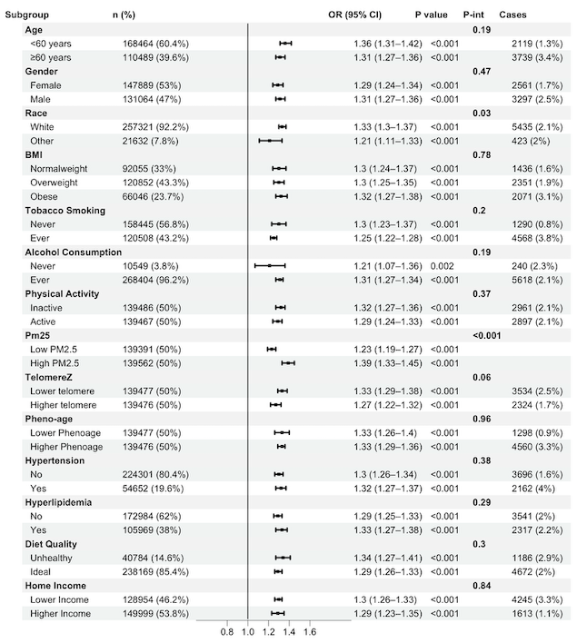
Figure X Subgroup analysis of the association between long-term low-concentration ambient benzene exposure and incident chronic obstructive pulmonary disease risk. BMI ( 18.5 kg/m2 -24.9 kg/m, 25 kg/m2- 29.9 kg/m2 , ≥30 kg/m2), PM2.5, particulate matter with diameter ≤ 2.5 μm;

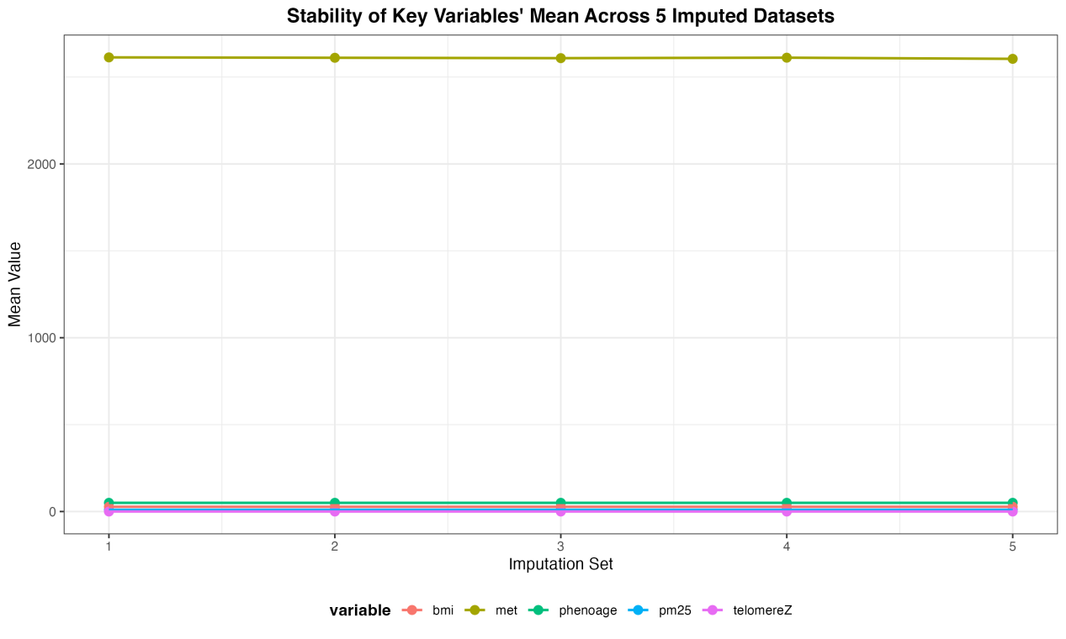

Figure X This figure presents the stability of mean values for key variables (BMI, metabolic equivalent (met), phenotypic age (phenoage), PM_{2.5} exposure (pm_{2.5}), telomere length Z-score (telomereZ)) across 5 multiple imputation datasets. The near-constant mean values across all imputation sets indicate that the multiple imputation procedure yielded consistent and stable datasets, supporting the reliability of subsequent statistical analyses.

