Appendix A: F-test and Breusch-Pagan Lagrange multiplier test
Appendix A1: F test
Model | P-value | Conclusion
Downward EM | 0.9983 | Accept H0
Upward EM | 0.0000 | Reject H0
Total EM | 0.4829 | Accept H0
- Downward EM F-test
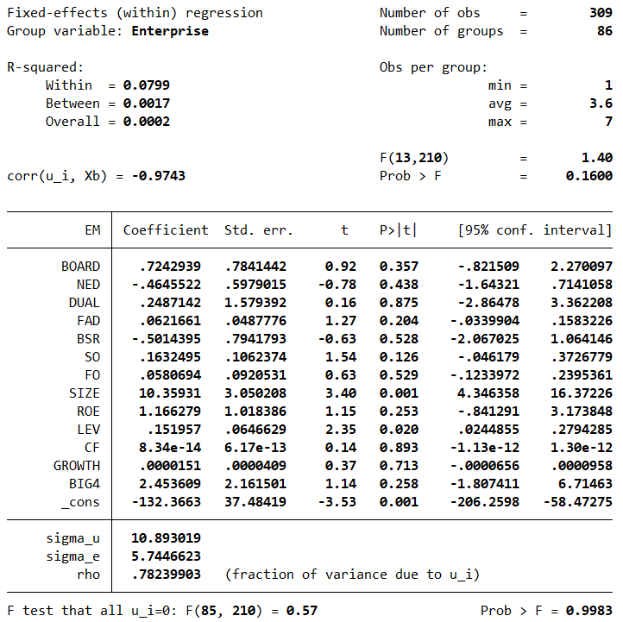

- Upward EM F-test

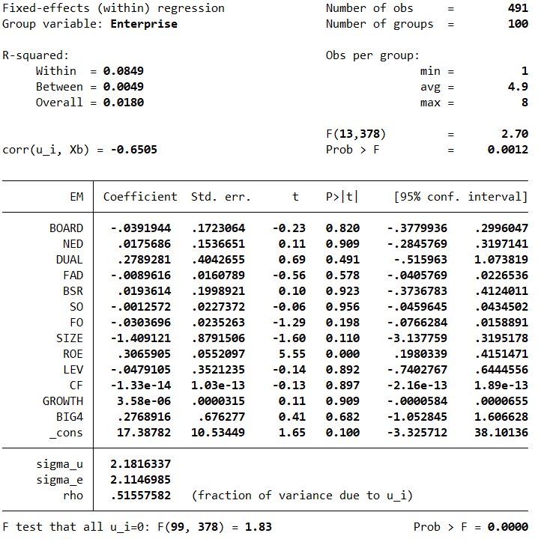

- Total EM F-test
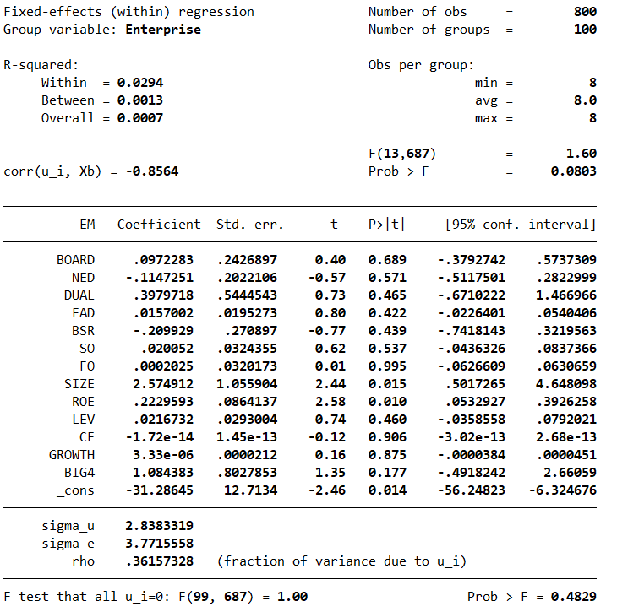

Appendix A2: Breusch-Pagan Lagrange multiplier test
Model | P-value | Conclusion
Downward | 1.0000 | Accept H0
Upward | 0.4034 | Accept H0
Total | 1.0000 | Accept H0

- Downward EM Breusch - Pagan Test
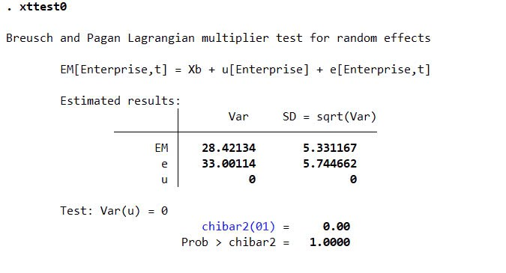
- Upward EM Breusch - Pagan Test

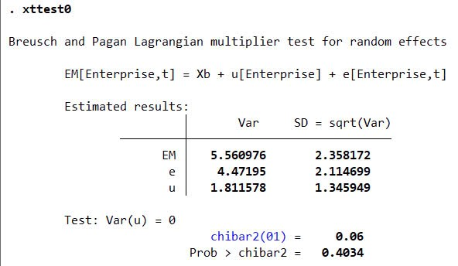

- Total EM Breusch - Pagan Test
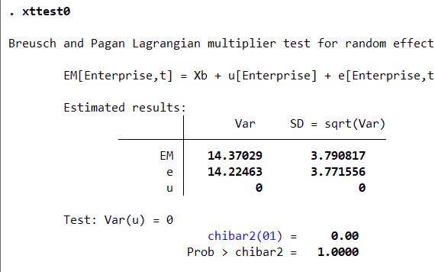

Appendix B: List of 100 Vietnam corporates used in this study
Number | Stock ticker | Name
1 | CAV | Vietnam Electric Cable Corporation
2 | CJC | Central Area Electrical Mechanical JSC
3 | EMC | Thu Duc Electro Mechanical Joint Stock Company
4 | EMG | Electrical Mechanical Equipment And Spare Parts JSC
5 | GEX | GELEX Group JSC
6 | KIP | Vietnam K.I.P JSC
7 | ASP | An Pha petrol Joint Stock Company
8 | CNG | CNG VietNam Joint Stock Company
9 | GAS | PetroVietnam Gas Joint Stock Corporation
10 | GSP | International Gas Product Shipping JSC
11 | HFC | HFC Petrol Joint Stock Company
12 | PEG | Petec Trading and Investment Corporation
13 | PEQ | Petrolimex Equipment Joint Stock Company
14 | PIC | PC3-Investment Joint Stock Company
15 | PJC | Petrolimex Hanoi Transportation & Trading JSC
16 | VTO | Viet Nam Tanker Joint Stock Company
17 | BTT | Ben Thanh Trading & Service Joint Stock Company
18 | CMV | CaMauTradingJointStockCompany
19 | COM | Materials-PetroleumJointStockCompany
20 | DGW | DIGIWORLD CORP
21 | HAX | Hang Xanh Motors Service Joint Stock Company
22 | HFX | Thanh Ha Export-Import Company
23 | HTC | HocMon Trade Joint Stock Company
24 | MSN | Masan Group Corporation
25 | PET | Petrovietnam General Services JSC Corporation
26 | PIT | Petrolimex International Trading Joint Stock Company
27 | PNG | Phu Nhuan Trading Joint Stock Company
28 | PNJ | Phu Nhuan Jewelry Joint Stock Company
29 | VNM | Viet Nam Dairy Products Joint Stock Company
30 | BVG | Bac Viet Group Joint Stock Company
31 | DTL | Dai Thien Loc Corporation
32 | HMC | VNSTEEL HOCHIMINH CITY METAL CORPORATION
33 | HPG | Hoa Phat Group JSC
34 | HSG | Hoa Sen Group
35 | NKG | Nam Kim Steel Joint Stock Company
36 | TVN | VietNam Steel Corporation
37 | VCA | VNSTEEL-VICASA JSC
38 | VDT | Vietourist Travel JSC
39 | VGS | Vietnam Germany Steel Pipe JSC
40 | ACV | Airports Corporation Of VietNam
41 | SAS | Southern Airports Services JSC
42 | SCS | SCSC Cargo Service Corporation
43 | BCP | BCP JOINT STOCK COMPANY
44 | DBM | Dak Lak Pharmaceutical Medical Equipment JSC
45 | DBT | Ben Tre Pharmaceutical Joint Stock Company
46 | DCL | Cuu Long Pharmaceutical JSC
47 | DHG | DHG Pharmaceutical Joint Stock Company
48 | DMC | Domesco Medical Import Export Joint Stock Corporation
49 | DPP | Dong Nai Pharmaceutical JSC
50 | IMP | Imexpharm Corporation
51 | MTP | Medipharco Pharmaceutical JSC
52 | NDC | Nam Duoc JSC
53 | OPC | OPC Pharmaceutical Joint Stock Company
54 | PMC | Pharmedic Pharmaceutical Medicinal JSC
55 | VMD | Vimedimex Medi-Pharma Joint Stock Company
56 | AAM | Mekong Fisheries Joint Stock Company
57 | ABT | Bentre Aquaproduct Import And Export JSC
58 | AGF | Angiang Fisheries Import Export JSC
59 | CMX | Camimex Group JSC
60 | ICF | Investment Commerce Fisheries Corporation
61 | AAA | AnPhat Bioplastics JSC
62 | IDI | I.D.I International Development & Investment Corporation
63 | MPC | Minh Phu SeafoodCorporation
64 | SCO | Sea Products Mechanical Shareholding Company
65 | SEA | Vietnam Seaproducts Joint Stock Corporation
66 | SGN | Saigon Ground Services JSC
67 | SNC | NamCan Seaproducts Import Export Joint Stock Company
68 | SPD | DaNang Seaproducts Import-Export Corporation
69 | SPH | Seaprodex Hanoi Joint Stock Company
70 | VHC | Vinh Hoan Corporation
71 | VNH | Viet Nhat Investment Corporation
72 | ADS | Dam San Joint Stock Company
73 | EVE | Everpia JS
74 | GIL | Binh Thanh Import-Export Production & Trade JSC
75 | GMC | Garmex Saigon Corporation
76 | HDM | Hue Textile Garment JSC
77 | HSM | Ha Noi Textile and Garment Joint Stock Corporation
78 | KMR | Mirae JSC
79 | MNB | NhaBe Garment Corporation-Joint Stock Company
80 | ARM | General Aviation Import Export JSC
81 | BSC | Ben Thanh Service JointStock Company
82 | CCP | HaiPhong Cua Cam Port Joint Stock Company
83 | CCR | Cam Ranh Port Joint Stock Company
84 | CDN | Danang Port Joint Stock Company
85 | CLL | CatLai Port Joint Stock Company
86 | CMP | Chan May Port Joint Stock Company
87 | DDM | Dong Do Marine Joint Stock Company
88 | DNL | Dang Nang Port Logistics JSC
89 | DVC | Hai Phong Port Trading And Services JSC
90 | DVP | Dinh Vu Port Investment and Development JSC
91 | DXP | Doan Xa Port JSC
92 | GMD | Gemadept Corporation
93 | GSP | International Gas Product Shipping JSC
94 | HAH | Hai An Transport & Stevedoring JSC
95 | HCT | Hai Phong Cement Transport & Trading JSC
96 | HHG | Hoang Ha Joint Stock Company
97 | HMH | Hai Minh Corporation
98 | HTV | Logistics Vicem Joint Stock Company
99 | SGP | Saigon Port Joint Stock Company
100 | SKG | Superdong Fast Ferry Kien Giang JSC

