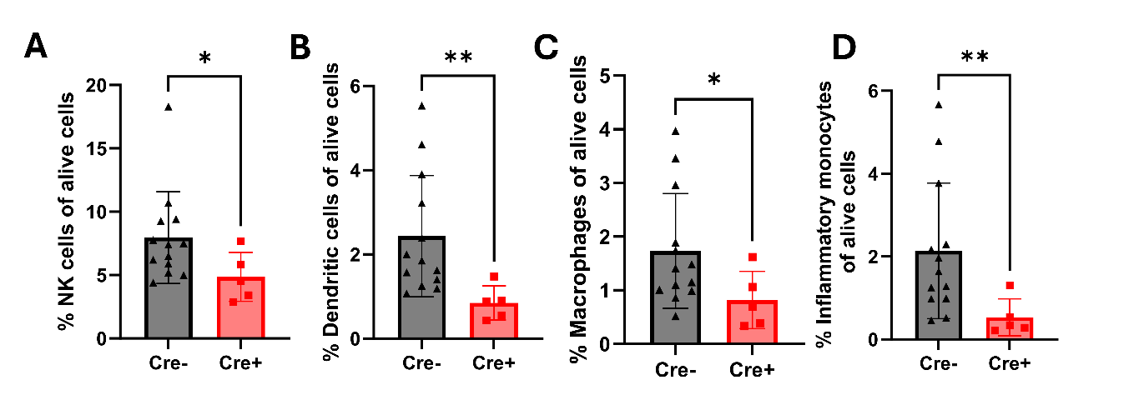
Figure S1. Reduced frequencies of several immune populations are observed in the Tmem119 K^{b} cKO 7 days post TMEV-OVA infection. (A) Bar chart show reduced frequencies of NK cells (TCRβ- CD19- NK1.1+), (B) Dendritic cells (TCRβ- CD19- NK1.1-, CD11c+MHC II+), (C) Macrophages (TCRβ- CD19- NK1.1- F480+) and (D) Inflammatory monocytes (TCRβ- CD19- NK1.1- CD11b+ Ly6C+) in the Cre+ group. Designation of symbols is as follows: ns or not shown for p > 0.05, * for p ≤ 0.05, ** for p ≤ 0.01, *** for p ≤ 0.001, **** for p ≤ 0.0001. Data presented as mean +/- SD.

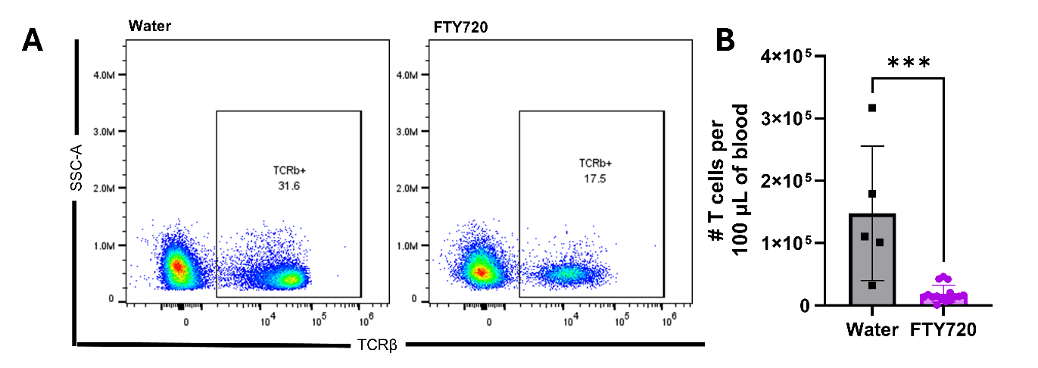
Figure S2. FTY720 treatment reduces T cell numbers in the blood at 7 days post TMEV infection. (A) Representative flow cytometry plots show differences between a water control mouse and a FTY720 injected mouse. (B) Bar charts show reduced numbers of T cells per 100 µL of blood in the FTY720 group. Designation of symbols is as follows: ns or not shown for p > 0.05, * for p ≤ 0.05, ** for p ≤ 0.01, *** for p ≤ 0.001, **** for p ≤ 0.0001. Data presented as mean +/- SD.

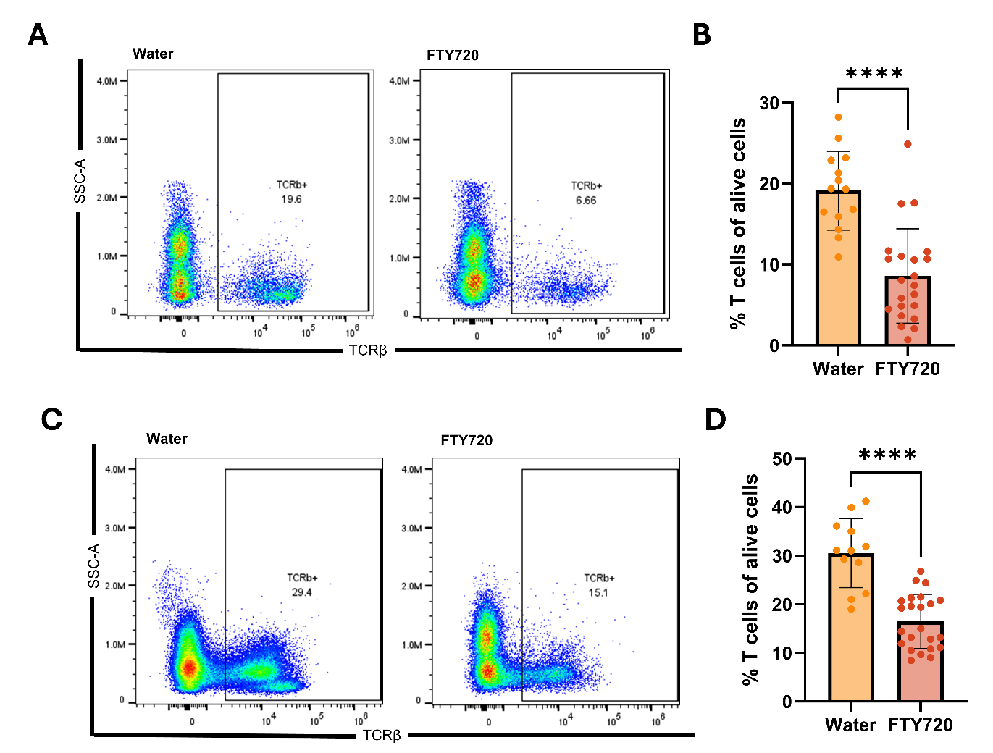
Figure S3. T cell frequencies are reduced in the blood after 5 days of treatment in a memory reactivation experiment. (A, B) First cohort of mice used to assess immune cell infiltration 48 hours post VP2₁₂₁₋₁₃₀ injection. (A) Representative flow cytometry plots show differences between a water control mouse and a FTY720 injected mouse. (B) Bar charts show reduced frequencies of T cells in the blood in the FTY720 group. (C, D) Second cohort of mice used for T1 gadolinium enhanced MRIs 48 hours post VP2₁₂₁₋₁₃₀ injection. (C) Representative flow cytometry plots show differences between a water control mouse and a FTY720 injected mouse. (D) Bar charts show reduced frequencies of T cells in the blood in the FTY720 group. Designation of symbols is as follows: ns or not shown for p > 0.05, * for p ≤ 0.05, ** for p ≤ 0.01, *** for p ≤ 0.001, **** for p ≤ 0.0001. Data presented as mean +/- SD.

