SUPPLEMENTAL MATERIALS

Title: Multi-generational exposure to glyphosate and glyphosate-based herbicides induces neurobehavioral alterations in Sprague-Dawley rats.

Menghetti, I.^{1*}, Thiara, I.^{2*} Panzacchi S.^{1*}, Falcioni L. ¹, Giovannini R. ¹, Iuliani M.¹, Manservigi M.¹, Nanni S. ¹, Sgargi D.¹, Strollo V. ¹ Perry M.J.³, Landrigan P.J.⁴⁵**, Smith D.R.²**, Mandrioli D.¹**

Supplemental Table 1. Summary of Glyphosate-Based Herbicide (GBH) exposure effects on activity and behavior outcomes in the Open Field test. Summary reflects results from mixed model analyses for each class of GBH, with GBH treatment, sex, and treatment x sex interaction as model main effects.
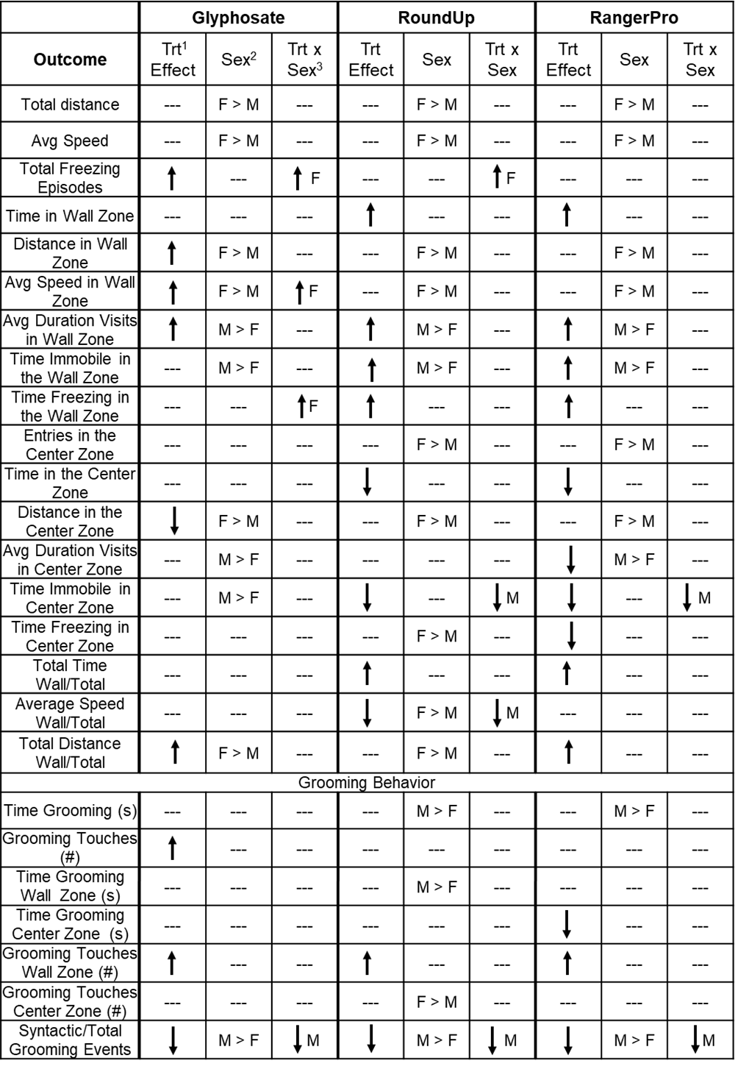

- Treatment effect = low, medium, or high dose versus controls (p<0.05). ‘---’ indicates no statistically significant effect (p>0.05).
- Sex effect = Relative difference between sexes, or greater treatment effect in one sex versus the other (p<0.05).
- Treatment x sex interaction = Treatment effect greater in the sex indicated (p<0.05; see text).
Supplemental Table 2. Summary of mixed model ANOVA analyses of Glyphosate-Based Herbicide (GBH) exposure effects on outcomes in the Open Field, Balance Beam, Grip Strength, and Passive Avoidance tests. Summary reflects results for each class of GBH, with GBH treatment, sex, and treatment x sex interaction as model main effects. ‘Source’ = model main effect, ‘Nparm’ = number of model parameters (n-1), ‘DFNum’ = numerator degrees of freedom, ‘DFDen’ = denominator degrees of freedom, ‘F Ratio’ = model F statistic, ‘Prob>F’ = p-value.

Supplemental Table 2 (Con’t).

