Supplementary material

Hybrid electrocoagulation - anodic oxidation for decentralized greywater reuse: performance, energy demand, and kinetics at domestic scale
Julio Urzúa-Ahumada^{*,1,5}, Tamara Rosas¹, Roxana Arce^{2,3}, Julio Romero⁴, Ricardo Abejón⁴, Esteban Quijada-Maldonado^{*,1}

S1. Electrode cleaning protocol
A 1 L glass reactor (Figure S1) was employed to perform the cleaning of each electrode. The protocol for each kind of electrode is detailed as follows:
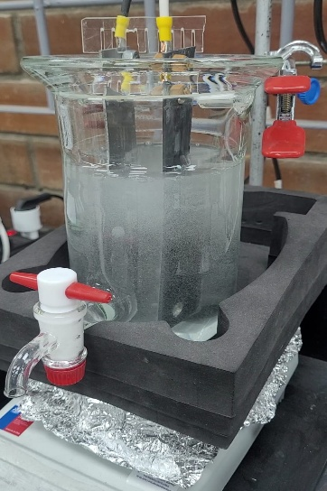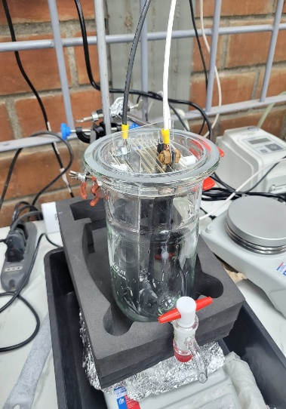
Figure S1: Reactor used for electrode cleaning.
Aluminum anodes
The electrodes are washed with milliQ water/acetone/milliQ water, then immersed in a 1.3 M HCl solution for 5 minutes, then removed and washed with plenty of milliQ water and dried in an oven at 60 °C for 5 minutes.

MMO anodes
Electrodes were washed with milliQ water/acetone/milliQ water, but cleaning is carried out with a 0.05 M H₂SO₄ solution by electrolysis for 30 minutes in a 1 [L] glass (Soviquim®) and an HVPower HVP-IGBT-1500 adjustable power supply, with a maximum power of 1,500 W with input voltage 220 AC 50Hz, output voltage of 0 – 40 V, maximum current 0 – 30 A, finally washed with milliQ water/acetone/milliQ water and left to dry at room temperature.

SS 304 stainless steel cathodes
Cathodes are washed with milliQ water/acetone/milliQ water, left to dry at room temperature, then polished with 2400 sandpaper and finally washed again with milliQ water/acetone/milliQ water to allow drying.

S2. Calculation of estimated ${BOD}_{5}$ from $COD$
BOD₅ concentrations were calculated from literature relationships regarding greywater biodegradability [1,2]. Several ranges are found, as reported [1,3]. A biodegradability ratio of 0.71 was used, considering that the literature states that GW are highly biodegradable.
$${BOD}_{5}≅COD∙0.71$$

S3. By-products identified by GC-MS

Table S3.1. Identified compounds by HS-SPME-GC-MS before SCE and TCE treatment (Figure S3.1a and Figure S3.1b)
Compound | Molecular structure | Retention time (min) | Kovats index (theoretical) | Kovats index (experimental)
2-ethyl-1-hexanol | 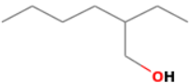 | 19.38 | 980 – 1060 | 1021.42
2,6-Dimethyl-7-octen-2-ol | 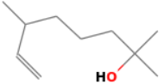 | 20.82 | 1056 – 1076 | 1064.76
(+)-2-Bornanone | 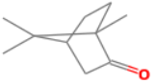 | 23.38 | 1121 – 1144 | 1144.33
Isoborneol | 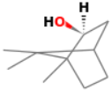 | 23.8 | 1132 – 1196 | 1157.91
1-Methyl-4-(1-methylethyl)-cyclohexanol | 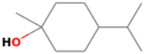 | 24.2 | 1162 – 1206 | 1170.63
L-α-Terpineol | 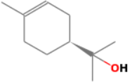 | 24.79 | 1143 – 1231 | 1189.00
Isobornyl acetate | 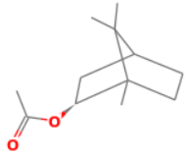 | 27.59 | 1262 – 1317 | 1285.13
2,6-Di-terc-butyl-4-hydroxy-4-methylcyclohexa-2,5-dien-1-one | 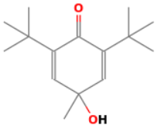 | 32.39 | 1478 | 1466.11
2,4-Di-terc-butylphenol | 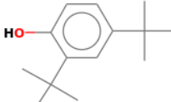 | 33.38 | 1502 – 1525 | 1504.72
p-Xilene | 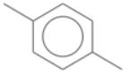 | 13.67 | 847 – 904 | 864.89
o-Xilene | 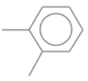 | 14.56 | 850 – 910 | 887.00
1,5,5-Trimethyl-bicyclo[2.2.1]heptan-2-ol | 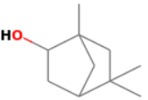 | 22.21 | 1119 | 1105.51
1-Methyl-4-(1-methylethyl)-3-cyclohexen-1-ol | 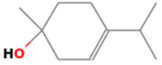 | 22.97 | 1162 – 1206 | 1170.63
α-Terpineol | 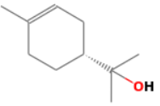 | 24.77 | 1143 – 1231 | 1188.39
Butylhydroxytoluene | 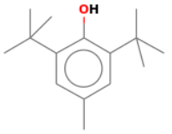 | 33.47 | NA | 1508.57
Endoborneol | 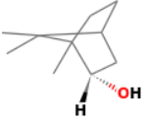 | 24.06 | 1130 – 1213 | 1166.52

a
b
Figure S3.1: Chromatograms of samples obtained by HS-SPME of GW after 0 (black line), 180 (red line) and 300 min (green line) of treatment, for SCE (a) and TCE (b).

Table S3.2. Identified compounds by HS-SPME-GC-MS in SCE and TCE after 180 min of treatment (Figure S3.2)
Compound | Molecular structure | Retention time (min) | Kovats index (theoretical) | Kovats index (experimental)
DL-Menthol | 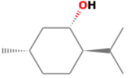 | 24.27 | 1140 – 1174 | 1172.83
2-methyl-5-(1-methylethyl)-phenol | 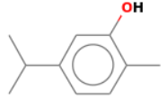 | 27.63 | 1271 – 1328 | 1286.46
3-hydroxy-2,2,4-trimethylpentyl isobutyrate | 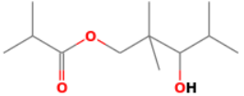 | 29.92 | 1380 | 1370.59
Tributyl phosphate | 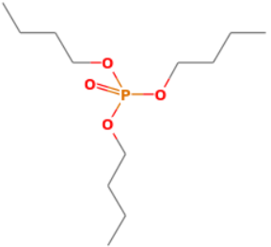 | 36.55 | 1638.7 – 1663 | 1639.06
1,2-Benzenedicarboxylic acid, bis(2-methylpropyl) ester | 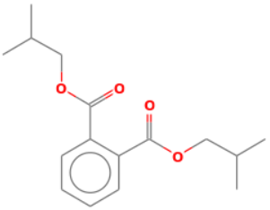 | 41.41 | 1862 – 1908 | 1864.47
Dibutyl phthalate | 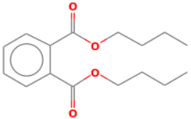 | 43.31 | 1907 – 1980 | 1959.73
Source: (National Institute of Standards and Technology, 2025)
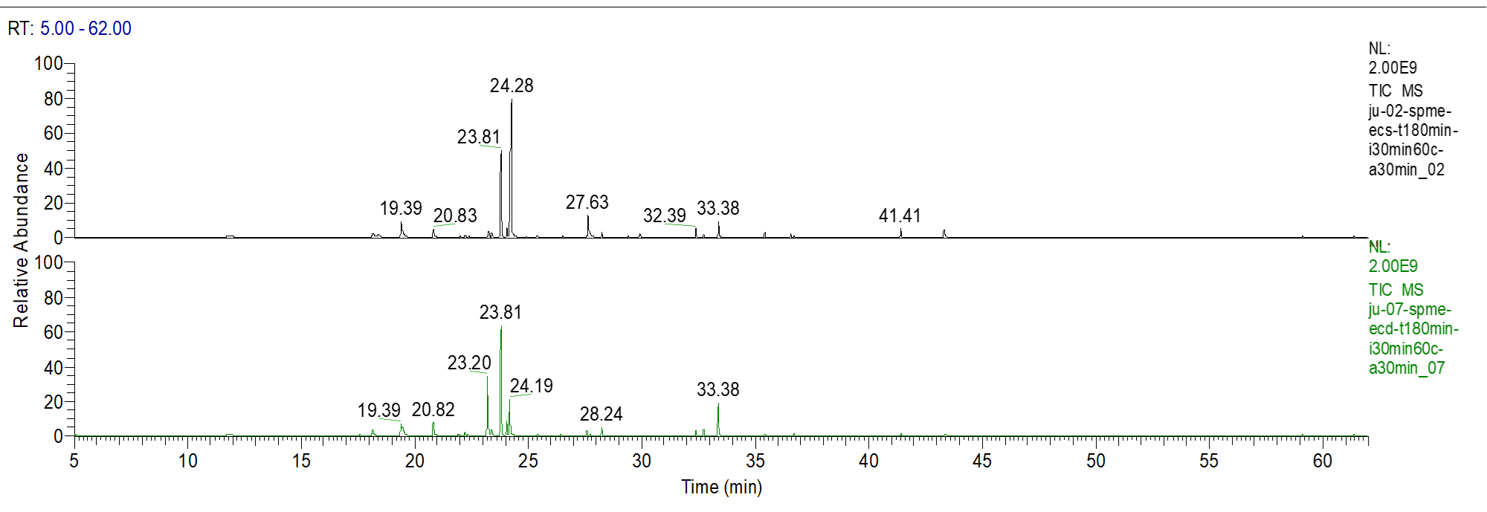
Figure S3.2: Chromatograms of samples obtained by HS-SPME of GW after 180 for SCE (black line) and TCE (green line).

References
[1] M. Oteng-Peprah, M.A. Acheampong, N.K. deVries, Greywater Characteristics, Treatment Systems, Reuse Strategies and User Perception—a Review, Water Air Soil Pollut. 229 (2018). https://doi.org/10.1007/s11270-018-3909-8.
[2] L.C. Espinoza, A. Llanos, M. Cepeda, A. Carreño, P. Velásquez, B. Cruz, G. Ramírez, J. Romero, R. Abejón, E. Quijada-Maldonado, M.J. Aguirre, R. Arce, Optimization of a Monopolar Electrode Configuration for Hybrid Electrochemical Treatment of Real Washing Machine Wastewater, Int. J. Mol. Sci. 26 (2025) 6445. https://doi.org/10.3390/ijms26136445.
[3] Shaikh, M.M. Ahammed, Quantity and quality characteristics of greywater from an Indian household, Environ. Monit. Assess. 194 (2022) 191. https://doi.org/10.1007/s10661-022-09820-0.

