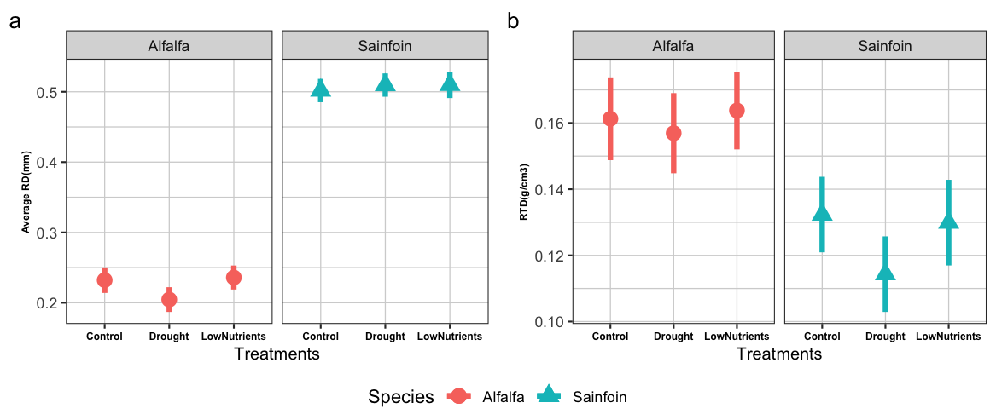
Fig S1 The effects of Drought and low nutrient treatment on average root diameter (RD) (a), and root tissue density (RTD) (b). Points and whiskers represent model-estimated means and 95% confidence intervals

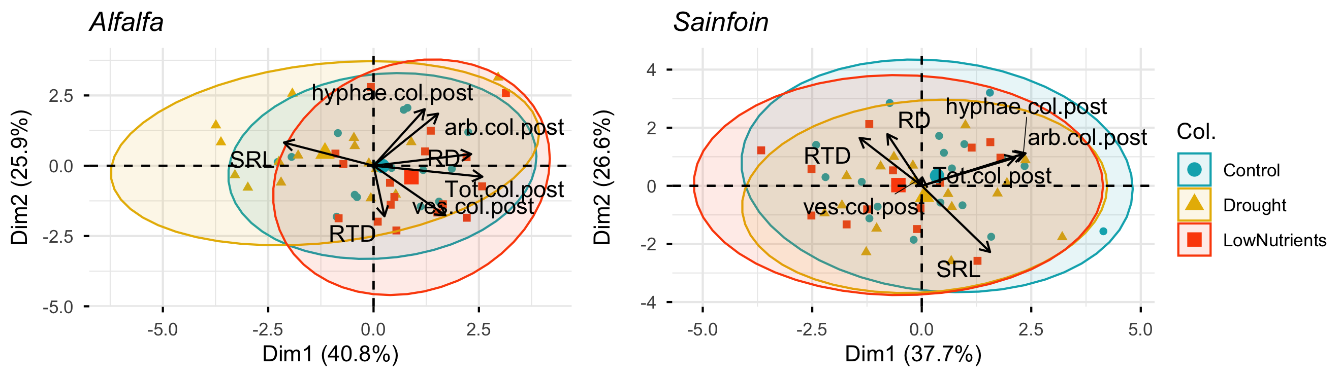
Fig S2 Principal component analysis (PCA) of post-treatment plant functional traits and arbuscular mycorrhizal fungal (AMF) structural colonization for alfalfa (left) and sainfoin (right). Points represent individual plants, colored by treatment (Control, Drought, Low nutrients). Ellipses indicate 95% confidence intervals for each treatment. Trait loadings are shown as vectors. Percent variance explained by each principal component is indicated on the axes. RD=average root diameter, RTD=root tissue density, SRL=specific root length, Tot.col.post=post treatment total colonization, arb.col.post=post treatment arbuscule colonization, ves.col.post=post treatment vesicle colonization, hyphae.col.post=post treatment hyphal colonization.

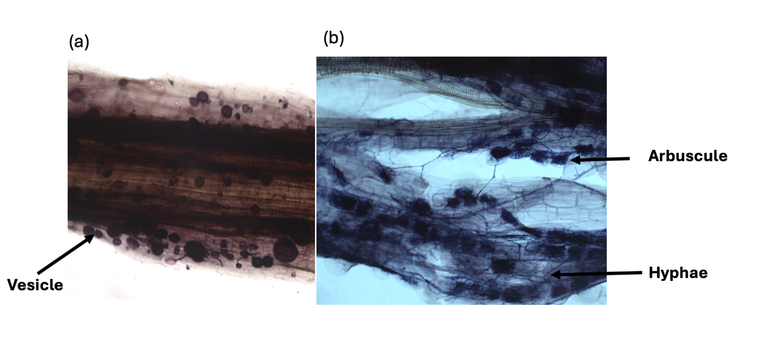

Fig S3 Microscopic view of AMF colonization in (a)alfalfa root cortex and (b) sainfoin root cortex at the post-treatment stage. Vesicles are visible in alfalfa roots, while sainfoin roots exhibit arbuscules and hyphae within the cortical cells.

Table S1 Results of two-way ANOVA testing the effects of species, treatment and their interaction on mycorrhizal colonization traits (total colonization, vesicle proportion, hyphae proportion and arbuscule proportion) and root traits (RTD and RD). P<.05 was considered a significant threshold.

Table S2 Model comparison assessing the ability of arbuscular mycorrhizal fungi (AMF) colonization metrics (pre-stress + post-stress) to predict plant performance. For each response variable, linear models included initial plant size as a covariate and differed only in the AMF predictor (total root colonization vs individual structural colonization). Model fit is summarized using the coefficient of determination (R²) and Akaike’s Information Criterion (AIC), with higher R² value and lower AIC values indicating stronger model support.

Response | Factor | DF | DenDF | F | P value
Total colonization | Species | 1 | 94 | 1.62 | 0.205
Total colonization | Treatment | 2 | 94 | 5.51 | 0.005
Total colonization | Species*Treatment | 2 | 94 | 0.99 | 0.373
Vesicle proportion | Species | 1 | 94 | 33.86 | <.001
Vesicle proportion | Treatment | 2 | 94 | 5.73 | 0.004
Vesicle proportion | Species* Treatment | 2 | 94 | 0.58 | 0.416
Hyphae proportion | Species | 1 | 94 | 12.17 | <.001
Hyphae proportion | Treatment | 2 | 94 | 0.47 | 0.621
Hyphae proportion | Species*Treatment | 2 | 94 | 1.80 | 0.169
Arbuscule proportion | Species | 1 | 94 | 16.56 | 0.001
Arbuscule proportion | Treatment | 2 | 94 | 0.40 | 0.670
Arbuscule proportion | Species*Treatment | 2 | 94 | 0.42 | 0.656
Root tissue density | Species | 1 | 94 | 8.68 | 0.004
Root tissue density | Treatment | 2 | 94 | 0.31 | 0.729
Root tissue density | Species*Treatment | 2 | 94 | 1.02 | 0.363
Average root diameter | Species | 1 | 94 | 506.30 | <.001
Average root diameter | Treatment | 2 | 94 | 3.57 | 0.031
Average root diameter | Species*Treatment | 2 | 94 | 1.95 | 0.146

Response variable | AMF predictor | Covariate | R² | AIC
Total plant mass | Total colonization (pre-treatment) | Initial plant size | 0.59 | 57.55
 | Structural colonization (pre-treatment) | Initial plant size | 0.64 | 36.01
Dead shoot proportion | Total colonization (pre-treatment) | Initial plant size | 0.44 | -178.82
 | Structural colonization (pre-treatment) | Initial plant size | 0.56 | -196.14
Shoot nitrogen | Total colonization (pre-treatment) | Initial plant size | 0.22 | -112.12
 | Structural colonization (pre-treatment) | Initial plant size | 0.34 | -124.33
Total plant mass | Total colonization (post-treatment) | Initial plant size | 0.64 | 39.17
 | Structural colonization (post-treatment) | Initial plant size | 0.65 | 54.79
Dead shoot proportion | Total colonization (post-treatment) | Initial plant size | 0.56 | -142.43
 | Structural colonization (post-treatment) | Initial plant size | 0.57 | -143.09
Shoot nitrogen | Total colonization (post-treatment) | Initial plant size | 0.36 | -127.57
 | Structural colonization (post-treatment) | Initial plant size | 0.33 | -119.91

Table S3 Results of ANOVA from stepwise linear regression model (forward and backward both) identifying the relationships between total shoot mass(g) and pre-treatment AMF structural colonization (vesicles, arbuscules, and hyphae). Total shoot mass (g) was modelled as a function of pre-treatment AMF structural colonization and initial basal area, including interactions with species and treatment.

 | DF | F value | P value
Initial basal area | 1,90 | 11.25 | 0.001
Species | 1,90 | 1.31 | 0.255
Treatment | 2,90 | 12.95 | <.001
Vesicle proportion | 1,90 | 5.96 | 0.016
Hyphae proportion | 1,90 | 0.59 | 0.444
Initial basal area: Species | 1,90 | 3.45 | 0.066
Treatment: Hyphae proportion | 2,90 | 3.18 | 0.046

Table S4 Results of ANOVA from stepwise linear regression model (forward and backward both) evaluating the relationships between dead shoot proportion and pre-treatment AMF structural colonization (vesicles, arbuscules, and hyphae). Dead shoot proportion was modelled as a function of AMF structural colonization and initial basal area, including interactions with species and treatment. P<.05 was considered as a significant threshold.

 | DF | F value | P value
Treatment | 2,90 | 36.71 | <.001
Vesicle proportion | 1,90 | 0 | 0.998
Arbuscule proportion | 1,90 | 1.36 | 0.246
Hyphae proportion | 1,90 | 2.05 | 0.156
Treatment: Vesicle proportion | 2,90 | 1.90 | 0.154
Treatment: Arbuscule proportion | 2,90 | 8.20 | <.001

Table S5 Results of ANOVA from stepwise linear regression model (forward and backward both) identifying the relationships between shoot nitrogen concentration (%) and pre-treatment AMF structural colonization (vesicles, arbuscules, and hyphae). Shoot nitrogen conc was modelled as a function of AMF structural colonization and initial basal area, including interactions with species and treatment.

 | DF | F value | P value
Species | 1,86 | 11.12 | 0.001
Treatment | 2,86 | 5.43 | 0.006
Initial basal area | 1,86 | 5.91 | 0.017
Hyphae proportion | 1,86 | 4.00 | 0.048
Arbuscule proportion | 1,86 | 1.97 | 0.164
Vesicle proportion | 1,86 | 1.06 | 0.305
Species: Treatment | 2,86 | 1.58 | 0.213
Species: Vesicle proportion | 1,86 | 0.84 | 0.363
Treatment: Vesicle proportion | 2,86 | 1.04 | 0.358
Species: Treatment: Vesicle proportion | 2,86 | 2.77 | 0.068

Table S6 Results of ANOVA from stepwise linear regression model (forward and backward) identifying the relationships between total shoot mass (g) and post-treatment AMF structural colonization (vesicles, arbuscules, and hyphae). Total shoot mass(g) was modelled as a function of AMF structural colonization and initial basal area, including interactions with species and treatment. P<.05 was considered a significant threshold.

 | DF | F value | Pr(>F)
Species | 1,90 | 40.61 | <.001
Treatment | 2,90 | 4.38 | 0.015
Initial basal area | 1,90 | 13.39 | <.001
Vesicle proportion | 1,90 | 0.08 | 0.777
Treatment: Initial basal area | 2,90 | 2.84 | 0.063
Treatment: Vesicle proportion | 2,90 | 5.12 | 0.007

Table S7 Results of ANOVA from stepwise linear regression model (forward and backward) identifying the relationships between dead shoot proportion and post-treatment AMF structural colonization (vesicles, arbuscules, and hyphae). Dead shoot proportion was modelled as a function of post-treatment AMF structural colonization and initial basal area, including interactions with species and treatment. P<.05 was considered the significant threshold.

 | DF | F value | Pr(>F)
Species | 1,87 | 0.12 | 0.727
Treatment | 2,87 | 28.61 | <.001
Vesicle proportion | 1,87 | 0.02 | 0.881
Arbuscule proportion | 1,87 | 0.38 | 0.542
Species: Treatment | 2,87 | 6.92 | 0.001
Species: Vesicle proportion | 1,87 | 0.20 | 0.652
Treatment: Vesicle proportion | 2,87 | 9.87 | <.001
Treatment: Arbuscule proportion | 2,87 | 1.98 | 0.144
Species: Treatment: Vesicle proportion | 2,87 | 4.07 | 0.020

Table S8 Results of ANOVA from stepwise linear regression model (forward and backward both) identifying the relationships between shoot N concentration and post-treatment AMF structural colonization (vesicles, arbuscules, and hyphae). Shoot nitrogen concentration was modelled as a function of post-treatment AMF structural colonization and initial basal area, including interactions with species and treatment. P<.05 was considered was considered as the significant threshold.

 | DF | F value | Pr(>F)
Species | 1,83 | 1.16 | 0.284
Treatment | 2,83 | 3.82 | 0.026
Initial basal area | 1,83 | 3.28 | 0.074
Vesicle proportion | 1,83 | 0.30 | 0.583
Arbuscule proportion | 1,83 | 6.28 | 0.014
Species: Treatment | 2,83 | 1.57 | 0.214
Species: Initial basal area | 1,83 | 2.12 | 0.149
Treatment: Vesicle proportion | 2,83 | 2.00 | 0.142
Species: Arbuscule proportion | 1,83 | 3.73 | 0.057
Treatment: Arbuscule proportion | 2,83 | 3.46 | 0.036
Species: Treatment: Arbuscule proportion | 2,83 | 4.67 | 0.012

Table S9 Results of ANOVA from stepwise linear regression model (forward and backward both) identifying the relationships between total shoot mass and post-treatment root traits (average root diameter (RD) and root tissue density (RTD)). Total shoot mass was modelled as a function of RD, RTD and initial basal area, including interactions with species and treatment. P<.05 was considered was considered as the significant.

 | DF | F value | P value
Treatment | 2,88 | 51.65 | <.001
RD | 1,88 | 5.34 | 0.023
Species | 1,88 | 0.23 | 0.634
RTD_gcm3 | 1,88 | 2.98 | 0.088
Initial basal area | 1,88 | 39.64 | <.001
Treatment: RD | 2,88 | 0.54 | 0.586
Treatment: Species | 2,88 | 1.85 | 0.163
Species: Initial basal area | 1,88 | 2.50 | 0.118

Table S10 Results of ANOVA from stepwise linear regression model (forward and backward both), identifying the relationships between dead shoot proportion and post-treatment average root diameter (RD). Dead shoot proportion was modelled as a function of RD and initial basal area, including interactions with species and treatment. P<.05 was considered the significant threshold.

 | DF | F value | P value
Treatment | 2,85 | 6.1247 | 0.003
RD | 1,85 | 0.0179 | 0.894
Species | 1,85 | 0.1598 | 0.690
Initial basal area | 1,85 | 1.489 | 0.226
Treatment: RD | 2,85 | 7.7548 | 0.001
Treatment: Species | 2,85 | 9.274 | <.001
RD: Species | 1,85 | 0.3765 | 0.541
Treatment: Initial basal area | 2,85 | 2.1198 | 0.126
Treatment: RD: Species | 2,85 | 7.5437 | 0.001

Table S11 Results of ANOVA from stepwise linear regression model (forward and backward both) identifying the relationships between dead shoot proportion and post-treatment root tissue density (RTD) (g/cm3). Dead shoot proportion was modelled as a function of RTD and initial basal area, including interactions with species and treatment. P<.05 was considered the significant threshold.

 | DF | F value | P value
Treatment | 2,88 | 3.56 | 0.033
Species | 1,88 | 0.04 | 0.852
RTD | 1,88 | 1.02 | 0.316
Treatment: Species | 2,88 | 3.81 | 0.026
Treatment: RTD | 2,88 | 2.25 | 0.111
Species: RTD | 1,88 | 0.04 | 0.850
Treatment: Species: RTD | 2,88 | 3.25 | 0.043

Table S12 Results of ANOVA from stepwise linear regression model (forward and backward both) identifying the relationships between shoot nitrogen concentration (%) and post-treatment average root diameter (RD) (mm) and root tissue density (RTD) (g/cm3). Shoot nitrogen concentration (%) was modelled as a function of RD, RTD and initial basal area, including interactions with species and treatment. P<.05 was considered the significant threshold.

 | DF | F value | P value
(Intercept) | 1,91 | 0.07 | 0.788
Treatment | 2,91 | 1.98 | 0.143
RD | 1,91 | 6.73 | 0.011
Species | 1,91 | 5.34 | 0.023
RTD | 1,91 | 4.13 | 0.044
Treatment: Species | 2,91 | 4.78 | 0.010
Species: RTD | 1,91 | 5.59 | 0.020

