Syllable-timescale organization of auditory–motor feedback control

Liliana Sanchez Zepeda¹, Rebeca Hernández-Soto¹ & M. Florencia Assaneo^{1*}
¹Instituto de Neurobiología, Universidad Nacional Autónoma de México; Querétaro, 76230, México
*Corresponding author: fassaneo@inb.unam.mx

Rate | Comparison | W | p_{unc} | p_{FDR} | r_{rb}
3 Hz | 30 vs 80 | 46.5 | 0.58 | 1 | 0.19
3 Hz | 30 vs 160 | 5.5 | 0.011 | 0.035 | 0.83
3 Hz | 30 vs 240 | 0 | <0.001 | <0.001 | 1
3 Hz | 30 vs 320 | 0 | <0.001 | <0.001 | 1
3 Hz | 30 vs 400 | 0 | <0.001 | <0.001 | 1
6 Hz | 30 vs 80 | 1.5 | <0.001 | <0.001 | 0.97
6 Hz | 30 vs 160 | 0 | <0.001 | <0.001 | 1
6 Hz | 30 vs 240 | 0 | <0.001 | <0.001 | 1
6 Hz | 30 vs 320 | 1 | <0.001 | <0.001 | 0.98
6 Hz | 30 vs 400 | 3 | <0.001 | 0.001 | 0.95

Supplementary Table 1. Results of post hoc Wilcoxon signed-rank tests comparing the baseline delay (30 ms) with each of the remaining delay conditions within each speaking-rate condition. P-values were corrected for multiple comparisons using the false discovery rate (FDR) procedure. Effect sizes are reported as rank-biserial correlations (r_{rb}).

Subject | 3hz | 6 Hz
S01 | FCz, C3, Cz, C4, CP5, CPz | F7, F4, Fz, Cz, FCz, C3
S02 | F3, C4, Cz, Fp1, Fp2 | F3, C4, Fz, Fp1, Fp2
S03 | F3, Fz, F4, FCz, C3, Cz, C4, CPz | F4, Cz, C4, CPz, Fz, FCz
S04 | FCz, C3, Cz, C4, CPz, Pz, P4 | FCz, C3, Cz, P4, CPz, Pz, P3
S05 | FCz, C3, Cz, CPz | F3, Fz, F4, FCz, Cz, C3, C4
S06 | C4, CP6, P4 | C3, CP5
S07 | C3, CP5, CPz, Pz, P3 | F3, F4, FCz, C3, Cz
S08 | FCz, C3, Cz, C4, CPz, Pz | FCz, C3, Cz, C4, CPz, Pz
S09 | Fz, FCz, C3, Cz, C4, CPz | Fp2, Fz, F4, FCz, Cz, C4, CPz, C3
S10 | C4, CP5, CPz, CP6, P3, Pz | FCz, C3, Cz, C4, CP5, CPz, CP6, P3, Pz, P4
S11 | F3, Fz, FCz, C3, Cz, C4 | F7, F3, Fz, FCz, C3, Cz
S12 | FCz, C3, Cz, C4, CPz | FCz, C3, Cz, C4, CP5, CPz
S13 | Fz, FCz, C3, Cz, C4, CPz | FCz, C3, Cz, C4, CPz, P3, Pz
S14 | Fz, FCz, C3, Cz, C4, CPz | Fz, FCz, C3, Cz, C4, CPz, Pz
S15 | Fz, FCz, Cz, C3, C4, CPz | Fp2, F3, Fz, F4, F8, FCz
S16 | Fp2, FCz, Cz, C4, F3, Fz, F4 | FCz, Cz, C4, C3, CPz
S17 | F3, Cz, C4, C3, CPz, CP5, CP6, P3, P4, Pz, O1, O2 | F3, Cz, C4, C3, CPz, CP5, CP6, P3, P4, Pz, O1, O2
S18 | FCz, C3, Cz, CPz, CP5, P3 | Fp2, Fz, FCz, C3, Cz
S19 | FCz, C3, Cz, CPz, C4 | FCz, C3, Cz, C4, CPz
S20 | F3, Fz, FCz, CP6 | Fz, F4, FCz, Cz, C4
S21 | Fp1, Fp2, F3, Fz, F4, FCz | Fp1, Fp2, F3, Fz, F4, FCz, Cz, C4
S22 | F3, Fz, F4, FCz, C3, Cz, C4, CPz | Fz, F4, FCz, C3, Cz, C4, CPz
S23 | FCz, C3, Cz, C4, CP5, CPz | Fz, F8, FCz, C3, Cz, CPz
S24 | FCz, C3, Cz, C4, CP5, CP6 | F4, FCz, C3, Cz, C4, CPz, CP5, Pz
S25 | Fp1, Fp2, Fz, F4, FCz | Fz, F4, FCz, Cz, C4, CPz
S26 | F7, C3, C4, CP5, CP6, P4 | Fz, F4, FCz, C3, Cz, C4
S27 | F4, FCz, Cz, C4, CPz | F4, FCz, C4, Cz, CPz
S28 | Fp1, Fz, F4, FCz, Cz, C4, CPz | Fp2, C3, Cz, C4, CPz, CP6

Supplementary Table 2. Channels selected per participant and speaking-rate condition. Channels were selected via cluster-based permutation test applied to listening condition epochs, retaining only those showing a significant negative deflection relative to baseline within the 50-150 ms post- stimulus time window.

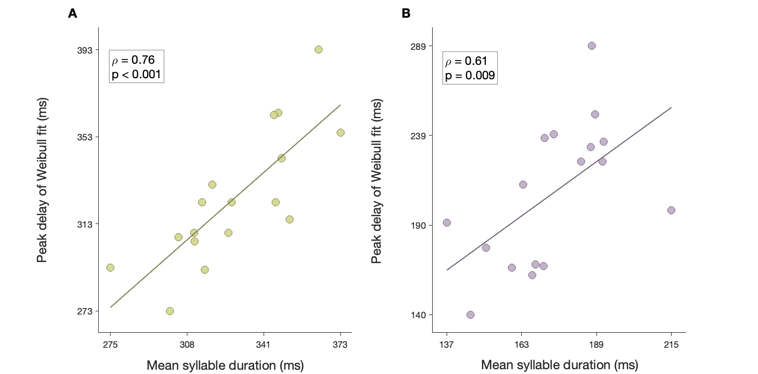
Supplementary Figure 1; The delay producing maximal disruption scales with syllable duration. Scatterplots showing the relationship between each participant's mean syllable duration during the rate-habituation phase and the feedback delay corresponding to the peak of the fitted Weibull function. A. Slow rate, 3 syllables-per-second. B. Fast rate, 6 syllables-per-second. Each dot represents one participant, and the solid line indicates the linear regression fit.

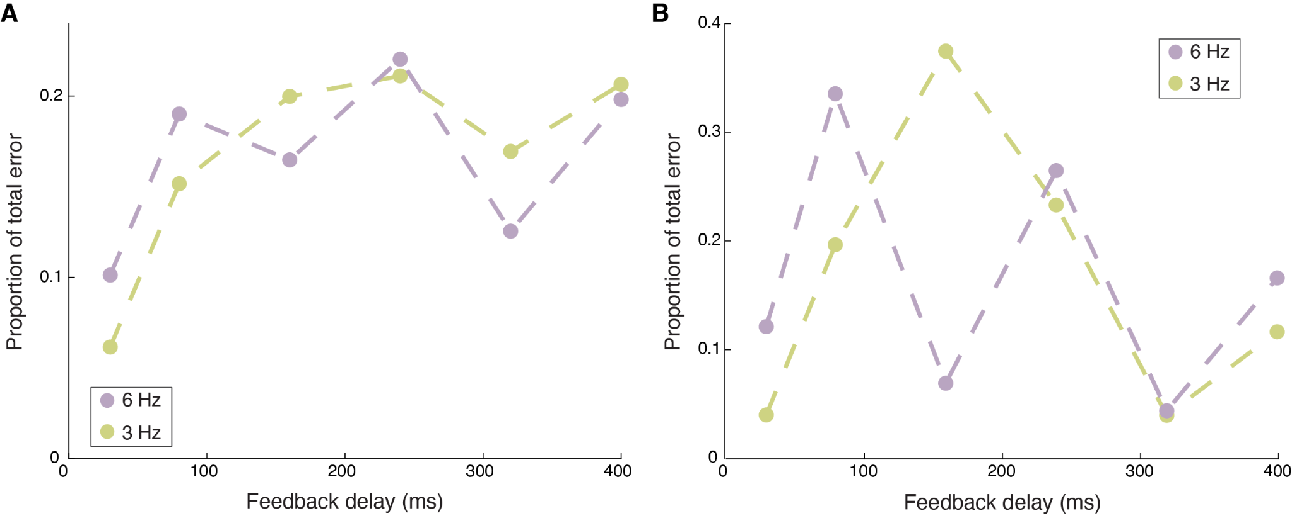
Supplementary Figure 2; DAF simulations for alternative computational models. Proportion of total error across feedback delays for a five-syllable sequence produced at two speaking rates (3 syllables/sec, green; 6 syllables/sec, purple). A. Mismatch was computed using a time-by-time comparison model, in which predicted and feedback cochlear representations were compared at each time point. B. Mismatch was computed from the phase difference between the broadband cochlear envelopes of the predicted and feedback signals. See Methods for a detailed description of both models.

