Supplementary material

Statistical Appendix

1. Rationale for model selection

Two outcomes were evaluated at 48 months: dental caries presence and number of carious teeth. Because caries presence was analysed as a binary outcome and prevalence ratios were preferred for interpretation, Poisson regression with log link was used for Models A and B. For the count outcome, a Poisson approach was initially considered, but the distribution of carious teeth showed overdispersion, as indicated by a mean of 2.9 and a standard deviation of 4.0. Therefore, negative binomial regression was selected for Models C and D.

2. Hierarchical conceptual framework

Model specification followed a hierarchical conceptual framework (Appendix Figure 1). Distal socioeconomic variables included household head education and maternal age at birth. Child sex was entered at the next level. The primary exposures were age at sugar introduction and frequency of added sugar at 12 months. Proximal oral health behaviour variables were oral hygiene during the first year and use of toothbrush plus fluoridated toothpaste. Covariates were retained in the progressively adjusted models when they improved model fit or were considered relevant within the conceptual framework.
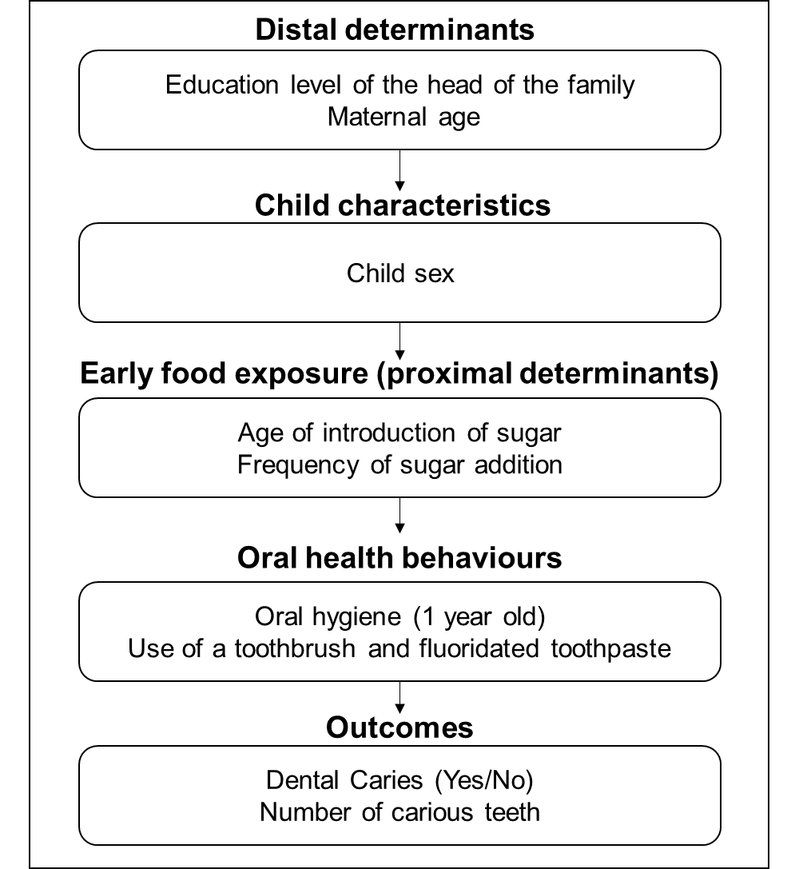

Appendix Figure 1. Hierarchical conceptual model.

3. Definition of analytic models

Model A assessed the association between age at sugar introduction, measured in months, and the presence of dental caries at 48 months. Model B assessed the association between frequency of added sugar at 12 months and the presence of dental caries at 48 months. Model C assessed the association between age at sugar introduction and the number of carious teeth at 48 months. Model D assessed the association between frequency of added sugar at 12 months and the number of carious teeth at 48 months.

4. Fit statistics and interpretation

Competing model specifications were compared using AIC and BIC. Lower values indicated better relative fit after accounting for model complexity. Model adequacy was additionally assessed using deviance/df and Pearson chi-square/df. For the binary outcome, the best-fitting Poisson model for sugar introduction was the unadjusted specification, with AIC 308.758 and BIC 315.177. For the count outcome, the negative binomial models also favored the unadjusted specification: Model C showed AIC 281.721 and BIC 288.140, and Model D showed AIC 284.424 and BIC 290.843.

Across the negative binomial models, deviance/df ranged from 0.635 to 0.652 and Pearson chi-square/df from 0.518 to 0.526, indicating adequate fit and no residual overdispersion after accounting for the count structure.

Appendix Table 1. Poison regression Model A n=183

 | Presence of dental caries
Variable | Step 1  Unadjusted  RP (IC 95%) | Step 2  Oral hygiene  RP (IC 95%) | Step 3  Toothbrush  Fluoride  RP (IC 95%) | Step 4  Full Model  RP (IC 95%)
Household head education ≥11 years | 0.87 (0.64-1.19) | 0.88 (0.64-1.20) | 0.87 (0.64-1.18) | 0.89 (0.65-1.22)
Household head education <11 years | 1.00 | 1.00 | 1.00 | 1.00
Maternal age at birth (years) | 0.98 (0.96-1.01) | 0.98 (0.96-1.01) | 0.98 (0.96-1.01) | 0.98 (0.96-1.01)
Sex male | 0.90 (0.67-1.22) | 0.91 (0.67-1.22) | 0.90 (0.67-1.21) | 0.91 (0.68-1.22)
Sex female | 1.00 | 1.00 | 1.00 | 1.00
Sugar introduction (months) | 1.01 (0.95-1.08) | 1.01 (0.95-1.08) | 1.01 (0.95-1.08) | 1.01 (0.95-1.08)
Oral hygiene in the first year | 4.50 (0.70-28.73) | 4.41 (0.71-27.29) | - | 4.79 (0.76-29.90)
No oral hygiene in the first year | 1.00 | 1.00 | - | 1.00
Use of toothbrush + fluoridated toothpaste | 0.92 (0.67-1.24) | - | 0.91 (0.67-1.24) | 0.84 (0.62-1.14)
Do not use of toothbrush + fluoridated toothpaste | 1.00 | - | 1.00 | 1.00
Model A: Exposition: Sugar introduction (months).

Appendix Table 2. Poison regression Model B n=183

 | Presence of dental caries
Variable | Step 1  Unadjusted  RP (IC 95%) | Step 2  Oral hygiene  RP (IC 95%) | Step 3  Toothbrush  Fluoride  RP (IC 95%) | Step 4  Full Model  RP (IC 95%)
Household head education ≥11 years | 0.87 (0.64-1.19) | 0.88 (0.64-1.20) | 0.87 (0.64-1.19) | 0.90 (0.65-1.22)
Household head education <11 years | 1.00 | 1.00 | 1.00 | 1.00
Maternal age at birth (years) | 0.98 (0.96-1.01) | 0.98 (0.96-1.01) | 0.98 (0.96-1.01) | 0.98 (0.96-1.01)
Sex male | 0.90 (0.67-1.22) | 0.92 (0.68-1.24) | 0.91 (0.67-1.24) | 0.92 (0.68-1.24)
Sex female | 1.00 | 1.00 | 1.00 | 1.00
Do not add sugar | 0.89 (0.57-1.38) | 0.91 (0.59-1.41) | 0.92 (0.59-1.43) | 0.92 (0.60-1.41)
Add sugar once a day | 0.94 (0.59-1.50) | 1.00 (0.63-1.57) | 0.99 (0.62-1.57) | 1.00 (0.64-1.56)
Add sugar ≥2 a day | 1.00 | 1.00 | 1.00 | 1.00
Oral hygiene in the first year | 4.50 (0.70-28.73) | 4.45 (0.70-28.32) | - | 4.81 (0.75-30.79)
No oral hygiene in the first year | 1.00 | 1.00 | - | 1.00
Use of toothbrush + fluoridated toothpaste | 0.92 (0.67-1.24) | - | 0.91 (0.67-1.24) | 0.84 (0.62-1.15)
Do not use of toothbrush + fluoridated toothpaste | 1.00 | - | 1.00 | 1.00
Model B: Exposition: Frequency of added sugar.

Appendix Table 3. Binomial negative regression Model C n=183

 | Number of carious teeth
Variable | Step 1  Unadjusted  RP (IC 95%) | Step 2  Oral hygiene  RP (IC 95%) | Step 3  Toothbrush  Fluoride  RP (IC 95%) | Step 4  Full Model  RP (IC 95%)
Household head education ≥11 years | 0.88 (0.57-1.35) | 0.80 (0.51-1.24) | 0.84 (0.54-1.30) | 0.80 (0.51-1.24)
Household head education <11 years | 1.00 | 1.00 | 1.00 | 1.00
Maternal age at birth (years) | 0.98 (0.95-1.00) | 0.97 (0.95-1.00) | 0.97 (0.95-1.00) | 0.97 (0.94-1.00)
Sex male | 0.96 (0.65-1.43) | 1.03 (0.69-1.52) | 0.99 (0.67-1.47) | 1.03 (0.70-1.52)
Sex female | 1.00 | 1.00 | 1.00 | 1.00
Sugar introduction (months) | 1.00 (0.92-1.08) | 1.00 (0.92-1.09) | 0.99 (0.91-1.08) | 1.00 (0.92-1.09)
Oral hygiene in the first year | 2.73 (0.42-17.52) | 3.11 (0.59-16.29) | - | 3.36 (0.63-17.77)
No oral hygiene in the first year | 1.00 | 1.00 | - | 1.00
Use of toothbrush + fluoridated toothpaste | 0.95 (0.64-1.42) | - | 0.92 (0.61-1.38) | 0.85 (0.57-1.28)
Do not use of toothbrush + fluoridated toothpaste | 1.00 | - | 1.00 | 1.00
Model C: Exposition: Sugar introduction (months).

Appendix Table 4. Binomial negative regression Model D n=183

 | Number of carious teeth
Variable | Step 1  Unadjusted  RP (IC 95%) | Step 2  Oral hygiene  RP (IC 95%) | Step 3  Toothbrush  Fluoride  RP (IC 95%) | Step 4  Full Model  RP (IC 95%)
Household head education ≥11 years | 0.88 (0.57-1.35) | 0.76 (0.48-1.18) | 0.79 (0.51-1.23) | 075 (0.48-1.17)
Household head education <11 years | 1.00 | 1.00 | 1.00 | 1.00
Maternal age at birth (years) | 0.98 (0.95-1.00) | 0.97 (0.95-1.00) | 0.97 (0.95-1.00) | 0.97 (0.94-1.00)
Sex male | 0.96 (0.65-1.43) | 1.08 (0.73-1.60) | 1.05 (0.71-1.55) | 1.08 (0.74-1.60)
Sex female | 1.00 | 1.00 | 1.00 | 1.00
Do not add sugar | 0.64 (0.37-1.12) | 0.65 (0.37-1.15) | 0.65 (0.36-1.16) | 0.67 (0.38-1.20)
Add sugar once a day | 0.77 (0.43-1.38) | 0.83 (0.46-1.51) | 0.84 (0.45-1.56) | 0.87 (0.47-1.61)
Add sugar ≥2 a day | 1.00 | 1.00 | 1.00 | 1.00
Oral hygiene in the first year | 2.73 (0.42-17.52) | 2.96 (0.53-16.50) | - | 3.18 (0.56-17.93)
No oral hygiene in the first year | 1.00 | 1.00 | - | 1.00
Use of toothbrush + fluoridated toothpaste | 0.95 (0.64-1.42) | - | 0.94 (0.62-1.42) | 0.87 (0.57-1.32)
Do not use of toothbrush + fluoridated toothpaste | 1.00 | - | 1.00 | 1.00
Model D: Exposition: Frequency of added sugar.

Appendix Table 5. Comparison of hierarchical regression models

Model | Outcome | Main exposure | Regression | Best-fitting specification | AIC | BIC | Deviance/df | Pearson/df
A | Caries presence | Sugar introduction (months) | Poisson | Unadjusted | 308.758 | 315.177 | 0.711 | 0.525
B | Caries presence | Added sugar frequency at 12 months | Poisson | Unadjusted | 310.711 | 320.339 | 0.715 | 0.528
C | Number of carious teeth | Sugar introduction (months) | Negative binomial | Unadjusted | 281.721 | 288.140 | 0.646 | 0.520
D | Number of carious teeth | Added sugar frequency at 12 months | Negative binomial | Unadjusted | 284.424 | 290.843 | 0.651 | 0.523

