Supplemental Material
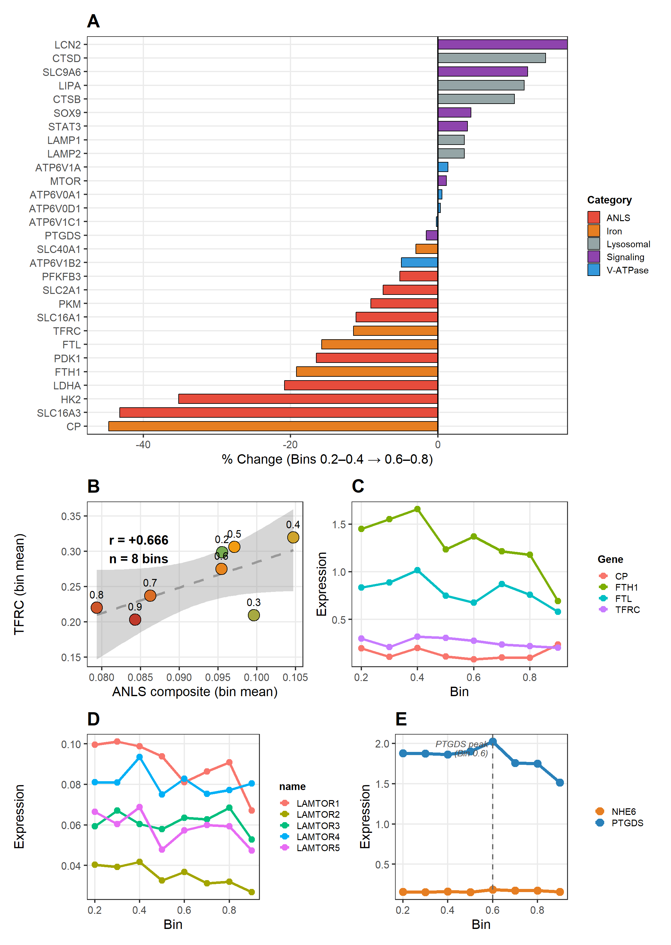
Supplemental Figure 1 | Astrocyte transcriptomic dissociation context. (A) Comprehensive gene expression changes (Bins 0.2–0.4 to 0.6–0.8) across 29 selected key genes grouped by functional category. (B) TFRC–ANLS coupling at the bin level (r = +0.666). (C) Iron gene trajectories (TFRC, FTH1, FTL, CP) showing directionally consistent co-decline with ANLS. (D) Ragulator subunit trajectories (LAMTOR1, LAMTOR2, LAMTOR3, LAMTOR4, LAMTOR5) showing parallel decline. (E) NHE6 (SLC9A6) and PTGDS dynamics with PTGDS compensatory peak annotated at Bin 0.6.

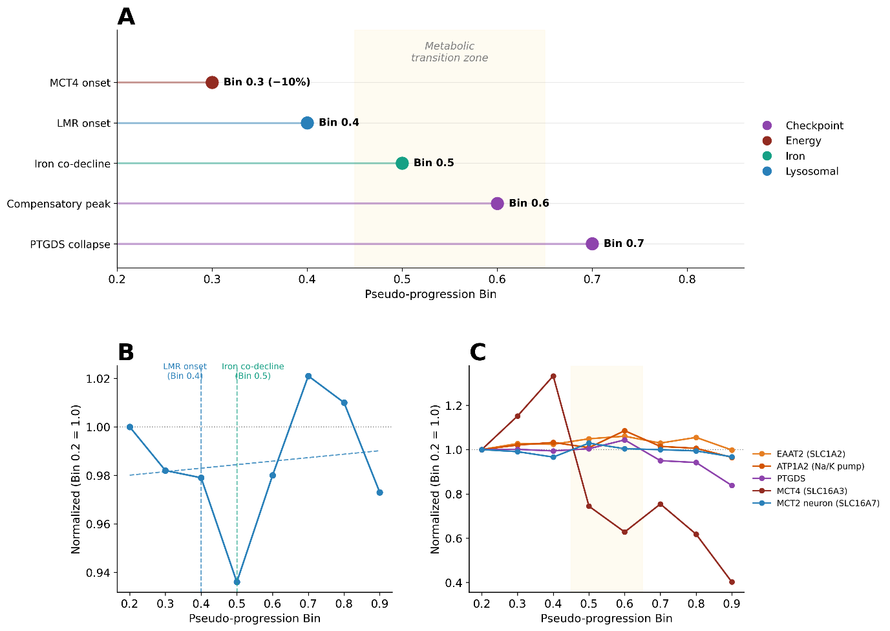
Supplemental Figure 2 | Temporal ordering and donor-level CPS-independent coupling. (A) Event timeline showing sequential ordering: MCT4 decline onset (Bin 0.3) precedes LMR decline (Bin 0.4), and iron-gene co-decline (Bin 0.5); the PTGDS/EAAT2/ATP1A2 compensatory peak (Bin 0.6) is followed by PTGDS collapse (Bin 0.7). (B) Lysosomal metabolic reserve (LMR) composite trajectory: decline precedes the iron-gene change-point by one pseudo-progression bin. (C) PTGDS, EAAT2, and ATP1A2 compensatory peak at Bin 0.6 within the metabolic transition zone (shaded), marking the metabolic overload checkpoint.
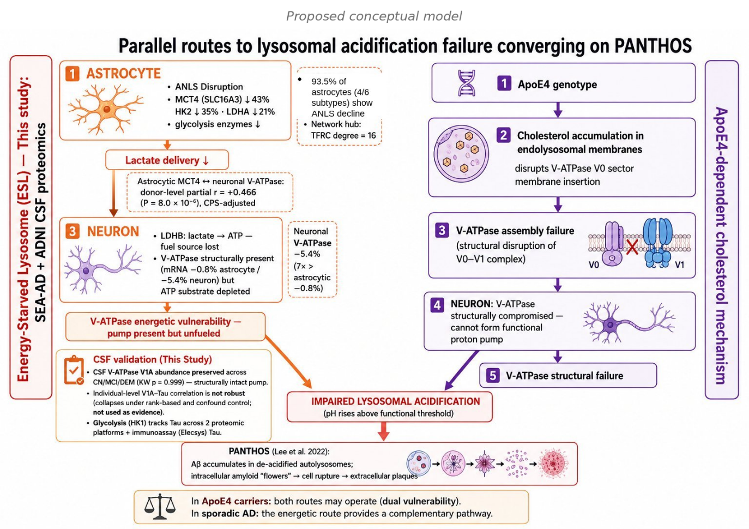
Supplemental Figure 3 | Parallel routes to lysosomal acidification failure. Left: the energetic route identified in this study — astrocytic ANLS disruption reduces lactate delivery to neurons, potentially limiting V-ATPase ATP supply despite preserved pump expression ('energy-starved lysosome'). Right: the structural route described by Lee et al. — ApoE4-dependent cholesterol accumulation disrupts V-ATPase assembly. Both routes converge on impaired lysosomal acidification and PANTHOS. In ApoE4 carriers, both mechanisms may operate simultaneously; in sporadic AD, the energetic route may provide a complementary pathway. Key statistics from this study annotated.

Supporting Data Values: Astrocyte gene expression values across pseudo-progression bins for all 179 genes. These data are also provided as a separate Excel file (Supporting Data Values).
Gene | Category | Bins 0.2–0.4 | Bins 0.6–0.8 | % Change
SLC16A3 (MCT4) | ANLS | 0.0633 | 0.0360 | -43.2%
HK2 | ANLS | 0.0726 | 0.0470 | -35.2%
LDHA | ANLS | 0.1053 | 0.0834 | -20.8%
SLC16A1 (MCT1) | ANLS | 0.0645 | 0.0573 | -11.1%
SLC2A1 (GLUT1) | ANLS | 0.1301 | 0.1204 | -7.4%
V-ATPase (10 sub.) | V-ATPase | 0.2978 | 0.2954 | -0.8%
LAMP1 | Lysosomal | 0.160 | 0.166 | +3.6%
CTSB | Lysosomal | 0.092 | 0.102 | +10.4%
TFRC | Iron | 0.2757 | 0.2441 | -11.5%
FTH1 | Iron | 1.553 | 1.254 | -19.2%
CP | Iron | 0.167 | 0.093 | -44.7%
SLC9A6 (NHE6) | pH reg. | 0.158 | 0.177 | +12.2%
Note: Bins 0.2–0.4 = early pseudo-progression; Bins 0.6–0.8 = late pseudo-progression. Bin 0.1 excluded due to extreme subtype dominance (Astro_6-SEAAD 54.1%, Astro_3 31.1%; combined 85.2%); sensitivity analysis including Bin 0.1 confirmed all primary findings (Supplemental Table 1). Values are mean log-normalized expression across n = 67,419 astrocytes.

Supplemental Table 1. Complete partial correlation analyses and Bin 0.1 sensitivity analyses (transcriptomic) at bin and donor levels.
Part A: Donor-level partial correlations (CPS-adjusted, n = 84)
Level | Astro marker | Neuron marker | Zero-order r | p | Partial r (CPS-adj) | Partial p | Change (%) | Interpretation
Donor (n=84) | MCT4 | V-ATPase | +0.533 | 1.9×10⁻⁷ | +0.466 | 8.0×10⁻⁶ | −12.5% | Survives CPS
Donor (n=84) | MCT4 | LAMP1 | +0.578 | 8.8×10⁻⁹ | +0.495 | 1.7×10⁻⁶ | −14.3% | Survives CPS
Donor (n=84) | MCT4 | LDHB | +0.438 | 3.1×10⁻⁵ | +0.407 | 1.2×10⁻⁴ | −7.1% | Survives CPS
Donor (n=84) | ANLS | V-ATPase | +0.356 | 8.9×10⁻⁴ | +0.305 | 4.8×10⁻³ | −14.3% | Attenuated
Note: Bin-level (trajectory) correlations across nine pseudo-progression bins are CPS-confounded and reported as secondary; the primary, between-donor cross-cellular statistics (true donor-level, n = 84; MCT4-V-ATPase partial r = +0.466, MCT4-LAMP1 +0.495, MCT4-LDHB +0.407) are given in Table 1. Partial correlations regress each variable on the CPS proxy and correlate residuals. ***p < 0.001, **p < 0.01, *p < 0.05.

Part B: Bin 0.1 sensitivity analysis
Analysis item | Primary (Bin 0.1 excluded, n = 8) | Sensitivity (Bin 0.1 included, n = 9) | Direction preserved?
MCT4 slope (β) | −1.036 (p = 0.011) | −0.727 (p = 0.016) | Yes ✓
V-ATPase slope (β) | −0.044 (p = 0.244, n.s.) | −0.168 (p = 0.073, n.s.) | Yes ✓
Δslope MCT4 vs V-ATPase (p) | p = 0.0005 | p = 0.0217 | Yes ✓
MCT4 % change (early→late) | −43.2% | −61.5%* | Consistent
V-ATPase % change (early→late) | −0.8% | −8.8% | Preserved
Bin 0.1 subtype composition | — | Astro_6-SEAAD 54.1% Astro_3 31.1% (combined 85.2%) | Leverage point confirmed
Note: Comparison of primary analysis (Bins 0.2–0.9, n = 8) versus sensitivity analysis including Bin 0.1 (n = 9). All primary findings were directionally preserved; the donor-level cross-cellular coupling was unaffected by this exclusion. The extreme subtype dominance in Bin 0.1 (Astro_6-SEAAD 54.1%, Astro_3 31.1%; combined 85.2%) confirms the rationale for conservative exclusion in the primary analysis. * The larger MCT4 % change with Bin 0.1 included reflects inflated apparent range due to Astro_6-SEAAD dominance — precisely the leverage effect motivating exclusion. n.s. = non-significant.

