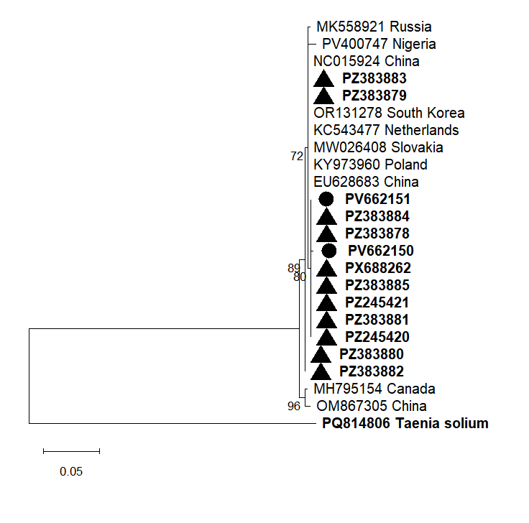
Supplementary Figure S1. The phylogenetic tree shows relationships among Baylisascaris transfuga isolates from Erzurum and reference B. transfuga isolates, based on COXI gene sequences. The branching structure was assessed using a bootstrap test with 1,000 replicates. Bootstrap values are shown at the base of each branch. Taenia solium served as the outgroup. Erzurum B. transfuga isolates obtained from adult parasites are indicated by solid circles (●), and those obtained from feces by solid triangles (▲).
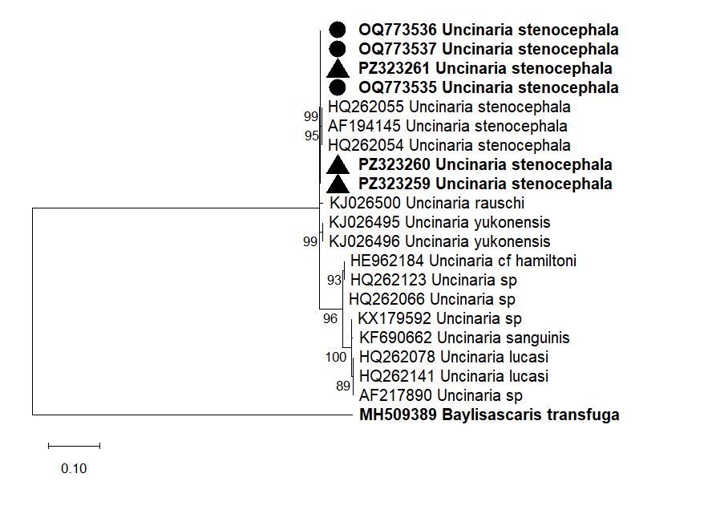
Supplementary Figure S2. The phylogenetic tree shows relationships among Uncinaria stenocephala isolates from Erzurum and reference U. stenocephala isolates, based on ITS1 gene sequences. Branching structure was assessed using a bootstrap test with 1,000 replicates. Bootstrap values are shown at the base of each branch. Baylisascaris transfuga served as the outgroup. Erzurum U. stenocephala isolates obtained from adult parasites are indicated by solid circles (●), obtained from feces by solid triangles (▲).

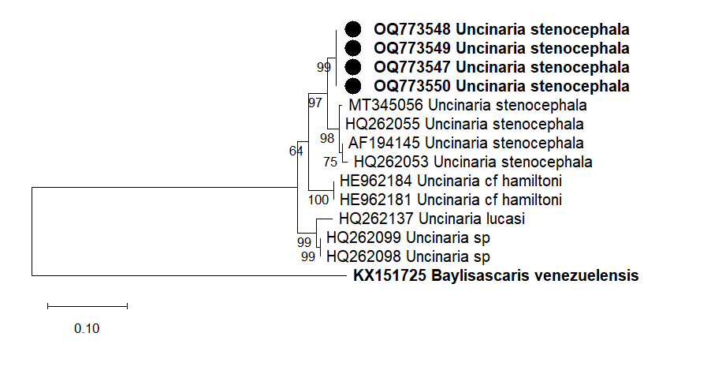
Supplementary Figure S3. The phylogenetic tree shows relationships among Uncinaria stenocephala isolates from Erzurum and reference U. stenocephala isolates, based on ITS2 gene sequences. Branching structure was assessed using a bootstrap test with 1,000 replicates. Bootstrap values are shown at the base of each branch. Baylisascaris venezuelensis served as the outgroup. Erzurum U. stenocephala isolates are indicated by solid circles (●).

