Pseudohaptic Social Touch Enhances Social Connection and Physiological Regulation in Virtual Reality

Authors
Irene Valori*, Giulia Anilia Gambaretti, John Desnoyers-Stewart, Ekaterina R. Stepanova, Bernhard E. Riecke, Merle T. Fairhurst
*Centre for Tactile Internet with Human-in-the-Loop (CeTI), Chair for Social Affective Touch, Technische Universität Dresden, Dresden, Germany, irene.valori@tu-dresden.de

Supplementary Materials

Here we report descriptive statistics for all dependent variables, and output of statistical models.
- Interpersonal comfort distance (IPD)
Descriptive statistics of IPD for each combination of Phase (Pre vs Post) and Partner (Experimenter vs Friend) are reported in Table S1. Below is the detailed output of the statistical model applied to IPD.
Table S1: Descriptive statistics of IPD. Mean (SD).
Phase | Partner | IPD
PRE | Experimenter | 54.0 (29.8)
POST | Experimenter | 46.5 (22.0)
PRE | Friend | 31.5 (20.8)
POST | Friend | 30.2 (18.4)

Analysis of Deviance Table (Type III Wald chisquare tests)

Response: IPD
Chisq Df Pr(>Chisq)
(Intercept) 5902.0095 1 < 2.2e-16 ***
Phase 7.0960 1 0.007726 **
Partner 103.6868 1 < 2.2e-16 ***
Phase:Partner 1.6908 1 0.193500
---
Signif. codes:
0 ‘***’ 0.001 ‘**’ 0.01 ‘*’ 0.05 ‘.’ 0.1 ‘ ’ 1

- Subjective experience and individual differences
A graphical visualisation of subjective responses to the virtual experience is presented in Figure S1. Table S2 reports means and SDs of all variables in each Block. Below is the detailed output of the statistical models.
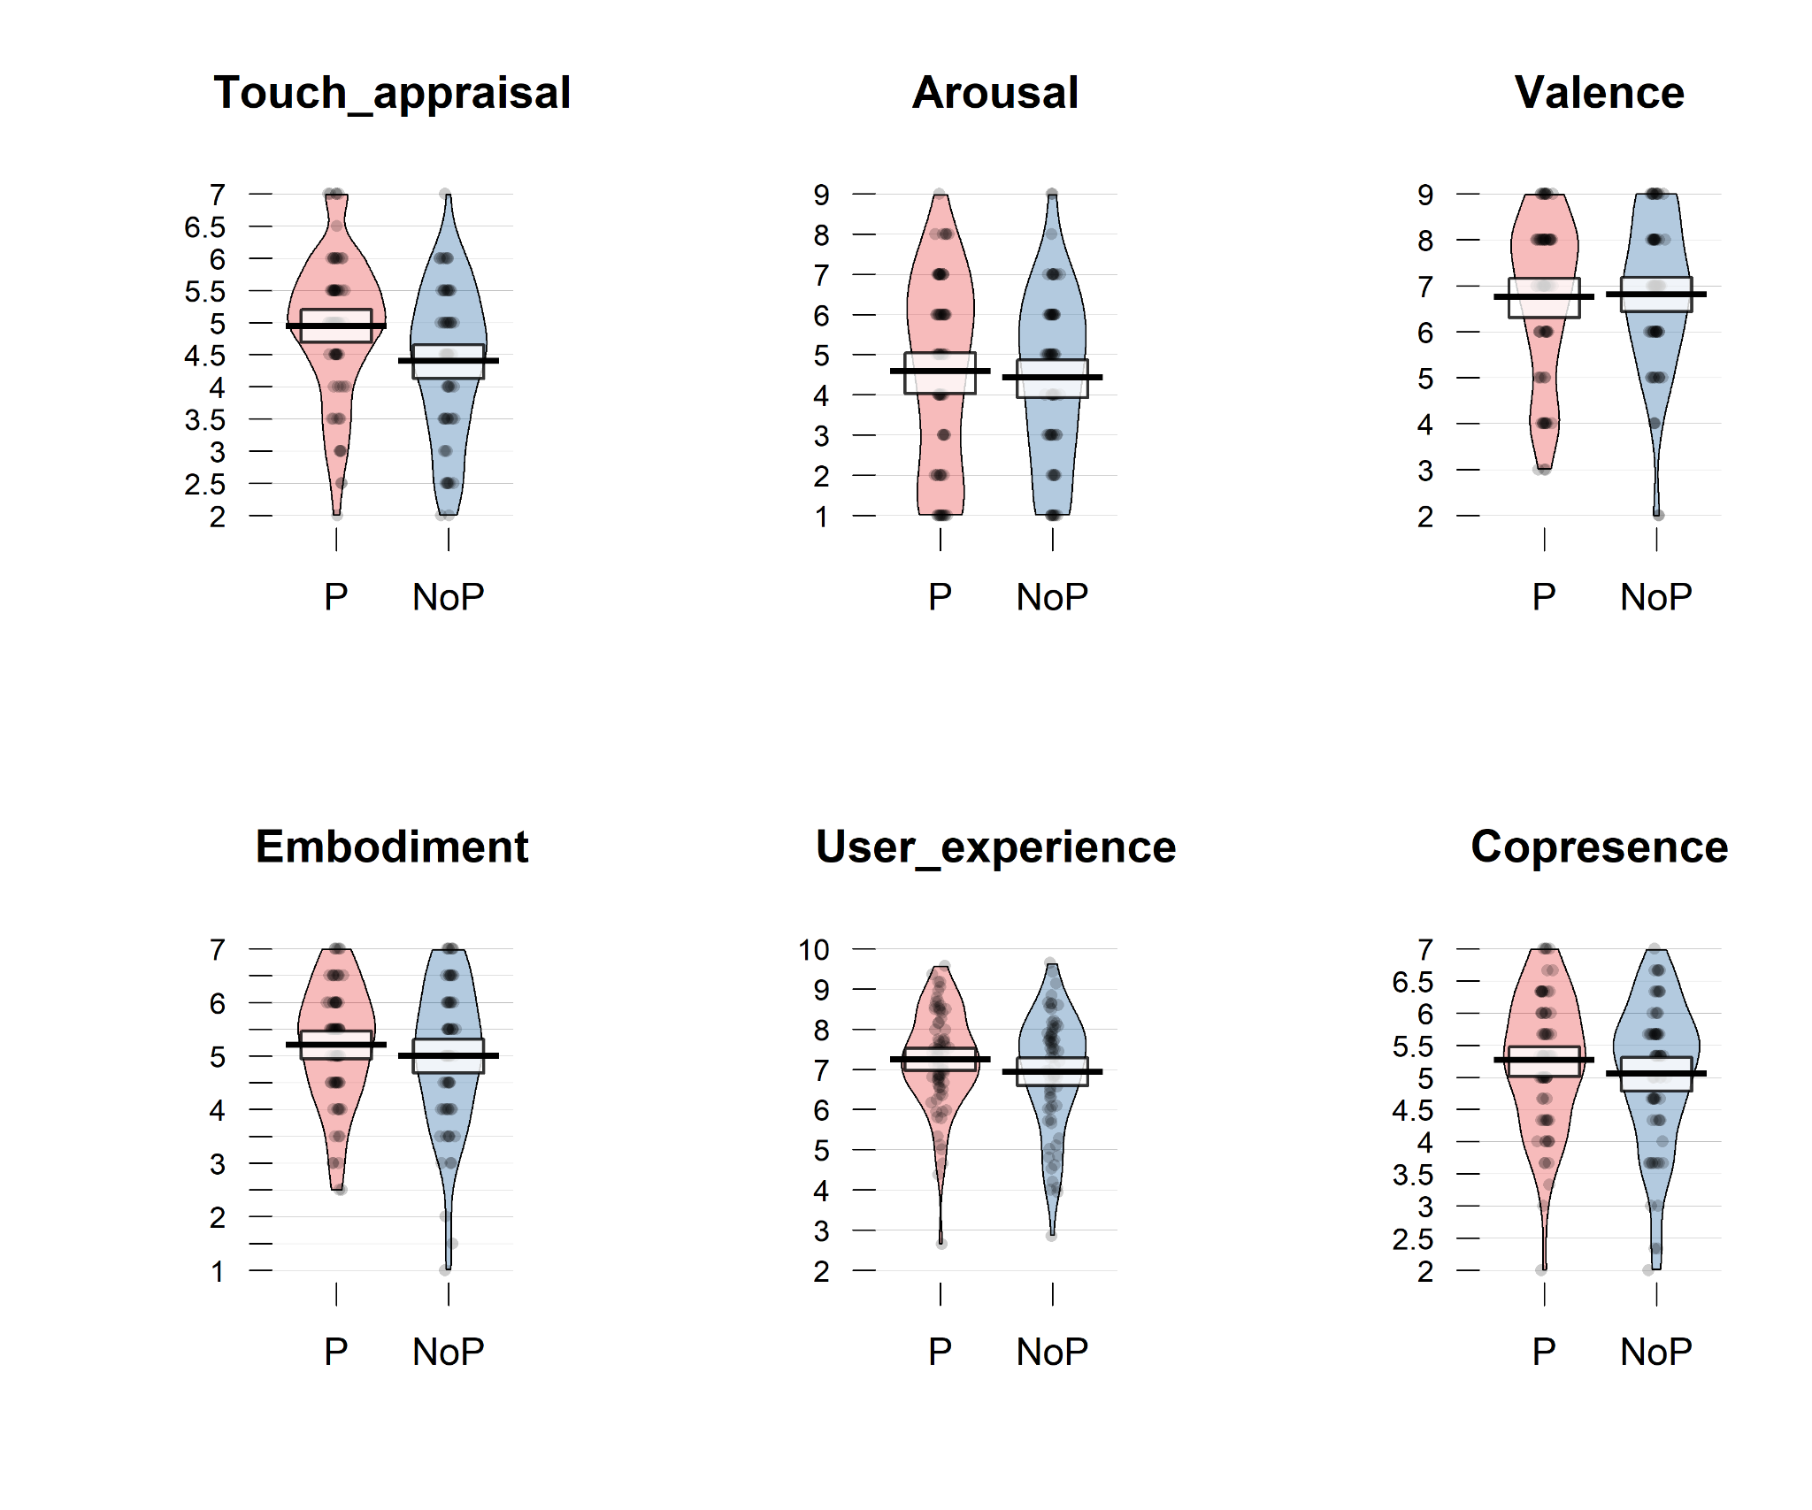Figure S1. Subjective experience of virtual exchanges. Pirate-plots illustrating the distribution of each outcome variable as a function of Block. Raw data points and density distribution, with horizontal lines indicating the group mean and boxes representing 95% confidence intervals.
Table S2: Descriptive statistics of self-report measures. Mean (SD).
Block | Touch_appraisal | Arousal | Valence | Embodiment | User_experience | Copresence
Pseudohaptics | 4.9 (1.1) | 4.6 (2.3) | 6.8 (1.7) | 5.2 (1.1) | 7.2 (1.2) | 5.3 (1.0)
NoPseudohaptics | 4.4 (1.1) | 4.4 (2.1) | 6.8 (1.6) | 5.0 (1.3) | 6.9 (1.4) | 5.1 (1.1)

- Touch appraisal
$Touch_appraisal
Analysis of Deviance Table (Type III Wald chisquare tests)

Response: Touch_appraisal
Chisq Df Pr(>Chisq)
(Intercept) 1221.1003 1 < 2.2e-16 ***
Block 8.0978 1 0.004432 **
MAIA 0.5829 1 0.445165
AIT 0.0067 1 0.934885
IOS 0.3474 1 0.555590
Block:MAIA 0.0122 1 0.912195
Block:AIT 0.2674 1 0.605071
Block:IOS 0.0592 1 0.807702
---
Signif. codes:
0 ‘***’ 0.001 ‘**’ 0.01 ‘*’ 0.05 ‘.’ 0.1 ‘ ’ 1
- Arousal
$Arousal
Analysis of Deviance Table (Type III Wald chisquare tests)

Response: Arousal
Chisq Df Pr(>Chisq)
(Intercept) 276.2788 1 < 2e-16 ***
Block 0.3898 1 0.53238
MAIA 0.8436 1 0.35838
AIT 1.5259 1 0.21672
IOS 0.8763 1 0.34922
Block:MAIA 0.5525 1 0.45730
Block:AIT 2.7153 1 0.09939 .
Block:IOS 4.7912 1 0.02861 *
---
Signif. codes:
0 ‘***’ 0.001 ‘**’ 0.01 ‘*’ 0.05 ‘.’ 0.1 ‘ ’ 1

- Valence
$Valence
Analysis of Deviance Table (Type III Wald chisquare tests)

Response: Valence
Chisq Df Pr(>Chisq)
(Intercept) 973.4975 1 < 2e-16 ***
Block 0.0453 1 0.83140
MAIA 0.3334 1 0.56365
AIT 0.3106 1 0.57731
IOS 0.3352 1 0.56264
Block:MAIA 3.2449 1 0.07165 .
Block:AIT 0.0167 1 0.89728
Block:IOS 0.3842 1 0.53536
---
Signif. codes:
0 ‘***’ 0.001 ‘**’ 0.01 ‘*’ 0.05 ‘.’ 0.1 ‘ ’ 1

- Embodiment
$Embodiment
Analysis of Deviance Table (Type III Wald chisquare tests)

Response: Embodiment
Chisq Df Pr(>Chisq)
(Intercept) 1118.5068 1 < 2e-16 ***
Block 0.1560 1 0.69284
MAIA 1.9525 1 0.16232
AIT 3.8037 1 0.05114 .
IOS 0.0219 1 0.88240
Block:MAIA 1.9143 1 0.16649
Block:AIT 0.7327 1 0.39200
Block:IOS 1.5030 1 0.22022
---
Signif. codes:
0 ‘***’ 0.001 ‘**’ 0.01 ‘*’ 0.05 ‘.’ 0.1 ‘ ’ 1

- User experience
$User_experience
Analysis of Deviance Table (Type III Wald chisquare tests)

Response: User_experience
Chisq Df Pr(>Chisq)
(Intercept) 1985.2001 1 <2e-16 ***
Block 2.1385 1 0.1436
MAIA 0.0559 1 0.8131
AIT 0.5585 1 0.4549
IOS 0.0025 1 0.9599
Block:MAIA 0.2366 1 0.6267
Block:AIT 1.1072 1 0.2927
Block:IOS 0.0114 1 0.9151
---
Signif. codes:
0 ‘***’ 0.001 ‘**’ 0.01 ‘*’ 0.05 ‘.’ 0.1 ‘ ’ 1

- Copresence
$Copresence
Analysis of Deviance Table (Type III Wald chisquare tests)

Response: Copresence
Chisq Df Pr(>Chisq)
(Intercept) 1775.8149 1 < 2e-16 ***
Block 1.8424 1 0.17467
MAIA 1.7119 1 0.19074
AIT 3.5015 1 0.06131 .
IOS 0.7766 1 0.37819
Block:MAIA 6.4274 1 0.01124 *
Block:AIT 0.0229 1 0.87968
Block:IOS 4.1795 1 0.04092 *
---
Signif. codes:
0 ‘***’ 0.001 ‘**’ 0.01 ‘*’ 0.05 ‘.’ 0.1 ‘ ’ 1

2.1. Spotlight on participants with lower IOS and MAIA
To delve deeper into the significant interaction effects, we further examined the effect of Block on Arousal and Copresence in participants with lower IOS (< -1) and lower MAIA (< -1). Below the specification of 3 additional models, and the results of Type II Wald chisquare tests.
.
- lmer(Arousal ~ Block + (1 | ID), data = participants with lower IOS
Response: Arousal
Chisq Df Pr(>Chisq)
Block 22.349 1 2.273e-06 ***
---
Signif. codes:
0 ‘***’ 0.001 ‘**’ 0.01 ‘*’ 0.05 ‘.’ 0.1 ‘ ’ 1

- lmer(Copresence ~ Block + (1 | ID), data = participants with lower IOS
Response: Copresence
Chisq Df Pr(>Chisq)
Block 1.9685 1 0.1606

- lmer(Copresence ~ Block + (1 | ID), data = participants with lower MAIA
Analysis of Deviance Table (Type II Wald chisquare tests)

Response: Copresence
Chisq Df Pr(>Chisq)
Block 2.4587 1 0.1169

2.2. Post-hoc power analysis
A post-hoc power analysis was performed on the Touch appraisal test using the “pwr” package (Champely, 2020). Effect size w was computed from the chi-square value using the formula below (Cohen, 2013). The estimated power of the test on Touch appraisal, given an alpha level of 0.05, 68 participants, and a chi-square value of 8.097 (df = 1) resulting in effect size w = 0.345, was approximately 0.81, indicating an 80% probability of detecting an effect of this size with the current sample.
$$w = \sqrt{\frac{χ²}{n}}$$

- Physiological activity
Descriptive statistics (raw mean and SD) of cardiac indices for each combination of Block and Trial are reported in Table S3. Below the detailed output of the GAMM models. Raw means are reported for descriptive purposes, whereas estimated marginal means from the GAMM reflect effects adjusted for temporal smooths, random effects, and autocorrelation. Therefore, slight discrepancies between raw and model-based estimates are plausible.

Table S3. Descriptive statistics of cardiac indices. Mean (SD).

Block | Trial | Heart Rate | RMSSD | Stress index
Pseudohaptics | No_touch | 89.08 (12.38) | 24.29 (16.85) | 17.57 (7.2)
Pseudohaptics | Touch | 88.87 (12.11) | 23.65 (15.68) | 17.9 (7.4)
No-pseudohaptics | No_touch | 90.18 (13.08) | 22.47 (12.1) | 18.12 (7.81)
No-pseudohaptics | Touch | 89.97 (13.03) | 22.21 (12.37) | 18.3 (7.6)

- Heart Rate
Family: gaussian
Link function: identity

Formula:
Mean_HR ~ Block * Trial + s(Time_norm, by = Block, k = 20, bs = "cr") +
s(Time_norm, by = Trial, k = 20, bs = "cr") + s(ID, Block,
bs = "re") + s(ID, Trial, bs = "re") + s(Time_norm, ID, bs = "fs",
k = 5, m = 1) + s(Block_Order, bs = "re")

Parametric Coefficients
Term | Estimate | Std. Error | t value | p-value
(Intercept) | 89.7651 | 1.8090 | 49.622 | < 2e-16 ***
BlockNo-pseudohaptics | -0.6533 | 0.5384 | -1.214 | 0.225
TrialTouch | -1.6283 | 0.1769 | -9.207 | < 2e-16 ***
BlockNo-pseudohaptics:TrialTouch | 2.8156 | 0.1412 | 19.940 | < 2e-16 ***

Approximate Significance of Smooth Terms
Term | edf | Ref.df | F | p-value
s(Time_norm):BlockPseudohaptics | 1.039e+00 | 1.652 | 0.622 | 0.499
s(Time_norm):BlockNo-pseudohaptics | 2.224e+00 | 2.928 | 0.892 | 0.458
s(Time_norm):TrialNo-touch | 1.001e+00 | 1.002 | 0.663 | 0.416
s(Time_norm):TrialTouch | 1.634e+01 | 18.331 | 34.237 | < 2e-16 ***
s(ID,Block) | 4.657e+01 | 94.000 | 91.112 | < 2e-16 ***
s(ID,Trial) | 3.302e+01 | 94.000 | 31.321 | < 2e-16 ***
s(Time_norm,ID) | 2.163e+02 | 239.000 | 9578.339 | < 2e-16 ***
s(Block_Order) | 5.470e-05 | 1.000 | 0.000 | 0.101

Signif. codes:
0 ‘***’ 0.001 ‘**’ 0.01 ‘*’ 0.05 ‘.’ 0.1 ‘ ’ 1

Rank: 513/514
R-sq.(adj) = 0.96 Deviance explained = 96%
fREML = -4322 Scale est. = 2.2858 n = 32164

Post-hoc contrasts
$emmeans
Block = Pseudohaptics:
Trial emmean SE df lower.CL upper.CL
No-touch 89.8 1.81 31844 86.2 93.3
Touch 87.9 1.81 31844 84.3 91.4

Block = No-pseudohaptics:
Trial emmean SE df lower.CL upper.CL
No-touch 89.1 1.81 31844 85.6 92.7
Touch 90.1 1.81 31844 86.5 93.6

Confidence level used: 0.95

$contrasts
Block = Pseudohaptics:
contrast estimate SE df t.ratio p.value
(No-touch) - Touch 1.883 0.179 31844 10.525 <.0001

Block = No-pseudohaptics:
contrast estimate SE df t.ratio p.value
(No-touch) - Touch -0.933 0.183 31844 -5.087 <.0001

- Heart Rate Variability (RMSSD)
Family: gaussian
Link function: identity

Formula:
log_RMSSD ~ Block * Trial + s(Time_norm, by = Block, k = 20,
bs = "cr") + s(Time_norm, by = Trial, k = 20, bs = "cr") +
s(ID, Block, bs = "re") + s(ID, Trial, bs = "re") + s(Time_norm,
ID, bs = "fs", k = 5, m = 1) + s(Block_Order, bs = "re")

Parametric Coefficients
Term | Estimate | Std. Error | t value | p-value
(Intercept) | 3.004069 | 0.081992 | 36.639 | <2e-16 ***
BlockNo-pseudohaptics | -0.026710 | 0.034629 | -0.771 | 0.441
TrialTouch | -0.008221 | 0.016653 | -0.494 | 0.622
BlockNo-pseudohaptics:TrialTouch | -0.007346 | 0.022920 | -0.320 | 0.749

Approximate Significance of Smooth Terms
Term | edf | Ref.df | F | p-value
s(Time_norm):BlockPseudohaptics | 1.000e+00 | 1.00 | 12.896 | 0.000329 ***
s(Time_norm):BlockNo-pseudohaptics | 1.000e+00 | 1.00 | 8.908 | 0.002839 **
s(Time_norm):TrialNo-touch | 1.000e+00 | 1.00 | 22.365 | 2.22e-06 ***
s(Time_norm):TrialTouch | 9.210e+00 | 12.33 | 4.343 | 3.21e-06 ***
s(ID,Block) | 4.146e+01 | 93.00 | 3.852 | 8.38e-06 ***
s(ID,Trial) | 1.703e-04 | 94.00 | 0.000 | 1.000000
s(Time_norm,ID) | 1.743e+02 | 239.00 | 227.951 | < 2e-16 ***
s(Block_Order) | 7.976e-01 | 1.00 | 203.396 | 0.026174 *

Signif. codes:
0 ‘***’ 0.001 ‘**’ 0.01 ‘*’ 0.05 ‘.’ 0.1 ‘ ’ 1
Rank: 513/514
R-sq.(adj) = 0.832 Deviance explained = 83.3%
fREML = -60975 Scale est. = 0.037042 n = 31803

- Stress Index
Family: gaussian
Link function: identity

Formula:
Stress_index ~ Block * Trial + s(Time_norm, by = Block, k = 20,
bs = "cr") + s(Time_norm, by = Trial, k = 20, bs = "cr") +
s(ID, Block, bs = "re") + s(ID, Trial, bs = "re") + s(Time_norm,
ID, bs = "fs", k = 5, m = 1) + s(Block_Order, bs = "re")

Parametric Coefficients
Term | Estimate | Std. Error | t value | p-value
(Intercept) | 17.80171 | 1.01321 | 17.570 | <2e-16 ***
BlockNo-pseudohaptics | 0.30494 | 0.43200 | 0.706 | 0.480
TrialTouch | 0.17639 | 0.27625 | 0.639 | 0.523
BlockNo-pseudohaptics:TrialTouch | 0.09816 | 0.38096 | 0.258 | 0.797

Approximate Significance of Smooth Terms
Term | edf | Ref.df | F | p-value
s(Time_norm):BlockPseudohaptics | 6.000e+00 | 8.130 | 1.827 | 0.06400
s(Time_norm):BlockNo-pseudohaptics | 1.001e+00 | 1.001 | 0.065 | 0.79927
s(Time_norm):TrialNo-touch | 1.000e+00 | 1.001 | 6.002 | 0.01428 *
s(Time_norm):TrialTouch | 8.620e+00 | 11.665 | 2.512 | 0.00292 **
s(ID,Block) | 3.615e+01 | 94.000 | 1.561 | 2.1e-06 ***
s(ID,Trial) | 5.382e-04 | 94.000 | 0.000 | 1.00000
s(Time_norm,ID) | 1.905e+02 | 239.000 | 71.467 | < 2e-16 ***
s(Block_Order) | 7.990e-01 | 1.000 | 53.250 | 0.02570 *

Signif. codes:
0 ‘***’ 0.001 ‘**’ 0.01 ‘*’ 0.05 ‘.’ 0.1 ‘ ’ 1

Rank: 513/514
R-sq.(adj) = 0.709 Deviance explained = 71.1%
fREML = 33535 Scale est. = 10.956 n = 32164

References
Champely, S. (2020). pwr: Basic Functions for Power Analysis. https://doi.org/10.32614/CRAN.package.pwr
Cohen, J. (2013). Statistical power analysis for the behavioral sciences. routledge.

