Pseudohaptic Social Touch Enhances Social Connection and Physiological Regulation in Virtual Reality

Authors
Irene Valori*, Giulia Anilia Gambaretti, John Desnoyers-Stewart, Ekaterina R. Stepanova, Bernhard E. Riecke, Merle T. Fairhurst
*Centre for Tactile Internet with Human-in-the-Loop (CeTI), Chair for Social Affective Touch, Technische Universität Dresden, Dresden, Germany, irene.valori@tu-dresden.de

Appendix A: Questionnaires
Inclusion of the Other in the Self (Gächter et al., 2015)
Which picture best describes your relationship with the friend you are here with?
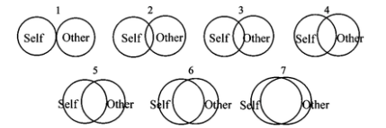
Post-block questionnaires
Affective state (Self-Assessment Mannequin - SAM) (Bradley & Lang, 1994)
How are you feeling right now?
- Arousal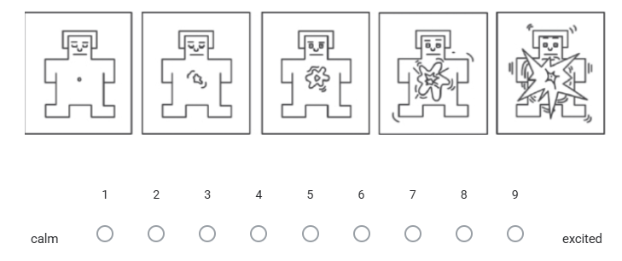
- Valence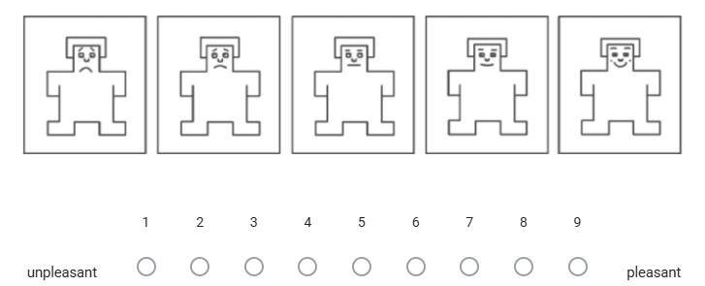

Touch appraisal
Likert scale from 1 (“not at all”) to 7 (“completely”). Adapted from (Sun et al., 2024).
When you touched the virtual body in front of you, how comfortable was this type of touch?
When you touched the virtual body in front of you, how real was this type of touch?
Embodiment
Likert scale from 1 (“not at all”) to 7 (“completely”). Adapted from (Sun et al., 2024).
- Body Ownership
I felt that the virtual body I saw when I looked down was my own body.
- Agency
I felt that the movements of the virtual body I saw when I looked down were caused by my own movements.
Co-Presence
Likert scale from 1 (“not at all”) to 7 (“completely”). Adapted from (Sun et al., 2024).
The movements of the virtual body in front of me were realistic.
The virtual body in front of me acted like a real person.
The interaction with the virtual body in front of me was pleasant.
User experience. User eXperience in Immersive Virtual Environment, adapted from (Tcha-Tokey et al., 2018), Likert scale from 1 (“strongly disagree”) to 10 (“strongly agree”):

- Engagement
The visual aspects of the virtual environment engaged me.
The sense of moving around inside the virtual environment was compelling.
I was involved in the virtual environment experience.
- Immersion
I felt stimulated by the virtual environment.
I became so involved in the virtual environment that I was not aware of things happening around me.
I identified with the character I played in the virtual environment.
Physically, I felt well in the virtual environment.
I became so involved in the virtual environment that I lost track of time.
- Flow
I felt I could perfectly control my actions.
I felt I controlled the situation.
Time seemed to flow differently than usual.
Time seemed to speed up.
I was losing the sense of time.
I was not worried about other people's judgement.
I was not worried about what other people would think of me.
I felt I was experiencing an exciting moment.
This experience was giving me a great sense of well-being.
When I think about the experience in the virtual environment, I feel emotions I would like to share.

References
Bradley, M. M., & Lang, P. J. (1994). Measuring emotion: The self-assessment manikin and the semantic differential. Journal of Behavior Therapy and Experimental Psychiatry, 25(1), 49–59. https://doi.org/10.1016/0005-7916(94)90063-9
Gächter, S., Starmer, C., & Tufano, F. (2015). Measuring the Closeness of Relationships: A Comprehensive Evaluation of the ‘Inclusion of the Other in the Self’ Scale. PLOS ONE, 10(6), e0129478. https://doi.org/10.1371/journal.pone.0129478
Sun, W., Banakou, D., Świdrak, J., Valori, I., Slater, M., & Fairhurst, M. T. (2024). Multisensory experiences of affective touch in virtual reality enhance engagement, body ownership, pleasantness, and arousal modulation. Virtual Reality, 28(4), 162. https://doi.org/10.1007/s10055-024-01056-2
Tcha-Tokey, K., Christmann, O., Loup-Escande, E., Loup, G., & Richir, S. (2018). Towards a Model of User Experience in Immersive Virtual Environments. Advances in Human-Computer Interaction, 2018(1), 7827286. https://doi.org/10.1155/2018/7827286

