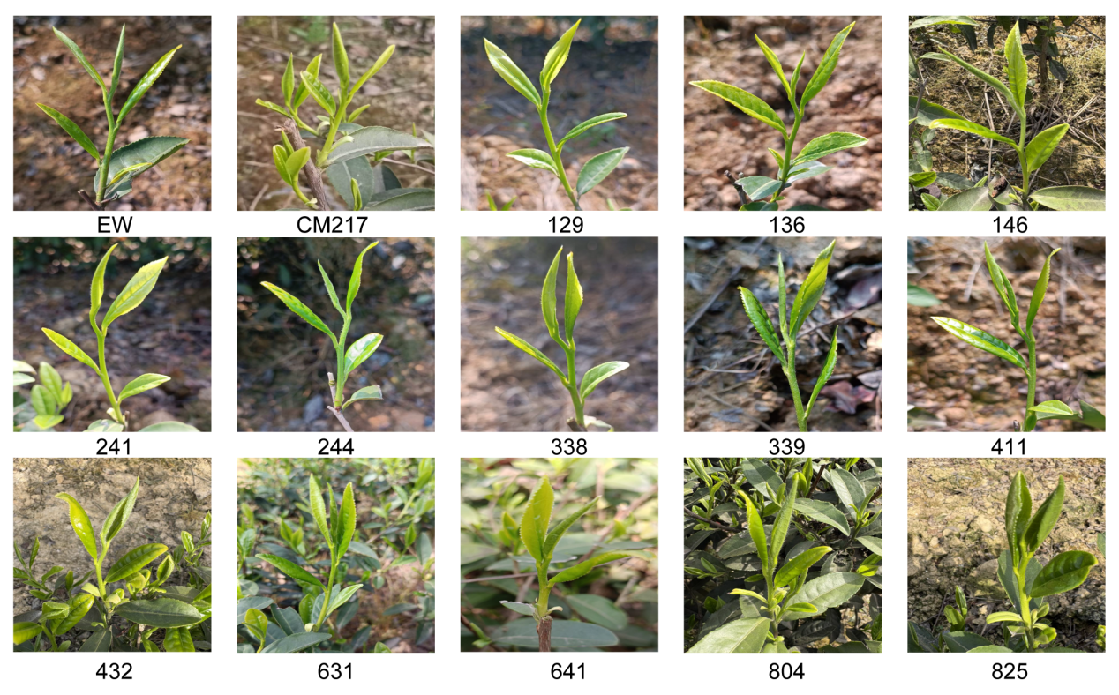Fig.S1 The shoots of parent and different progeny lines in tea plants

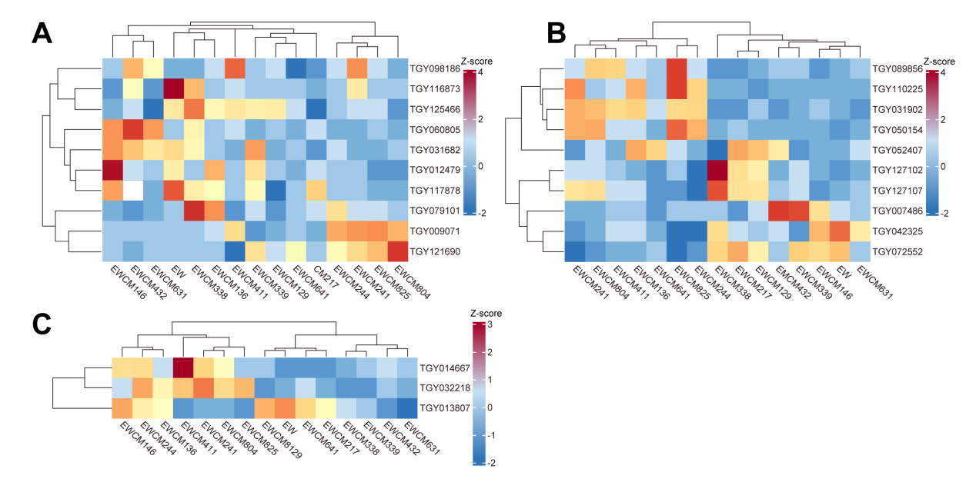Fig. S2 Clustered heatmaps of gene expression profiles for key secondary metabolite pathways in tea plant
(A). catechin pathway genes. (B). caffeine pathway genes. (C). theanine pathway genes. Each heatmap shows expression levels of the indicated genes (Y-axis) across 15 tea accessions (X-axis: two parents and 13 F₁ hybrids). Color gradient (red: high expression; blue: low expression) represents transcript abundance across samples.

