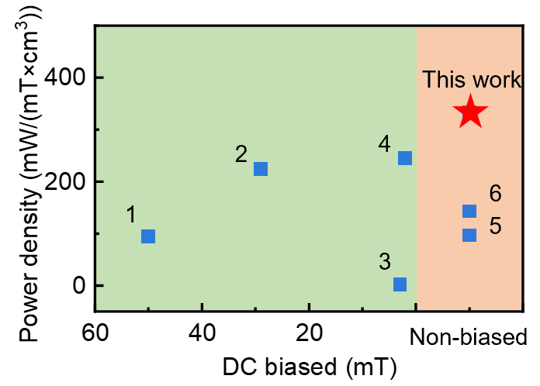
Fig S1. Energy‑harvesting performance of the MAGSuture compared with state‑of‑the‑art systems.
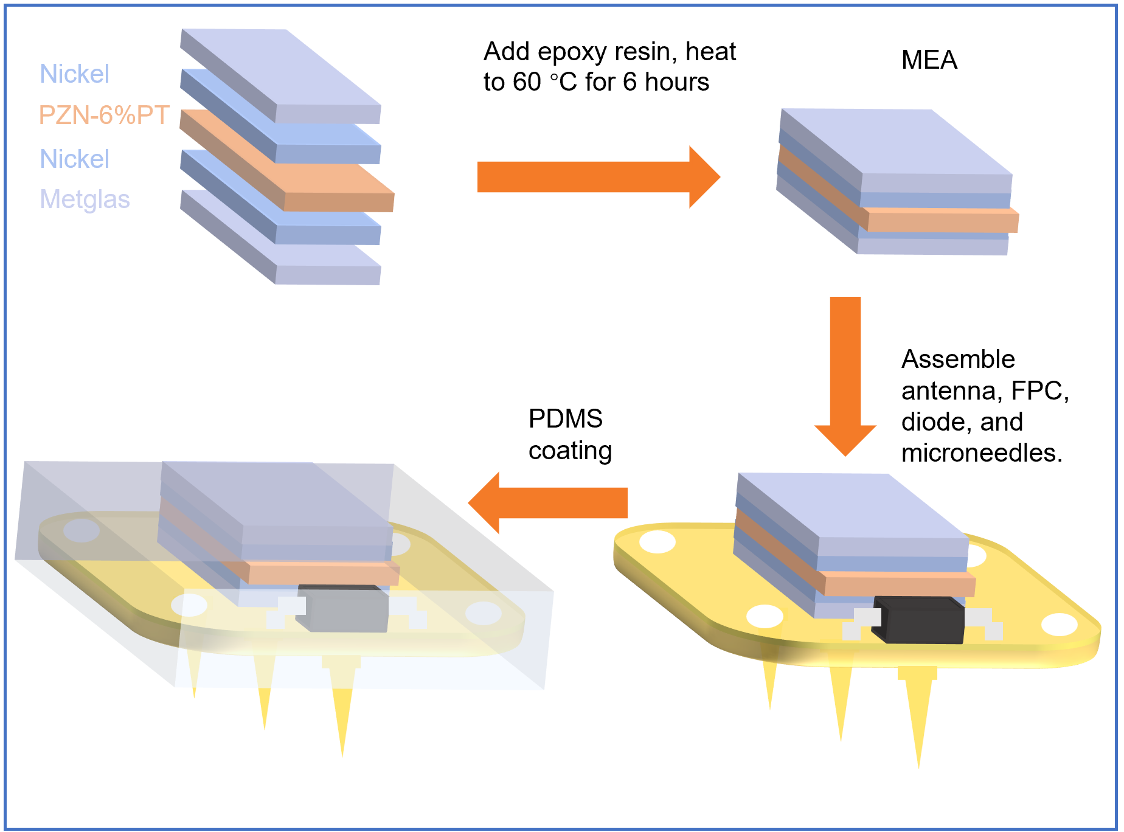
Fig S2. Fabrication process of the stitching magnetoelectric gastrointestinal stimulator.
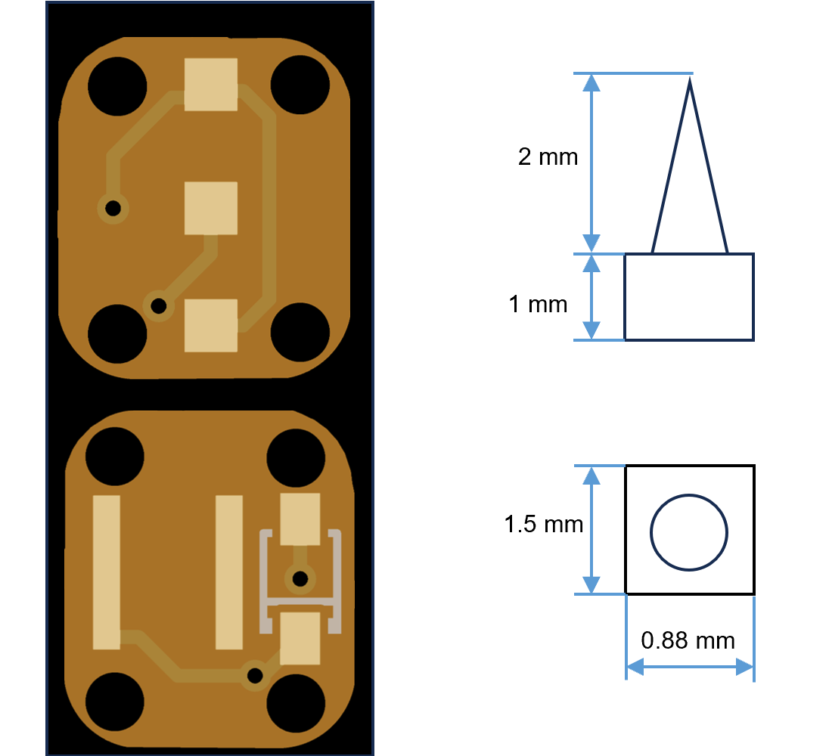
Fig S3. layout of the FPC and size of the microneedle.

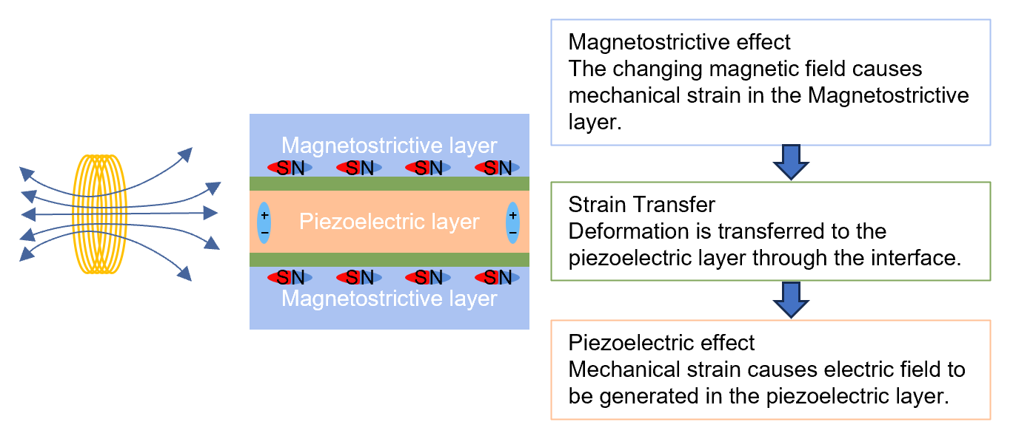
Fig S4. Energy conversion principle.
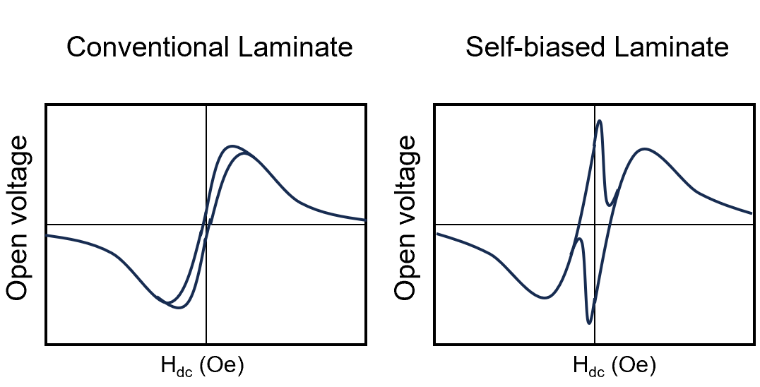
Fig S5. Open voltage as a function of DC magnetic field for conventional and self-biased laminate.

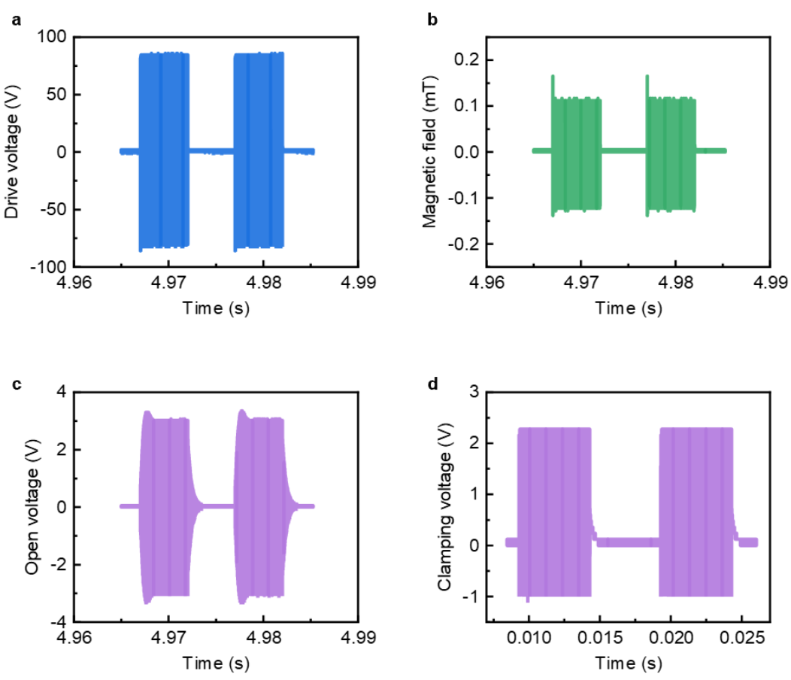
Fig S6. Process of converting alternating magnetic field into direct current stimulation. (a) Driven voltage of the Helmholtz coil. (b) Applied magnetic field. (c) Open voltage of the MEA. (d) Rectified voltage of the MEA.

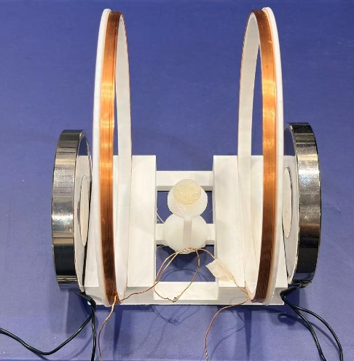
Fig. S7. Optical image of experimental setup.

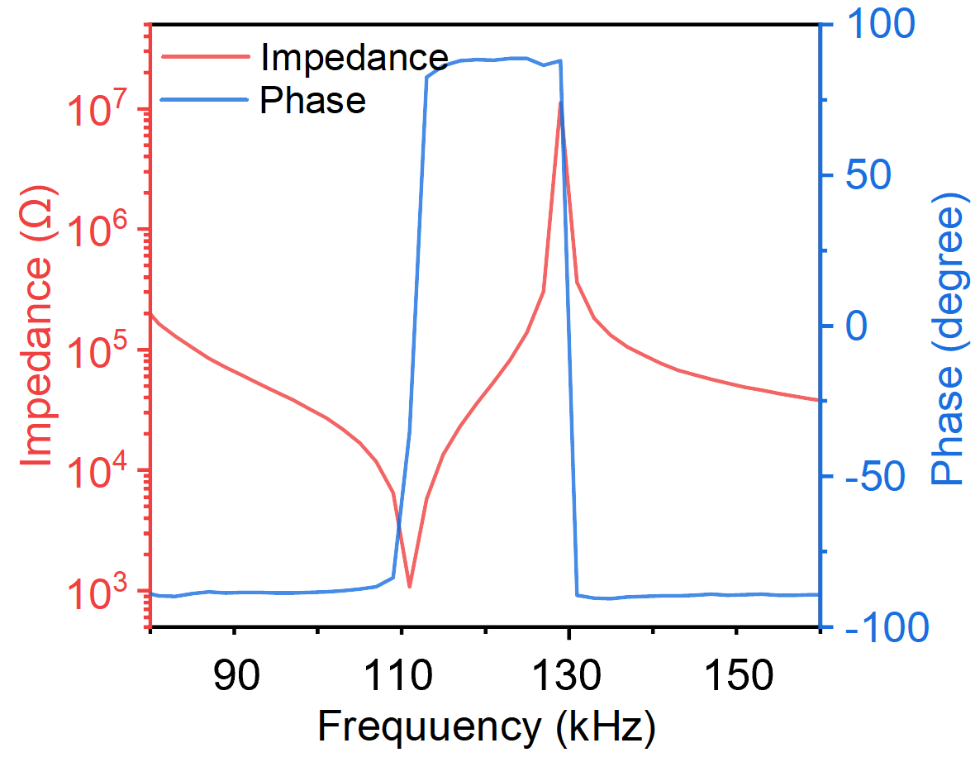
Fig S8. Impedance of the MEA

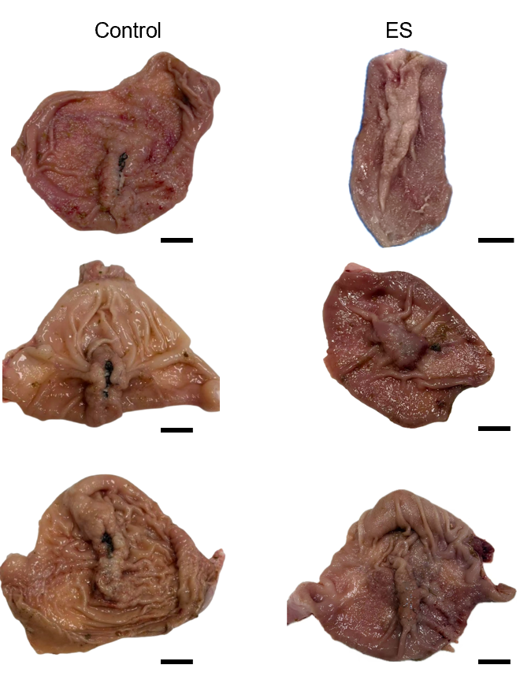
Fig S9. Images of the inner sides of the gastric wound in the control group and the ES group. Scale bar, 5 mm.

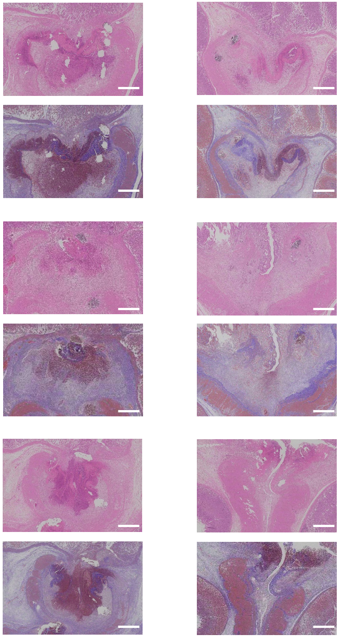
Fig S10. Representative H&E (top) and MT (bottom) staining of the original wound site in the four groups 12 days after treatment. Scale bar, 500 μm

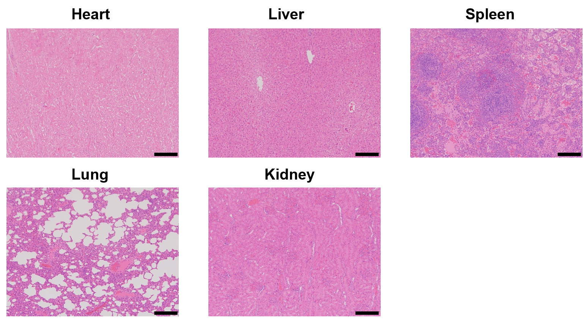
Fig S11. Histological analysis of the in vivo application of MAGSuture. Hematoxylin and eosin (H&E) staining of various visceral organs harvested from a rabbit model with a gastric wound 12 days after ES. Scale bar, 200 μm

