Supplementary methodological appendix

Supplementary Table S1. Operational definitions
Table S1. Variable definitions
Construct | Operational definition | Interpretation
Elevated childbirth fear | Source category = High Fear or Severe Fear | Primary reference classification
Severe childbirth fear | Source category = Severe Fear | Secondary reference classification
GAD broad screen | GAD-7 total >=5 | At least mild general anxiety symptoms
GAD restrictive screen | GAD-7 total >=10 | More clinically restrictive anxiety rule
Broad generic composite | Any of GAD-7 >=5, DASS anxiety above normal, DASS depression above normal, DASS stress above normal | Inclusive analytical rule; not a validated algorithm
Moderate generic composite | Any of GAD-7 >=10 or DASS anxiety/depression/stress moderate or greater | Restrictive analytical rule
Missed case | Reference positive and generic rule negative | Operational coverage gap
FOC-only profile | Elevated childbirth fear and GAD-7 <5 | Discordant childbirth-specific profile
Both-positive profile | Elevated childbirth fear and GAD-7 >=5 | Concordant positive profile
FOC = fear of childbirth; DASS = Depression Anxiety Stress Scales.

Supplementary Table S2. Full selected generic-rule metrics
Table S2. Full classification table for elevated childbirth fear
Rule | Positive n | Positive % | TP | FP | TN | FN | Capture % | Spec. % | PPV % | NPV % | Kappa
GAD-7 >=5 | 234 | 27.4 | 129 | 105 | 294 | 327 | 28.3 | 73.7 | 55.1 | 47.3 | 0.019
GAD-7 >=10 | 72 | 8.4 | 32 | 40 | 359 | 424 | 7.0 | 90.0 | 44.4 | 45.8 | -0.028
DASS anxiety above normal | 169 | 19.8 | 94 | 75 | 324 | 362 | 20.6 | 81.2 | 55.6 | 47.2 | 0.017
DASS depression above normal | 82 | 9.6 | 38 | 44 | 355 | 418 | 8.3 | 89.0 | 46.3 | 45.9 | -0.025
DASS stress above normal | 54 | 6.3 | 28 | 26 | 373 | 428 | 6.1 | 93.5 | 51.9 | 46.6 | -0.004
Any broad general screen positive | 316 | 37.0 | 170 | 146 | 253 | 286 | 37.3 | 63.4 | 53.8 | 46.9 | 0.007
Any moderate-or-greater general screen positive | 147 | 17.2 | 70 | 77 | 322 | 386 | 15.4 | 80.7 | 47.6 | 45.5 | -0.038
TP, FP, TN and FN are defined relative to the high-or-severe source classification. These are overlap metrics, not diagnostic accuracy against clinical assessment.

Supplementary Table S3. Multinomial screening-profile model
Table S3. Full multinomial logistic model
Comparison | Predictor | RRR | Lower 95% | Upper 95% | p
FOC-only vs neither | Intercept | 0.99 | 0.31 | 3.19 | 0.984
FOC-only vs neither | Secondary education | 1.87 | 1.05 | 3.34 | 0.034
FOC-only vs neither | Tertiary education | 2.75 | 1.44 | 5.25 | 0.002
FOC-only vs neither | Income >=50,000 | 1.19 | 0.85 | 1.67 | 0.315
FOC-only vs neither | Nulliparous | 0.60 | 0.40 | 0.89 | 0.011
FOC-only vs neither | Second trimester | 0.94 | 0.55 | 1.61 | 0.817
FOC-only vs neither | Third trimester | 0.87 | 0.50 | 1.51 | 0.614
FOC-only vs neither | Age, per year | 0.99 | 0.95 | 1.03 | 0.528
FOC-only vs neither | Prior miscarriage | 1.19 | 0.70 | 2.04 | 0.521
FOC-only vs neither | Psychiatric history | 0.27 | 0.08 | 0.89 | 0.031
GAD-only vs neither | Intercept | 0.33 | 0.05 | 1.96 | 0.221
GAD-only vs neither | Secondary education | 1.31 | 0.50 | 3.40 | 0.583
GAD-only vs neither | Tertiary education | 1.82 | 0.66 | 5.05 | 0.251
GAD-only vs neither | Income >=50,000 | 1.12 | 0.69 | 1.82 | 0.635
GAD-only vs neither | Nulliparous | 1.11 | 0.63 | 1.96 | 0.722
GAD-only vs neither | Second trimester | 1.38 | 0.60 | 3.15 | 0.452
GAD-only vs neither | Third trimester | 1.20 | 0.54 | 2.66 | 0.651
GAD-only vs neither | Age, per year | 0.98 | 0.92 | 1.03 | 0.391
GAD-only vs neither | Prior miscarriage | 1.45 | 0.67 | 3.14 | 0.343
GAD-only vs neither | Psychiatric history | 2.32 | 1.00 | 5.40 | 0.050
Both vs neither | Intercept | 1.55 | 0.26 | 9.18 | 0.632
Both vs neither | Secondary education | 0.86 | 0.42 | 1.76 | 0.680
Both vs neither | Tertiary education | 1.91 | 0.84 | 4.32 | 0.120
Both vs neither | Income >=50,000 | 1.93 | 1.30 | 2.86 | 0.001
Both vs neither | Nulliparous | 0.41 | 0.22 | 0.74 | 0.003
Both vs neither | Second trimester | 1.21 | 0.47 | 3.11 | 0.691
Both vs neither | Third trimester | 1.36 | 0.50 | 3.72 | 0.550
Both vs neither | Age, per year | 0.94 | 0.90 | 0.99 | 0.014
Both vs neither | Prior miscarriage | 1.10 | 0.52 | 2.35 | 0.805
Both vs neither | Psychiatric history | 2.14 | 0.59 | 7.80 | 0.249
Reference outcome: neither positive. Reference predictor categories: none/primary education, income <50,000, multiparous, first trimester, no prior miscarriage and no psychiatric history. Standard errors clustered by PHC.

Supplementary Table S4. Model for being missed among women with elevated fear
Table S4. Centre-clustered logistic model of broad-composite missed cases
Predictor | OR | Lower 95% | Upper 95% | p
Intercept | 0.59 | 0.11 | 3.08 | 0.530
Secondary education | 1.30 | 0.62 | 2.72 | 0.494
Tertiary education | 1.03 | 0.44 | 2.45 | 0.940
Income >=50,000 | 0.71 | 0.48 | 1.04 | 0.081
Nulliparous | 1.38 | 0.79 | 2.42 | 0.254
Second trimester | 0.72 | 0.29 | 1.77 | 0.473
Third trimester | 0.65 | 0.26 | 1.64 | 0.364
Age, per year | 1.05 | 1.00 | 1.10 | 0.048
Prior miscarriage | 0.82 | 0.44 | 1.54 | 0.541
Prior preterm birth | 0.28 | 0.05 | 1.67 | 0.162
Prior caesarean section | 0.69 | 0.13 | 3.64 | 0.661
Psychiatric history | 0.20 | 0.04 | 0.96 | 0.044
Sample restricted to women with elevated childbirth fear. Outcome = negative on the broad generic composite. Sparse-event estimates require caution.

Supplementary Figure S1. PHC-level descriptive comparison
Figure S1. Centre-level elevated fear and generic-screen positivity
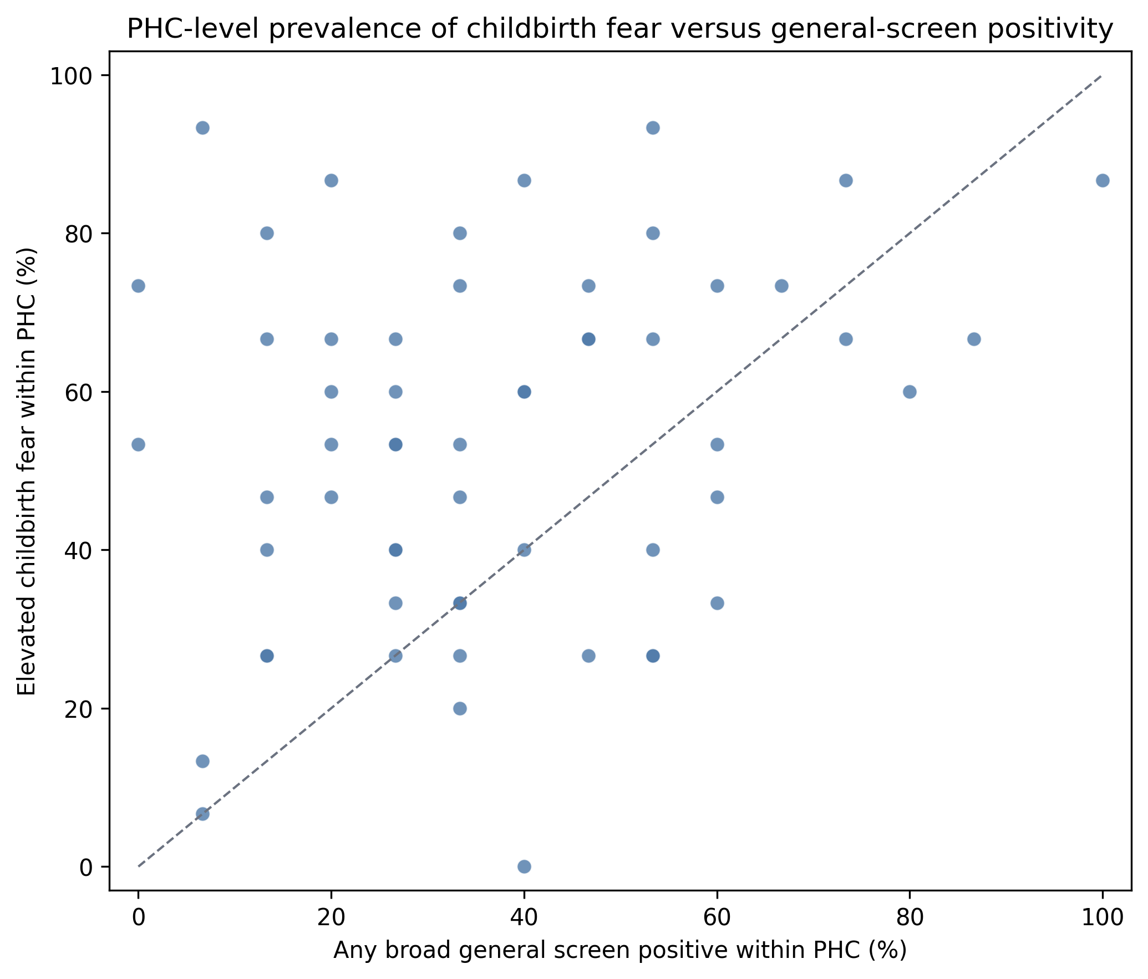
Each point represents one PHC with 15 participants. The diagonal indicates equality. Percentages are unstable and are included only to show that facility-level general-screen positivity does not closely track childbirth-fear prevalence.

Additional files
Additional file 1. tokophobia_screening_analysis_enhanced.py - complete reproducible analysis code for data processing, descriptive analyses, cluster-bootstrap intervals, regression models, grouped cross-validation and figures.
Additional file 2. STROBE checklist - to be completed and uploaded with the final submission.

