Supporting Information for
Synthesis, thermal, spectroscopic, X-ray diffraction and theoretical studies of some novel nickel(II) chelates of a heterocyclic based tridentate NNO donor aroylhydrazone: In vitro DNA binding and docking studies
Yamuna Nairª, Francis Joyª, Vinod T. P.ª, Vineetha M. C^{b,c}., M. R. Prathapachandra Kurup^{b,d,}*, Savaş Kaya^{e}, Goncagül Serdaroğlu,^{f} Sultan ERKAN^{e}
ªDepartment of Chemistry, CHRIST (Deemed to be University), Hosur Road, Bengaluru-560 029, Karnataka, India
^{b}Department of Applied Chemistry, Cochin University of Science and Technology, Kochi 682 022, Kerala, India
^{c}Department of Chemistry, Sree Kerala Varma College, Thrissur 680 011, Kerala, India
^{d}Department of Chemistry, School of Physical Sciences, Central University of Kerala, Kasaragod 671 320, India
^{e}Sivas Cumhuriyet University, Faculty of Science, Department of Chemistry, 58140, Sivas, TURKEY, email: sultanerkan@cumhuriyet.edu.tr

^{e}Sivas Cumhuriyet University, Faculty of Science, Department of Chemistry, 58140, Sivas, TURKEY, email: savaskaya@cumhuriyet.edu.tr

^{f}Cumhuriyet University, Faculty of Education, Department of Science Education, 58040, Sivas, Turkey
serdaroglu@cumhuriyet.edu.tr

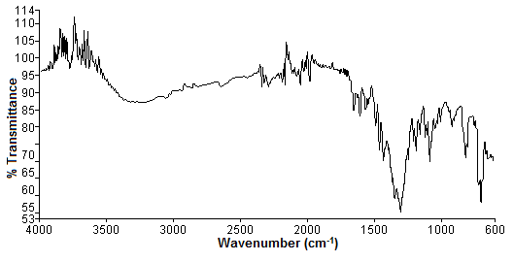
Fig. S1. IR spectrum of [Ni(FPB)(NO₃)]·2H₂O (9).
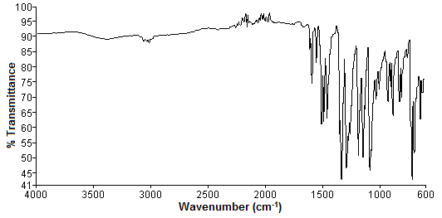
Fig. S2. IR spectrum of [Ni(HFPB)(FPB)]Cl (10).
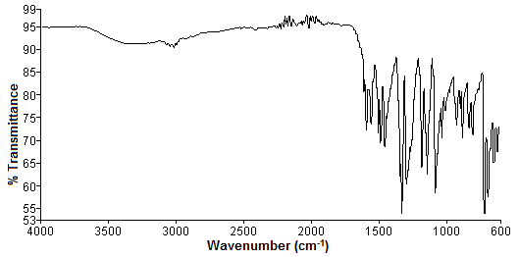
Fig. S3. IR spectrum of [Ni(FPB)(OAc)DMF](11).
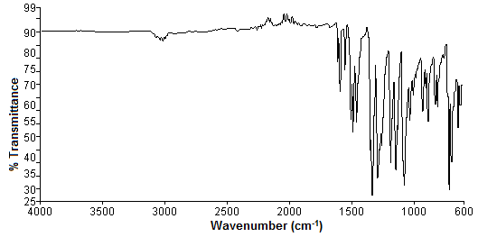

Fig. S4. IR spectrum of [Ni(FPB)(ClO₄)]·DMF (12).
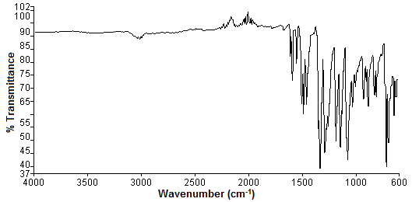
Fig. S5. IR spectrum of [Ni(FPB)₂] (13).

Table S6. Selected torsion angles [°] for [Ni(FPB)₂] (13).
Torsion angles
 | [Ni(FPB)₂] (13)
N1–C5–C6–N2 | -1.2(4)
C1–C5–C6–N2 | 179.8(3)
N4–C18–C19–N5 | 0.8(4)
C17–C18–C19–N5 | -178.8(3)
N3–N2–C6–C5 | 178.7(2)
C18–C19–N5–N6 | -176.8(3)
C6–N2–N3–C7 | 179.9(2)
C19–N5–N6–C20 | 180.0(3)
N2–N3–C7–C8 | 177.8(2)
C21–C20–N6–N5 | -175.0(2)
N2–N3–C7–O1 | -2.0(4)
O2–C20–N6–N5 | 3.7(4)

Table S7. Interaction parameters present in [Ni(FPB)₂] (13)
Hydrogen bonding interactions
D–H···A | D–H (Å) | H···A (Å) | D···A (Å) | ∠D–H···A (°)
C(10)–H(10)···O(2)ª | 0.93 | 2.47 | 3.271(4) | 145
C(15)–H(15)···N(3)^{b} | 0.93 | 2.55 | 3.455(4) | 163
C(25)–H(25)···F(2)^{c} | 0.93 | 2.53 | 3.296(4) | 140
π···π interactions
Cg(I)···Cg(J) | Cg···Cg (Å) | α (º) | β (º) | γ (º)
Cg(5)···Cg(7)^{d} | 3.7048(17) | 3.18(14) | 23.47 | 26.49
Cg(7)···Cg(5)ª | 3.7047(17) | 3.18(14) | 26.49 | 23.47
C–H···π interactions
C–H···Cg | H···Cg (Å) | C–H···Cg (˚) | C···Cg (Å)
C(3)–H(3)···Cg(6)^{d} | 2.99 | 152 | 3.834(3)
C–F···π interactions
C–F···Cg | F···Cg (Å) | C–F···Cg (˚) | C···Cg (Å)
C(1)–F(1)···Cg(5)^{e} | 3.313(2) | 99.72(15) | 3.783(3)
C(1)–F(1)···Cg(7)^{d} | 3.666(2) | 69.19(14) | 3.427(3)
C(17)–F(2)···Cg(2)^{f} | 3.317(3) | 98.7(2) | 3.758(4)
Symmetry code: a = x,-1+y,z; b = 1-x,-y,-z; c = x,1/2-y,1/2+z; d = x,1+y,z; e = 1-x,1-y,-z; f = 2-x,-y,-z
D = Donor, A = acceptor, Cg = Centroid
Cg(2) = Ni(1), O(2), C(20), N(6), N(5)
Cg(5) = N(1), C(4), C(3), C(2), C(1), C(5)
Cg(6) = N(4), C(14), C(15), C(16), C(17), C(18)
Cg(7) = C(8), C(9), C(10), C(11), C(12), C(13)
α(°) = Dihedral Angle between planes I and J
β(°) = Angle between Cg(I)···Cg(J) and Cg(J) perp
γ(°) = Angle between Cg(I)···Cg(J) vector and Cg(I) perp

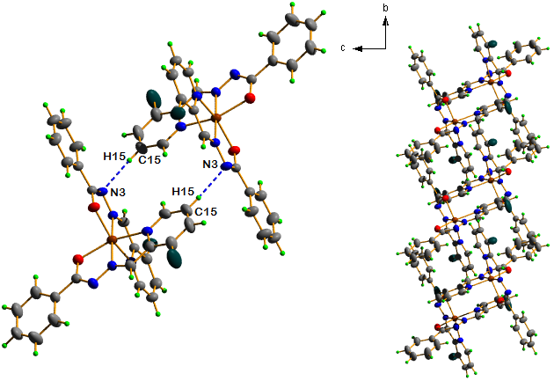
Fig. S8. C–H···N hydrogen bonding interactions in the complex along b axis.

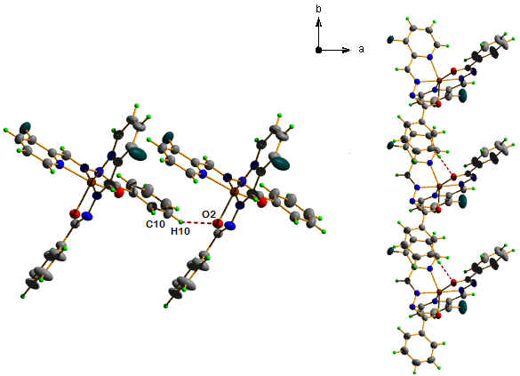
Fig. S9. C–H···O hydrogen bonding interactions connecting adjacent molecules and propagating along b axis.

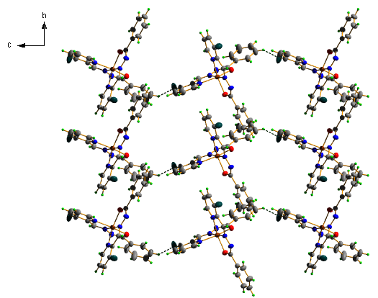
Fig. S10. C–H···F hydrogen bonding interactions connecting adjacent molecules and propagate along b axis.

Table S1. NBO analysis results of HFPB at B3LYP/6-31++g**/LANL2DZ level
Donor(i) | ED_{i}/e | Acceptor (j) | ED_{j}/e | E⁽²⁾/ kcalmol⁻¹ | E(j)-E(i)/ a.u | F(i.j)/ a.u
HFPB
Π N1-C2 (2) | 1.91646 | Π* C6-C9 | 0.39814 | 10.19 | 0.34 | 0.057
Π C5-N13 (2) | 1.73129 | Π* C6-C9  Π* C7-C10 | 0.39814  0.32759 | 23.90  13.95 | 0.31  0.31 | 0.079  0.060
Π C6-C9 (2) | 1.60793 | Π* N1-C2  Π* C5-N13  Π* C7-C10 | 0.18325  0.34762  0.32759 | 14.79  16.80  20.68 | 0.29  0.29  0.29 | 0.061  0.062  0.070
Π C7-C10 (2) | 1.66455 | Π* C5-N13  Π* C6-C9 | 0.34762  0.39814 | 24.31  20.49 | 0.28  0.28 | 0.073  0.068
Π C14-C15 (2) | 1.65794 | Π* C4-O28  Π* C16-C19  Π* C17-C21 | 0.26520  0.29413  0.32280 | 16.01  19.06  18.95 | 0.29  0.29  0.28 | 0.062  0.067  0.066
Π C16-C19 (2) | 1.64636 | Π* C14-C15  Π* C17-C21 | 0.37384  0.32280 | 20.08  21.14 | 0.27  0.28 | 0.066  0.069
Π C17-C21 (2) | 1.65134 | Π* C14-C15  Π* C16-C19 | 0.37384  0.29413 | 21.07  18.19 | 0.28  0.29 | 0.069  0.065
LP(1) N3 | 1.65992 | Π* N1-C2  Π* C4-O28 | 0.18325  0.26520 | 30.14  44.80 | 0.28  0.31 | 0.086  0.107
LP(1) N13 | 1.91134 | σ* C5-C7  σ* C6-C9 | 0.02658  0.04117 | 10.27  10.11 | 0.89  0.87 | 0.086  0.085
LP(3) F26 | 1.92819 | Π* C6-C9 | 0.39814 | 17.40 | 0.43 | 0.085
1
Π N2-C12 (2) | 1.89106 | Π* C3-C5 | 0.39768 | 11.67 | 0.35 | 0.061
Π C3-C5 (2) | 1.60008 | Π* N2-C12  Π* C4-N11  Π* C6-C8 | 0.34969  0.41509  0.32082 | 17.16  14.94  20.81 | 0.27  0.27  0.30 | 0.062  0.057  0.072
Π C4-N11 (2) | 1.79175 | Π* C3-C5  Π* C6-C8 | 0.39768  0.32082 | 20.43  10.12 | 0.34  0.35 | 0.078  0.054
Π C6-C8 (2) | 1.64708 | Π* C3-C5  Π* C4-N11 | 0.39768  0.41509 | 20.25  30.45 | 0.27  0.25 | 0.067  0.079
Π C15-N16 (2) | 1.72021 | Π* N2-C12 | 0.34969 | 32.97 | 0.26 | 0.085
Π C22-C23 (2) | 1.61477 | Π* C15-N16  Π* C24-C27  Π* C25-C29 | 0.41890  0.29435  0.32273 | 27.59  20.53  18.36 | 0.23  0.28  0.28 | 0.072  0.069  0.065
Π C24-C27 (2) | 1.65623 | Π* C22-C23  Π* C25-C29 | 0.37304  0.32273 | 18.50  21.54 | 0.28  0.28 | 0.065  0.070
Π C25-C29 (2) | 1.63712 | Π* C22-C23  Π* C24-C27 | 0.37304  0.29435 | 22.81  18.00 | 0.28  0.28 | 0.072  0.065
LP(1) N11 | 1.69366 | LP*(5) Ni | 0.80070 | 33.88 | 0.21 | 0.087
LP(2) O14 | 1.69560 | LP*(5) Ni | 0.80070 | 30.78 | 0.22 | 0.085
LP(1) O18 | 1.93963 | LP*(6) Ni | 0.29980 | 9.31 | 0.91 | 0.087
LP(3) O18 | 1.69338 | LP*(5) Ni  Π* N19-O20 | 0.80070  0.06525 | 47.55  8.62 | 0.23  0.92 | 0.108  0.085
LP(2) O20 | 1.86180 | σ* O18-N19  σ* N19-O21 | 0.13535  0.07092 | 25.56  18.53 | 0.53  0.69 | 0.104  0.102
LP(2) O21 | 1.86021 | σ* O18-N19  Π* N19-O20 | 0.13535  0.06525 | 16.64  18.34 | 0.55  0.75 | 0.086  0.107
LP(3) F17 | 1.91318 | Π* C3-C5 | 0.39768 | 20.09 | 0.42 | 0.089
2
Π N8-C11 (2) | 0.87209 | Π* N5-C7 | 0.16665 | 14.90 | 0.27 | 0.082
Π C14-C17 (2) | 0.82757 | Π* C12-N29 | 0.18082 | 12.42 | 0.27 | 0.073
Π C20-C22 (2) | 0.80783 | Π* N5-C7  Π* C21-N28  Π* C23-C25 | 0.16665  0.19644  0.15087 | 8.59  7.11  9.81 | 0.27  0.27  0.30 | 0.062  0.056  0.070
Π C21-N28 (2) | 0.89511 | Π* C20-C22 | 0.19663 | 10.33 | 0.33 | 0.077
Π C23-C25 (2) | 0.82421 | Π* C20-C22  Π* C21-N28 | 0.19663  0.19644 | 10.39  14.57 | 0.27  0.25 | 0.067  0.078
Π C30-C31 (2) | 0.81697 | Π* O3-C10  Π* C32-C35  Π* C33-C37 | 0.15792  0.14883  0.15948 | 11.75  10.30  8.92 | 0.25  0.28  0.28 | 0.069  0.069  0.064
Π C32-C35 (2) | 0.82920 | Π* C30-C31  Π* C33-C37 | 0.18197  0.15948 | 9.10  10.51 | 0.28  0.28 | 0.064  0.069
Π C33-C37 (2) | 0.82354 | Π* C30-C31  Π* C32-C35 | 0.18197  0.14883 | 11.04  9.04 | 0.28  0.28 | 0.070  0.064
Π C41-C42 (2) | 0.80952 | Π* N8-C11  Π* C43-C46 | 0.20389  0.14905 | 11.46  10.14 | 0.24  0.28 | 0.067  0.069
Π C43-C46 (2) | 0.82594 | Π* C41-C42  Π* C44-C48 | 0.18585  0.16439 | 9.39  10.75 | 0.28  0.28 | 0.065  0.069
Π C44-C48 (2) | 0.82107 | Π* C41-C42  Π* C43-C46 | 0.18585  0.14905 | 11.12  8.97 | 0.28  0.28 | 0.071  0.064
LP(2) O2 | 0.85038 | LP*(5) Ni | 0.39440 | 13.24 | 0.23 | 0.081
LP(1) N4 | 0.85603 | LP*(5) Ni | 0.39440 | 19.88 | 0.24 | 0.100
LP(1) N9 | 0.83117 | Π* O3-C10  Π* N4-C6 | 0.15792  0.11339 | 21.68  7.23 | 0.31  0.28 | 0.105  0.059
LP(1) N28 | 0.84211 | LP*(5) Ni | 0.39440 | 15.51 | 0.21 | 0.083
LP(3) F54 | 0.96193 | Π* C20-C22 | 0.19663 | 9.16 | 0.43 | 0.086
3
Π C3-N47 (2) | 1.89107 | Π* C6-C8 | 0.39145 | 11.52 | 0.35 | 0.061
Π N4-C5 (2) | 1.75090 | Π* C3-N47 | 0.32254 | 29.10 | 0.28 | 0.081
Π C6-C8 (2) | 1.60498 | Π* C3-N47  Π* C7-N14  Π* C9-C11 | 0.32254  0.39261  0.31941 | 16.23  15.05  20.85 | 0.27  0.27  0.29 | 0.060  0.057  0.071
Π C7-N14 (2) | 1.78374 | Π* C6-C8  Π* C9-C11 | 0.39145  0.31941 | 21.00  10.20 | 0.33  0.34 | 0.078  0.054
Π C9-C11 (2) | 1.65677 | Π* C6-C8  Π* C7-N14 | 0.39145  0.39261 | 19.75  28.56 | 0.27  0.26 | 0.066  0.078
Π C15-C17 (2) | 1.62157 | Π* N4-C5  Π* C16-C18  Π* C20-C22 | 0.39912  0.29671  0.32619 | 24.93  20.37  18.56 | 0.24  0.28  0.28 | 0.070  0.069  0.065
Π C16-C18 (2) | 1.65561 | Π* C15-C17  Π* C20-C22 | 0.37058  0.32619 | 18.59  21.35 | 0.28  0.28 | 0.065  0.069
Π C20-C22 (2) | 1.64389 | Π* C15-C17  Π* C16-C18 | 0.37058  0.29671 | 22.03  17.94 | 0.28  0.28 | 0.070  0.064
LP (3) F27 | 1.92397 | Π* C6-C8 | 0.39145 | 18.09 | 0.43 | 0.086
LP (1) O28 | 1.92068 | LP*(6) Ni | 0.26285 | 8.82 | 0.76 | 0.077
LP (2) O28 | 1.75511 | LP*(7) Ni  Π* C29-O30 | 0.12551  0.25025 | 6.19  41.91 | 0.52  0.34 | 0.052  0.107
LP (3) O28 | 1.68590 | LP*(5) Ni  Π* C29-O30 | 0.79811  0.25025 | 47.25  8.34 | 0.23  0.50 | 0.107  0.059
LP (1) N47 | 1.64465 | LP*(7) Ni | 0.12551 | 19.44 | 0.68 | 0.109
4
Π N2-C12 (2) | 1.89633 | Π* C3-C5 | 0.39331 | 11.16 | 0.35 | 0.061
Π C3-C5 (2) | 1.60809 | Π* N2-C12  Π* C4-N11  Π* C6-C8 | 0.34308  0.40280  0.30789 | 17.73  14.46  20.17 | 0.27  0.27  0.30 | 0.062  0.056  0.071
Π C4-N11 (2) | 1.79253 | Π* C3-C5  Π* C6-C8 | 0.39331  0.30789 | 20.66  9.95 | 0.34  0.35 | 0.078  0.054
Π C6-C8 (2) | 1.64839 | Π* C3-C5  Π* C4-N11 | 0.39331  0.40280 | 20.45  30.36 | 0.27  0.25 | 0.067  0.079
Π C15-N16(2) | 1.72912 | Π* N2-C12 | 0.34308 | 32.07 | 0.26 | 0.084
Π C19-C20 (2) | 1.61359 | Π* C15-N16  Π* C21-C24  Π* C22-C26 | 0.41410  0.29299  0.32059 | 28.27  20.51  18.15 | 0.23  0.28  0.28 | 0.073  0.069  0.065
Π C21-C24 (2) | 1.65667 | Π* C19-C20  Π* C22-C26 | 0.37429  0.32059 | 18.42  21.48 | 0.28  0.28 | 0.065  0.070
Π C22-C26 (2) | 1.63474 | Π* C19-C20  Π* C21-C24 | 0.37429  0.29299 | 23.02  17.97 | 0.28  0.28 | 0.072  0.065
LP (1) N11 | 1.69224 | LP*(5) Ni | 0.79509 | 37.39 | 0.21 | 0.090
LP (1) N16 | 1.92125 | σ* O14-C15 | 0.02900 | 9.43 | 0.88 | 0.082
LP (1) O14 | 1.93839 | LP*(6) Ni | 0.29656 | 8.54 | 0.81 | 0.079
LP (2) O14 | 1.68156 | LP*(5) Ni  σ* C15-C19 | 0.79509  0.04464 | 37.83  9.28 | 0.22  0.93 | 0.093  0.089
LP (2) O18 | 1.89938 | σ* O30-Cl-32  σ* O31-Cl-32 | 0.22266  0.23677 | 6.10  8.37 | 0.49  0.47 | 0.050  0.058
LP (3) O18 | 1.71893 | LP*(5) Ni | 0.79509 | 33.98 | 0.25 | 0.096
LP (2) O30 | 1.81162 | σ* O31-Cl-32  σ* O33-Cl-32 | 0.23677  0.24261 | 18.45  13.27 | 0.45  0.44 | 0.082  0.069
LP (3) O30 | 1.77991 | σ* O18-Cl-32 | 0.35588 | 24.52 | 0.32 | 0.082
LP (2) O31 | 1.82578 | σ* O30-Cl-32  σ* O33-Cl-32 | 0.22266  0.24261 | 16.86  12.35 | 0.47  0.44 | 0.081  0.067
LP (3) O31 | 1.80278 | σ* O18-Cl-32 | 0.35588 | 22.07 | 0.33 | 0.079
LP (2) O33 | 1.82803 | σ* O30-Cl-32  σ* O31-Cl-32 | 0.22266  0.23677 | 13.73  15.64 | 0.47  0.45 | 0.073  0.076
LP (3) O33 | 1.79754 | σ* O18-Cl-32 | 0.35588 | 22.31 | 0.33 | 0.080
LP (3) F17 | 1.91289 | Π* C3-C5 | 0.39331 | 20.31 | 0.42 | 0.089
5
Π N8-C11 (2) | 0.86586 | Π* N5-C7 | 0.17348 | 15.44 | 0.27 | 0.083
Π C12-C14 (2) | 0.81448 | Π* C16-C17 | 0.16887 | 11.09 | 0.27 | 0.070
Π C13-N29 (2) | 0.84774 | Π* C12-C14 | 0.16288 | 13.12 | 0.32 | 0.082
Π C16-C17 (2) | 0.83249 | Π* C13-N29 | 0.24438 | 11.13 | 0.28 | 0.075
Π C20-N28 (2) | 0.86115 | Π* C21-C23 | 0.15384 | 12.56 | 0.34 | 0.083
Π C21-C23 (2) | 0.80505 | Π* C20-N28  Π* C22-C25 | 0.27601  0.17166 | 8.55  11.54 | 0.24  0.27 | 0.059  0.071
Π C22-C25 (2) | 0.82180 | Π* C20-N28  Π* C21-C23 | 0.27601  0.15384 | 13.87  8.09 | 0.26  0.30 | 0.079  0.063
Π C30-C31 (2) | 0.81112 | Π* C32-C35 | 0.15404 | 10.27 | 0.28 | 0.068
Π C32-C35 (2) | 0.82843 | Π* C30-C31  Π* C33-C37 | 0.17773  0.16957 | 9.42  10.78 | 0.28  0.27 | 0.065  0.069
Π C33-C37 (2) | 0.82906 | Π* C30-C31  Π* C32-C35 | 0.17773  0.15404 | 9.12  10.44 | 0.29  0.28 | 0.069  0.065
Π C41-C42 (2) | 0.80954 | Π* N8-C11  Π* C43-C46  Π* C44-C48 | 0.20688  0.14906  0.16548 | 11.26  10.15  9.32 | 0.24  0.28  0.27 | 0.066  0.069  0.065
Π C43-C46 (2) | 0.82577 | Π* C41-C42  Π* C44-C48 | 0.18487  0.16548 | 9.40  10.81 | 0.28  0.28 | 0.065  0.069
Π C44-C48 (2) | 0.82262 | Π* C41-C42  Π* C43-C46 | 0.18487  0.14906 | 11.00  8.94 | 0.28  0.28 | 0.070  0.064
σ O3-N9 | 0.57830 | Π* N4-C6 | 0.16710 | 15.59 | 0.16 | 0.074
LP (2) O2 | 0.85405 | LP*(5) Ni | 0.39593 | 10.64 | 0.25 | 0.074
LP (1) N28 | 0.85130 | LP*(5) Ni | 0.39593 | 11.85 | 0.22 | 0.074
LP (3) F55 | 0.96304 | Π* C16-C17 | 0.16887 | 9.03 | 0.43 | 0.084
*$E^{(2)}={∆E}_{ij}=qi\frac{{(Fij)}^{2}}{(εj-εi)}$ shows the lowering of stabilization energy, where qi is the donor orbital occupancy, εi, and εj are donor and acceptor orbital energies (diagonal elements), and Fij is the off-diagonal NBO Fock matrix element.

*Corresponding author. Tel.: +91 9895226115 E-mail addresses: mrpcusat@gmail.com, mrp@cukerala.ac.in (M.R.P. Kurup)

