Table S1 Winter oilseed rape samples collected from three geographical regions in Sweden
Sample number | P. lingam isolates | County | Location | Cultivar | Date of sampling
 |  |  |  |  | 2022 (Leaves) | 2023 (Stems)
1 |  | Östergötland | Motala 1 | na¹ | 18-Nov | July
2 |  | Östergötland | Motala 2 | na | 18-Nov | July
3 |  | Östergötland | Linköping | Atora | 17-Nov | July
4 |  | Östergötland | Norrköping | Aganos | 17-Nov | July
5 |  | Västra Götaland | Götene | DK Expat | 28-Nov | 18-Jul
6 |  | Västra Götaland | Lidköping 1 | DK Expat | 28-Nov | 21-Jul
7 |  | Västra Götaland | Lidköping 2 | DK Expat | 28-Nov | 17-Jul
8 |  | Västra Götaland | Vara | DK Expat | 28-Nov | 20-Jul
9 |  | Västra Götaland | Lidköping 3 | DK Explicit | 28-Nov | 13-Jul
10 |  | Västra Götaland | Hjo | Atora | 28-Nov | 14-Jul
11 |  | Västra Götaland | Tidaholm | Atora | 28-Nov | 14-Jul
12 |  | Västra Götaland | Skövde | Atora | 28-Nov | 14-Jul
13 |  | Västra Götaland | Falköping | DK Explicit | 28-Nov | 14-Jul
14 | Lm 2; 6 | Skåne | Tomelilla | na | 30-Nov | 27-Jul
15 |  | Skåne | Lund | Crocodile | 30-Nov | 26-Jul
16 |  | Skåne | Helsingborg | DK Expat | 01-Dec | 14-Jul
17 | Lm 4-5 | Skåne | Lund | V367OL | 05-Dec | 12-Jul
18 | Lm 3 | Skåne | Vellinge | KWS Hambre | 01-Dec | 18-Jul
19 |  | Skåne | Trelleborg 1 | Darling | 01-Dec | 18-Jul
20 | Lm 1; 7 | Skåne | Skurup | DK Exsteel | 01-Dec | 12-Jul
21 |  | Skåne | Trelleborg 2 | V316OL | 01-Dec | 13-Jul
 |  |  |  |  | Date of sampling
 |  |  |  |  | 2023  (Leaves) | 2024  (Stems)
1 |  | Östergötland | Motala 1 | LG Austin | 24-Nov | 19-Jul
2 | Lm 34 | Östergötland | Motala 2 | DK Explicit | 24-Nov | 19-Jul
3 |  | Östergötland | Motala 3 | Akilah | 24-Nov | 19-Jul
4 | Lm 29 | Västra Götaland | Lidköping 1 | na | 10-Nov | 19-Jul
5 |  | Västra Götaland | Lidköping 2 | DK Expat | 7-Nov | July
6 |  | Västra Götaland | Götene | DK Expat | 7-Nov | July
7 |  | Västra Götaland | Skövde | DK Expat | 7-Nov | July
8 | Lm 22 | Skåne | Trelleborg 1 | DK Explicit | 12-Nov | 10-Jul
9 |  | Skåne | Tomelilla | DK Explicit | 13-Nov | 10-Jul
10 | Lm 23 | Skåne | Ängelholm 1 | Crocodile | 12-Nov | 10-Jul
11 | Lm 31 | Skåne | Lund | Crocodile | 13-Nov | 10-Jul
12 |  | Skåne | Ystad | Crocodile | 13-Nov | 10-Jul
13 | Lm 24 | Skåne | Tomelilla 2 | Akilah | 13-Nov | 10-Jul
14 | Lm 32 | Skåne | Trelleborg 2 | Akilah | 12-Nov | 10-Jul
15 |  | Skåne | Trelleborg 3 | LG Austin | 12-Nov | 10-Jul
16 | Lm 33 | Skåne | Tomelilla 3 | LG Austin | 12-Nov | 10-Jul
17 | Lm 26 | Skåne | Helsingborg | DK Expat | 20-Nov | 10-Jul
18 | Lm 35 | Skåne | Eslöv | HoII316 | 20-Nov | 10-Jul
¹Cultivar name is not available.

Table S2 Differential hosts used for severity assessment of Plenodomus lingam isolates
Lines | Genes | Reference
02.22.2.1 | Rlm3 | Plissonneau et al. 2016
01.23.2.1 | RLm7 | Delourme et al. 2004
Topas-LepR1 | LepR1 | Larkan et al. 2016
Topas-LepR2 | LepR2 | Larkan et al. 2016
cv. Westar | none | Balesdent et al. 2005

Table S3 Control reference isolates of Plenodomus lingam used for severity assessment
Isolate | Origin | Year | Source of prior information
00-100 | Canada | 2000 | Kutcher et al. 2010; Larkan et al 2016; Ghanbarnia et al. 2018
Au7309 | Australia | 2015 | Bousset et al. 2020
D53 | Australia | 2016 | Bousset et al. 2020
IBCN16 | Australia | 1988 | Purwantara et al. 2000; Marcroft et al. 2012

Table S4 Univariate ANOVA breakdown analysis of the factors influencing occurrence of blackleg pathogens
Factor | Plenodomus biglobosus (Response log Pb gene copies g⁻¹)
 | Df | Sum Sq | Mean Sq | F value | Pr(>F)
County | 2 | 23.086 | 11.543 | 16.3633 | 2.606e-07 | ***
Year | 2 | 141.229 | 70.614 | 100.1019 | < 2.2e-16 | ***
Sample | 1 | 69.673 | 69.673 | 98.7671 | < 2.2e-16 | ***
County: Year | 4 | 14.847 | 3.712 | 5.2616 | 0.0004741 | ***
County: Sample | 2 | 31.156 | 15.578 | 22.0835 | 2.139e-09 | ***
 | Plenodomus lingam (Response log Pl gene copies g⁻¹)
 | Df | Sum Sq | Mean Sq | F value | Pr(>F)
County | 2 | 58.130 | 29.065 | 28.3886 | 1.384e-11 | ***
Year | 2 | 21.418 | 10.709 | 10.4597 | 4.771e-05 | ***
Sample | 1 | 35.104 | 35.104 | 34.2867 | 1.914e-08 | ***
County: Year | 4 | 24.614 | 6.153 | 6.0102 | 0.0001376 | ***
County: Sample | 2 | 22.289 | 11.144 | 10.8849 | 3.248e-05 | ***

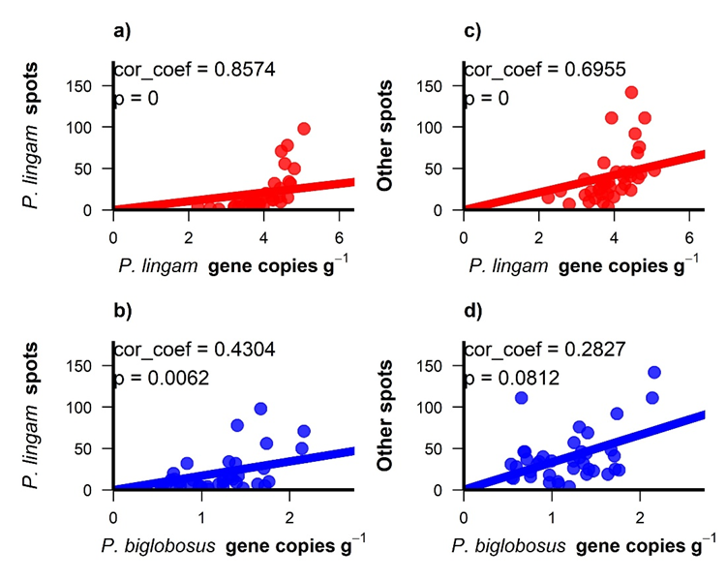
Fig. S1 Correlation between blackleg pathogens log-transformed number of gene copies g⁻¹ sample, determined by Droplet digital PCR, and visual disease assessment determined as leaf spots caused by Plenodomus lingam “P. lingam spots” and leaf spots caused by P. biglobosus including other pathogens “Other spots”. a) P. lingam gene copies and “P. lingam spots”, b) P. lingam gene copies and “Other spots”, c) P. biglobosus gene copies and “P. lingam spots” and d) P. biglobosus and “Other spots”. cor_coef = Spearman’s correlation coefficient.

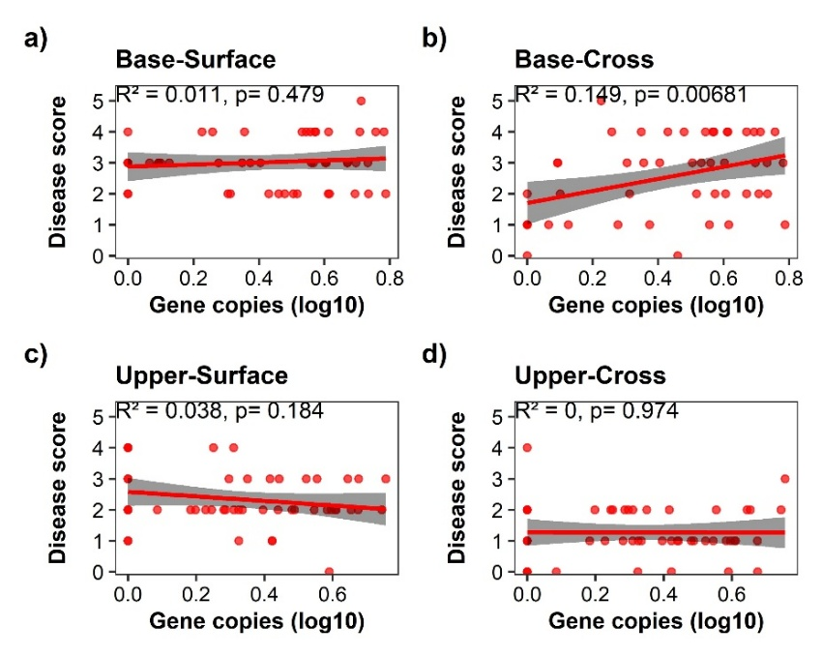
Fig. S2 The relationship between Plenodomus lingam DNA analysed by Droplet digital PCR, expressed as log gene copies g⁻¹ of stem sections samples, and the visual disease assessment expressed as infection scores at both stem base and upper stem sections in the stem cross-section and surface. a) association between gene copies g⁻¹ and disease score on the stem base surface, b) stem base cross-section, c) upper stem surface and d) upper stem cross-section. Analyses performed by Linear regression, R²= coefficient of determination.

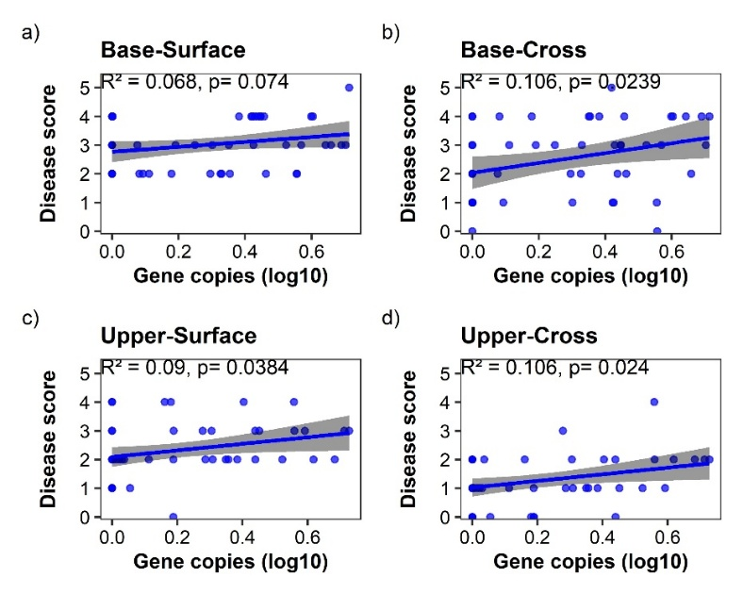
Fig. S3 The relationship between Plenodomus biglobosus DNA analysed by Droplet digital PCR, expressed as log gene copies g⁻¹ of stem sections samples, gene copies g⁻¹ of sample in stem sections, and the visual disease assessment expressed as infection scores at both stem base and upper stem sections in the cross-section and surface. a) association between gene copies per g⁻¹ and disease score on the stem base surface, b) stem base cross-section, c) upper stem surface and d) upper stem cross-section. Analyses performed by Linear regression, R²= coefficient of determination.

Fig. S4 Virulence assessment of isolate Lm23, 14 days post inoculation, indicating compatible interaction on the genetic line with LepR2 resistance gene in comparison with Plenodomus lingam reference isolate Au7309. Other Swedish isolates included in the same test were: Lm22, Lm24, Lm27, Lm29, Lm33–34 and reference isolates 00-100, D53 and IBCN16. Note: threshold line at score 5

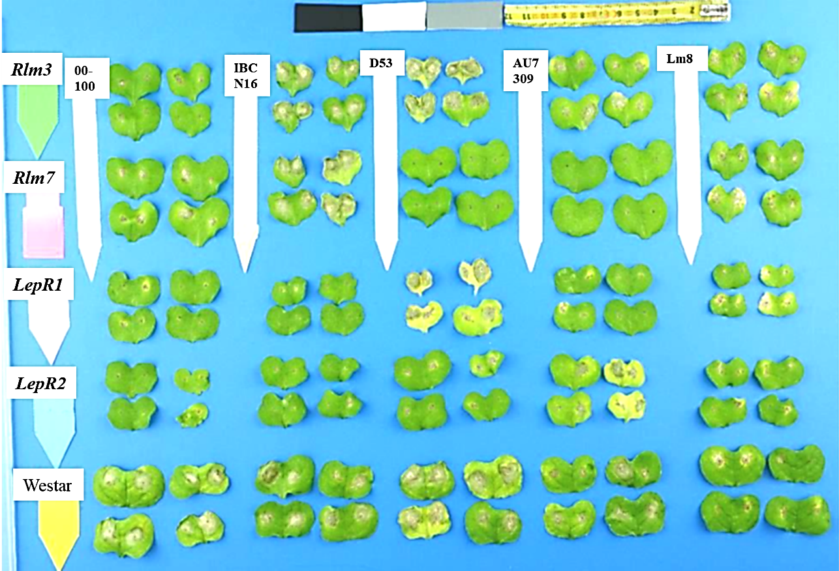
Fig. S5 Virulence assessment of Plenodomus lingam reference isolates, 00-100, IBCN16, D53 and Au7309, and Lm8 isolate in four genetic lines and susceptible cv.” Westar”. Note the abnormal symptoms produced by isolate Lm8 in all genetic lines and cv.” Westar”

