Supplementary Materials

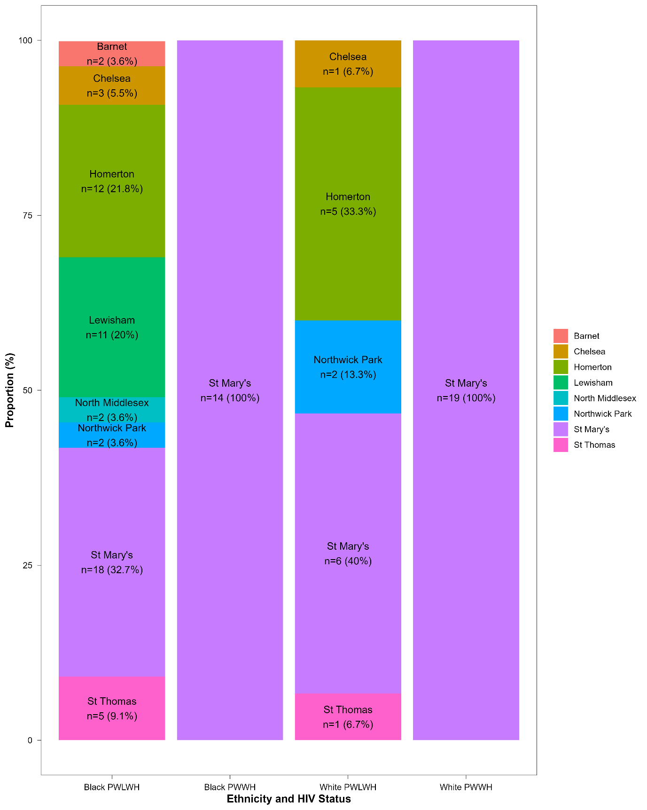
Supplementary Figure 1 - Recruitment clinic distribution by ethnicity and HIV status. Data taken from samples provided at 20–21-week second trimester cross section. All PWWH were recruited from a general antenatal clinic. Recruitment clinic distribution was not significantly different between PWLWH (p = 0.37).
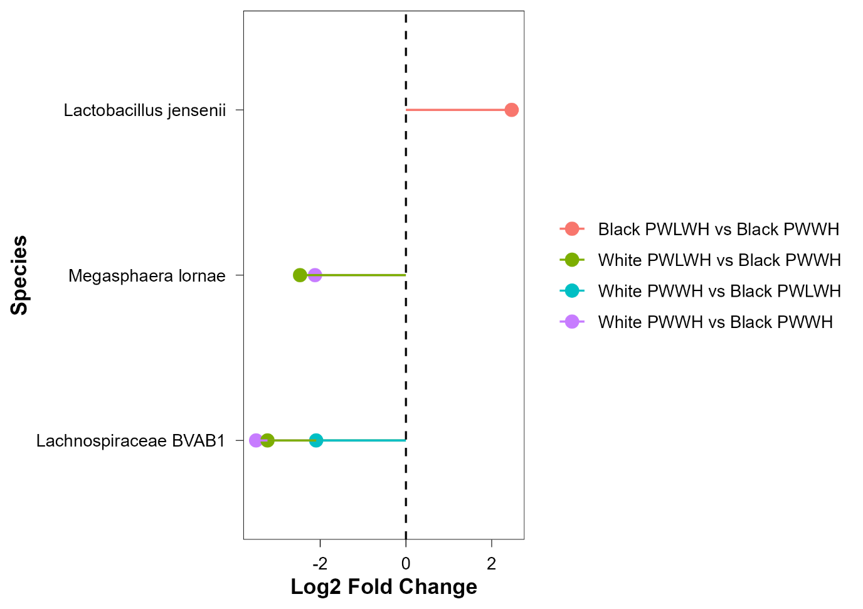
Supplementary Figure 2 - Differential abundance by ethnicity and HIV status during pregnancy. Differentially abundant species as determined by ANCOM and paired between subgroups. The results shown on the figure are unadjusted p < 0.05 (not FDR adjusted). L. jensenii was more abundant in Black PWLWH than Black PWWH (unadjusted p = 0.01, adjusted p = 0.24) Lachnospiraceae BVAB1 (Ca. Lachnocurva vaginae) was more abundant in Black PWWH than in White PWWH (unadjusted p = 9.00e-04, adjusted p = 0.02) and PWLWH (unadjusted p = 0.004, adjusted p = 0.07) and more common in Black PWLWH than in White PWLWH (unadjusted p = 0.04, adjusted p = 0.58). Megasphaera lornae was also more abundant in black PWWH than in white PWWH (unadjusted p = 0.03, adjusted p = 0.50) and PWLWH (unadjusted p = 0.02, adjusted p = 0.33).

Supplementary Table 1: Pairwise Comparisons of Cytokines by Ethnicity and HIV Status During Pregnancy
FDR-Adjusted Wilcoxon P values | Significant (p < 0.05) results in bold
Cytokine | Black PWLWH vs White PWLWH | Black PWLWH vs Black PWWH | Black PWLWH vs White PWWH | White PWLWH vs White PWWH | Black PWWH vs White PWLWH | Black PWWH vs White PWWH
IFN-γ | 0.88 | 0.28 | 1.00e-03 | 1.00e-03 | 0.24 | 0.50
IL-1β | 0.63 | 0.67 | 0.11 | 0.63 | 0.60 | 0.11
IL-10 | 0.99 | 0.99 | 8.10e-06 | 5.00e-03 | 0.99 | 0.01
IL-12p70 | 0.91 | 0.91 | 8.58e-07 | 1.32e-04 | 0.91 | 2.00e-03
IL-13 | 0.56 | 0.89 | 1.19e-11 | 1.26e-05 | 0.79 | 0.02
IL-2 | 0.72 | 0.89 | 1.79e-10 | 1.91e-04 | 1.00 | 5.00e-03
IL-4 | 0.74 | 0.86 | 7.44e-07 | 3.39e-05 | 0.86 | 2.00e-03
IL-6 | 0.48 | 0.49 | 0.07 | 0.05 | 0.71 | 0.12
IL-8 | 0.93 | 0.93 | 2.05e-04 | 7.00e-03 | 0.93 | 0.02
TNF-α | 0.70 | 0.88 | 7.68e-06 | 6.00e-03 | 0.55 | 6.00e-03

Supplementary Table 2: Pairwise Emmeans Comparisons of Cytokines by Ethnicity and HIV Status
Linear regression estimates adjusted for age and BMI (FDR P value) | Bold indicates p < 0.05
Cytokine | Black PWWH vs Black PWLWH | Black PWWH vs White PWWH | Black PWWH vs White PWLWH | Black PWLWH vs White PWWH | Black PWLWH vs White PWLWH | White PWWH vs White PWLWH
IFN-γ | -0.63 (0.59) | 0.36 (0.97) | -0.77 (0.59) | 1.00 (0.02) | -0.14 (0.97) | -1.13 (0.05)
IL-10 | -0.11 (0.99) | 1.02 (0.04) | -0.28 (0.99) | 1.13 (6.55e-05) | -0.17 (0.99) | -1.30 (1.14e-03)
IL-12p70 | 0.03 (1.00) | 1.09 (1.19e-03) | -0.01 (1.00) | 1.06 (2.57e-06) | -0.03 (1.00) | -1.10 (5.16e-04)
IL-13 | -0.26 (0.98) | 1.35 (3.08e-05) | -0.11 (0.98) | 1.62 (0.01) | 0.15 (0.98) | -1.47 (3.49e-07)
IL-1β | 0.13 (0.99) | 0.93 (0.53) | 0.33 (0.99) | 0.79 (0.20) | 0.19 (0.99) | -0.60 (0.83)
IL-2 | -0.12 (0.98) | 1.56 (2.01e-04) | -0.23 (0.98) | 1.68 (3.23e-09) | -0.11 (0.98) | -1.79 (1.54e-06)
IL-4 | -0.04 (1.00) | 0.96 (7.60e-03) | -0.07 (1.00) | 1.00 (1.14e-05) | -0.03 (1.00) | -1.03 (8.33e-04)
IL-6 | 0.13 (1.00) | 0.73 (0.25) | -0.03 (1.00) | 0.59 (0.13) | -0.17 (1.00) | -0.76 (0.13)
IL-8 | -0.18 (1.00) | 1.09 (0.09) | -0.17 (1.00) | 1.27 (6.44e-05) | 0.02 (1.00) | -1.26 (4.92e-03)
TNF-α | -0.08 (1.00) | 1.41 (3.65e-03) | 0.06 (1.00) | 1.50 (1.51e-06) | 0.14 (1.00) | -1.35 (2.71e-03)

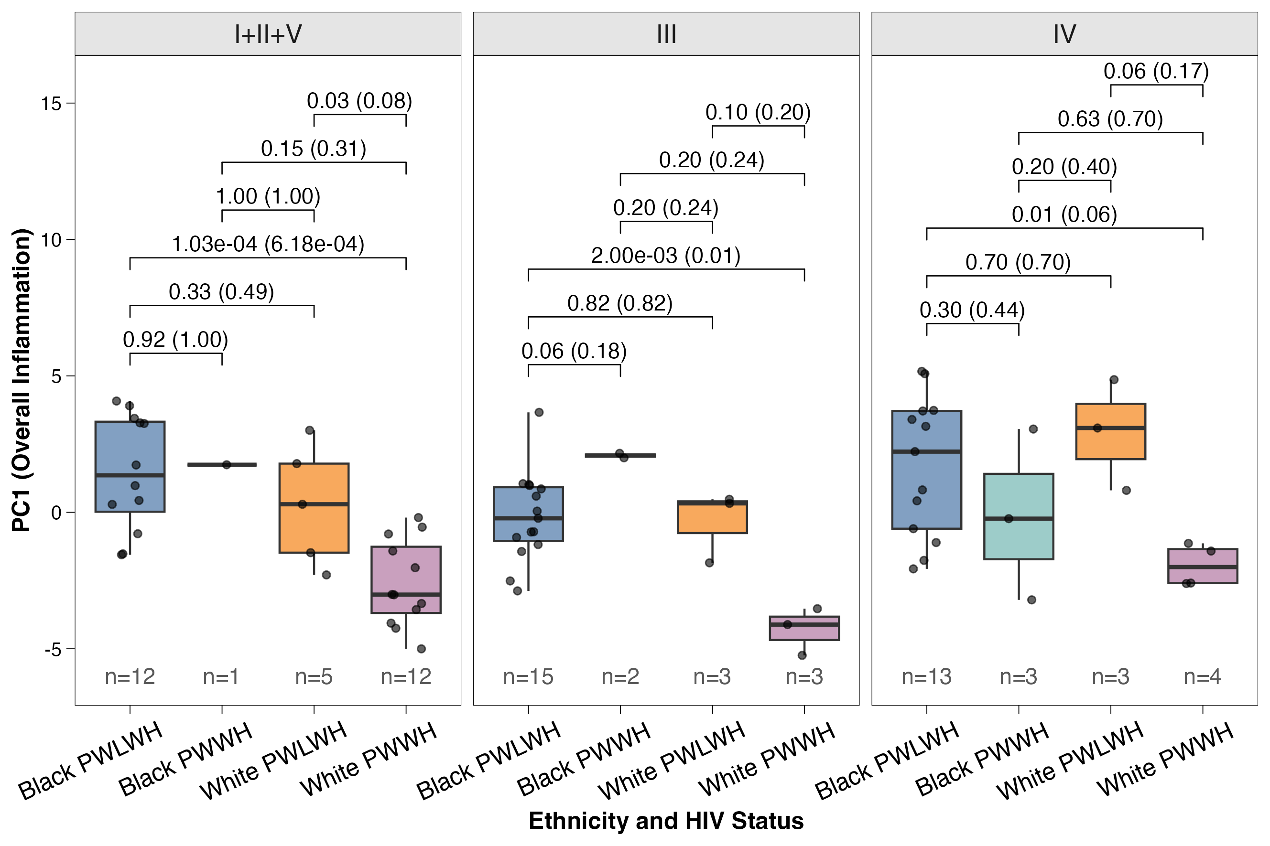Supplementary Figure 3 - PC1 inflammation scores across ethnicity and HIV status groups stratified by CST grouping. Boxplots showing PC1 inflammation scores among pregnant women in the CST I+II+V, CST III, and CST IV groups. Pairwise comparisons were performed via Wilcoxon rank-sum tests and unadjusted p values with FDR adjustment in parentheses are presented above each comparison. The sample size varied by CST within subgroups and is noted below each box.

Supplementary Table 3: Pairwise Comparisons of Cytokines by Ethnicity and HIV Status in CSTs I+II+V During Pregnancy
FDR-adjusted Wilcoxon P-values | Significant (p < 0.05) Results are in Bold
Cytokine | Black PWLWH vs Black PWWH | Black PWLWH vs White PWLWH | Black PWLWH vs White PWWH | Black PWWH vs White PWLWH | Black PWWH vs White PWWH | White PWLWH vs White PWWH
IFN-γ | 0.55 | 0.55 | 0.16 | 0.55 | 1.00 | 0.17
IL-1β | 0.96 | 0.58 | 0.41 | 1.00 | 0.96 | 0.96
IL-10 | 0.74 | 0.74 | 5.95e-04 | 0.80 | 0.45 | 0.45
IL-12p70 | 1.00 | 1.00 | 1.00e-03 | 1.00 | 0.40 | 0.11
IL-13 | 0.27 | 0.34 | 1.85e-05 | 0.67 | 0.27 | 0.06
IL-2 | 0.27 | 0.62 | 1.30e-04 | 0.80 | 0.27 | 0.11
IL-4 | 0.74 | 0.74 | 7.44e-05 | 0.80 | 0.36 | 0.04
IL-6 | 0.86 | 0.86 | 0.17 | 0.86 | 0.86 | 0.23
IL-8 | 1.00 | 0.48 | 0.05 | 1.00 | 0.48 | 0.24
TNF-α | 0.92 | 0.90 | 0.01 | 0.92 | 0.29 | 0.29

Supplementary Table 4: Pairwise Comparisons of Cytokines by Ethnicity and HIV Status in CST III During Pregnancy
FDR-adjusted Wilcoxon P-values | Significant (p < 0.05) Results are in Bold
Cytokine | Black PWLWH vs Black PWWH | Black PWLWH vs White PWLWH | Black PWLWH vs White PWWH | Black PWWH vs White PWLWH | Black PWWH vs White PWWH | White PWLWH vs White PWWH
IFN-γ | 1.00 | 0.85 | 0.30 | 1.00 | 1.00 | 0.30
IL-1β | 0.60 | 0.82 | 0.60 | 0.60 | 0.60 | 0.82
IL-10 | 0.24 | 0.50 | 0.23 | 0.24 | 0.24 | 0.24
IL-12p70 | 0.24 | 1.00 | 0.06 | 0.24 | 0.24 | 0.24
IL-13 | 0.35 | 0.50 | 0.01 | 0.30 | 0.30 | 0.30
IL-2 | 0.24 | 0.65 | 0.03 | 0.24 | 0.24 | 0.24
IL-4 | 0.35 | 0.43 | 0.16 | 0.30 | 0.30 | 0.30
IL-6 | 0.30 | 0.40 | 0.15 | 0.40 | 0.30 | 0.30
IL-8 | 0.18 | 1.00 | 0.03 | 0.24 | 0.24 | 0.20
TNF-α | 0.28 | 0.57 | 0.06 | 0.28 | 0.28 | 0.28

Supplementary Table 5: Pairwise Comparisons of Cytokines by Ethnicity and HIV Status in CST IV During Pregnancy
FDR-adjusted Wilcoxon P-values | Significant (p < 0.05) Results are in Bold
Cytokine | Black PWLWH vs Black PWWH | Black PWLWH vs White PWLWH | Black PWLWH vs White PWWH | Black PWWH vs White PWLWH | Black PWWH vs White PWWH | White PWLWH vs White PWWH
IFN-γ | 0.63 | 0.63 | 0.31 | 0.40 | 0.63 | 0.31
IL-1β | 0.94 | 1.00 | 0.94 | 1.00 | 0.94 | 0.94
IL-10 | 0.44 | 0.36 | 0.17 | 0.36 | 0.63 | 0.17
IL-12p70 | 0.73 | 1.00 | 0.17 | 0.60 | 0.60 | 0.17
IL-13 | 0.59 | 1.00 | 5.00e-03 | 1.00 | 1.00 | 0.17
IL-2 | 0.29 | 0.52 | 5.00e-03 | 0.30 | 0.48 | 0.17
IL-4 | 0.53 | 0.90 | 0.30 | 0.53 | 0.53 | 0.30
IL-6 | 1.00 | 1.00 | 1.00 | 1.00 | 1.00 | 1.00
IL-8 | 0.26 | 0.84 | 0.12 | 0.30 | 0.84 | 0.17
TNF-α | 0.54 | 0.94 | 0.03 | 0.54 | 0.46 | 0.17

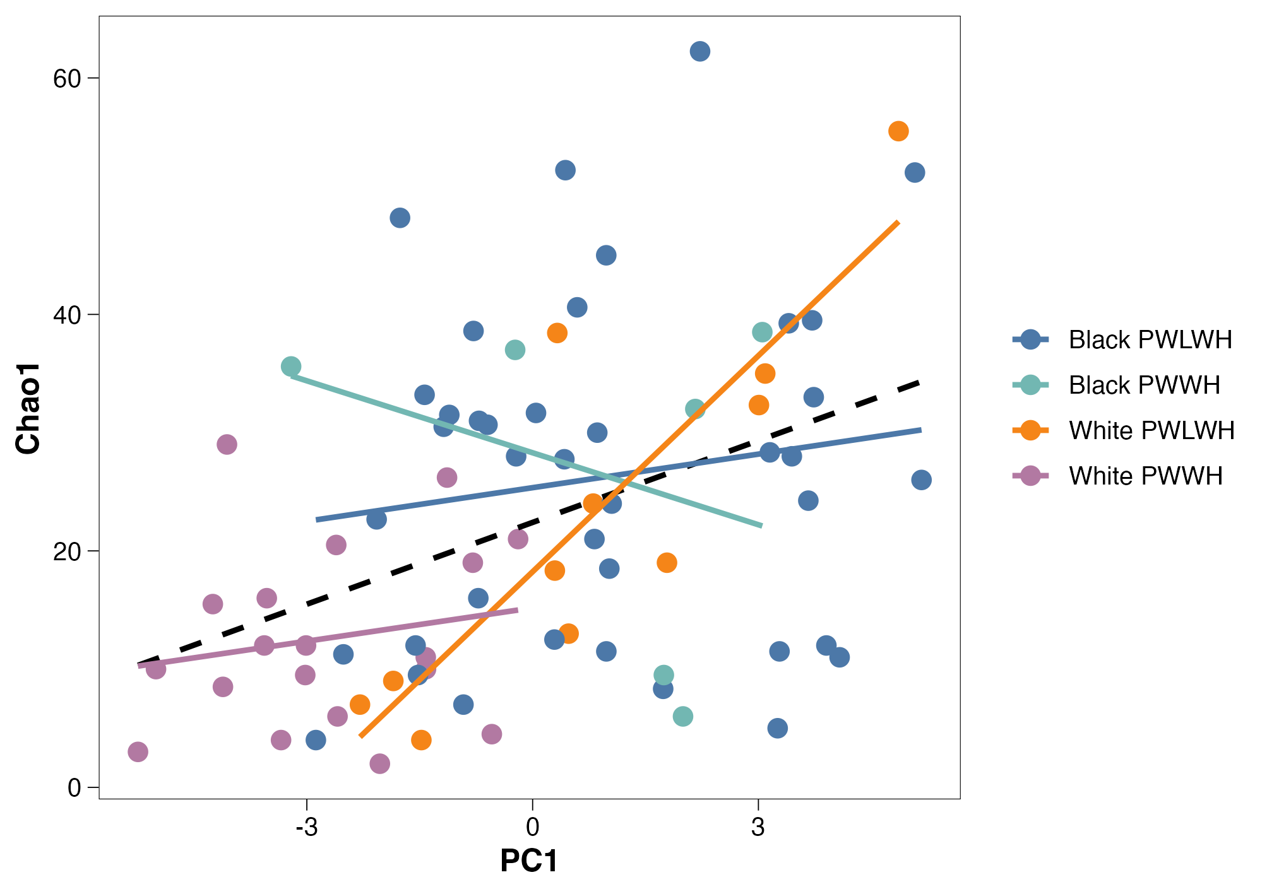
Supplementary Figure 4 - Spearman correlation by PC1 and Chao1 diversity of pregnant women during the second trimester. This scatterplot displays the relationship between PC1 (inflammation) and Chao1 species richness by HIV status and ethnicity. Lines represent subgroups and dots are individual subjects. The overall correlation (indicated by the black dashed line) is statistically significant (ρ = 0.31, p = 2.17e-04).
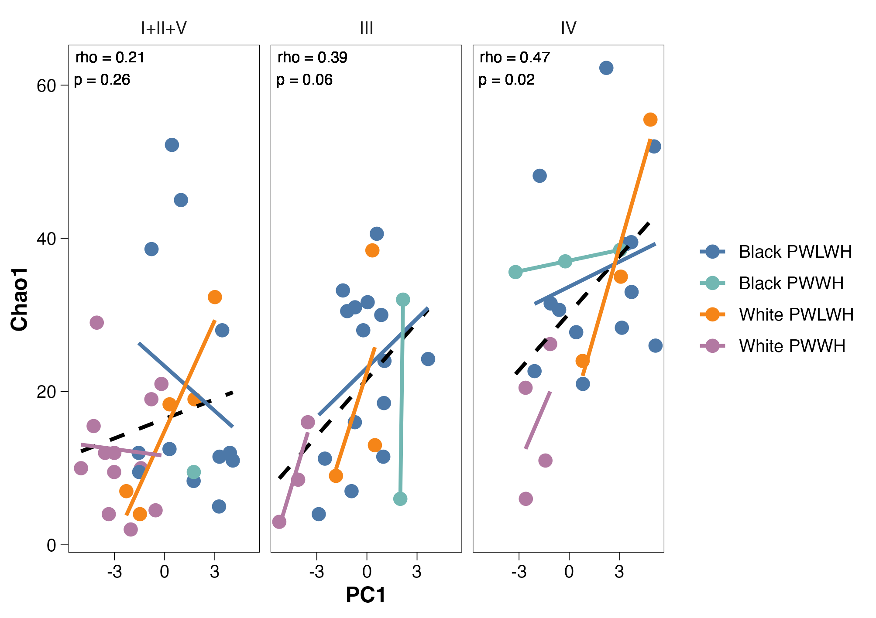
Supplementary Figure 5 - Spearman correlation by PC1 and Chao1 diversity stratified by CST group. This scatterplot displays the relationship between PC1 (inflammation) and Chao1 species richness by HIV status and ethnicity within each CST grouping (CST I+II+V, III, and IV). Lines represent subgroups and dots are individual subjects. The within-CST Spearman correlations were not significant for CST I+II+V (ρ = 0.21, p = 0.26) and CST III (ρ = 0.39, p = 0.06), while CST IV showed a statistically significant positive association (ρ = 0.47, p = 0.02).

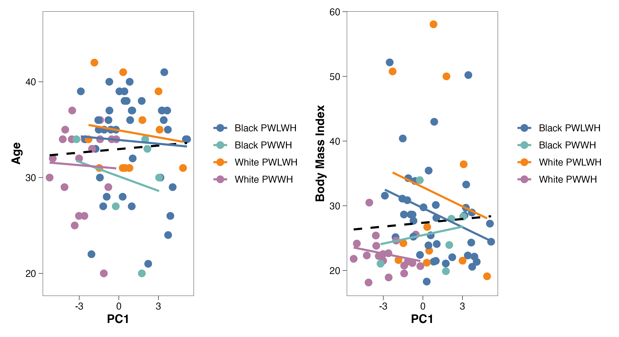
Supplementary Figure 6 - Spearman correlation by PC1 and Age (left) and PC1 and Body Mass Index (right), stratified by ethnicity and HIV status. These scatterplots display the relationship between PC1 (inflammation) and Age or BMI by HIV status and ethnicity. Lines represent subgroups and dots are individual subjects. Neither correlation was statistically significant; overall association between PC1 and Age (ρ = 0.12, p = 0.31) and between PC1 and BMI (ρ = 0.08, p = 0.52).

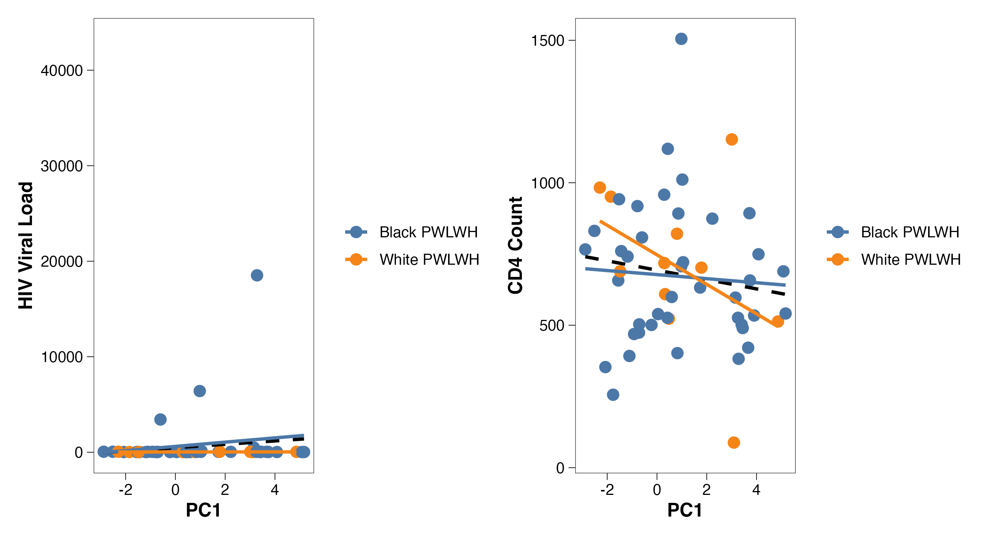
Supplementary Figure 7 - Spearman correlation by PC1 and HIV viral load (left) and PC1 and CD4 count (right) in PWLWH stratified by ethnicity. These scatterplots display the relationship between PC1 (inflammation) and HIV viral load or CD4 count in PWLWH by ethnicity. Lines represent subgroups and dots are individual subjects. Neither correlation was statistically significant; overall association between PC1 and HIV viral load (ρ = 0.08, p = 0.59) and between PC1 and CD4 count (ρ = -0.13, p = 0.35).
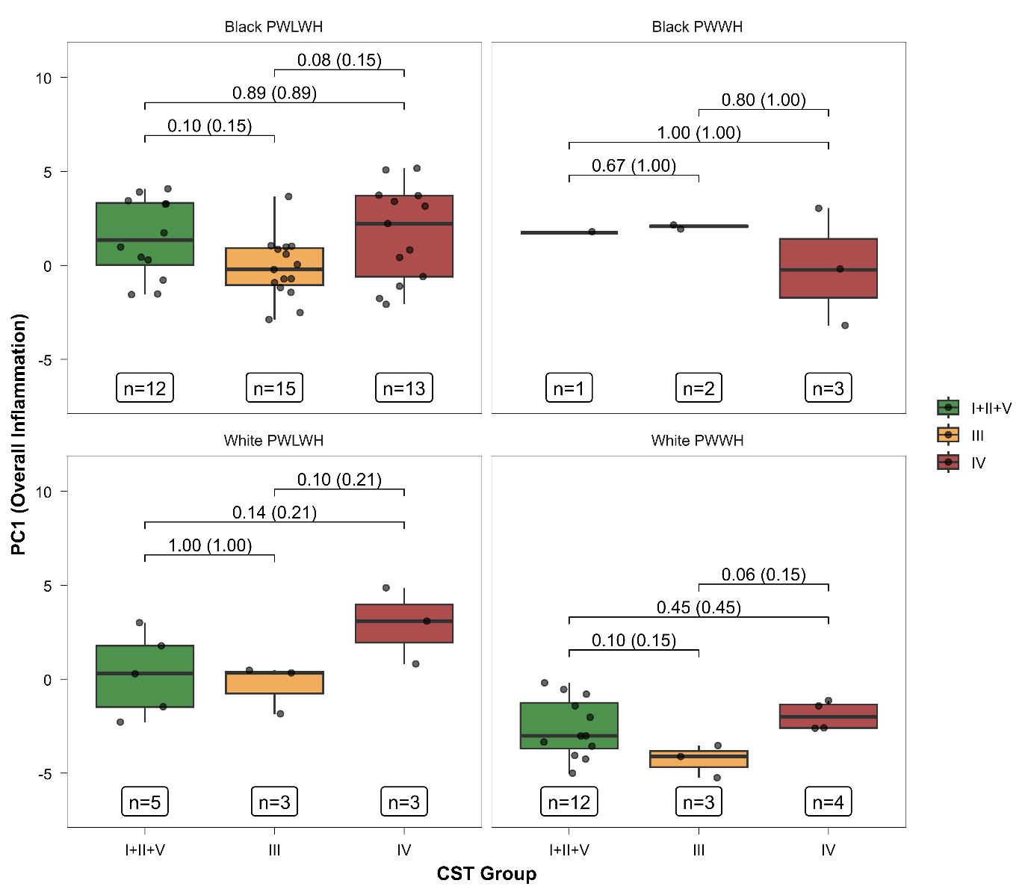
Supplementary Figure 8 - PC1 scores by CST group, faceted by ethnicity and HIV status. These boxplots show PC1 within CSTs by ethnicity. CSTs are compared with a Wilcoxon signed-rank test between CST groupings within subgroups. Unadjusted p values with FDR-adjusted p values in parentheses. Sample size varied by CST and subgroups and is included below each box plot.

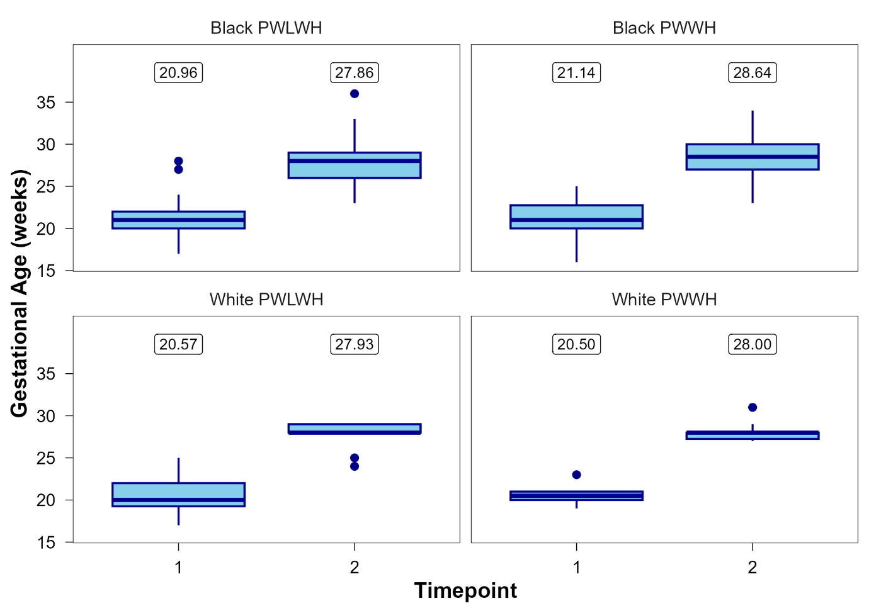Supplementary Figure 9 - Gestational age by ethnicity and HIV status at Timepoints 1 and 2. This boxplot displays the distribution of gestational age (weeks) at two timepoints across the subgroups. Mean gestational ages are shown above each box. Overall averages: timepoint 1 – 20.84 weeks, timepoint 2 – 28.01 weeks

Supplementary Table 6: Average time between longitudinal samples provided during pregnancy by subgroup
Weeks between visits was not significantly different between subgroups (p = 0.21)
Group | Mean Weeks | Standard Deviation | N
Black PWLWH | 6.97 | 2.19 | 49
Black PWWH | 7.52 | 1.95 | 14
White PWLWH | 7.31 | 2.34 | 14
White PWWH | 7.42 | 1.23 | 18

