Enhanced Cr(VI) removal using zero-valent manganese nanoparticles

Jian Peng ^{a, 1}, Canbin Zhong ^{b, 1}, Wei Liu ^{b}, Jialin Liao ^{c}, Baofu Gao ^{c}, Wubiao Lin ^{b}, Ruixiong Huang ^{d}, Rikun Lai ^{e}, Yong Yang ^{f}, Huosheng Li ^{b}, Ying Zhou ^{b}, Xinqian Zhou ^{b}, Jianyou Long ^{b, *}

ª Zhongchengjian Shengyi (Shenzhen) Environmental Technology Co., Ltd, Shenzhen 518102, China
^{b} Key Laboratory for Water Quality and Conservation of the Pearl River Delta, Ministry of Education, School of Environmental Science and Engineering, Guangzhou University, Guangzhou 510006, China.
^{c} Shenzhen Bao'an Bay Environmental Technology Development Co., Ltd, Shenzhen 518102, China
^{d} China Nineteen Metallurgical Group Co., Ltd, Shenzhen 610031, China
^{e} Panyu Environmental Engineering Co., Ltd, Guangzhou 511400, China
^{f} Central & Southern China Municipal Engineering Design and Research Institute Co., Ltd, Wuhan 430010, China

¹: Jian Peng and Canbin Zhong contribute equally to this manuscript.

* Corresponding author

E-mail: longjyou@gzhu.edu.cn (J. Long)

Contents

Figure S1…………………………………………………………………………………1
Figure S2…………………………………………………………………………………2
Figure S3…………………………………………………………………………………3
Table S1…………………………………………………………………………………..4
Table S2…………………………………………………………………………………..5
Table S3…………………………………………………………………………………..6
Table S4…………………………………………………………………………………..7
Table S5…………………………………………………………………………………..8
Table S6…………………………………………………………………………….……..9
References……………………………………………………………………………….10

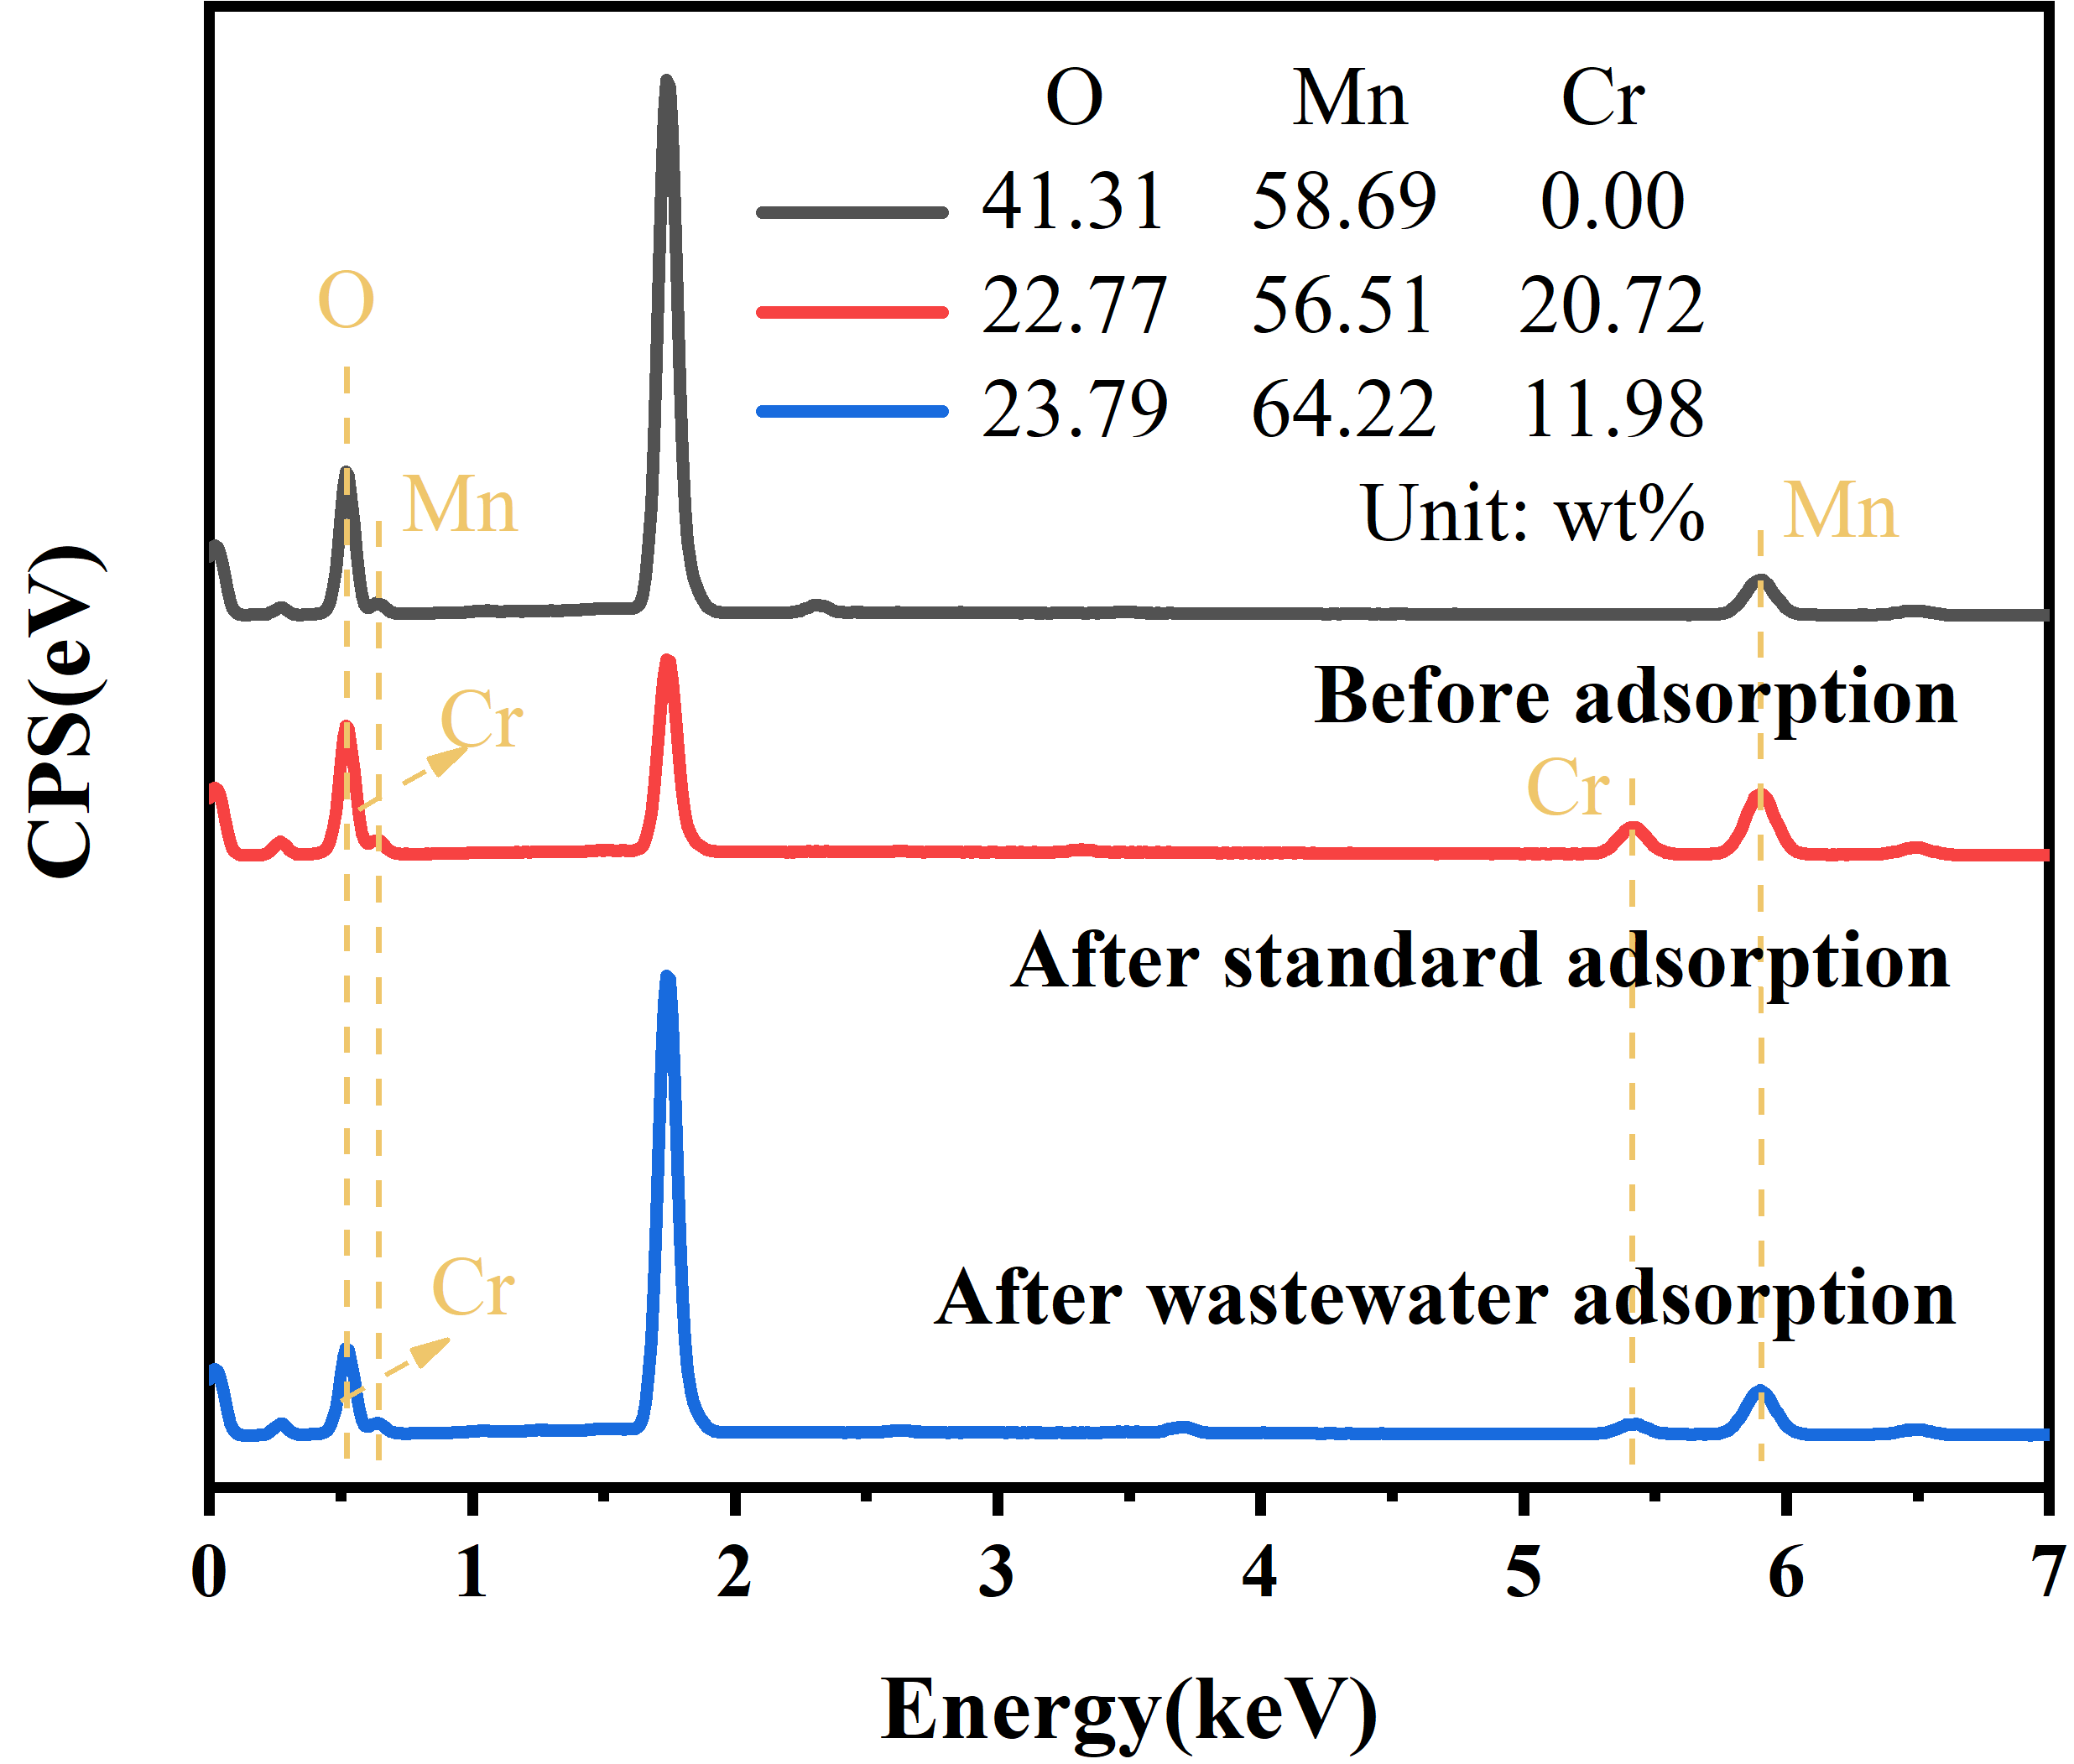

Fig. S1. EDS surface analysis.

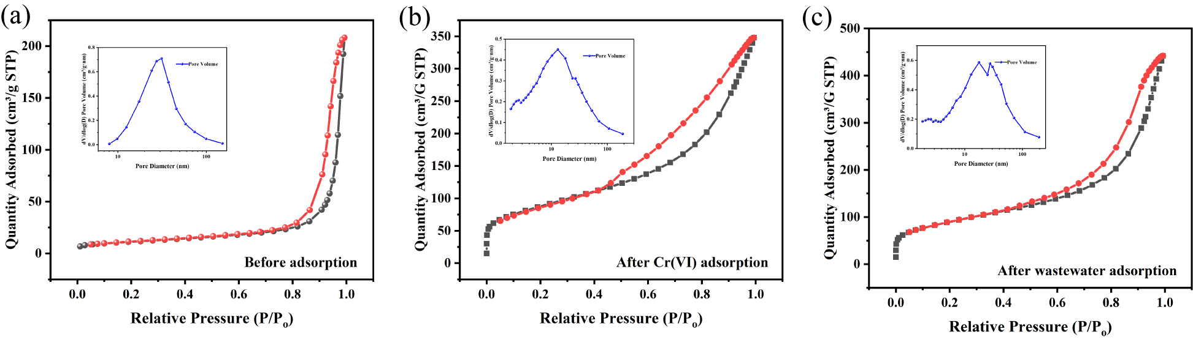 Fig. S2. N₂ adsorption-desorption isotherm and pore size of (a) ZVMn, (b) ZVMn-After standard Cr(VI) adsorption, (c) ZVMn- After actual Cr(VI) wastewater adsorption.

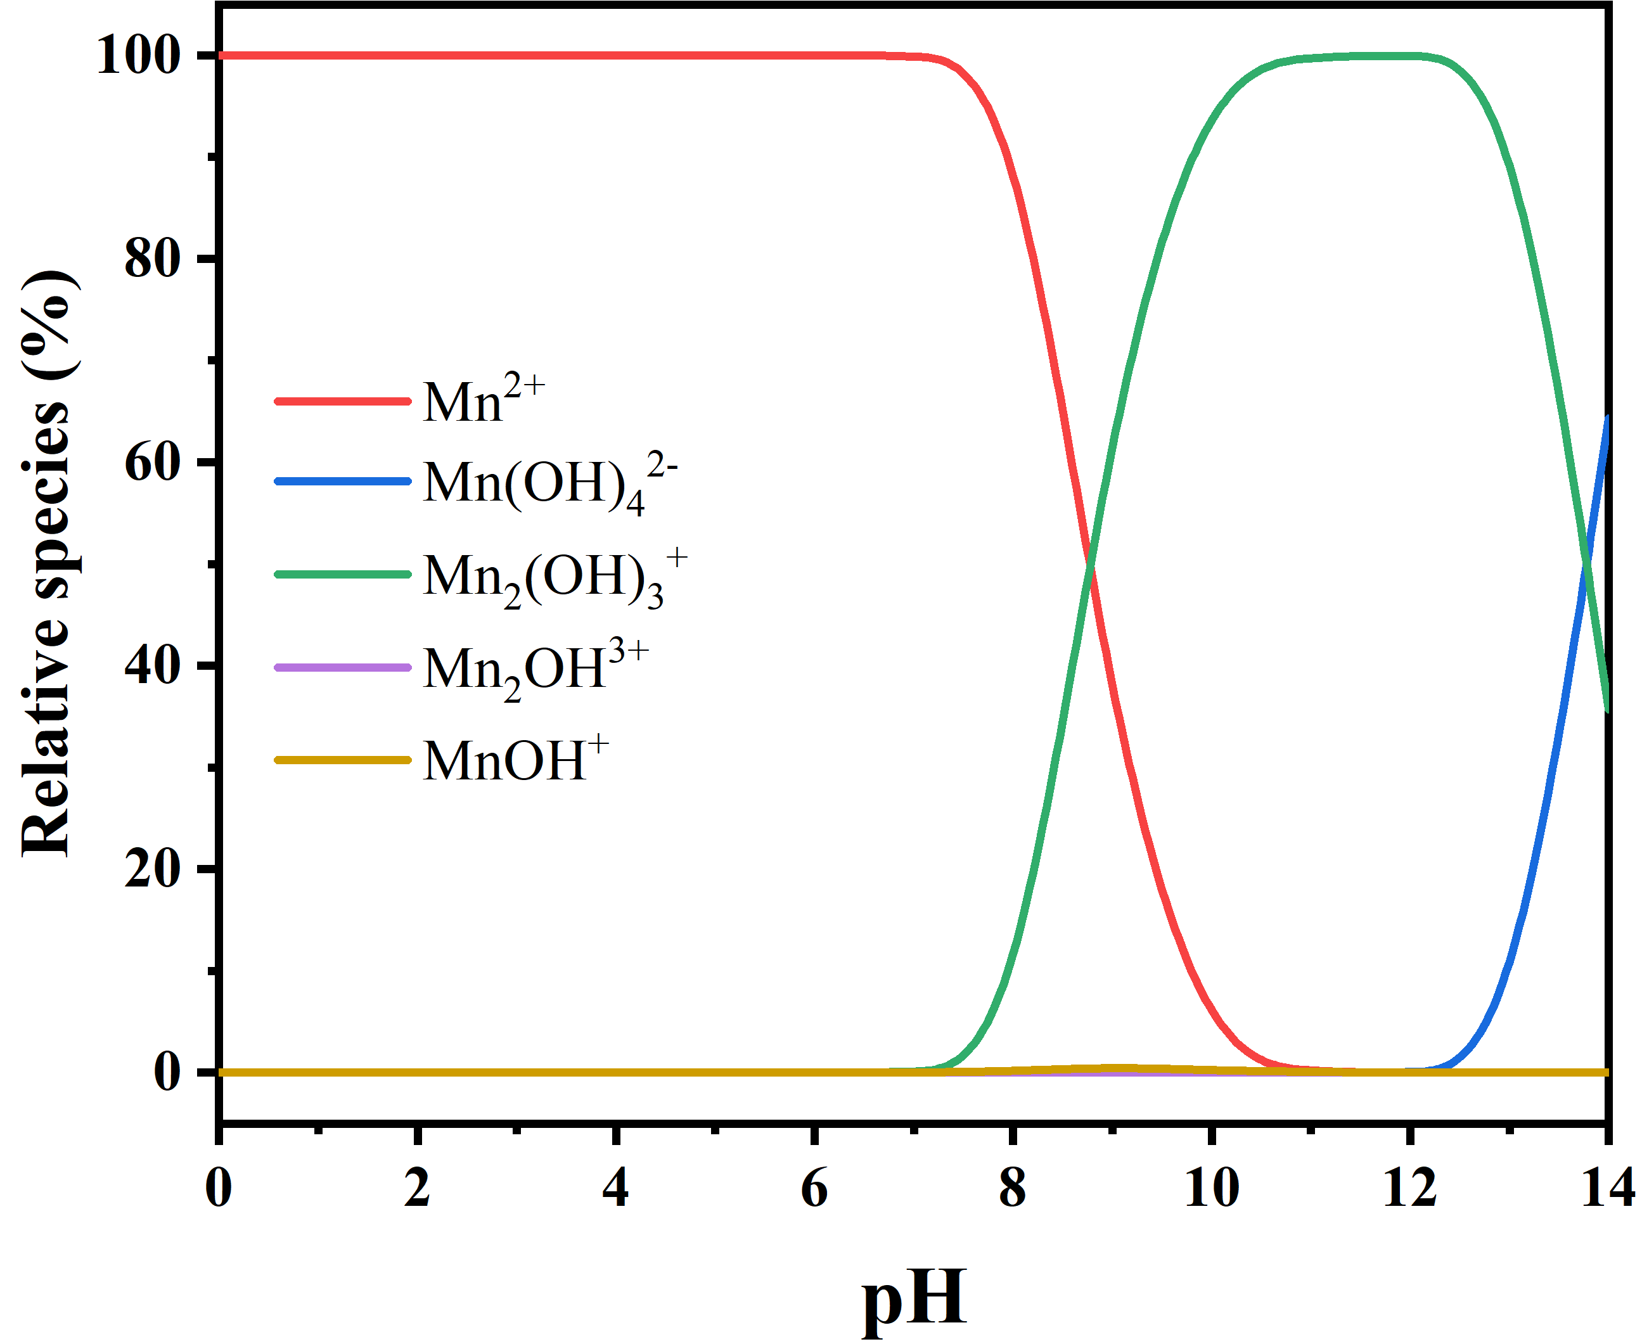

Fig. S3. Relative species of Mn(II) at various solution pH ([Mn(II)]₀ = 1 g/L)

- Concentrations of major composition in actual Cr(VI)-containing wastewater.
Ion | Ca²⁺ | Cr(VI) | K⁺ | Mg²⁺ | Na⁺ | Si | SO₄²⁻
Concentration  (mg/L) | 76 | 56.4 | 14.1 | 29.9 | 378 | 5.6 | 42.5

- The specific surface area and pore parameters for ZVMn before and after adsorption.
Adsorption Behavior | Specific Surface Area (m²/g) | Pore Size (nm) | Pore Volume (cm³/g)
Before Adsorption | 40.1 | 25.95 | 0.32
After Cr(VI) Adsorption | 312 | 8.16 | 0.50
After Wastewater Adsorption | 320 | 10.24 | 0.65

- The kinetic model parameters for the adsorption of Cr(VI) on ZVMn.
Initial Cr(VI) (mg/L) | Pseudo-first-order model |  |  | Pseudo-second-order model
Initial Cr(VI) (mg/L) | q_{e} (mg/g) | k₁  (min⁻¹) | R² | q_{e} (mg/g) | k₂ (g/(mg·min) | R²
40 | 35.98 | 0.030 | 0.641 | 35.73 | 2.98E⁻³ | 0.898
50 | 45.60 | 0.009 | 0.949 | 46.15 | 1.24E⁻³ | 0.874
60 | 53.52 | 0.023 | 0.727 | 54.22 | 1.04E⁻³ | 0.881
70 | 61.71 | 0.018 | 0.599 | 62.70 | 9.42E⁻⁴ | 0.891
Wastewater | 51.71 | 0.054 | 0.269 | 51.70 | 2.61E⁻³ | 0.896

- Langmuir and Freundlich isotherm parameters for Cr(VI) sorption on the ZVMn.
T (K) | Langmuir model |  |  | Freundlich model
T (K) | q_{max} (mg/g) | K_{L} (L/mg) | R² | K_{F} (L/g) | 1/n | R²
298 | 168.3 | 0.065 | 0.741 | 40.41 | 0.260 | 0.972

- Comparison of Cr(VI) adsorption performances with various synthetic adsorbents.
Adsorbents | pH | T (℃) | Dosage (g/L) | Initial Cr(VI) (mg/L) | Max capacity (mg/g) | Equilibrium time (h) | Reference
nZVI-Alkaline -Ti₃C₂ | 2 | 25 | 0.2 | 10-100 | 194.87 | 6 | (He et al., 2020)
CaFe₂O₄/ZrO₂-Magnetic nanocomposite | 2 | 30 | 0.4 | 25-150 | 178.57 | 1 | (Bhowmik et al., 2022)
Modified Garcinia kola hull particles | 2 | 40 | 8 | 10-60 | 217.39 | 1 | (Popoola, 2024)
SZVMn | 5 | 25 | 1 | 10-200 | 190.8 | 24 | (Long et al., 2023)
S-mZVI/Sulfur-doped graphene like biochar | 5.7 | - | 1 | 0-200 | 70.2 | 2 | (Wang et al., 2023)
Biochar- Carboxymethyl cellulose-nZVI | 5.6 | 25 | 1.25 | 5-200 | 112.5 | 24 | (Zhang et al., 2019)
nZVI/Attapulgite | 6.2 | 20 | 0.2 | 20-100 | 27.36 | 3 | (Wei et al., 2022)
ZVMn | 6 | 25 | 1 | 10-300 | 168.3 | 4 | This study

- XPS result of ZVMn surface before and after adsorption.
Species |  | BE(eV) | Relative abundance (area %)
 |  | BE(eV) | Before adsorption | After adsorption-Standard Cr(VI) (100 mg/L) | After adsorption-Actual Cr(VI) wastewater
Mn 2p_{3/2} | Mn⁰ | 639.2 | 5.11 | 2.80 | 0.00
Mn 2p_{3/2} | Mn(II) | 640.7 | 30.93 | 39.50 | 23.66
Mn 2p_{3/2} | Mn(III) | 642.0 | 45.35 | 42.30 | 57.63
Mn 2p_{3/2} | Mn(IV) | 643.5 | 18.62 | 15.41 | 18.70
Cr 2p_{3/2} | Cr(III) | 576.8 | - | 97.03 | 89.29
Cr 2p_{3/2} | Cr(VI) | 578.9 | - | 2.97 | 10.71
O 1s | O²⁻ | 529.8 | 22.68 | 51.55 | 51.55
O 1s | -OH | 531.0 | 51.55 | 36.60 | 44.85
O 1s | H₂O | 532.1 | 25.77 | 11.34 | 25.26

References:
Bhowmik, M., Debnath, A. and Saha, B. 2022. Scale-up Design and Treatment Cost Analysis for Abatement of Hexavalent Chromium and Metanil Yellow Dye from Aqueous Solution Using Mixed Phase CaFe₂O₄ and ZrO₂ Nanocomposite. International Journal of Environmental Research 16(5).
He, L., Huang, D., He, Z., Yang, X., Yue, G., Zhu, J., Astruc, D. and Zhao, P. 2020. Nanoscale zero-valent iron intercalated 2D titanium carbides for removal of Cr(VI) in aqueous solution and the mechanistic aspect. Journal of Hazardous Materials 388.
Long, J., Zheng, Y., Zha, S., Huang, J., Peng, D., Zhang, G., Xiao, T., Liu, Y., Yang, G. and Li, H. 2023. Freshly formed elemental sulfur-sulfidated zero-valent manganese for enhanced chromium(VI) removal from wastewater. Chemical Engineering Journal 472.
Popoola, L.T. 2024. Parameter Influence, Characterization and Adsorption Mechanism Studies of Alkaline-Hydrolyzed Garcinia kola Hull Particles for Cr(VI) Sequestration. Environmental Health Insights 18.
Wang, Y., Liu, Z., Huang, W., Lu, J., Luo, S., Czech, B., Li, T. and Wang, H. 2023. Capture-reduction mechanism for promoting Cr(VI) removal by sulfidated microscale zerovalent iron/sulfur-doped graphene-like biochar composite. Carbon Research 2(1).
Wei, Y., Usman, M., Farooq, M., Adeel, M., Haider, F.U., Pan, Z., Chen, W., Liu, H. and Cai, L. 2022. Removing Hexavalent Chromium by Nano Zero-Valent Iron Loaded on Attapulgite. Water, Air, & Soil Pollution 233(2).
Zhang, S., Lyu, H., Tang, J., Song, B., Zhen, M. and Liu, X. 2019. A novel biochar supported CMC stabilized nano zero-valent iron composite for hexavalent chromium removal from water. Chemosphere 217, 686-694.

